Supplementary Data

Expression of PIH1D1 and TILs: A. Association of TILs abundances with PIH1D1 level; B and C. most significant TILs with the negative and positive Spearman’s correlation with PIH1D1 levels respectively (supplementary data 1).
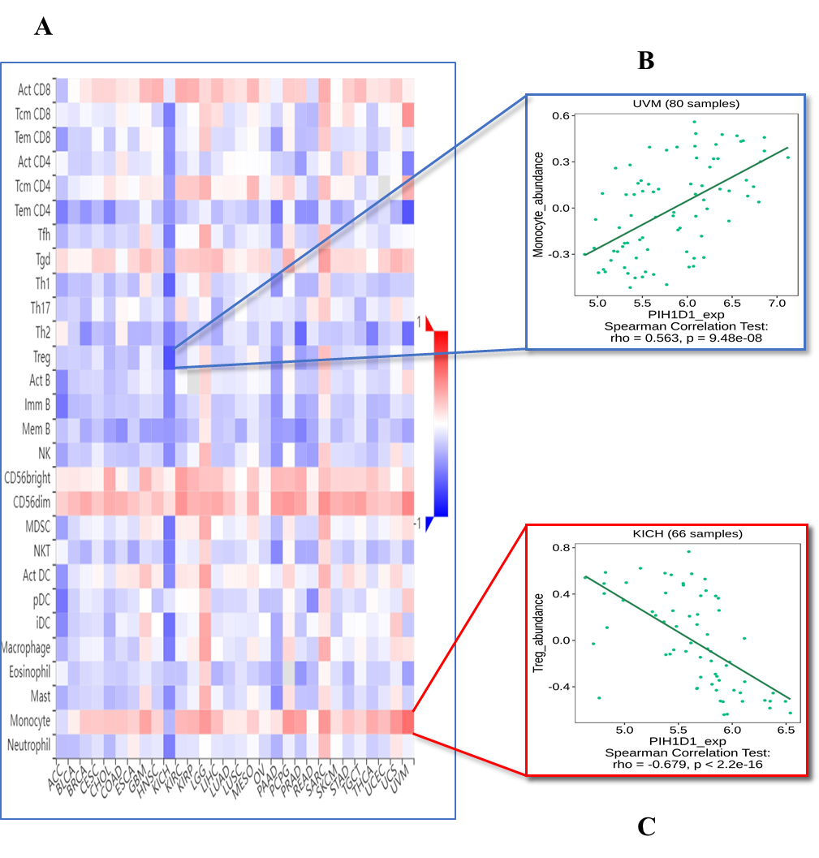

Expression of PIH1D1 and Immunoinhibitor: A. Association of Immunoinhibitor abundances with PIH1D1 level; B and C. most significant Immunoinhibitor with the positive and negative Spearman’s correlation with PIH1D1 levels respectively (supplementary data 2)
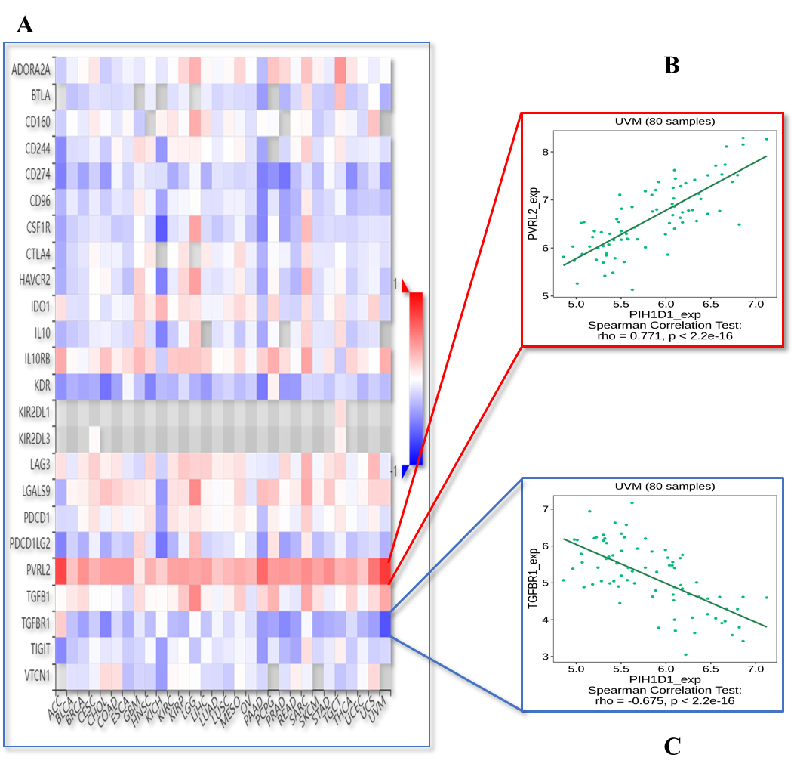

Expression of PIH1D1 and Immunostimulator: A. Association of Immunostimulator abundances with PIH1D1 level; B and C. most significant Immunostimulator with the negative and positive Spearman’s correlation with PIH1D1 levels respectively (supplementary data 3).
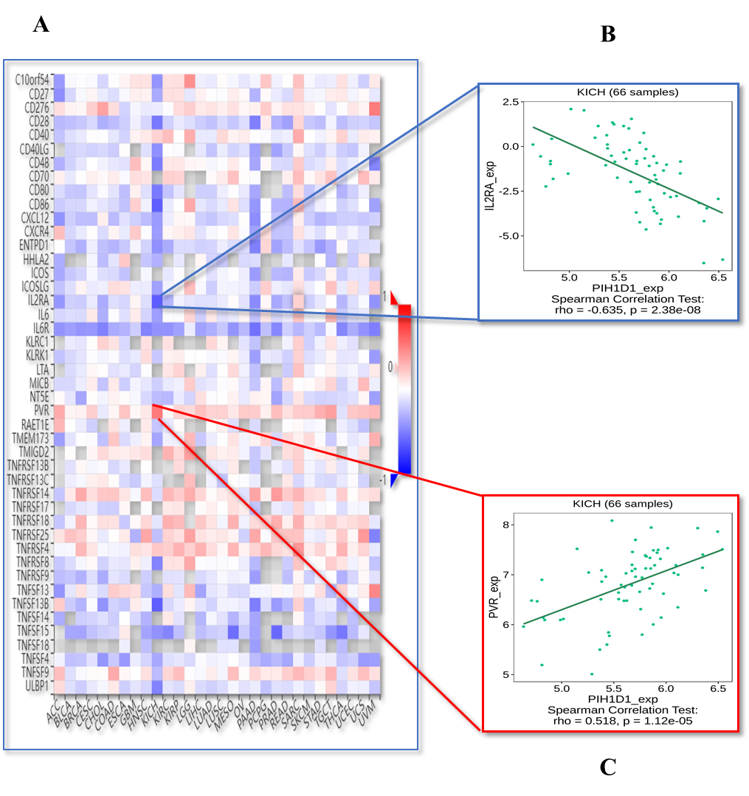

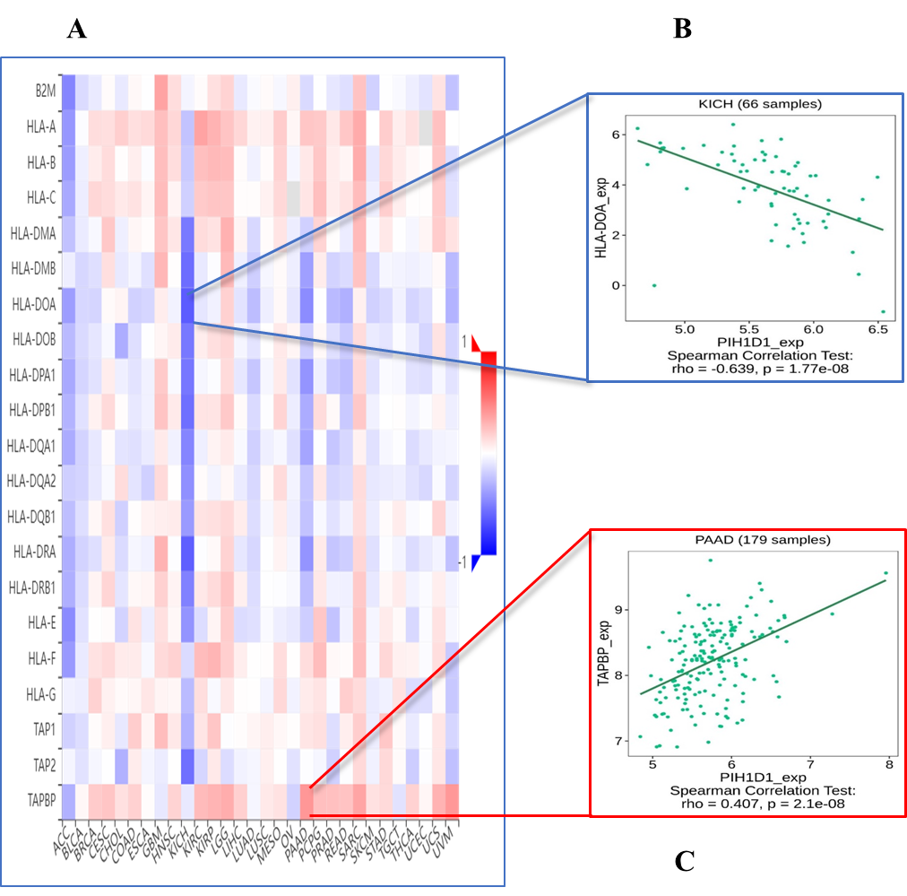
Expression of PIH1D1 and MHC molecule: A. Association of MHC molecule abundances with PIH1D1 level; B and C. most significant MHC molecule with the negative and positive Spearman’s correlation with PIH1D1 levels respectively (supplementary data 4).

Figure 13. Expression of PIH1D1 and Chemokines: A. Association of Chemokines abundances with PIH1D1 level; B and C. most significant Chemokines with the positive and negative Spearman’s correlation with PIH1D1 levels respectively (supplementary data 5).
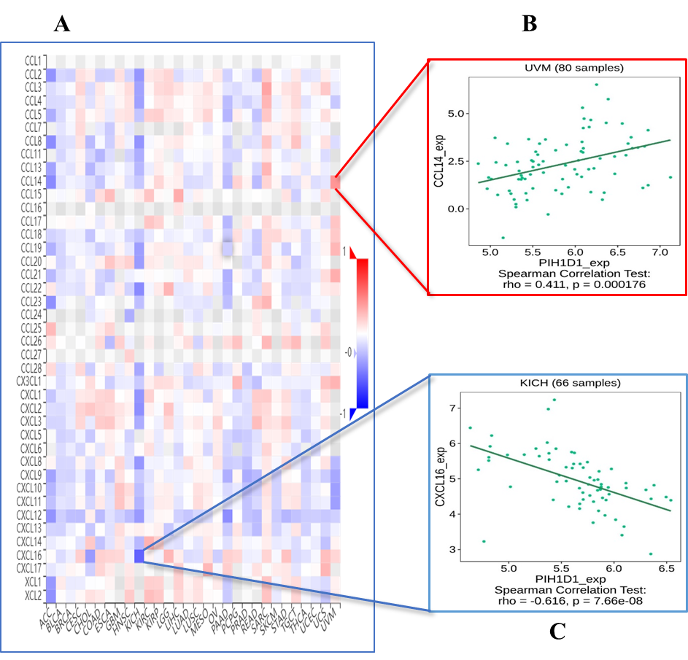

Expression of PIH1D1 and Receptors: A. Association of Receptors abundances with PIH1D1 level; B and C. most significant Receptors with the negative and positive Spearman’s correlation with PIH1D1 levels respectively (supplementary data 6).
