Table of Contents
Figure S1 : Principal Component Analysis of common variation in NORDiC cases and unaffected controls. 2
Figure S2 : Principal Component Analysis of common variation in NORDiC Norwegian and Swedish samples. 3
Figure S3 : Scree plot for Principal Component Analysis of common variation. 4
Figure S4 : Log R Ratio Standard Deviation mean and standard deviation per dataset. 5
Figure S5 : mean and standard deviation for raw CNV call count per dataset. 6
Figure S6 : mean and standard deviation for analysis-ready CNV call count per dataset. 7
Figure S7 : QQ plots for locus-based association tests using small CNVs 30-100kb in size. 8
Figure S8 : QQ plots for locus-based association tests using CNVs between 100kb and 500kb in size. 9
Figure S9 : Leave-one-out analyses of global CNV burden in cases versus controls. 10
Figure S10 : Covariate leave-one-out analyses of global CNV burden in cases versus controls. 11
Figure S11 : Global CNV burden in cases versus controls stratified by CNV size. 12
Figure S12 : Global CNV burden in cases versus controls stratified by CNV frequency. 13
Figure S13 : Burden of CNVs in overlapping genes that are haplosensitive or triplosensitive. 14
Figure S14 : Global burden of noncoding CNV bases in cases versus controls, stratified by mammalian constraint. 15

Figure S1 : Principal Component Analysis of common variation in NORDiC cases and unaffected controls.
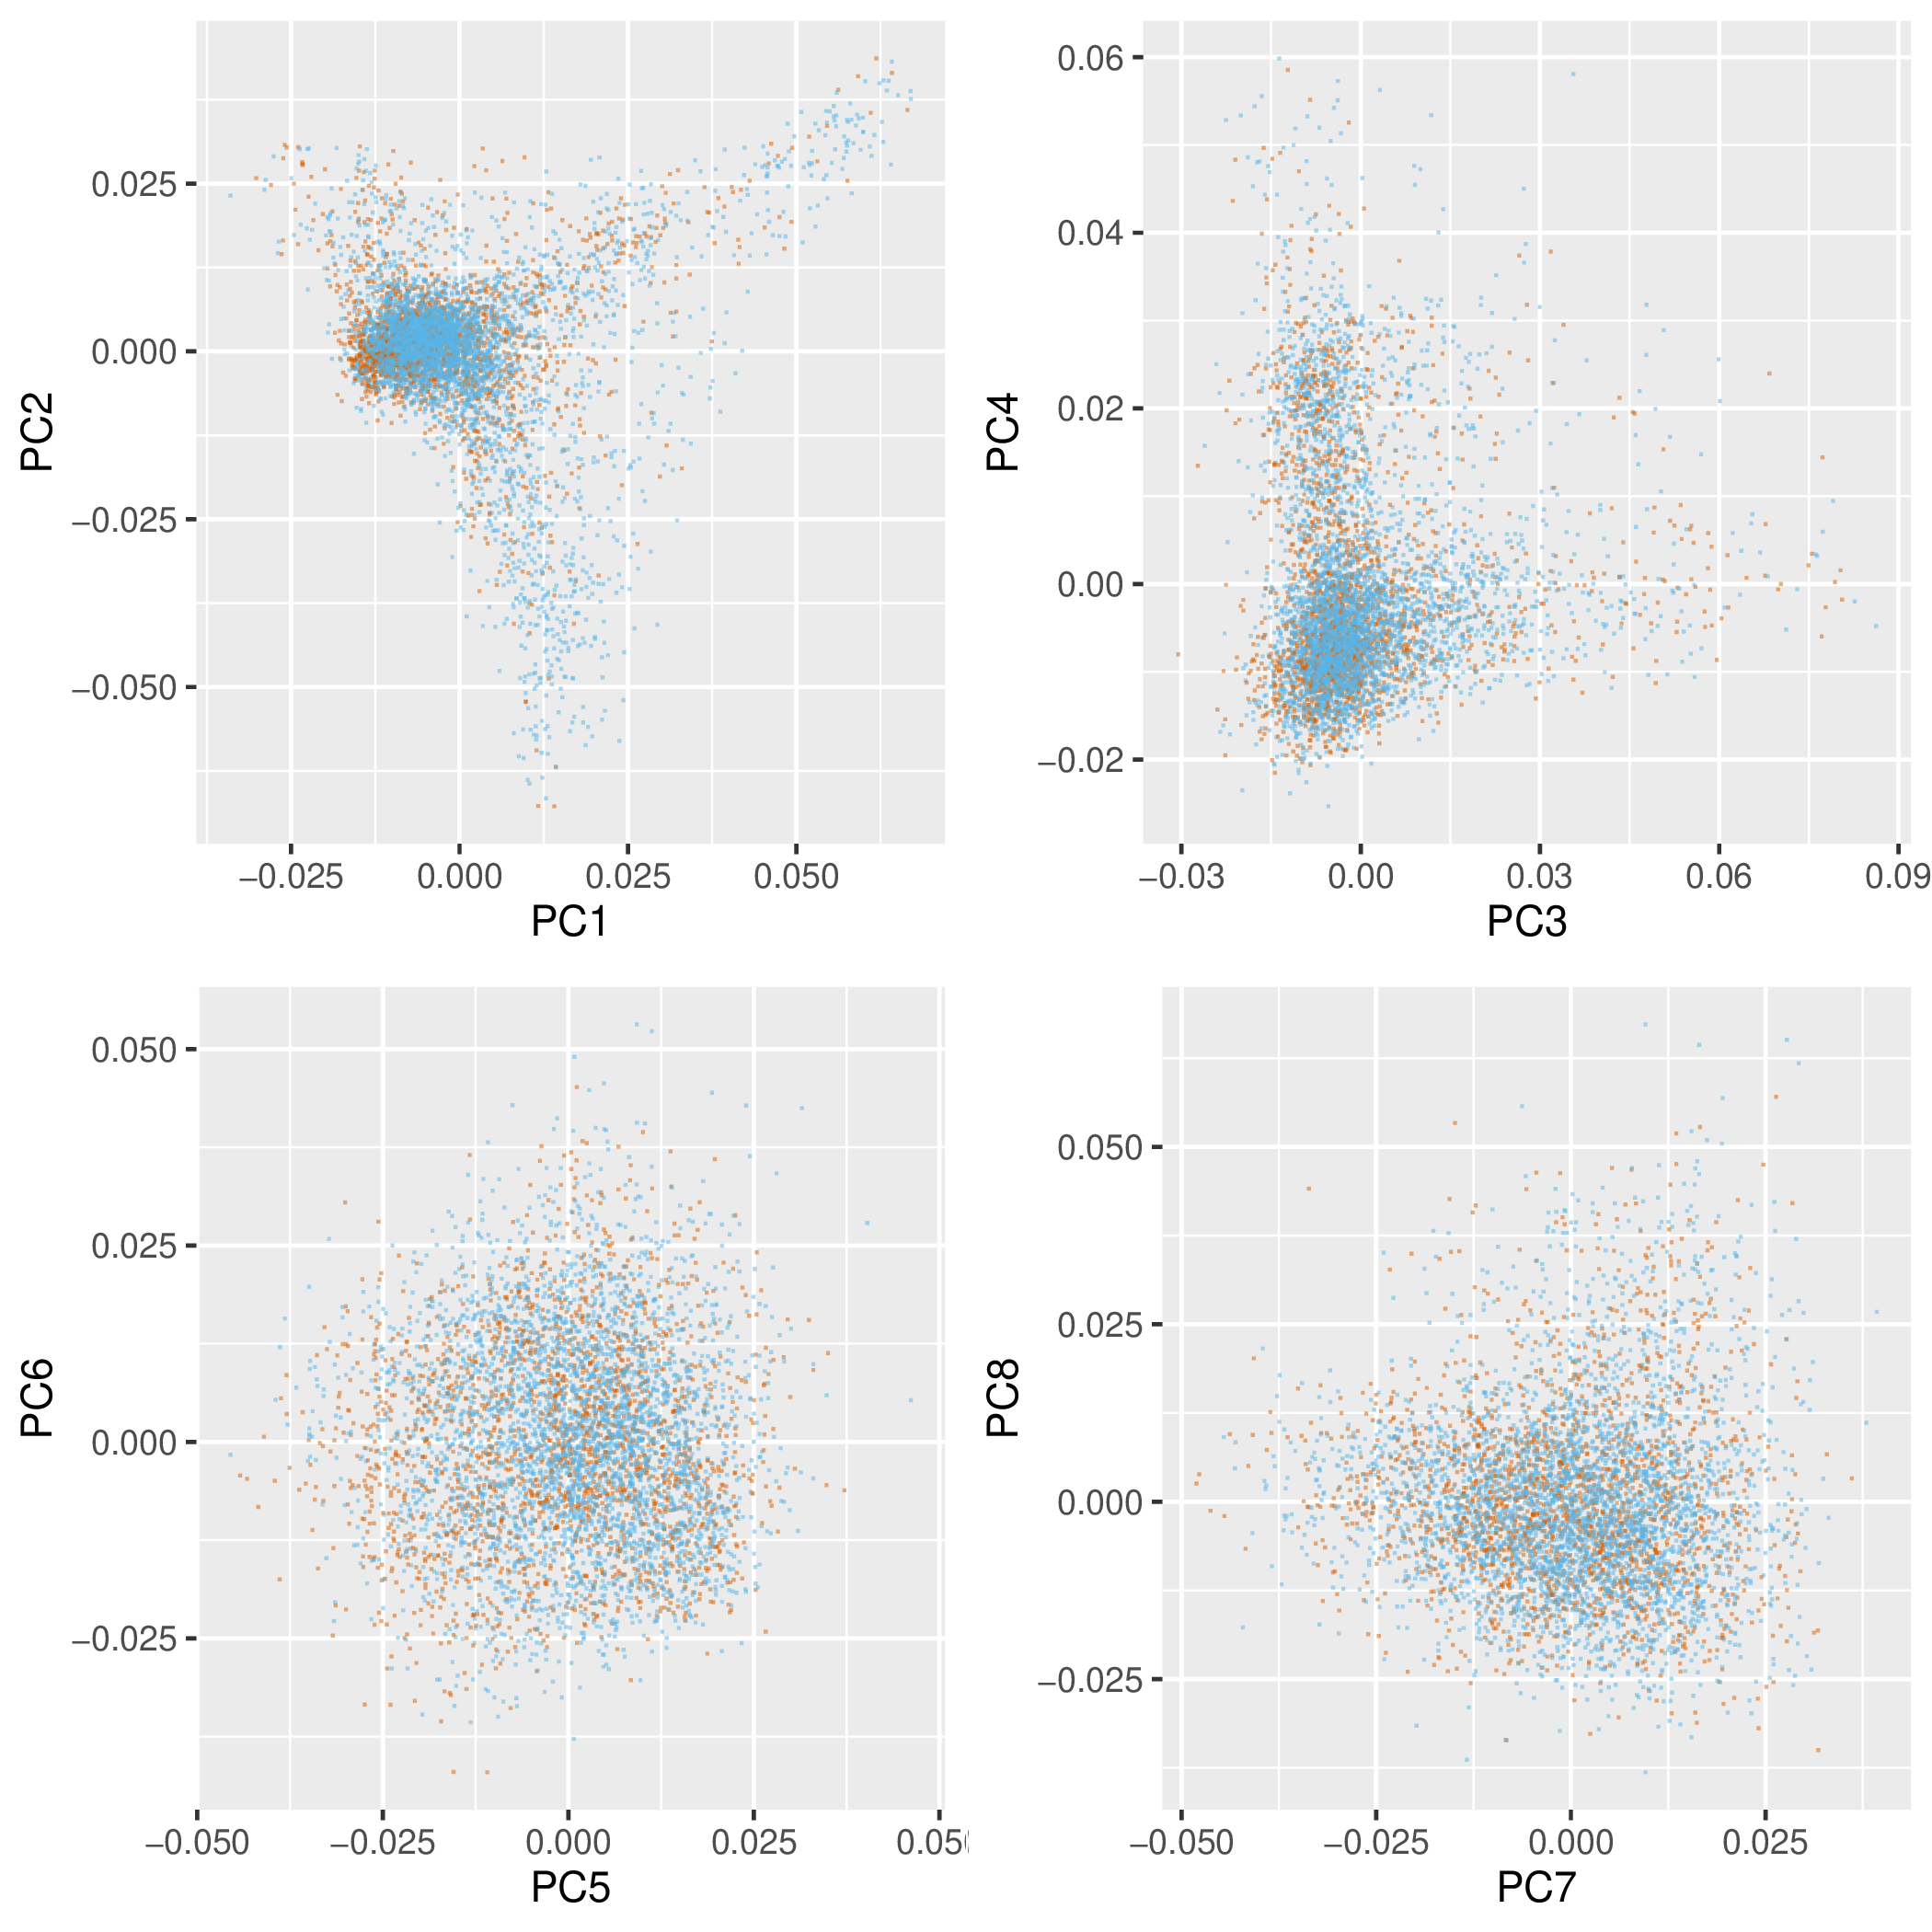
Figure 1 shows a Principal Component Analysis of common variation in NORDiC cases (orange) and unaffected controls (blue). There is no visible stratification of cases and controls along the main principal components.

Figure S2 : Principal Component Analysis of common variation in NORDiC Norwegian and Swedish samples.
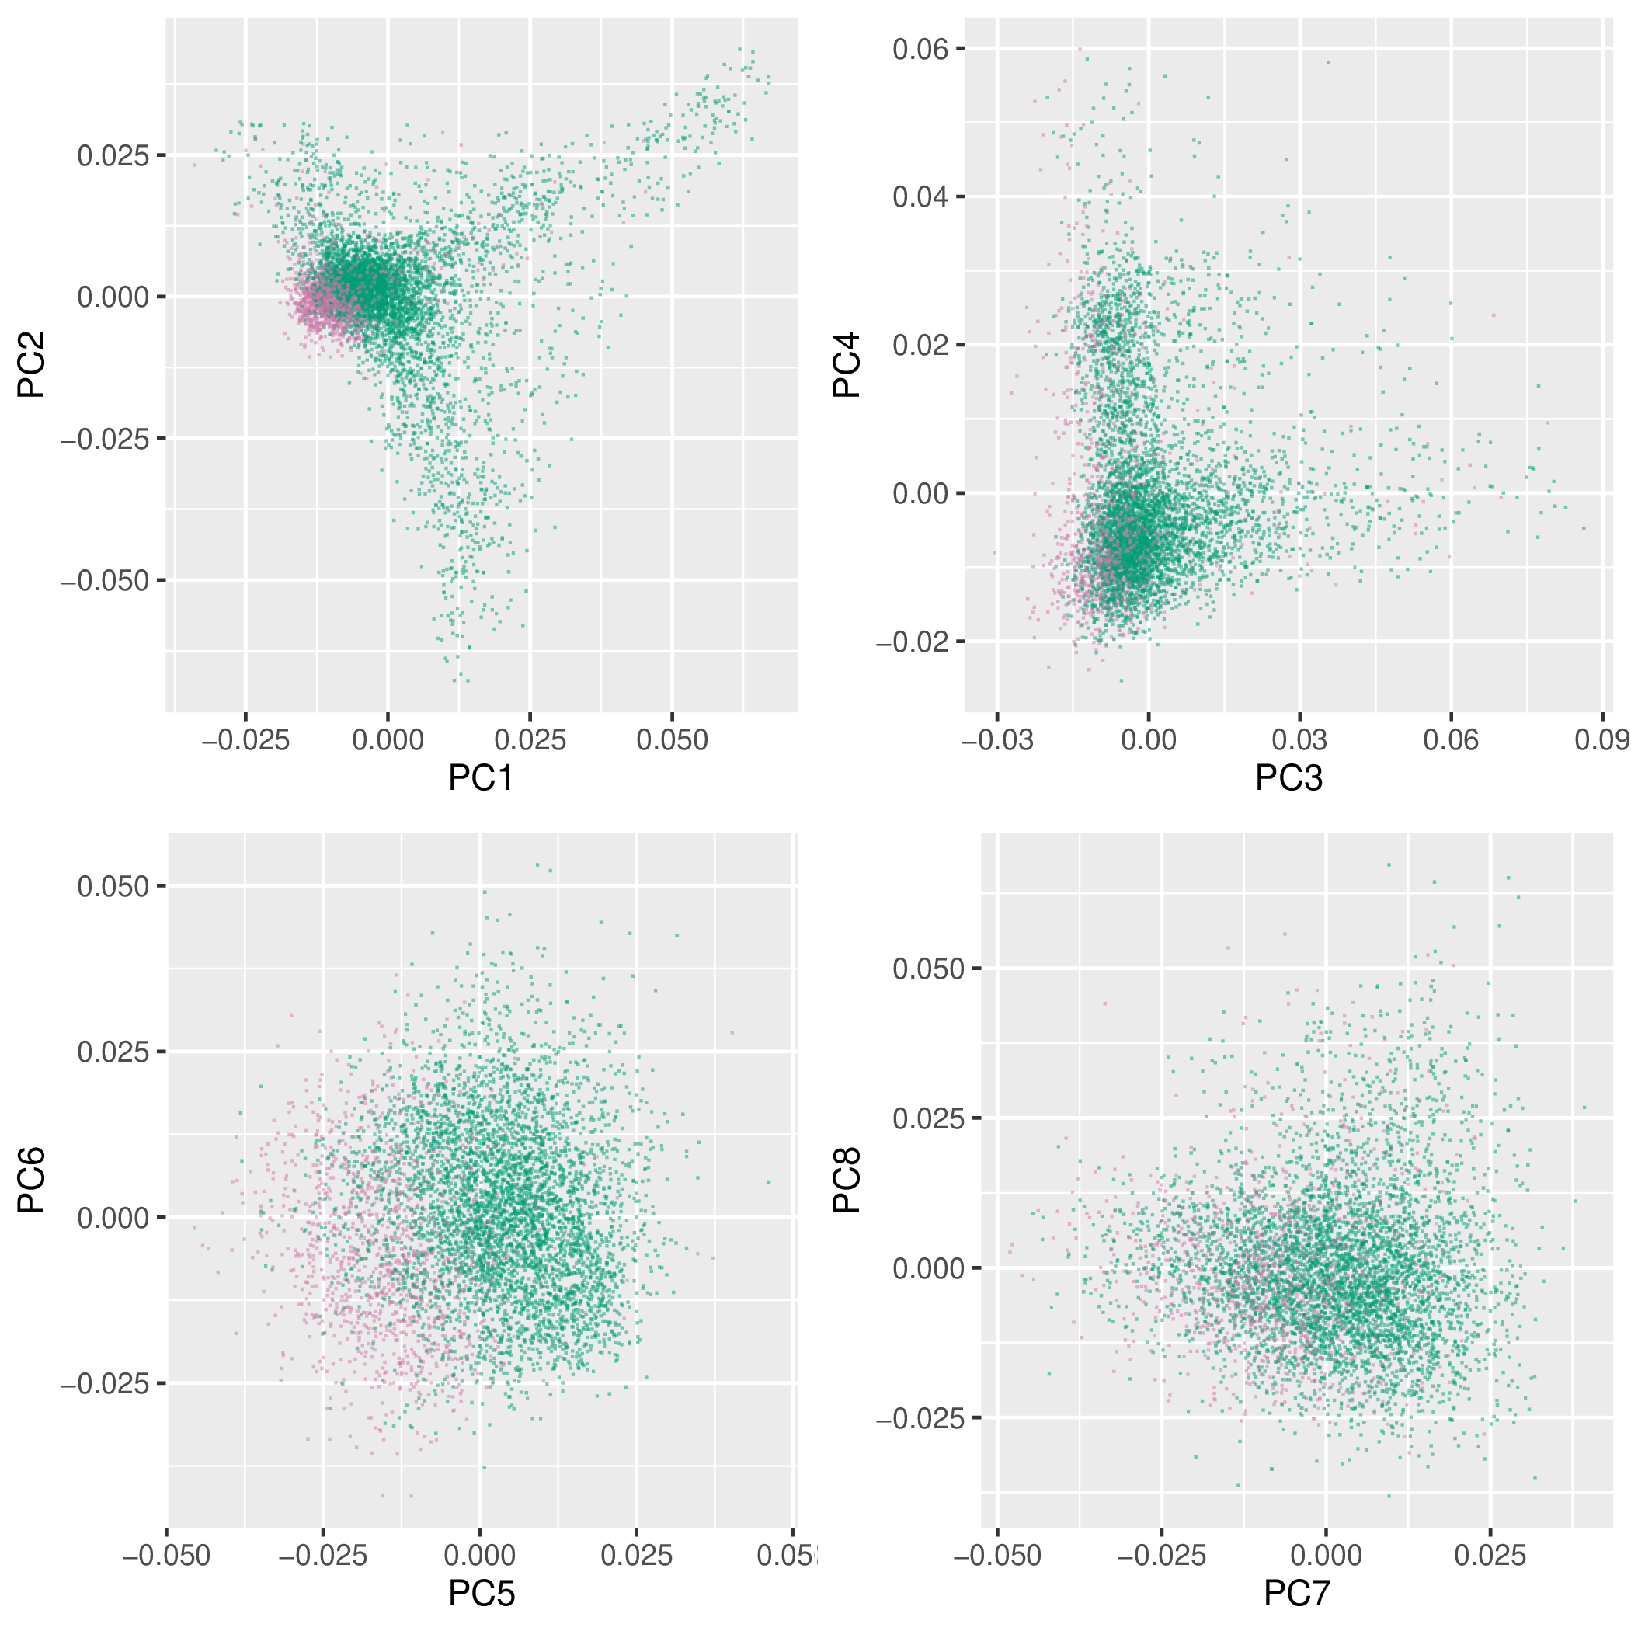
Figure 2 shows the same Principal Component Analysis as that depicted in Figure S1, but here, samples are colored by country of origin. Swedish samples are in green, and Norwegian samples are in purple. Here, we can see that Swedish and Norwegian samples do separate along some of the main principal components (PCs 1 and 5 in particular). There is both Swedish and Norwegian representation in both the case and control groups, but these results make it clear that controlling for Swedish vs. Norwegian ancestry is appropriate in this analysis.

Figure S3 : Scree plot for Principal Component Analysis of common variation.
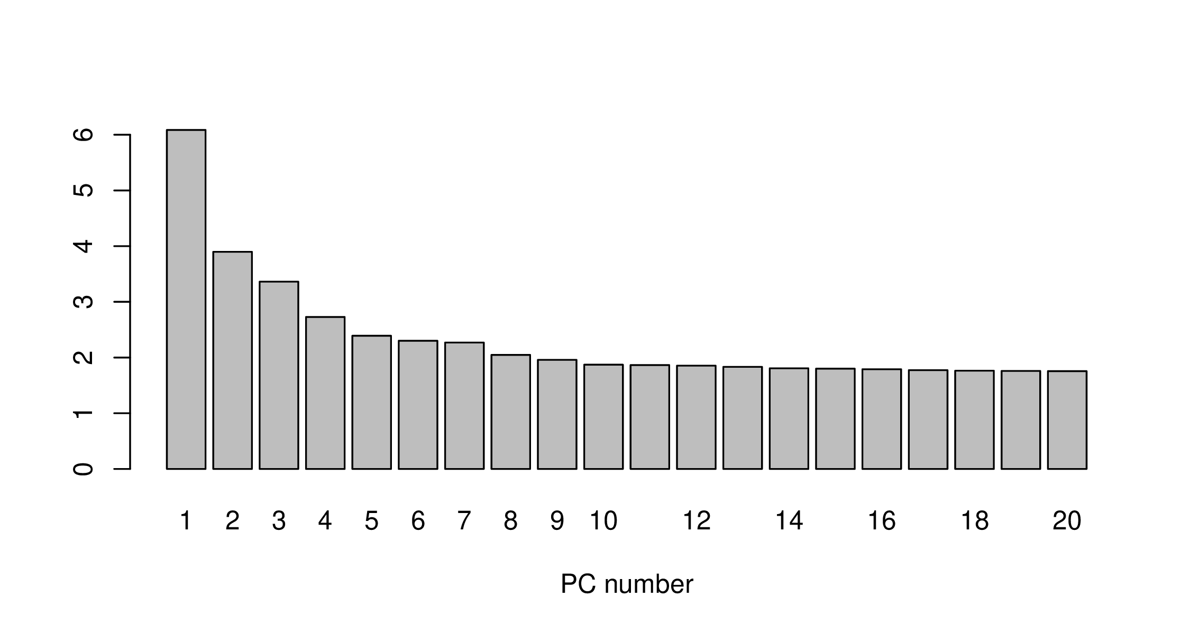
Figure 3 depicts a Scree plot for the Principal Component Analysis of common variation, showing the amount of variance explained by each of the principal components computed. We see that the large majority of the variance explained in the data comes specifically from the first 5 PCs. We use these PCs as covariates in our regression models by default, along with the subset of PCs 6-20 that showed nominal association with both case status and raw CNV count (P<0.01 for both).

Figure S4 : Log R Ratio Standard Deviation mean and standard deviation per dataset.
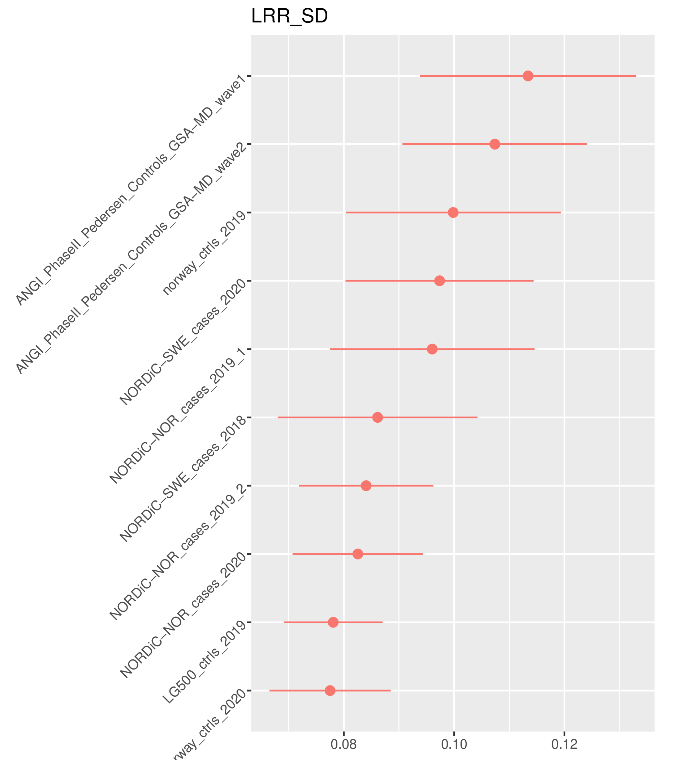
Figure 4 shows the mean and standard deviation of the Log R Ratio Standard Deviation metrics per input dataset. In general, LRR SD metrics are well controlled, with no individual dataset having a mean LRR SD greater than 0.12. It is notable that the both ANGI datasets appear to have slightly higher LRR SD values than the other datasets, particularly since for these datasets, we received them in the form of pre-clustered VCFs with intensity metrics, and were unable to put them down precisely the same gtc2vcf pipeline as other cohorts.

Figure S5 : mean and standard deviation for raw CNV call count per dataset.
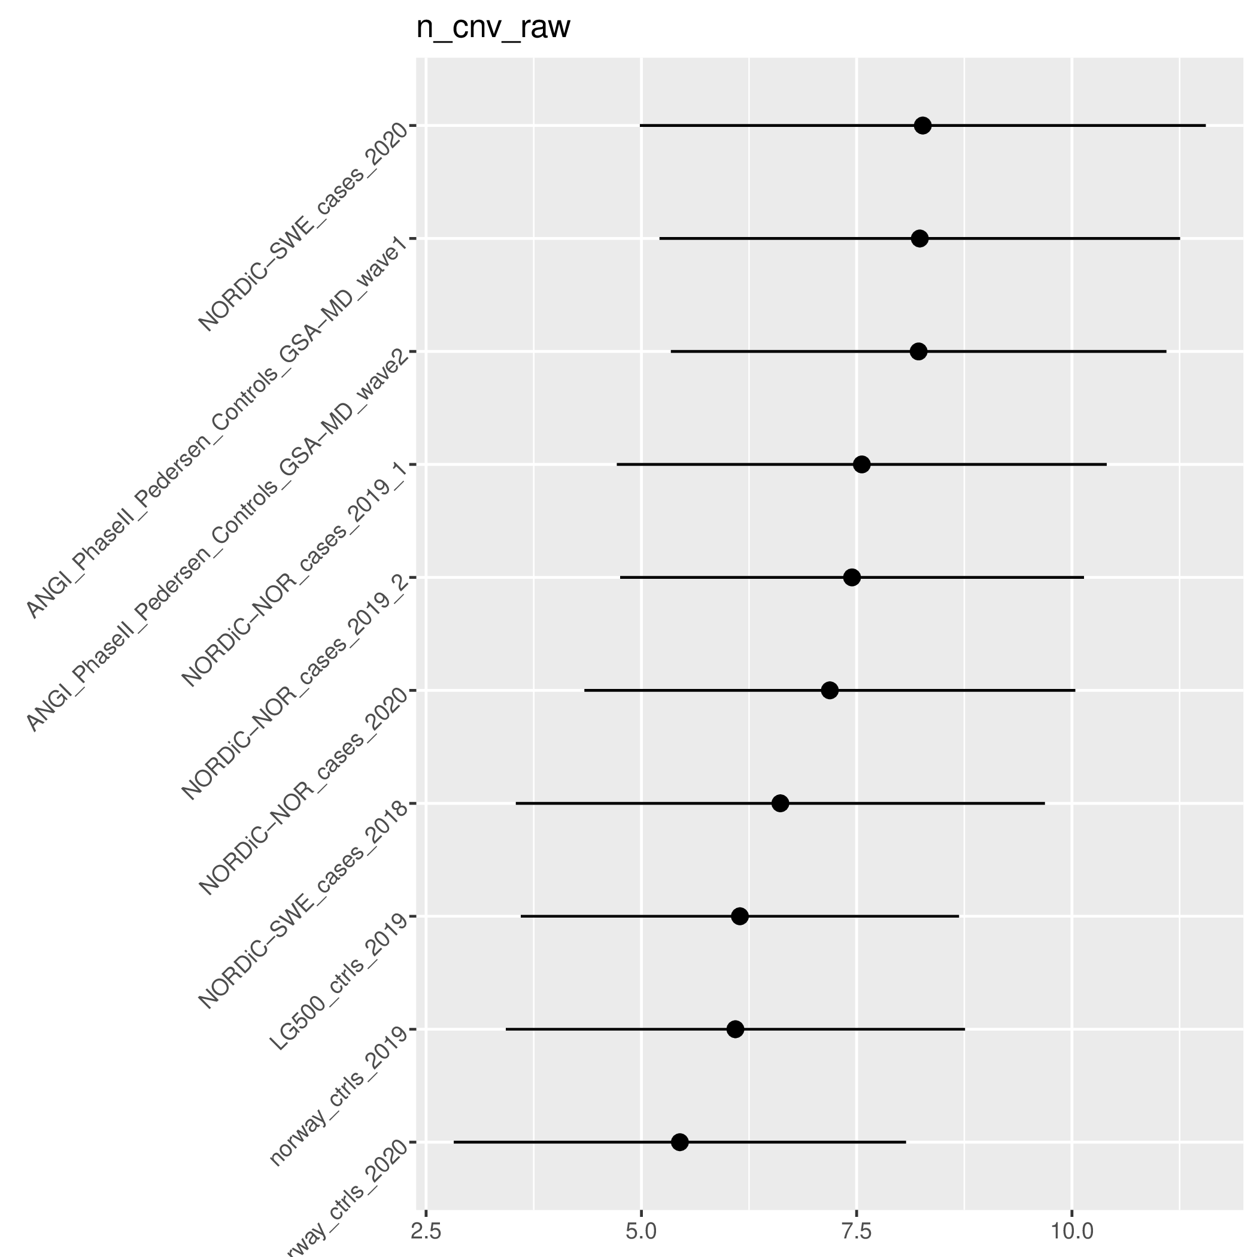
Figure 5 shows the mean and standard deviation of raw CNV call count per input dataset used in this study. There is notable variance in raw counts across datasets, necessitating stringent quality control of CNV calls included in comparisons.

Figure S6 : mean and standard deviation for analysis-ready CNV call count per dataset.
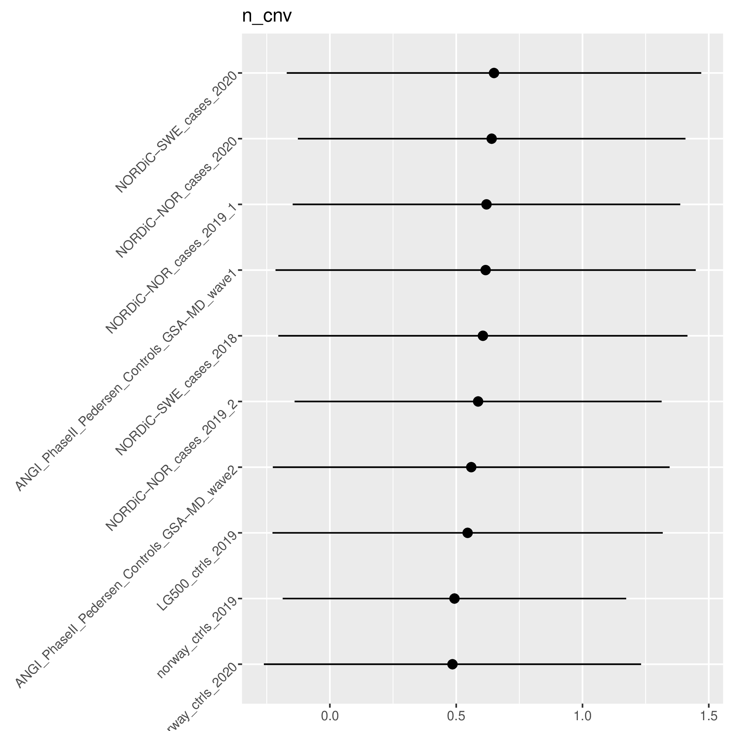
Figure 6 shows the mean and standard deviation of post-QC, analysis-ready CNV call counts per dataset. We see that here, relative to raw pre-QC CNV counts shown in Figure S5, call count metrics across separate datasets are far more comparable, with mean call counts per dataset ranging from around 0.5 to 0.65.

Figure S7 : QQ plots for locus-based association tests using small CNVs 30-100kb in size.
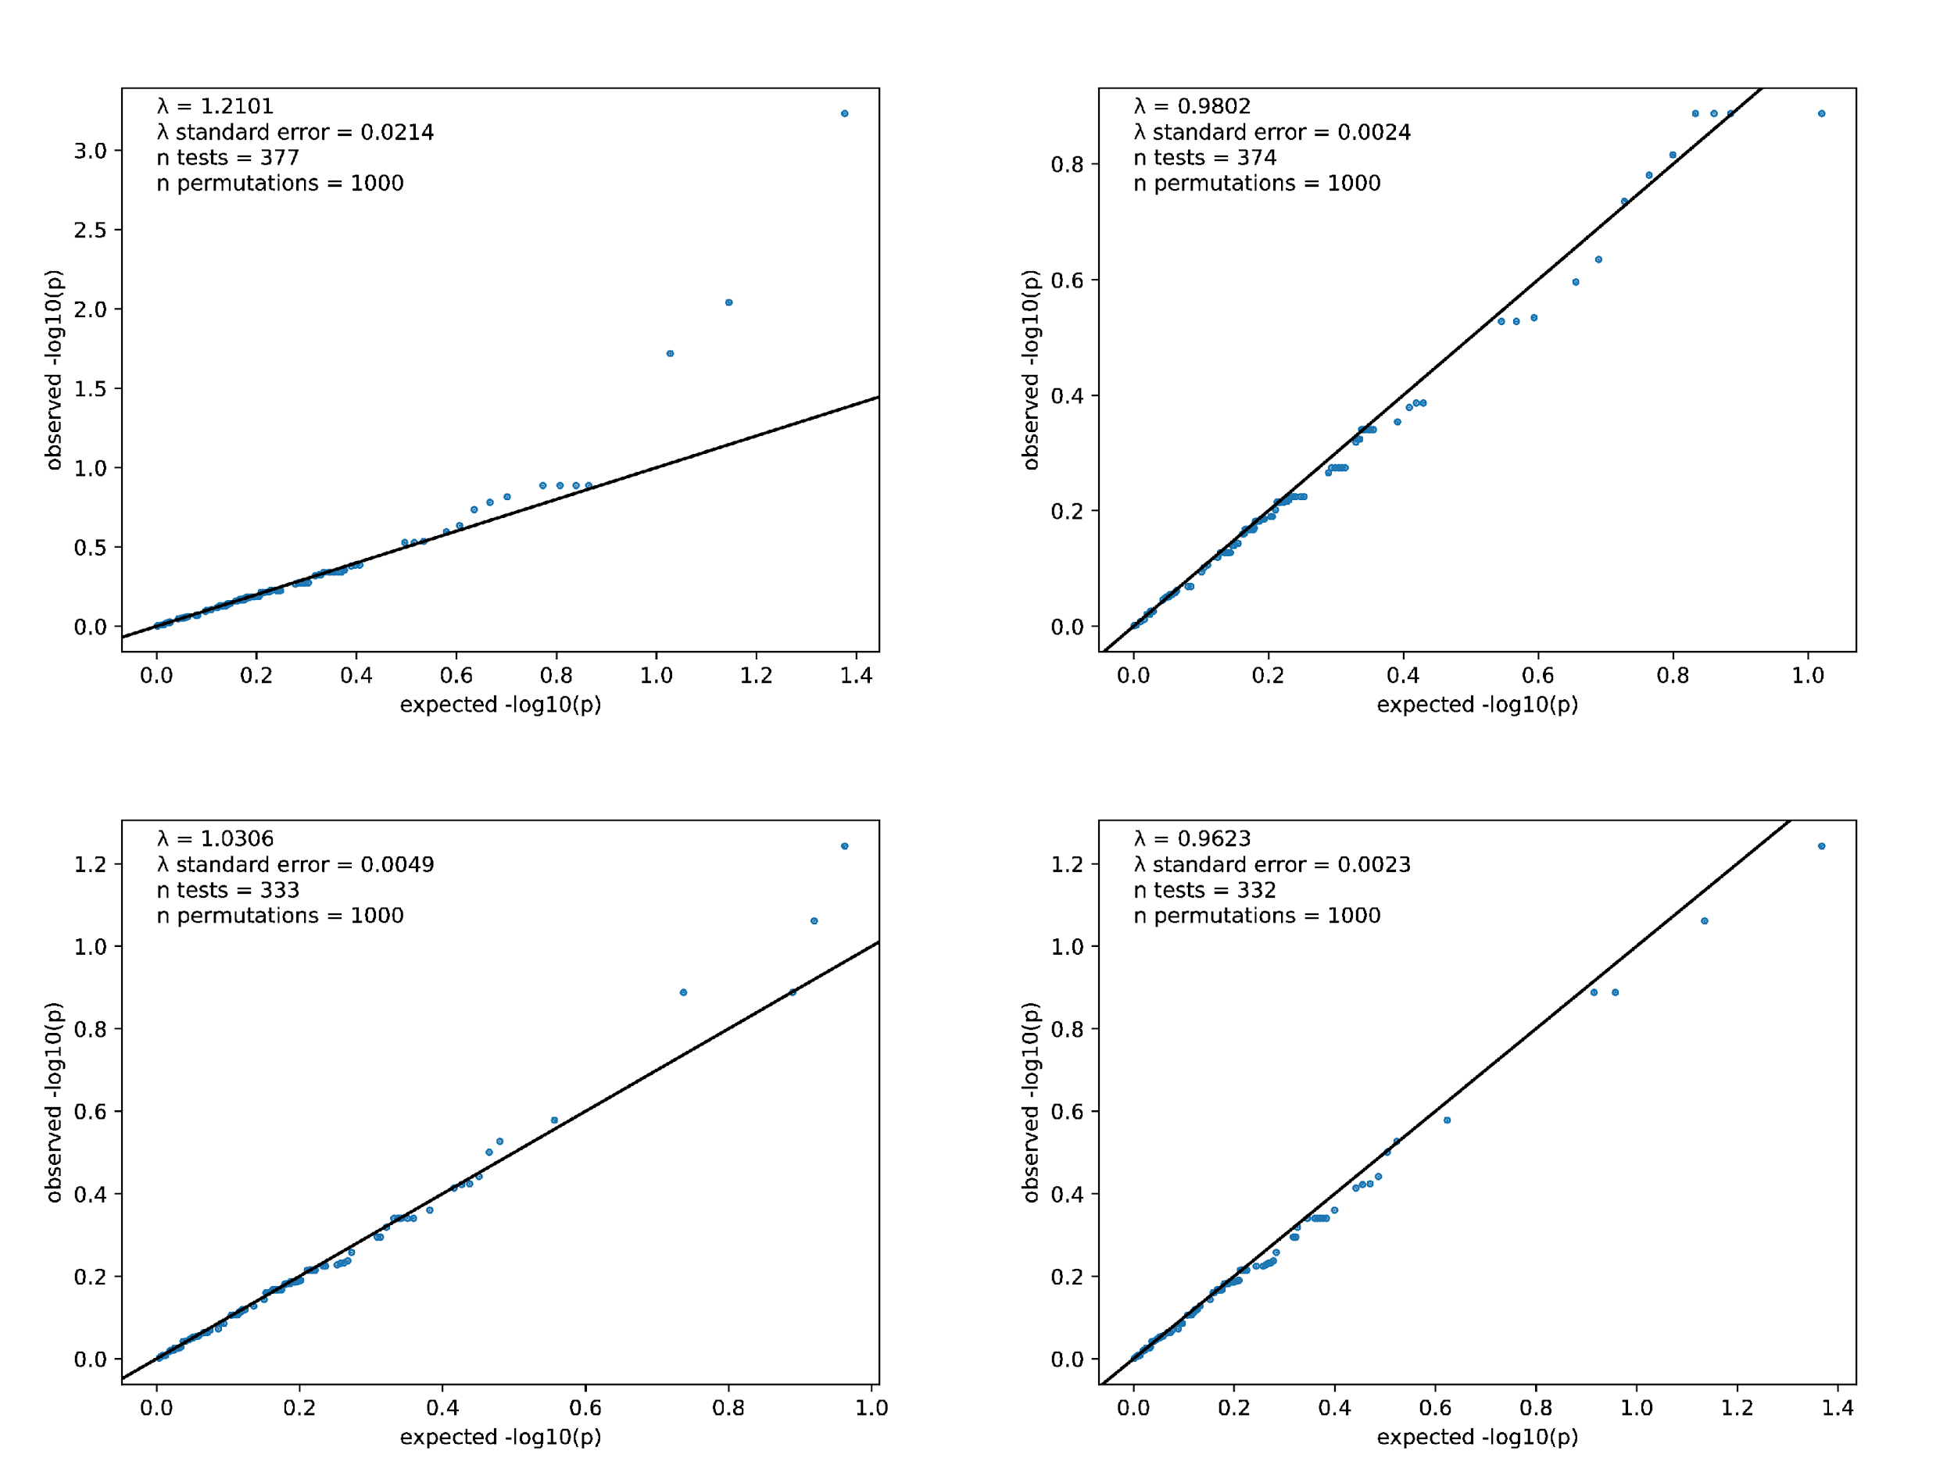
Figure 7 shows QQ plots for locus-based association tests using CNVs between 30kb and 100kb in size, with the intended purpose of finding loci that harbor clusters of case or control-biased CNV calls that are more likely from batch effects than true biology. We find evidence of some p-value inflation when producing a QQ plot specific to small deletions (top left). After exclusion of small CNVs that overlap these 3 specific loci, the inflation for deletions is gone (top right). There is not the same amount of obvious p-value inflation for duplications (bottom left), though we see that the genomic inflation estimate lambda for duplications goes down after duplications from these 3 prior mentioned loci are excluded (bottom right).

Figure S8 : QQ plots for locus-based association tests using CNVs between 100kb and 500kb in size.
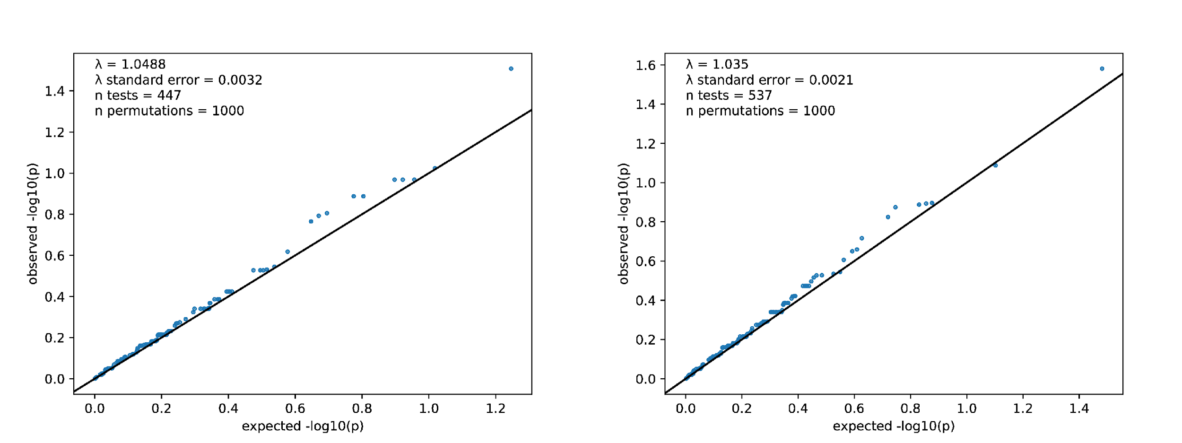
Figure 8 shows a QQ plot of locus-based association tests for deletions (left) and duplications (right) specifically for CNVs between 100 and 500 kb in size. There is no evidence of unreasonable p-value inflation across either set of tests.

Figure S9 : Leave-one-out analyses of global CNV burden in cases versus controls.
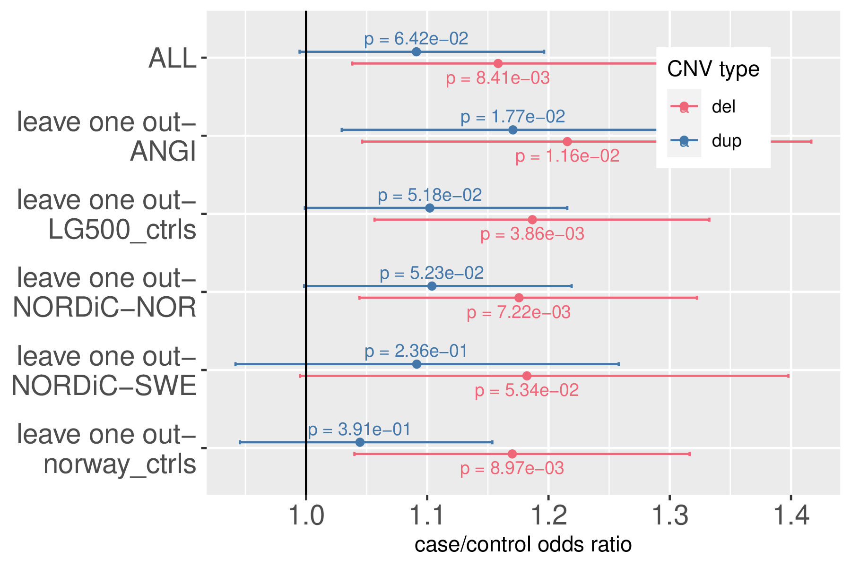
Figure 9 depicts the odds ratio estimate and 95% confidence interval for association between case status and each additional analysis-qualifying CNV call, in both the global case/control comparison and in leave-one-out analyses of specific cohorts included. While the case duplication excess is unstable across leave-one-out analyses, the case deletion excess appears to be stable (P<0.05 for all control leave-one-out comparisons, and P<0.1 for all case leave-one-out comparisons).

Figure S10 : Covariate leave-one-out analyses of global CNV burden in cases versus controls.
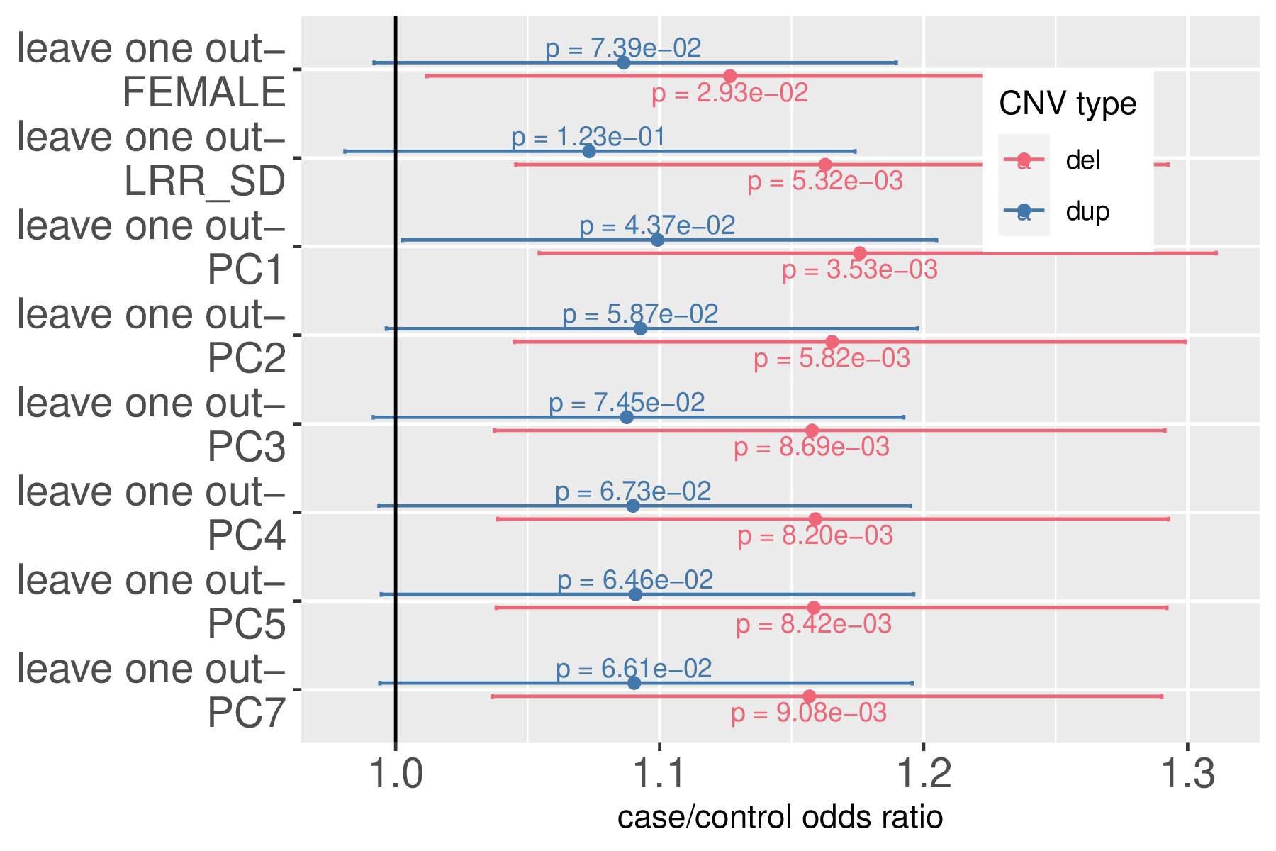
Figure 10 shows the results of leave-one-out analyses of global CNV burden versus case status, specific to individual covariates used in the regression model. Sex appears to be the covariate that has the greatest impact on association strength, likely due to the fact that the ANGI dataset is heavily female skewed (97.9% of cohort).

Figure S11 : Global CNV burden in cases versus controls stratified by CNV size.
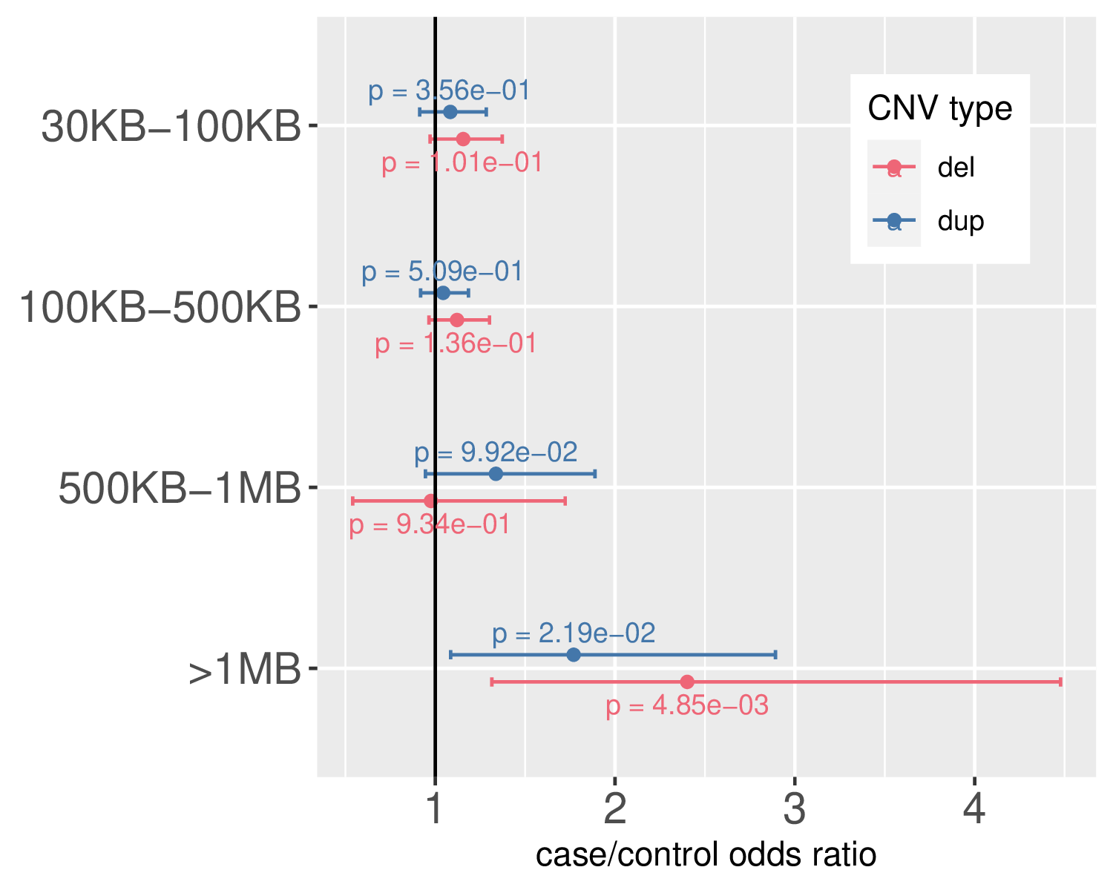
Figure 11 depicts association test results between CNV deletion (red) and duplication (blue) burden and OCD case status. As has been seen in similar studies of other psychiatric case cohorts, the CNVs that confer the largest amount of case relative risk are those that are particularly large (>1MB in size).

Figure S12 : Global CNV burden in cases versus controls stratified by CNV frequency.
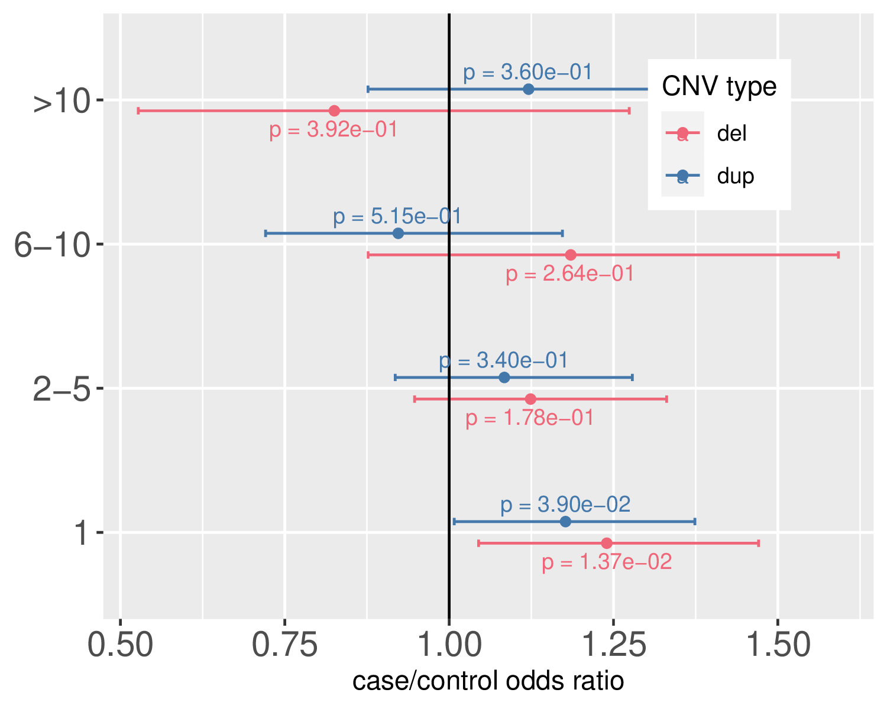
Figure 12 shows association test results between CNV count and case status, stratified by CNV frequency. We see that association test statistics for both deletions (red) and duplications (blue) are strongest for singleton CNVs, which are only observed once in the case/control cohort.

Figure S13 : Burden of CNVs in overlapping genes that are haplosensitive or triplosensitive.
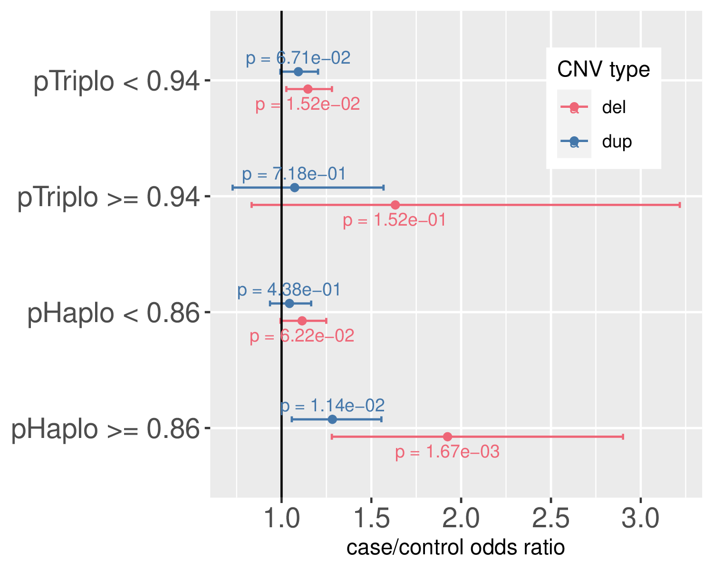
Figure 13 shows the results of association tests between CNV count and case status, stratified by whether or not a gene is impacted that is Triplosensitive or Haplosensitive based on a recently described CNV dosage sensitivity metric. The triplosensitivity metric does not prove effective in identifying genes enriched for CNV burden in OCD cases, whereas the haplosensitivity metric does appear effective in doing this for both duplications and deletions.

Figure S14 : Global burden of noncoding CNV bases in cases versus controls, stratified by mammalian constraint.
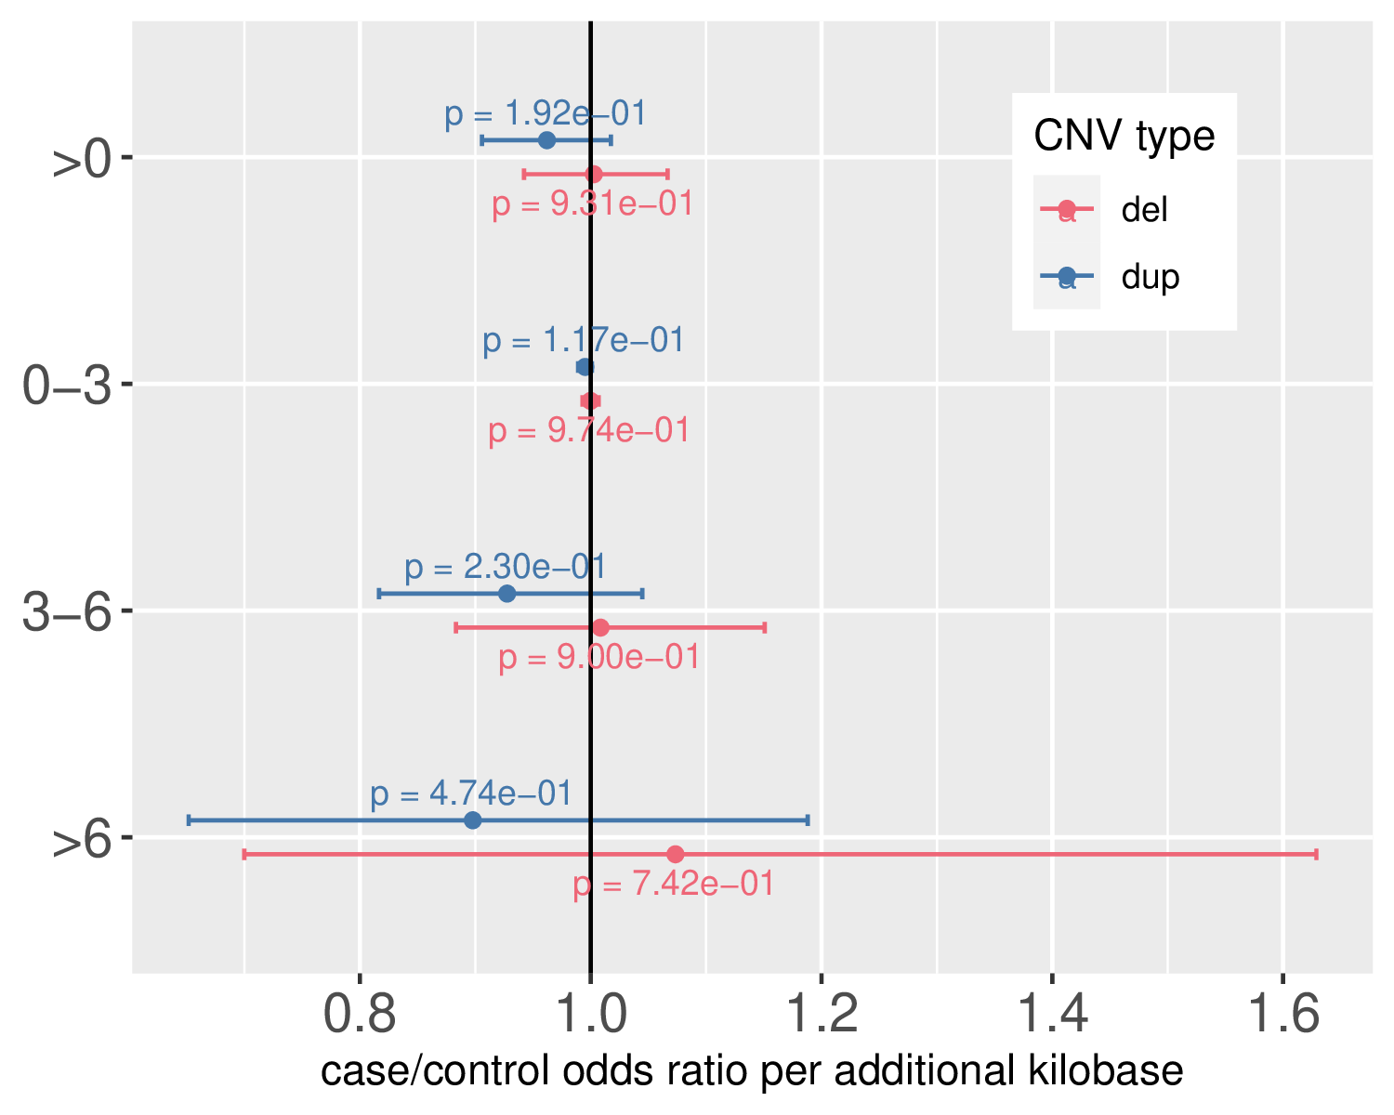
Figure 14 depicts association statistics between cumulative number of noncoding bases overlapping a CNV call and case status, with base counts stratified by mammalian constraint score bin. There is no significant association between burden and case status across any of these constraint bins.

