Graphical Abstract

Figure 1. Synthesis of Mixed ligand complex of p-MINAP and 1, 10-phenanthroline with Cu (II) metal ion.
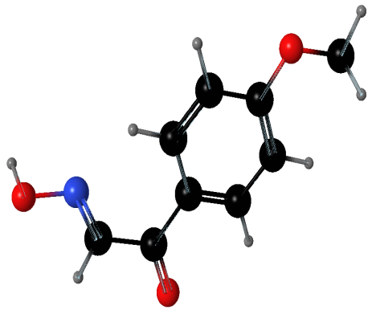
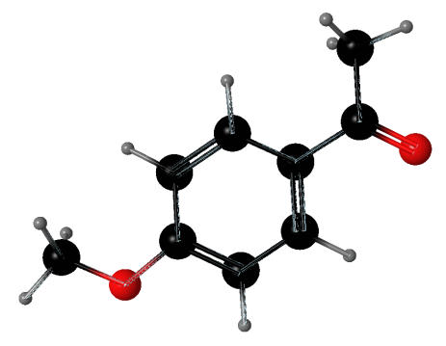
p-Methoxy Isonitroso Acetophenone (p-MINAP)
p-Methoxy Acetophenone

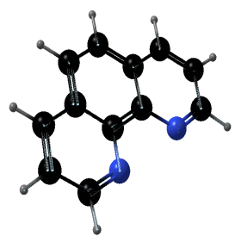
Mixed Ligand Complex of [Cu(p-MINAP)(1,10-Phen).2H₂O]
1,10-Phen

