Figure S1. Observed versus population (A) and individual (B) predicted concentrations (mg/L) for the ceftazidime pharmacokinetic model.
A
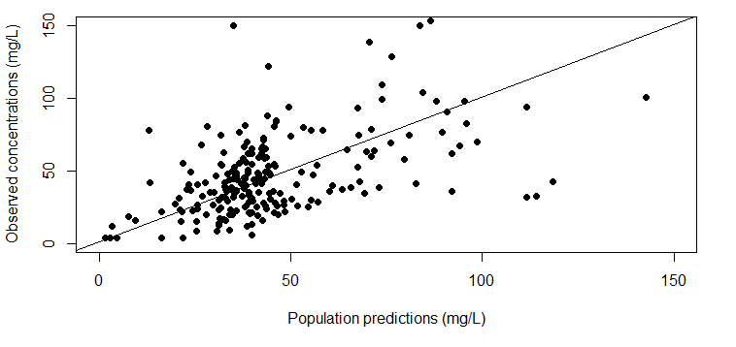
B