Supplement Figure 1: Study flowchart. RT-PCR: reverse-transcription polymerase chain reaction.
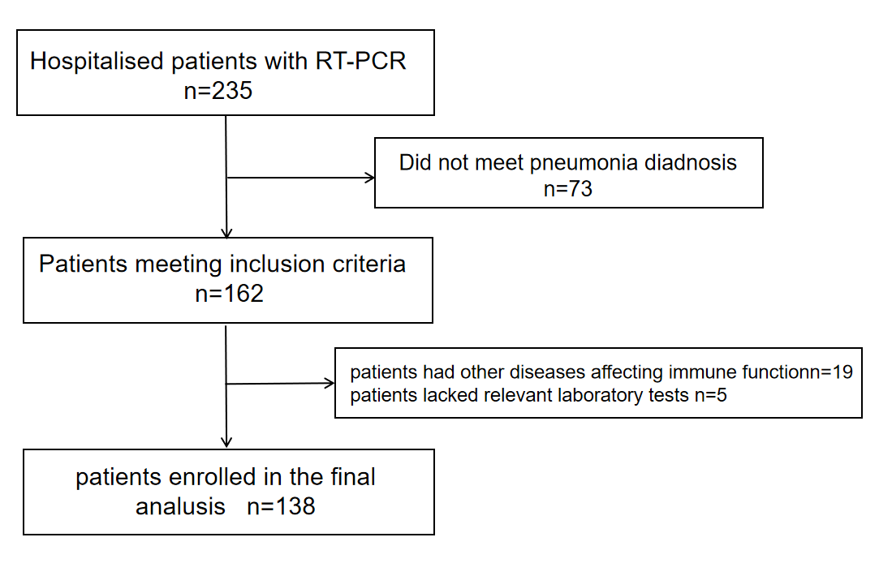
supplement table 1: Viral pneumonia virus species
virus species of Viral pneumonia | number
novel coronavirus | 54
human herpes virus | 38
influenza a virus | 8
rhinovirus | 9
human parainfluenza virus | 7
Human adenovirus | 8
influenza virus | 3
enterovirus | 2
respiratory syncytial virus | 2
human metapneumovirus | 2
Bocavirus | 1
cytomegalovirus | 3
Human parvovirus | 1

supplemet table2 :Types of bacterial infection
Types of bacterial infection | number
Candida albicans | 1
Acinetobacter baumannii | 9
enterococcus faecalis | 3
escherichia coli | 7
Haemophillus influenzae | 3
Klebsiella pneumoniae | 10
mycoplasma | 1
Pneumocystis carinii | 2
aspergillus fumligatus | 2
pseudomonas aeruginosa | 5
streptococcus constellatus | 2
streptococcus pneumoniae | 3
hemolytic streptococcus | 2

Supplement Table3. Coefficient estimates were analyzed by LASSO regression
 | Prediction value
(Intercept) | -0.0876
age | 0.0045
gender | .
Co_infection | 0.1087
CD4 | -0.0002
CD8 | .
CD4+/CD8+_ratio | -0.0152
lymphocyte | .
Multi_loben | 0.1030
smoking | 0.0045
hypertension | 0.0618
ICU_days | 0.0360
hospital_days | 0.0011

Supplement table4：Results Table of Logistic multivariate regression coefficients；

variable | coefficien | standard deviation | 95%CI | P
 | -6.5640 | 3.4930 | -14.99~-0.63 | 0.0060
age | 0.0405 | 0.0446 | -0.04~0.15 | 0.0363
Co-infection(Yes) | 0.5107 | 1.1700 | -1.93~2.88 | 0.0363
CD4 | -0.0012 | 0.0038 | -0.01~0.01 | 0.0074
CD4+/CD8+_ratio | -1.2800 | 1.1890 | -3.98~0.9 | 0.0282
Multi lobe | 1.9370 | 1.1450 | -0.24~4.52 | 0.0091
Smoking(Once) | 1.8390 | 1.5630 | -1.13~5.45 | 0.1239
Smoking | 0.4606 | 1.1950 | -2.07~2.92 | 0.0400
Hypertension | 0.0154 | 1.2520 | -2.73~2.44 | 0.0190
ICU days | 8.2460 | 12.2618 | 2.23~12.61 | 0.194
Hospital days | 0.1355 | 0.0801 | 0~0.33 | 0.0091

