Supplementary Material
Calculation of Pollution Level
Soil Geo-accumulation Index Method
$$I_{geo}=\log_{2 }\left(C/1.5B\right)$$
Where C is the measured concentration of trace elements and B is the background value of the corresponding elements. The back ground value for Arsenic is Where C is the measured concentration of trace elements, and B is the background value of the Arsenic is 19.05 mg/kg.

Weighted arithmetic Water Quality Index (WQI) method
q_{i}=C_{i}/S_{i}X100
W_{i}=1/S_{i}
WQI=∑q_{i}w_{i}/∑w_{i}
Calculation of Average Daily Dose (ADD) of Arsenic
Soil
The equation for the calculation of average daily dose through two major exposure pathways i.e., oral and skin is as follows:
$$ADDingestion=\frac{CsXIRsXEFXED}{BWXAT}X1/ 1000000$$
$$ADDdermal=\frac{CsXSAXAFXABSXEFXED}{BWXAT}X1/1000000$$

Bioaccumulation factor
$$BAFs= C_{sp }/C_{medium}$$
Where C_{sp} is the concentration of heavy metals in oligocheats and C medium is the concentration of heavy metals in soil.

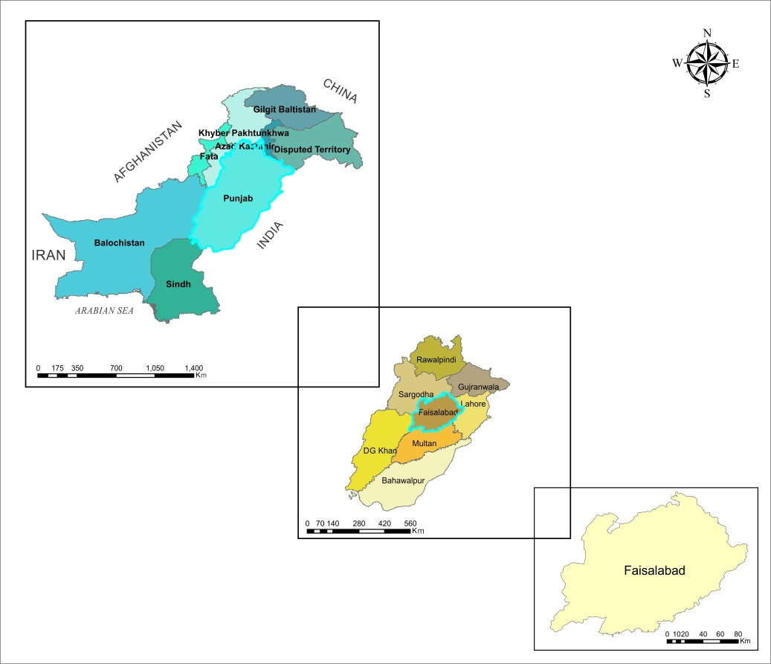
Figure S1: Study Area Punjab, Pakistan (Saleem et al., 2014).

Class | Igeo | Pollution Level | Mean value
0 | ≤0 | Clean | -
1 | 0<Igeo≤1 | Mild-moderate | -
2 | 1<Igeo≤2 | Moderate | -
3 | 2<Igeo≤3 | Moderate-intense | -
4 | 3<Igeo≤4 | Intense | -
5 | 4<Igeo≤5 | Intense-strong | -
6 | 5<Igeo≤10 | Very strong | -
Table S1: The pollution index classification standard and trace elements
Table 1: The pollution index classification standard and trace elements for Strontium, Zinc, Calcium, Copper, Iron, Manganese, Cobalt, Chromium, Lead, Cadmium, and Nickle pollution degree classification
Regions/Metals | Sr | Zn | Ca | Cu | Fe | Mn | Co | Cr | Pb | Cd | Ni
Okara | 1.82 | -5.99 | -10.49 | 0.07 | -0.01 | 0.45 | -2.65 | -6.42 | 1 | 3.18 | -8.22
Layyah | 0.44 | -5.38 | -10.7 | -0.01 | 0.29 | -0.04 | -1.81 | -4.8 | 1 | 4.14 | -9.86
Faisalabad | 0.13 | -5.06 | -10.78 | -0.03 | -0.41 | -0.49 | -2.23 | -5 | 1 | 3.9 | -8.43
Chiniot | -1.01 | -3.7 | -8.08 | -1.29 | -1.04 | -3.08 | -0.52 | -3.31 | 1 | 3.1 | -8.06
Shahkot | -1.28 | -4.32 | -10.5 | -0.66 | -0.56 | -1.56 | -1.04 | -3.6 | 1 | 3.68 | -8.4
T.T Sing | 0.06 | -4.74 | -8.08 | -0.22 | -0.85 | -0.81 | -2.05 | -4.65 | 1 | 3.64 | -8.4
Kamaliya | 0.11 | -6.08 | -8.76 | 0.15 | -2.21 | -0.93 | -3.18 | -6.78 | 1 | 2.49 | -8.31
Samundri | 0.12 | -5.04 | -8.5 | 0.01 | -0.34 | -0.6 | -2.29 | -4.96 | 1 | 3.97 | -7.96
Jaranwala | 0.12 | -5.04 | -8.08 | 0.01 | -0.34 | -0.6 | -2.29 | -4.96 | 1 | 3.97 | -7.95
Pensara | 0.7 | -4.9 | -9.06 | -0.26 | -0.19 | -0.59 | -1.9 | -4.35 | 1 | 3.86 | -8.92
DG Khan | -0.11 | -4.55 | -8.08 | -0.41 | 0.11 | -0.73 | -1.16 | -3.62 | 1 | 4.12 | -8.02
Bahawalnager | 1.59 | -4.3 | -11.08 | 0.19 | 0.42 | -0.34 | -1 | -3.38 | 1 | 4.5 | -8.05
Kot Addu | -0.55 | -4.57 | -11.08 | -0.37 | -2.57 | -1.52 | -1.73 | -4.64 | 1 | 3.86 | -8.78
Muzaffargarh | -0.07 | -5.89 | -11.08 | -0.02 | -1.62 | -0.4 | -2.34 | -5.27 | 1 | 4.4 | -8.61
Gujranwala | 0.28 | -4.98 | -8.15 | -0.16 | -0.23 | -0.32 | -2.09 | -4.84 | 1 | 3.75 | -8.18
Vehari | 0.18 | -6.03 | -10.4 | 0.14 | -2.68 | -0.39 | -3.07 | -6.71 | 1 | 2.88 | -7.2
Nankana | 1.64 | -4.49 | -11.08 | -0.02 | 0.48 | -0.06 | -1.33 | -3.84 | 1 | 4.47 | -7.99
Gojra | -0.62 | -6.03 | -8.27 | 0.08 | -3.5 | -0.23 | -2.9 | -6.26 | 1 | 3.37 | -6.89
Sangla Hill | -0.22 | -5.7 | -8.27 | 0.13 | -0.03 | -0.05 | -2.32 | -5.94 | 1 | 3.86 | -7.98

Table S2: Background value of heavy metal in soil
Sr. no | Heavy metal | Background value (mg/kg)
1 | Sr | 2237
2 | Zn | 21
3 | Cd | 3
4 | Pb | 22
5 | Cr | 88
6 | Co | 13
7 | Ni | 72
8 | Mn | 654
9 | Fe | 5357
10 | Cu | 23
11 | Ca | 14.44

Table S3: The value and significances of the parameters for calculating health risk
Parameters | Unit and Value | Significance
C_{S} | mg/kg 95% UCL | Concentration in soil
EF | 365 d/yr | Exposure frequency
ED | adults 70 yr;  children 6 yr | Exposure duration
AT | 365×ED day | Averaging time for (non) carcinogens
BW | adults: 70 kg and children: 18kg | Body weight
SA | Adults: 5700 cm²day⁻¹  Children: 2800 cm²day⁻¹ | Exposed skin area
AF | Adults: 0.07 mg cm⁻²  Children: 0.02 mg cm⁻² | Adherent factor
ABS | 0.001 | Dermal absorption fraction
CF | 10⁻⁶×10 kg mg⁻¹ | Units’ conversion factor
IR_{S} | Adult: 100 mg day⁻¹  Children: 200 mg day⁻¹ | Ingestion rate of soil
(Cai et al., 2019).

Table S4: RFD and CSF value of heavy metal
Sr. no | Heavy metal | RFD | CSF
1 | Sr | 0.6 oral  0.12_{dermal} | -
2 | Zn | 0.3 | -
3 | Cd | 0.001 | 15
4 | Pb | 0.0036 | 8.50E-03
5 | Cr | 1.5 | 0.5
6 | Co | 0.02 | -
7 | Ni | 0.02 | 0.91
8 | Mn | 0.14 | -
9 | Fe | 7.00E-01 | -
10 | Cu | 0.0371 | -

Table S5: Cluster of observations bioaccumulation factor in different region of Central Punjab, Pakistan
step |  | No of cluster | Similarity level | Distance level | Cluster joined |  | New cluster | No. of observation in new cluster
1 |  | 18 | 99.8910 | 0.000380 | 8 | 9 | 8 | 2
2 |  | 17 | 99.9481 | 0.001039 | 12 | 17 | 12 | 2
3 |  | 16 | 99.9411 | 0.001178 | 8 | 15 | 8 | 3
4 |  | 15 | 99.8615 | 0.002770 | 2 | 10 | 2 | 2
5 |  | 14 | 99.8528 | 0.002943 | 6 | 8 | 6 | 4
6 |  | 13 | 99.7750 | 0.004499 | 3 | 14 | 3 | 2
7 |  | 12 | 99.6447 | 0.007105 | 2 | 11 | 2 | 3
8 |  | 11 | 99.4575 | 0.010849 | 2 | 6 | 2 | 7
9 |  | 10 | 99.3648 | 0.012703 | 7 | 16 | 7 | 2
10 |  | 9 | 99.2716 | 0.014568 | 5 | 13 | 5 | 2
11 |  | 8 | 99.1417 | 0.017167 | 3 | 12 | 3 | 4
12 |  | 7 | 99.1118 | 0.017765 | 7 | 18 | 7 | 3
13 |  | 6 | 99.0423 | 0.019153 | 1 | 19 | 1 | 2
14 |  | 5 | 98.7502 | 0.024995 | 3 | 5 | 3 | 6
15 |  | 4 | 89.0660 | 0.038679 | 2 | 3 | 2 | 13
16 |  | 3 | 97.3663 | 0.052674 | 1 | 7 | 1 | 5
17 |  | 2 | 96.9391 | 0.061217 | 2 | 4 | 2 | 14
18 |  | 1 | 93.2786 | 0.134428 | 1 | 2 | 1 | 19

Table S6: Cluster of observation of Strontium, Zinc, Copper, Iron, Manganese, Cobalt, Chromium, Lead, Cadmium, and Nickel concentration in soil in different region of Central Punjab, Pakistan
step | No of cluster | Similarity level | Distance level | Cluster joined |  | New cluster | No of observation in new cluster
1 | 10 | 91.9185 | 1.9246 | 5 | 6 | 5 | 2
2 | 9 | 91.3724 | 2.0546 | 3 | 9 | 3 | 2
3 | 9 | 88.3319 | 2.7787 | 3 | 4 | 3 | 3
4 | 7 | 86.4938 | 3.2164 | 3 | 5 | 3 | 5
5 | 6 | 69.2604 | 7.3205 | 2 | 3 | 2 | 6
6 | 5 | 62.0555 | 9.0363 | 1 | 10 | 1 | 2
7 | 4 | 47.8980 | 12.4078 | 1 | 8 | 1 | 3
8 | 3 | 28.4057 | 17.0499 | 1 | 2 | 1 | 9
9 | 2 | 27.4432 | 17.2791 | 1 | 7 | 1 | 10
10 | 1 | 0.0000 | 23.8145 | 1 | 11 | 1 | 11

