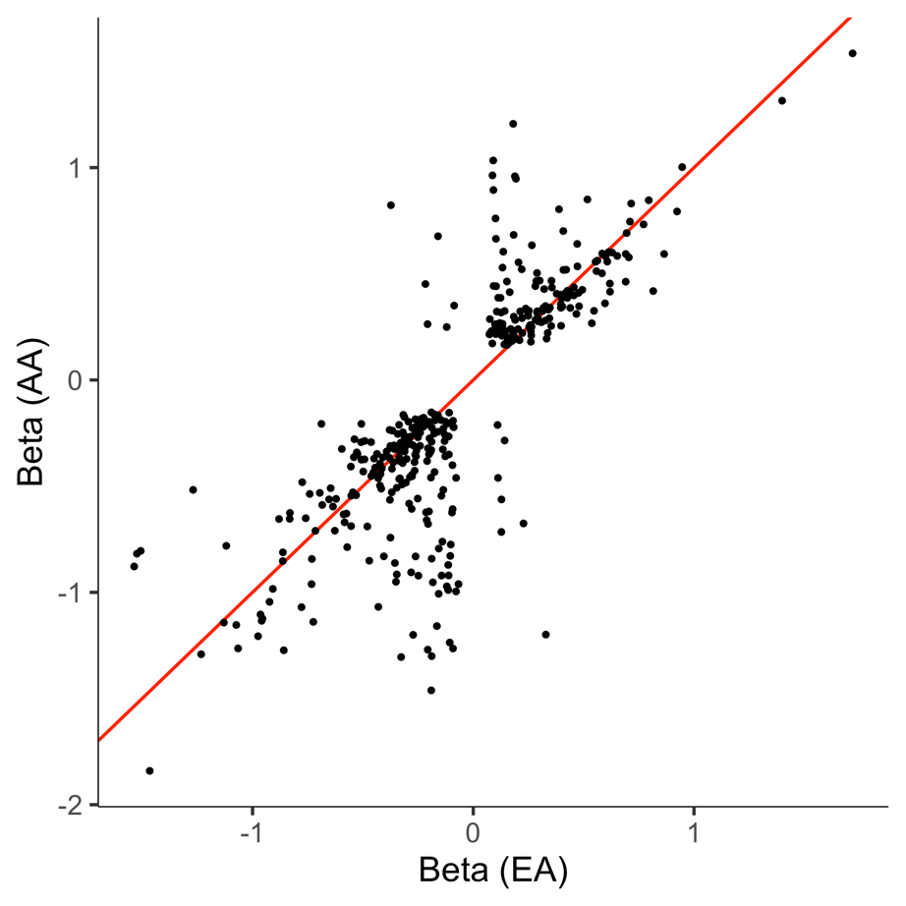

Supplementary Fig. 1: Conditional independent cis-pQTLs identified in both populations showed highly-correlated effect sizes (Pearson correlation coefficient r = 0.79). Red line is diagonal.
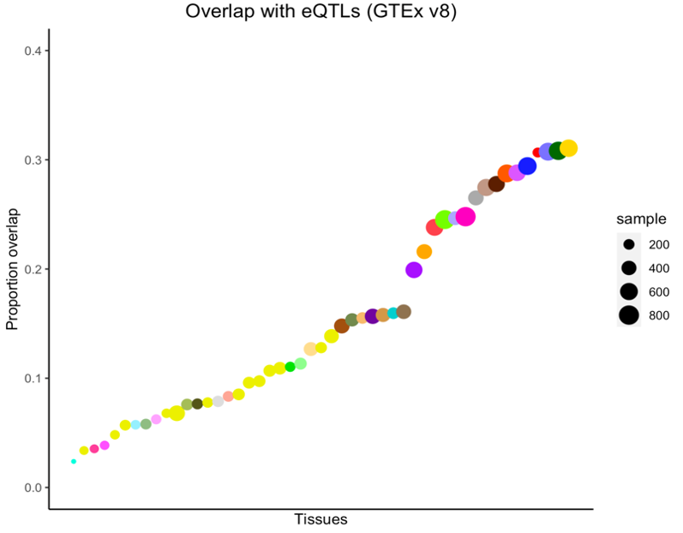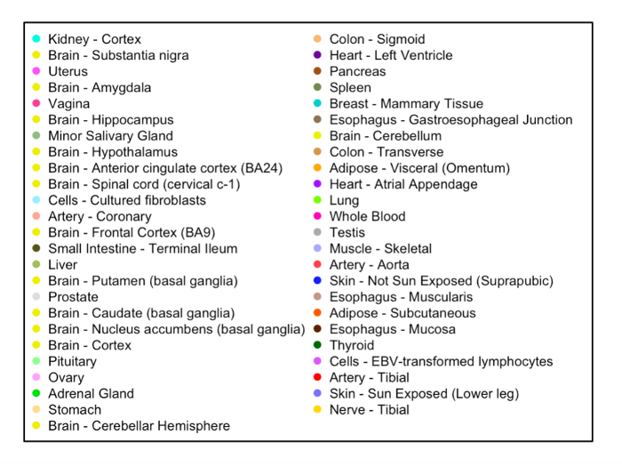

Supplementary Fig. 2: Proportion of conditionally independent EA population cis-pQTLs (including their LD-proxies) that were identified as cis-eQTLs across 49 different tissues in GTEx V8. Results are ordered by the size of overlap.
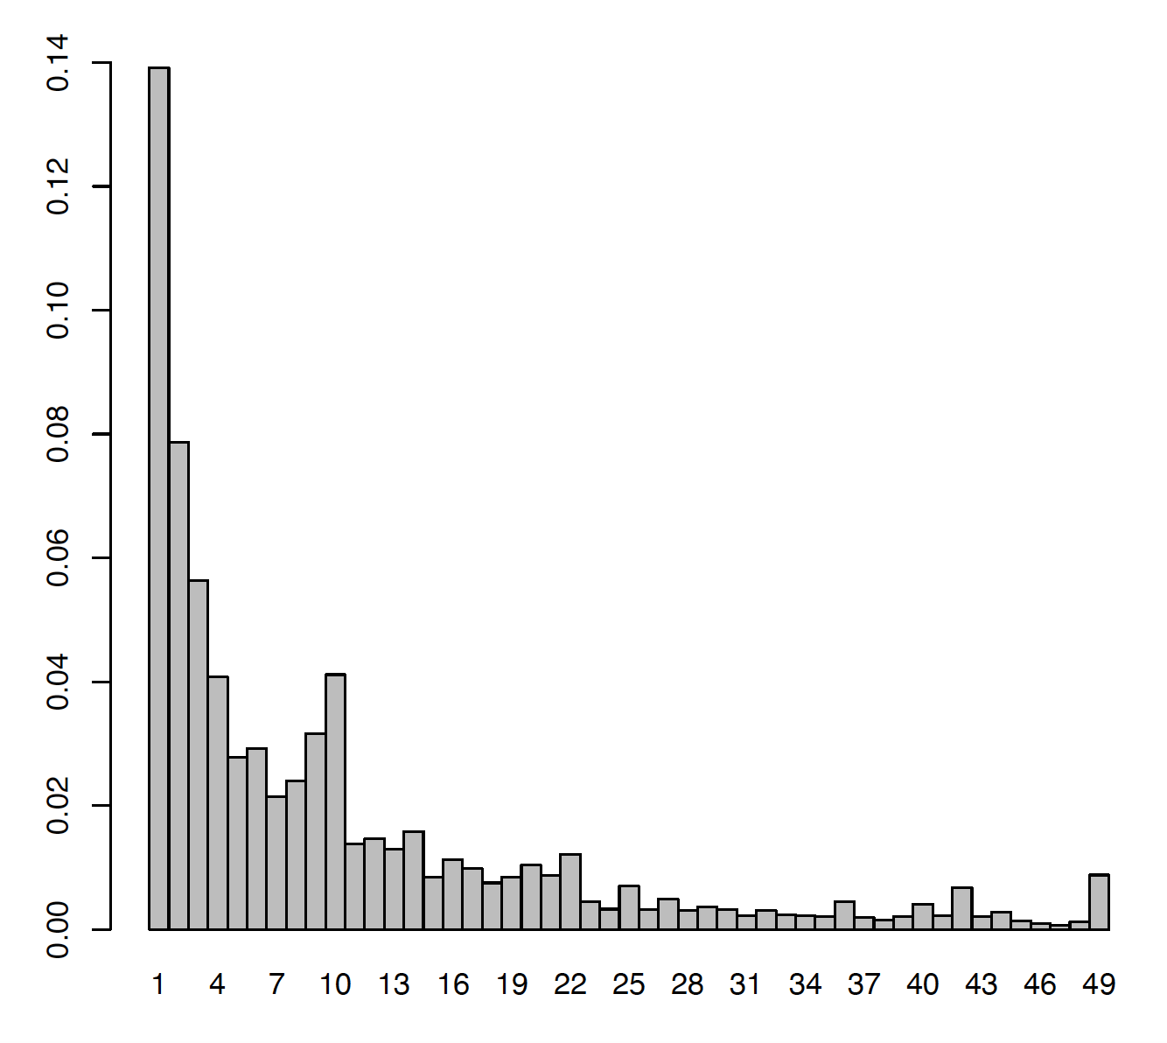
Proportion of pQTLs
Number of Tissues
Tissue sharing of pQTLs

Supplementary Fig. 3: Tissue sharing of the cis-pQTLs which are also cis-eQTLs in at least one tissue in GTEx (V8). Vertical bars represent the proportion of cis-pQTL which was also identified to be a cis-eQTL in a particular number of tissues.
a
b

Supplementary Fig. 4: Functional enrichment of the conditionally independent cis-pQTLs in (a) EA and (b) AA across different functional categories (See Methods). The red dots denote the estimated log2-enrichment statistic, and the black lines represent the corresponding confidence intervals.
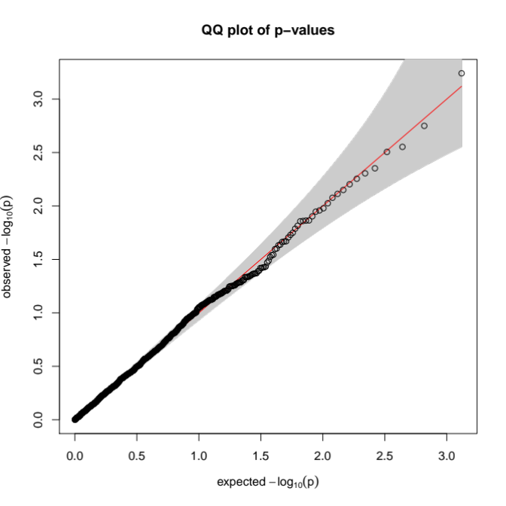

Supplementary Fig. 5: Type-1 error of PWAS is well controlled. Quantile-quantile plots of p-values of for PWAS of a simulated null continuous phenotype, with grey 95% confidence band and red diagonal line. Each point represents a p-value of an association test between the cis-genetic regulated plasma protein level of a SOMAmer. Analyses were performed based on genotype data on unrelated European ancestry individuals (N= 337,484) from UK Biobank and simulated null phenotypes.
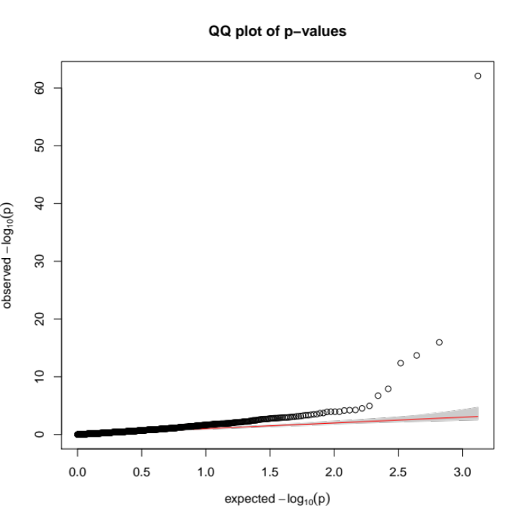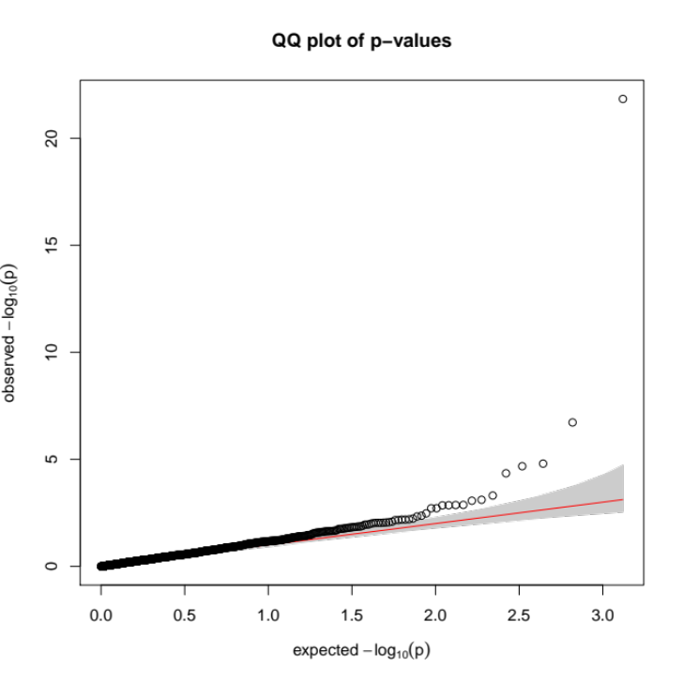
b
a

Supplementary Fig. 6: Quantile-quantile plots of p-values for PWAS of (a) serum urate levels and (b) gout with grey 95% confidence bands and red diagonal lines. Each point represents a p-value of an association test between the cis-genetic regulated plasma protein level of a gene and the phenotypes.

