The challenge of phasing out fossil fuel finance in the banking sector

Supplementary Information

J. Rickman¹, M. Falkenberg², S. Kothari¹, F. Larosa³, M. Grubb¹, N. Ameli¹

¹Institute for Sustainable Resources, University College London, UK
² Department of Mathematics, City University of London, London, UK
³ KTH Royal Institute of Technology, Sweden

Supplementary materials containing supplementary figures, tables and methods.

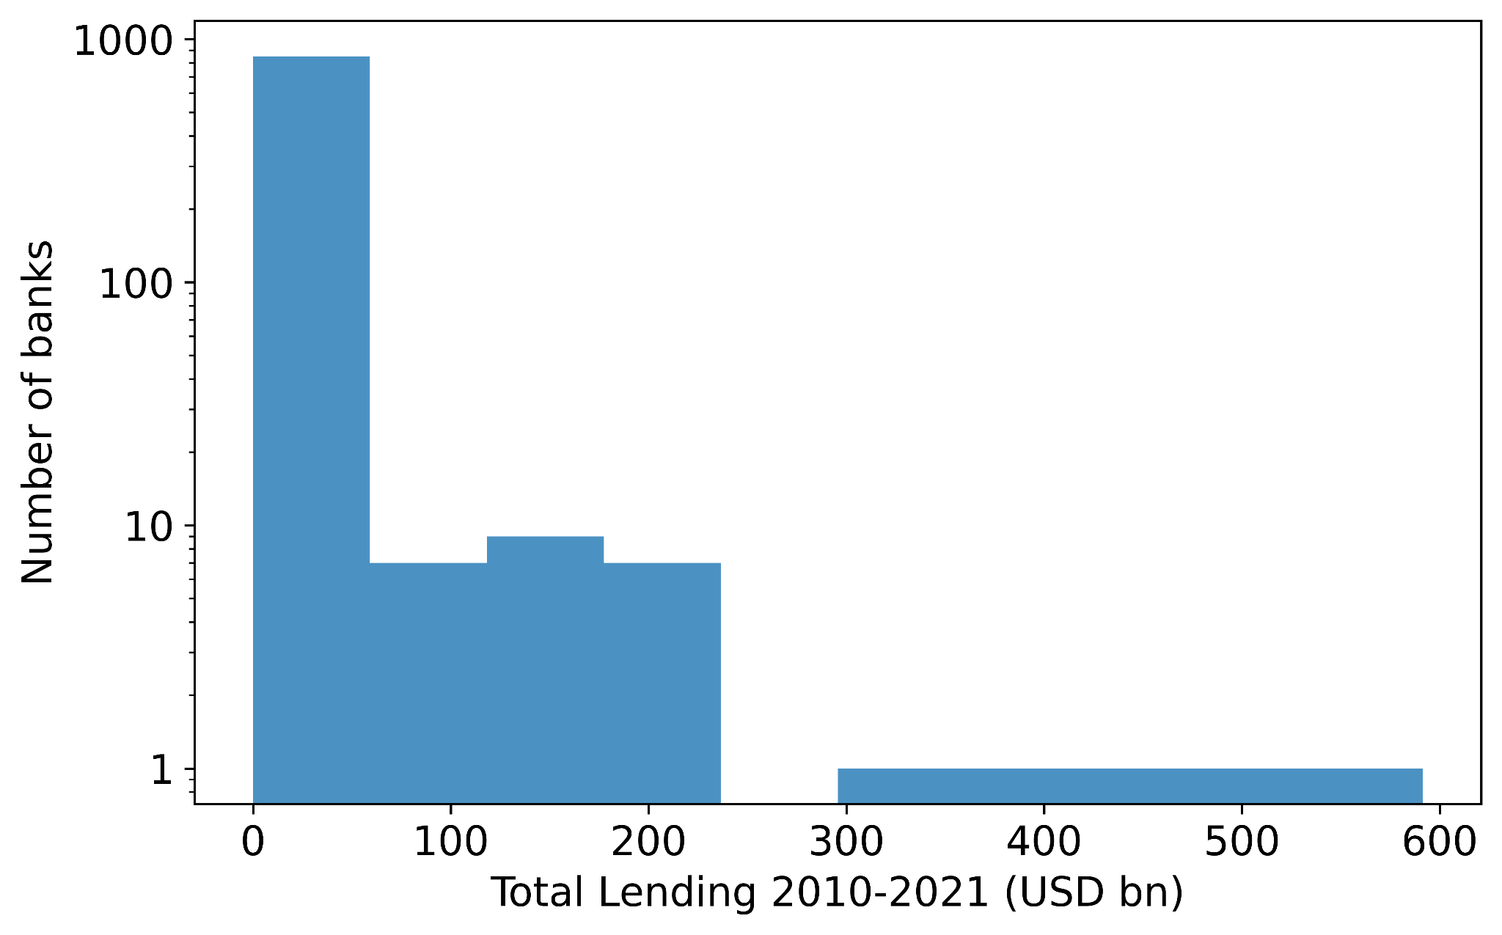
Figure S1. Lending activity across the banking sector. Histogram shows the total lending of 709 banks between 2010 and 2021.

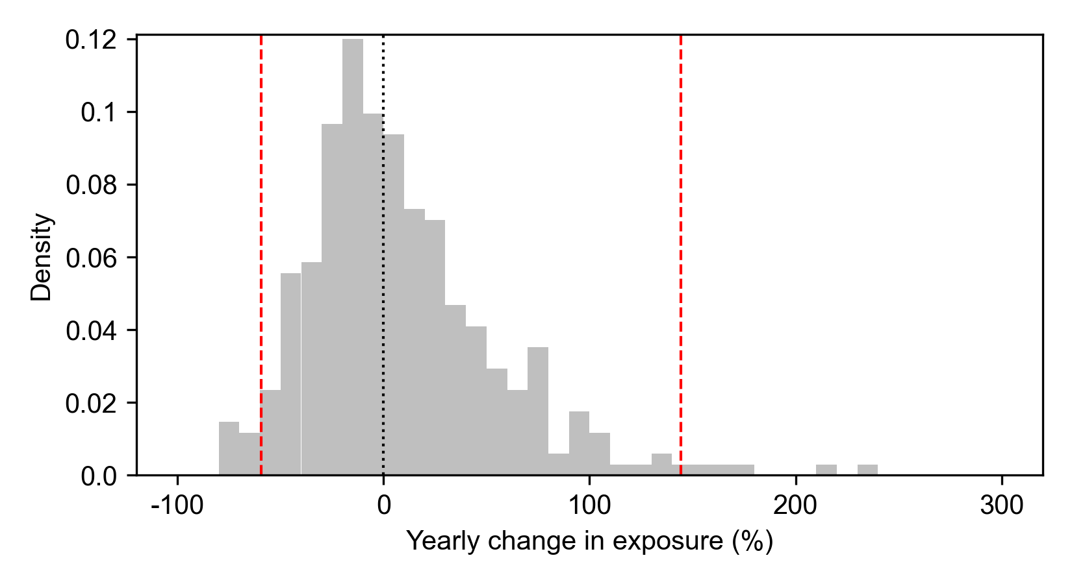
Figure S2. Year on year change in fossil fuel exposure for the top 30 banks. Data is aggregated across the period 2010 to 2021. Dashed black line corresponds to 0% change in exposure. Dashed red lines indicate 95% confidence interval.
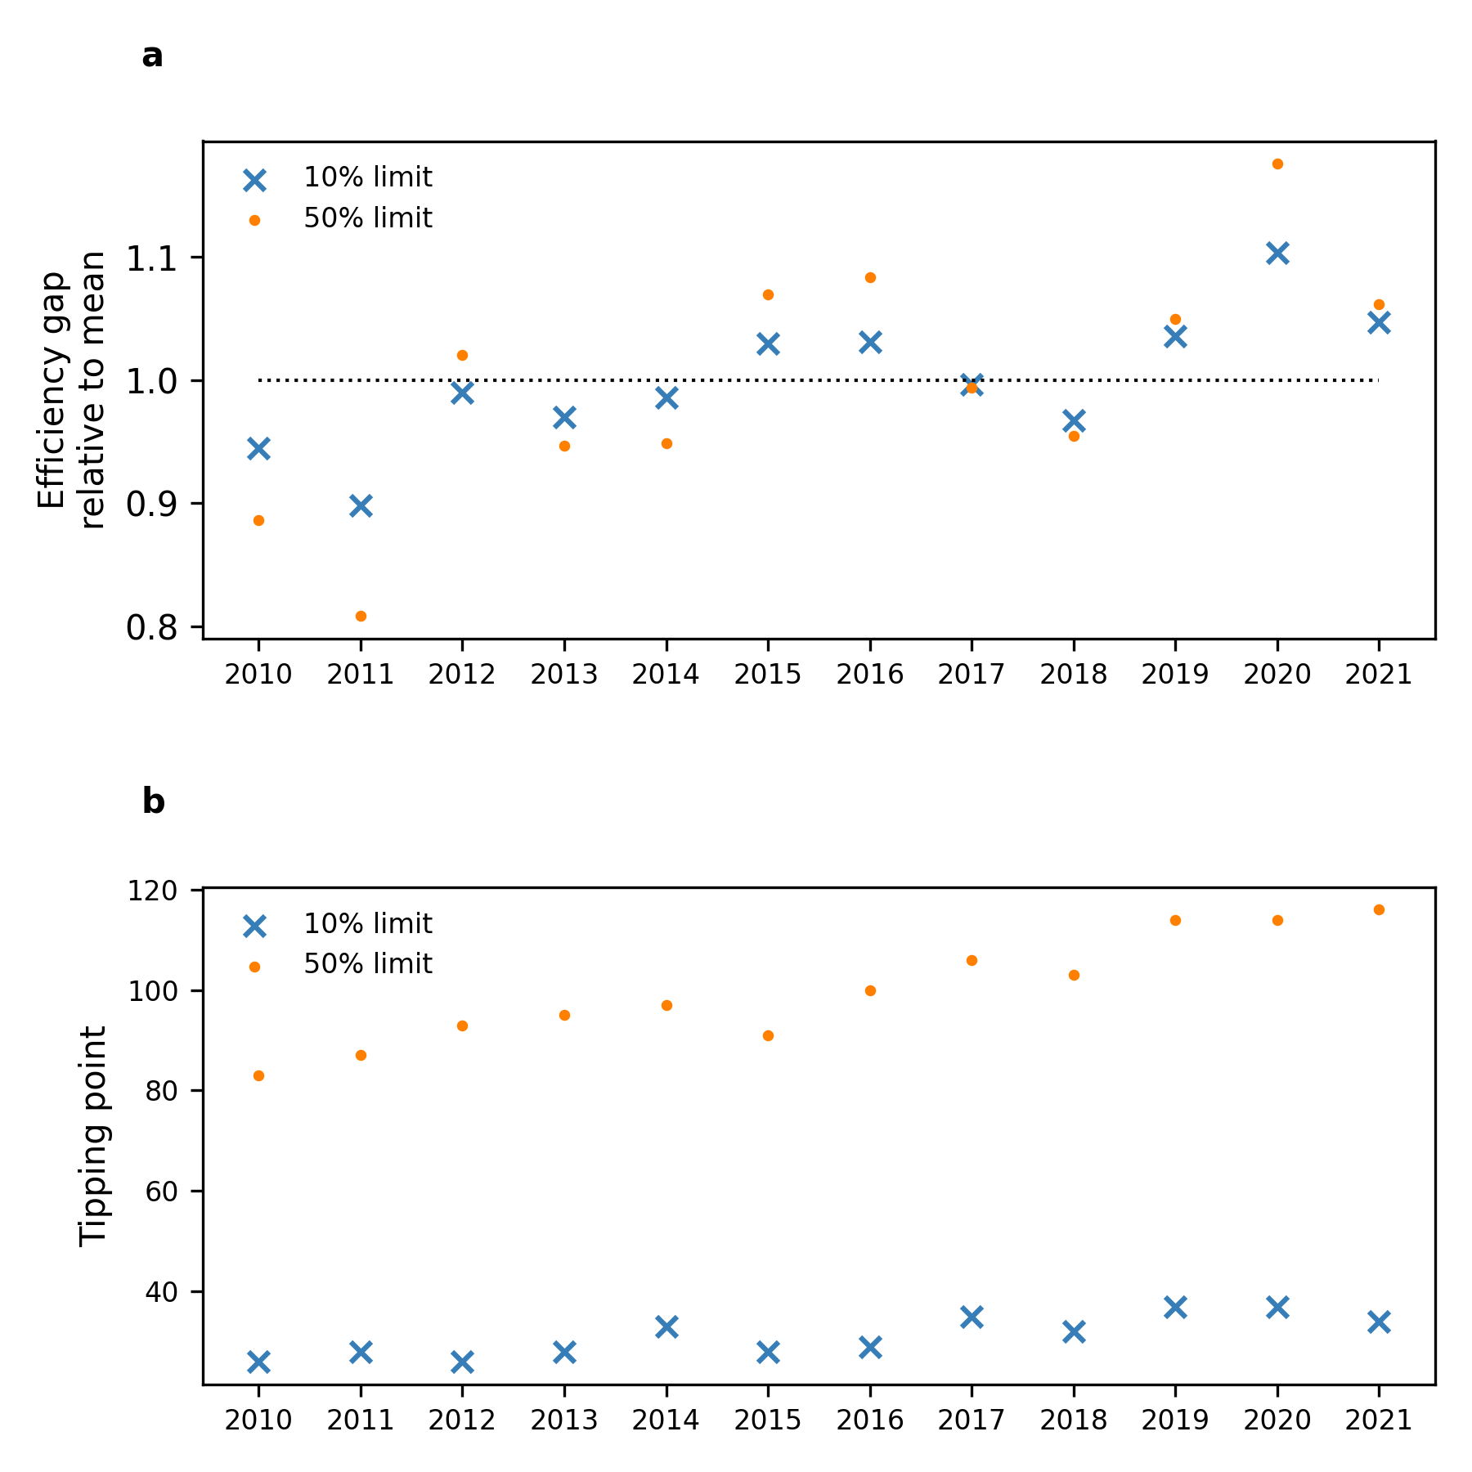

Figure S3. Efficiency gap and tipping point each year. (a) The size of the efficiency gap as a multiple of the average efficiency gap in the period 2010-2021. The efficiency gap is relatively stable for a fixed finance limit over time, fluctuating between +/-20% in the observed time period. Larger finance limits result in larger fluctuations in the efficiency gap. (b) The number of banks that must be removed to reach the tipping point for each year in the period 2010-2021 for two different finance limits. Note that the tipping point is larger for the 2021 syndicated network than for any previous year, despite not having the largest efficiency gap. This is a consequence of growing deal syndication between 2010-2021.

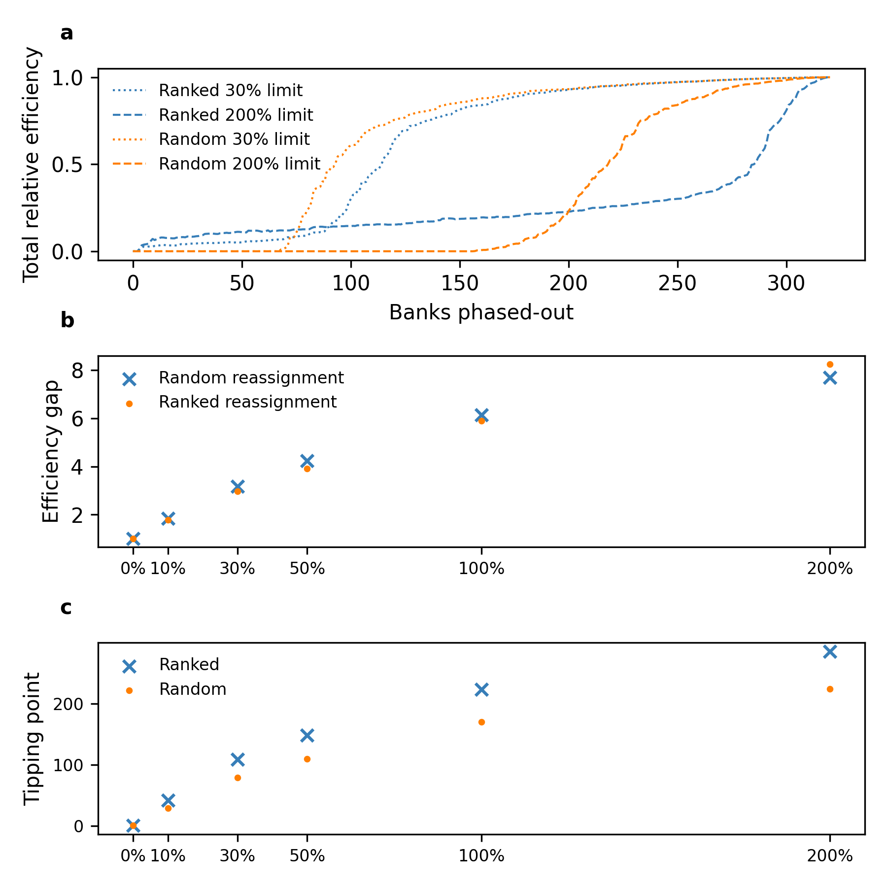
Figure S4. Phase-out model variant comparing random and ranked substitution. In the random model substituted finance is replaced by a random bank, in the ranked model finance is substituted by banks ranked according to the number of existing relationships with the existing syndicate. (a) The relative efficiency of the phase-out process for two different finance limits. (b) The efficiency gap for the ranked and random models with different finance limits. (c) The tipping point for the ranked and random models with different finance limits.

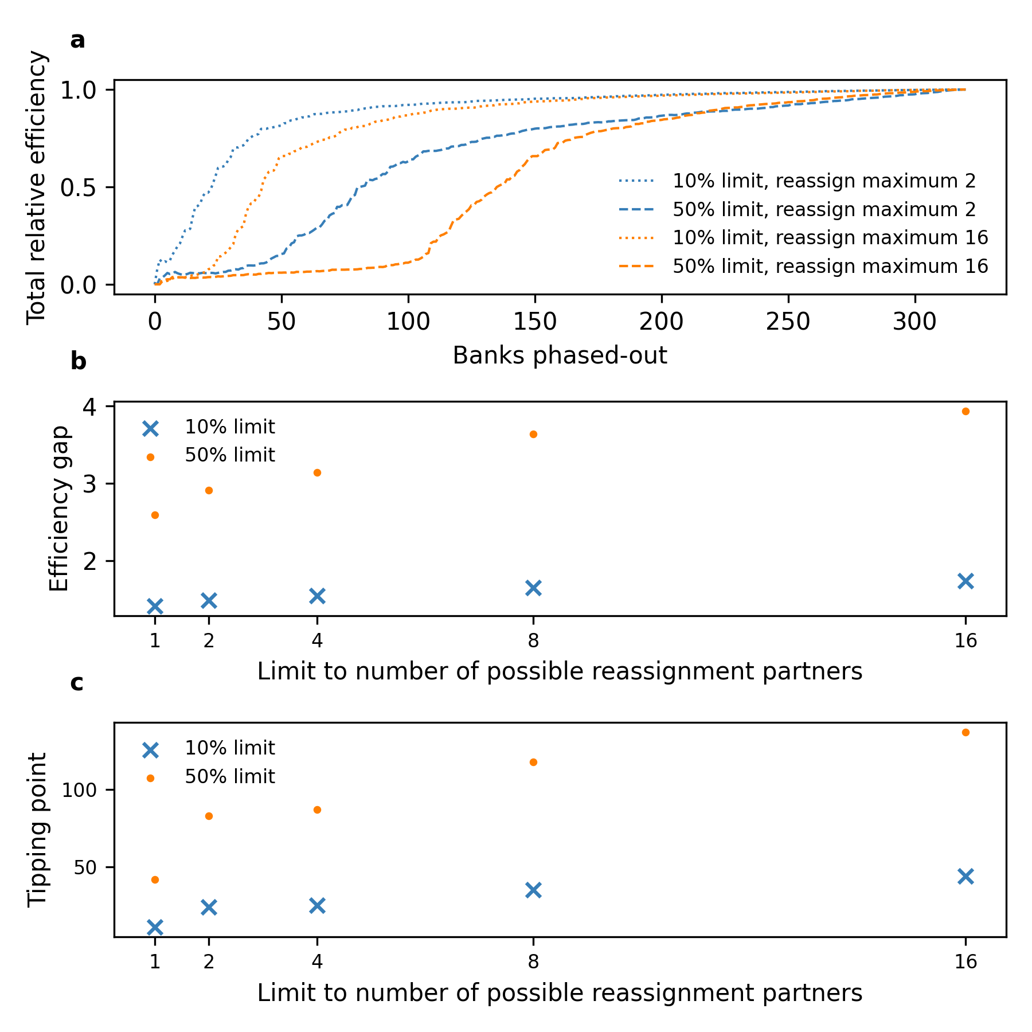
Figure S5. Phase-out model variant with restrictions on the maximum number of banks that can substitute finance into a deal at risk. (a) The total relative efficiency with two different finance limits (10% and 50%) and two values of the bank substitute partner limit (2 and 16 for illustrative purposes), which restricts the number of candidate banks from whom substitute finance can be acquired. (b) The efficiency gap as a function of the finance limit and the bank partner reassignment limit. (c) The tipping point as a function of the finance limit and the bank partner reassignment limit.

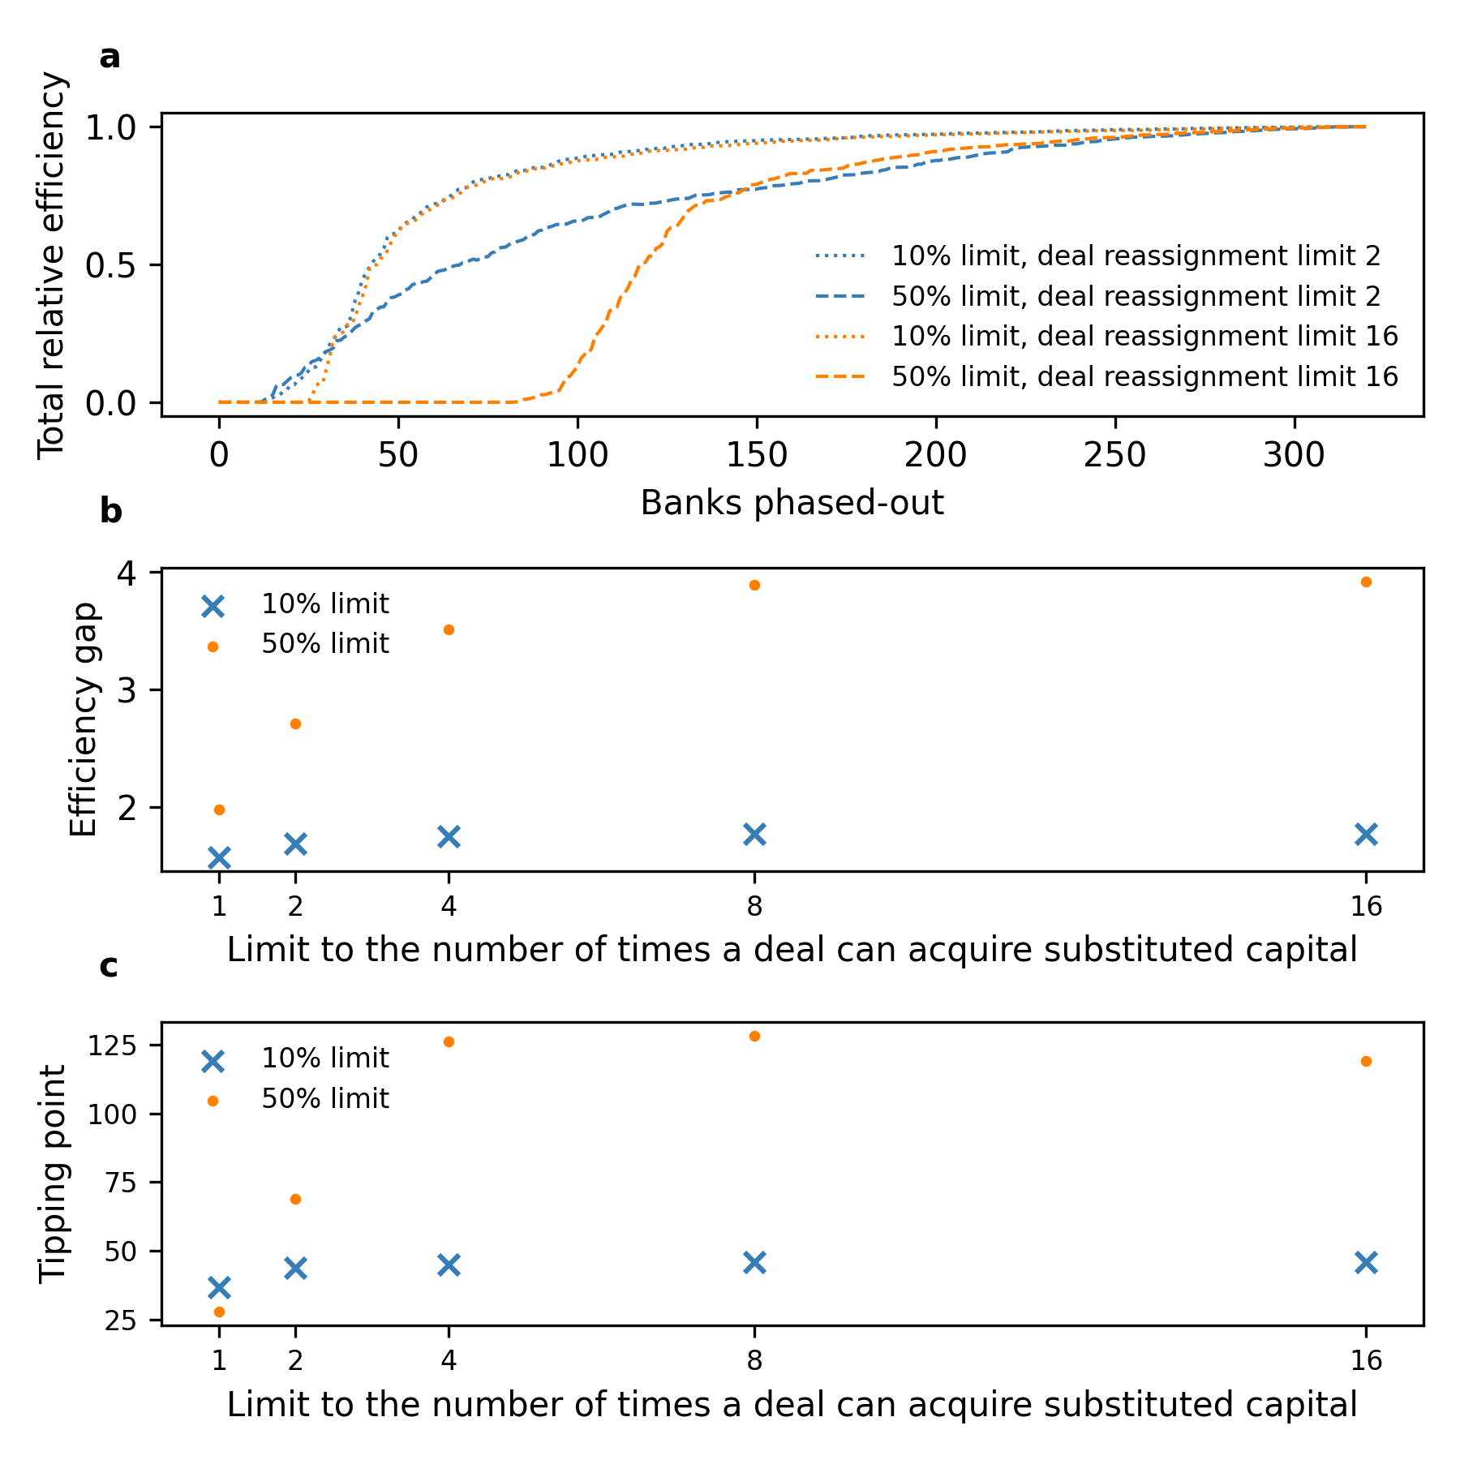
Figure S6. Phase-out model variant restricting the number of times a single deal can acquire substituted finance before automatically failing. (a) The total relative efficiency with two different finance limits (10% and 50%) and two values for the finance substitution limit (2 and 16 for illustrative purposes), which restricts the number of times a single deal can acquire substituted finance after a partner bank phases-out from the fossil fuel sector, before the deal automatically fails. (b) The efficiency gap as a function of the finance limit and the deal substitution limit. (c) The tipping point as a function of the finance limit and the deal substitution limit.

Centrality Measure | Pre-Paris (2010-2016) | Post-Paris (2017-2021)
Degree | 0.98 | 0.99
Eigenvector | 0.98 | 0.98
Closeness | 0.34 | 0.35
Betweenness | 0.63 | 0.61
Table S1. Correlation between banks’ centrality and syndication activity. Pearson’s correlation coefficient between banks’ syndication activity and network centrality measures in a pre-Paris Agreement (2010-2016) and post-Paris Agreement (2017-2021) period. The weighted versions of eigenvector and betweenness centrality are computed.

Supplementary Methods

Data coverage
Comparing the Bloomberg data with a joint report by leading industry analysts Rainforest Action Network, BankTrack, Indigenous Environmental Network, Oil Change International, Reclaim Finance, Sierra Club and urgewald¹ affirms that it is representative of the finance provided by the global banking sector. The joint report cites that 742 billion USD of bank finance (debt and equity) was provided to the fossil fuel sector in 2021. A conservative range for the equity share of total finance is 10-20%², which indicates 593-668 billion USD was provided as bonds and loans. This figure compares well with the Bloomberg data, which reports 592 billion USD of bonds and loans in 2021.
Phase-out model results for the years 2010-2021
Figure S2 shows the yearly change in fossil fuel exposure for the top thirty banks in our dataset, measured in terms of absolute value of fossil fuel deals underwritten during the period. Data is aggregated across the period 2010 to 2021. The figure shows that the modal annual change in fossil fuel exposure during this period is a small annual decrease. However, there are many cases where banks significantly increase their fossil fuel exposure, in some cases by over 100%. The 95% confidence interval for the annual change in fossil fuel exposure for top banks falls in the range [-60%,+160%].
Figure S3 shows results for the phase-out model computed with data from 2010 to 2021. For each year, we compute the efficiency gap and tipping point using two different values of the finance limit percentage. In Fig. S3a we plot the efficiency gap for both finance limits (10% and 50% for illustrative purposes) relative to the mean efficiency gap across all 12 years. We find that the efficiency gap only varies by small amounts over time for fixed finance limit percentages. In years with greater fossil fuel lending and syndication, the efficiency gap is generally larger than in years where lending is lower. These effects are larger for higher finance limit percentages. However, overall fluctuations in the finance limit are small, with the efficiency gap always within 20% of the mean value across the time period.
In terms of the tipping point, we see that our result that the tipping point is delayed for larger finance limits is robust across all 12 years studied. We note that although the efficiency gap has fluctuated over time, reaching a peak in 2020, the tipping point has steadily grown over time. This is indicative of the growing level of syndication of the fossil fuel lending network in the period 2010-21.
Variants of the phase-out model
We now study three variants of the basic phase-out model. First, we study how changes to the procedure for finding new syndicate partners for substitution affect fossil fuel phase-out (Fig. S4). In the ‘random’ phase-out model substituted finance is replaced by a random bank, in the ‘ranked’ phase-out model finance is replaced by banks ranked according to the number of existing relationships with the existing syndicate. Then, we consider limits to the number of banks who can act as candidates for substitution for any given at-risk deal (Fig. S5). Finally, we test a model variant that accounts for the increased perceived risk of a deal that acquires substitute finance multiple times, by limiting the number of times a deal can substitute finance before automatically failing (Fig. S6).
- Ranked vs. random substitution
In the base model, candidate syndicate partners for substitution are chosen at random from all banks who are not phased-out from the sector and who are not yet part of the syndicate. We refer to this as the ‘random’ case. We now compare this to a model where syndicate partners are chosen preferentially in order of the total number of syndicates in which the existing syndicate banks co-invest with the candidate bank. We refer to this as the ‘ranked’ case. Results are shown in Fig. S4 using two different values for the finance limit, 30% and 200% for illustrative purposes.
In Fig. S4a, we see two key differences between the random and ranked cases: (1) In the ranked case, there is non-zero phase-out efficiency before the tipping point is reached (efficiency > 0.5), with the efficiency slowly growing throughout the phase-out process. However, (2) this increase in early phase-out efficiency appears to delay the onset of the tipping point. Overall, we see in Fig S3b&c that there is very little difference in the efficiency gap and tipping point that arises between the two cases for fixed finance limits.
The lack of a sharp transition from zero to non-zero phase-out efficiency in the ranked case is the result of deals for which the syndicate members have co-investment relationships with only a small number of banks. Hence, if these candidate banks for substitution phase-out or reach their finance limits, no other banks can substitute finance. This effect is representative of deals which are regionally isolated and only involve a small number of local / regional banks who do not have relationships with the broader fossil fuel lending network. However, these effects do not have a significant impact on the overall efficiency of phase-out.
- Limiting the number of candidate banks for substitution
In the base model, a deal at risk will attempt to acquire substitute finance from any of the banks which are not yet phased-out of the sector. Here, we adapt the model to limit the number of possible banks who can act as a candidate for substitution. If a deal at risk fails to acquire substitute finance from those limited candidate banks, the deal fails. Results with two finance limits (10% and 50% for illustrative purposes) are shown in Fig. S5.
Figure S5a shows that imposing limits to the number of substituting partners reduces the number of banks which must phase-out of the sector to reach the tipping point. In particular, if the limit on the candidate banks is highly restrictive, this can substantially improve phase-out efficiency. However, the key feature of the model – a sharp transition from low to high phase-out efficiency – persists in this variant. The efficiency gap and tipping point both decrease with tighter limits on the number of substitute banks (Fig. S5b & c). However, phase-out efficiency remains low, even with tight limits on the number of substitute banks, unless strict finance limits are also in place.
- Limiting the number of finance substitutions
In the base model, there is no limit to the number of times a single deal can substitute finance when a syndicate partner phases-out from the fossil fuel sector. In this model variant we incorporate a feature of reflecting the perceived ‘risk’ of a deal whereby a deal can only substitute finance a certain number of times before automatically failing. Results are shown in Fig. S6 for two fixed values of the finance limit and variable limits to the number of times a single deal can substitute finance.
Fig. S6a shows that limiting the number of times a deal can acquire substitute finance significantly increases phase-out efficiency so that fewer banks are required to reach the tipping point. Note however, that Fig. S6b shows that limits to the number of times a deal can acquire substitute finance are only effective if the limit is very small (1 or 2 substitutions), and that this effect is secondary to restrictions on finance limits.

References
- Rainforest Action Network, Indigenous Environmental Network, Reclaim Finance, and Sierra Club. 2023. 'Banking on Climate Chaos 2023'.
- Cojoianu, Theodor F., et al. 2023. "The city never sleeps: but when will investment banks wake up to the climate crisis?." Regional Studies, 57(2).

