Supplementary Materials
Table S1. International Classification of Disease 10th revision (ICD-10) codes for CVD categories according to GBD 2019 study.
Table S2. Population and economic status of country and territories in 1990 and 2019.
Table S3. Trends of global healthy inequality in total cardiovascular diseases and five kinds of cardiovascular disease from 1990 to 2019
Table S4. Trends of global healthy inequality in five other types of cardiovascular disease from 1990 to 2019.
Figure S1. Change in burden of rheumatic heart disease by region, 1990 vs 2019. Columns and error bar representing the central estimates and 95% uncertainty interval of DALYs cases (A) and DALYs rates (B) in all ages population, respectively. DALYs, disability-adjusted life-years; SDI, Sociodemographic Index.
Figure S2. Change in burden of ischemic heart disease by region, 1990 vs 2019. Columns and error bar representing the central estimates and 95% uncertainty interval of DALYs cases (A) and DALYs rates (B) in all ages population, respectively. DALYs, disability-adjusted life-years; SDI, Sociodemographic.
Figure S3. Change in burden of stroke by region, 1990 vs 2019. Columns and error bar representing the central estimates and 95% uncertainty interval of DALYs cases (A) and DALYs rates (B) in all ages population, respectively. DALYs, disability-adjusted life-years; SDI, Sociodemographic.
Figure S4. Change in burden of hypertensive heart disease by region, 1990 vs 2019. Columns and error bar representing the central estimates and 95% uncertainty interval of DALYs cases (A) and DALYs rates (B) in all ages population, respectively. DALYs, disability-adjusted life-years; SDI, Sociodemographic Index.
Figure S5. Change in burden of non-rheumatic valvular heart disease by region, 1990 vs 2019. Columns and error bar representing the central estimates and 95% uncertainty interval of DALYs cases (A) and DALYs rates (B) in all ages population, respectively. DALYs, disability-adjusted life-years; SDI, Sociodemographic Index.
Figure S6. Change in burden of cardiomyopathy and myocarditis by region, 1990 vs 2019. Columns and error bar representing the central estimates and 95% uncertainty interval of DALYs cases (A) and DALYs rates (B) in all ages population, respectively. DALYs, disability-adjusted life-years; SDI, Sociodemographic Index.
Figure S7. Change in burden of atrial fibrillation and flutter by region, 1990 vs 2019. Columns and error bar representing the central estimates and 95% uncertainty interval of DALYs cases (A) and DALYs rates (B) in all ages population, respectively. DALYs, disability-adjusted life-years; SDI, Sociodemographic Index.
Figure S8. Change in burden of aortic aneurysm by region, 1990 vs 2019. Columns and error bar representing the central estimates and 95% uncertainty interval of DALYs cases (A) and DALYs rates (B) in all ages population, respectively. DALYs, disability-adjusted life-years; SDI, Sociodemographic Index.
Figure S9. Change in burden of peripheral artery disease by region, 1990 vs 2019. Columns and error bar representing the central estimates and 95% uncertainty interval of DALYs cases (A) and DALYs rates (B) in all ages population, respectively. DALYs, disability-adjusted life-years; SDI, Sociodemographic Index.
Figure S10. Change in burden of endocarditis by region, 1990 vs 2019. Columns and error bar representing the central estimates and 95% uncertainty interval of DALYs cases (A) and DALYs rates (B) in all ages population, respectively. DALYs, disability-adjusted life-years; SDI, Sociodemographic Index.

Table S1. International Classification of Disease 10th revision (ICD-10) codes for CVD categories according to GBD 2019 study.
CVD category | ICD-10 Codes
Ischemic Heart Disease | I20-I25.9
Stroke | G45-G46.8, I63-I63.9, I65-I66.9, I67.2-I67.3, I67.5-I67.6, I69.3, I60-I62.9, I67.0-I67.1, I68.1-I68.2, I69.0-I69.2
Atrial Fibrillation and Flutter | I48-I48.9
Rheumatic Heart Disease | I01-I01.9, I02.0, I05-I09.9
Non-rheumatic valvular heart disease | I34-137.9
Hypertensive Heart Disease | I11-I11.9
Cardiomyopathy and myocarditis | B33.2, I40-I41.9, I42.1-I42.8, I43-I43.9, I51.4
Aortic Aneurysm | I71-I71.9
Peripheral Artery Diseases | I70.2-I70.8, I73-I73.9
Endocarditis | I33-I33.9, I38-I39.9

Table S2. Population and economic status of country and territories in 1990 and 2019.
 | 1990 |  | 2019
 | Population a | SDI ^{b} | Population a | SDI ^{b}
Afghanistan | 11·42 (9·8 to 12·98) | 0·187 | 38·28 (26·16 to 50·47) | 0·343
Albania | 3·31 (3·05 to 3·57) | 0·54 | 2·72 (2·42 to 3·02) | 0·681
Algeria | 25·28 (23·11 to 27·32) | 0·436 | 41·85 (36·02 to 47·46) | 0·652
American Samoa | 0·05 (0·05 to 0·05) | 0·606 | 0·06 (0·05 to 0·06) | 0·712
Andorra | 0·05 (0·05 to 0·05) | 0·834 | 0·08 (0·08 to 0·09) | 0·894
Angola | 10·32 (8·41 to 12·4) | 0·238 | 30·14 (27·05 to 33·12) | 0·47
Antigua and Barbuda | 0·06 (0·06 to 0·07) | 0·579 | 0·09 (0·08 to 0·1) | 0·743
Argentina | 33·12 (30·78 to 35·43) | 0·581 | 45·12 (39·51 to 51·07) | 0·708
Armenia | 3·41 (3·16 to 3·68) | 0·536 | 3·02 (2·65 to 3·39) | 0·689
Australia | 16·86 (15·61 to 18·09) | 0·738 | 24·57 (22·51 to 26·78) | 0·839
Austria | 7·77 (7·23 to 8·33) | 0·753 | 8·92 (8·17 to 9·67) | 0·849
Azerbaijan | 7·33 (6·81 to 7·88) | 0·576 | 10·28 (8·95 to 11·64) | 0·683
Bahamas | 0·26 (0·24 to 0·27) | 0·692 | 0·38 (0·33 to 0·42) | 0·796
Bahrain | 0·51 (0·47 to 0·55) | 0·553 | 1·44 (1·25 to 1·61) | 0·751
Bangladesh | 109·05 (101·36 to 117·15) | 0·267 | 159·26 (141·2 to 177·85) | 0·483
Barbados | 0·25 (0·24 to 0·27) | 0·649 | 0·3 (0·26 to 0·33) | 0·742
Belarus | 10·47 (9·67 to 11·26) | 0·591 | 9·5 (8·35 to 10·68) | 0·745
Belgium | 9·98 (9·17 to 10·74) | 0·746 | 11·42 (10·54 to 12·32) | 0·851
Belize | 0·19 (0·17 to 0·2) | 0·428 | 0·41 (0·36 to 0·46) | 0·603
Benin | 4·85 (4·47 to 5·25) | 0·209 | 12·67 (11·32 to 13·98) | 0·352
Bermuda | 0·06 (0·05 to 0·06) | 0·685 | 0·06 (0·06 to 0·07) | 0·813
Bhutan | 0·61 (0·52 to 0·71) | 0·228 | 0·75 (0·7 to 0·82) | 0·455
Bolivia (Plurinational State of) | 6·42 (5·91 to 6·91) | 0·412 | 12·01 (10·64 to 13·42) | 0·566
Bosnia and Herzegovina | 4·54 (4·22 to 4·86) | 0·533 | 3·3 (2·95 to 3·65) | 0·718
Botswana | 1·3 (1·2 to 1·39) | 0·431 | 2·34 (2·08 to 2·61) | 0·634
Brazil | 148·84 (138·23 to 159·33) | 0·487 | 216·66 (189·88 to 242·5) | 0·64
Brunei Darussalam | 0·26 (0·24 to 0·28) | 0·676 | 0·44 (0·38 to 0·49) | 0·823
Bulgaria | 8·68 (7·97 to 9·39) | 0·631 | 6·93 (6·36 to 7·55) | 0·764
Burkina Faso | 9·56 (8·61 to 10·52) | 0·125 | 22·69 (19·38 to 26·17) | 0·257
Burundi | 5·57 (5·2 to 5·94) | 0·198 | 11·93 (10·3 to 13·53) | 0·284
Cabo Verde | 0·35 (0·33 to 0·38) | 0·292 | 0·56 (0·49 to 0·63) | 0·525
Cambodia | 10·38 (9·19 to 11·62) | 0·266 | 16·6 (14·21 to 18·87) | 0·469
Cameroon | 10·39 (9·49 to 11·32) | 0·313 | 29·1 (24·78 to 33·6) | 0·49
Canada | 27·26 (25·2 to 29·42) | 0·790 | 36·52 (33·33 to 39·6) | 0·873
Central African Republic | 2·74 (2·53 to 2·98) | 0·186 | 5·3 (4·46 to 6·19) | 0·274
Chad | 6·02 (5·5 to 6·55) | 0·108 | 16·4 (14·33 to 18·68) | 0·238
Chile | 13·28 (12·24 to 14·35) | 0·592 | 18·2 (16·75 to 19·62) | 0·759
China | 1183·68 (1103·09 to 1271·61) | 0·433 | 1422·35 (1239·3 to 1597·06) | 0·686
Colombia | 32·55 (29·72 to 35·41) | 0·478 | 47·78 (44·17 to 51·54) | 0·633
Comoros | 0·47 (0·43 to 0·5) | 0·274 | 0·71 (0·59 to 0·84) | 0·455
Congo | 2·44 (2·17 to 2·7) | 0·364 | 5·27 (4·51 to 6·01) | 0·568
Cook Islands | 0·02 (0·02 to 0·02) | 0·625 | 0·02 (0·02 to 0·02) | 0·764
Costa Rica | 3·04 (2·73 to 3·36) | 0·532 | 4·72 (4·16 to 5·27) | 0·68
Croatia | 4·9 (4·53 to 5·28) | 0·68 | 4·25 (3·75 to 4·76) | 0·794
Cuba | 10·83 (9·51 to 12·09) | 0·578 | 11·36 (10·09 to 12·74) | 0·668
Cyprus | 0·78 (0·72 to 0·84) | 0·662 | 1·31 (1·16 to 1·48) | 0·841
Czechia | 10·3 (9·47 to 11·07) | 0·688 | 10·64 (9·78 to 11·5) | 0·828
CÃ´te d'Ivoire | 12·23 (11·19 to 13·24) | 0·256 | 26·17 (23·57 to 28·87) | 0·408
Democratic People's Republic of  Korea | 21·05 (19·26 to 22·82) | 0·431 | 26·23 (22·63 to 29·91) | 0·558
Democratic Republic of the Congo | 38·59 (34·64 to 42·63) | 0·26 | 87·67 (61·75 to 112·59) | 0·382
Denmark | 5·14 (5·11 to 5·18) | 0·806 | 5·8 (5·33 to 6·26) | 0·89
Djibouti | 0·49 (0·43 to 0·54) | 0·275 | 1·2 (1·05 to 1·36) | 0·459
Dominica | 0·07 (0·07 to 0·08) | 0·579 | 0·07 (0·06 to 0·08) | 0·729
Dominican Republic | 7·2 (6·58 to 7·81) | 0·425 | 10·88 (9·63 to 12·28) | 0·592
Ecuador | 10·03 (9·32 to 10·7) | 0·503 | 17·59 (15·4 to 19·75) | 0·64
Egypt | 55·7 (50·56 to 60·91) | 0·403 | 99·07 (90·57 to 107·52) | 0·658
El Salvador | 5·27 (4·85 to 5·68) | 0·39 | 6·26 (5·39 to 7·1) | 0·573
Equatorial Guinea | 0·43 (0·38 to 0·48) | 0·208 | 1·42 (1·29 to 1·55) | 0·685
Eritrea | 3 (2·67 to 3·32) | 0·198 | 6·71 (4·78 to 8·6) | 0·396
Estonia | 1·57 (1·56 to 1·58) | 0·665 | 1·31 (1·2 to 1·42) | 0·835
Eswatini | 0·81 (0·73 to 0·88) | 0·392 | 1·14 (1·05 to 1·23) | 0·577
Ethiopia | 51·39 (46·66 to 56·07) | 0·144 | 107·59 (92·02 to 122·78) | 0·343
Fiji | 0·76 (0·69 to 0·83) | 0·527 | 0·91 (0·84 to 0·98) | 0·664
Finland | 5·01 (4·98 to 5·04) | 0·757 | 5·53 (5·09 to 5·99) | 0·856
France | 57·77 (53·65 to 61·44) | 0·738 | 66·2 (60·09 to 72·43) | 0·834
Gabon | 0·99 (0·91 to 1·09) | 0·388 | 1·75 (1·57 to 1·94) | 0·656
Gambia | 0·99 (0·91 to 1·08) | 0·218 | 2·25 (2·03 to 2·48) | 0·399
Georgia | 5·51 (5·1 to 5·92) | 0·654 | 3·66 (3·31 to 4·04) | 0·702
Germany | 79·94 (79·37 to 80·54) | 0·819 | 84·91 (77·69 to 92·22) | 0·898
Ghana | 15·02 (13·4 to 16·6) | 0·355 | 31·54 (27·45 to 35·19) | 0·557
Greece | 10·39 (9·62 to 11·17) | 0·682 | 10·34 (9·07 to 11·49) | 0·794
Greenland | 0·06 (0·06 to 0·06) | 0·655 | 0·06 (0·05 to 0·06) | 0·761
Grenada | 0·09 (0·08 to 0·09) | 0·463 | 0·1 (0·09 to 0·12) | 0·669
Guam | 0·14 (0·13 to 0·15) | 0·693 | 0·17 (0·15 to 0·19) | 0·813
Guatemala | 7·97 (7·18 to 8·71) | 0·315 | 17·78 (14·65 to 20·93) | 0·526
Guinea | 6·19 (5·51 to 6·86) | 0·175 | 12·64 (11·37 to 13·95) | 0·325
Guinea-Bissau | 1·01 (0·93 to 1·08) | 0·2 | 1·9 (1·67 to 2·15) | 0·355
Guyana | 0·77 (0·71 to 0·82) | 0·452 | 0·77 (0·68 to 0·86) | 0·618
Haiti | 6·36 (5·58 to 7·12) | 0·307 | 12·4 (10·37 to 14·71) | 0·432
Honduras | 4·71 (4·34 to 5·1) | 0·33 | 9·81 (8·82 to 10·83) | 0·496
Hungary | 10·39 (9·64 to 11·13) | 0·659 | 9·67 (8·52 to 10·79) | 0·791
Iceland | 0·25 (0·25 to 0·26) | 0·764 | 0·34 (0·32 to 0·37) | 0·869
India | 855·59 (791·72 to 918·89) | 0·327 | 1390·71 (1237·77 to 1558·77) | 0·566
Indonesia | 185·38 (172·86 to 197·99) | 0·452 | 259·47 (226·84 to 292) | 0·66
Iran (Islamic Republic of) | 58·54 (53·28 to 63·54) | 0·404 | 84·3 (77·33 to 91·94) | 0·67
Iraq | 17·6 (15·98 to 19·18) | 0·392 | 42·12 (31·43 to 52·98) | 0·671
Ireland | 3·6 (3·33 to 3·86) | 0·73 | 4·91 (4·48 to 5·36) | 0·867
Israel | 4·96 (4·47 to 5·45) | 0·717 | 9·31 (8·16 to 10·55) | 0·803
Italy | 56·8 (52·81 to 60·69) | 0·712 | 60·31 (55·36 to 64·98) | 0·801
Jamaica | 2·36 (2·18 to 2·54) | 0·542 | 2·81 (2·48 to 3·13) | 0·684
Japan | 125·87 (117·09 to 134·21) | 0·791 | 127·79 (115·77 to 139·88) | 0·87
Jordan | 3·77 (3·43 to 4·13) | 0·52 | 11·64 (10·59 to 12·68) | 0·731
Kazakhstan | 16·37 (15·09 to 17·53) | 0·602 | 18·39 (16·79 to 19·92) | 0·723
Kenya | 23·19 (21·58 to 24·92) | 0·333 | 50·23 (43·65 to 56·75) | 0·508
Kiribati | 0·07 (0·07 to 0·08) | 0·425 | 0·12 (0·11 to 0·13) | 0·527
Kuwait | 1·76 (1·59 to 1·93) | 0·655 | 4·43 (3·93 to 4·93) | 0·851
Kyrgyzstan | 4·46 (4·12 to 4·81) | 0·532 | 6·54 (5·7 to 7·32) | 0·596
Lao People's Democratic Republic | 4·15 (3·72 to 4·56) | 0·268 | 7·16 (6·47 to 7·83) | 0·49
Latvia | 2·66 (2·46 to 2·86) | 0·675 | 1·92 (1·76 to 2·07) | 0·82
Lebanon | 3·28 (2·73 to 3·82) | 0·462 | 5·18 (4·46 to 5·93) | 0·708
Lesotho | 1·81 (1·65 to 1·97) | 0·321 | 2·09 (1·91 to 2·27) | 0·507
Liberia | 1·96 (1·75 to 2·17) | 0·221 | 4·79 (4·13 to 5·42) | 0·37
Libya | 4·24 (3·82 to 4·67) | 0·405 | 6·74 (5·71 to 7·67) | 0·709
Lithuania | 3·67 (3·4 to 3·95) | 0·67 | 2·79 (2·57 to 3·03) | 0·843
Luxembourg | 0·38 (0·35 to 0·41) | 0·815 | 0·62 (0·57 to 0·67) | 0·895
Madagascar | 11·95 (10·9 to 12·98) | 0·265 | 26·69 (20·37 to 32·84) | 0·396
Malawi | 9·56 (8·75 to 10·35) | 0·213 | 18·44 (17·15 to 19·75) | 0·384
Malaysia | 17·66 (16·28 to 18·99) | 0·542 | 31·3 (27·34 to 35·19) | 0·737
Maldives | 0·22 (0·21 to 0·24) | 0·303 | 0·5 (0·45 to 0·55) | 0·562
Mali | 8·67 (7·92 to 9·47) | 0·126 | 21·92 (19·13 to 24·87) | 0·263
Malta | 0·37 (0·33 to 0·41) | 0·666 | 0·44 (0·39 to 0·49) | 0·801
Marshall Islands | 0·05 (0·04 to 0·05) | 0·398 | 0·06 (0·05 to 0·06) | 0·544
Mauritania | 2·07 (1·9 to 2·24) | 0·308 | 4·01 (3·56 to 4·44) | 0·496
Mauritius | 1·1 (1·03 to 1·18) | 0·527 | 1·28 (1·11 to 1·44) | 0·705
Mexico | 85·49 (79·47 to 91·26) | 0·507 | 124·94 (108·61 to 140·63) | 0·649
Micronesia (Federated States of) | 0·1 (0·09 to 0·12) | 0·447 | 0·1 (0·09 to 0·11) | 0·58
Monaco | 0·03 (0·03 to 0·03) | 0·834 | 0·04 (0·03 to 0·04) | 0·902
Mongolia | 2·15 (2 to 2·32) | 0·465 | 3·39 (2·98 to 3·8) | 0·606
Montenegro | 0·63 (0·58 to 0·67) | 0·701 | 0·62 (0·55 to 0·7) | 0·791
Morocco | 25·3 (22·97 to 27·68) | 0·347 | 35·95 (32·34 to 39·43) | 0·548
Mozambique | 13·07 (11·6 to 14·59) | 0·12 | 29·53 (27·06 to 31·81) | 0·307
Myanmar | 41·1 (36·66 to 45·49) | 0·284 | 54·68 (48·91 to 60·24) | 0·521
Namibia | 1·41 (1·31 to 1·52) | 0·454 | 2·4 (2·11 to 2·69) | 0·612
Nauru | 0·01 (0·01 to 0·01) | 0·499 | 0·01 (0·01 to 0·01) | 0·618
Nepal | 19·54 (18·03 to 21·03) | 0·198 | 30·42 (26·61 to 34·24) | 0·422
Netherlands | 14·92 (14·82 to 15·03) | 0·796 | 17·16 (15·68 to 18·61) | 0·883
New Zealand | 3·42 (3·16 to 3·67) | 0·757 | 4·5 (4·01 to 4·97) | 0·84
Nicaragua | 3·89 (3·49 to 4·26) | 0·338 | 6·51 (5·51 to 7·57) | 0·517
Niger | 8·02 (7·37 to 8·64) | 0·0728 | 23·3 (20·8 to 25·93) | 0·162
Nigeria | 90·19 (83·3 to 96·85) | 0·305 | 214·82 (193·13 to 236·57) | 0·515
Niue | 0·002 (0·002 to 0·003) | 0·566 | 0·002 (0·001 to 0·002) | 0·711
North Macedonia | 2·02 (1·84 to 2·21) | 0·618 | 2·15 (1·79 to 2·53) | 0·744
Northern Mariana Islands | 0·05 (0·04 to 0·05) | 0·692 | 0·04 (0·04 to 0·05) | 0·771
Norway | 4·25 (3·97 to 4·54) | 0·807 | 5·35 (4·94 to 5·75) | 0·913
Oman | 1·94 (1·77 to 2·12) | 0·441 | 4·58 (4·21 to 4·95) | 0·783
Pakistan | 112·84 (100·26 to 125·22) | 0·247 | 224·06 (207·08 to 241·66) | 0·449
Palau | 0·02 (0·01 to 0·02) | 0·621 | 0·02 (0·02 to 0·02) | 0·738
Palestine | 2·07 (1·84 to 2·31) | 0·314 | 4·96 (4·56 to 5·33) | 0·588
Panama | 2·39 (2·21 to 2·55) | 0·544 | 4·16 (3·66 to 4·68) | 0·686
Papua New Guinea | 4·09 (3·54 to 4·62) | 0·292 | 9·87 (8·69 to 10·95) | 0·394
Paraguay | 4·05 (3·7 to 4·38) | 0·465 | 6·93 (5·7 to 8·11) | 0·638
Peru | 21·73 (19·83 to 23·54) | 0·501 | 34 (31·12 to 36·63) | 0·648
Philippines | 63·29 (59·12 to 67·61) | 0·497 | 112·14 (101·58 to 121·87) | 0·623
Poland | 38·16 (35·13 to 41·09) | 0·632 | 38·43 (35·38 to 41·36) | 0·802
Portugal | 10·14 (9·35 to 10·88) | 0·607 | 10·65 (9·43 to 11·91) | 0·743
Puerto Rico | 3·61 (3·36 to 3·88) | 0·67 | 3·52 (3·11 to 3·99) | 0·814
Qatar | 0·45 (0·4 to 0·49) | 0·585 | 2·86 (2·6 to 3·12) | 0·83
Republic of Korea | 44·34 (41·18 to 47·17) | 0·686 | 53·4 (48·44 to 58·41) | 0·878
Republic of Moldova | 4·45 (4·13 to 4·77) | 0·585 | 3·69 (3·1 to 4·33) | 0·696
Romania | 23·4 (21·57 to 25·26) | 0·625 | 19·24 (17·03 to 21·54) | 0·76
Russian Federation | 151·02 (139·03 to 162·58) | 0·695 | 146·72 (128·85 to 165·17) | 0·805
Rwanda | 7·17 (6·65 to 7·73) | 0·257 | 12·69 (11·34 to 14·08) | 0·429
Saint Kitts and Nevis | 0·04 (0·04 to 0·04) | 0·583 | 0·06 (0·05 to 0·07) | 0·746
Saint Lucia | 0·14 (0·13 to 0·15) | 0·483 | 0·17 (0·15 to 0·2) | 0·67
Saint Vincent and the Grenadines | 0·11 (0·1 to 0·12) | 0·462 | 0·11 (0·1 to 0·13) | 0·627
Samoa | 0·16 (0·15 to 0·17) | 0·531 | 0·21 (0·19 to 0·23) | 0·641
San Marino | 0·02 (0·02 to 0·03) | 0·814 | 0·03 (0·03 to 0·04) | 0·884
Sao Tome and Principe | 0·12 (0·11 to 0·13) | 0·299 | 0·21 (0·18 to 0·23) | 0·502
Saudi Arabia | 16·05 (14·65 to 17·36) | 0·48 | 35·73 (31·18 to 40·19) | 0·805
Senegal | 7·62 (7·01 to 8·22) | 0·227 | 15·13 (13·5 to 16·85) | 0·389
Serbia | 9·4 (8·63 to 10·12) | 0·626 | 8·75 (7·83 to 9·73) | 0·767
Seychelles | 0·07 (0·07 to 0·08) | 0·567 | 0·1 (0·09 to 0·11) | 0·724
Sierra Leone | 3·65 (3·3 to 4·02) | 0·207 | 8·28 (7·53 to 9·08) | 0·347
Singapore | 3·05 (2·85 to 3·25) | 0·688 | 5·67 (5·23 to 6·06) | 0·861
Slovakia | 5·28 (5·25 to 5·31) | 0·656 | 5·44 (4·97 to 5·92) | 0·812
Slovenia | 1·97 (1·76 to 2·18) | 0·726 | 2·07 (1·91 to 2·24) | 0·84
Solomon Islands | 0·34 (0·31 to 0·37) | 0·279 | 0·66 (0·57 to 0·74) | 0·407
Somalia | 7·15 (6·55 to 7·79) | 0·0508 | 20·34 (15·2 to 25·7) | 0·081
South Africa | 36·83 (32·99 to 40·74) | 0·552 | 55·59 (49·17 to 62·72) | 0·678
South Sudan | 5·86 (5·18 to 6·55) | 0·248 | 9·28 (8·05 to 10·61) | 0·363
Spain | 38·78 (36·19 to 41·73) | 0·647 | 46·02 (42·09 to 49·98) | 0·767
Sri Lanka | 17·22 (15 to 19·31) | 0·504 | 21·85 (19·45 to 24·14) | 0·69
Sudan | 20·2 (18·4 to 21·93) | 0·227 | 40·81 (35·36 to 46·01) | 0·515
Suriname | 0·39 (0·34 to 0·43) | 0·498 | 0·58 (0·51 to 0·65) | 0·636
Sweden | 8·59 (8·53 to 8·65) | 0·769 | 10·22 (9·31 to 11·13) | 0·872
Switzerland | 6·87 (6·42 to 7·32) | 0·868 | 8·78 (8·02 to 9·56) | 0·929
Syrian Arab Republic | 12·89 (11·63 to 14·09) | 0·367 | 14·49 (12·17 to 16·8) | 0·619
Taiwan (Province of China) | 20·4 (20·29 to 20·52) | 0·667 | 23·62 (21·66 to 25·44) | 0·868
Tajikistan | 5·38 (4·99 to 5·78) | 0·468 | 9·49 (8·21 to 10·67) | 0·539
Thailand | 56·88 (53·14 to 60·82) | 0·508 | 70·11 (61·33 to 78·91) | 0·687
Timor-Leste | 0·78 (0·73 to 0·84) | 0·274 | 1·33 (1·21 to 1·45) | 0·514
Togo | 3·66 (3·24 to 4·09) | 0·266 | 7·92 (6·94 to 8·9) | 0·417
Tokelau | 0·002 (0·002 to 0·002) | 0·427 | 0·001 (0·001 to 0·002) | 0·626
Tonga | 0·1 (0·09 to 0·11) | 0·51 | 0·1 (0·09 to 0·11) | 0·636
Trinidad and Tobago | 1·2 (1·12 to 1·28) | 0·618 | 1·39 (1·23 to 1·55) | 0·757
Tunisia | 8·44 (7·65 to 9·24) | 0·434 | 11·57 (10·42 to 12·76) | 0·672
Turkey | 59·77 (55·76 to 63·6) | 0·473 | 81·36 (71·37 to 91·24) | 0·748
Turkmenistan | 3·71 (3·42 to 3·99) | 0·548 | 5·08 (4·61 to 5·54) | 0·67
Tuvalu | 0·01 (0·01 to 0·01) | 0·426 | 0·01 (0·01 to 0·01) | 0·589
Uganda | 17·32 (16·04 to 18·61) | 0·167 | 41·12 (37·02 to 44·96) | 0·404
Ukraine | 52·66 (48·71 to 56·41) | 0·653 | 44·04 (35·75 to 52·27) | 0·736
United Arab Emirates | 1·87 (1·69 to 2·06) | 0·621 | 9·24 (7·76 to 10·59) | 0·88
United Kingdom | 57·47 (53·85 to 61·19) | 0·745 | 67·22 (60·47 to 73·93) | 0·847
United Republic of Tanzania | 25·9 (23·78 to 28·01) | 0·26 | 56·74 (50·5 to 63·23) | 0·423
United States of America | 253·61 (235·88 to 271·14) | 0·768 | 327·98 (285·96 to 369·32) | 0·859
United States Virgin Islands | 0·11 (0·1 to 0·11) | 0·788 | 0·1 (0·09 to 0·12) | 0·877
Uruguay | 3·14 (2·82 to 3·48) | 0·581 | 3·44 (3·03 to 3·88) | 0·697
Uzbekistan | 20·95 (19·35 to 22·58) | 0·49 | 33·68 (25·41 to 42·32) | 0·631
Vanuatu | 0·15 (0·14 to 0·16) | 0·361 | 0·29 (0·27 to 0·32) | 0·485
Venezuela (Bolivarian Republic of) | 18·83 (17·47 to 20·19) | 0·509 | 28·07 (24·77 to 31·42) | 0·607
Viet Nam | 67·94 (62·48 to 73·33) | 0·39 | 96·37 (83·07 to 109·01) | 0·617
Yemen | 13·73 (12·45 to 15·06) | 0·176 | 31·5 (26·6 to 36·78) | 0·412
Zambia | 7·94 (7·38 to 8·51) | 0·299 | 18·24 (15·89 to 20·47) | 0·505
a.Population data from GBD 2019 study, shown as central estimates (million) with 95% uncertainty intervals.
b.SDI (social-demographic index) data from GBD 2019 study. According to the GBD 2019 study, countries or territories were categorized as high SDI (0·805129, 1), high-middle SDI (0·689504, 0·805129), middle SDI (0·607679, 0·689504), low-middle SDI (0·454743, 0·607679), low SD (0, 0·454743).

Table S3. Trends of global healthy inequality in total cardiovascular diseases and five kinds of cardiovascular disease from 1990 to 2019.
Disease | Cardiovascular disease |  | Rheumatic heart disease |  | Ischemic heart disease |  | Stroke |  | Hypertensive heart disease |  | Non-rheumatic valvular heart disease
Year | Slope index of inequality | Concentration index | Slope index of inequality | Concentration index | Slope index of inequality | Concentration index | Slope index of inequality | Concentration index | Slope index of inequality | Concentration index | Slope index of inequality | Concentration index
1990 | 3760.40 (3758.26 to 3756.53) | 11.75 (11.42 to 12.09) | -345.95 (-346.47 to -345.42) | -22.28 (-24.00 to -20.57) | 2833.18 (2831.67 to 2834.69) | 20.17 (19.70 to 20.65) | 788.36 (787.04 to 789.69) | 6.40 (6.13 to 6.66) | -82.07 (-82.56 to -81.59) | -5.16 (-5.60 to -4.71) | 89.79 (89.55 to 30.03) | 42.07 (40.32 to 43.82)
1991 | 3729.53 (3727.41 to 3731.64) | 11.72 (11.39 to 12.05) | -345.97 (-346.49 to -345.45) | -22.65 (-24.26 to -21.03) | 2780.05 (2778.56 to 2781.55) | 19.87 (19.40 to 20.33) | 796.13 (794.82 to 797.44) | 6.51 (6.24 to 6.78) | -80.76 (-81.23 to -80.28) | -5.08 (-5.50 to -4.67) | 90.72 (90.48 to 90.96) | 42.27 (40.53 to 44.02)
1992 | 3775.09 (3772.99 to 3777.18) | 11.85 (11.53 to 12.17) | -344.74 (-345.25 to -344.23) | -22.92 (-24.60 to -21.24) | 2780.33 (2778.85 to 2781.82) | 19.80 (19.35 to 20.26) | 822.12 (820.82 to 823.42) | 6.71 (6.44 to 6.99) | -77.09 (-77.56 to -76.62) | -4.89 (-5.27 to -4.50) | 91.95 (91.71 to 92.19) | 42.50 (40.79 to 44.20)
1993 | 4124.28 (4122.18 to 4126.39) | 12.79 (12.48 to 13.11) | -331.65 (-332.15 to -331.15) | -22.55 (-24.11 to -20.99) | 2968.28 (2966.78 to 2969.78) | 20.71 (20.26 to 21.15) | 938.50 (937.20 to 939.80) | 7.59 (7.31 to 7.87) | -69.85 (-70.32 to -69.39) | -4.48 (-4.81 to -4.16) | 93.95 (93.71 to 94.19) | 42.87 (41.21 to 44.53)
1994 | 4251.65 (4249.56 to 4253.74) | 13.15 (12.84 to 13.45) | -324.48 (-324.97 to -323.99) | -22.52 (-24.03 to -21.01) | 3007.74 (3006.24 to 3009.23) | 20.82 (20.41 to 21.23) | 997.37 (996.08 to 998.67) | 8.05 (7.77 to 8.34) | -63.37 (-63.83 to -62.91) | -4.13 (-4.40 to -3.86) | 93.97 (93.73 to 94.21) | 42.83 (41.20 to 44.47)
1995 | 4192.37 (4190.30 to 4194.44) | 13.08 (12.78 to 13.37) | -322.96 (-323.44 to -322.48) | -23.02 (-24.56 to -21.49) | 2927.94 (2926.47 to 2929.41) | 20.48 (20.07 to 20.88) | 998.25 (996.97 to 999.54) | 8.11 (7.82 to 8.39) | -59.21 (-59.66 to -58.76) | -3.91 (-4.15 to -3.68) | 94.05 (93.81 to 94.28) | 42.87 (41.28 to 44.46)
1996 | 3922.28 (3920.24 to 3924.32) | 12.37 (12.10 to 12.64) | -329.51 (-329.98 to -329.03) | -24.00 (-25.58 to -22.41) | 2719.10 (2717.66 to 2720.54) | 19.30 (18.93 to 19.68) | 938.92 (937.65 to 940.19) | 7.68 (7.43 to 7.93) | -57.03 (-57.47 to -56.58) | -3.80 (-4.03 to -3.57) | 92.72 (92.49 to 92.95) | 42.58 (40.99 to 44.16)
1997 | 3596.16 (3594.15 to 3598.17) | 11.42 (11.18 to 11.67) | -341.49 (-341.96 to -341.01) | -25.13 (-26.84 to -23.43) | 2482.22 (2480.81 to 2483.63) | 17.80 (17.45 to 18.15) | 861.10 (859.85 to 862.36) | 7.07 (6.86 to 7.29) | -55.43 (-55.87 to -54.99) | -3.72 (-3.93 to -3.51) | 91.18 (90.95 to 91.41) | 42.14 (40.49 to 43.79)
1998 | 3491.70 (3489.71 to 3493.68) | 11.17 (10.93 to 11.41) | -345.51 (-345.99 to -345.04) | -25.81 (-27.60 to -24.02) | 2383.15 (2381.76 to 2384.54) | 17.26 (16.93 to 17.59) | 847.21 (845.97 to 848.76) | 6.99 (6.78 to 7.21) | -50.46 (-50.90 to -50.03) | -3.41 (-3.60 to -3.23) | 90.78 (90.55 to 91.01) | 42.07 (40.39 to 43.74)
1999 | 3656.71 (3654.73 to 3658.69) | 11.65 (11.40 to 11.90) | -343.40 (-343.87 to -342.93) | -25.99 (-27.73 to -24.24) | 2444.86 (2443.47 to 2446.25) | 17.62 (17.28 to 17.96) | 921.22 (919.98 to 922.47) | 7.56 (7.33 to 7.80) | -40.91 (-41.34 to -40.47) | -2.77 (-2.91 to -2.63) | 89.45 (89.23 to 89.68) | 41.82 (40.16 to 43.47)
2000 | 3728.07 (3726.10 to 3730.04) | 11.85 (11.59 to 12.11) | -329.69 (-330.14 to -329.23) | -25.52 (-27.23 to -23.80) | 2422.84 (2421.46 to 2424.22) | 17.43 (17.10 to 17.77) | 971.10 (969.86 to 972.34) | 7.92 (7.68 to 8.16) | -28.74 (-29.17 to -28.31) | -1.95 (-2.05 to -1.86) | 87.98 (87.76 to 88.20) | 41.53 (39.85 to 43.20)
2001 | 3675.92 (3673.96 to 3677.88) | 11.68 (11.42 to 11.93) | -323.09 (-323.54 to -322.64) | -25.72 (-27.45 to -24.00) | 2329.48 (2328.11 to 2330.84) | 16.73 (16.41 to 17.06) | 978.19 (976.97 to 979.42) | 7.98 (7.74 to 8.22) | -18.09 (-18.52 to -17.67) | -1.24 (-1.30 to -1.18) | 87.38 (87.16 to 87.60) | 41.45 (39.77 to 43.12)
2002 | 3845.23 (3843.28 to 3847.19) | 12.14 (11.87 to 12.41) | -291.15 (-291.58 to -290.72) | -24.06 (-25.63 to -22.48) | 2286.10 (2284.74 to 2287.46) | 16.26 (15.94 to 16.58) | 1129.71 (1128.48 to 1130.94) | 9.17 (8.90 to 9.45) | -17.16 (-17.58 to -16.74) | -1.18 (-1.24 to -1.13) | 88.38 (88.16 to 88.60) | 41.71 (40.09 to 43.33)
2003 | 4009.55 (4007.60 to 4011.50) | 12.66 (12.40 to 12.93) | -275.15 (-275.57 to -274.74) | -23.49 (-25.00 to -21.98) | 2317.21 (2315.86 to 2318.57) | 16.43 (16.11 to 16.75) | 1290.73 (1289.50 to 1291.95) | 10.51 (10.21 to 10.08) | -7.35 (-7.77 to -6.94) | -0.51 (-0.54 to -0.48) | 86.86 (86.65 to 87.08) | 41.15 (39.58 to 42.72)
2004 | 3956.14 (3954.21 to 3958.06) | 12.64 (12.37 to 12.90) | -265.34 (-265.75 to -264.93) | -23.30 (-24.76 to -21.84) | 2252.40 (2251.07 to 2253.74) | 16.17 (15.85 to 16.48) | 1228.58 (1227.37 to 1229.79) | 10.13 (9.85 to 10.41) | -0.50 (-0.91 to -0.09) | -0.04 (-0.06 to -0.01) | 85.80 (85.58 to 86.01) | 40.93 (39.44 to 42.43)
2005 | 4015.98 (4014.06 to 4017.90) | 12.80 (12.52 to 13.08) | -265.99 (-266.40 to -265.59) | -23.68 (-25.19 to -22.16) | 2244.55 (2243.22 to 2245.88) | 16.01 (15.68 to 16.34) | 1213.11 (1211.91 to 1214.31) | 10.07 (9.78 to 10.35) | 7.35 (6.94 to 7.75) | 0.52 (0.47 to 0.57) | 87.06 (86.85 to 87.27) | 41.17 (39.69 to 42.66)
2006 | 3684.64 (3682.76 to 3686.53) | 11.93 (11.68 to 12.18) | -267.00 (-267.40 to -266.60) | -24.30 (-25.95 to -22.66) | 2016.05 (2014.75 to 2017.36) | 14.56 (14.27 to 14.86) | 1164.75 (1163.57 to 1165.3) | 9.90 (9.63 to 10.16) | 13.63 (13.23 to 14.04) | 0.96 (0.89 to 1.03) | 87.31 (87.10 to 87.53) | 41.12 (39.63 to 42.62)
2007 | 3439.92 (3438.06 to 3441.78) | 11.22 (10.98 to 11.46) | -268.07 (-268.47 to -267.68) | -24.91 (-26.54 to -23.27) | 1875.67 (1874.38 to 1876.95) | 13.59 (13.31 to 13.88) | 1037.74 (1036.58 to 1038.90) | 8.95 (8.71 to 9.19) | 20.61 (20.21 to 21.02) | 1.44 (1.35 to 1.53) | 88.69 (88.47 to 88.90) | 41.31 (39.80 to 42.80)
2008 | 3377.86 (3376.01 to 3379.71) | 11.00 (10.76 to 11.23) | -270.20 (-270.60 to -269.81) | -25.40 (-27.04 to -23.76) | 1842.54 (1841.27 to 1843.82) | 13.27 (12.98 to 13.55) | 1030.07 (1028.92 to 1031.22) | 8.92 (8.68 to 9.16) | 33.00 (32.60 to 33.40) | 2.27 (2.14 to 2.40) | 89.53 (89.32 to 89.75) | 41.25 (39.75 to 42.75)
2009 | 3377.31 (3375.48 to 3379.15) | 11.07 (10.84 to 11.30) | -261.29 (-261.67 to -260.90) | -25.20 (-26.81 to -23.58) | 1733.43 (1732.16 to 1734.69) | 12.55 (12.29 to 12.82) | 1101.05 (1099.91 to 1102.19) | 9.61 (9.36 to 9.87) | 53.00 (52.59 to 53.40) | 3.60 (3.40 to 3.80) | 90.77 (90.56 to 90.99) | 41.43 (39.94 to 42.92)
2010 | 3352.78 (3350.95 to 3354.60) | 10.97 (10.71 to 11.23) | -257.36 (-257.74 to -256.98) | -25.23 (-26.90 to -23.57) | 1694.54 (1693.28 to 1695.79) | 12.19 (11.91 to 12.48) | 1108.86 (1107.73 to 1109.99) | 9.71 (9.43 to 10.00) | 64.83 (64.43 to 65.24) | 4.33 (4.09 to 4.57) | 92.25 (92.04 to 92.47) | 41.58 (40.10 to 43.05)
2011 | 3216.91 (3215.11 to 3218.72) | 10.57 (10.31 to 10.82) | -248.61 (-248.98 to -248.23) | -24.89 (-26.53 to -23.24) | 1578.65 (1577.41 to 1579.90) | 11.35 (11.07 to 11.63) | 1128.33 (1127.21 to 1129.45) | 9.97 (9.67 to 10.27) | 71.40 (70.99 to 71.81) | 4.68 (4.40 to 4.97) | 92.81 (92.60 to 93.03) | 41.29 (39.81 to 42.77)
2012 | 3120.70 (3118.91 to 3122.49) | 10.28 (10.03 to 10.53) | -242.01 (-242.38 to -241.65) | -24.89 (-26.62 to -23.16) | 1489.94 (1488.71 to 1491.18) | 10.70 (10.45 to 10.96) | 1098.75 (1097.64 to 1099.86) | 9.79 (9.50 to 10.09) | 77.65 (77.24 to 78.06) | 4.99 (4.68 to 5.31) | 94.79 (94.58 to 95.01) | 41.57 (40.07 to 43.07)
2013 | 3071.69 (3069.91 to 3073.46) | 10.15 (9.90 to 10.40) | -238.28 (-238.64 to -237.92) | -25.01 (-26.82 to -23.21) | 1465.79 (1464.56 to 1467.01) | 10.54 (10.28 to 10.80) | 1070.78 (1069.68 to 1071.88) | 9.63 (9.33 to 9.92) | 85.29 (84.88 to 85.71) | 5.37 (5.01 to 5.74) | 95.58 (95.36 to 95.79) | 41.42 (39.92 to 42.92)
2014 | 3115.70 (3113.94 to 3117.47) | 10.33 (10.06 to 10.60) | -229.88 (-230.24 to -229.53) | -24.76 (-26.52 to -22.99) | 1482.48 (1481.26 to 1483.70) | 10.70 (10.43 to 10.97) | 1086.44 (1085.35 to 1087.53) | 9.82 (9.50 to 10.14) | 94.89 (94.48 to 95.31) | 5..86 (5.44 to 6.29) | 96.78 (96.57 to 97.00) | 41.49 (40.00 to 42.98)
2015 | 3220.28 (3218.51 to 3222.04) | 10.59 (10.29 to 10.88) | -225.92 (-226.27 to -225.57) | -24.65 (-26.48 to -22.81) | 1527.08 (1525.85 to 1528.30) | 10.87 (10.58 to 11.17) | 1118.61 (1117.52 to 1119.69) | 10.08 (9.73 to 10.43) | 102.49 (102.08 to 102.91) | 6.23 (5.75 to 6.71) | 98.56 (98.35 to 98.77) | 41.51 (40.03 to 42.99)
2016 | 3212.03 (3210.28 to 3213.79) | 10.53 (10.21 to 10.85) | -220.98 (-221.32 to -220.64) | -24.48 (-26.32 to -22.63) | 1498.86 (1497.65 to 1500.07) | 10.64 (10.32 to 10.97) | 1127.94 (1126.85 to 1129.02) | 10.13 (9.74 to 10.51) | 107.12 (106.70 to 107.53) | 6.44 (5.93 to 6.94) | 99.18 (98.96 to 99.39) | 41.38 (39.87 to 42.88)
2017 | 3194.48 (3192.73 to 3196.22) | 10.46 (10.11 to 10.81) | -218.19 (-218.53 to -217.85) | -24.48 (-26.36 to -22.60) | 1474.91 (1473.70 to 1476.12) | 10.46 (10.11 to 10.81) | 1132.04 (1130.96 to 1133.11) | 10.15 (9.74 to 10.57) | 107.87 (107.46 to 108.29) | 6.46 (5.95 to 6.97) | 98.98 (98.77 to 99.19) | 41.16 (39.61 to 42.70)
2018 | 3290.33 (3288.59 to 3292.08) | 10.69 (10.29 to 11.10) | -212.31 (-212.64 to -211.98) | -24.09 (-26.19 to -22.00) | 1522.17 (1520.96 to 1523.38) | 10.69 (10.26 to 11.12) | 1179.07 (1178.00 to 1180.15) | 10.51 (10.04 to 10.98) | 105.01 (104.59 to 105.42) | 6.27 (5.76 to 6.77) | 99.66 (99.45 to 99.88) | 40.95 (39.37 to 42.53)
2019 | 3400.38 (3398.64 to 3402.13) | 10.96 (10.52 to 11.40) | -204.34 (-204.67 to -204.01) | -23.55 (-25.80 to -21.30) | 1560.28 (1559.07 to 1561.48) | 10.85 (10.39 to 11.32) | 1237.48 (1236.40 to 1238.55) | 10.94 (10.41 to 11.46) | 108.99 (108.57 to 109.40) | 6.45 (5.95 to 6.95) | 100.95 (100.74 to 101.16) | 40.96 (39.30 to 42.62)
Central estimates with 95% confidence intervals.

Table S4. Trends of global healthy inequality in five other types of cardiovascular disease from 1990 to 2019.
Disease | Cardiomyopathy and myocarditis |  | Atrial fibrillation and flutter |  | Aortic aneurysm |  | Peripheral artery disease |  | Endocarditis
Year | Slope index of inequality | Concentration index | Slope index of inequality | Concentration index | Slope index of inequality | Concentration index | Slope index of inequality | Concentration index | Slope index of inequality | Concentration index
1990 | 273.05 (272.62 to 273.47) | 31.90 (29.22 to 34.58) | 163.01 (162.69 to 163.34) | 35.02 (32.62 to 37.42) | 104.91 (104.65 to 105.17) | 41.36 (39.48 to 43.25) | 55.46 (55.27 to 55.66) | 51.81 (44.71 to 58.91) | -4.50 (-4.64 to -4.36) | -3.53 (-3.86 to -3.19)
1991 | 278.12 (277.69 to 278.54) | 32.42 (29.77 to 35.07) | 162.08 (161.76 to 162.41) | 34.76 (32.43 to 37.09 | 107.65 (107.39 to 107.91) | 41.71 (39.83 to 43.58) | 55.57 (55.37 to 55.76) | 51.66 (44.53 to 58.80) | -3.78 (-3.91 to -3.64) | -2.96 (-3.23 to -2.68)
1992 | 289.32 (288.89 to 289.75) | 33.23 (30.56 to 35.90) | 161.69 (161.37 to 162.01) | 34.58 (32.29 to 36.86) | 110.11 (109.85 to 110.38) | 42.01 (40.20 to 43.83) | 55.93 (55.74 to 56.13) | 51.58 (44.44 to 58.73) | -2.82 (-2.96 to -2.69) | -2.21 (-2.40 to -2.01)
1993 | 309.87 (309.43 to 310.31) | 34.50 (31.60 to 37.40) | 162.73 (162.41 to 163.05) | 34.50 (32.26 to 36.74) | 113.46 (113.19 to 113.72) | 42.32 (40.58 to 44.06) | 56.63 (56.44 to 56.83) | 51.59 (44.39 to 58.79) | -1.63 (-1.76 to --1.49) | -1.26 (-1.38 to --1.15)
1994 | 323.39 (322.95 to 323.83) | 35.23 (32.15 to 38.32) | 162.92 (162.60 to 163.24) | 34.37 (32.13 to 36.61) | 114.46 (114.20 to 114.73) | 42.23 (40.54 to 43.92) | 56.85 (56.66 to 57.04) | 51.41 (44.18 to 58.65) | -0.22 (-0.36 to -0.09) | -0.17 (-0.21 to -0.13)
1995 | 327.57 (323.12 to 324.01) | 35.39 (32.60 to 38.17) | 164.05 (163.74 to 164.37) | 34.36 (32.11 to 36.62) | 115.09 (114.83 to 115.35) | 42.23 (40.61 to 43.86) | 57.08 (56.89 to 57.27) | 51.33 (44.14 to 58.52) | 1.15 (1.01 to 1.28) | 0.87 (0.78 to 0.96)
1996 | 317.00 (316.57 to 317.43) | 35.28 (32.88 to 37.67) | 164.75 (164.43 to 165.06) | 34.27 (32.03 to 36.51) | 113.83 (113.57 to 114.09) | 41.87 (40.28 to 43.47) | 57.21 (57.02 to 57.40) | 51.25 (44.13 to 58.38) | 2.27 (2.13 to 2.40) | 1.71 (1.54 to 1.87)
1997 | 307.30 (306.87 to 307.73) | 34.91 (32.72 to 37.10) | 165.14 (164.83 to 165.45) | 34.11 (31.88 to 36.34) | 111.84 (111.58 to 112.09) | 41.29 (39.69 to 42.89) | 57.19 (57.00 to 57.37) | 51.09 (44.01 to 58.17) | 3.45 (3.32 to 3.58) | 2.60 (2.36 to 2.83)
1998 | 305.28 (304.86 to 305.70) | 34.93 (32.86 to 37.01) | 166.81 (166.50 to 167.12) | 34.14 (31.90 to 36.37) | 111.95 (111.70 to 112.20) | 41.26 (39.69 to 42.84) | 57.48 (57.30 to 57.67) | 51.09 (44.03 to 58.16) | 5.63 (5.50 to 5.76) | 4.20 (3.84 to 4.56)
1999 | 315.13 (314.70 to 315.55) | 35.56 (33.55 to 37.57) | 169.47 (169.16 to 169.78) | 34.25 (32.02 to 36.47) | 113.61 (113.36 to 113.86) | 41.52 (40.03 to 43.01) | 58.24 (58.06 to 58.43) | 51.20 (44.04 to 58.35) | 8.94 (8.81 to 9.07) | 6.54 (6.02 to 7.05)
2000 | 331.31 (330.88 to 331.74) | 36.46 (34.61 to 38.32) | 171.89 (171.57 to 172.20) | 34.33 (32.08 to 36.58) | 111.97 (111.72 to 112.22) | 41.09 (39.62 to 42.56) | 58.54 (58.36 to 58.73) | 51.12 (43.99 to 58.25) | 11.60 (11.47 to 11.74) | 8.42 (7.81 to 9.03)
2001 | 344.70 (344.27 to 345.14) | 37.26 (35.53 to 38.99) | 174.82 (174.51 to 175.13) | 34.43 (32.17 to 36.68) | 110.08 (109.83 to 110.32) | 40.77 (39.31 to 42.24) | 58.93 (58.775 to 59.12) | 51.14 (44.03 to 58.25) | 13.87 (13.73 to 14.00) | 10.11 (9.45 to 10.78)
2002 | 367.42 (366.97 to 667.87) | 38.29 (36.57 to 40.01) | 181.60 (181.28 to 181.91) | 34.98 (32.67 to 37.28) | 109.95 (109.70 to 110.19) | 40.67 (39.25 to 42.09) | 59.94 (59.75 to 60.13) | 51.30 (44.14 to 58.45) | 13.51 (13.38 to 13.64) | 9.91 (9.30 to 10.52)
2003 | 368.14 (367.69 to 368.58) | 37.38 (35.73 to 39.04) | 185.08 (184.76 to 185.40) | 35.02 (32.75 to 37.29) | 102.97 (102.73 to 103.20) | 38.67 (37.34 to 40.00) | 58.98 (58.79 to 59.16) | 50.42 (43.37 to 57.46) | 13.09 (12.96 to 13.22) | 9.66 (9.10 to 10.23)
2004 | 387.19 (386.73 to 387.67) | 38.17 (36.38 to 39.97) | 187.60 (187.28 to 187.91) | 35.03 (32.74 to 37.33) | 100.39 (100.16 to 100.62) | 38.23 (37.00 to 39.45) | 59.27 (59.09 to 59.45) | 50.35 (43.29 to 57.41) | 13.53 (13.41 to 13.66) | 10.08 (9.49 to 10.67)
2005 | 430.83 (430.36 to 431.31) | 39.92 (37.42 to 42.43) | 191.76 (191.44 to 192.08) | 35.14 (32.86 to 37.42) | 99.51 (99.28 to 99.74) | 37.92 (36.67 to 39.18) | 59.70 (59.52 to 59.89) | 50.21 (43.07 to 57.35) | 13.51 (13.38 to 13.64) | 10.02 (9.45 to 10.59)
2006 | 417.63 (417.17 to 418.10) | 39.58 (37.07 to 42.07) | 194.65 (194.33 to 194.97) | 35.12 (32.80 to 37.43) | 96.29 (96.07 to 96.52) | 37.12 (35.89 to 38.35) | 60.20 (60.02 to 60.38) | 50.25 (43.14 to 57.36) | 14.03 (13.90 to 14.16) | 10.46 (9.85 to 11.07)
2007 | 402.01 (401.56 to 402.46) | 39.09 (36.48 to 41.70) | 198.86 (198.54 to 199.18) | 35.19 (32.86 to 37.52) | 94.10 (93.88 to 94.32) | 36.49 (35.23 to 37.72) | 60.52 (60.34 to 60.70) | 50.14 (43.05 to 57.24) | 14.38 (14.25 to 14.51) | 10.72 (10.10 to 11.33)
2008 | 391.72 (391.28 to 392.17) | 38.73 (36.14 to 41.32) | 202.74 (202.42 to 203.06) | 35.14 (32.81 to 37.47) | 91.97 (91.76 to 92.19) | 35.69 (34.45 to 36.92) | 60.95 (60.77 to 61.13) | 49.93 (42.82 to 57.03) | 14.56 (14.52 to 14.78) | 10.89 (10.26 to 11.52)
2009 | 363.57 (363.14 to 354.00) | 37.72 (35.24 to 40.20) | 208.08 (207.76 to 208.40) | 35.37 (33.00 to 37.75) | 90.16 (89.95 to 90.37) | 35.20 (34.02 to 36.39) | 61.28 (61.10 to 61.46) | 49.81 (42.72 to 56.89) | 14.54 (14.42 to 14.67) | 10.85 (10.23 to 11.47)
2010 | 344.57 (344.16 to 344.99) | 36.98 (34.63 to 39.34) | 211.90 (211.58 to 212.23) | 35.35 (32.96 to 37.74) | 88.99 (88.78 to 89.20) | 34.69 (33.52 to 35.87) | 61.70 (61.52 to 61.88) | 49.52 (42.48 to 56.56) | 14.78 (14.65 to 14.90) | 11.01 (10.39 to 11.63)
2011 | 307.93 (307.54 to 308.32) | 35.27 (33.18 to 37.35) | 216.49 (216.17 to 216.82) | 35.42 (33.03 to 37.81) | 87.65 (87.44 to 87.86) | 34.22 (33.04 to 35.41) | 62.25 (62.07 to 62.43) | 49.38 (42.33 to 56.42) | 14.52 (14.39 to 14.64) | 10.81 (10.20 to 11.43)
2012 | 290.45 (290.07 to 290.83) | 34.47 (32.50 to 36.43) | 220.35 (220.03 to 220.68) | 35.37 (32.94 to 37.80) | 87.24 (87.03 to 87.45) | 34.01 (32.77 to 35.24) | 63.06 (62.88 to 63.24) | 49.28 (42.20 to 56.36) | 14.89 (14.77 to 15.01) | 11.08 (10.45 to 11.72)
2013 | 276.22 (275.86 to 276.59) | 33.66 (31.78 to 35.55) | 223.04 (222.71 to 223.36) | 35.13 (32.67 to 37.60) | 86.39 (86.19 to 86.60) | 33.62 (32.43 to 34.80) | 63.54 (63.37 to 63.72) | 49.01 (42.01 to 56.02) | 14.90 (14.78 to 15.03) | 11.07 (10.45 to 11.69)
2014 | 270.16 (269.80 to 270.52) | 33.43 (31.62 to 35.25) | 225.63 (225.30 to 225.96) | 34.90 (32.41 to 37.40) | 86.40 (86.20 to 86.60) | 33.40 (32.24 to 34.56) | 64.22 (64.04 to 64.40) | 48.81 (41.83 to 55.79) | 15.53 (15.41 to 15.65) | 11.50 (10.85 to 12.15)
2015 | 270.48 (270.13 to 270.84) | 33.69 (31.87 to 35.51) | 230.22 (229.89 to 230.55) | 34.87 (32.44 to 37.30) | 87.45 (87.25 to 87.66) | 33.31 (32.19 to 34.43) | 65.17 (64.99 to 65.34) | 48.71 (41.72 to 55.69) | 16.14 (16.02 to 16.26) | 11.84 (11.17 to 12.51)
2016 | 264.11 (263.76 to 264.47) | 33.46 (31.68 to 35.23) | 233.19 (232.86 to 233.52) | 34.70 (32.24 to 37.16) | 87.96 (87.76 to 88.17) | 33.05 (31.90 to 34.21) | 65.80 (65.62 to 65.98) | 48.52 (41.54 to 55.49) | 16.26 (16.14 to 16.38) | 11.90 (11.22 to 12.58)
2017 | 257.18 (256.84 to 257.53) | 33.19 (31.42 to 34.96) | 235.67 (235.34 to 236.00) | 34.48 (31.98 to 36.98) | 88.60 (88.40 to 88.81) | 32.90 (31.71 to 34.09) | 66.07 (65.89 to 66.24) | 48.20 (41.24 to 55.15) | 16.20 (16.08 to 16.32) | 11.95 (11.25 to 12.65)
2018 | 253.38 (253.04 to 253.72) | 32.83 (30.86 to 34.80) | 240.96 (240.63 to 241.29) | 34.48 (31.96 to 36.99) | 89.62 (89.41 to 89.82) | 32.66 (31.35 to 33.97) | 66.54 (66.36 to 66.72) | 47.70 (40.73 to 54.66) | 15.89 (15.77 to 16.01) | 11.68 (10.98 to 12.37)
2019 | 250.76 (250.42 to 251.09) | 32.59 (30.49 to 34.69) | 245.43 (245.09 to 245.76) | 34.42 (31.97 to 36.87) | 91.14 (90.94 to 91.35) | 32.57 (31.25 to 33.89) | 67.87 (67.70 to 68.05) | 47.67 (40.72 to 54.61) | 16.00 (15.88 to 16.12) | 11.72 (11.02 to 12.43)

Central estimates with 95% confidence intervals.

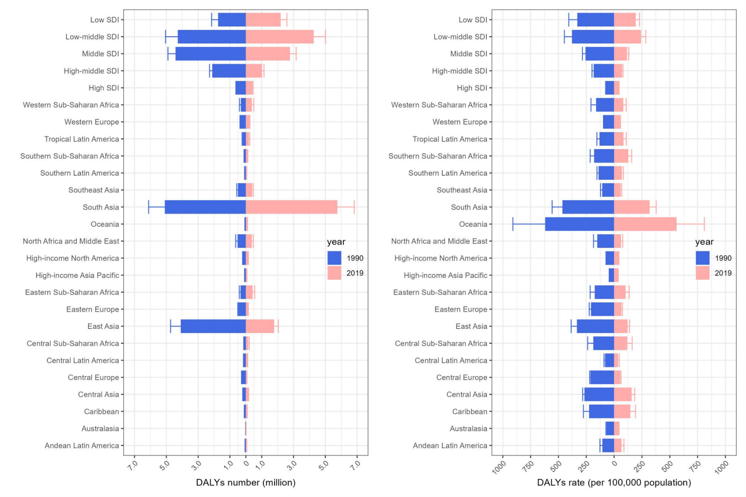
Figure S1. Change in burden of rheumatic heart disease by region, 1990 vs 2019. Columns and error bar representing the central estimates and 95% uncertainty interval of DALYs cases (A)and DALYs rates (B) in all ages population, respectively. DALYs, disability-adjusted life-years; SDI, Sociodemographic Index.

Figure S2. Change in burden of ischemic heart disease by region, 1990 vs 2019. Columns and error bar representing the central estimates and 95% uncertainty interval of DALYs cases
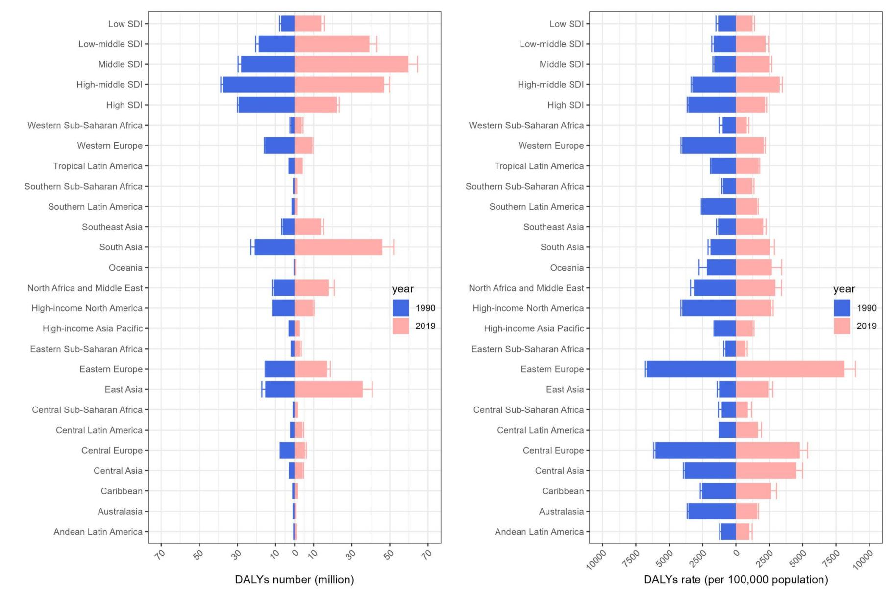
(A)and DALYs rates (B) in all ages population, respectively. DALYs, disability-adjusted life-years; SDI, Sociodemographic Index.

Figure S3. Change in burden of stroke by region, 1990 vs 2019. Columns and error bar representing the central estimates and 95% uncertainty interval of DALYs cases
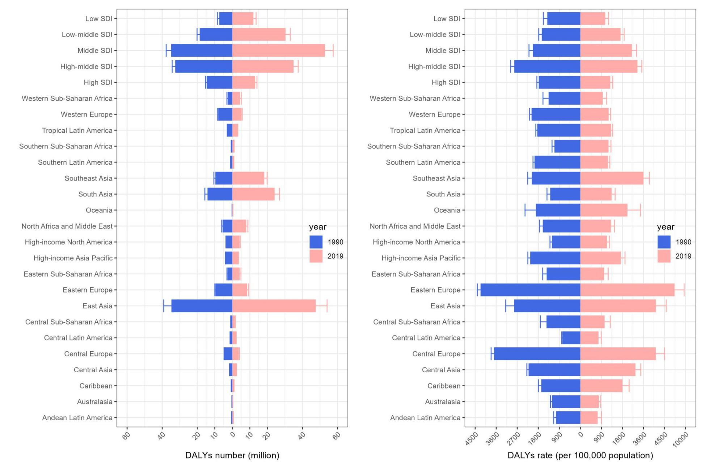
(A) and DALYs rates (B) in all ages population, respectively. DALYs, disability-adjusted life-years; SDI, Sociodemographic Index.
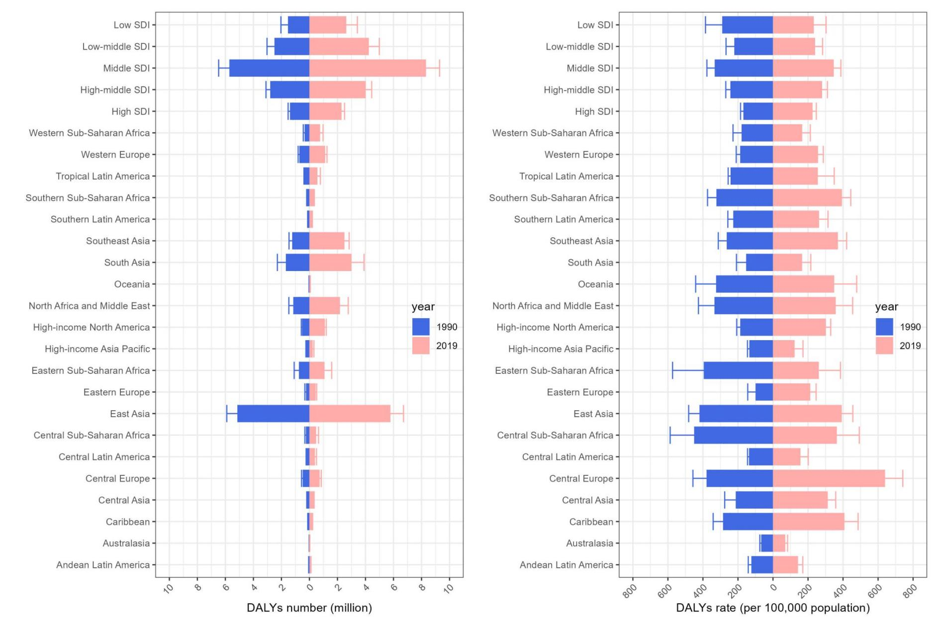
Figure S4. Change in burden of hypertensive heart disease by region, 1990 vs 2019. Columns and error bar representing the central estimates and 95% uncertainty interval of DALYs cases (A) and DALYs rates (B) in all ages population, respectively. DALYs, disability-adjusted life-years; SDI, Sociodemographic Index.

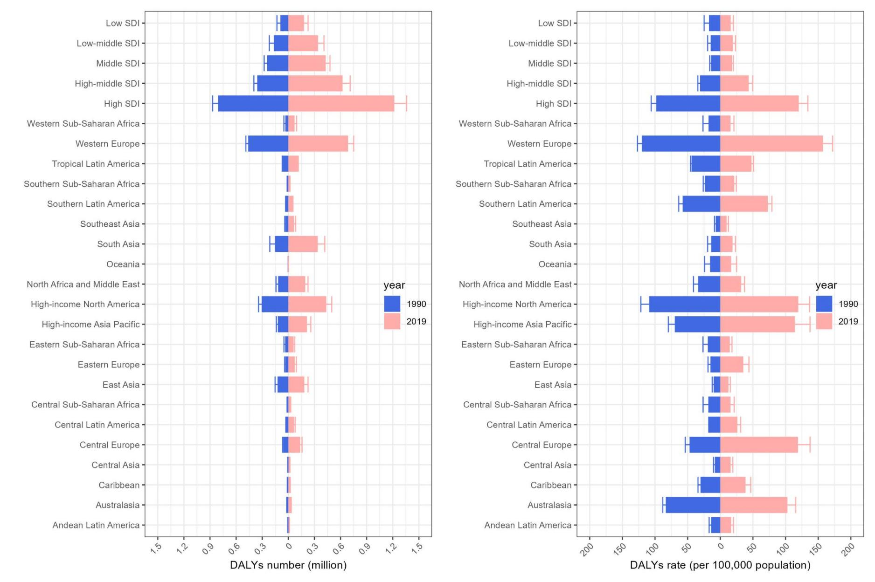
Figure S5. Change in burden of non-rheumatic valvular heart disease by region, 1990 vs 2019. Columns and error bar representing the central estimates and 95% uncertainty interval of DALYs cases (A) and DALYs rates (B) in all ages population, respectively. DALYs, disability-adjusted life-years; SDI, Sociodemographic Index.

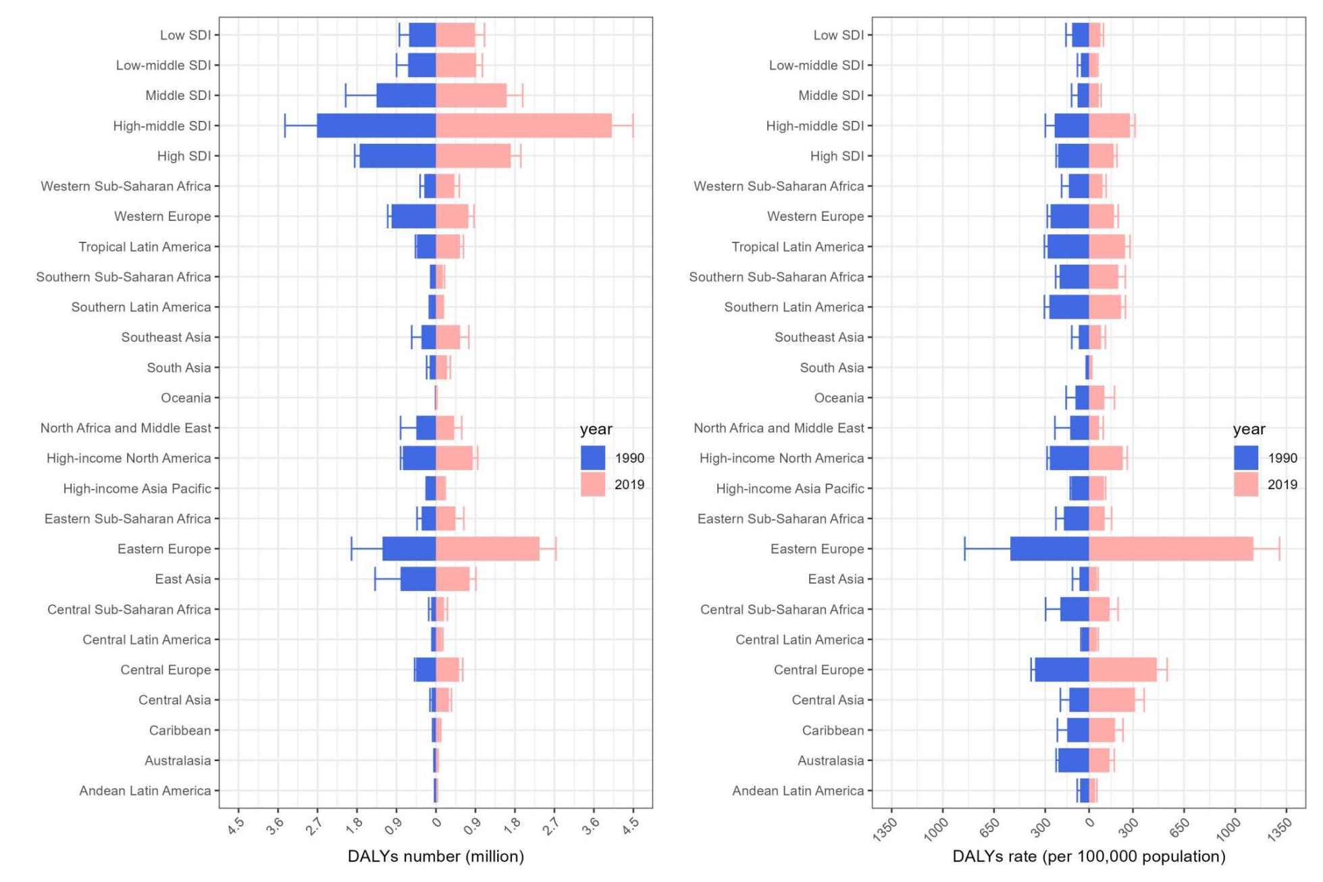
Figure S6. Change in burden of cardiomyopathy and myocarditis by region, 1990 vs 2019. Columns and error bar representing the central estimates and 95% uncertainty interval of DALYs cases (A) and DALYs rates (B) in all ages population, respectively. DALYs, disability-adjusted life-years; SDI, Sociodemographic Index.

Figure S7. Change in burden of atrial fibrillation and flutter by region, 1990 vs 2019. Columns and error bar representing the central estimates and 95% uncertainty interval of DALYs cases (A) and DALYs rates (B) in all ages population, respectively. DALYs, disability-adjusted life-years; SDI, Sociodemographic Index.
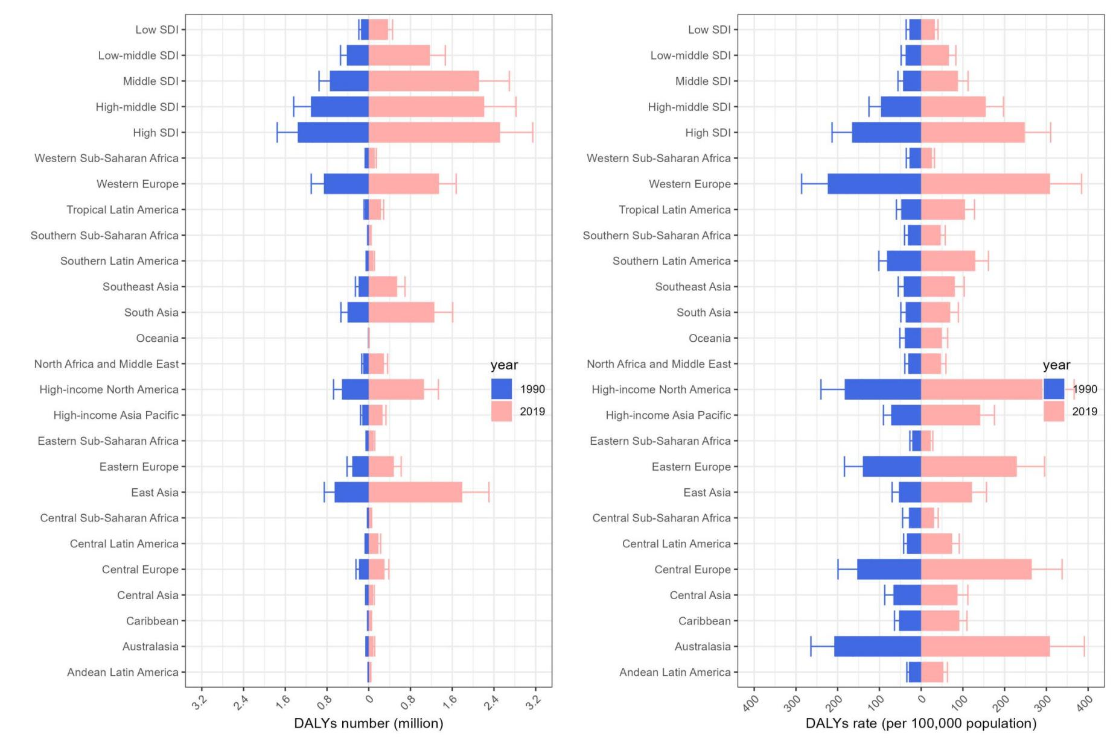

Figure S8. Change in burden of aortic aneurysm by region, 1990 vs 2019. Columns and error bar representing the central estimates and 95% uncertainty interval of DALYs cases (A) and DALYs rates (B) in all ages population, respectively. DALYs, disability-adjusted life-years; SDI, Sociodemographic Index.
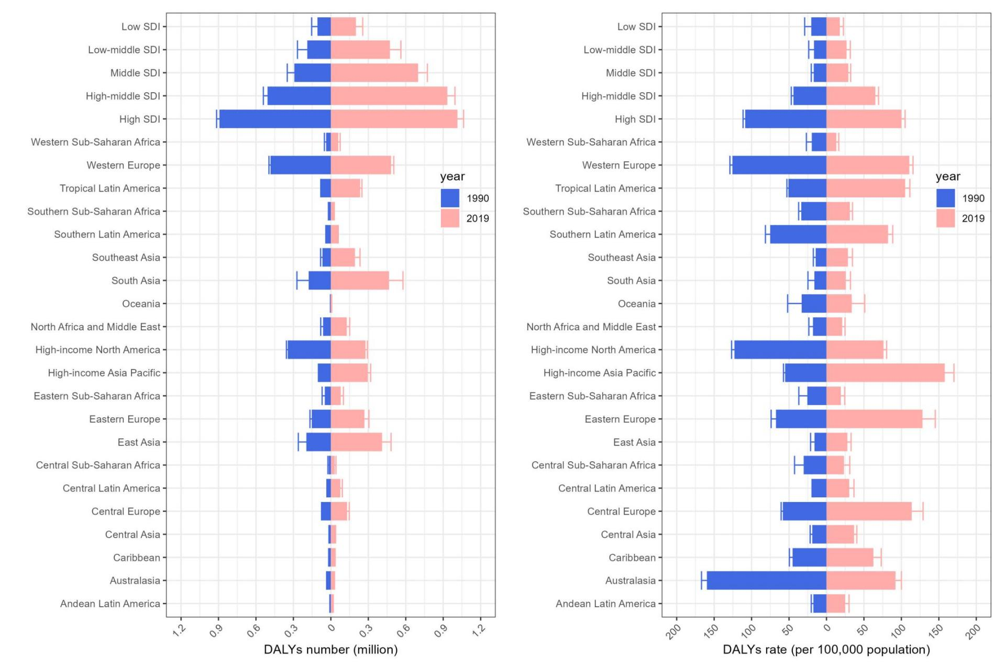

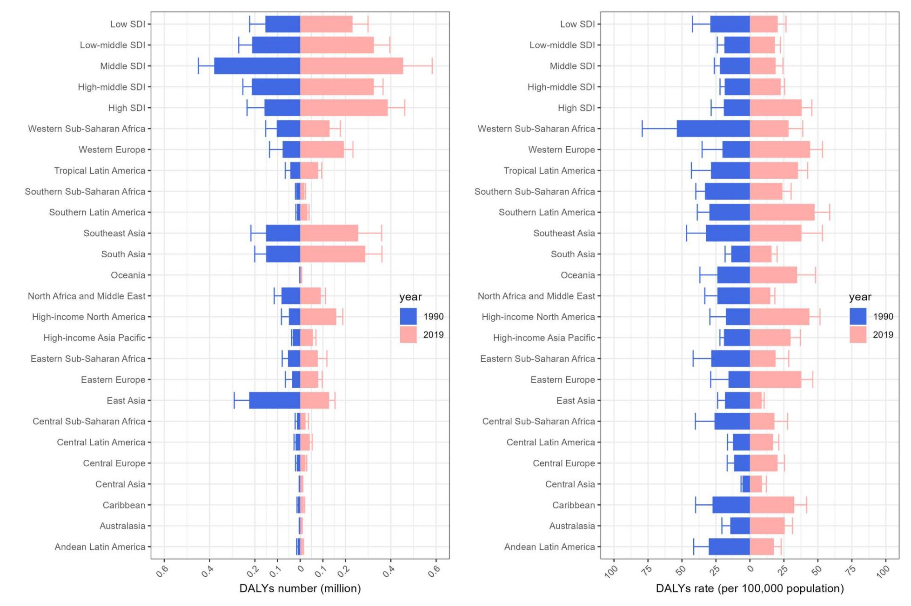
Figure S9. Change in burden of peripheral artery disease by region, 1990 vs 2019. Columns and error bar representing the central estimates and 95% uncertainty interval of DALYs cases (A) and DALYs rates (B) in all ages population, respectively. DALYs, disability-adjusted life-years; SDI, Sociodemographic Index.

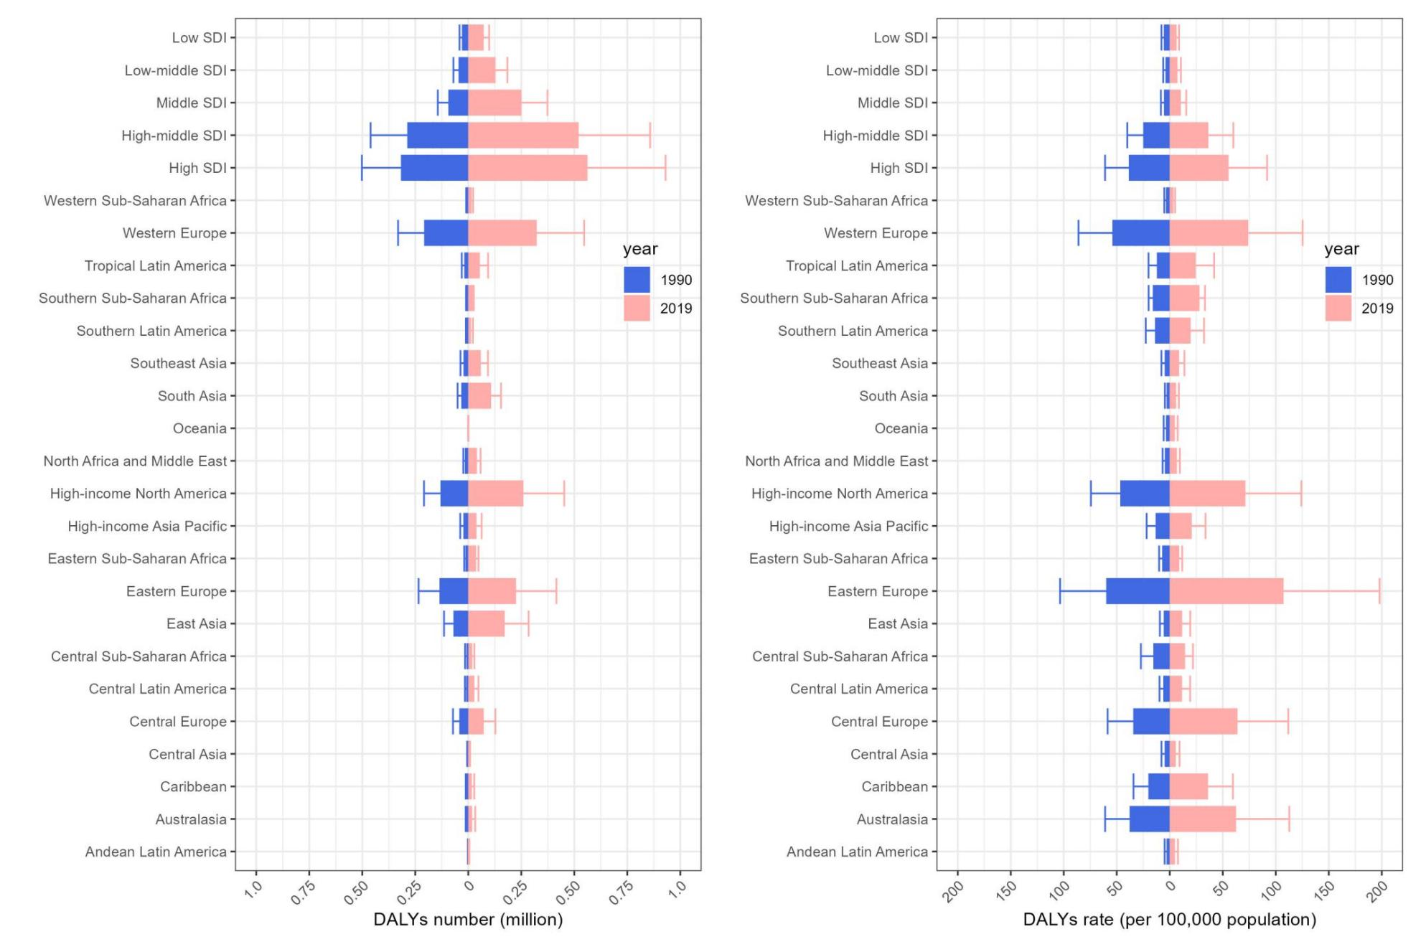
Figure S10. Change in burden of endocarditis by region, 1990 vs 2019. Columns and error bar representing the central estimates and 95% uncertainty interval of DALYs cases (A) and DALYs rates (B) in all ages population, respectively. DALYs, disability-adjusted life-years; SDI, Sociodemographic Index.

