Supplementary Information
Hydrophobic and anti-fouling polyelectrolyte complex coating for durable flame-retardant cotton fabric

Jia-Lin He ª, Wei Luo ª, Jin-Ni Deng ^{a, b, *}, Ting Wang ^{a, b}, Zhi-Cheng Fu ^{a, b}, Chang-Lin Xia ^{c}, Sheng-Chao Huang ^{d}, Ming-Jun Chen ^{a, b *}

ª Green Preparation and Recycling Laboratory of Functional Polymeric Materials, School of Science, Xihua University, Chengdu, 610039, China
^{b} Food Microbiology Key Laboratory of Sichuan Province, School of Food and Bioengineering, Xihua University, Chengdu, Sichuan, 610039, China
^{c} Yibin Hiest Fibre Limited Corporation, Yibin, 644002, China
^{d} Hubei Three Gorges Laboratory, Yichang, 443000, China

*Corresponding Authors. Tel. & Fax: +86-28-87387181.
E-mail: cmjchem@126.com (Ming-Jun Chen); dengjinniddd@163.com (Jin-Ni Deng)

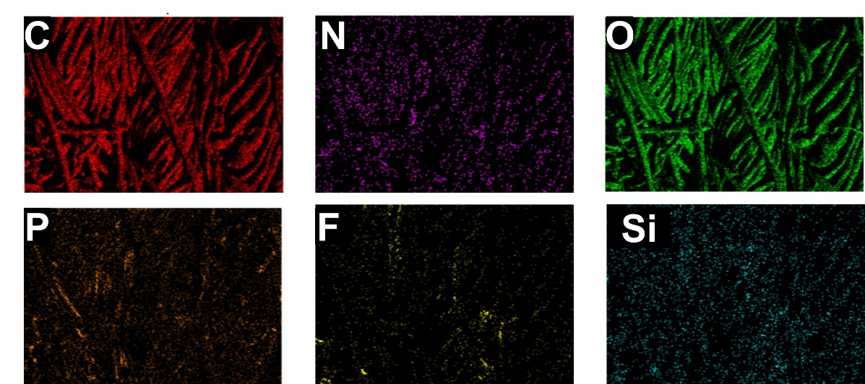
Fig. S1 SEM-EDX of F-PEC coated cotton fabric.

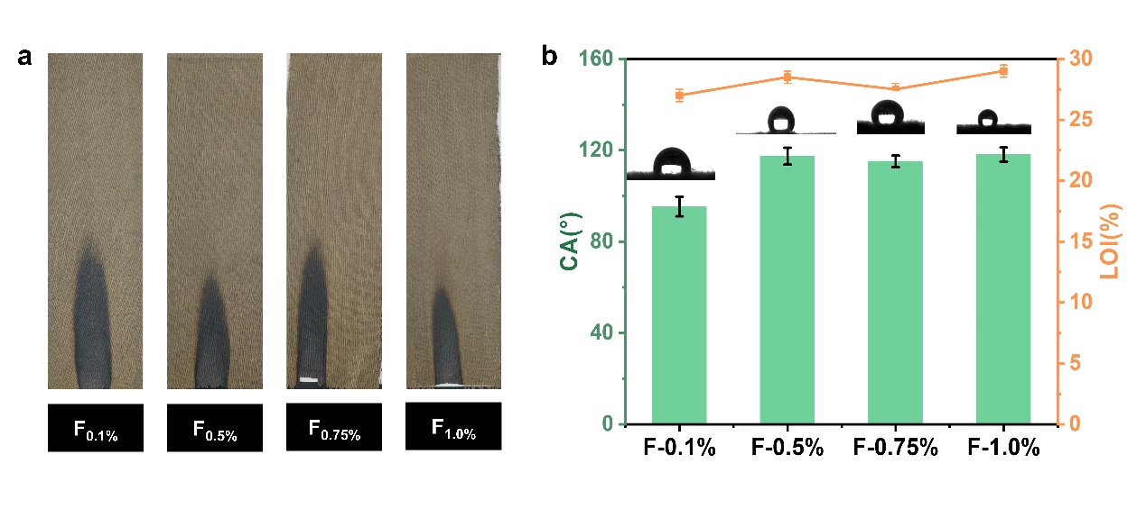
Fig. S2 Different content of PFTS coated fabrics (a) after vertical burning test, the CA and LOI of different content of PFTS coated fabrics (b).

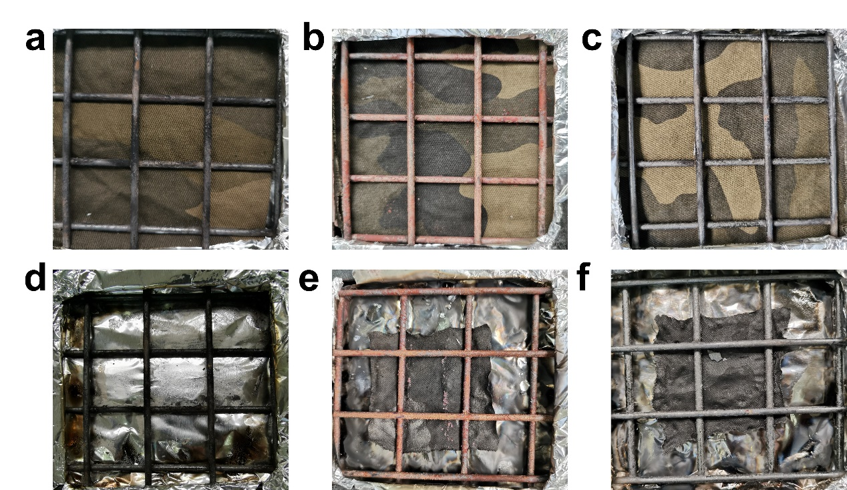
Fig. S3 Digital photos of pristine fabric (a, d), PEC (b, e) and F-PEC (c, f) coated fabrics before and after cone colorimeter tests.

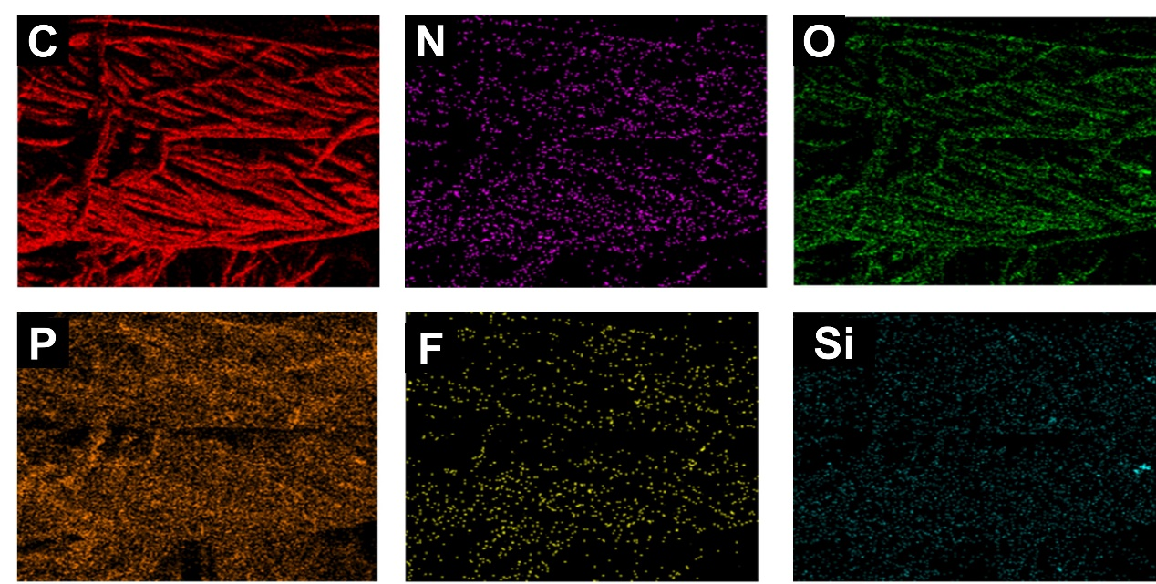
Fig. S4 SEM-EDX of F-PEC coated cotton fabric after VFT.

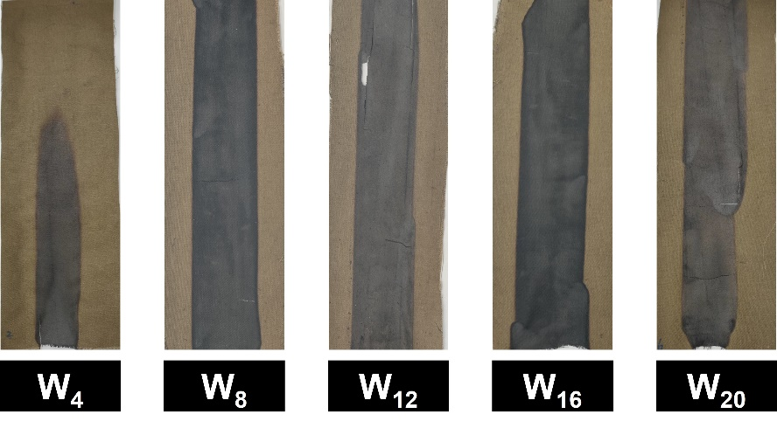
Fig. S5 Digital photos of PEC coated fabrics after different washing times.

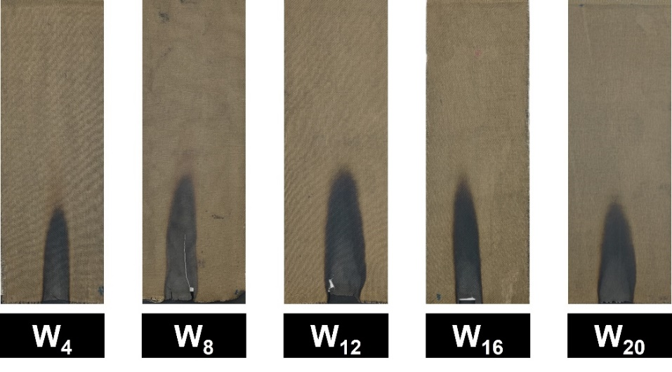
Fig. S6 Digital photos of F-PEC coated fabrics after different washing times.

Table S1 Data from VFT, LOI and water contact angle test.
Sample | Weight  gain (%) | Damaged length(mm) | Afterflame time (s) | Afterglow time (s) | LOI  (%) | CA  ( °)
F_{0.1%} | 12±1 | 130±1 | 0 | 0 | 27.0±0.5 | 95.3±4.2
F_{0.5%} | 12±1 | 110±1 | 0 | 0 | 28.5±0.5 | 117.4±3.7
F_{0.75%} | 12±1 | 130±1 | 0 | 0 | 27.5±0.5 | 115.1±2.5
F_{1.0%} | 12±1 | 100±1 | 0 | 0 | 29.0±0.5 | 118.1±3.1

