Supplementary Information (SI)

SI 1: Experimental design matrix for optimization of biosurfactant production by the Pseudomonas aeruginosa and the actual responses obtained.

Run Coded values (Actual values)
X₁(g) X₂ (g) X₃ (ml) X₄ (ml) Y
Conc of C Conc of N₂ Inoculum size Medium Vol/250ml E24(%)
1 0 (15) 0 (15) 0 (2.0) 2 (60) 57.3
2 -1 (10) 1 (20) -1 (1.5) 1 (50) 72.1
3 0 (15) 0 (15) 0 (2.0) 0 (40) 66.2
4 -1 (10) 1 (20) -1 (1.5) -1 (30) 55.0
5 1 (20) -1 (10) 1 (2.5) 1 (50) 52.1
6 1 (20) 1 (20) -1 (1.5) -1 (30) 75.6
7 0 (15) -2 (5) 0 (2.0) 0 (40) 63.3
8 -1 (10) 1 (20) -1 (1.5) -1 (30) 81.6
9 0 (15) 0 (15) 0 (2.0) 0 (40) 93.3
10 1 (20) -1 (10) -1 (1.5) 1 (50) 84.7
11 0 (15) 0 (15) 0 (2.0) 0 (40) 70.0
12 0 (15) 2 (25) 0 (2.0) 0 (40) 75.5
13 0 (15) 0 (15) 0 (2.0) 0 (40) 55.0
14 0 (15) 0 (15) -2 (1.0) 0 (40) 60.0
15 -1 (10) -1 (10) 1 (2.5) 1 (50) 50.3
16 1 (20) 1 (20) 1 (2.5) 1 (50) 64.3
17 0 (15) 0 (15) 0 (15) 0 (40) 45.3
18 -1 (10) -1 (10) 1 (2.5) -1 (30) 77.1
19 -1 (10) -1 (10) 1 (2.5) 1 (50) 80.0
20 2 (25) 0 (15) 0 (2.0) 0 (40) 73.3
21 -1 (10) 1 (20) 1 (2.5) 1 (50) 50.5
22 0 (15) 0 (15) 0 (2.0) 0 (40) 45.2
23 1 (20) 1 (20) 1 (2.5) -1 (30) 83.3
24 1 (20) -1 (10) 1 (2.5) -1 (30) 65.0
25 0 (15) 0 (15) 2 (2.5) 0 (40) 47.3
26 -1 (10) -1 (10) -1 (1.5) -1 (30) 50.0
27 1 (20) 1 (20) -1 (1.5) 1 (50) 93.8
28 0 (15) 0 (15) 0 (2.0) 0 (40) 45.1
29 -2 (5) 0 (15) 0 (2.0) 0 (40) 75.0
30 0 (15) 0 (15) 0 (2.0) -2 (20) 50.2
31 1 (20) -1 (10) -1 (1.5) -1 (30) 90.0

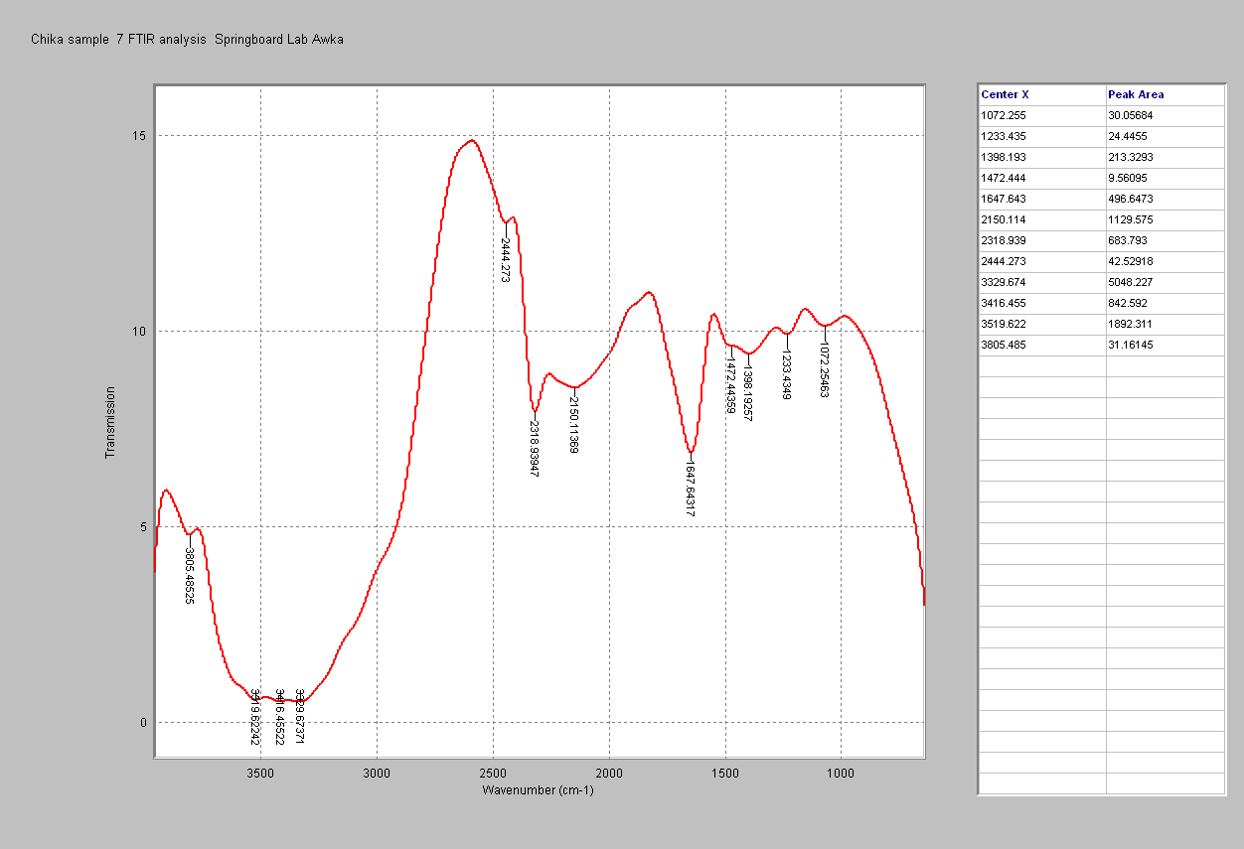

SI 2: The Transform Infrared Spectroscopy (FT-IR) spectrum of the biosurfactant produced by Pseudomonas aeruginosa, showing the hydrophilic moieties

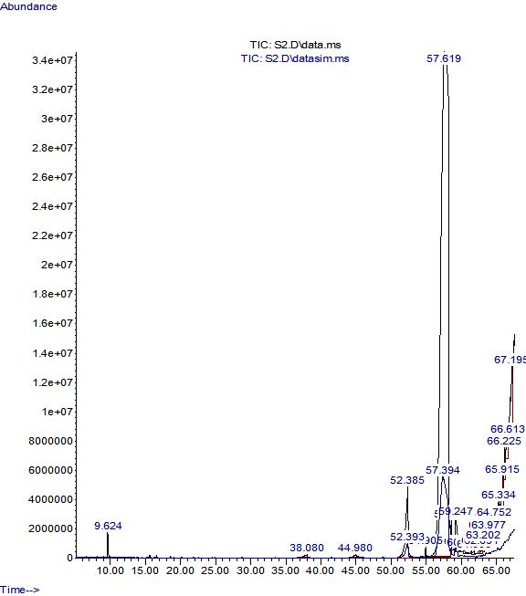
SI 3: Mass spectrum from GC-MS analysis of the biosurfactant from P.aeruginosa, showing the peaks of abundant fatty acid components

