Supplementary Information

Funding and Ethics Statement 1
Funding statement. 1
Ethical standards statement. 1
Informed consent statement. 1
Conflict of interest statement. 1
Data, Code, and Reproducibility 2
Data Availability Statement 2
Table S0. Supplementary Information concerning data, code, and reproducibility 2
Recruitments and Training 3
Supplementary Figures 4
Figure S1: Description of the process to build the Research Dataset 4
Figure S2. Processing for computing Graph Languages Features 5
Figure S3: Multi-channel Classifier from Vanni et al. 2023. 5
Figure S4. Distribution of word numbers based on exposition type and PTSD diagnosis 5
Figure S5: Distribution of word numbers based on gender and PTSD diagnosis 6
Figure S6: Description of multiple evaluation metrics for ML Classifiers 6
Figure S7. Average ROC curves for each text CNN Classifier related to each DSM-5 Criterion 7
Figure S8. Average ROC curves for each text CNN Classifier related to each DSM-5 Criterion using sequences-based evaluations 8
Supplementary Tables 9
Table S1. - Exhaustive list and description of language features 9
Table S2: Reported performances of detecting passive voice in our corpora using the custom spacy matcher 11
Table S3: Dataset Size and Performances for each custom camembert-based token classifier model 11
Table S4. Metrologic validation of the trauma interview on the 85 participants of the “Etude 1000” who were diagnosed using SCID. 11
Table S5. Synthesis of the results produced by statistics and machine learning analysis 12
Table S6. Not Translated most significant sequence associated with Full or Partial PTSD 14
Interview Material (Translated) 15
First Part, open questions about the event 15
Second Part, Semi-standardized interview for PTSD diagnosis assessment 16

Funding and Ethics Statement

Funding statement.
The study was conducted within the framework of the “Programme 13-Novembre”, funded by the French General Secretariat for Investment (SGPI) through the National Research Agency (ANR) and the “Programme d’investissement pour l’Avenir” (PIA ANR-10-EQPX-0021-01). It also receives the support of Region île-de-France through deliberation n°CP2021-297.

Informed consent statement.
Before they participated in this study, all participants were provided with a detailed explanation of the research objectives, procedures, potential risks, benefits, and their rights as participants. All participants provided their voluntary informed consent by signing a consent form indicating their understanding of the study and their willingness to participate. It was explicitly communicated that participation was entirely voluntary, and participants were assured that they could withdraw from the study at any time without facing any consequences. Their confidentiality and privacy rights were emphasized, and they were made aware of how their data would be collected, stored, and used. The informed consent form is available upon request from the corresponding author.

Conflict of interest statement.
The authors whose names are listed above certify that they have NO affiliations with or involvement in any organization or entity with any financial interest (such as honoraria; educational grants; participation in speakers’ bureaus; membership, employment, consultancies, stock ownership, or other equity interest; and expert testimony or patent-licensing arrangements), or non-financial interest (such as personal or professional relationships, affiliations, knowledge, or beliefs) in the subject matter or materials discussed in this manuscript.

Data, Code, and Reproducibility

Data Availability Statement

Table S0. Supplementary Information concerning data, code, and reproducibility
Description | Access Link
Data
Text features dataset | text_features.csv
Anonymized psycho-socio-economic dataset | socio_psycho_dataset.csv
Application and visualization
Web application for data visualization | https://13-november-data-viz.streamlit.app/
Web application for computing passive voice | https://passive-fr.streamlit.app/
Models
Token classifier for the value of present tense | https://huggingface.co/binbin83/fr_present_tense_value  DOI: 10.57967/hf/1189
Token classifier of the value for the pronoun “on” | https://huggingface.co/binbin83/fr_on_value  DOI: 10.57967/hf/1188
Token classifier models for Death | https://huggingface.co/binbin83/fr_lexical_death  DOI: 10.57967/hf/1186
Token classifier models for Sensation and body | https://huggingface.co/binbin83/fr_sensations_and_body  DOI: 10.57967/hf/1187
Code
Detection of passive voice | NLP-for-Psycholinguistic/passive_detection_app
Extract features from text | psycholinguistics2125/text_feature_toolbox
Finetuning CamemBERT model with spacy | psycholinguistics2125/train_NER
Reproduce ML and stats results | psycholinguistics2125/linguistic_code_of_ptsd  DOI: 10.5281/zenodo.8414555
Reproduce DL results | Performances: NLP-for-Psycholinguistic/deep_text_classifier  Interpretation: psycholinguistics2125/hyperdeep

Recruitments and Training
All the participants were volunteers and were recruited through information provided by newspapers, Paris City Halls, and victims' associations. To facilitate the recruitment of volunteers, a mediation team was established. Their role involves identifying potential volunteers, providing them with information about the program's objectives, ensuring that they have received all necessary information, inviting them to participate, scheduling meetings for recruitment, and maintaining communication with the volunteers. Volunteers can get in touch with the mediators through four different channels,
- Face-to-face contact: Mediators introduce the program to potential volunteers during street flyer distributions and other field operations.
- Email communication: Mediators receive and respond to messages sent to "participation@memoire13Novembre.fr," subsequently contacting the volunteers.
- Phone calls: The mediation team manages two telephone lines, allowing volunteers to inquire and sign up for the program via phone.
- Sign-up during public meetings: During public meetings, events, or association gatherings, the mediation team provides contact sheets that enable them to re-establish contact with the volunteers.
The study's inclusion criteria do not consider socio-professional, age, or gender factors as the study is not representative of a specific population. Primarily, geographical criteria are used to include volunteers based on their proximity to terrorist attacks. Special attention is given to volunteers' statements to verify the coherence of their claims (such as their presence at the scenes of the attacks) without delving into specific details. Non-Inclusion Criteria are (1) Residents of unaffected cities in different regions (Type C4). (2) Minors. (3) Volunteers who do not wish to be filmed (4) Those who reject the filming authorization contract or do not give their informed consent. All 934 people recruited were filmed during the interview.
The investigators were carefully selected and were typically individuals with doctorate degrees or doctoral candidates, specializing in fields such as sociology, anthropology, and psychology. They possess prior experience in conducting interviews and fieldwork, particularly in challenging and sensitive contexts. To ensure inclusivity, recruitment efforts also focus on diversifying the age range of the investigators. The training process is extensive and spans several days. It includes,
- Program Orientation: Investigators receive comprehensive explanations and presentations covering all scientific dimensions of the program.
- Test Interviews: Training involves conducting test interviews both in a controlled studio environment and in real-world field settings.
- Specialized Training: Investigators receive specific training for engaging with individuals from the first circle. This training is conducted through collaborative sessions with specialists in post-traumatic stress disorders, who have contributed to the development of the interview guide.
- Utilization of Tools: Investigators are equipped with two key resources: an interview guide for questionnaires (comprising 28 pages) and an investigator's manual (12 pages). These resources provide detailed instructions on how to handle follow-up interactions and maintain the appropriate behavior while conducting interviews.

Supplementary Figures

Figure S1: Description of the process to build the Research Dataset
A1, A2, A3, and A4 represent the exposition criterion of DSM-5
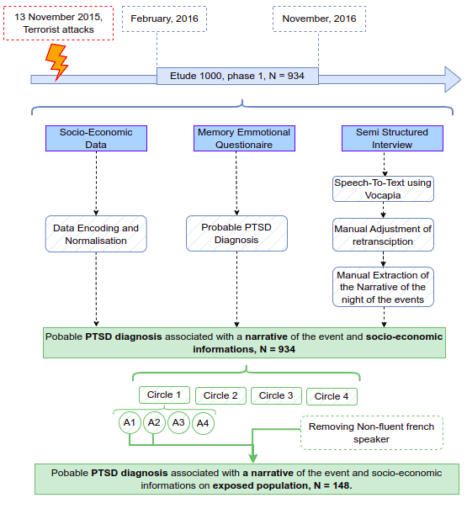

Figure S2. Processing for computing Graph Languages Features
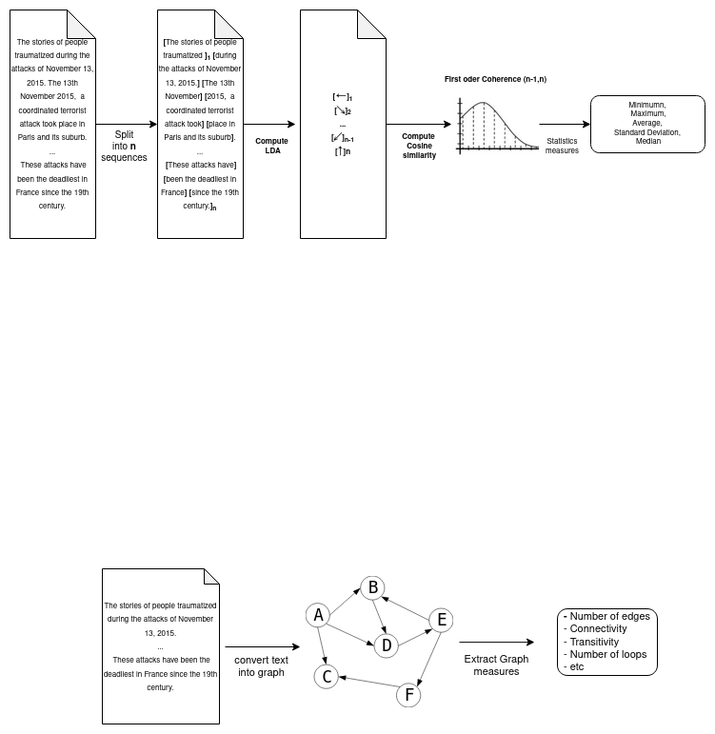

Figure S3: Multi-channel Classifier from Vanni et al. 2023.
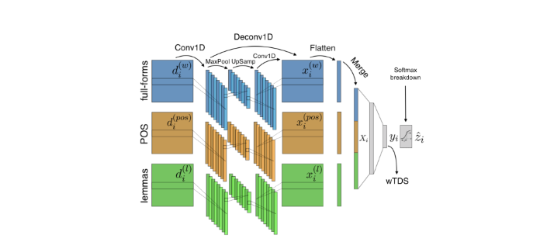
Three channels of convolution/deconvolution for three representations of the input 1) full-forms (words), 2) part-of-speech (POS), 3) lemma

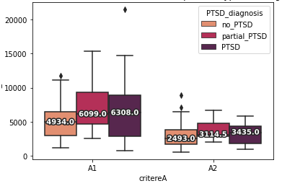
Figure S4. Distribution of word numbers based on exposition type and PTSD diagnosis

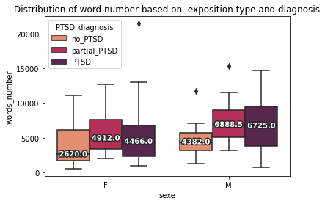
Figure S5: Distribution of word numbers based on gender and PTSD diagnosis

Figure S6: Description of multiple evaluation metrics for ML Classifiers
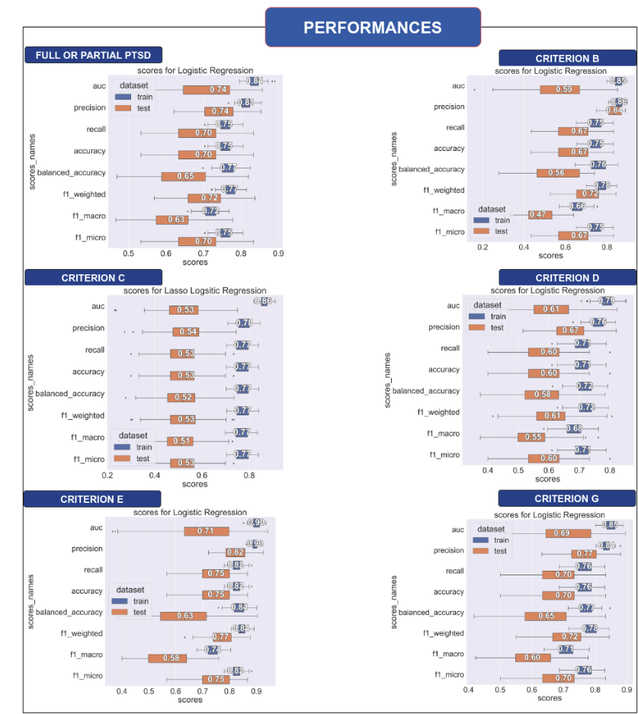
Performances on the train and test set averaged over 100 random runs

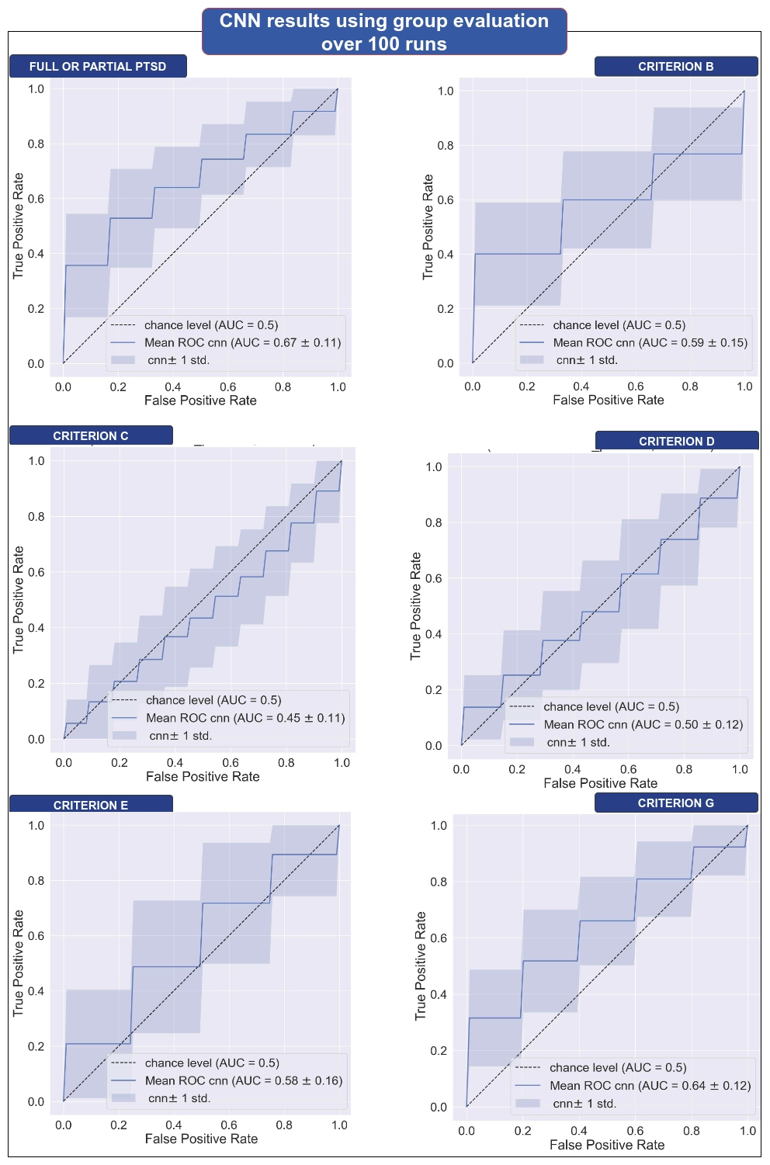
Figure S7. Average ROC curves for each text CNN Classifier related to each DSM-5 Criterion

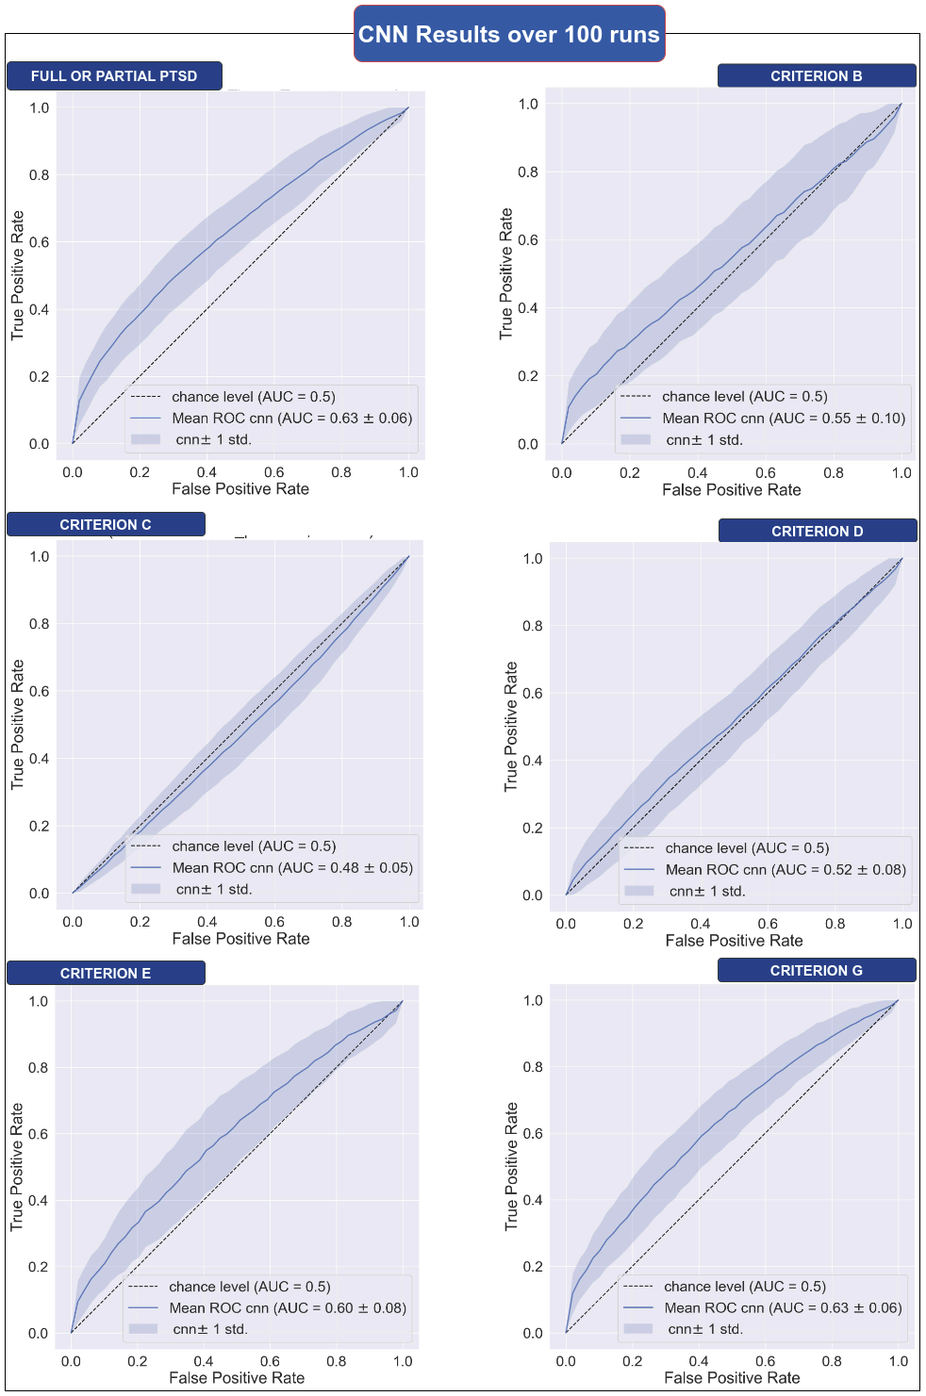
Figure S8. Average ROC curves for each text CNN Classifier related to each DSM-5 Criterion using sequences-based evaluations

Supplementary Tables

Table S1. - Exhaustive list and description of language features
Feature Name | Description | N
xxxx_number | Number of words or sentences in each narrative | 2
Sentiments and Emotion Features |  | 27
liwc_xxx | Proportion of words associated with the xxx’s LIWC French category. We selected only the categories associated with emotions, death and body | 4
gobin_xxx | Emotional valences of 10 emotions (disgust, sadness, fear etc.) | 10
textblob_xxx | Polarity and subjectivity scores | 2
labMT | labMT happiness score | 1
feel_xxx | Score associated to 7 emotion, based on FEEL lexicon | 7
polarimot_xxx | Score of polarity based on polarimot lexicon (neutral, positive, negative) | 3
Lexical Features |  | 4
model_PERCEPTIONS_xx | Proportion of verb and word related to sensorial perception | 2
model_PHYSICAL_SENSATION | Proportion of token associated with physical sensation | 1
model_DEATH | Proportion of token associated with death | 1
Morphological features |  | 18
xx_personal_pronoun_x | Proportion of personal pronoun for singular and plural ofeach person (1,2,3) | 4
verb_tense_x | Proportion of each tense in the narrative (participle past, imperfect, present, future, conditional) | 6
PQP_scores | Proportion of verb conjugate to “Plus Que Parfait” tense | 1
modell_ON_xx | Proportion of each value of the pronoun on (generic, someone, we) | 3
model_PRESENT_xx | Proportion of each value of the present (generic, enunciative, historical) | 3
prop_PROPN | Proportion of proper noun in the text | 1
Syntactic Features |  | 4
passive_count | Number of passive form found | 1
passive_sents_count | Number of sentences in passive form | 1
passive_percentages | Proportion of sentences in passive form | 1
passive_count_norm | Passive_count normalized by the logarithm of token numbers | 1
Dysfluences Features |  | 9
repetition_x_order | Normalize count of repetition of syllables, distanced by x syllabus | 3
score_generical_connector_matches | Proportion of connectors in text : ‘mais','donc','aussi','parce que',"et" etc. | 1
score_temporal_connector_matches | Proportions of temporal connector in text: "quand", "lorsque", "avant que" | 1
score_parenthetique_matches | Proportion of parenthetical in text: "à savoir", "c'est-à-dire" etc. | 1
score_paticules_matches | Proportion of discourseparticles in text: "bon","bah","voila","ben","quoi" | 1
score_troncations_matches | Normalized number of “...” in text, that referred to truncated words | 1
score_onomatopea_matches | The proportion of onomatopoeia in text : “ah”, “crac” etc.. | 1
Readability Features |  | 5
xx_ratio_score | Lexical diversity score for nouns, adverb and verb | 4
direct_discourse_score | Proportion of discourse direct in text | 1
Discourse coherence features |  | 11
degree_average | Average degrees of each node in the text graph | 1
PE (Parallel Edges) | Number of nodes with a degree superior to 1: number of words repeated more than one time. | 1
average_clustering | Average clustering the text graph | 1
average_shrotest_path_g0 | Average shortest path in the largest connected graph | 1
diameter_g0 | Diameter of the largest connected graph | 1
LCC, LSC | Number of nodes weakly and strongly connected, is a lexical diversity index | 2
transitivity | Number of triangles in the graph divided by the number of triplets | 1
L1, L2, L3 | Adjacent matrix trace representing the Number of repetition at different order | 3
Total = 80 Language Features

Table S2: Reported performances of detecting passive voice in our corpora using the custom spacy matcher
Model | Recall | Precision | f1-score
Spacy large | 0.84 | 0.70 | 0.77
spacy transformer | 0.89 | 0.85 | 0.86

Table S3: Dataset Size and Performances for each custom camembert-based token classifier models
Task | Labels Name | Dataset size (number of labels) |  |  | Performances on validation
Task | Labels Name | Train | Test | Validation | Precision | Recall | f1-score
Value of present tense | Historical Present | 1131 | 292 | 156 | 0.83 | 0.8 | 0.82
Value of present tense | Enunciative Present | 2253 | 603 | 324 | 0.80 | 0.83 | 0.82
Value of present tense | Generic Present | 732 | 192 | 104 | 0.54 | 0.60 | 0.56
Value of “on” pronoun | “on” meaning we | 1088 | 310 | 157 | 0.91 | 0.96 | 0.93
Value of “on” pronoun | “on “meaning someone | 102 | 29 | 20 | 1 | 0.8 | 0.89
Value of “on” pronoun | “on” with generic value | 235 | 44 | 16 | 0.64 | 0.56 | 0.60
Specific lexical fields | death | 147 | 35 | 18 | 0.93 | 0.83 | 0.88
Specific lexical fields | body | 543 | 140 | 98 | 0.90 | 0.87 | 0.88
Specific lexical fields | physical sensations | 115 | 27 | 18 | 0.68 | 0.94 | 0.80
Specific lexical fields | verbs sensory perception | 636 | 195 | 85 | 0.79 | 0.91 | 0.84
Specific lexical fields | words sensory perception | 294 | 102 | 44 | 0.88 | 0.84 | 0.86

Table S4. Metrologic validation of the trauma interview on the 85 participants of the “Etude 1000” who were diagnosed using SCID.
Diagnosis | Precision | Sensibility | Specificity
PTSD | 0.95 | 0.92 | 0.96
Partial PTSD | 0.71 | 0.77 | 0.94
Partial PTSD or PTSD | 0.94 | 0.94 | 0.91

Table S5. Synthesis of the results produced by statistics and machine learning analysis
🮱 Statistical Evidences 🗹 Machine Learning Evidences ✅ Deep Learning interpretation
Feature Name | Full or partial PTSD | Criteria
Feature Name | Full or partial PTSD | B | C | D | E | G
Words number | 🮱 |  |  |  | 🮱 | 🮱
sentences_number |  |  |  |  | 🮱
Sentiment and emotional features
labMT | 🮱 |  |  |  | 🮱 | 🮱
feel_positive | 🮱 |  |  |  | 🮱
liwc_positive_emotion | 🮱 |  |  |  |  | 🮱
gobin_positive | 🮱 |  |  |  |  | 🮱
gobin_joy | 🮱
textblob_polarity |  |  |  |  | 🮱
textblob_subjectivity | 🗹 | 🗹
Lexical features
BODY | 🮱 🗹 | 🮱🗹 | 🮱 🗹 | 🗹 | 🮱🗹 | 🮱 🗹
PHYSICAL_SENSATIONS | 🮱 🗹 | 🮱 🗹 | 🮱 🗹 | 🗹 | 🮱🗹 | 🮱 🗹
liwc_death | 🮱 | 🮱 |  |  |  | 🮱
DEATH | 🗹 ✅ | 🮱 🗹 |  | 🗹 | 🮱 🗹 | 🮱 🗹
PERCEPTIONS’ VERBS | 🗹 | 🗹 | 🗹 | 🗹 | 🗹
Morphosyntactic Features
Past Participle | 🗹 |  | 🮱 🗹
PRON |  |  |  | 🮱
Proper Name |  |  |  |  | 🮱
ON_someone |  |  |  | 🮱 🗹 |  | 🗹
ON_we | 🗹
first_personal_pronoun_plur |  | 🗹 |  | 🮱 🗹 | 🗹
verb_indicatif_future |  |  |  |  | 🮱🗹
first_personal_pronoun_sing | 🗹 ✅ |  |  |  | 🗹 | 🮱🗹
Historical_Present | 🗹 |  |  | 🗹 |  | 🗹
Generical_present | 🮱 |  |  |  |  | 🮱
Direct Discourse score | 🗹
Syntactic Features
passive_count_norm | 🮱 🗹 |  |  |  | 🮱 | 🮱🗹
Speech Disfluencies Features
score_troncations_matches | 🮱 🗹 ✅ | 🮱 🗹 |  |  | 🗹 | 🗹
score_generical_connector_matches |  |  |  |  | 🮱
Readability Features
token_ratio_score | 🮱 |  |  |  | 🮱 | 🮱
noun_ratio_score | 🮱 |  |  |  | 🮱
adverb_ratio_score |  |  |  |  | 🮱
Discourse Coherence Features
graph_PE | 🮱 |  |  |  | 🮱 🗹 | 🮱🗹
graph_degree_average | 🮱 🗹 |  |  |  | 🮱 🗹 | 🮱
graph_average_clustering | 🮱 | 🗹
graph_L2 | 🮱 🗹 | 🗹 |  |  | 🮱🗹 | 🮱🗹
graph_L3 | 🮱 🗹 |  |  | 🗹
graph_average_shrotest_path_g0 |  |  |  |  | 🮱
Diameter_g0 | 🗹 |  |  |  | 🗹
graph_transitivity |  | 🗹 |  |  | 🗹

Table S6. Not Translated most significant sequence associated with Full or Partial PTSD
Extracted using CNN probabilities

[...] un rapport à la mort , dans ces cas là ... où ben j' en avais vu d' autres de les morts ... dans le Bataclan ... et euh ... de le coup bon moment OK ... Marie est morte , et c' était plus par rapport à sa famille , où je penser à sa famille , me dire : " C' est trop con , elle est arrivée jusque -là et ... ben , c' est à le poste de secours , où elle est décédée alors que c' est le ... voilà . " Don c' est ... mais je me suis pas ... je me suis pas de le tout projetée par contre à me dire que ça pourrait être moi ... ça , c' est des mois après que j' ai pu me dire des choses comme ça , mais ... pas de le tout sur le coup . Euh ... de le coup euh ... bah voilà Marie est décédée et puis ... dans ... c' était très fouillis , je me souviens que les secours ... on sentait qu' y avait quand même un peu de panique quoi , c' est ... je les voyais s' agiter mais revenir quinze fois à le même endroit et la pauvre Marie on est venu à le moins trois , quatre fois , voir si elle allait bien et puis elle était décédée à chaque fois donc euh ... donc PRON , je , je me souviens , de m' être dit aussi que , normalement , on fait des codes couleurs pour ça , pour que ... pour identifier les , les , les , décédés , les ... l' état de gravité de les blessés . Donc euh ... donc voilà . Et euh ... et à le moment où j' ai commencé à vraiment trouver le temps long , je me suis ... je me souviens avoir croisé le regard ... je me suis peut -être relevée , un peu ... et j' ai croisé le regard d' une fille qu' on était en train d' évacuer , et je me souviens qu' on s' est regardé et que c' était vraiment ... une connivence , de se dire: " Putain mais de quoi on ressort là ? " De voir ... oui , le regard comme on pouvait pas se parler , parce qu' on était à l' autre bout de la cour , l' une de l' autre , mais vraiment de ... et puis contente d' accrocher le regard de quelqu'un , aussi . Donc cette fille est partie et puis on a quand même fini par m' évacuer , mais j' étais ... y avait plus grand monde dans la cour , quand on m'[..]

Interview Material (Translated)

First Part, open questions about the event
[See the Manual for the preparation in front of the camera and before the interview]
First of all, thank you very much for accepting this interview.
We are going to start with a filmed exchange, during which I will ask you to look at me, rather than at the camera. During this exchange, I may take some written notes: don't worry about it, it simply helps me to follow what you are saying.
This interview will take place in two stages: a first part that is fairly free, and a second during which I will ask you a few more precise questions, requiring short answers. Then we will stop the video recording, and I will accompany you to another room where you will fill in a short written questionnaire.
QUESTION 1
«To begin with, could you tell me about November 13th 2015?»
The interviewee can spontaneously interpret the question as he or she wishes. Thus, if he/she asks: «What happened or what I experienced?»
Answer: «As you wish.»
- 1st scenario: he starts with his personal experience. Let his speech develop by encouraging him (cf. below) and, after the thematic relaunches, open with the account of the events if he does not address it spontaneously.
- 2nd scenario: he starts with the account of events ("what happened"). Leave the speech develop by encouraging him (cf. below) and, after the thematic prompts, move on to the personal experience if he does not address it spontaneously.
Personal experience of November 13th

Do not forget to encourage the interviewee to expand on what he or she has said as much as possible by encouraging them to say more, by repeating a word or phrase from the volunteer if the person is silent.

Second Part, Semi-standardized interview for PTSD diagnosis assessment

«I'll start by asking you some questions about your memories.»
QUESTION 1.
First, do you feel like you've been thinking about November 13 and the days that followed in this past month?
o No:
o If so, please specify: «often", «too often» or neither"?

QUESTION 2.
Have you ever had images or thoughts related to these events come back to you unexpectedly?
o No
o Yes
Do you ever think about it deliberately, in the form of thoughts or general memories?
o No
o If yes:

2.1.1. Are these thoughts distressing?
o No: how would you characterize them? ……………………………………………….
o If so, please specify: «very distressing» or «a bit distressing» (mark the correct answer)
2.1.2. How often would you say you have thought about this in the past month?
Please specify: «not at all», «several times a week», «once a week», «several times a month», «once a month»
2.1.3. Do you feel that you have been dwelling on this event?
o No
o If yes: again this last month? ………………..
If yes: how often this last month?: «several times a week»,»once a week», «several times a month», «once a month»
is it rather in the form of:
Sensations (or precise images)
Thoughts (i.e. general memories or reflections)
Both
DK
What form do they take?
Specify: «sounds», «images», «odors», «tactile sensations»
Do they sometimes seem so vivid or detailed that you feel as if you are (re)experiencing the scene?
o No
o Yes
Are they distressing?
o No: how would you characterize them? ……………………………
o If yes, please specify: «very distressing», «a little distressing»
Did these specific memories occur again this last month?
o No
o If so, please specify their frequency: «several times a week»,»once a week», «several times a month», «once a month»
Did you also deliberately think about it this past month?
o No
o If so, please specify their frequency: «several times a week», «once a week», «several times a month», «once a month»
o Do you have the impression that you have, at some point, dwelled on this event?
o No
o If so: still the case this last month?
If so: how often this last month? «several times a week», «once a week», «several times a month», «once a month»
Are these thoughts distressing?
o No: how would you characterize them? ………………………….
o If so, please specify: very distressing, a little distressing
Have these thoughts occurred again this past month?
o No
o If so, please specify their occurrence: «several times a week», «once a week», «several times a month», «once a month»

Did you ever think about it deliberately?
o No
o If so, please specify the frequency: «several times a week», «once a week», several times a month», «once a month»
Do you feel that you have been rehashing this event?
o No
o If so: also this last month?
If so: how often this last month? «several times a week», «once a week», «several times a month», «once a month»

When you think about it, is it things that you have experienced, media images or things that you have been told?
If nothing matches, add other:
If an example is given spontaneously, note it:

QUESTION 3.
Do you ever try to avoid thinking about it?
o No
o If so: What do you do about it?
…………………………………………………………….
QUESTION 4.
During this last month, have you ever returned to or avoided certain locations, certain media, certain people?
o No
o If so, please specify:
Certain locations?
Returned to: No Yes: specify………………. Avoided No Yes: specify …………….
Certain media?
Returned to: No Yes: specify ……………..
Avoided: No Yes: specify ……………..
Certain people?
Returned to: No Yes: specify ………………. Avoided:
No Yes: specify ……………….
QUESTION 5.
What emotions do you feel when you think about the events of November 13 during this past month?
Feelings: free expression …………………………………………………………..
Then proposition: anger, incomprehension, empathy, sadness, disgust, fear, astonishment, surprise, interest, joy, satisfaction...

QUESTION 6.
Does thinking about these events trigger any physical reactions in you?
o No
o If so (or hesitation), suggest: trembling, pain, sweat, difficulty to breathe, stomach ache, palpitations...
If so: does it still happen this last month?
QUESTION 7.
Do events ever come back to you in your sleep?
o No
o if so:
Dreams or nightmares? (mark the answer)
Very close to reality? Yes No
Was it still true this last month? Yes No
■ if so: How often? ………………………………….
Have you had any event-related difficulties in the past month:
To fall asleep? Yes No
Waking with a start ? Yes No
Other sleep related problems? Yes No

«We are now going to ask you about things that may have changed for you since November 13 and the events that followed.»
QUESTION 8.
Would you say that you have confidence in the media's information about November 13th?
o Rather Yes
o Rather No
o Not at all or feeling of manipulation
QUESTION 9.
Could you tell us if this event has changed the way you function in your daily life or in your relationships?
o No
o If so, please specify: Work, studies, family, couple, friends?
(Complete the following only in the area(s) where changes are reported)

Are these changes:
Work or studies:
More positive or negative? Intense or moderate?
Do they still persist this last month?

Family or couple:
More positive or negative? Intense or moderate?
Do they still persist this last month?
Friends:
More positive or negative? Intense or moderate?
Do they still persist this last month?
QUESTION 10.
Do you feel that you have matured, or that you think better about the world or about your life since these events?
About the world:
o No
o Yes
About your life:
o No
o Yes
QUESTION 11.
Are you sometimes more on guard since these events? Yes No
Do you have startle reactions? Yes No
Do you take any special precautions? Yes No
If yes: specify………………………………………………
Do you feel more irritable? Yes No
QUESTION 12.
Do you forget things more than usual?
o No
o if so: can you give an example ………………………………..
Have you ever felt on «autopilot», i.e. disconnected from reality??
o No
o If so: more than you used to?
if so: is it still the case this last month?
o No
o Yes
Do you have difficulty concentrating?
o No
o If so: more than you used to?
if so: still during this last month?
o No
o Yes
Are you particularly distracted?
o No
o Yes
o If so: more than you used to?
if Yes: Still during this last month?
o No
o Yes
QUESTION 13.
Do you often talk about these events?
o No
o If so, specify: To whom? …………………
Free expression
Then proposal: Friends, family, colleagues, health care professionals …
How often?.......................
Do you talk more about events in general or memories that come back to you?
QUESTION 14.
Has your involvement in certain activities changed since?
o No
o if so, which activity?
Propose Political activities, Cultural activities, Leisure and entertainment activities, Religious activities, Professional activities …
o For each activity mentioned, specify: s’agit-il d’une implication plus forte ou au contraire de moins d’engagement, de moins d’intérêt?

QUESTION 15.
Overall, do you feel more optimistic or more pessimistic?
Both answers are possible
In relation to the world as it is?
o More optimistic
o More pessimistic
o Neither of them
If yes to any of these questions: Would you say a little or a lot?
What about yourself, your qualities or your future?
o More optimistic
o More pessimistic
o Neither of them
If yes to any of these questions: Would you say a little or a lot?

QUESTION 16.
Finally, and this will be my last question, did the events of November 13 remind you of other events?
From your personal life?
o No
o If so, please specify which ones:
From your family?
o No
o If so, please specify which ones:
Or even History (with a capital H)?
O No
o If so, please specify which ones:

