Supporting Information
Climate Change Effects on the Sundarban Mangrove Ecosystem and Tiger Population Dynamics in the Indian Region
Parthasarathi Barik^{1,2*} and K C Gouda^{2*}
¹Department of life Sciences, Chalmers University of Technology, Gothenburg-41296, Sweden
²CSIR Center for Mathematical modeling and computer simulation (repositioned CSIR Fourth Paradigm Institute), Wind tunnel road, Bangalore-560037, India
*Equally contributed to this paper.
Corresponding Author: Parthasarathi Barik
¹Department of life Sciences, Chalmers University of Technology, Gothenburg-41296, Sweden
²CSIR Center for Mathematical modeling and computer simulation (repositioned CSIR Fourth Paradigm Institute), Wind tunnel road, Bangalore-560037, India
Email: - parthabarik2@gmail.com
Phone-91-7205593729

Supplementary figure: Inter annual variability of monsoon rainfall for the period of 1987-2013 over Sundarban region. Here the number in the bracket represents correlation coefficients between mangrove distribution and monsoon rainfall. The equation shows the decreasing trend value of monsoon rainfall.

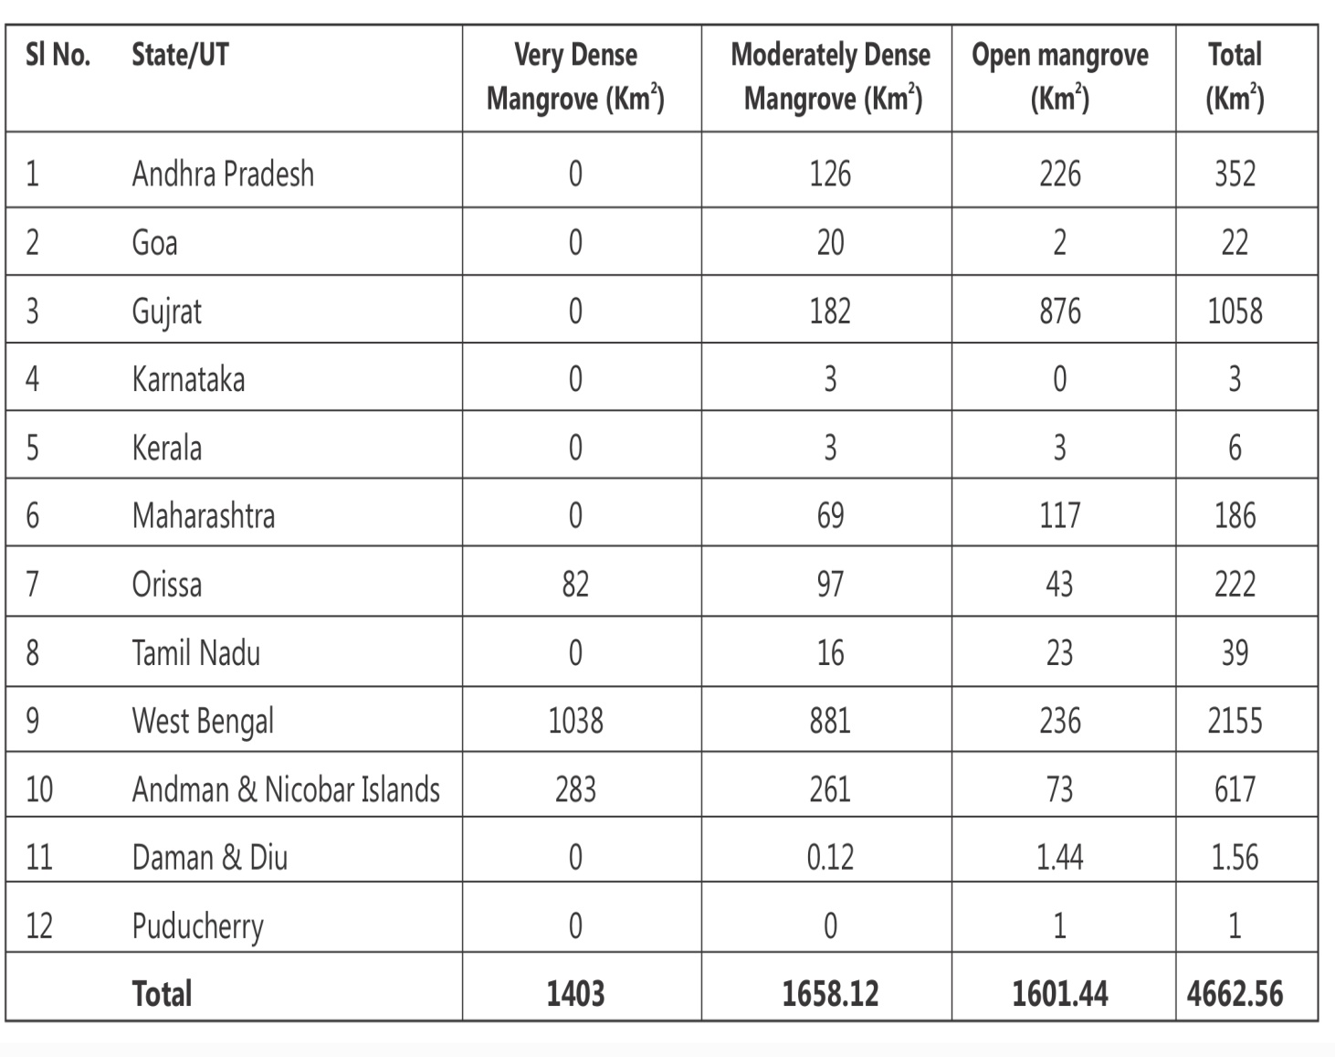
Supplementary table: Mangrove distribution over east and west coast of India. Here West Bengal (Sundarban) is the largest mangrove forest followed by Gujarat.

