Appendix A. Pairwise comparison data.

Appendix B. Decision matrix.
Decision matrix (standardized matrix)
 | B1 | B2 | B3 | B4 |  |  |  | Consistency ratio
B1 | 1 | 3 | 1/5 | 1/5 |  |  |  | 0.09467
B2 | 1/3 | 1 | 1/3 | 1/5
B3 | 5 | 3 | 1 | 1/3
B4 | 5 | 5 | 3 | 1
 | Cr1 | Cr2 | Cr3 |  |  |  |  | Consistency ratio
Cr1 | 1 | 5 | 7 |  |  |  |  | 0.06239
Cr2 | 1/5 | 1 | 3
Cr3 | 1/7 | 1/3 | 1
 | Cr8 | Cr9 | Cr10 | Cr11 | Cr12 | Cr13 |  | Consistency ratio
Cr8 | 1 | 5 | 5 | 3 | 7 | 7 |  | 0.09462
Cr9 | 1/5 | 1 | 5 | 1 | 3 | 3
Cr10 | 1/5 | 1/5 | 1 | 1/3 | 3 | 3
Cr11 | 1/3 | 1 | 3 | 1 | 3 | 5
Cr12 | 1/7 | 1/3 | 1/3 | 1/3 | 1 | 3
Cr13 | 1/7 | 1/3 | 1/3 | 1/5 | 1/3 | 1
Appendix C. Rating scale.
Rating scale
Intensity of importance | Definition | Explanation
1 | Equal importance | Two elements contribute equally to the objective
3 | Moderate importance | Experience and judgment slightly favor one element over another
5 | Strong Importance | Experience and judgment strongly favor one element over another
7 | Very strong importance | One element is favored very strongly over another; its dominance is demonstrated in practice.
9 | Extreme importance | The evidence favoring one element over another is of the highest possible order of affirmation.
2, 4, 6, and 8 can be used to express intermediate values

Appendix D. Criteria scope for RE projects.
The scope of criteria and subcriteria for determining the impact of the project.
Category A | Category (criteria) |  | Assigned no. | Weight (%) | Category (subcriteria) | Assigned no. | Individual weight
Level 1 | Level 2 |  |  |  | Level 3
 |  |  |  |  | Distance to roads and highways | C1 | 73.06%
 | Economic |  | B1 | 52.53% | Distance to transmission lines | C2 | 18.84%
 |  |  |  |  | Slope | C3 | 8.10%
Solar | Environmental |  | B2 | 7.12% | Distance to sensitive sites | C4 | 50.00%
 |  |  |  |  | Distance to protected areas | C5 | 50.00%
 | Social & Safety |  | B3 | 9.47% | Distance to land use (restricted areas) | C6 | 83.33%
 |  |  |  |  | Elevation | C7 | 16.67%
 | Technical |  | B4 | 30.88% | Solar radiation: Global horizontal irradiation (GHI) | C8 | 45.33%
 |  |  |  |  | Aspect | C9 | 17.48%
 |  |  |  |  | Photovoltaic power potential (PVOUT) | C10 | 8.08%
 |  |  |  |  | Temperature | C11 | 19.53%
 |  |  |  |  | Global tilted irradiation (GTI) | C12 | 5.85%
 |  |  |  |  | Optimum tilt of PV modules (OPTA) | C13 | 3.73%
 |  |  |  |  |  |  | 100%

Appendix E. 16 best site locations for PV solar farms and all-island transmission lines. 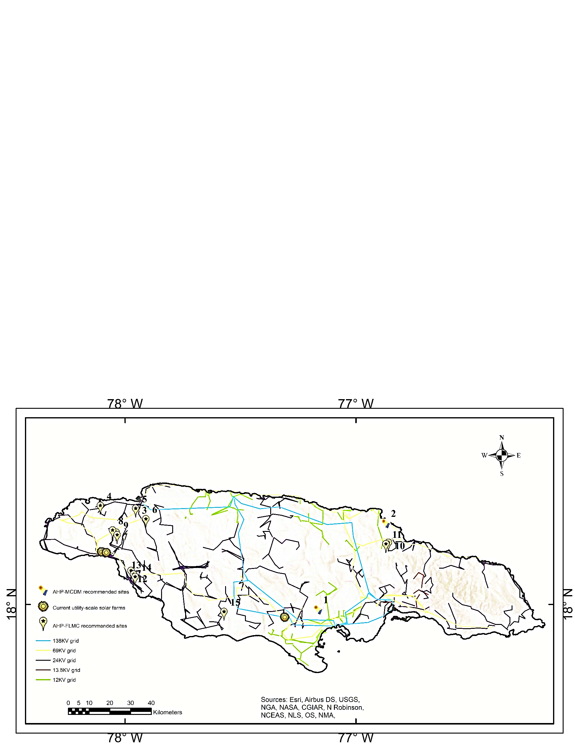
Appendix F. 16 best site locations for commercial solar PV farm expansion.
