Supplementary Material

Astroglia proliferate upon biogenesis of tunneling nanotubes via α-synuclein dependent transient nuclear translocation of focal adhesion kinase

Abinaya Raghavan¹, Rachana Kashyap¹⁺, Sreedevi P²⁺, Sneha Jos³, Suchana Chatterjee¹, Ann Alex¹, Michelle Ninochka D’Souza⁴, Mridhula Giridharan², Ravi Muddashetty⁴, Ravi Manjithaya², Sivaraman Padavattan³, Sangeeta Nath^{1*}.

¹Manipal Institute of Regenerative Medicine, Bengaluru, Manipal Academy of Higher Education, Manipal, India
² Autophagy Laboratory, Molecular Biology and Genetics Unit, Jawaharlal Nehru Centre for Advanced Scientific Research, Bengaluru, India.
³ Department of Biophysics, National Institute of Mental Health and Neurosciences, Bengaluru, India.
⁴Centre for Brain Research, Indian Institute of Science, CV Raman Avenue, Bengaluru, India.

+ Equally contributed
*Correspondence to be addressed to sangeeta.nath@manipal.edu

Supplementary Figures
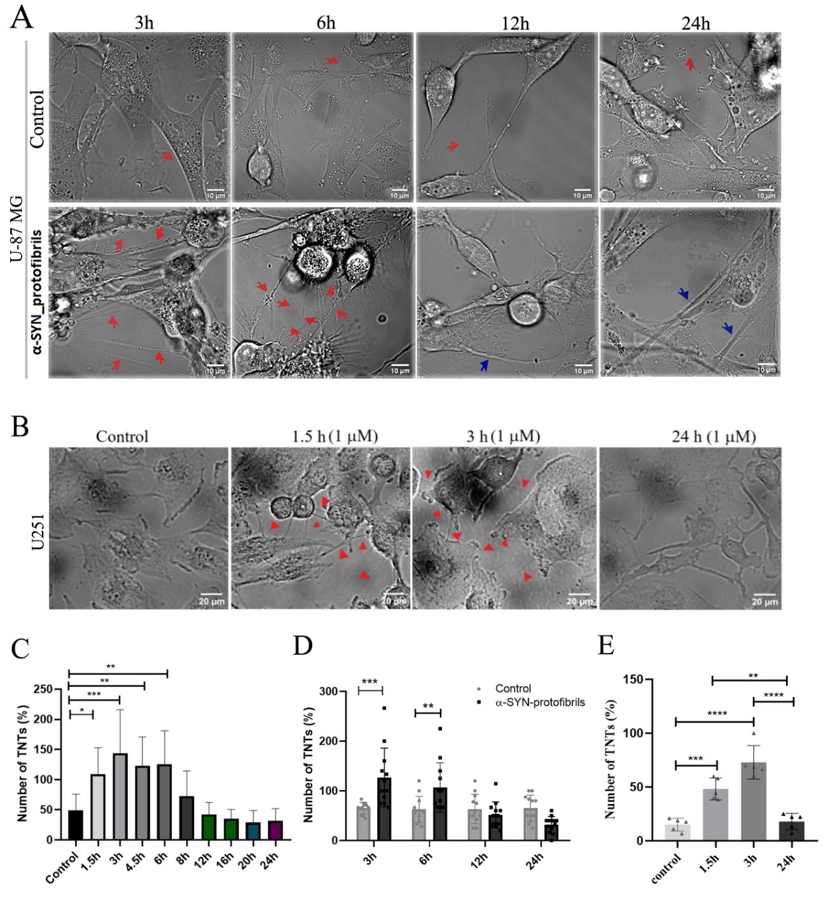
Supplementary Figure 1: Transient TNT-biogenesis upon treatment with α-SYN protofibrils in U-87 MG and U-251 cells. A) U-87 MG and B) U251 cells were treated with 1µM α-SYN protofibrils for varying time points from 1.5h to 24h. Increased TNT formation was observed in the early time points 1.5h-3h (marked by red arrow heads) in the DIC images. C) Percentage of TNT numbers were counted across time points varying from 1.5h-24h on treatment with 1µM α-SYN protofibrils in U-87 MG cells. D, E) Percentage of transient TNT-biogenesis was quantified from U-87 MG (D) and U251 (E) cells compared to their respective controls. Scale bars are denoted on the images. Data are expressed as mean ± SD, *** p ≤ 0.001. Statistics were analysed using one-way ANOVA (EV1C and EV1E) and one-way ANOVA (EV1D). n=3.
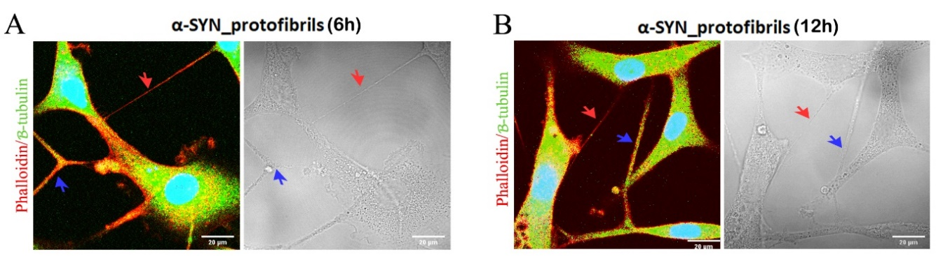
Supplementary Figure 2: Identification and characterization of TNTs and TMs: A-B) U-87 MG cells treated with 1µM α-SYN protofibrils for 6h and 12h, stained for actin and β-tubulin. A) Phalloidin-positive actin-stained thin TNTs and B) β-tubulin positive thicker TMs. Fluorescence images stained with phalloidin and β-tubulin (on the left panels) at 6h and 12h. Red arrows indicate actin-positive TNTs and blue arrows indicate β-tubulin positive TMs. The right panels show DIC images of the same. n =3.
Supplementary Figure 3: No evidence of cell-to-cell transfer of mitochondria through condition media: Conditional media from the mitoDsRed transfected cells treated with 1μM of α-SYN for 3 h, was given to the green cells transfected with EGFP-lifeact. Images were taken after 3 h. n=3.

Supplementary Figure 4: α-SYN protofibril induced cellular senescence. A) U251 cells were treated with 1µM α-SYN protofibrils for 3-24h and were stained with DAPI. White arrows indicate fragmented nuclei. B) The percentage of the fragmented nucleus per frame was quantified and plotted. Quantifications are done from 5 image frames of a set and each image frame has 10-20 cells. C) U251 cells were treated with 1µM α-SYN protofibrils for 3-24h and checked for β-galactosidase activity. Cellular senescence-like characteristics of DNA fragmentation and increased β-galactosidase activity (blue color) were observed at early time points. Scale bars are denoted on the images. Data are expressed as mean ± SD, *** p ≤ 0.001. Statistics were analysed using two-way ANOVA. n=3.
Supplementary Figure 5: α-SYN treatments on U-87 MG and N2a cells in a time and concentration-dependent manner. A) U-87 MG cells treated with varying concentrations (0.5µM-3µM) of α-SYN protofibrils showed time (24h and 48h) and concentration-dependent increase in cell numbers. B) Quantification of the cell numbers. Quantifications are done from 5 image frames of a set and each image frame has 100-250 cells. C) Neurons derived from differentiation of mouse neuroblastoma (N2a) cells treated with toxic α-SYN protofibrils (0.5µM-3µM) for (24h and 48h). The treated cells were imaged and the images show time and concentration-dependent occurrence of toxic morphology and floating dead cells. D) MTT assay of N2a cells treated with varying concentrations of α-SYN protofibrils at 24h and 48h. Scale bars are denoted on the images. Data are expressed as mean ± SD, *** p ≤ 0.001. Statistics were analysed using two-way ANOVA. n=3.

Supplementary Figure 6: Effect of inhibitors on TNT length. Length of TNTs formed in U-87 MG cells after treatment with 1µM α-SYN protofibrils, 50 µM CK-666 (Arp2/3 inhibitor), 5 µM Y-27632 (ROCK inhibitor), and 75 µM Blebbistatin (Blebb) was measured using Image J software. Scale bars are denoted on the images. Quantifications are done from 15 image frames of a set and each image frame has 15-20 cells. Data are expressed as mean ± SD, *** p ≤ 0.001. Statistics were analysed using one-way ANOVA. n=3.

Supplementary Figure 7: Effect of α-SYN on cell adherence and FAK translocation. A) U-87 MG cells were treated with 1µM α-SYN protofibrils for 3-24h, and DIC images were taken. Blue arrows indicate non-adherent cells and red arrows indicate TNTs formed from the non-adherent cells. B) Nuclear translocation of FAK was established from a 3D view of the xz and yz planes. C)Nuclear FAK translocation in U251 cells and D) quantification of the FAK at the nucleus. Quantifications are done from 15 image frames of a set and each image frame has 15-20 cells. Scale bars are denoted on the images. Data are expressed as mean ± SD, *** p ≤ 0.001. Statistics were analysed using two-way ANOVA. n=3.

Supplementary Figure 8: Effect of α-SYN treatment on senescence marker-P2. Full-length western blot images of 4 biological repeats of senescence marker-P21 (MW 21 kDa) (representing WB of Figure 5H) with loading controls (actin / GAPDH) are represented here, along with a protein ladder of molecular weight markers. The blots were developed with ECL solution, therefore all the proteins in the marker lanes (M) are not visible in some of the blots. Represented markers are demonstrated here to show the molecular weight of the corresponding bands. Blot 2 has been given GAPDH, then stripped and cut into 2 blots. To which p21 and ROCK1 are given. The same GAPDH blot is used in the supplementary figure 10.
Supplementary Figure 9: Effect of α-SYN treatment on ROCK pathway. Full-length western blot images of 3 biological repeats of ROCK1 and ROCK2 (MW of 160 kDa) (representing WB of Figure 7I) with loading controls (GAPDH) are represented here, along with a protein ladder of molecular weight markers. A) After developing the blot (ii) with GAPDH, the blot was stripped and cut at 55kDa. The top portion (i) was given ROCK2 antibody and developed while the bottom part [Supplementary Figure 10 B (i)] was given pERK1-pERK2 cocktail. Blots (iii) and (iv) were cut from a single blot and the top portion (iii) was given ROCK2 antibody and the bottom portion was given GAPDH antibody. Similarly, blots (v) and (vi) are also cut from a single blot. B) Blots (i) and (ii) are cut from a single blot and similarly blots (iii) and (iv) are cut from a single blot. Blots (i) and (iii) were given ROCK1 antibody and blots (ii) and (iv) were given GAPDH antibody. After developing the blot (vi) with GAPDH it was stripped and cut into two. The top portion was given ROCK1 antibody and the bottom portion (Supplementary Figure 8 western blot 2) was given p21 antibody. In some of the biological repeats, ROCK1 and ROCK2 showed another non-specific band near the original band of 160 kDa. The blots were developed with ECL solution, therefore in some of the western blots, no markers are visible. Represented markers are demonstrated here to show the molecular weight of the corresponding bands. All the blots are biological repeats.
Supplementary Figure 10: Effect of α-SYN treatment on Proliferation pathway. Full-length western blot images of 3 biological repeats of NF-κB (MW 70 kDa), pERK1/ERK2 (MW 42 kDa), and CDK1(MW 34 kDa) (representing WB of Figure 7K) with loading controls (GAPDH) are represented here, along with a protein ladder of molecular weight markers. A) (i) NF-kB and GAPDH antibodies were given together. Blots (ii) and (iii) were cut from a single blot and the top portion (ii) was given NF-kB antibody and the bottom portion was given GAPDH antibody. Similarly, blots (iv) and (v) are cut from a single blot. B) As mentioned earlier blot (ii) was stripped after giving GAPDH and the bottom portion (i) was given pERK1-pERK2 cocktail. Blot A) (v) after developing with GAPDH was stripped and given pERK1-pERK2 cocktail (iii). Hence A (v) and B (iv) are the same GAPDH blots. After developing with GAPDH blot (vi) was stripped and given pERK1-pERK2 cocktail (v). C) After developing blot (ii) with GAPDH the blot was stripped and then given CDK1 antibody (i). After developing A) (iii) with GAPDH the blot was stripped and given CDK1 antibody (iii). Hence the blots A) (iii) and C) (iv) are the same. Blot (vi) after giving GAPDH was stripped and given CDK1 antibody (v). The blots were developed with an ECL solution, therefore in some of the western blots, no molecular markers are visible. Represented markers are demonstrated here to show the molecular weight of the corresponding bands. All the blots are biological repeats.

Figure legends of supplementary movies:
Movie 1: Time-lapse video was captured using a DIC channel in the confocal microscope with α-SYN protofibrils (1 μM) treated U-87MG cells for 3h. The formation of numerous thin (nanosized in diameter) membrane channels or TNTs between neighbouring cells were observed upon treatment with α-SYN protofibrils for 3h. Organelles were observed to move (indicated by white and black arrows) unidirectional inside the TNTs.

Movie 2: Time-lapse video of α-SYN protofibrils (1 μM) treated U-87MG cells for 6h was captured in a confocal microscope using a DIC channel. The formation of numerous thin (nanosized in diameter) membrane channels or TNTs between neighbouring cells were observed upon α-SYN protofibrils treatment. Organelles were observed to move unidirectionally (indicated by a white arrow) inside the TNTs.

Movie 3: Time-lapse video of α-SYN protofibrils (1 μM) treated U-87MG cells for 6h was captured in a confocal microscope using fluorescence and DIC channels, to see movements of fluorescently labelled α-SYN-TMR protofibrils and lysotracker positive vesicles inside the TNTs. The composite video shows unidirectional movements of vesicles colocalized (yellow) with α-SYN-TMR (red) and lysotracker (green) in long, thin TNTs (indicated by white arrow).

Movie 4: Time-lapse video of α-SYN protofibrils (1 μM) treated U-87MG cells for 3h was captured in a confocal microscope using fluorescence and DIC channels, to see movements of mitotracker (cyan) positive vesicles inside the TNTs. The composite video shows unidirectional movements of mitochondria in long, thin TNTs (indicated by a white arrow).

Movies 5: Time-lapse video captured direct cell-to-cell transfer of α-SYN-TMR (red) accumulated lysotracker (green) positive vesicles (yellow vesicles; indicated by black arrow) via TNTs between neighbouring U-87MG cells. The video was captured after 3h of α-SYN protofibril (1 μM) treatments.

Movies 6: Time-lapse video can capture direct cell-to-cell transfer of α-SYN-TMR (red) treated mitotracker positive vesicles (cyan vesicles; indicated by black arrow) via TNTs between neighbouring U-87MG cells. The video was captured after 3h of α-SYN protofibril (1 μM) treatments.

