Visible-Light Photocatalytic Direct Arylation of Arenes Using Silver Iodide Nanoparticles Supported on Magnesium-Aluminum Layered Double Hydroxide

Table of contents
Supplementary Fig. 1. 4
Supplementary Fig. 2. 5
Supplementary Fig. 3. 6
Supplementary Fig. 4. 7
Supplementary Fig. 5. 8
Supplementary Fig. 6. 9
Supplementary Fig. 7. 10
Supplementary Fig. 8. 11
Supplementary Fig. 9. 12
Supplementary Fig. 10. 13
Supplementary Fig. 11. 14
Supplementary Fig. 12. 15
Supplementary Fig. 13. 16
Supplementary Fig. 14. 17
Supplementary Fig. 15. 18
Supplementary Fig. 16. 19
Supplementary Fig. 17. 20
Supplementary Fig. 18. 21
Supplementary Fig. 19. 22
Supplementary Fig. 20. 23
Supplementary Fig. 21. 24
Supplementary Fig. 22. 25
Supplementary Fig. 23. 26
Supplementary Fig. 24. 27
Supplementary Fig. 25. 28
Supplementary Fig. 26. 29
Supplementary Fig. 27. 30
Supplementary Fig. 28. 31
Supplementary Fig. 29. 32
Supplementary Fig. 30. 33
Supplementary Fig. 31. 34
Supplementary Fig. 32. 35
Supplementary Fig. 33. 36
Supplementary Fig. 34. 37
Supplementary Table 1. 38
Supplementary Table 2. 39
Supplementary Table 3. 40
Supplementary Table 4. 41
References: 41

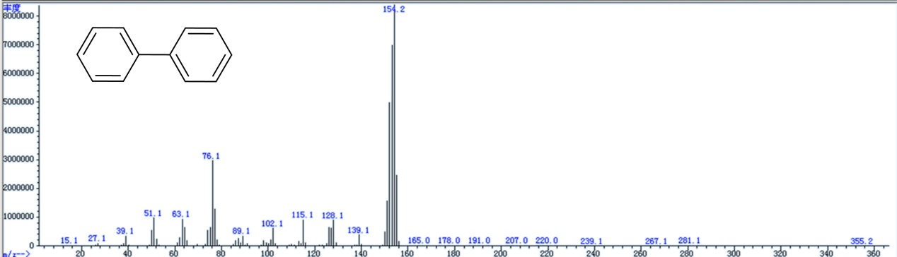

Supplementary Fig. 1. GC-MS analysis of biphenyl product.
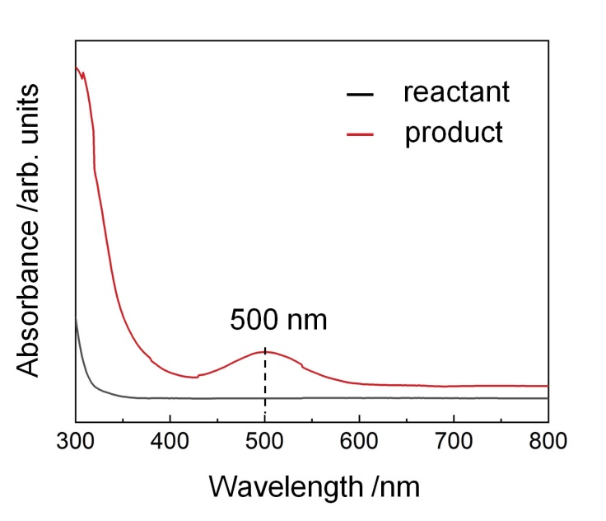

Supplementary Fig. 2. UV-Vis spectrum of the reactant and liquid obtained in direct arylation of benzene with iodobenzene using AgI/Mg₂Al₁LDH photocatalyst.

It is seen from Supplementary Fig. 2 that the UV-Vis spectrum of the product obtained in the direct arylation of benzene with iodobenzene exhibited obviously a broadband with a peak at a wavelength of 500 nm, which can be ascribed to the molecular iodine (I₂) dissolved in organic solvents¹.
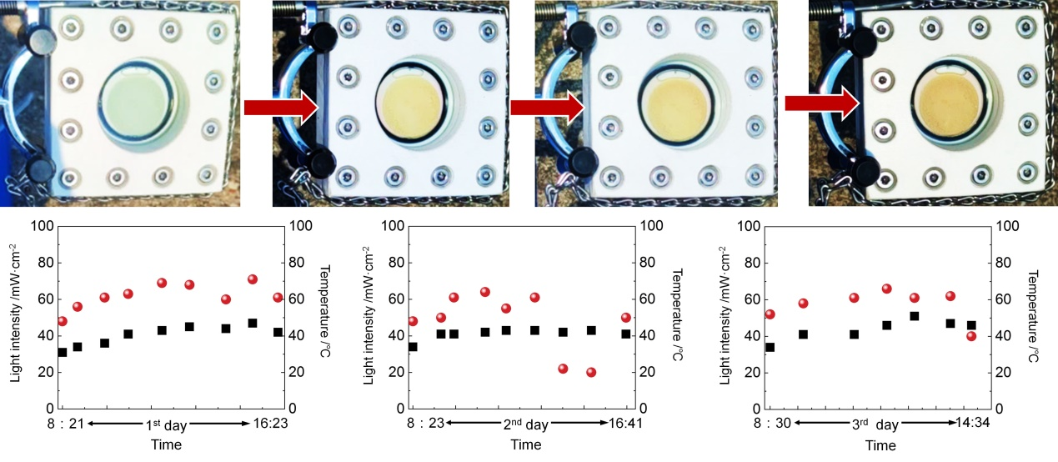
Supplementary Fig. 3. The experiment under sunlight. Photographs of the iodobenzene in benzene mixed with AgI/Mg₂Al₁LDH catalyst before, during, and after the reaction. The bottom shows the temperature and sunlight intensity variations during the experiment. Biphenyl yield of 60% is achieved, indicating that the direct arylation of unactivated arenes can be driven with the catalyst using sunlight as the sole energy input.
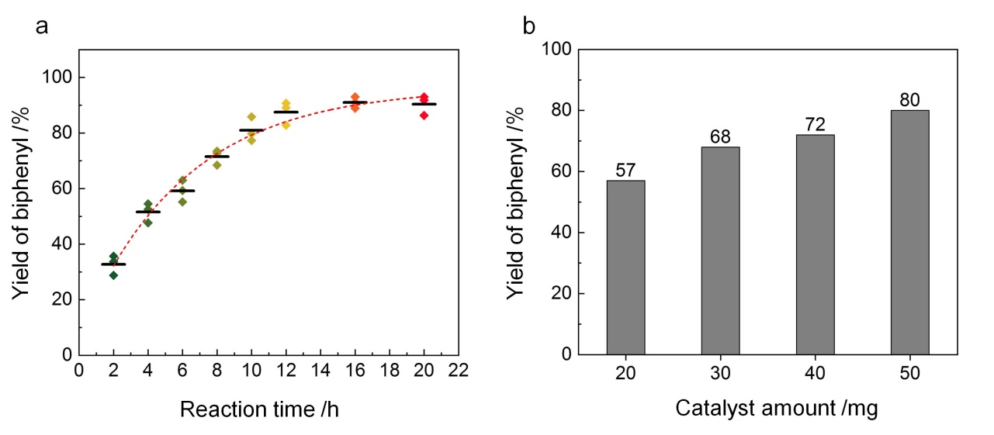
Supplementary Fig. 4. a The influence of reaction time on the photocatalytic performance of AgI/Mg₂Al₁LDH catalyst on producing biphenyl. Reaction conditions: 50 mg of catalyst, iodobenzene (0.1 mmol), 1 mL of benzene as both the reactant and solvent, 1 atm Ar atmosphere, under irradiation of 0.1 W cm⁻² from a LED lamp of 400 nm wavelength at 60℃. b The effect of AgI/Mg₂Al₁LDH photocatalyst mass on producing biphenyl. Reaction conditions: iodobenzene (0.1 mmol), 1 mL of benzene as both the reactant and solvent, 1 atm Ar atmosphere, under irradiation of 0.1 W cm⁻² from a LED lamp of 400 nm wavelength for 10 h at 60℃.
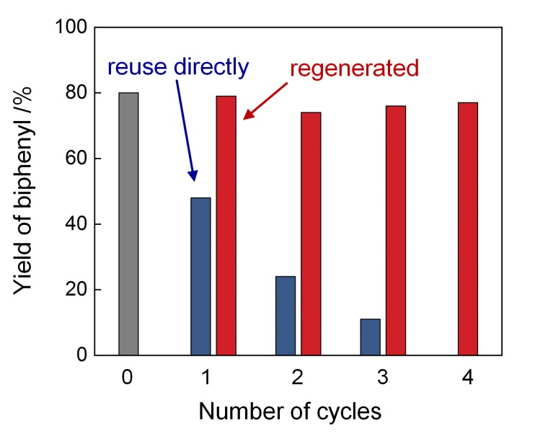
Supplementary Fig. 5. The recycling performance of AgI/Mg₂Al₁LDH catalyst. Reaction conditions: iodobenzene (0.1 mmol), benzene (1 mL), AgI/Mg₂Al₁LDH catalyst (50 mg), Ar atmosphere, irradiated under a 400 nm wavelength LED light at 0.1 W cm⁻² of intensity, the reaction was conducted at 60℃ for 10 h. The regeneration method can be found in the Method part.
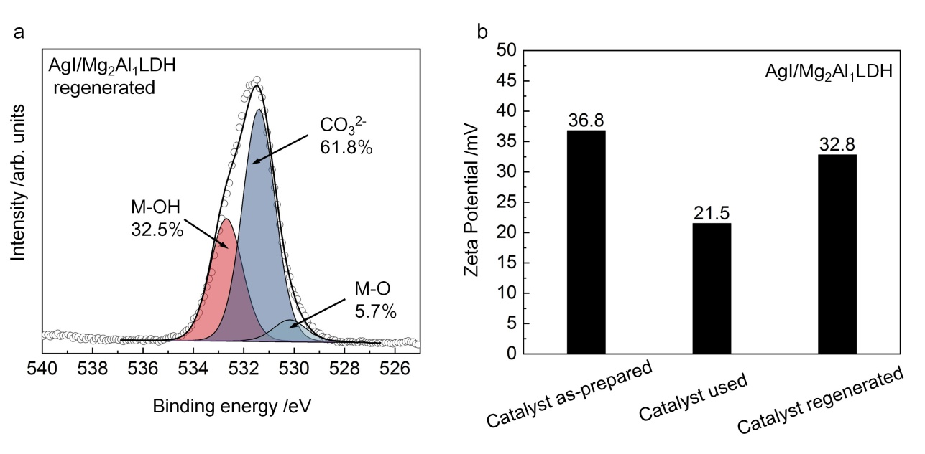
Supplementary Fig. 6. Characterization of the regenerated AgI/Mg₂Al₁LDH photocatalyst. a. The O 1s XPS spectrum of the AgI/Mg₂Al₁LDH photocatalyst after regeneration. b. Zeta potential values of the as-prepared, used, and regenerated AgI/Mg₂Al₁LDH photocatalyst.

The XPS result shows that the amount of surface hydroxyl groups in the regenerated AgI/Mg₂Al₁LDH photocatalyst is obviously higher than that of the used catalyst (Fig. 4b), and is comparable to that of the as-prepared catalyst (Fig. 4a). The zeta potential value of the as-prepared catalyst was as high as 36.8 mV that can be ascribed to the dense surface hydroxyl groups of LDH². The zeta potential of the used catalyst decreased to 21.5 mW which is due to the production of oxygen vacancies on the LDH surface³. This is consistent with the ESR result that an obvious signal of oxygen vacancy can be found in the used catalyst (Fig. 4c).
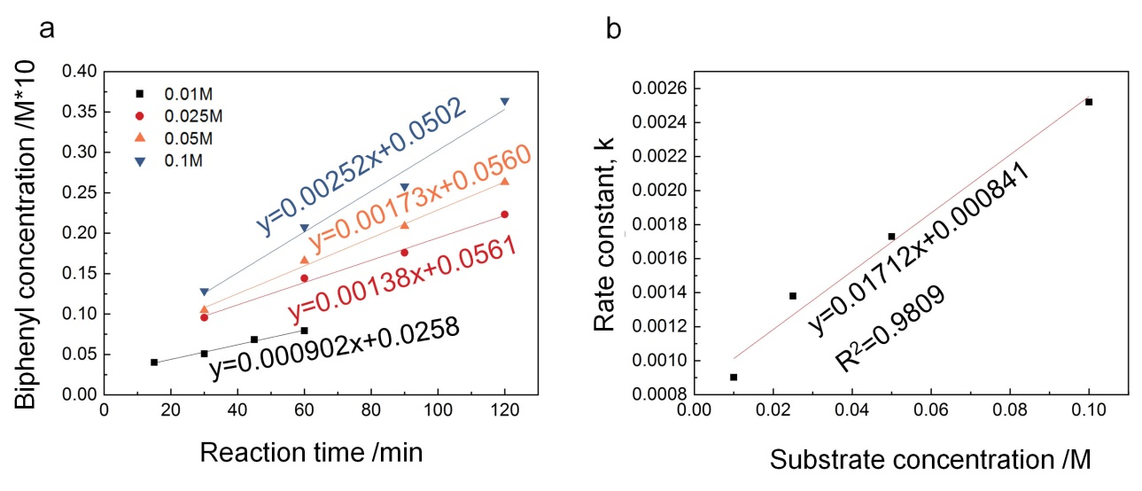
Supplementary Fig. 7. Rate dependence on substrate concentration. Initial rate data for the biphenyl concentration as a function of time at different iodobenzene concentrations (a) and the dependence of the rate constants on iodobenzene concentration (b). Reaction conditions: iodobenzene with various concentrations, benzene (1 mL), AgI/Mg₂Al₁LDH catalyst (50 mg), Ar atmosphere, irradiated under a 400 nm wavelength LED light at 0.1 W cm⁻² of intensity, the reaction was conducted at 60℃ for various times.
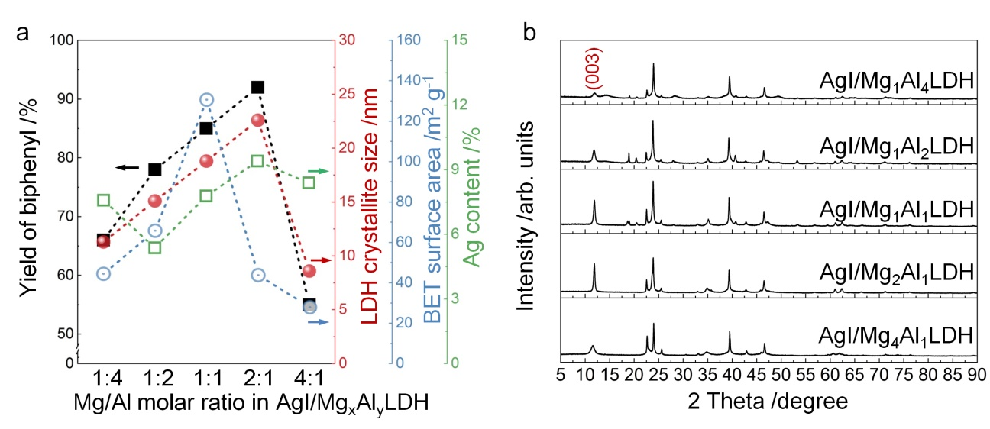
Supplementary Fig. 8. (a) Impact of different structural parameters on the photocatalytic performance of AgI/Mg_{x}Al_{y}LDH catalyst for producing biphenyl under visible light irradiation. The raw data is provided in Supplementary Figs. 8b and 9, Tables 2 and 3. (b) The XRD patterns of the AgI/Mg_{x}Al_{y}LDH photocatalysts.
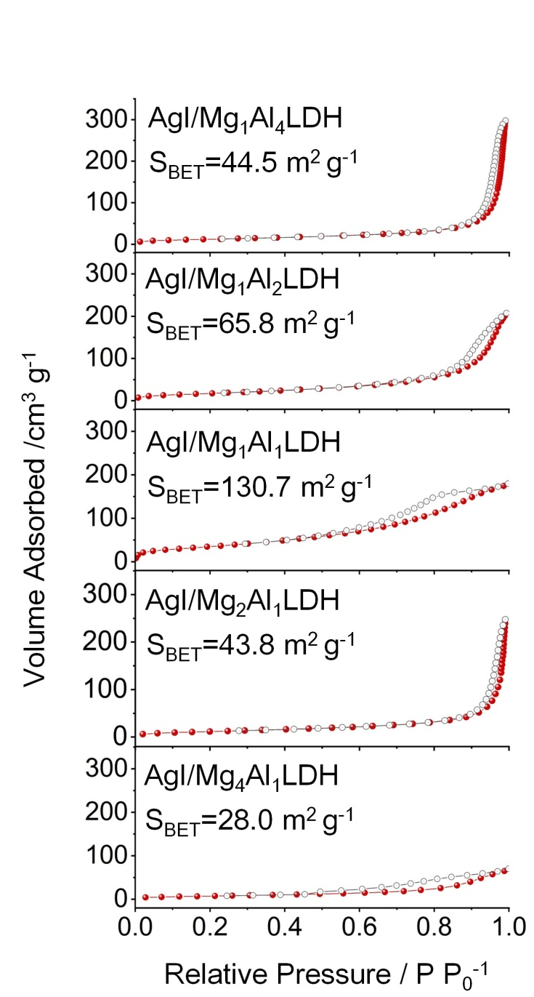
Supplementary Fig. 9. Nitrogen adsorption-desorption isotherms of as-synthesized AgI/Mg_{x}Al_{y}LDH catalysts.
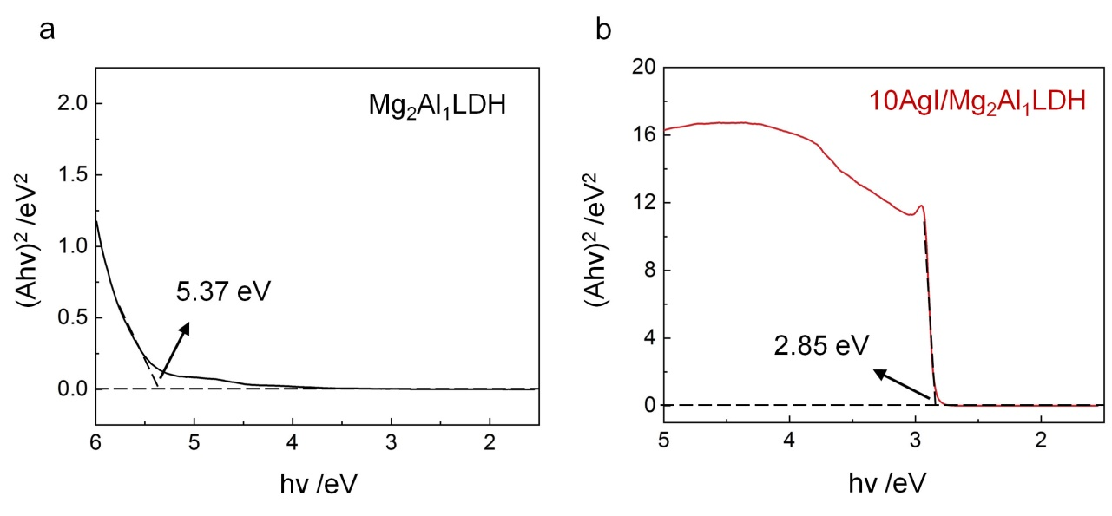
Supplementary Fig. 10. Tauc plots of Mg₂Al₁LDH support (a) and AgI/Mg₂Al₁LDH catalyst (b).

The bandgap width of the photocatalytic material was calculated using the Tauc plot function, as shown in the equation: (ahv)^{n} = K(hv-Eg), where a represents the absorption coefficient, h represents the Planck constant, v represents the frequency of light, K represents a proportionality constant, E_{g} represents the bandgap width of the photocatalytic material, n depended on the way of the optical transition in semiconductor (n = 2 for direct transition or n = 1/2 for indirect transition). Because of the direct transition of the AgI and Mg_{x}Al_{y}LDH^{4,5}, the E_{g} values were determined as 5.37 eV and 2.85 eV from the plot of (ahv)² versus hv as shown in Supplementary Fig. 10.

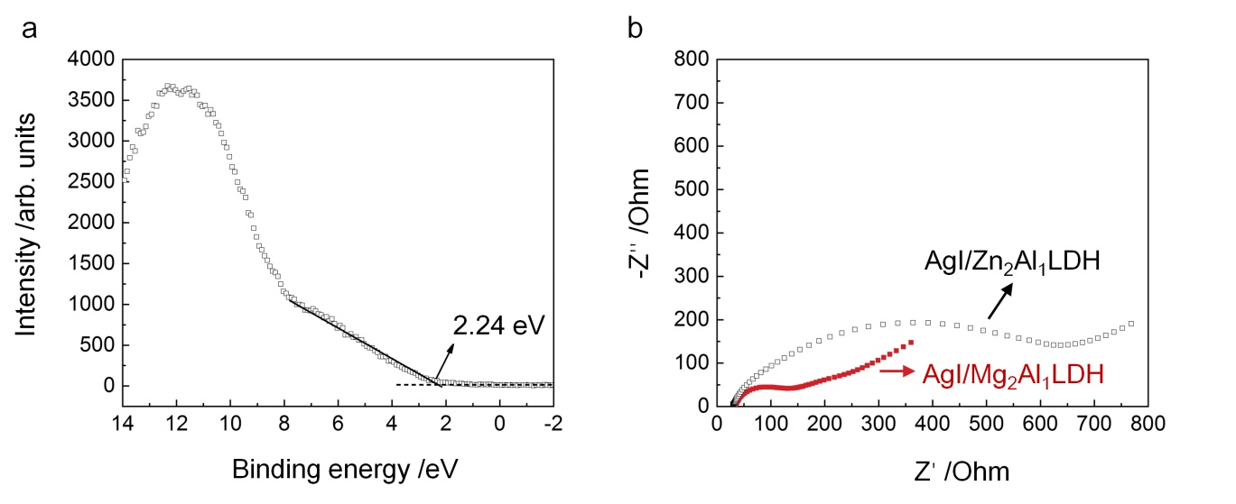

Supplementary Fig. 11. (a) Valence band XPS analysis of Zn₂Al₁LDH support. (b) Electrochemical impedance spectroscopy (EIS) analysis of AgI/Zn₂Al₁LDH and AgI/Mg₂Al₁LDH catalysts.
AgI/Zn₂Al₁LDH and AgI/Mg₂Al₁LDH catalysts were prepared using the same method, and their XRD patterns are provided in Supplementary Fig. 33. It has been reported that the VBM of ZnAl-LDH has a higher potential energy compared with that of MgAl-LDH ⁶. This is supported by the VB-XPS result that the E_{VB} of Zn₂Al₁LDH is observed to shift towards a higher potential (Supplementary Fig. 11a). The transfer rate of photo-induced holes in AgI to Zn₂Al₁LDH should be slow due to their small VBM difference⁷. This is evidenced by the higher interfacial charge transfer activity of AgI/Mg₂Al₁LDH catalyst, supported by the EIS result shown in Supplementary Fig. 11b.
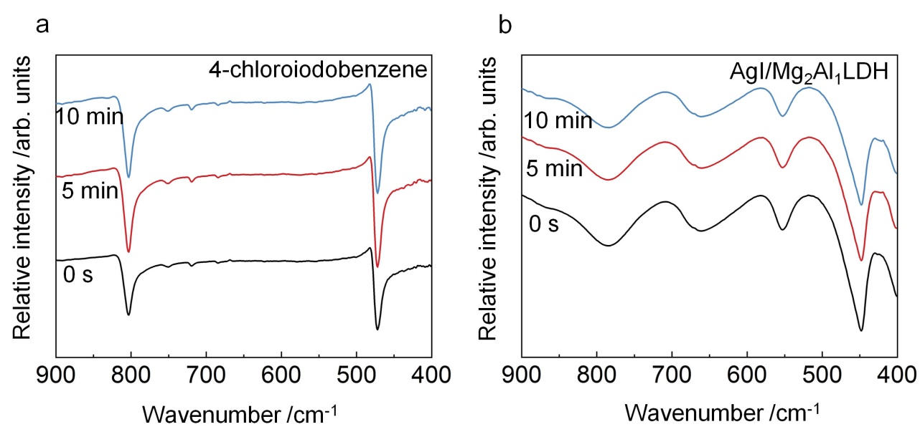
Supplementary Fig. 12. Time-dependent ATR-FTIR spectra of 4-chloroiodobenzene (a) and AgI/Mg₂Al₁LDH catalyst (b). The setup can be found in Supplementary Fig. 15.
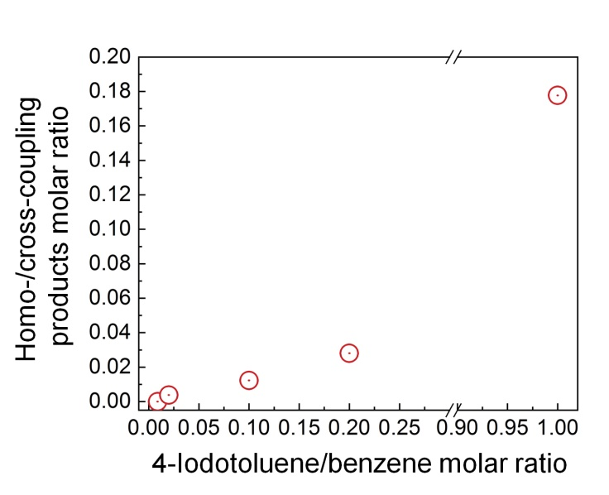
Supplementary Fig. 13. The dependence of homo-coupling product on the molar ratio of the reactants. Reaction conditions: 1 mL of benzene mixed with various amount of 4-iodotoluene as the reactant, AgI/Mg₂Al₁LDH catalyst (50 mg), Ar atmosphere, irradiated under a 400 nm wavelength LED light with 0.1 W cm⁻² of intensity, the reaction was conducted at 60℃ for 20 h.

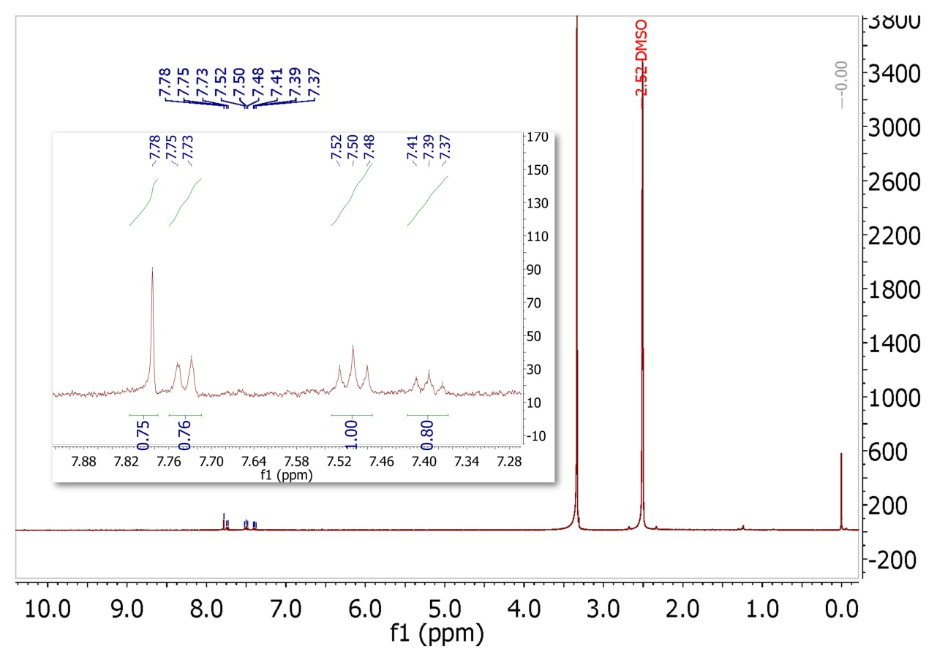
Supplementary Fig. 14. 1H NMR spectrum of the mixture obtained in the kinetic isotope effect experiment (in DMSO-d6). Reaction conditions: iodobenzene (0.1 mmol), benzene (0.5 mL), benzene-d₆ (0.5 mL), AgI/Mg₂Al₁LDH catalyst (50 mg), Ar atmosphere, irradiated under a 400 nm wavelength LED light at 0.1 W cm⁻² of intensity, the reaction was conducted at 60℃ for 20 h. The combined yield was calculated to be 78%.

The KIE value was calculated by solving the two equations:
4x = 0.76 (1)
2x + 3y = 0.80 (2)
where x and y are the amounts of biphenyl (C₁₂H₁₀) and partially deuterated biphenyl (C₁₂H₅D₅) produced after the reaction, respectively. So KIE = x/y = 0.19/0.14 = 1.36

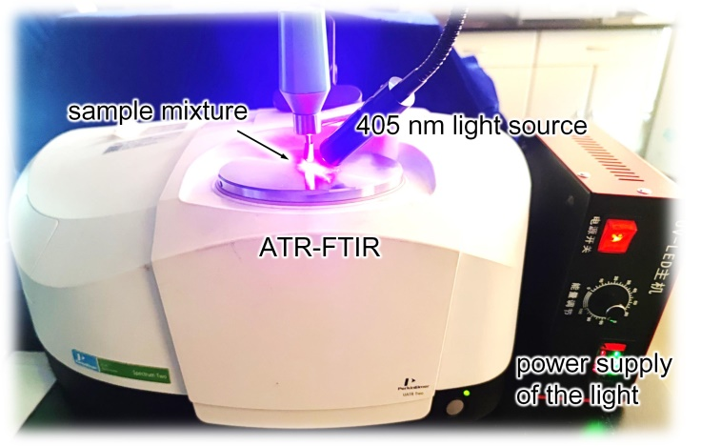
Supplementary Fig. 15. The setup of the time-dependent ATR-FTIR.
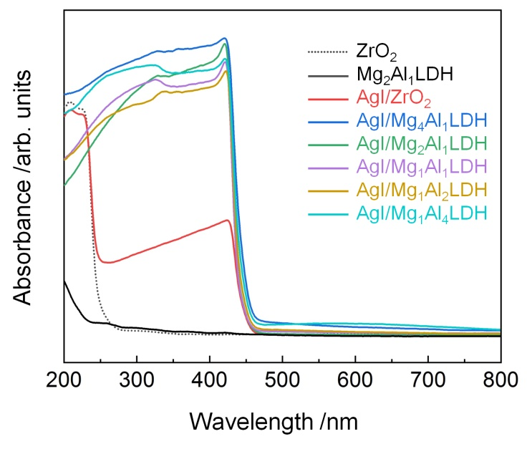
Supplementary Fig. 16. The diffuse reflectance ultraviolet-visible (DR UV-vis) spectra of the catalysts and support.

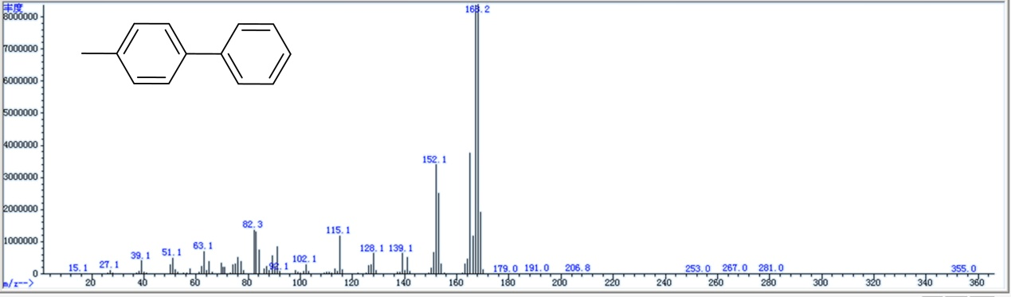
Supplementary Fig. 17. GC-MS analysis of 4-methyl-1,1'-biphenyl product.
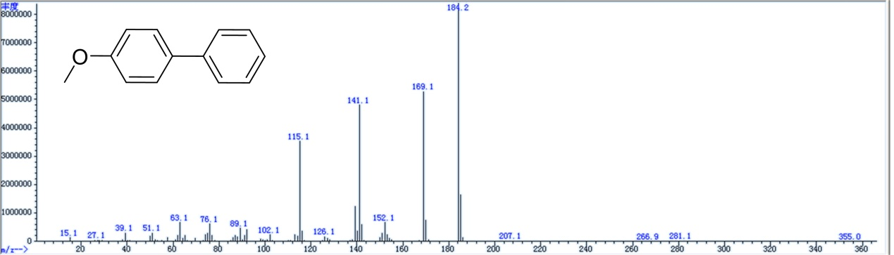
Supplementary Fig. 18. GC-MS analysis of 4-methoxy-1,1'-biphenyl product.
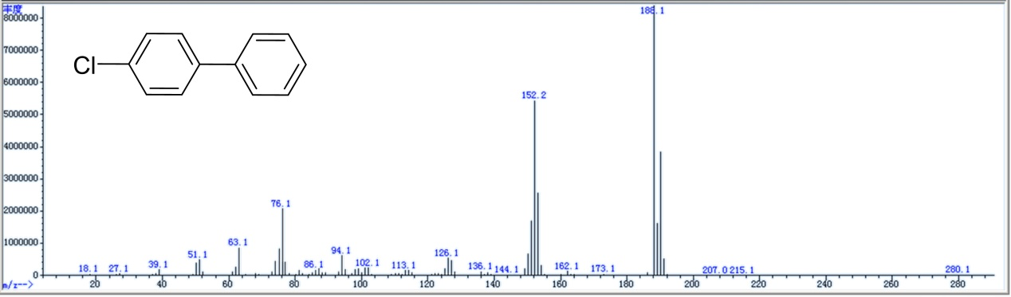
Supplementary Fig. 19. GC-MS analysis of 4-chloro-1,1'-biphenyl product.
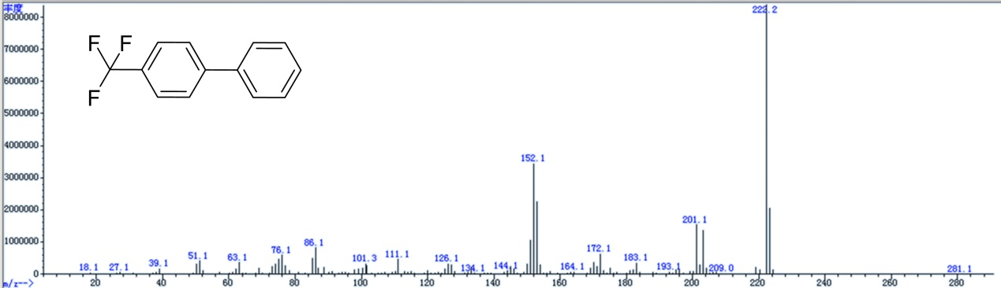
Supplementary Fig. 20. GC-MS analysis of 4-(trifluoromethyl)-1,1'-biphenyl product.
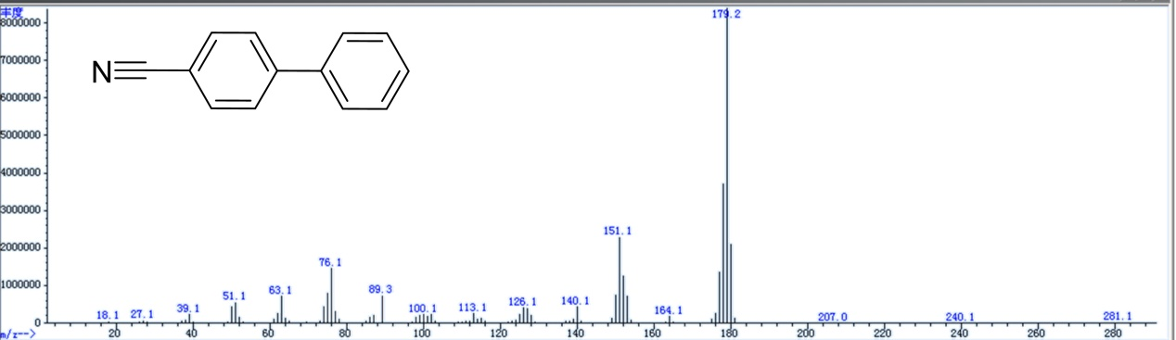
Supplementary Fig. 21. GC-MS analysis of [1,1'-biphenyl]-4-carbonitrile product.
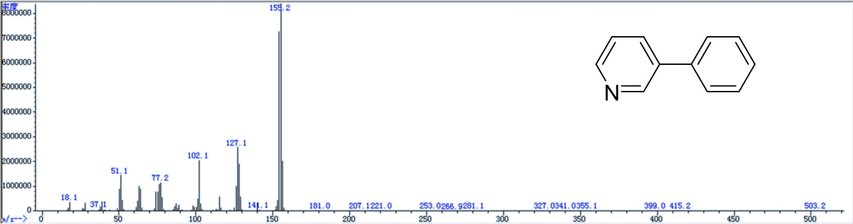
Supplementary Fig. 22. GC-MS analysis of 3-phenylpyridine product.
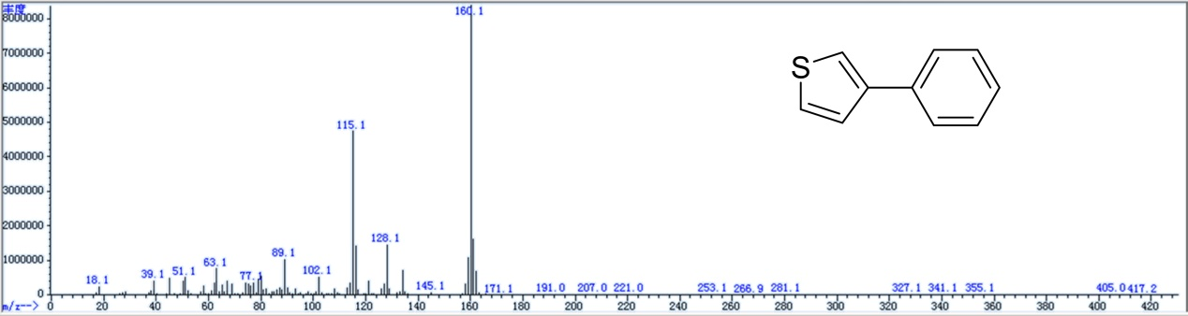
Supplementary Fig. 23. GC-MS analysis of 3-phenylthiophene product.
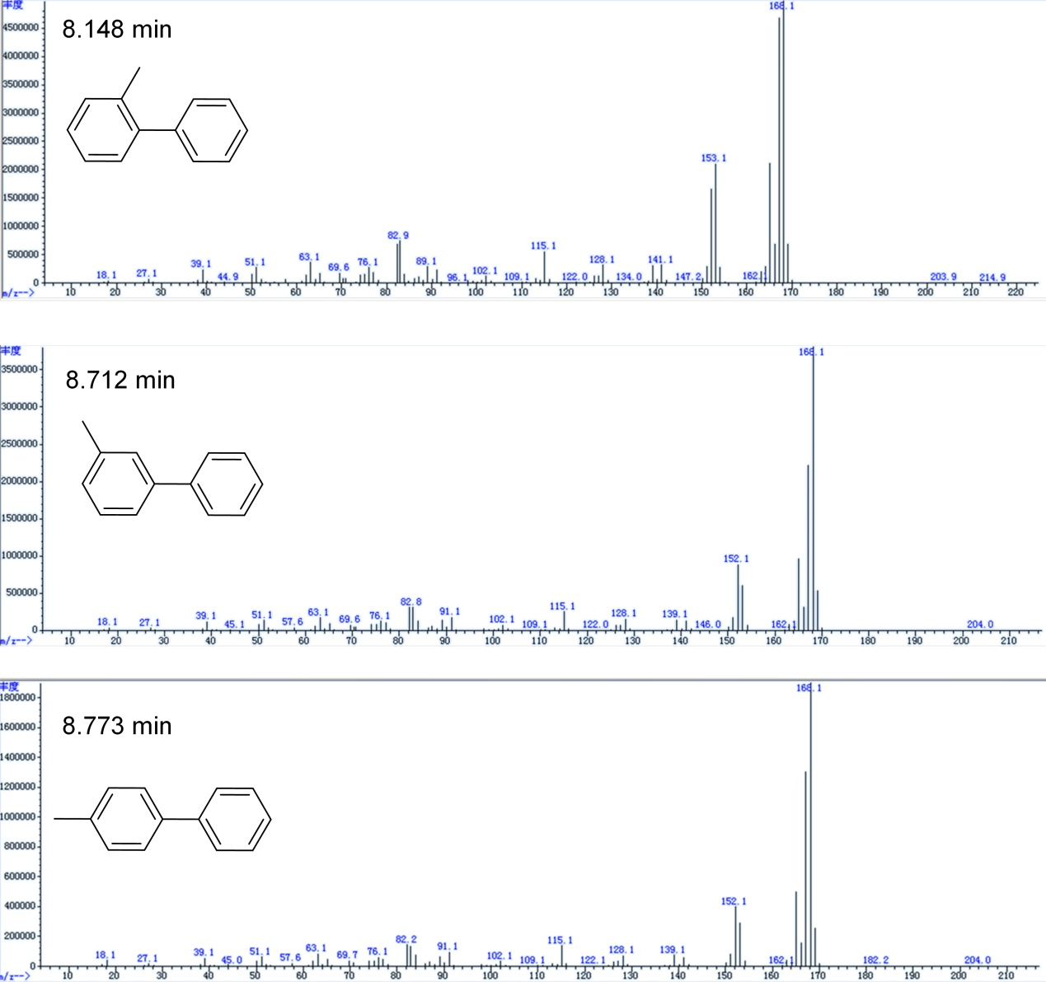Supplementary Fig. 24. GC-MS analysis of 2-, 3-, and 4-methylbiphenyls product.

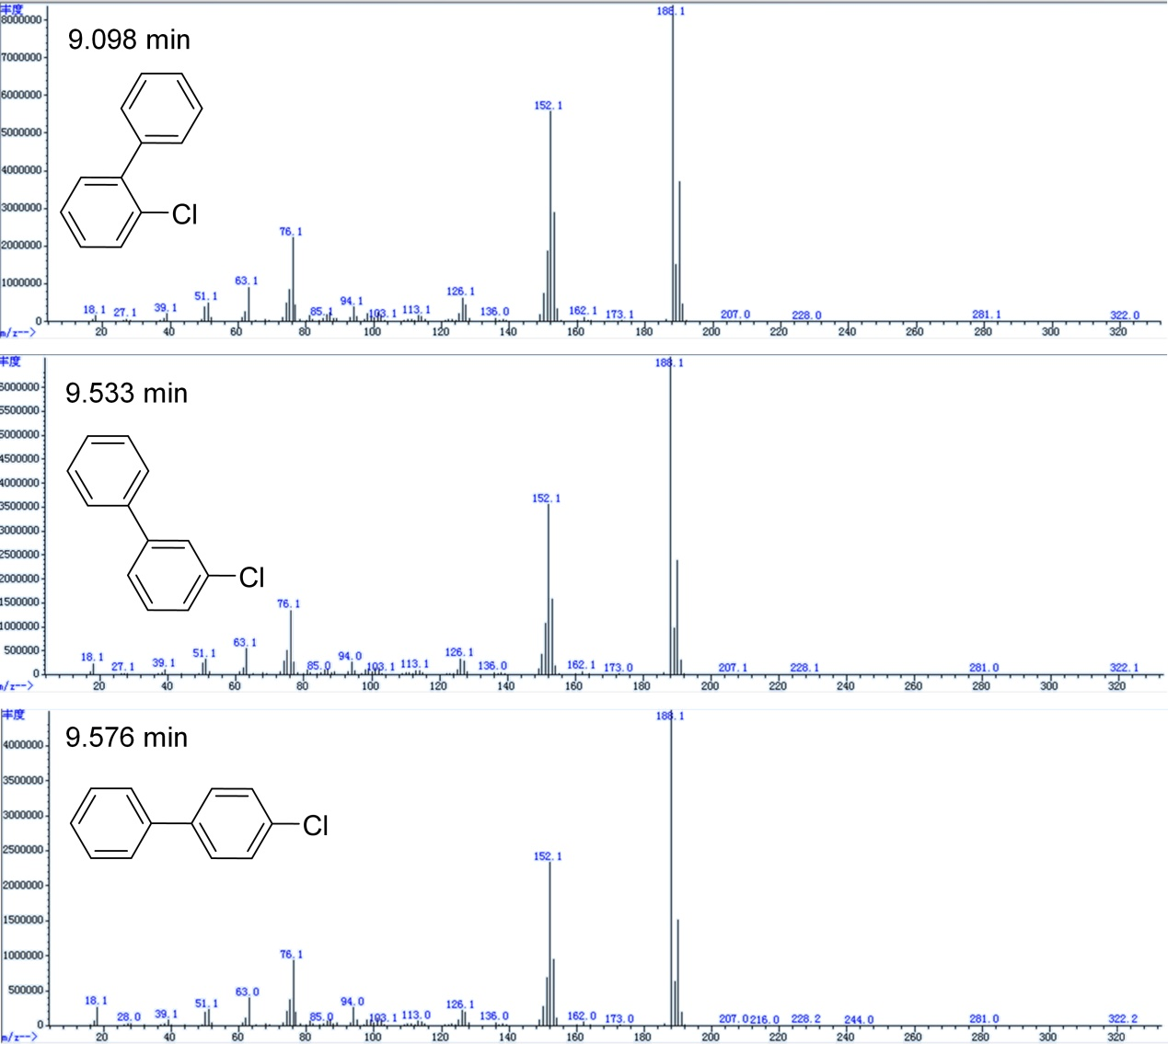
Supplementary Fig. 25. GC-MS analysis of 2-, 3-, and 4-chlorobiphenyls product.

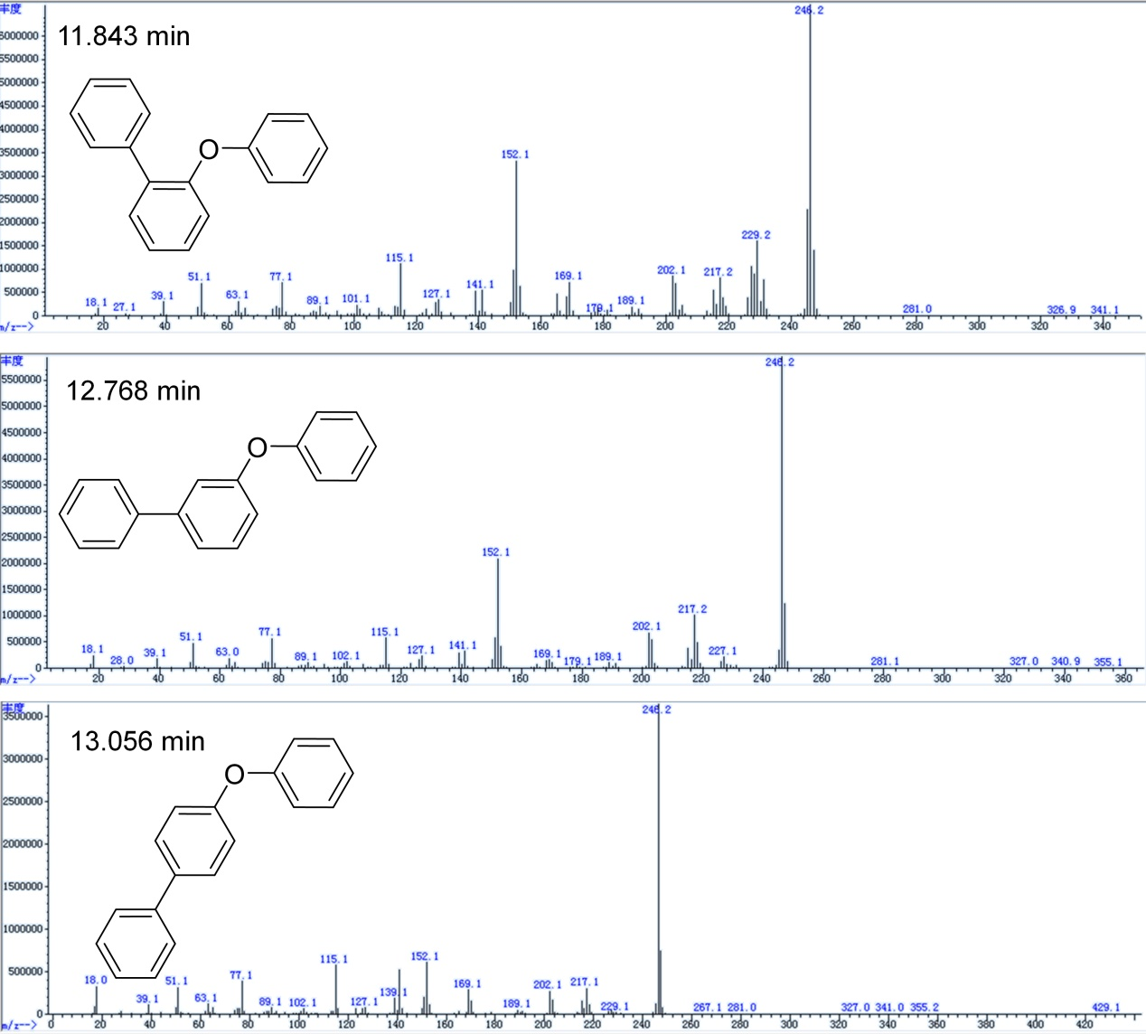
Supplementary Fig. 26. GC-MS analysis of 2-, 3-, and 4-phenoxydiphenyls product.
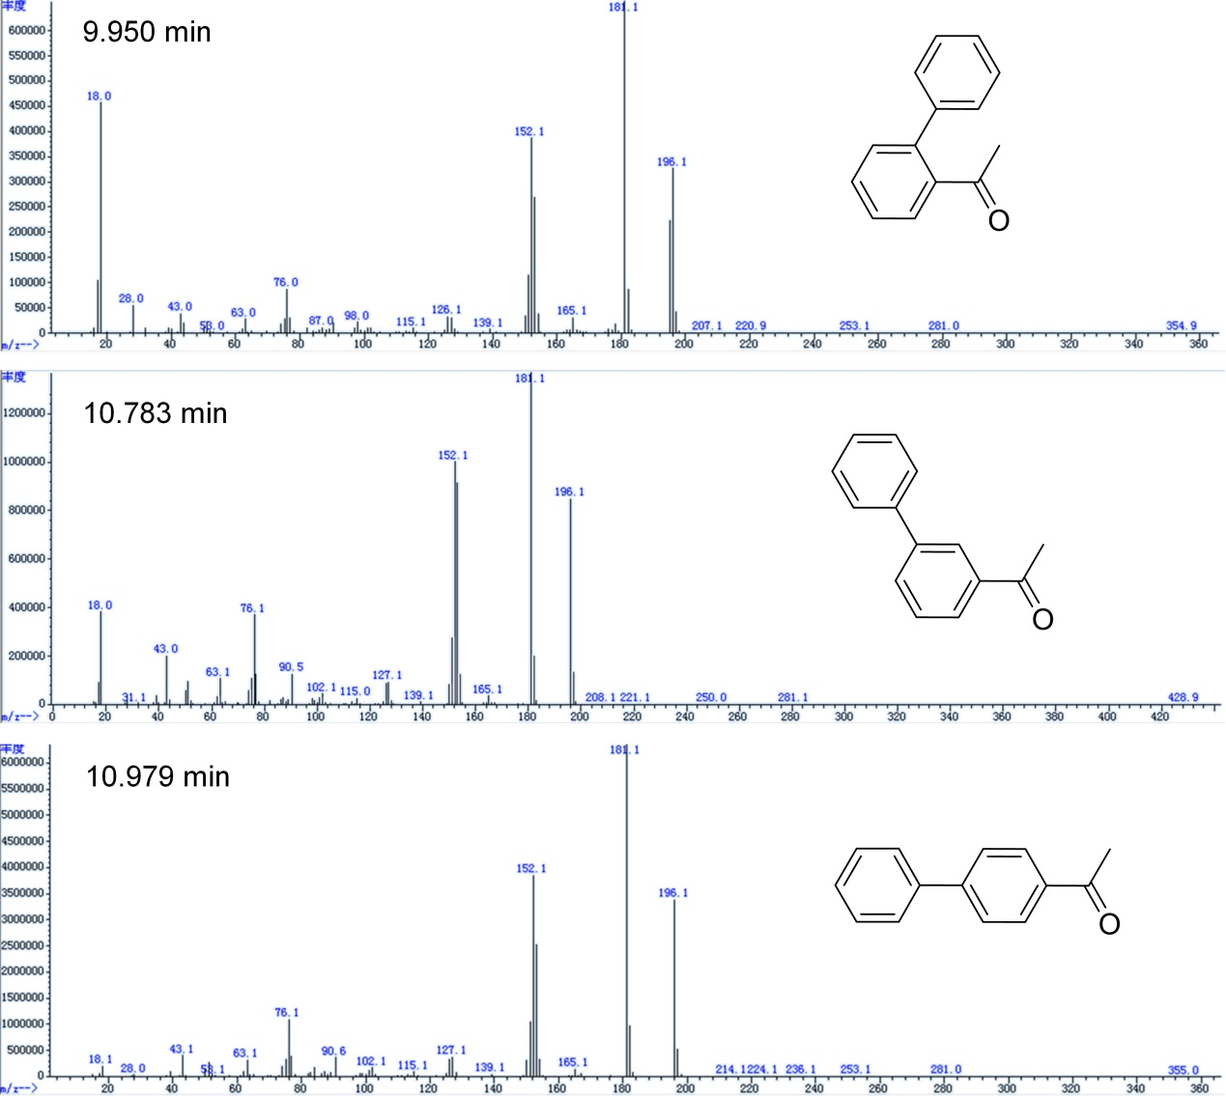
Supplementary Fig. 27. GC-MS analysis of 2-, 3-, and 4-phenylacetophenone
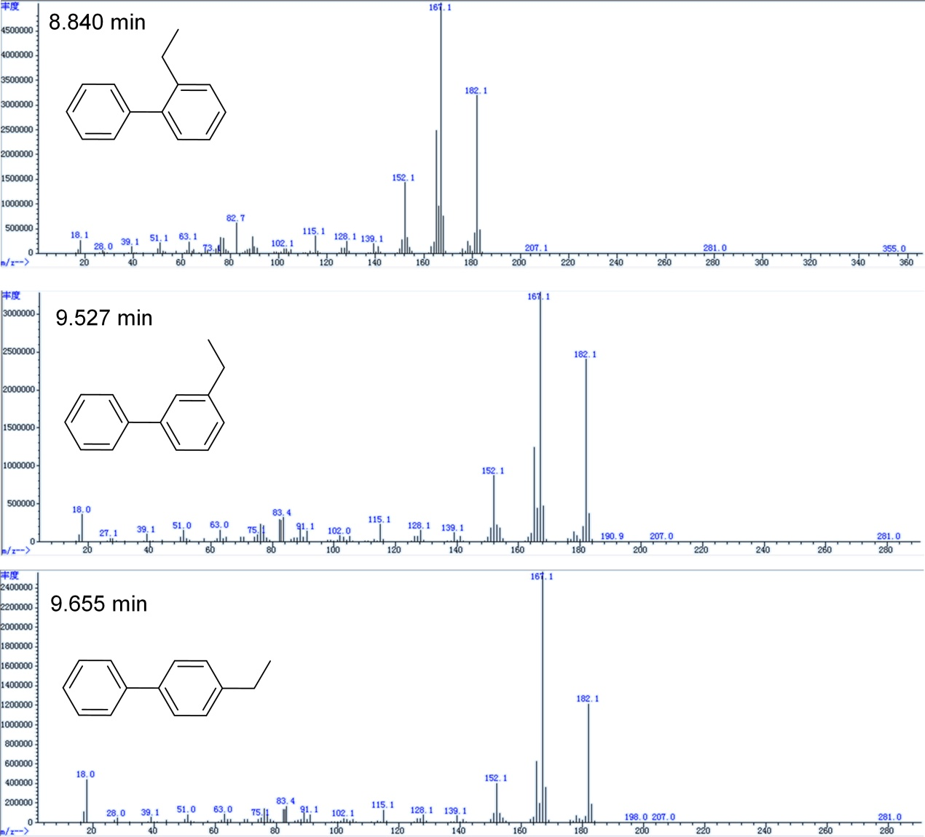
Supplementary Fig. 28. GC-MS analysis of 2-, 3-, 4-ethylbiphenyls.
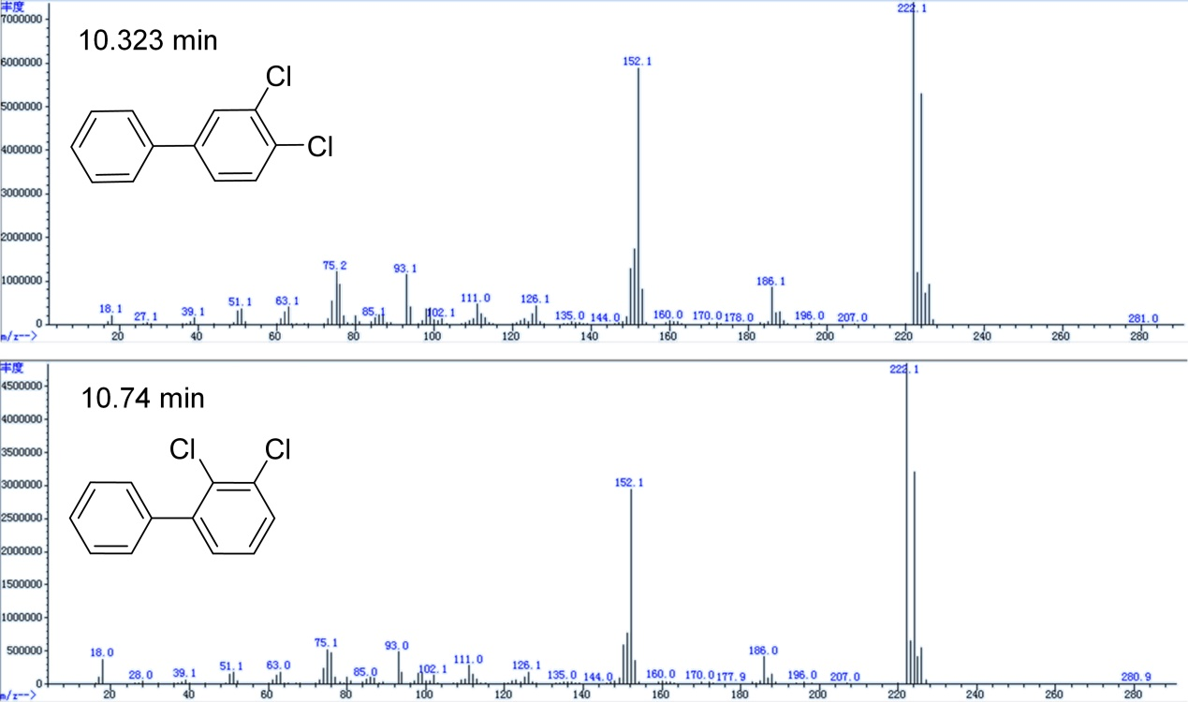
Supplementary Fig. 29. GC-MS analysis of 3,4-/2,3-dichlorobiphenyls.

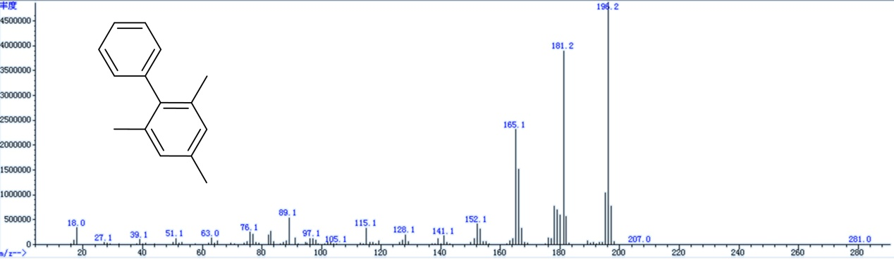
Supplementary Fig. 30. GC-MS analysis of 2,4,6-trimethylbiphenyl.
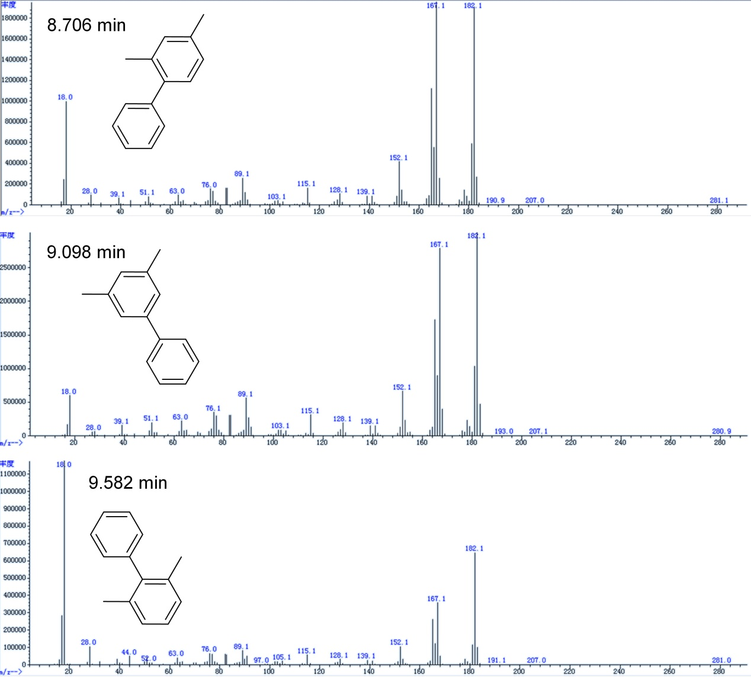
Supplementary Fig. 31. GC-MS analysis of 2,4-/3,5-/2,6- dimethylbiphenyls.
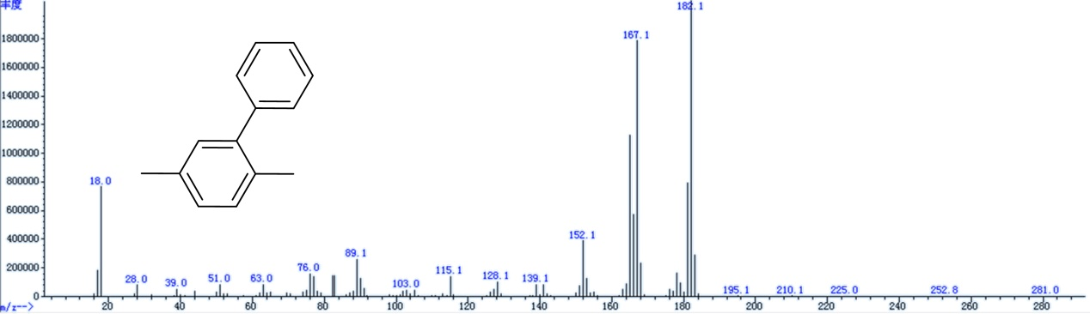
Supplementary Fig. 32. GC-MS analysis of 2,5-dimethylbiphenyl.

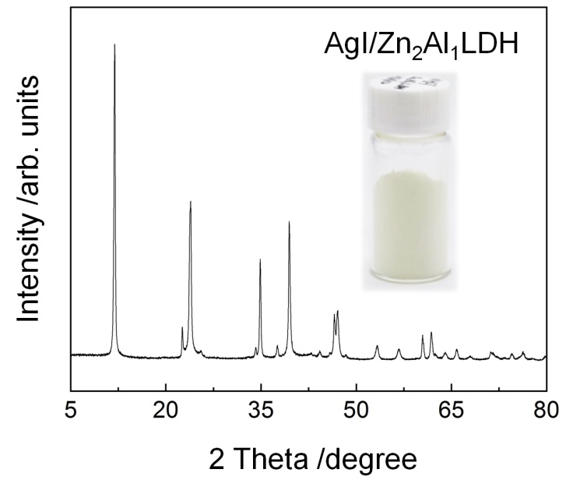
Supplementary Fig. 33. The XRD patterns of the AgI/Zn₂Al₁LDH photocatalyst. The insets show photograph of the as-prepared sample.

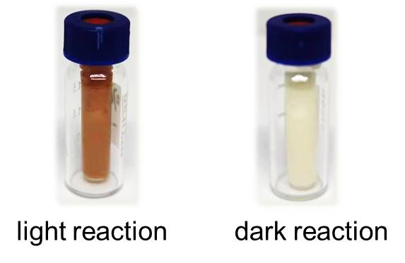

Supplementary Fig. 34. Photographs of the samples obtained after light reaction and dark reaction.

Supplementary Table 1. Dependence of photocatalytic performance of AgI/Mg_{x}Al_{y}LDH for the direct arylation of benzene on the Mg/Al molar ratio.
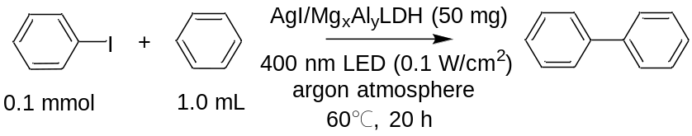
Entry | x:y | Yield (%)
1 | 4:1 | 55
2 | 2:1 | 93
3 | 1:1 | 85
4 | 1:2 | 78
5 | 1:4 | 66

Supplementary Table 2. The silver content analysis of the catalysts.
Entry | Prepared samples | Ag wt. %
1 | AgI/Mg₂Al₁LDH | 9.4
2 | AgI/ZrO₂ | 9.5
3 | AgI/Mg₄Al₁LDH | 8.4
4 | AgI/Mg₁Al₁LDH | 7.8
5 | AgI/Mg₁Al₂LDH | 5.4
6 | AgI/Mg₁Al₄LDH | 7.6
10 mg of powder sample was dissolved in 1 mL of HNO₃ (70%) and then diluted with deionized water. Prior to the analysis, the mixture obtained was filtered through a filter with a pore size of 0.22 μm to remove the solid residues.

Supplementary Table 3. The crystallite size of the AgI/Mg_{x}Al_{y}LDH samples measured from XRD using the Debye-Sherrer equation.
Entry | x:y | Crystallite size, nm Plane (003)
1 | 1:4 | 11.3
2 | 1:2 | 15.1
3 | 1:1 | 18.8
4 | 2:1 | 22.6
5 | 4:1 | 8.6

Supplementary Table 4. Determination of water content in the mixture after reaction by Karl Fischer titration.
Entry | Water content (light reaction sample) - water content (dark reaction sample) /% | Amount of produced water /mg
1 | 0.1304 | 1.24
Reaction conditions: iodobenzene (0.1 mmol), benzene (1 mL), catalyst (50 mg), Ar atmosphere, irradiated under a 400 nm wavelength LED light with 0.1 W cm⁻² of intensity or in the dark, the reaction was conducted at 60℃. Supplementary Fig. 34 shows the photographs of the samples.

References:
1 Mhatre, A. M., Chappa, S., Ojha, S. & Pandey, A. K. Functionalized glass fiber membrane for extraction of iodine species. Sep. Sci. Technol. 54, 1469-1477 (2019).
2 Nguyen, V. P. et al. Dual-electronic nanomaterial (synthetic clay) for effective removal of toxic cationic and oxyanionic metal ions from water. J. Nanomater. 2020, 1783749 (2020).
3 Zou, R., Xie, R., Wang, L., Lin, Y. & Lu, C. Electrochemiluminescence detection of oxygen vacancies in layered double hydroxides. Chem. Commun. 58, 423-426 (2022).
4 Sankapal, B., Baviskar, P. & Salunkhe, D. Synthesis and characterization of AgI thin films at low temperature. J. Alloy. Compd. 506, 268-270 (2010).
5 Sun, C. et al. In situ preparation of novel p-n junction photocatalyst MgAl-LDH/(BiO)2CO3 for enhanced photocatalytic degradation of tetracycline. Mat. Sci. Semicon. Proc. 150, 106939 (2022).
6 Bian, X., Zhang, S., Zhao, Y., Shi, R. & Zhang, T. Layered double hydroxide‐based photocatalytic materials toward renewable solar fuels production. InfoMat 3, 719-738 (2021).
7 Robel, I., Kuno, M. & Kamat, P. V. Size-dependent electron injection from excited CdSe quantum dots into TiO₂ nanoparticles. J. Am. Chem. Soc. 129, 4136-4137 (2007).

