Table 1. Screening of reaction conditions for direct arylation of benzene.
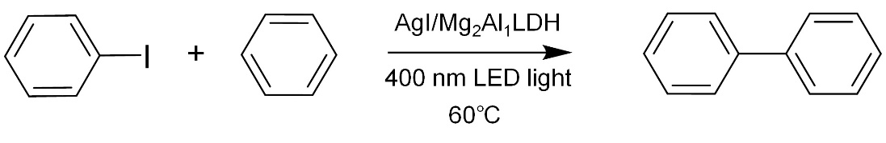
Entry | Variation from the standard condition | Yield (%)
1 | None | 93
2 | Without irradiation | 0.1
3 | Without AgI/Mg₂Al₁LDH | 1.2
4 | Without iodobenzene | 0
5 | Hexane instead of benzene | 1.5
6 | Mg₂Al₁LDH | 2.3
7 | AgI/ZrO₂ | 10.5
8 | AgI/ZrO₂, with Na₂CO₃ added (50 mg) | 11.1
9 | Air instead of argon | 56.4
Standard reaction conditions: iodobenzene (0.1 mmol), benzene (1 mL), catalyst (50 mg), Ar atmosphere, irradiated under a 400 nm wavelength LED light with 0.1 W cm⁻² of intensity, the reaction was conducted at 60℃ for 20 h. Yields are determined by GC analysis.

Table 2. Reaction scope of (hetero) aryl iodides and arenes.
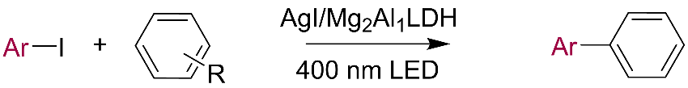
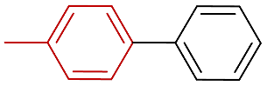  1ª 87% (<0.1%) | 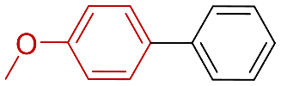  2^{b} 91% (<0.1%) | 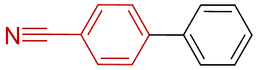  3^{b} 99% (1%) | 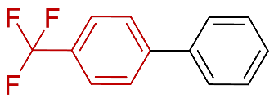  4^{c} 99% (<0.1%)
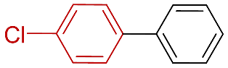  5^{c} 98% (0.1%) | 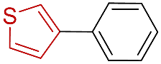  6^{d} 94% (0.1%) | 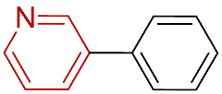  7^{d} 91% (0.1%) | 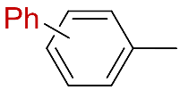  8e 63% (<0.1%), o/m/p = 62/24/14
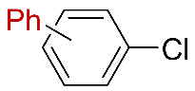 | 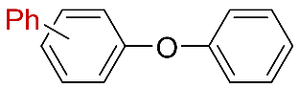 | 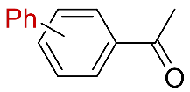 | 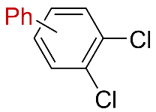
9^{f} 94% (<0.1%)  o/m/p = 61/24/15 | 10^{f} 98% (<0.1%)  o/m/p = 56/28/16 | 11^{f} 74% (<0.1%)  o/m/p = 53/33/14 | 12^{f} 97% (<0.1%)  3,4-/2,3-dichlorobiphenyl = 69/31
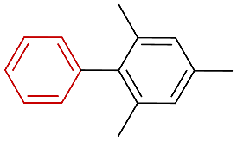 | 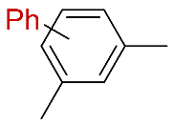 | 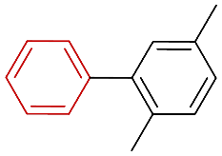 | 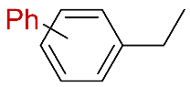
13^{f} 54% (<0.1%) | 14^{f} 52% (<0.1%)  2,4-/3,5-/2,6- dimethylbiphenyl= 50/43/7 | 15^{f} 46% (<0.1%) | 16^{f} 27% (<0.1%)  o/m/p = 52/31/17
Reaction conditions: aryl iodide (0.1 mmol), arene (1 mL), AgI/Mg₂Al₁LDH catalyst (50 mg), Ar atmosphere, irradiated under a 400 nm wavelength LED light. Yields were determined by GC analysis. ªReaction was conducted at 60℃ for 20 h, and the light intensity was 0.1 W cm⁻². ^{b}Reaction was conducted at 80℃ for 20 h, and the light intensity was 0.1 W cm⁻². ^{c}Reaction was conducted at 60℃ for 48 h, and the light intensity was 0.1 W cm⁻². ^{d}Reaction was conducted at 85℃ for 48 h, and the light intensity was 0.2 W cm⁻². To enhance the yield of the products 1-7, the catalyst was filtered out at half of the reaction time during photocatalysis, followed by the addition of 50 mg of fresh catalyst to the liquid mixture. ^{e}Reaction was conducted at 60℃ for 20 h, and the light intensity was 0.2 W cm⁻². ^{f}Reaction was conducted at 60℃ for 20 h, and the light intensity was 0.1 W cm⁻². Iodobenzene was used in producing the products 8-16.

