Supporting information for

Discovering the potential role of giant viruses in antibiotic resistance spread

Xinzhu Yi^{1, †}, Jie-Liang Liang^{1, †}, Ping Wen¹, Pu Jia¹, Shi-wei Feng¹, Shen-yan Liu¹, Yuan-yue Zhuang¹, Yu-qian Guo¹, Jing-li Lu¹, Sheng-ji Zhong¹, Bin Liao², Zhang Wang¹, Wen-sheng Shu¹, & Jin-tian Li^{1,*}

¹Institute of Ecological Science, Guangzhou Key Laboratory of Subtropical Biodiversity and Biomonitoring, Guangdong Provincial Key Laboratory of Biotechnology for Plant Development, School of Life Sciences, South China Normal University, Guangzhou 510631, PR China
²School of Life Sciences, Sun Yat-sen University, Guangzhou 510275, PR China

†These authors contributed equally to this work.

*Corresponding author:
School of Life Sciences, South China Normal University, Guangzhou 510631, PR China
E-mail: Jin-tian Li (lijintian@m.scnu.edu.cn)
Tel.: +86 20 85211850; Fax: +86 20 85211850

Number of supplementary figures: 8
Number of supplementary tables: 6
Supplementary figures
Figure S1. Habitat distribution of viral genomes and their ARG contents. A, D: Habitat distribution of the genomes of A) NCLDV and D) phages analyzed in this study. B, E: Percentage of ARG-carrying genomes of a given habitat to the overall number of genomes of that habitat of B) NCLDVs and E) phages. C, F: Average percentage of the ARG-like ORFs to the overall predicted ORFs per genome of a given habitat of C) NCLDVs and F) phages. Lower-case letters above the bars represent significantly different groups at p value < 0.05 with Kruskal-Wallis test. For clarity, only seven major habitats are shown individually, with other habitats being referred to as “others” and shown as a whole.
Figure S2. Sequence alignment of two putative tetracycline resistance (MFS transporter) genes in an ancient NCLDV and reference sequences in bacteria. Residues involved in tetracycline resistance on the first sequence from Escherichia coli were obtained from Wright et al.¹. The other reference sequences from bacteria were downloaded from the Resfams database ². Transmembrane (TM) regions were predicted by DeepTMHMM web platform ³. NCLDV sequence labels are marked blue.
Figure S3. Sequence alignment of the nucleotide binding domain (NBD) of the putative macB gene in an ancient NCLDV and reference macB ABC transporter sequences in bacteria. Residues involved in erythromycin resistance on the first sequence from Aggregatibacter actinomycetemcomitans were obtained from Crow et al.⁴ The other reference sequences from bacteria were downloaded from the Resfams database ². NCLDV sequence labels are marked blue.
Figure S4. Average numbers of ARG subtypes detected in different families of A) NCLDVs and B) phages. Lower-case letters above the dots represent significantly different groups at p value < 0.05 with Kruskal-Wallis test.
Figure S5. Phylogenetic tree of 1143 dfr protein sequences. The dfr sequences consisted of 415 de-replicated NCLDV sequences, 346 de-replicated phage sequences, 177 prokaryotic sequences screened by Sánchez-Osuna et al. ⁵, and 205 eukaryote sequences selected by us according to taxonomy.
Figure S6. Sequence alignment of the putative dfr proteins in NCLDVs and reference sequences in bacteria. The binding residues of trimethoprim (purple stars below the alignments) and the accessions of dfr sequences from bacteria were obtained from Coque et al. ⁶. NCLDV sequence labels are marked blue.
Figure S7. IS-carriage by different families of NCLDVs and phages. A, C: Percentage of IS-carrying genomes (ICGs) of a given family to the total number of genomes of that family of A) NCLDVs and C) phages. B, D: Average percentage of the IS-like ORFs to the overall predicted ORFs per genome of different families of B) NCLDVs and D) phages. For clarity, only NCLDV families with more than 10 genomes available or those with more than 5 ICGs are displayed in A) and B). Likewise, only the 5 most abundant phage families (according to the number of genomes belonging to individual families) and those with more than 5 ICGs are displayed in C) and D). Lower-case letters above the bars represent significantly different groups at p value < 0.05 with Kruskal-Wallis test. Family names are displayed above the bars where colors cannot be clearly recognized.
Figure S8. IS-carriage by NCLDVs and phages from different habitats. A, C: Percentage of ICGs of A) NCLDVs and C) phages from a given habitat to the total number of genomes from that habitat. B, D: Average percentage of IS-like ORFs to the overall predicted ORFs per genome of a given habitat of B) NCLDVs and D) phages. Lower-case letters above the bars represent significantly different groups at p value < 0.05 with Kruskal-Wallis test. Habitat names are displayed above the bars where colors cannot be clearly recognized.

Supplementary tables
Table S1. Details of nucleocytoplasmic large DNA virus (NCLDV) genomes analyzed in this study.
Table S2. Details of phage genomes analyzed in this study.
Table S3. Details of two NCLDV dfr genes randomly selected for functional validation.
Table S4. ARG-carriage by different NCLDV families.
Table S5. ARG-carriage by different phage families.
Table S6. Most prevalently detected AMR gene families or ARG subtypes in NCLDV and phage genomes.

Supplementary references
1. Wright, D.J., and Tate, C.G. (2015). Isolation and characterisation of transport-defective substrate-binding mutants of the tetracycline antiporter TetA(B). Biochimica et Biophysica Acta (BBA) - Biomembranes 1848, 2261-2270. https://doi.org/10.1016/j.bbamem.2015.06.026.
2. Gibson, M.K., Forsberg, K.J., and Dantas, G. (2015). Improved annotation of antibiotic resistance determinants reveals microbial resistomes cluster by ecology. ISME J. 9, 207-216. https://doi.org/10.1038/ismej.2014.106.
3. Hallgren, J., Tsirigos, K., D., Pedersen, M.D., Armenteros, J.J.A., Marcatili, P., Nielsen, H., Krogh, A., and Winther, O. (2022). DeepTMHMM predicts alpha and beta transmembrane proteins using deep neural networks. bioRxiv, 2022.2004.2008.487609. https://doi.org/10.1101/2022.04.08.487609.
4. Crow, A., Greene, N.P., Kaplan, E., and Koronakis, V. (2017). Structure and mechanotransmission mechanism of the MacB ABC transporter superfamily. Proc. Natl. Acad. Sci. USA 114, 12572-12577. https://doi.org/10.1073/pnas.1712153114.
5. Sánchez-Osuna, M., Cortés, P., Llagostera, M., Barbé, J., and Erill, I. (2020 ). Exploration into the origins and mobilization of di-hydrofolate reductase genes and the emergence of clinical resistance to trimethoprim. Microbial Genomics 6, mgen000440. https://doi.org/10.1099/mgen.0.000440.
6. Coque, T.M., Singh, K.V., Weinstock, G.M., and Murray, B.E. (1999). Characterization of dihydrofolate reductase genes from trimethoprim-susceptible and trimethoprim-resistant strains of Enterococcus faecalis. Antimicrob. Agents Chemother. 43, 141-147. https://doi.org/10.1128/aac.43.1.141.

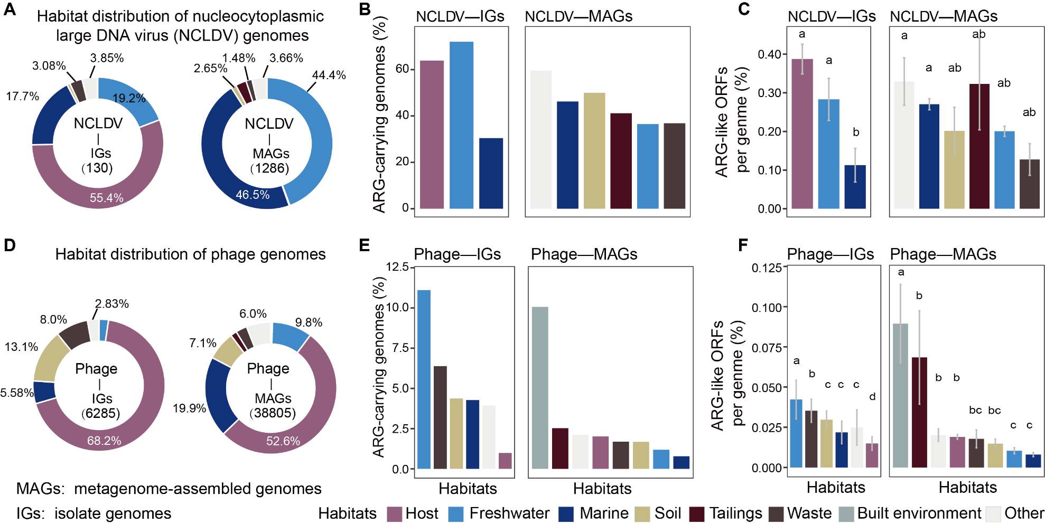
Figure S1

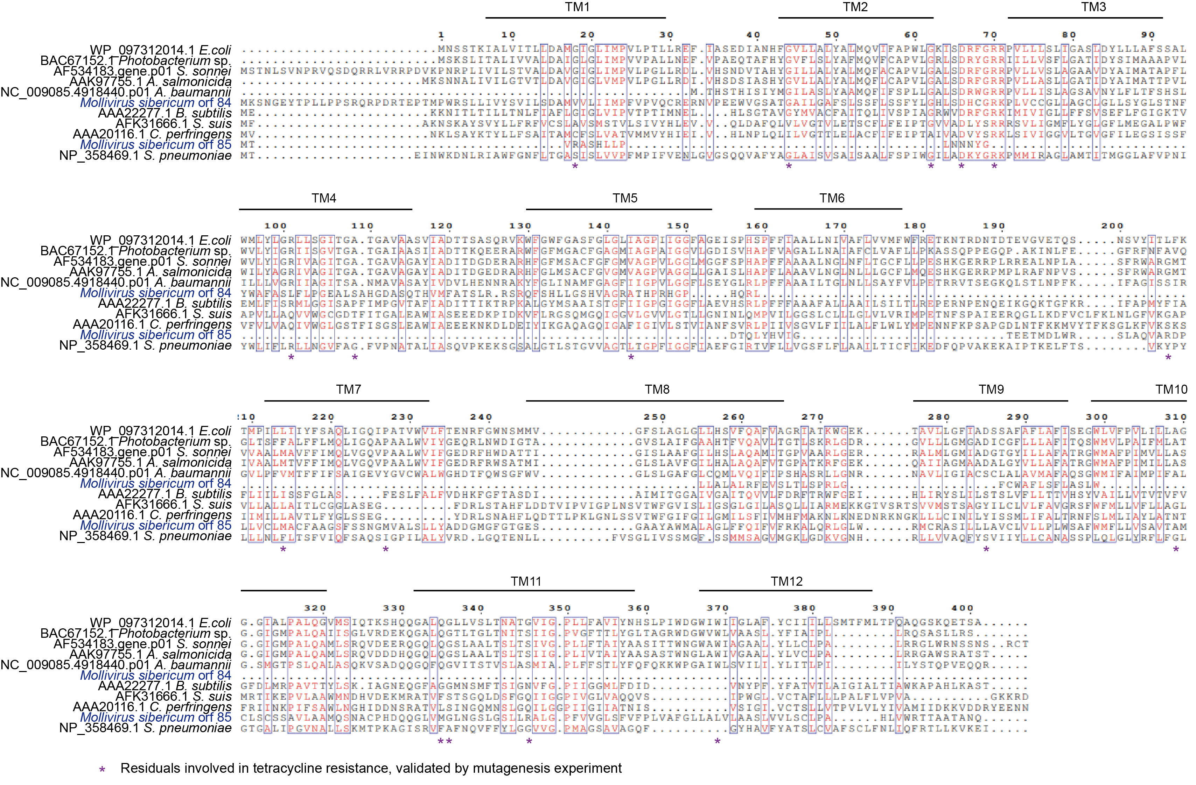
Figure S2

Figure S3
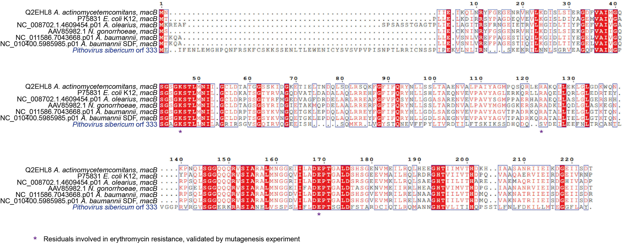

Figure S4

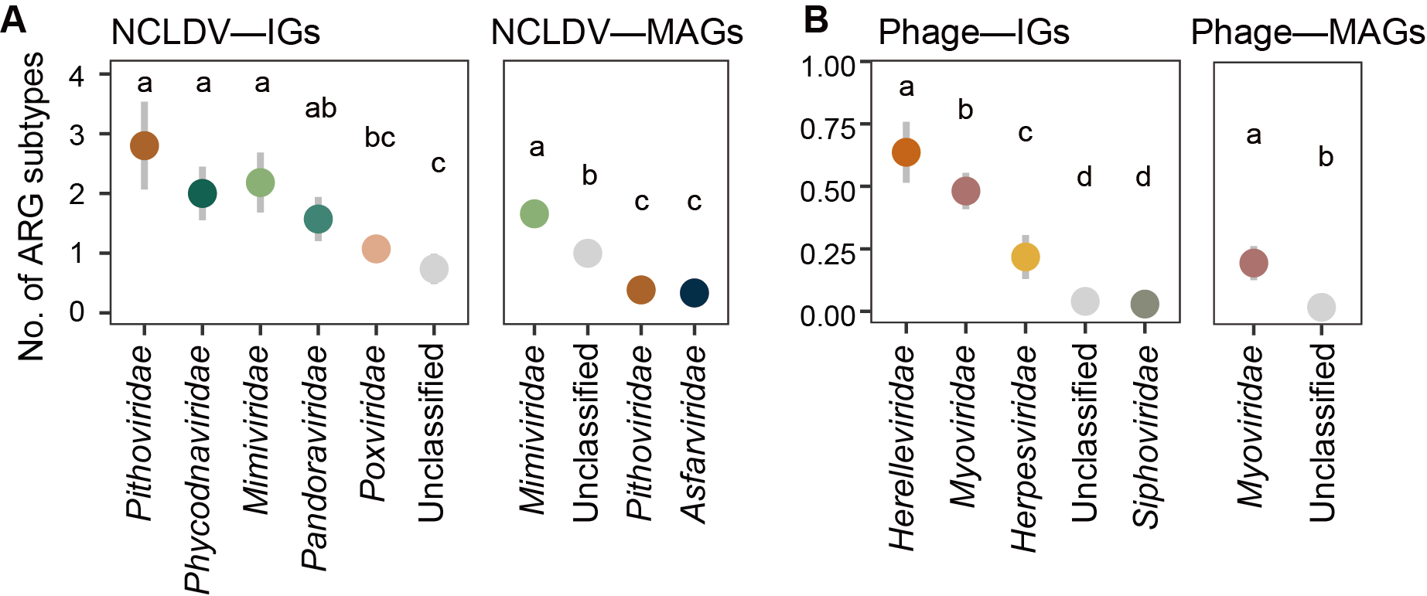
Figure S5

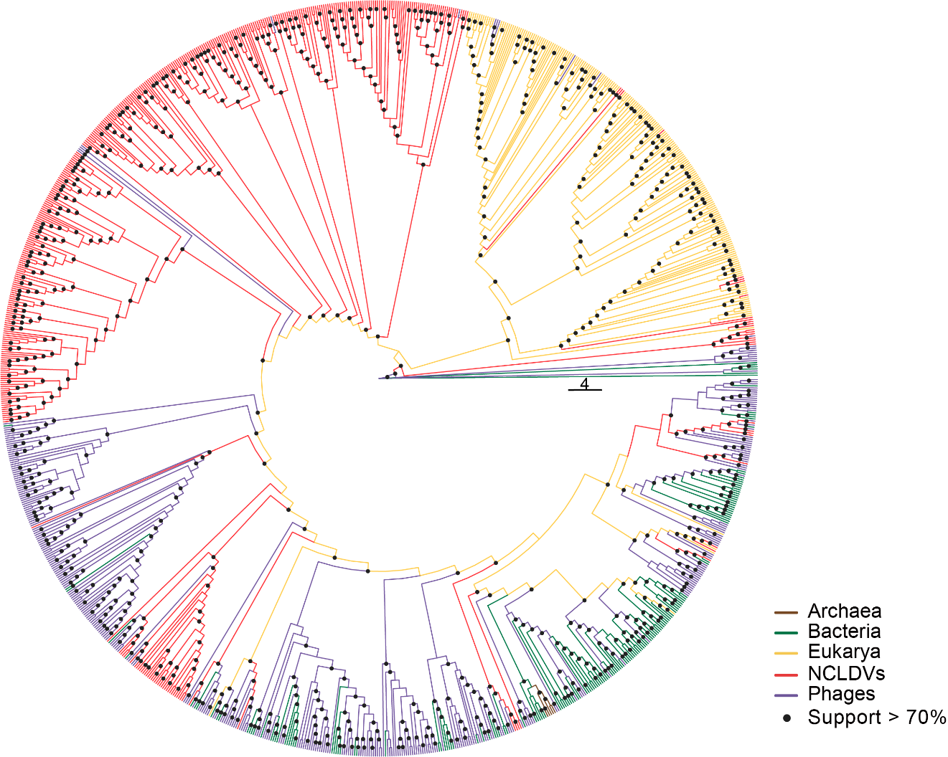
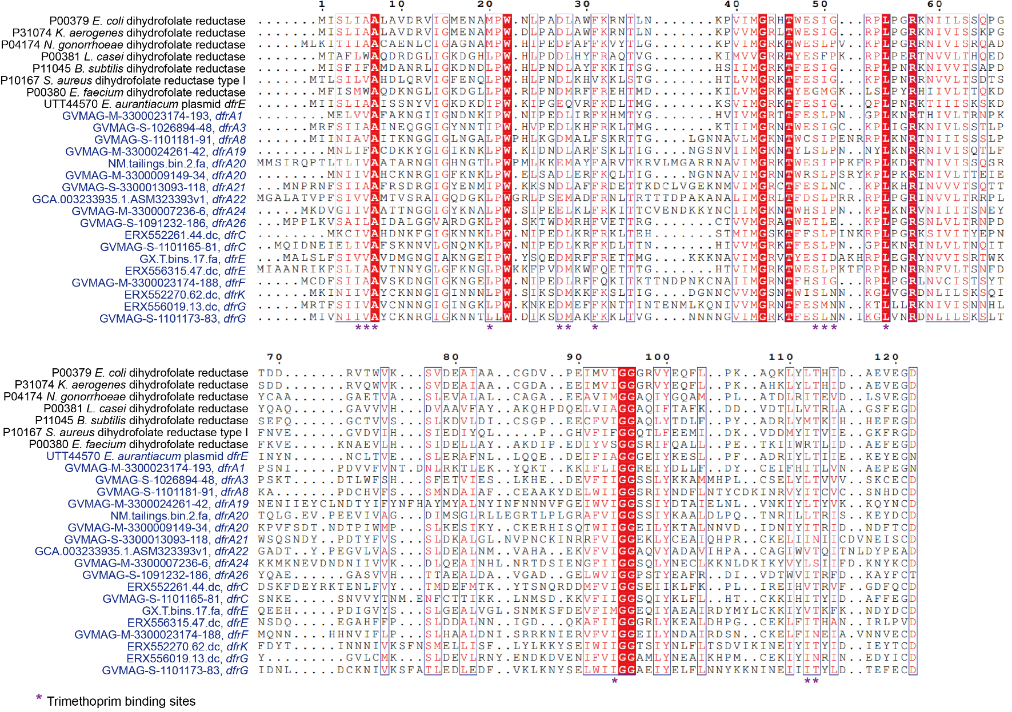
Figure S6

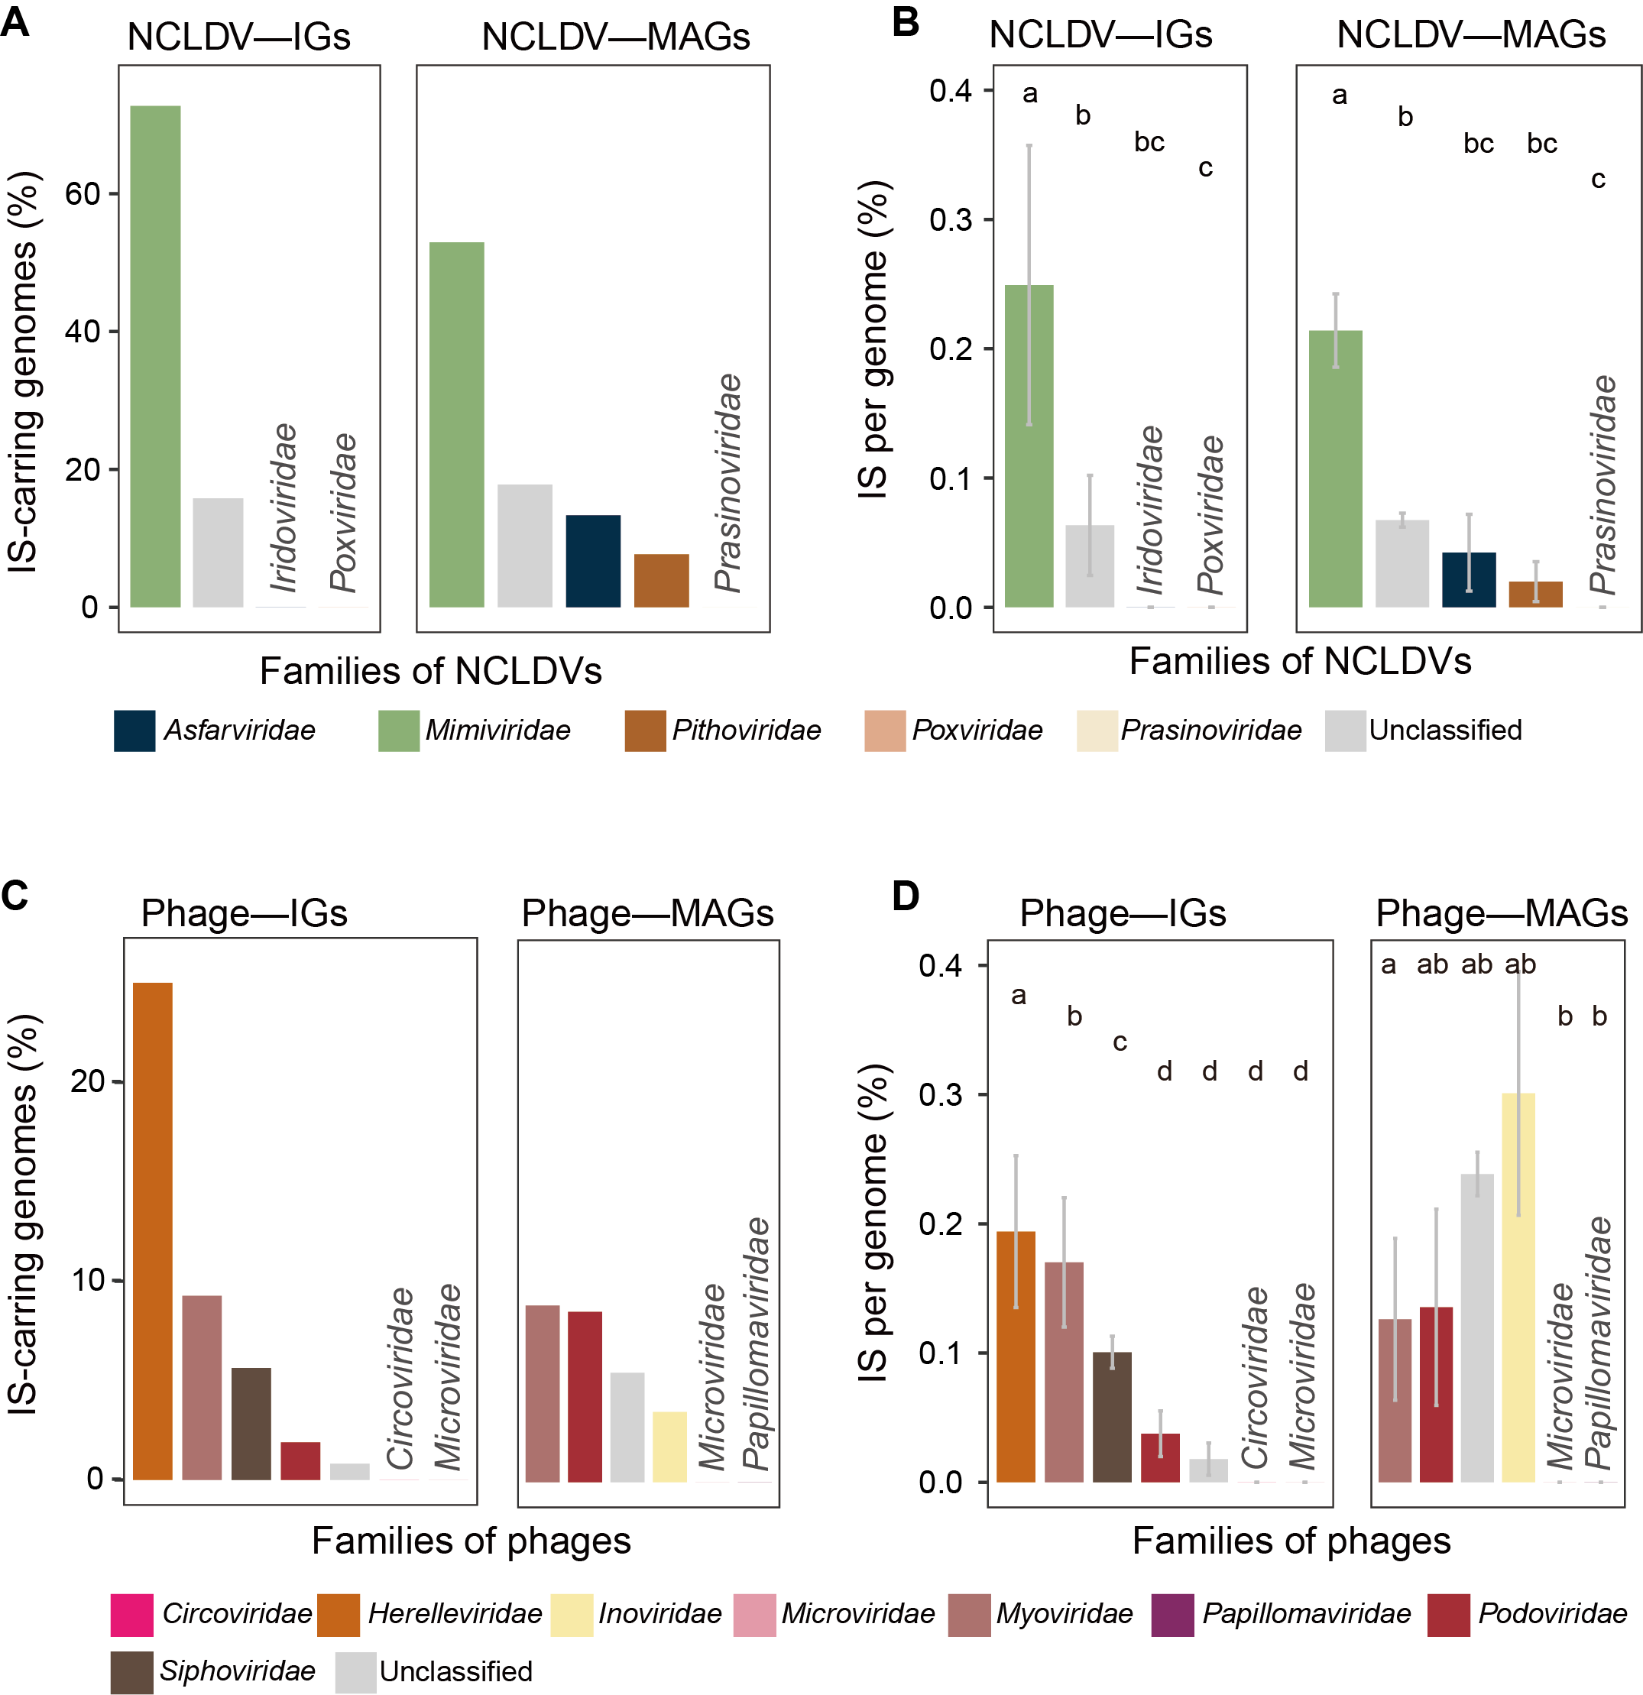
Figure S7

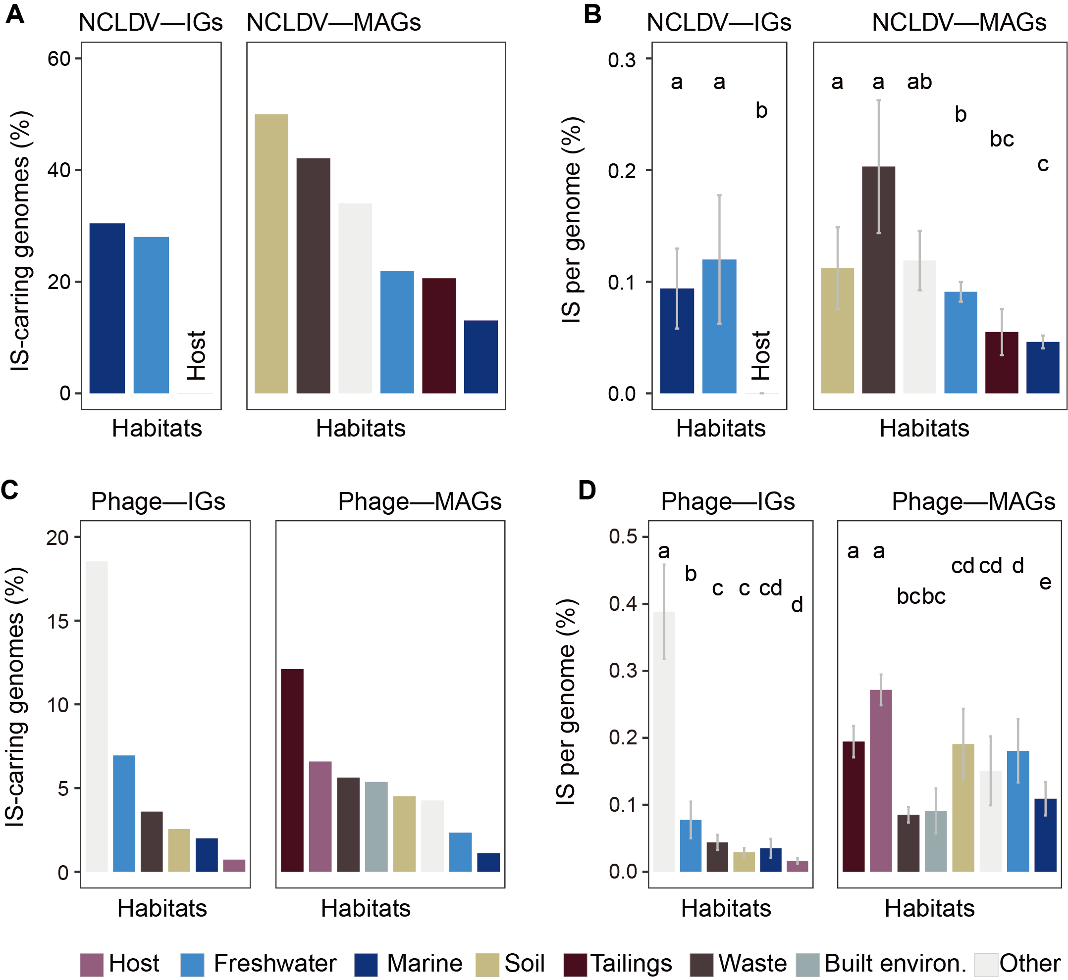
Figure S8

