Supplementary Data 1, S1
a.
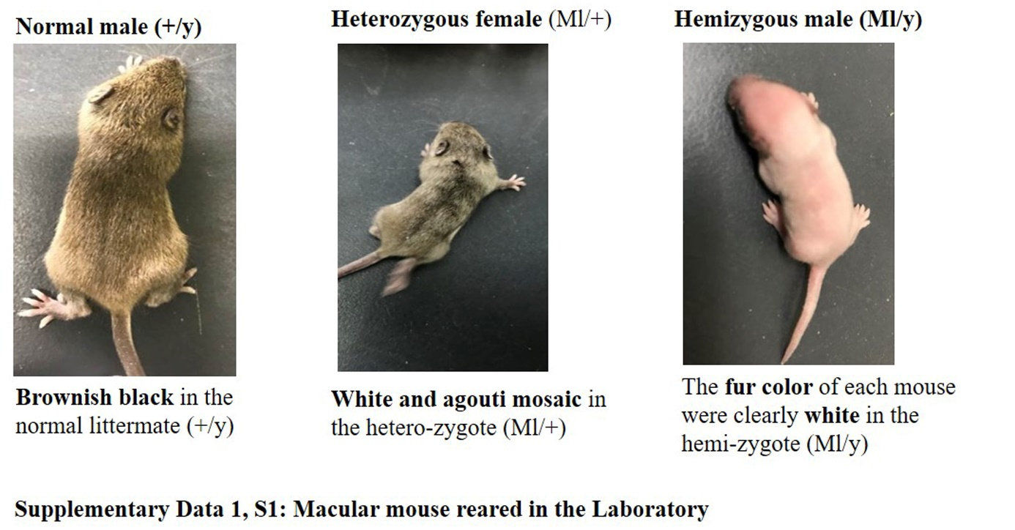

Supplementary Data 2, S2
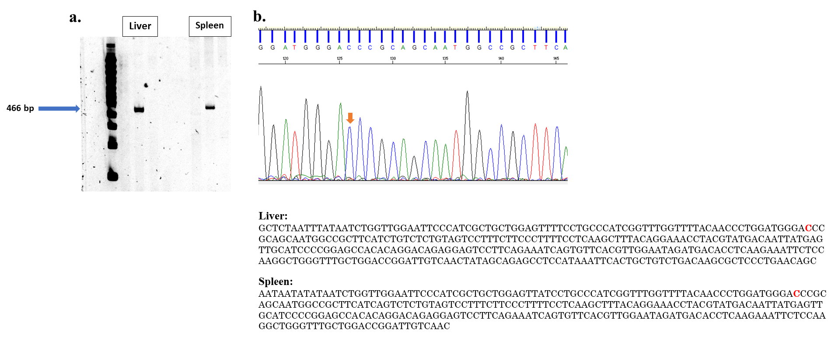

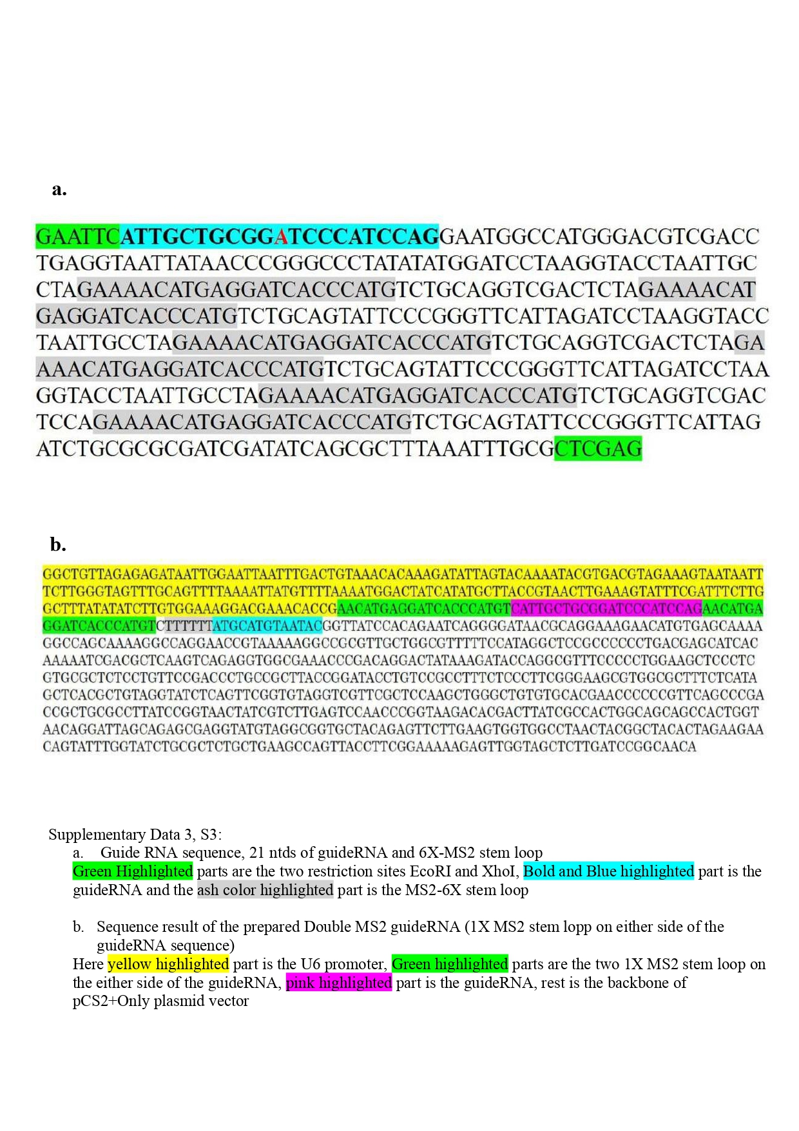
Supplementary Data 3, S3

Supplementary Data 4, S4
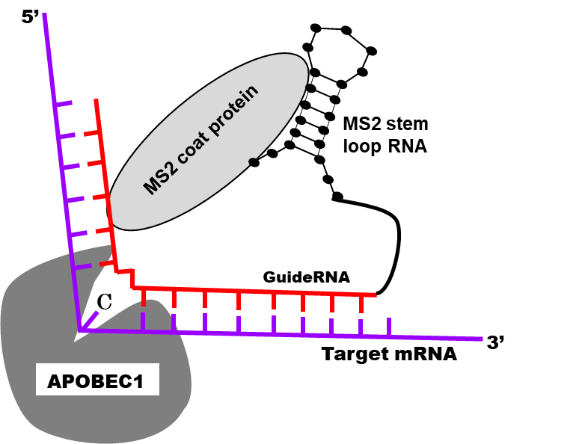

Supplementary Data 5, S5
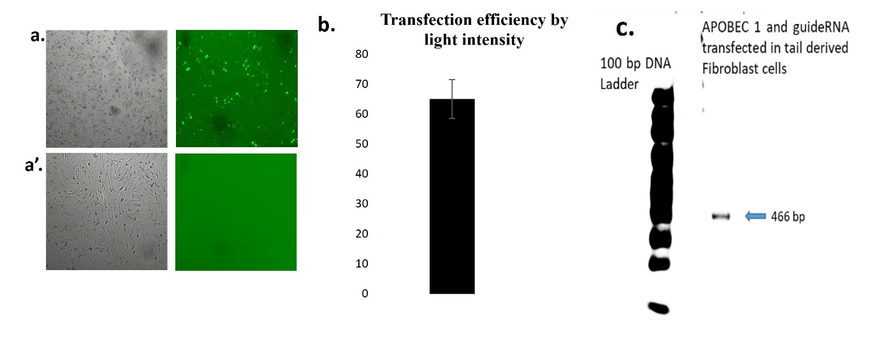

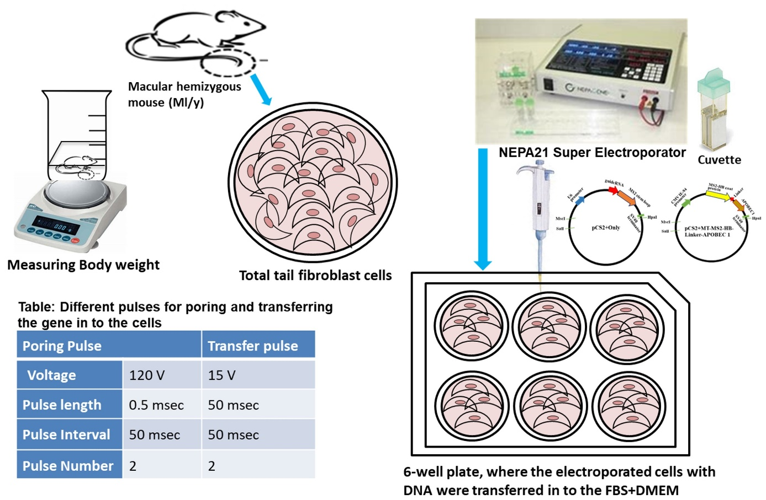
Supplementary Data 6, S6

Supplementary Data 7, S7
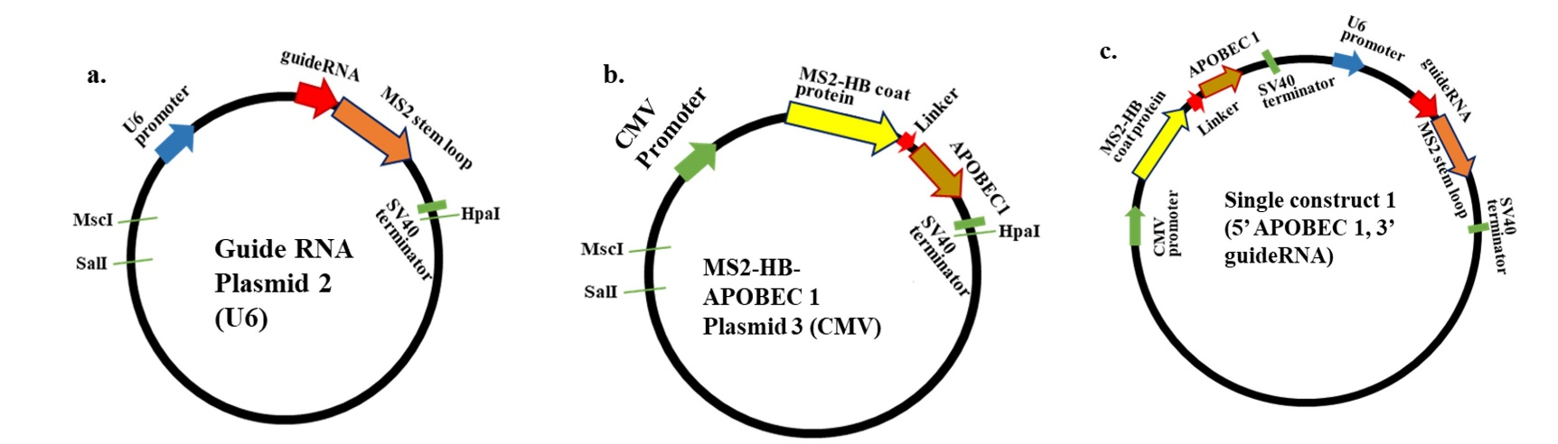

Supplementary Data 8, S8
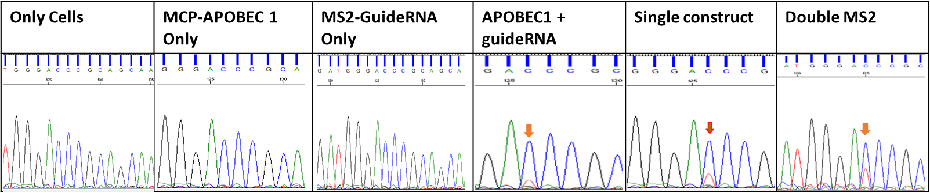

Supplementary Data 1, S1
Supplementary Data, S1:
- Macular mouse reared in the Laboratory

Supplementary Data 2, S2
Supplementary Data 2, S2: a. PCR amplification of the targeted portion from cDNA of Liver and Spleen hemizygous macular mouse
b. Sequence confirmation of the T-to-C mutation in ATP7A gene from the collected Liver and Spleen samples

Supplementary Data 3, S3
Supplementary Data 3, S3:
- Guide RNA sequence, 21 ntds of guide RNA and 6X-MS2 stem loop
Green Highlighted parts are the two restriction sites EcoRI and XhoI, Bold and Blue Highlighted part is the guide RNA and the ash color Highlighted part is the MS2-6X stem loop
- Sequence result of the prepared Double MS2 guide RNA (1X MS2 stem loop on the either side of the guide RNA sequence)
Here yellow Highlighted part is the U6 promoter, Green Highlighted parts are the two 1X MS2 stem loop on the either side of the guide RNA, pink highlighted part is the guide RNA, rest is the backbone of pCS2+Only plasmid vector

Supplementary Data 4, S4
Supplementary Data 4, S4:
Schematic model of the MS2-APOBEC1 system where the MS2-stem loop is attached with the guide RNA and the MS2-Coat Protein is fused with the APOBEC 1 deaminase, transfection of the system into the mice fibroblast cells do the editing.

Supplementary Data 5
Supplementary Data 5, S5:
- Fluorescence image showing the transfection efficiency while the wild type GFP was transfected into the macular mouse tail derived fibroblast cells having ATP7A gene,
a’. On the contrary when the APOBEC 1 and guide RNA was transfected into the macular mouse tail derived fibroblast cells having mutated ATP7A gene there was no fluorescence expression as there was no expressing gene, image was taken by Juli fluorescence microscope
- Transfection efficiency of the electroporation was calculated from the fluorescence
intensity after application of the only wild type GFP into the macular mouse tail derived fibroblast cells without other editing factors, n=3
- PCR amplification of the targeted ATP7A gene from the predicted restored sample, transfected with the editing deaminase APOBEC 1 and guide RNA

Supplementary Data 6, S6
Supplementary Data 6, S6:
Collection of the Fibroblast cells from Macular mouse and condition of electroporation along with the editase and guideRNA.

Supplementary Data 7, S7
Supplementary Data 7, S7:
a. Guide RNA Plasmid 2 (U6): Guide RNA construct under the control of the pol III U6 promoter
b. MS2-HB-APOBEC 1 Plasmid 3 (CMV): APOBEC 1 deaminase construct under the control of pol II CMV promoter
c. Single construct 1 (5’-APOBEC 1, 3’-guideRNA): Single construct, the guide portion under the control of the pol III U6 promoter and the APOBEC 1 deaminase portion under the control of the pol II CMV promoter. Here CMV promoter is located at the upstream of the U6 promoter

Supplementary Data 8, S8
Supplementary Data 8, S8
Panel of sequencing result, Column 1: control (only fibroblast cells no transfection), column 2: Only MCP-APOBEC1, column 3: Only MS2-guideRNA, column 4: MCP-APOBEC1+MS2-guideRNA (Edited), column 5: Single construct, and column 6: Double MS2 system

