Supplementary Materials

Global Trends in the Research and Development of Petrochemical Waste Gas from 1981 to 2022
Mengting Wu ª, Wei Liuª, Zhifei Ma ª, Tian Qinª, Zhiqin Chen ª, Yalan Zhang ª,
Ning Cao ^{b}*, Xianchuan Xie ª, Sunlin Chi ª, Jinying Xu ª, Yi Qi ^{c}**
ª Key Laboratory of Poyang Lake Environment and Resource Utilization of Ministry of Education, School of Resource and Environment, Nanchang University, Nanchang 330031, China
^{b} Department of Applied Foreign Language Studies, Nanjing University, Nanjing 210023, China
^{c} School of Architecture and Urban Planning, Nanjing University, Nanjing 210093, China

*and ** Corresponding author. Email: catherineaning@gmail.com; jnjn@163.com

Supplementary information 1. Supplementary Text

1. Methods

1.1. Database selection
Web of Science (WOS) was founded in 1997 and is currently the largest comprehensive academic information resource database globally, covering the most disciplines. WOS’s topic search is equivalent to a keyword search of some fields, including title, abstracts, author keywords, and keywords plus. Considering that the Web of Science Core Collection (WOSCC) is the one of the most suitable database collections for bibliometric studies (Mongeon and Paul-Hus, 2016), and that the full references and citations are mandatory for bibliometric analyses. To ensure the quality and accessibility of the data, we focus on the WOSCC database.

1.2. Data collection
Two researchers independently analyzed the data to ensure the accuracy of the data and the repeatability of the research. Microsoft Excel 2019 was used to analyze and export the files of top-cited or productive authors, countries/regions, publications, journals, and institutions. In this review, CiteSpace 6.1.R3 (64-bit) and VOSviewer (1.6.18) were used to accomplish visualization to obtain insights into the research of MPW and identify the research horizon and knowledge base of the field in large amounts of data.

1.3. References to be included
There will be no limitation in the number of included references. Articles and reviews will be included, and each title of the available editorial materials and proceeding papers will be inspected for inclusion. In order to reflect the research trends, there will be no limitations on language, time, and populations.

1.4. References to be excluded
Publications with irrelevant or out-of-scope topics will be excluded, such as: book chapters, monographs, conference papers or magazines. We will exclude publications categorized under corrections or retracted.

2. Software and data analysis
Different software can be used to conduct scientometric analysis, that aims to produce systematic mapping, research trends, and influence networks. The different software used automatically extract various data items, such as title, name of all authors, country, affiliation, author’s G-Index, number of citations, journals names, publication date, institutions names, keywords, keywords plus, funding’s, grants, major topic or subject area. In this study, we will use different software.

2.1. CiteSpace (6. 1. R3)
CiteSpace is a Java application for visualizing and analyzing trends and patterns in scientific literature. It is designed as a tool for progressive knowledge domain visualization (Chen, 2006; Chen et al., 2010). It focuses on finding critical points in the development of a field or a domain, especially intellectual turning points and pivotal points.
We will use this software for production of both co-citation network and co-occurrence networks. In this paper, CiteSpace was adopted to generate visual knowledge maps, including countries, institutions, authors, journals, keyword clustering, and references citation bursts. Some knowledge map identification methods and parameters were involved in the results of the bibliometric analysis, which would be explained in paragraphs, respectively. Besides, a node indicated an item (country, institution, journal, author, or keyword), and links represented co-citation or co-occurrence between these nodes. Co-citation networks are based on co-citation, which is defined as a linkage between a pair of documents concurrently cited by a third document (Sabe et al., 2022; Stroup et al., 2000).
Co-citation networks extended from a single-slide equivalent to multiple-slice network analysis, i.e. a time series of networks in order to detect critical transitions over time more effectively. In CiteSpace, clusters are built on hybrid networks of co-cited articles and terms citing these articles.
Co-occurrence networks are the collective interconnection of terms based on their paired presence within a specified unit of text. We will use this software for production of both co-citation network and co-occurrence networks:
- Co-citation document networks
- Journal co-citation networks
- Author co-citation networks
Co-occurrence networks that are based on undirected graphs, directed graphs and hypergraphs:
- Co-occurrence authors keywords networks
- Co-authorship networks
- Co-authorship at the institutional level
- Co-authorship at the country level

2.2. VOSviewer (1.6.18)
VOSviewer (1.6.18) was used to identify productive countries/regions, institutions, journals and authors, and the main cocited journals, authors and references and related visual networks were also constructed. We managed the data and analyzed the publication trends using Microsoft Office Excel 2019. In the VOSviewer network maps, the size of the nodes reflects the number of studies or cooccurrence frequencies, the links between nodes represent the cooccurrence relationships, and the size of the links indicates the co-occurrence frequencies of two nodes. The impact factors (IFs) of the academic journals were collected from the 2021 Journal Citation Reports (JCR).
We will complement the results obtained with CiteSpace using VOSviewer. When adequate we will produce:
-Co-authorship network
-Journal co-citation network
-Co-occurring author’s keywords network.

3 Evaluation index
Some indicators are used in this paper to evaluate countries, research institutions, researchers, journals and so on. These indicators can intuitively compare with their influence. For example, the IFs of an academic journal is a measure reflecting the average number of citations to recent articles published in that journal, which is frequently used as a proxy for the relative importance of a journal within its field. Journals with higher impact factors are deemed to be more important than those with lower ones. H-index, also known as h-factor, is a new way to evaluate academic achievement. “H” stands for “high citations”, and a researcher's h-index means that he has at most h papers cited at least h times. The H-index can more accurately reflect a person's academic achievement. The higher the H-index of a person is, the greater the influence of his paper will be. For better or worse, academics use citation counts as one of several ways to assess the value of a researcher's output.
CiteSpace produces a variety of metrics of significance, with temporal metrics such as citation burstness, structural metrics such as betweenness centrality, modularity, and silhouette score as well as a combination of both, namely, the sigma metric. Betweenness centrality measures the number of times a node (e.g., one article, one author) lies on the shortest path between other nodes based on Freeman’s betweenness centrality metric (Freeman, 1977). Nodes with high betweenness centrality generally connect different clusters and are considered key hubs. Burstness measures the rate of change. The burstness of the frequency of an entity over time indicates a specific duration when an abrupt change in the frequency takes place, thus identifying emergent terms (Kleinberg, 2003). CiteSpace also combines betweenness centrality as a structural property with citation burstness as a temporal property using a metric called sigma. Sigma is computed as (centrality +1)^{burstness} (Chen et al., 2010) with higher values indicating works with higher influential potential. The modularity (the Q score) of a network measures the extent to which a network can be divided into modules or clusters, and the silhouette (the S score) is a method of interpretation and validation of consistency within clusters of data (Shibata et al., 2008). The Q metric ranges from 0 to +1, and the S metric ranges from −1 to +1. For both metrics, a score close to +1 represents the best clustering model. When the Q value is greater than 0.3, the cluster structure is considered significant, and higher values may indicate a well-structured network; when the silhouette coefficients exceed 0.3, 0.5, or 0.7, the network is considered homogenous, reasonable, or highly credible, respectively. A silhouette score of 1 may, however, indicate that the corresponding cluster is relatively isolated. The cluster labels are generated from noun phrases of the keyword lists of articles cited in each cluster using the likelihood ratio test (p < 0.001). Each cluster was closely inspected, and automatic labels were re-labelled according to authors’ expertise, if needed. The impact factors of the included journals were retrieved from the 2021 Journal Citation Reports (data were extracted from WOSCC in plain text files).

3.1. Network analysis metrics and data analysis
Different network metrics will be used in our analysis, such as betweenness centrality, burstness analysis, sigma scores, and modularity and silhouette scores.
①Betweenness centrality: The algorithm calculates unweighted shortest paths between all pairs of nodes in a graph. Each node receives a score, based on the number of shortest paths that pass through the node (Freeman, 1977).
②Burstness analysis: Citation burst is a detection of a burst event (Kleinberg, 2003). A citation burst provides evidence that a particular publication is associated with a surge of citations. Furthermore, if a cluster contains numerous nodes with strong citation bursts, then the cluster as a whole captures an active area of research, or an emerging trend.
③Modularity scores: Modularity is a measure of the structure of a graph, measuring the density of connections within a module. Graphs with a high modularity score will have many connections within a module but only few pointing outwards to other modules. Its value ranges from 0 to 1 (Newman, 2006).
④Silhouette scores: Silhouette score is a metric used to calculate the goodness of a clustering technique (Rousseeuw, 1987). Its value ranges from -1 to 1.
1: clusters are isolated from each other.
0: clusters are indifferent, or we can say that the distance between clusters is not significant.
-1: clusters are assigned in the wrong way.
⑤Sigma scores: This indicator measures the combined strength of structural and temporal properties of a node, namely, its betweenness centrality and citation burst (Chen et al., 2012).

3.2. Additional data extraction
We will extract top unit of measure for a specific time period:
- The top 10 cited units of measure (e.g. top 10 cited journals)
- The top 10 most productive units of measure (e.g. top 10 most cited reference)
- Journal’s impact factors
- Journal’s year of first appearance
- Author full names

4. Sensitivity analyses
When adequate, we will reduce the time period to the last 5 years (2017-2022), and/or to the last year (2022) in order to further explore latest research trends of modifications of unit of measure. Specific unit of measure will be extracted with different software in order to inspect different results (e.g. keywords). If possible, we will conduct structural variation analysis using centrality and modularity divergence to monitor and discern the potential of newly published papers in context.

5. Data availability
The extracted database will be seared upon reasonable request.

Supplementary information . Supplementary Figures
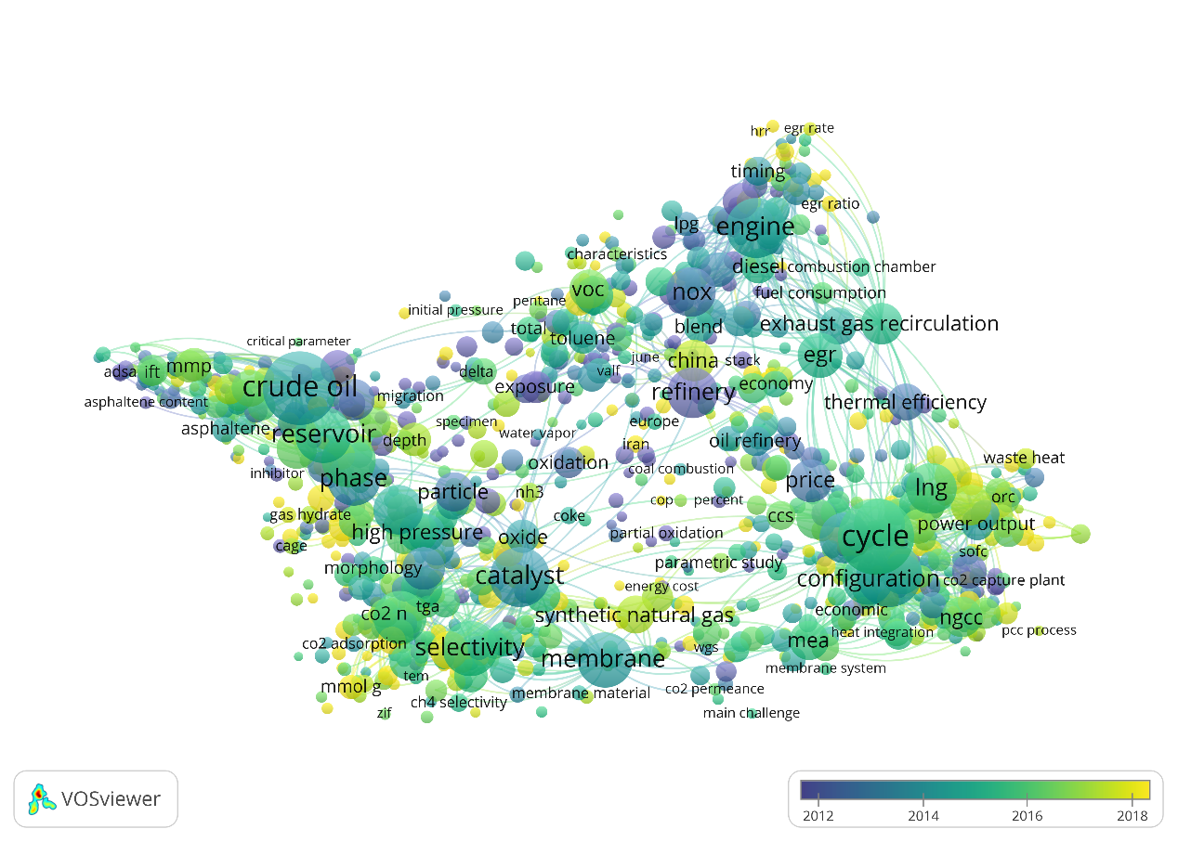
Fig. S1. Keyword co-occurrence network based on article-years
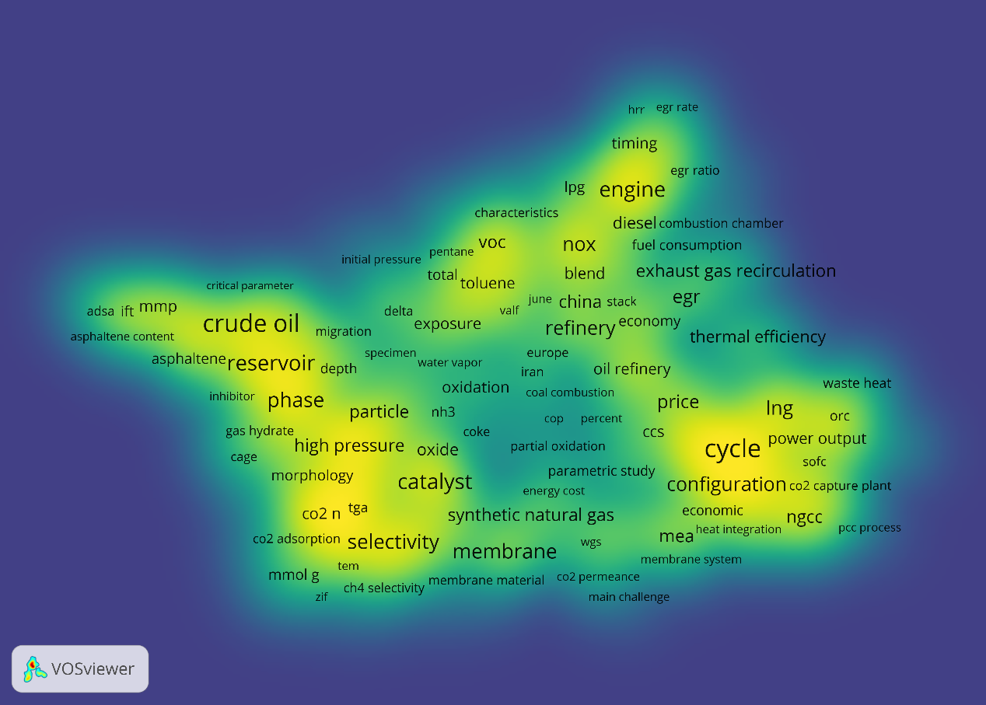
Fig. S2. Keyword density map related to PWG
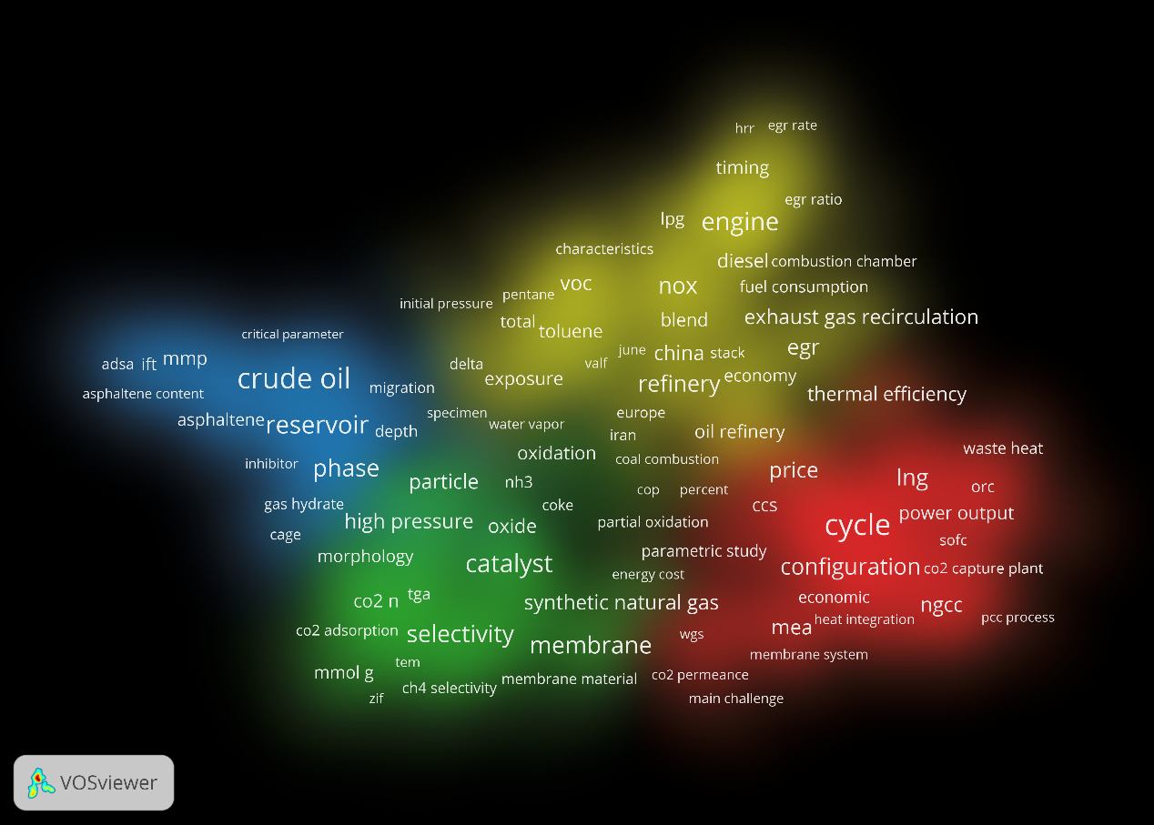
Fig. S3. Keyword distance density map related to PWG
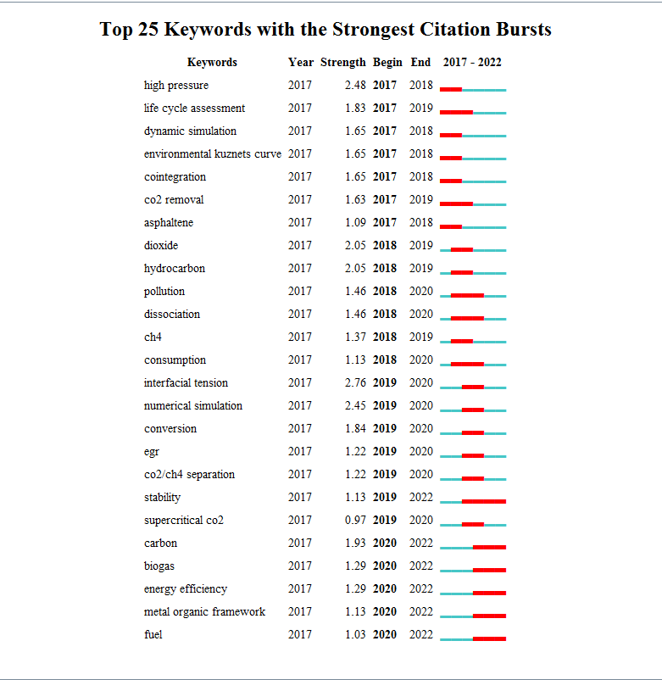
Fig. S4. Top 25 keywords with the strongest beginning year of citation burst. Sorted by burst time (2017-2022).
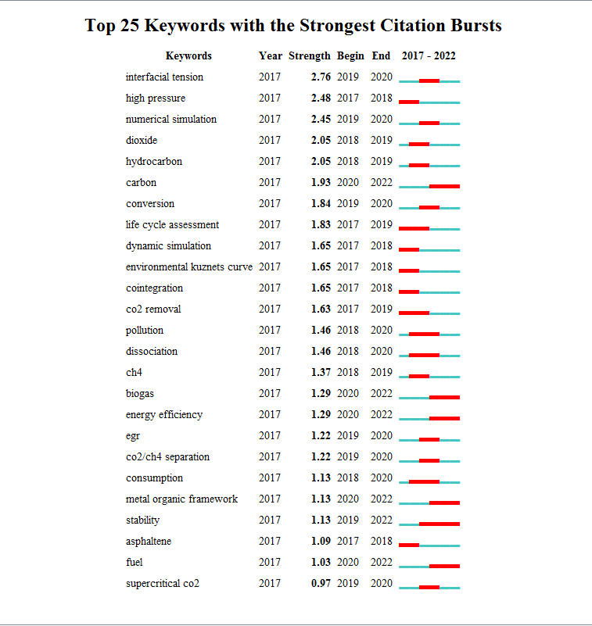
Fig. S5. Top 25 keywords with the strongest beginning year of citation burst. Sorted by burst intensity (2017-2022).
Fig S6. The clustering map of keywords (1981–2022)
Fig S7 Co-citation references network (1981–2022) (a) Co-citation reference network with cluster visualization and burstness of hotspots. (b) Visualization map of the corresponding clusters.

References
Chen, C. 2006. CiteSpace II: Detecting and visualizing emerging trends and transient patterns in scientific literature. Journal of the American Society for Information Science and Technology 57(3), 359-377.
Chen, C., Hu, Z., Liu, S. and Tseng, H. 2012. Emerging trends in regenerative medicine: a scientometric analysis in CiteSpace. Expert Opinion on Biological Therapy 12(5), 593-608.
Chen, C., Ibekwe-SanJuan, F. and Hou, J. 2010. The structure and dynamics of cocitation clusters: A multiple-perspective cocitation analysis. Journal of the American Society for Information Science and Technology 61(7), 1386-1409.
Egghe, L. 2007. Item-time-dependent Lotkaian informetrics and applications to the calculation of the time-dependent h-index and g-index. Mathematical and Computer Modelling 45(7), 864-872.
Freeman, L.C. 1977. A Set of Measures of Centrality Based on Betweenness. Sociometry 40(1), 35-41.
Kleinberg, J. 2003. Bursty and Hierarchical Structure in Streams. Data Mining and Knowledge Discovery 7(4), 373-397.
Mongeon, P. and Paul-Hus, A. 2016. The journal coverage of Web of Science and Scopus: a comparative analysis. Scientometrics 106(1), 213-228.
Newman, M.E.J. 2006. Modularity and community structure in networks. Proceedings of the National Academy of Sciences 103(23), 8577-8582.
Rousseeuw, P.J. 1987. Silhouettes: A graphical aid to the interpretation and validation of cluster analysis. Journal of Computational and Applied Mathematics 20, 53-65.
Sabe, M., Pillinger, T., Kaiser, S., Chen, C., Taipale, H., Tanskanen, A., Tiihonen, J., Leucht, S., Correll, C.U. and Solmi, M. 2022. Half a century of research on antipsychotics and schizophrenia: A scientometric study of hotspots, nodes, bursts, and trends. Neuroscience & Biobehavioral Reviews 136, 104608.
Shibata, N., Kajikawa, Y., Takeda, Y. and Matsushima, K. 2008. Detecting emerging research fronts based on topological measures in citation networks of scientific publications. Technovation 28(11), 758-775.
Stroup, T.S., J, A.L., M, S.S. and McEvoy, J.P. 2000. Comparative effectiveness of antipsychotic drugs in schizophrenia. Dialogues Clin Neurosci 2(4), 373-379.

