Supplemental Information for

Neolithic humans and dogs - transient reservoirs for Yersinia pestis

Julian Susat¹, Magdalena Haller¹, Joanna H. Bonczarowska¹, Nicolas da Silva¹, Kerstin Schierhold², Michael M. Rind², Ulrich Schmölcke³, Wiebke Kirleis⁴, Christoph Rinne⁴, Johannes Müller⁴, Almut Nebel¹, Ben Krause-Kyora^{1*}

¹Institute of Clinical Molecular Biology, Kiel University, Kiel, Germany
²LWL-Archäologie für Westfalen, Münster, Germany
³Centre for Baltic and Scandinavian Archaeology (ZBSA), Schloss Gottorf, Schleswig, Germany
⁴Institute of Pre- and Protohistoric Archaeology, Kiel University, Kiel, Germany

*Correspondence: b.krause-kyora@ikmb.uni-kiel.de
Table S4. Mapping statistics for the Y. pestis-positive samples. Overview of statistics after mapping to the chromosome and plasmids of the Y. pestis reference genome.
Sample | Mapping reads | Cov 1x (%) | Cov 2x (%) | Cov 3x (%) | Mean coverage
chromosome NC_003143.1
Warburg_1 | 340,021 | 89.45 | 76.32 | 58.09 | 3.22X
Warburg_2 | 3,090,021 | 94.84 | 94.68 | 94.58 | 28.89X
C90 | 31,549 | 8.42 |  |  | 0.31X
pMT1 NC_003134.1
Warburg_1 | 3,081 | 57.52 | 33.57 | 16.49 | 1.5X
Warburg_2 | 38,137 | 74.55 | 73.04 | 72.67 | 17.03X
C90 | 187 | 6.04 |  |  | 0.07X
pPCP1 NC_003132.1
Warburg_1 | 2,347 | 79.85 | 79.80 | 79.67 | 11.34X
Warburg_2 | 25,344 | 80.28 | 80.20 | 80.19 | 117.31X
C90 | 63 | 20.92 |  |  | 0.26X
pCD1 NC_003131.1
Warburg_1 | 12,718 | 92.14 | 90.62 | 88.44 | 8.38X
Warburg_2 | 70,082 | 92.86 | 92.33 | 92.09 | 43.96X
C90 | 263 | 12.45 |  |  | 0.14X

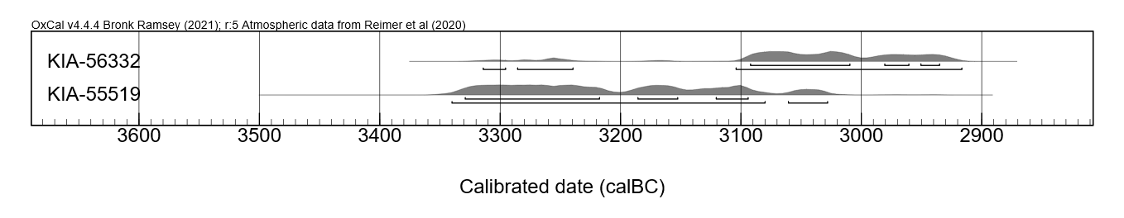
Figure S1. Radiocarbon dating results for Warburg_1 (KIA-55519) and Warburg_2 (KIA-56332).

Figure S2. Genomic ancestry components using unsupervised ADMIXTURE. For the two Warburg individuals (red), most models indicate two major genetic components: one maximized in Western hunter-gatherers (i.e., Luxembourg_Loschbour) and the other in Anatolian farmers (i.e., Turkey_N).
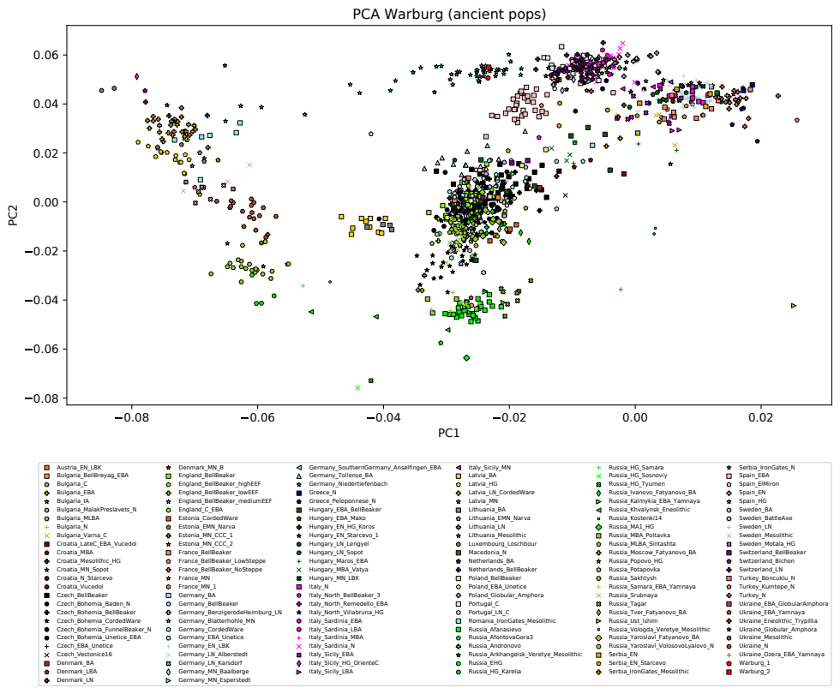
Figure S3. Principal component analysis of the individuals Warburg_1 and Warburg_2 buried in the WBC gallery graves of Warburg (red) in the context of 150 prehistoric populations, including individuals from the WBC gallery grave of Niedertiefenbach (blue stars).
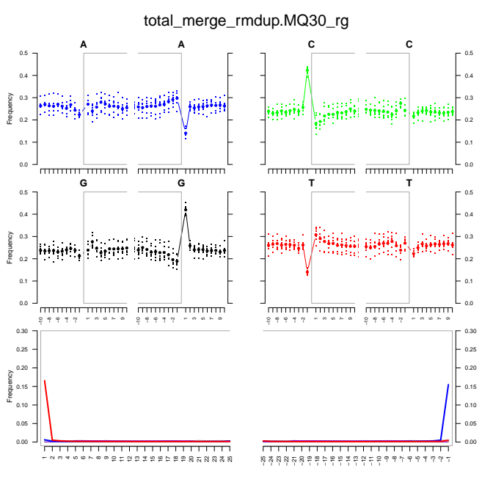
Figure S4. Damage plots supporting the ancient origin of Y. pestis reads for Warburg_1.
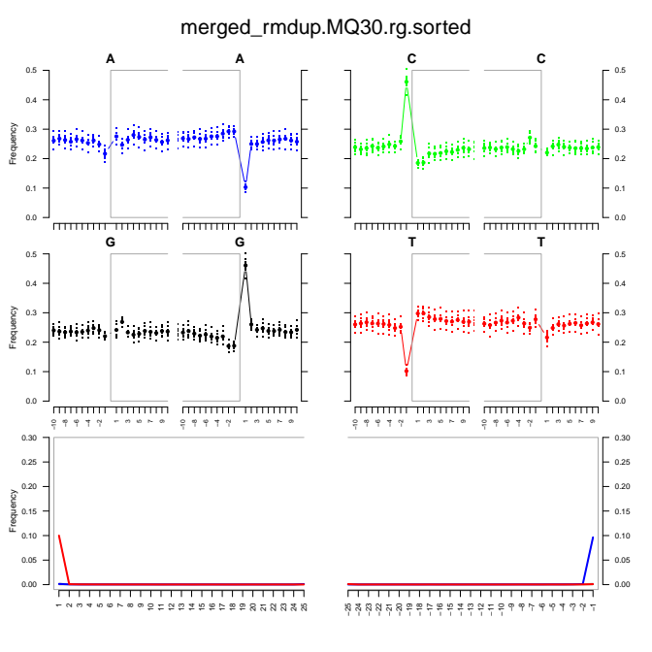Figure S5. Damage plots supporting the ancient origin of Y. pestis reads for Warburg_2.

Figure S6. Visualization of virulence factors in ancient Y. pestis strains. Heatmap shows the presence or absence of 159 virulence factors on the chromosome (n=115) and the plasmids pCD1 (n=37), pMT1 (n=6) and pPCP1 (n=1). Genomes are sorted according to their placement in the phylogenetic tree.

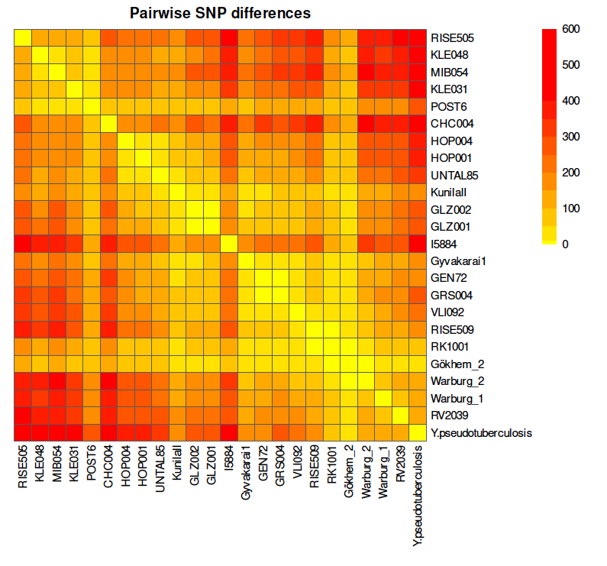
Figure S7. SNP distance matrix of LNBA and LN strains based on the Fasta alignments.

