Supplemental Table 1. Neonatal Modified KDIGO Criteria for Acute Kidney Injury²²
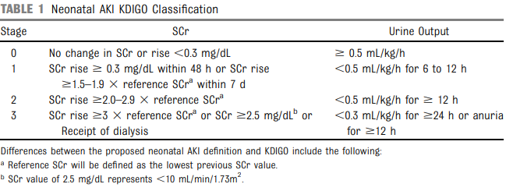

Supplemental Table 2. Acute Kidney Injury by Brain MRI Status (n = 57)
