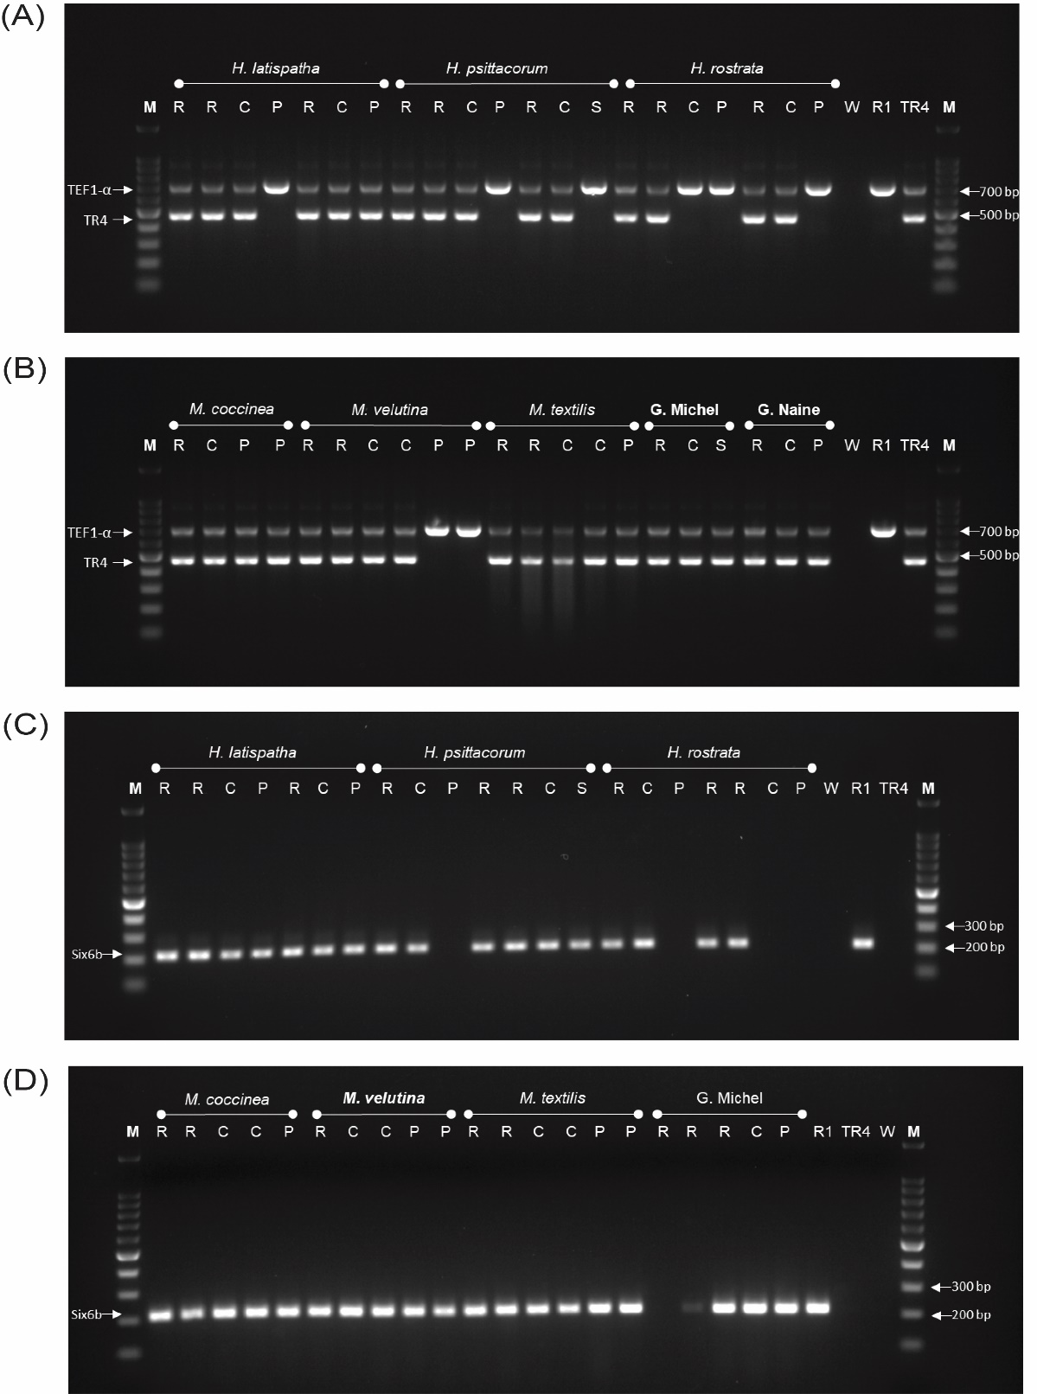
Figure S1- PCR identification of re-isolates obtained from different Heliconia and Musa species. (A) and (B) Agarose gel (1.5%) showing PCR amplicons following the molecular diagnosis of Dita et al., (2010), with the internal TEF1α amplicon and the TR4 diagnostic amplicon, corresponding with re-isolates from plants inoculated with TR4. (C) and (D) Agarose gel (1.5%) showing the results of PCR identification, according to the molecular diagnosis of Carvalhais et al., (2019), of the re-isolates obtained from plants inoculated with Race 1. Samples obtained from roots (R), corm (C), pseudostem (P). Controls comprise Fusarium odoratissimum strain II5 (TR4), F. phialophorum strain CR1.1A (R1) and water (W).

