Supplemental Text and Figures
Controlling metabolic stability of food microbiome for stable indigenous liquor fermentation
Yuwei Tan^{a,b}, Yang Zhu^{b}, René H. Wijffels^{b, c}, Hongxia Zhangª, William T. Scott Jr.^{d, e}, Yan Xuª*, Vitor Martins dos Santos^{b,f}*

- Laboratory of Brewing Microbiology and Applied Enzymology, Key Laboratory of Industrial Biotechnology of Ministry of Education, Jiangnan University, Wuxi, Jiangsu, China
- Bioprocess Engineering, Wageningen University and Research, P.O. Box 16, 6700AA Wageningen, Netherlands
- Faculty Biosciences and Aquaculture, Nord University, N-8049 Bodø, Norway
- Laboratory of Systems and Synthetic Biology, Wageningen University and Research, Stippeneng 4, 6708 WE Wageningen, Netherlands
- UNLOCK, Wageningen University & Research and Delft University of Technology, Netherlands
- Lifeglimmer GmbH, Berlin, GmbH, Berlin, Germany

* Corresponding authors
Tel.: +86-510-85964112; Fax: +86-510-85918201.
E-mail address: yxu@jiangnan.edu.cn or vitor.martinsdossantos@wur.nl

This supplementary file includes:
Supplementary figures: Fig. S1–Fig. S7
Supplementary tables: Table S1

Other supplementary information for this manuscript includes:
Supplementary dataset.xlsx: Dataset 1–Dataset 5
Dataset 1 Fermentation parameters and productivity types at end of batches.
Dataset 2 Dynamics of fermentation parameters throughout industrial fermentations.
Dataset 3 FPKM values of genes in glycolysis, pyruvate metabolism and xenobiotics metabolism.
Dataset 4 Express level of sub-clusters metabolites.
Dataset 5 Fungal and bacterial gene overexpression mapping in representative batches

Supplementary figures:
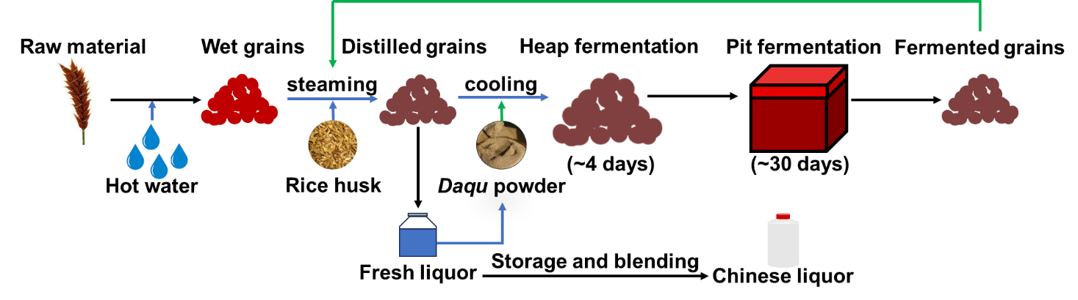
Figure S1| Manufacture chart of indigenous Chinese liquor fermentation. Blue lines represent operations that can affect abiotic parameters. Green lines represent operations that can affect biotic parameters.

Figure S2| Unstable fermentation predictions based on initial parameters. (a) The modelling steps for unstable fermentation predictions. (b) Values of sensitivity analysis (more information see table S1). (c) Prior distribution of parameters at end of batches for potential model optimization (Bayesian inference, etc.).

Figure S3| (a) Bacterial and (b) fungal succession during fermentation at genera taxonomic level.

Figure S4| Contribution of biotic and abiotic factors to eight fermentation parameters in (a) batch A and (b) batch B by random forest prediction.

Figure S5| Comparison of metabolism flux between two batches of fermentation. Gene transcription difference in primary metabolism. Significance was calculated via pair-sample t test (P < 0.05, *). The bar plot in the button shows the alternative core species of ADH expression.
Figure S6| Volatile flavor profiles of simulated fermentations. (a) The principal co-ordinates analysis (PCoA) plot of fermentation flavour. (b) Association between dilution and fermentation flavor (one-way ANOVA test).

Figure S7| Experimental design of simulated fermentations. The external fermentation conditions of all batches were same, including moisture and fermentation temperature. Dilutions of starters were used to adjust initial microbial spatial density.

Supplementary tables
Table S1. Sensitivity analysis of linear models
Initial parameters | BMV |  | TMV |  | Output
Acidity-0 | 0.000 |  | 0.000000425 |  | Alcohols-30(yield)
Reducing sugar-0 | 0.000 |  | 1.230 |  | Alcohols-30(yield)
Moisture-0 | 1.624 |  | 5.860 |  | Alcohols-30(yield)
Starch-0 | 0.142 |  | 4.410 |  | Alcohols-30(yield)
Alcohols-0 | 1.078 |  | 0.239 |  | Alcohols-30(yield)
Acetate-0 | 0.094 |  | 0.424 |  | Alcohols-30(yield)
Acidity-0 |  | 0.979 |  | 1.181 | PC1(quality)
Reducing sugar-0 |  | 1.751 |  | 4.248 | PC1(quality)
Moisture-0 |  | 0.857 |  | 0.000158 | PC1(quality)
Starch-0 |  | 0.000 |  | 0.004599 | PC1(quality)
Alcohols-0 |  | 7.525 |  | 8.337 | PC1(quality)
Acetate-0 |  | 0.265 |  | 0.000184 | PC1(quality)
Acidity-0 |  | 0.396 |  | 1.794 | PC2(quality)
Reducing sugar-0 |  | 0.046 |  | 0.053 | PC2(quality)
Moisture-0 |  | 0.464 |  | 0.088 | PC2(quality)
Starch-0 |  | 0.854 |  | 0.188 | PC2(quality)
Alcohols-0 |  | 0.291 |  | 0.489 | PC2(quality)
Acetate-0 |  | 0.000 |  | 1.165 | PC2(quality)
Acidity-0 |  | 0.966 |  | 2.931 | Acidity-30(quality)
Reducing sugar-0 |  | 0.000 |  | 0.141 | Acidity-30(quality)
Moisture-0 |  | 0.000 |  | 0.021 | Acidity-30(quality)
Starch-0 |  | 1.039 |  | 0.700 | Acidity-30(quality)
Alcohols-0 |  | 2.250 |  | 1.750 | Acidity-30(quality)
Acetate-0 |  | 0.146 |  | 1.115 | Acidity-30(quality)
Acidity-0 |  | 1.097 |  | 1.088 | R. sugar -30(quality)
Reducing sugar-0 |  | 1.892 |  | 4.012 | R. sugar -30(quality)
Moisture-0 |  | 0.815 |  | 0.054 | R. sugar -30(quality)
Starch-0 |  | 0.136 |  | 0.120 | R. sugar -30(quality)
Alcohols-0 |  | 6.879 |  | 8.668 | R. sugar -30(quality)
Acetate-0 |  | 0.295 |  | 0.000346 | R. sugar -30(quality)
Acidity-0 |  | 0.535 |  | 1.097 | Moisture -30(quality)
Reducing sugar-0 |  | 0.050 |  | 4.912 | Moisture -30(quality)
Moisture-0 |  | 2.809 |  | 11.64 | Moisture -30(quality)
Starch-0 |  | 1.147 |  | 11.23 | Moisture -30(quality)
Alcohols-0 |  | 5.693 |  | 0.062 | Moisture -30(quality)
Acetate-0 |  | 0.676 |  | 0.121 | Moisture -30(quality)
Acidity-0 |  | 0.788 |  | 1.186 | Starch -30(quality)
Reducing sugar-0 |  | 0.000 |  | 3.500 | Starch -30(quality)
Moisture-0 |  | 0.882 |  | 6.472 | Starch -30(quality)
Starch-0 |  | 1.889 |  | 7.863 | Starch -30(quality)
Alcohols-0 |  | 5.594 |  | 0.447 | Starch -30(quality)
Acetate-0 |  | 1.011 |  | 0.057 | Starch -30(quality)
Acidity-0 |  | 0.000 |  | 1.656 | Acetate -30(quality)
Reducing sugar-0 |  | 0.681 |  | 0.692 | Acetate -30(quality)
Moisture-0 |  | 0.666 |  | 0.00315 | Acetate -30(quality)
Starch-0 |  | 1.989 |  | 0.911 | Acetate -30(quality)
Alcohols-0 |  | 0.0413 |  | 0.002 | Acetate -30(quality)
Acetate-0 |  | 0.0315 |  | 2.253 | Acetate -30(quality)

