Table 1. Summary of carbon-based nanomaterial - Description, structure, and abbreviation.
CARBON NANOMATERIALS | STRUCTURE (SIZE) | MAIN RESULTS | REFERENCE
Carbon nanotubes (CNTs) | 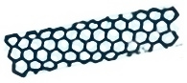(0.2-50 µm) | - Antineoplastic agent  - Vaccine nanocarrier  - DDSs  - Immunomodulatory | [32, 35]
Graphene (G)  Oxide graphene (OG) | 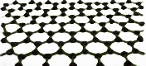(0.142 nm), | - Antineoplastic agent  - DDSs | [46, 47]
Quantum dots (QDs) | 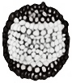(2-10 nm) | - Antineoplastic agent  - Photothermal therapy | [48, 50]
Fullerene | 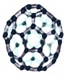(0.71 nm) | - Anti-pancreatic cancer  - DDSs  - Anti-lymphoma effect | [51, 53]
Nanodiamonds | 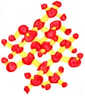(4-6 nm) | - Antineoplastic agent  - DDSs | [55, 56]
Carbon nanofibers (CNFs) | 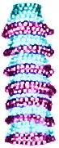(125 nm) | - Antineoplastic agent  - Immunomodulatory | [44, 57]
Nanohorn | (20-150 nm) | - Antineoplastic agent  - Anti-inflammatory | [58, 59]

