Ecological dynamics of anoxygenic phototrophs in stably redox-stratified waters: Intra and inter-seasonal variability of Lake Cadagno
N. Storelli^{1,2*}, O. Sepúlveda Steiner^{3,4}, F. Di Nezio^{1,2}, S. Roman^{1,5}, A. Buetti-Dinh¹, and D. Bouffard^{3,6}

1: University of Applied Sciences and Arts of Southern Switzerland (SUPSI), Department of Environment, Constructions and Design, Institute of Microbiology, Via Flora Ruchat-Roncati 15, 6850 Mendrisio, Switzerland.
2: University of Geneva, Department of Plant Sciences, Boulevard d’Yvoy 4, 1205 Geneva, Switzerland.
3: Eawag, Swiss Federal Institute of Aquatic Science and Technology, Surface Waters – Research and Management, Seestrasse 79, 6047 Kastanienbaum, Switzerland.
4: Civil & Environmental Engineering, University of California – Davis, 3155 Ghausi Hall, Davis, CA 95616, USA.
5: Alpine Biology Center Foundation, Via Mirasole 22A, 6500 Bellinzona, Switzerland.
6: Institute of Earth Surface Dynamics, University of Lausanne, Quartier UNIL-Mouline, 1015 Lausanne, Switzerland.

*Corresponding author: Nicola Storelli (nicola.storelli@supsi.ch)
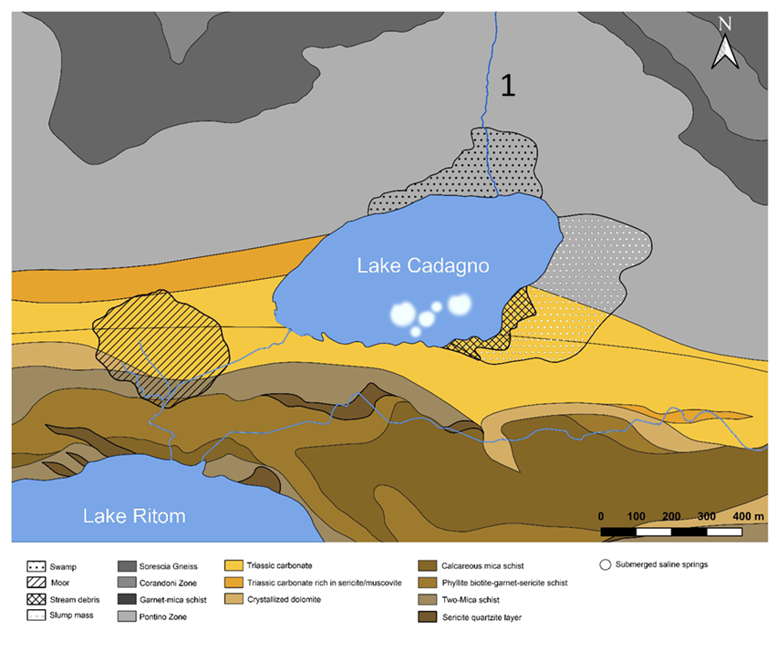
Figure S1. Overview of the geological composition of the Piora valley. The Piora-syncline is colored in yellow. The blue lines correspond to the streams, such as the one flowing from Stabbio Lake (1), which feeds crystal-clear water into the mixolimnion of Lake Cadagno. The “white spots” visible in Lake Cadagno are the entry points of sublacustrine springs that feed water enriched in salts, from dolomite, into the lake. Map created using QGIS® software (version 3.32.1). Data sourced from the Swiss Federal Office of Topography (https://www.swisstopo.admin.ch/).

Table S1. Data used to make Figure 5, and supplementary data not shown.
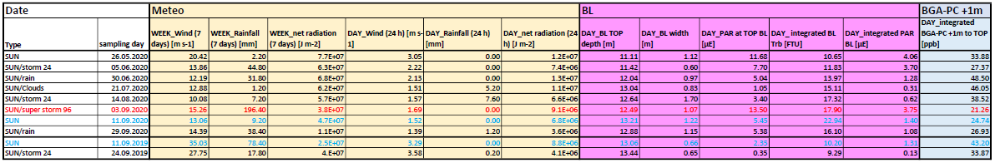
Red: refers to the sampling that occurred 4 days after the major storm event on August 30, 2020.
Light blue: the values referring to the same day in the year 2020 and 2019, the latter used as a reference of a "normal" situation without extreme storm events (e.g., August 30, 2020).

The complete dataset used for calculating the various parameters shown in the table and partly in Figure 5 are in the excel sheet "2020_meteo-BL" available online.

