Supporting Information

Surfactant-Free Cellulose Filaments Stabilized Oil in Water Emulsions
Amir Varamesh¹, Ragesh Prathapan¹, Ali Telmadarreie¹, Jia Li¹, Keith Gourlay², Gurminder Minhas², Qingye Lu¹, Steven L. Bryant^{1,*}, Jinguang Hu^{1,}
1. Department of Chemical and Petroleum Engineering, University of Calgary, Calgary T2N 1N4, Canada
2. Performance BioFilaments, 700 West Pender Street, Vancouver V6C 1G8, Canada

Table S1. Span index of the emulsion immediately after their preparation
CFs concentration (wt%) | d₁₀ (µm) | d₅₀ (µm) | d₉₀ (µm) | Span Index
0.05 | 7.458 | 23.152 | 57.968 | 2.182
0.10 | 19.945 | 35.218 | 43.187 | 0.660
0.25 | 15.124 | 24.360 | 34.328 | 0.788
0.50 | 12.966 | 19.932 | 27.490 | 0.729

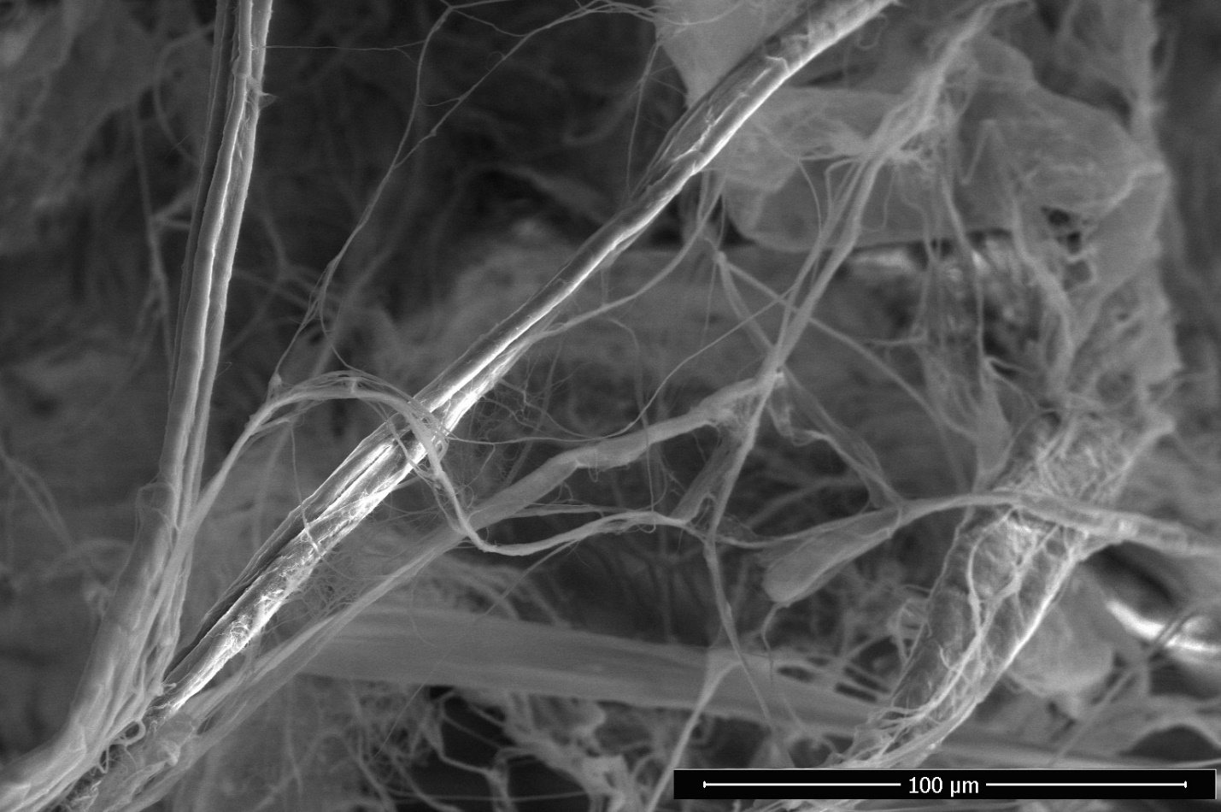
Figure S1. SEM image of the CFs sample

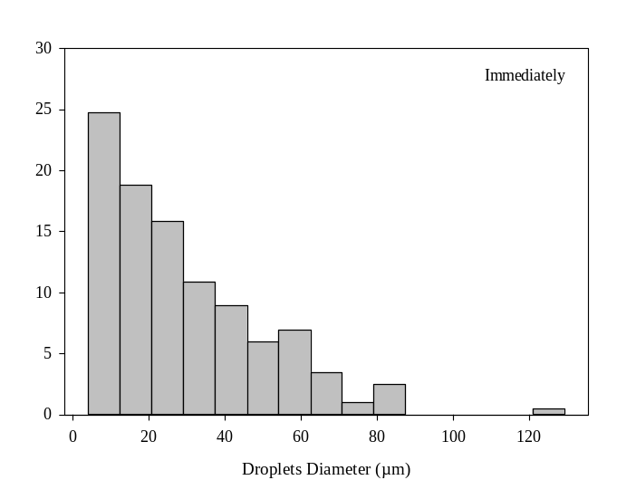
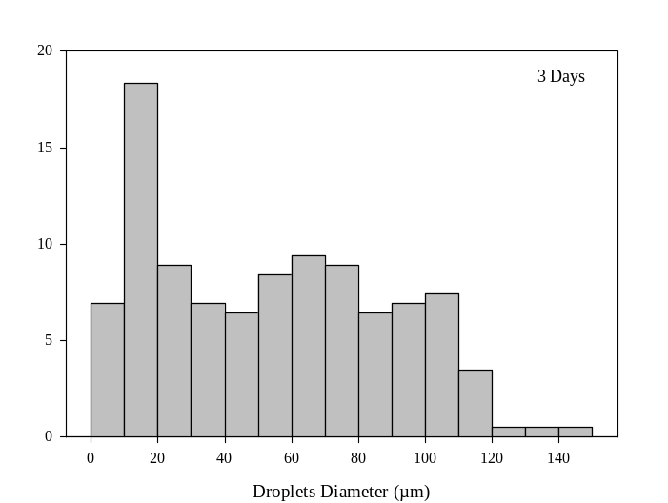
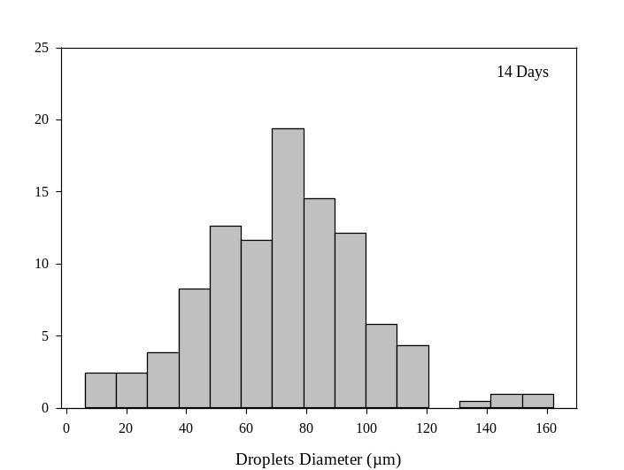

Figure S2. Size distribution of the emulsions at 0.05 wt% CFs concentration
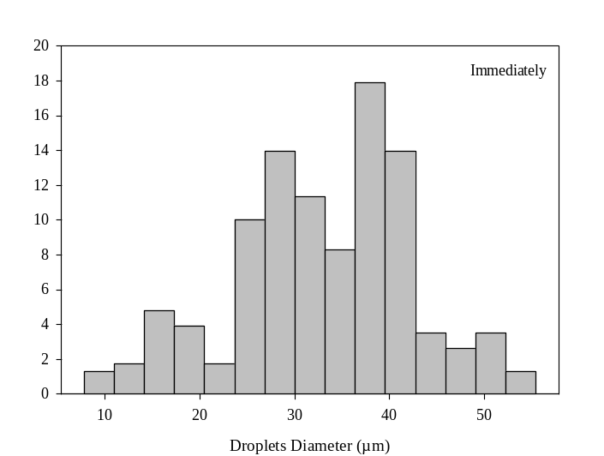
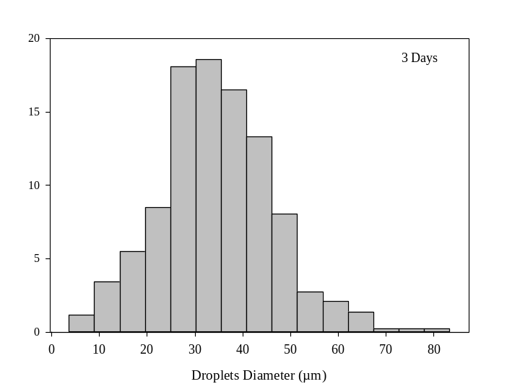
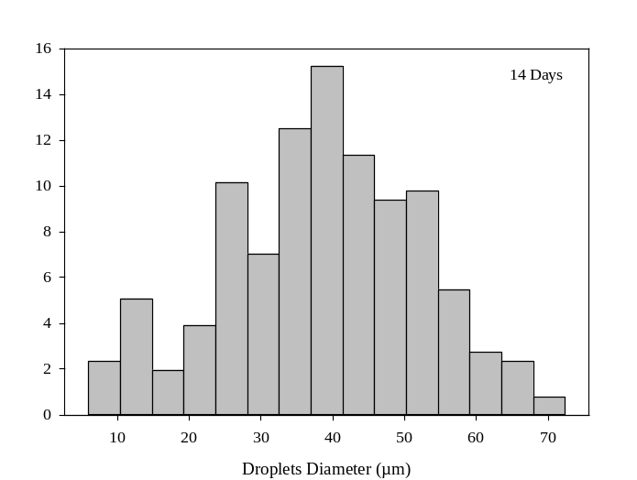

Figure S3. Size distribution of the emulsions at 0.1 wt% CFs concentration
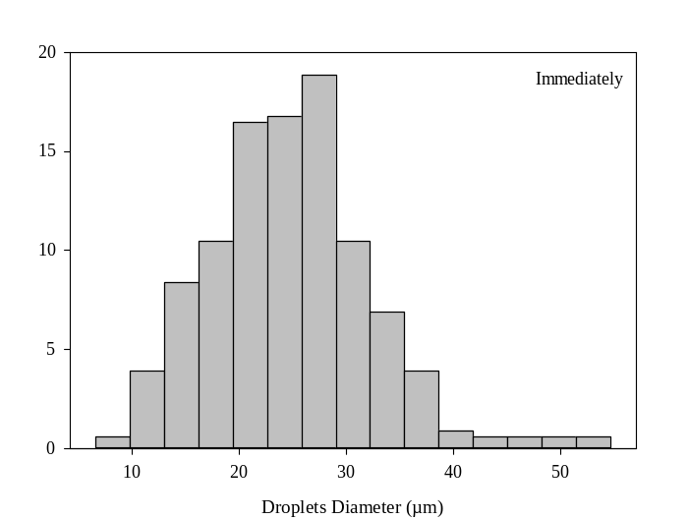
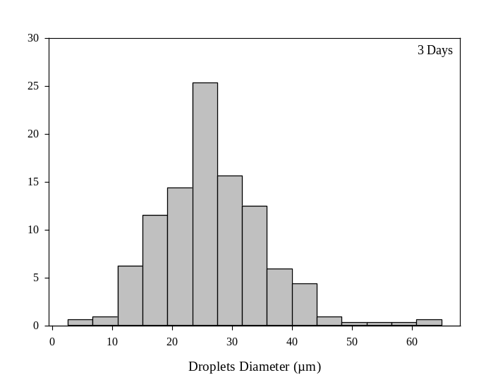
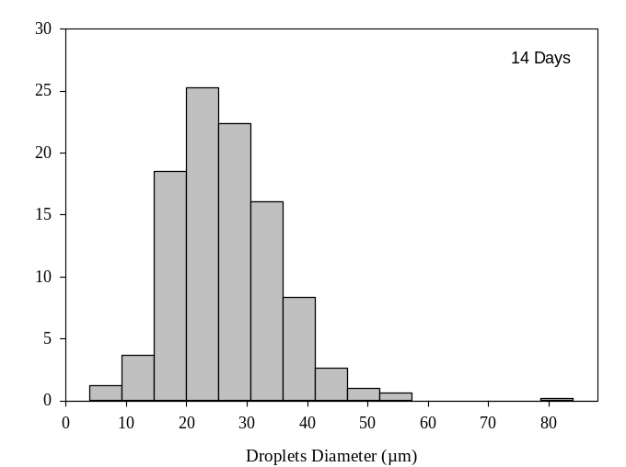

Figure S4. Size distribution of the emulsions at 0.25 wt% CFs concentration
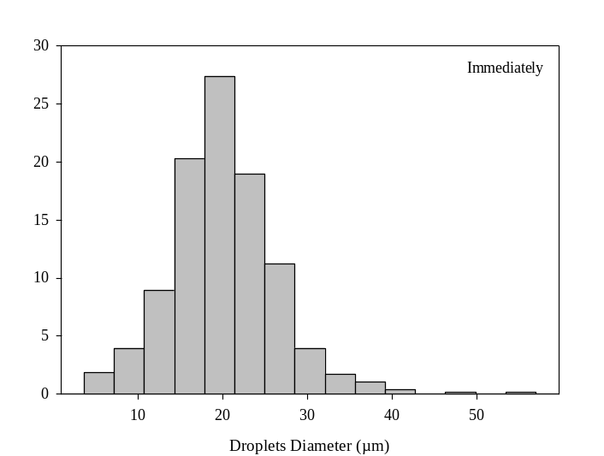

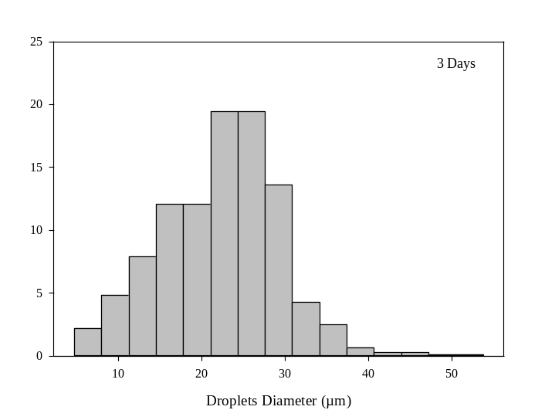

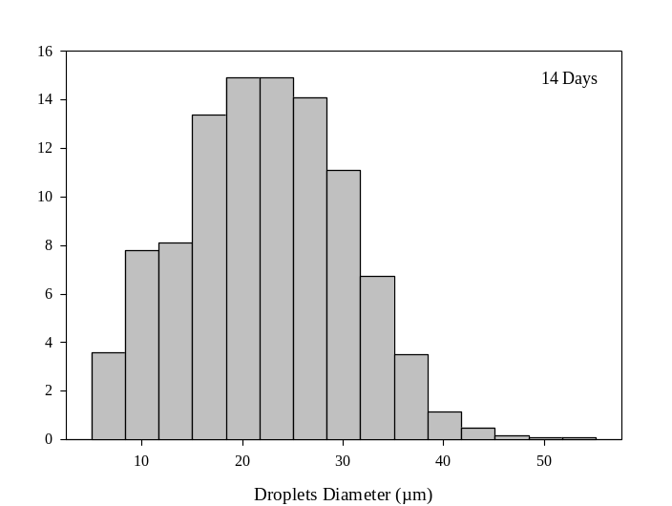

Figure S5. Size distribution of the emulsions at 0.5 wt% CFs concentration

Corresponding authors: Steven L. Bryant (steven.bryant@ucalgary.ca), Jinguang Hu (jinguang.hu@ucalgary.ca)

