Supplementary information

The kinship coefficient but not male coloration predicts early offspring growth in lake char
Laura Garaud¹#, David Nusbaumer¹#, Lucas Marques da Cunha¹, Christian de Guttry^{1,2}, Laurie Ançay¹, Audrey Atherton¹, Emilien Lasne^{3,4} & Claus Wedekind¹*

¹ Department of Ecology & Evolution, University of Lausanne, Lausanne, Switzerland
² Swiss Institute of Bioinformatics (SIB), Environmental Bioinformatic Group, Lausanne, Switzerland
³ Université Savoie Mont Blanc, INRAE, MR CARRTEL, Station d’Hydrobiologie Lacustre, Thonon Cedex, France
⁴ UMR DECOD (Ecosystem Dynamics and Sustainability), INRAE, Institut Agro, IFREMER, Rennes, France

* Correspondence: Claus Wedekind, claus.wedekind@unil.ch; orcid.org/0000-0001-6143-4716
# Equal contributors

Content

Figure S1. Yolk-sac larvae at hatching and 14 days later
Figure S2. Larval lengths and yolk sac volumes over time
Figure S3. Larval growth 14dph predicted by treatment and male characteristics
Figure S4. Offspring inbreeding coefficients predicted by male inbreeding coefficients

Table S1. Linear mixed model on larval length 14 days post hatching (1st experiment)
Table S2. Testing the effects of excluding the male with an extra-ordinary low F_{β.male} (2nd experiment)

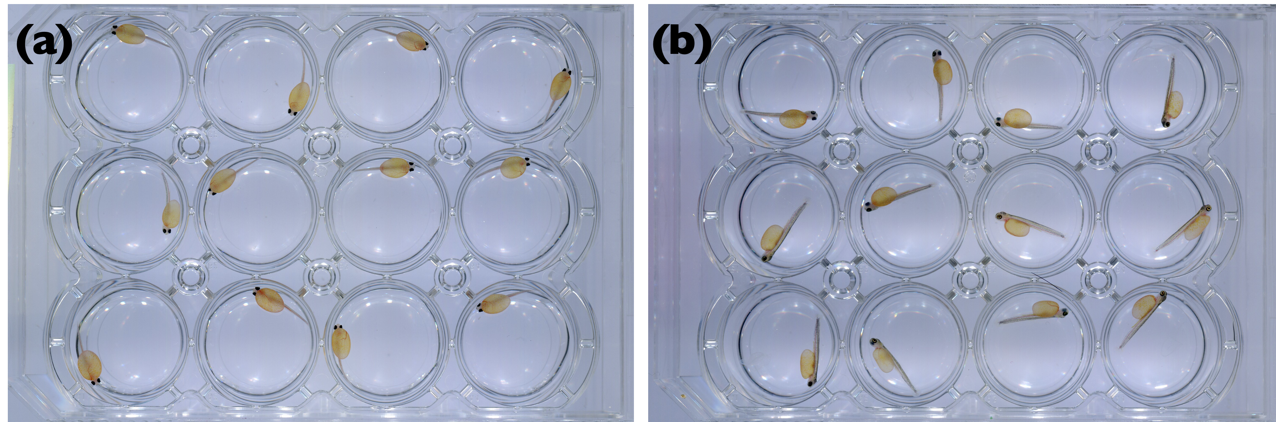

Supplementary Figure S1. Yolk-sac larvae raised at 4.5°C in 12-well plates from hatching on. The photos were taken (a) at hatching and (b) 14 days later.

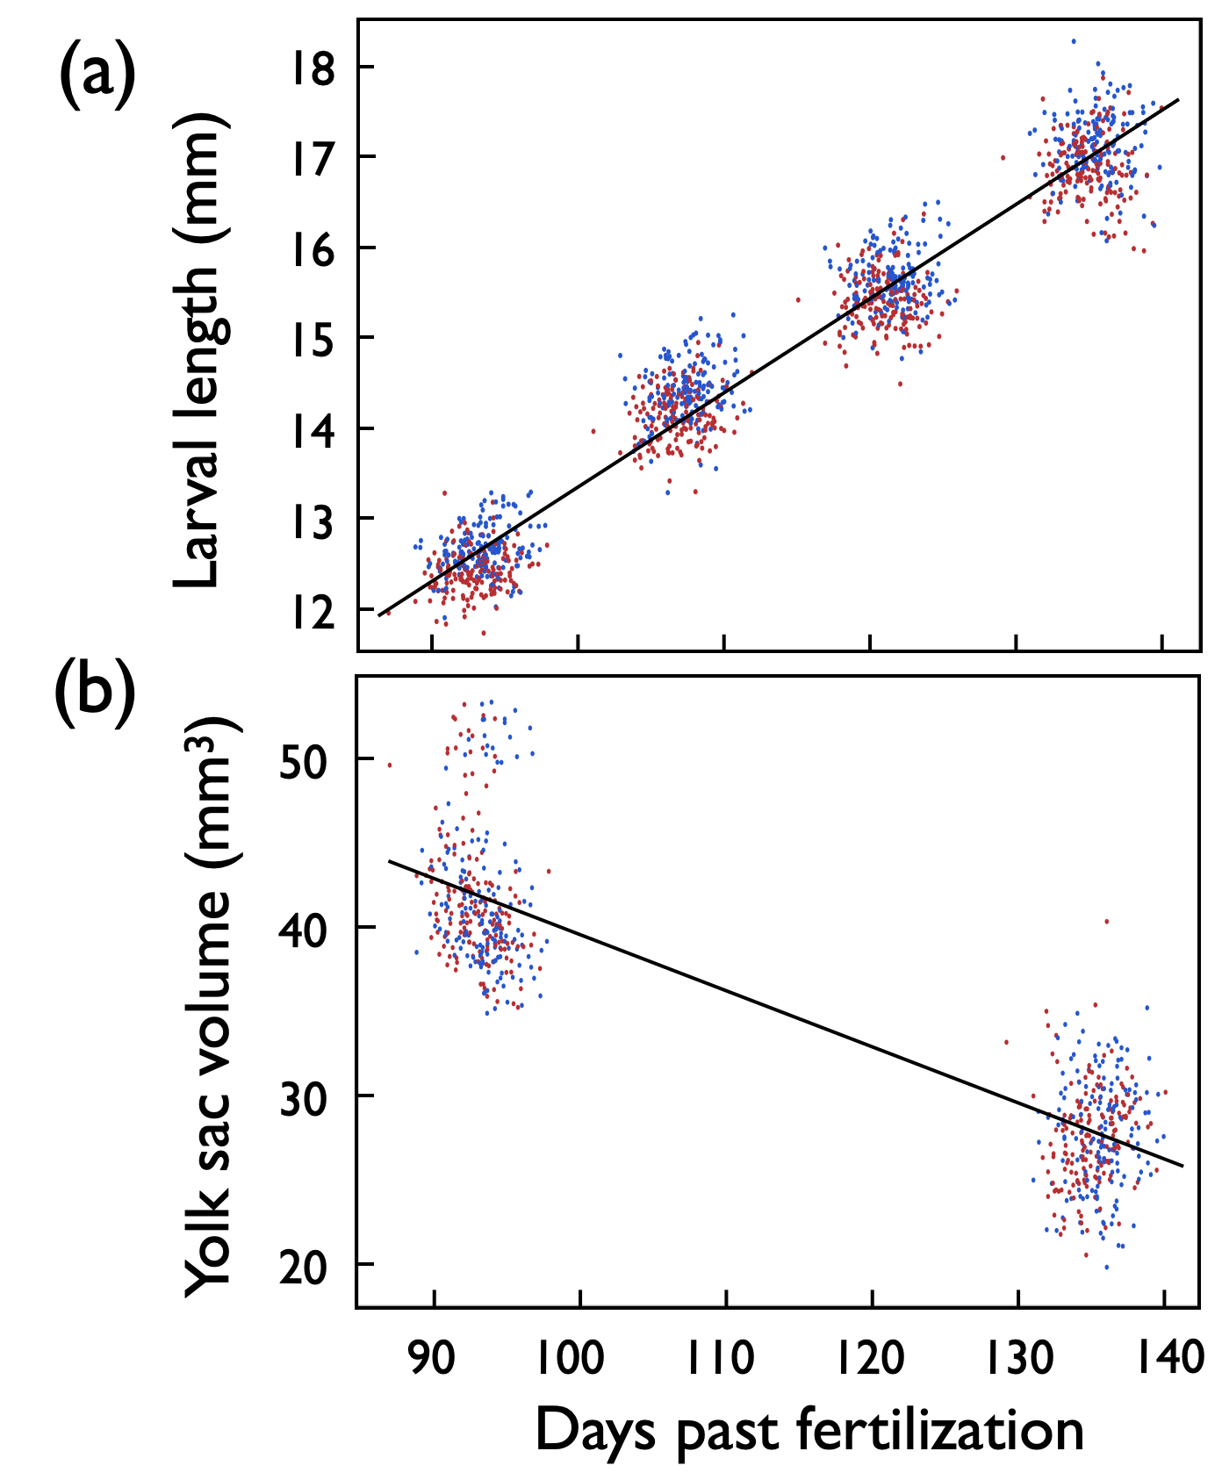

Supplementary Figure S2. Days past fertilization (dpf) versus (a) average larval length and (b) average yolk sac volume per full-sib family and treatment (red: exposed to Aeromonas salmonicida, blue: sham exposed). Larval lengths were measured at the day of hatching and 14, 28, and 42 days later. Yolk sac volumes were measured at the day of hatching and 42 days later. The lines give the linear regressions.
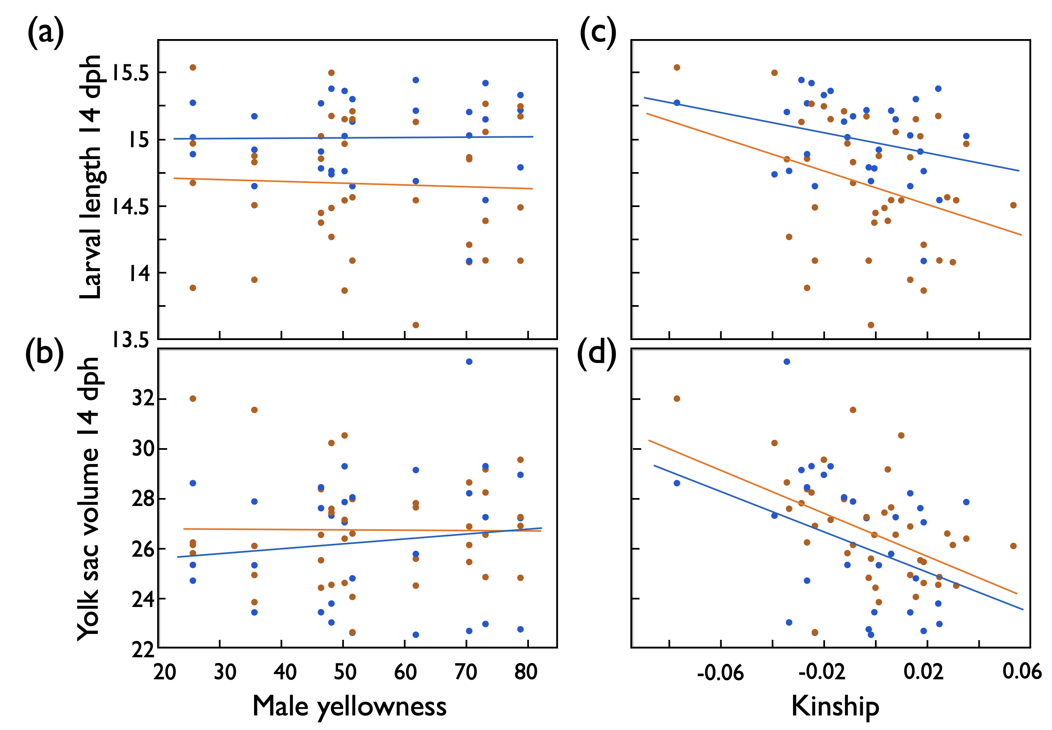

Supplementary Figure S3. Larval growth in 1st experiment: Mean larval length (mm) 14 days past hatching (dph), and mean yolk sac volume at that time (means per full-sib family) predicted by (a,b) male skin coloration (yellowness) or (c,d) by the genetic similarity between males and females (kinship) after exposure to remainders of ovarian fluids (orange symbols and regression lines), or sham exposed (blue). See Table S1 for statistics.

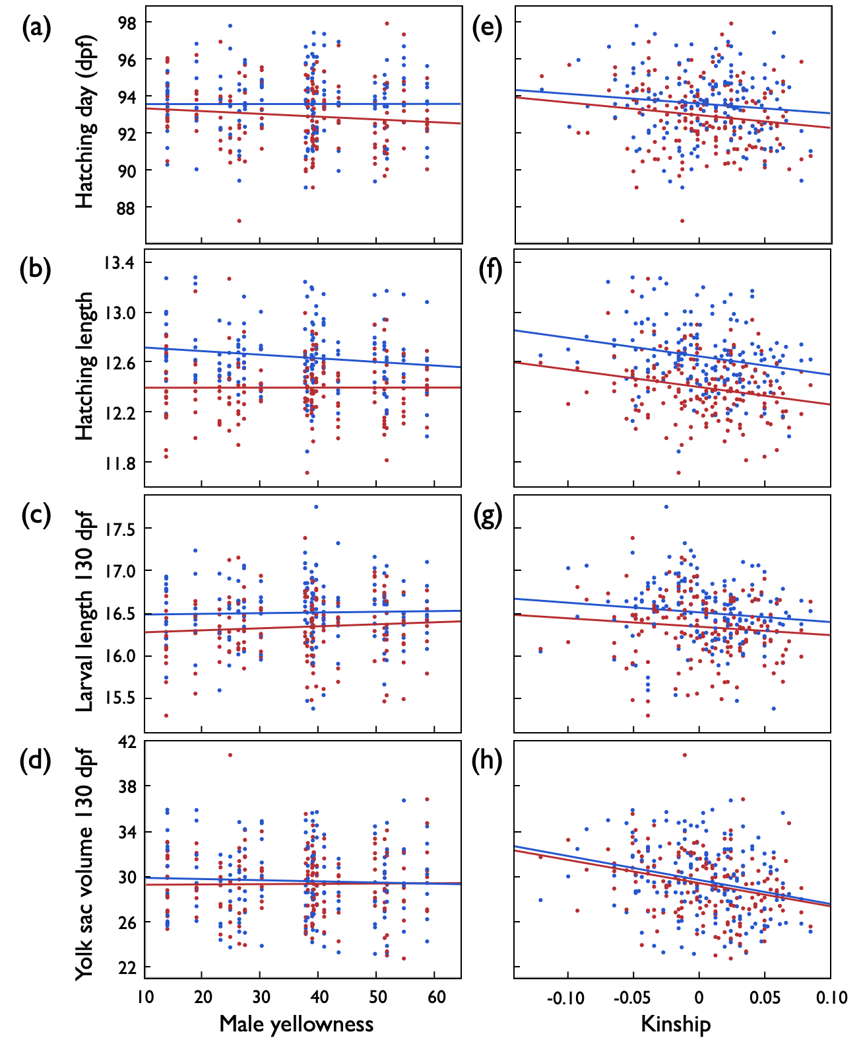

Supplementary Figure S4. Second experiment: Embryo development after exposure to Aeromonas salmonicida (red symbols and regression lines) or sham exposure (blue) after excluding one male with extremely low F_{β.male} and kinship values (text Figure 3). (a) Mean hatching time (dpf = days past fertilization), (b) mean larval length at hatching (mm), (c) mean larval length 130 dpf (mm), and (d) mean yolk sac volume 130 dpf (mm³) per full-sib family predicted by male skin coloration (yellowness), and (e,f,g.h) predicted by the genetic similarity between males and females (kinship). See Table S3 for statistics.

Supplementary Table S1. Testing for effects on larval growth in 1st experiment: Linear mixed model on larval length 14 days post hatching (dph) when predicted by treatment and (a) male skin coloration (yellowness) or (b) the genetic similarity between males and females (kinship). Hatching date was included as further fixed factor. Family identity and the interaction between family ID and treatment were included as random factors. New significant p-values are highlighted in bold (parental effects and effects of treatment and hatching date had already been reported in Nusbaumer et al. (2021)).

 |  | Larval length 14 dph |  |  |  | Yolk sac volume 14 dph
Effects | d.f. | Variance component | F | p |  | Variance component | F | p
(a) Male skin coloration
Fixed effects:
Treatment | 1 |  | 17.1 | <0.001 |  |  | 3.4 | 0.08
Yellowness | 1 |  | 0.9 | 0.95 |  |  | 0.2 | 0.65
Treatment x yellowness | 1 |  | 0.9 | 0.88 |  |  | 0.9 | 0.34
Hatching date | 1 |  | 38.0 | <0.001 |  |  | 79.5 | <0.001
Random effects¹:
Family ID |  | 0.13±0.04 |  | <0.001 |  | 2.01±0.76 |  | 0.008
Family x treatment |  | 0.05±0.02 |  | 0.02 |  | 0.28±0.44 |  | 0.52
Residual |  | 0.65±0.03 |  |  |  | 26.8±1.3
(b) Male & female kinship
Fixed effects:
Treatment | 1 |  | 17.4 | <0.001 |  |  | 4.5 | 0.04
Kinship | 1 |  | 2.9 | 0.09 |  |  | 14.3 | <0.001
Treatment x kinship | 1 |  | 1.2 | 0.29 |  |  | 0.7 | 0.40
Hatching date | 1 |  | 37.3 | <0.001 |  |  | 86.9 | <0.001
Random effects¹:
Family ID |  | 0.12±0.04 |  | 0.002 |  | 1.13±0.59 |  | 0.05
Family x treatment |  | 0.04±0.02 |  | 0.03 |  | 0.25±0.46 |  | 0.58
Residual |  | 0.65±0.03 |  |  |  | 26.8±1.1
¹REML unbounded variance components ± standard error, Wald p-values
Supplementary Table S2. Second experiment: Rerunning the analyses presented in Table 3 when excluding the male with an extra-ordinary low F_{β.male} (see Figure 1): Linear mixed model on embryo hatching time and hatchling length when predicted by treatment and (a) male skin coloration (yellowness) or (b) the genetic similarity between males and females (kinship). Hatching date was included as further fixed factor when testing for effects on hatchling length. Family identity and the interaction between family ID and treatment were included as random factors. Significant p-values are highlighted in bold.

 |  | Hatching time |  |  |  | Hatchling length |  |  |  | Larval length 130dpf |  |  |  |  |  |  | Yolk sac volume 130dpf
Effects | d.f. | Variance component | F | p-value |  | Variance component | F | p-value |  | Variance component |  |  | F | p-value |  | Variance component |  |  | F |  |  | p-value
(a) Male skin coloration
Fixed effects:
Treatment | 1 |  | 21.0 | <0.001 |  |  | 166.8 | <0.001 |  |  |  |  | 71.1 | <0.001 |  |  |  |  | 1.7 |  |  | 0.20
Yellowness | 1 |  | 0.6 | 0.44 |  |  | 0.1 | 0.81 |  |  |  |  | 1.2 | 0.28 |  |  |  |  | 0.07 |  |  | 0.79
Treatment x yellowness | 1 |  | 1.6 | 0.20 |  |  | 7.6 | 0.006 |  |  |  |  | 0.5 | 0.46 |  |  |  |  | 0.6 |  |  | 0.44
Hatching date | 1 |  |  |  |  |  | 294.4 | <0.001
Random effects¹:
Family ID |  | 1.60±0.28 |  | <0.001 |  | 0.03±0.005 |  | <0.001 |  | 0.09±0.01 |  |  |  | <0.001 |  | 4.7±0.8 |  |  |  |  |  | <0.001
Family x treatment |  | 1.04±0.17 |  | <0.001 |  | 0.004±0.002 |  | 0.11 |  | 0.003±0.004 |  |  |  | 0.41 |  | 0.7±0.5 |  |  |  |  |  | 0.38
Residual |  | 4.13±0.11 |  |  |  | 0.16±0.004 |  |  |  | 0.21±0.007 |  |  |  |  |  | 25.8±0.8
(b) Genetic similarity
Fixed effects:
Treatment | 1 |  | 21.1 | <0.001 |  |  | 160.1 | <0.001 |  |  |  |  | 70.7 | <0.001 |  |  |  |  | 1.7 |  |  | 0.19
Kinship | 1 |  | 3.9 | 0.05 |  |  | 4.6 | 0.03 |  |  |  |  | 2.5 | 0.12 |  |  |  |  | 19.2 |  |  | <0.001
Treatment x kinship | 1 |  | 0.1 | 0.71 |  |  | 0.03 | 0.87 |  |  |  |  | 0.01 | 0.91 |  |  |  |  | 0.001 |  |  | 0.97
Hatching date | 1 |  |  |  |  |  | 287.3 | <0.001
Random effects¹:
Family ID |  | 1.55±0.27 |  | <0.001 |  | 0.03±0.005 |  | <0.001 |  | 0.09±0.01 |  |  |  | <0.001 |  | 3.9±0.7 |  |  |  |  |  | <0.001
Family x treatment |  | 1.05±0.17 |  | <0.001 |  | 0.005±0.003 |  | 0.06 |  | 0.003±0.004 |  |  |  | 0.35 |  | 0.7±0.5 |  |  |  |  |  | 0.11
Residual |  | 4.13±0.11 |  |  |  | 0.16±0.004 |  |  |  | 0.21±0.007 |  |  |  |  |  | 25.8±0.8
¹REML unbounded variance components ± standard error, Wald p-values

