Mapping the race between crop's phenology and climate risks; a case-study for wheat in France under climate change conditions.
Author list:
Renan Le Roux*, Alexis Durand¹, Jean-Charles Deswarte, Marie-Odile Bancal, Karine Chenu, Nathalie de Noblet-Ducoudré, Burak Bulut⁵, Carina Furusho-Percot¹, Iñaki García de Cortázar-Atauri¹, Olivier Maury¹, Jérémie Décome¹, Marie Launay¹*.
* Corresponding authors: Le Roux, R. (renan.le-roux@inrae.fr,ORCID iD 0000-0001-7778-1878) & Launay M. (marie.launay@inrae.fr; ORCID iD 0000-0003-4067-3907)

Figure S1. Normalization functions: (a) Modified exponential (shown here with the specific coefficients applied for the indicator of the number of days with very cold temperatures leading to mortality between emergence and ear 1 cm stages), (b) Inverse sigmoid (shown here with the specific coefficients applied for the indicator of heat days damaging grain filling between anthesis and grain maturity), (c) Sigmoid (shown here with the specific coefficients applied for the indicator of vernalizing days between emergence and ear 1 cm stages)

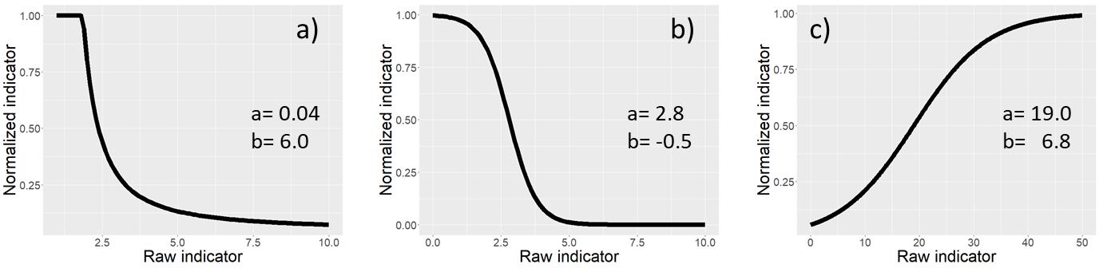

Sigmoid function:
$$y=\frac{1}{1+e^{\frac{\left(a-x\right)}{b}}⁡}$$

Modified exponential function:
$$y=min\left(a×e^{\frac{b}{x}},1\right)$$

Figure S2: Simulated vs. observed dates of phenological stages ear 1 cm (green dots), flag leaf (orange dots) and anthesis (purple dots). Each point represents a site x year observation from the EPIPHYT database (https://data.pheno.fr/). Black continue line represents the 1:1 relationship.

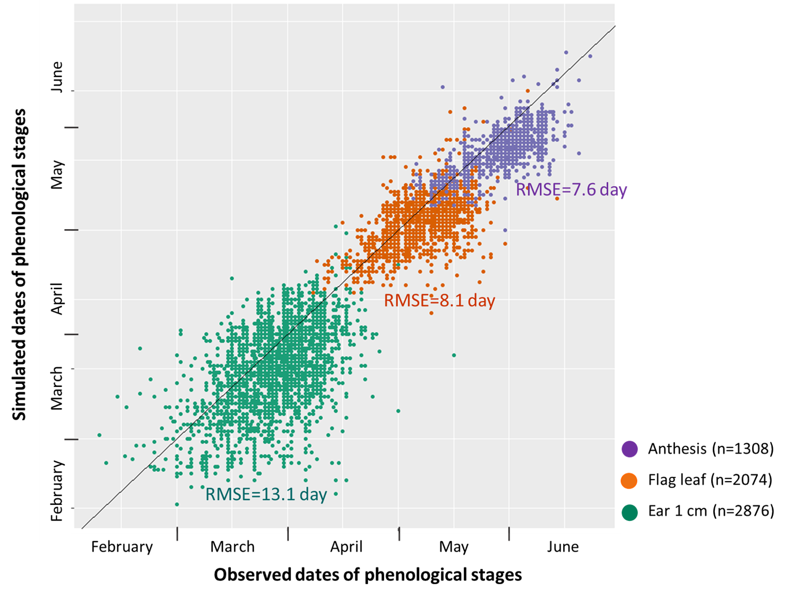

Figure S3: Historical (1991-2020), near (2041-2070) and far (2071-2100) futures’ distribution of wheat main phenological phases (EM-E1: emergence to ear 1 cm; E1-FL: ear 1 cm to flag leaf; FL-AN: flag leaf to anthesis; AN-GM: anthesis to grain maturity) under RCP 4.5 scenario in the 7 French wheat ecoclimatic zones (WEZs A to G). DOY: day of the year.

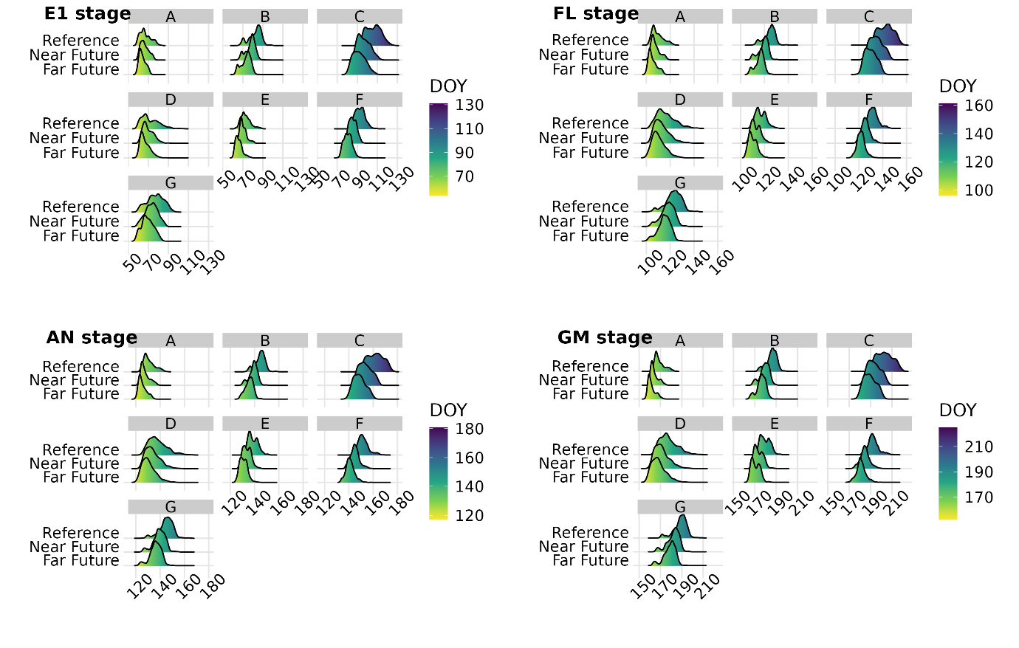

Table S1: Median of the simulated dates of phenological stages per Wheat Ecoclimatic Zone in France, for RCP 4.5 and 8.5 scenarios, and historical (1991-2020), near future (2041-2070) and far future (2071-2100) periods.
Figure S4. Evolution of the frequency (number of years over a 30-year period) of the different types of climatic risks since historical (1991-2020), near (2041-2070) and far (2071-2100) futures in the 7 French wheat ecoclimatic zones (WEZs A to G) under RCP 4.5 scenario. The different types of climatic risks concern cold temperatures, excess water, heat and drought. The size of the circles corresponds to the percentage of the area of the WEZ affected by the risk. The transparent area delimited by the dotted lines represents the 95 and 5 quantiles of the distribution.

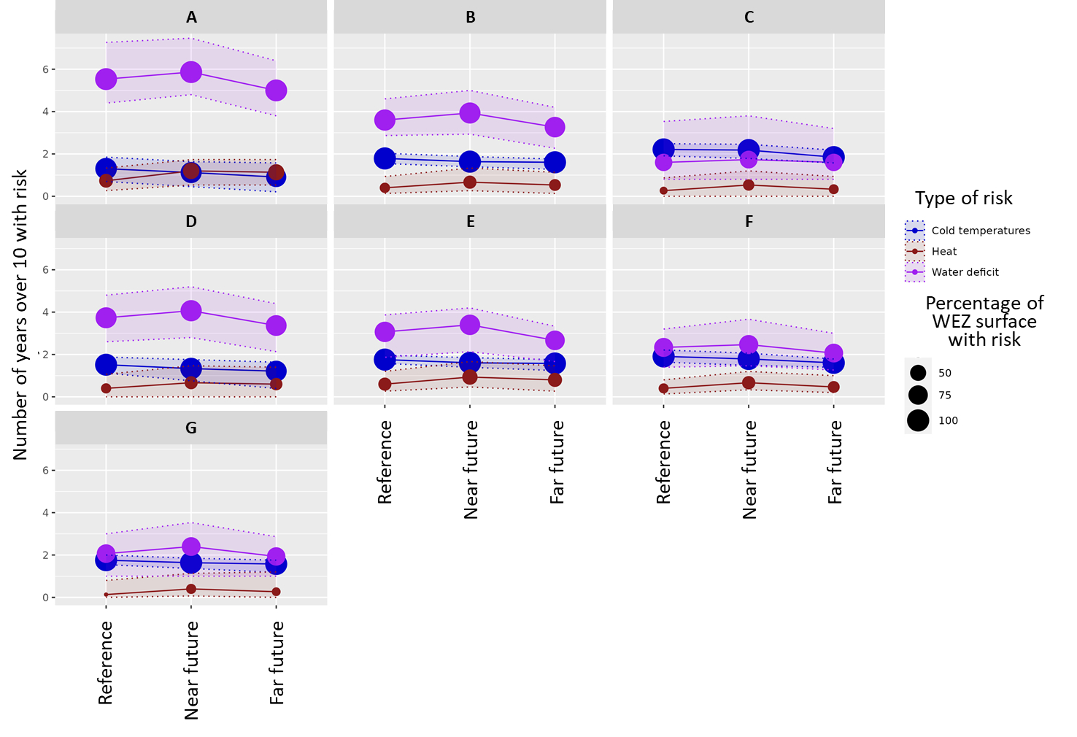

Figures S5: Bivariate maps of heat and water deficit indicators per phenological phase

Figure S5.1. Bivariate maps of heat and water deficit indicators per phenophase for different periods for RCP 8.5. A) represents historical (1991-2020), B) near future (2041-2071) and C) far future (2071-2100). EM-E1: emergence to ear 1cm stage; E1-FL: ear 1cm to flag leaf stage; FL-AN: flag leaf to anthesis stage; AN-GM: anthesis to grain maturity stage. Each cell of the legend corresponds to a class of heat and water deficit combined risk and corresponds to the median of the three models.
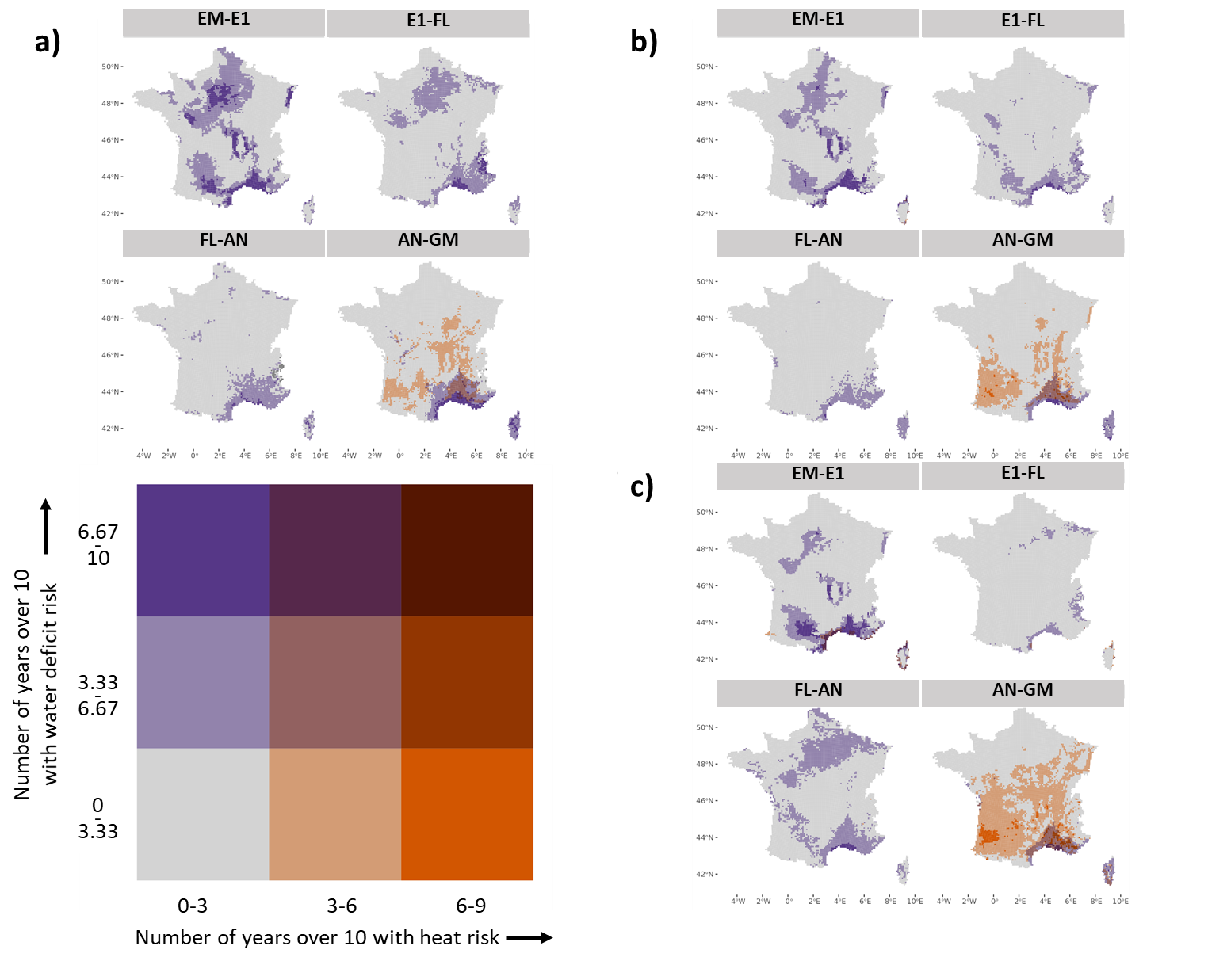

Figure S5.2. Bivariate maps of heat and water deficit indicators per phenophase for different periods for RCP 4.5. A) represents historical (1991-2020), B) near future (2041-2071) and C) far future (2071-2100). EM-E1: emergence to ear 1cm stage; E1-FL: ear 1cm to flag leaf stage; FL-AN: flag leaf to anthesis stage; AN-GM: anthesis to grain maturity stage. Each cell of the legend corresponds to a class of heat and water deficit combined risk and corresponds to the median of the three models.
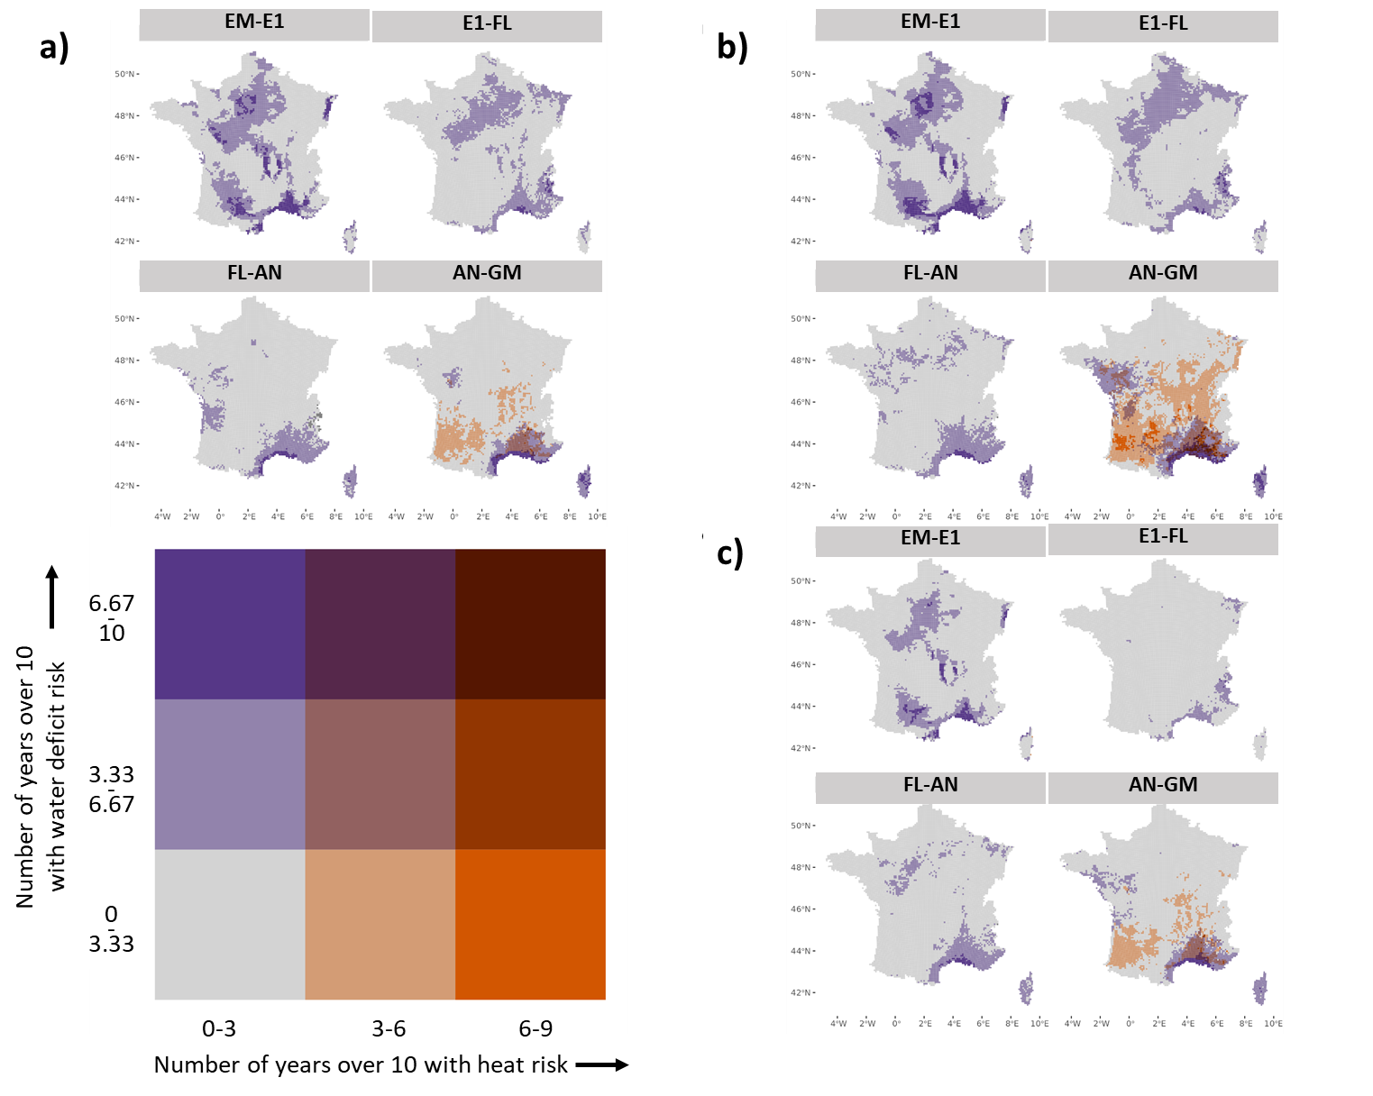

Figure S6. Bivariate maps of heat and water deficit indicators for different periods for RCP 4.5. A) represents historical (1991-2020), B) near future (2041-2071) and C) far future (2071-2100). Each cell of the legend corresponds to a class of heat and water deficit combined risk. Large maps (on the left) correspond to the median of the three models while Q5 and Q95 maps are associated with quantiles 0.05 and 95 of the three models.

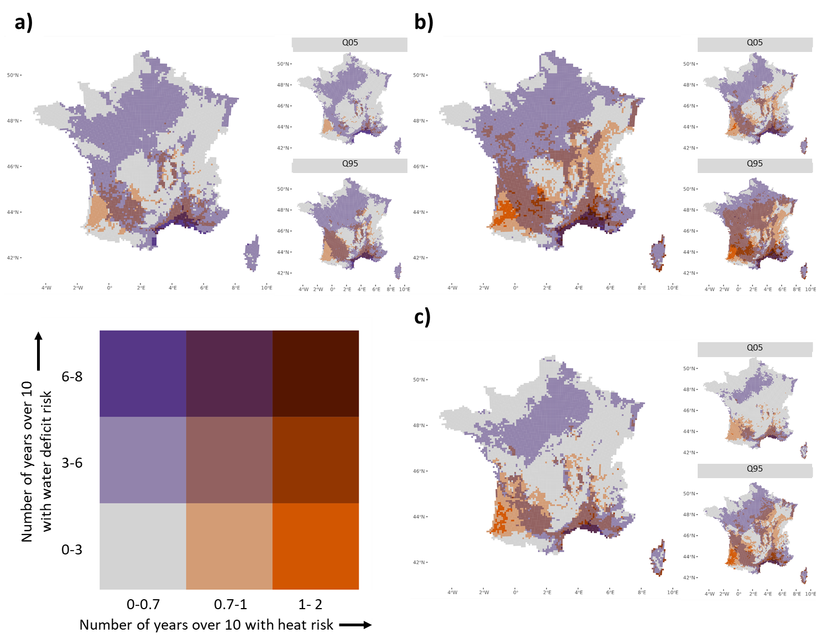

INRAE, US AgroClim, F-84914, Avignon, France
ARVALIS - Institut du Végétal, Villiers-le- Bâcle, France
Université Paris-Saclay, INRAE, UMR Ecosys Agroparistech, F-78850, Thiverval-Grignon, France
The University of Queensland, Queensland Alliance for Agriculture and Food Innovation (QAAFI), Leslie Research Facility, 13 Holberton street, Toowoomba, QLD 4350, Australia
Laboratoire des Sciences du Climat et de l`Environnement LSCE/IPSL, Unité Mixte CEA-CNRS-UVSQ, Université Paris-Saclay, 91191 Gif-Sur-Yvette, France

