Appendix I. Forest plots for included analyses
Table of Contents
Barnes 2019 {3836} 5
Hypnotherapy alone versus Placebo- Abstinence/cessation, 12 months 5
Cahill 2010 {1652} 6
Stage-based expert systems or tailored self-help materials versus Assessment only- Abstinence/cessation, 6+ months 6
Stage-based interactive computer programmes versus Usual care- Abstinence/cessation, 12+ month 6
Stage-based telephone counselling versus Usual Care- Abstinence/cessation, 12 months 7
Stage-based individual counselling and/or advice versus Usual care- Abstinence/cessation, 6+ months 7
Stage-based individual counselling or advice versus Assessment only- Abstinence/cessation, 6+ months 7
Cahill 2016 {1960} 8
Cystisine versus Placebo- Abstinence/cessation (continuous), 6+ months 8
Cytisine versus Placebo- Abstinence/cessation (point prevalence), 2 years 8
Varenicline versus Placebo- Abstinence/cessation, longest follow-up (6+ months) 9
Varenicline versus Placebo- Abstinence/cessation, 6 months 10
Long term varenicline versus Placebo- Abstinence/cessation, 6-12 months 10
Low dose varenicline versus Placebo- Abstinence/cessation- 12 months 11
Variable dosing of varenicline versus Placebo- Abstinence/cessation, 12 months 11
Varenicline versus Placebo- Abstinence/cessation in smokers reducing to quit, 12 months 11
Varenicline versus Placebo- Abstinence/cessation in smokers with schizophrenia, bipolar, or other psychiatric disorder, 6 months 12
Varenicline versus Placebo- Abstinence/cessation in smokers with depression and motivated/wishing to quit, 12 months 12
Varenicline versus Placebo- Abstinence/cessation in smokers who previously failed to quit on varenicline but are motivated/wishing to try quitting again, 12 months 12
Varenicline versus Placebo- Adverse events (nausea), Range of follow-up times 13
Varenicline versus Placebo- Adverse events (insomnia), Range of follow-up times 14
Varenicline versus Placebo- Adverse events (abnormal dreams), Range of follow-up times 15
Varenicline versus Placebo- Adverse events (headache), Range of follow-up times 16
Varenicline versus Placebo- Adverse events (depression), Range of follow-up times 17
Varenicline versus Placebo- Adverse events (suicidal ideation), Range of follow-up times 18
Varenicline versus Placebo- Serious adverse event (at least one), Range of follow-up times 19
Varenicline versus Placebo- Serious adverse event (at least one during or immediately after treatment), Range of follow-up times 20
Varenicline versus Placebo- Neuropsychiatric events (depression, suicidal ideation), not deaths, Range of follow-up times 21
Varenicline versus Placebo- Serious adverse events (cardiac, including deaths), Range of follow-up times 22
Farley 2012 {1469} 23
Buproprion versus Placebo- Weight gain, End of treatment 23
Buproprion versus Placebo- Weight gain, 6 months 23
Buproprion versus Placebo- Weight gain, 12 months 23
NRT versus Placebo- Weight gain, End of treatment 24
NRT versus Placebo- Weight gain, 6 months 25
NRT versus Placebo- Weight gain, 12 months 26
Varenicline 2mg/day versus Placebo- Weight gain, End of treatment 27
Varenicline 2mg/day versus Placebo- Weight gain, 6 months 27
Varenicline 2mg/day versus Placebo- Weight gain, 12 months 27
Varenicline 1mg/day versus Placebo- Weight gain, End of treatment 27
Hartmann-Boyce 2018 {332} 28
NRT patch versus Placebo- Adverse events (Palpitations/chest pains), Range of follow-up times 28
Hollands 2015 {916} 29
Interventions to increase adherence for tobacco dependence versus Usual or standard care- Abstinence/cessation, 6 months 29
Hughes 2014 {1147} 30
Bupropion versus Placebo- Abstinence/cessation, 6 months 30
Bupropion versus Placebo- Reduction in cotinine >50%, 12 months 30
St John’s wort versus Placebo- Abstinence/cessation, 6 months 30
S-Adenosyl-L-Methionine (SAMe) versus Placebo- Abstinence/cessation, 6 months 30
Lancaster 2017 {539} 31
Individual counselling versus Minimal contact control- Abstinence/cessation, 6+ months 31
Lindson-Hawley 2016 {671} 32
NRT versus Placebo- Abstinence/cessation, 12 months to 24 months 32
NRT versus Placebo- Reduction in cigarettes/day of >50% of baseline or cessation, 12+ months 33
Bupropion versus Placebo- Abstinence/cessation, 6 months 33
Bupropion versus Placebo- Reduction in cigarettes/day of >50% of baseline or cessation, 12 months 34
Varenicline versus Placebo- Abstinence/cessation, 6 months 34
Telephone counselling plus self-help materials versus Usual care- Abstinence/cessation, 12 months & 34
Telephone counselling plus self-help materials versus Usual care- Reduction in cigarettes/day of >50% of baseline or cessation, 12 months 34
E-cigarettes versus Placebo- Abstinence/cessation, 12 months 35
E-cigarettes versus Placebo- Reduction in cigarettes/day of >50% of baseline or cessation, 12months 35
Livingstone-Banks 2019 {1077} 36
Non-tailored print-based self-help materials (no face-to-face contact) versus No materials/no intervention- Abstinence/cessation, 6+ months 36
Non-tailored print-based self-help (no face-to-face contact) versus No materials/no interventions- Abstinence/cessation, 6 months 36
Non-tailored print-based self-help materials (no face-to-face contact) versus Brief leaflet- Abstinence/cessation, 6+ months 37
Non-tailored print-based self-help materials (with face-to-face contact) versus No treatment or leaflet only- Abstinence/cessation, 6+ months 37
Individually tailored print-based self-help materials (no face-to-face contact) versus No materials/ no interventions- Abstinence/cessation- 6+ months 38
Matkin 2019 {1228} 39
Hotline and self-help materials versus Minimal intervention- Abstinence/cessation, 12-18 months 39
Intense telephone counselling versus Minimal intervention- Abstinence/cessation, 6+ months 39
Brief motivational telephone counselling versus Usual care telephone call- Abstinence/cessation- 12 months 39
Telephone counselling for smoking reduction versus Usual care telephone call- Abstinence/cessation, 12 months 40
Stead 2013 {1998} 41
Physician advice (minimal or intensive interventions) versus No advice (or usual care)- Abstinence/cessation, 6+ months 41
Physician advice with follow-up versus Minimal intervention /advice with single visit- Abstinence/cessation, 6+ months 42
Intensive advice versus Minimal advice- Abstinence/cessation, 6+ months 43
Stead 2016 {1356} 44
Combined pharmacotherapy and behavioural interventions versus Usual care or minimal intervention- Abstinence/cessation, 6+ months 44
Combined pharmacotherapy and behavioural interventions versus Usual care or no intervention- Abstinence/cessation, 12 months 45
Stead 2017 {538} 46
Group therapy versus No intervention- Abstinence/cessation, 6+ months 46
Taylor 2017 {411} 47
Interactive and tailored internet intervention versus Non-active control- Abstinence/cessation, 6-12 months 47
Internet plus behavioural support versus Non-internet-based non-active control- Abstinence/cessation, 6-12 months 47
Tsoi 2013 {1698} 48
Bupropion versus Placebo- Abstinence/cessation, 6 months 48
Bupropion versus Placebo- Reduction in number of cigarettes per day from baseline, 6 months 48
Bupropion versus Placebo- Tobacco smoking reduction- Expired CO level, 6 months 49
Bupropion versus Placebo- Change in emotional state End of treatment & 49
Varenicline versus Placebo- Abstinence/cessation, 6 months 50
Van der Meer 2013 {1223} 51
Bupropion versus Placebo (current depression)- Abstinence/cessation, 6-12 months 51
Bupropion versus Placebo (past depression)- Abstinence/cessation, 6-12 months 51
NRT versus Placebo (past depression)- Abstinence/cessation, 6+ months 51
Vodoplivec-Jamsek 2012 {1343} 53
Mobile phone short message service versus Control- Abstinence/cessation, 6 months 53
Mobile phone short message service versus Control - Adverse events (rates of car crash), 6 months 53
Mobile phone short message service versus Control - Adverse events (pain in thumb/finger joint), 6 months 54
White 2014 {1618} 55
Acupuncture versus Sham acupuncture- Abstinence/cessation, 6-12 months 55
Acupuncture versus Waiting list/no intervention- Abstinence/cessation, 6-12 months 55
Continuous auricular stimulation versus Sham stimulation- Abstinence/cessation, 6-12 months 56
Laser therapy versus Sham laser- Abstinence/cessation, 6-12 months 56
Electrostimulation versus Sham electrostimulation- Abstinence/cessation, 6-12 months 57
Whittaker 2016 {1803} 58
Mobile-phone based intervention versus Usual care Abstinence/cessation, 6+ months 58

Barnes 2019 {3836}

Hypnotherapy alone versus Placebo- Abstinence/cessation, 12 months

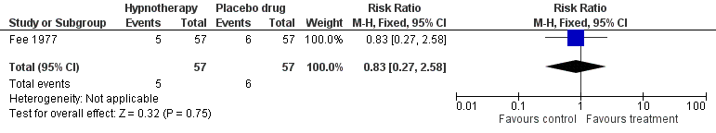

Cahill 2010 {1652}

Stage-based expert systems or tailored self-help materials versus Assessment only- Abstinence/cessation, 6+ months

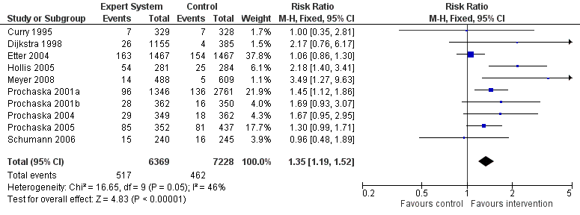

Stage-based interactive computer programmes versus Usual care- Abstinence/cessation, 12+ month

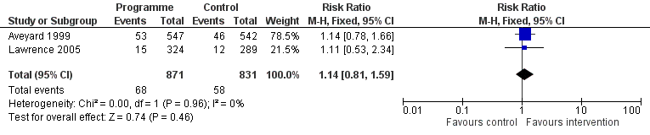

Stage-based telephone counselling versus Usual Care- Abstinence/cessation, 12 months

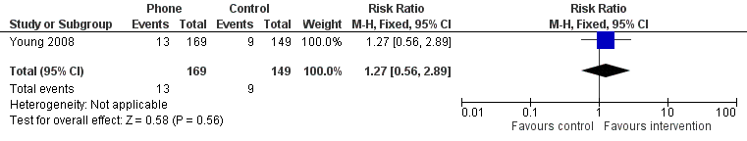

Stage-based individual counselling and/or advice versus Usual care- Abstinence/cessation, 6+ months

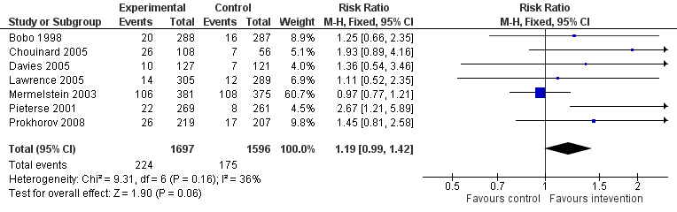

Stage-based individual counselling or advice versus Assessment only- Abstinence/cessation, 6+ months

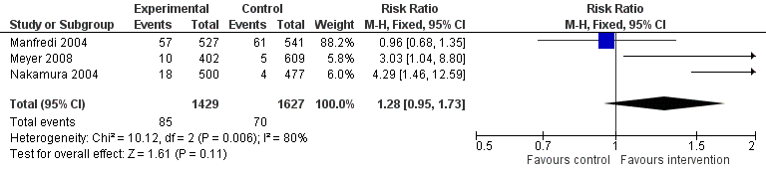

Cahill 2016 {1960}

Cystisine versus Placebo- Abstinence/cessation (continuous), 6+ months

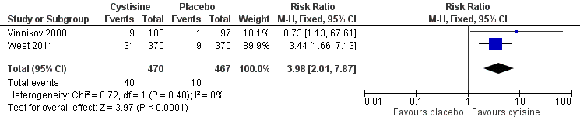

Cytisine versus Placebo- Abstinence/cessation (point prevalence), 2 years

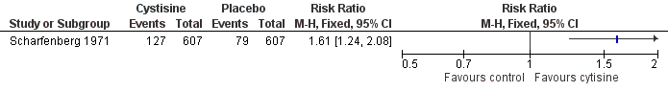

Varenicline versus Placebo- Abstinence/cessation, longest follow-up (6+ months)

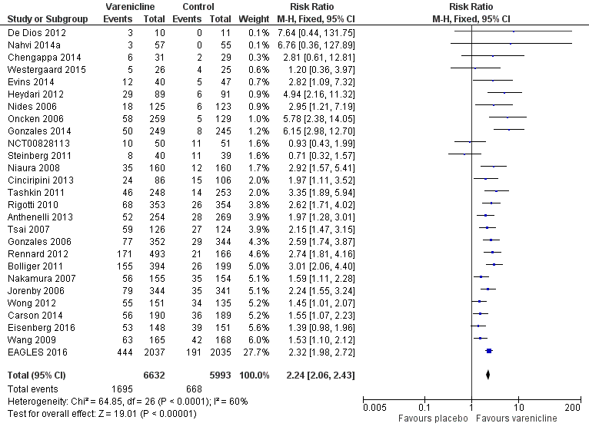

Varenicline versus Placebo- Abstinence/cessation, 6 months

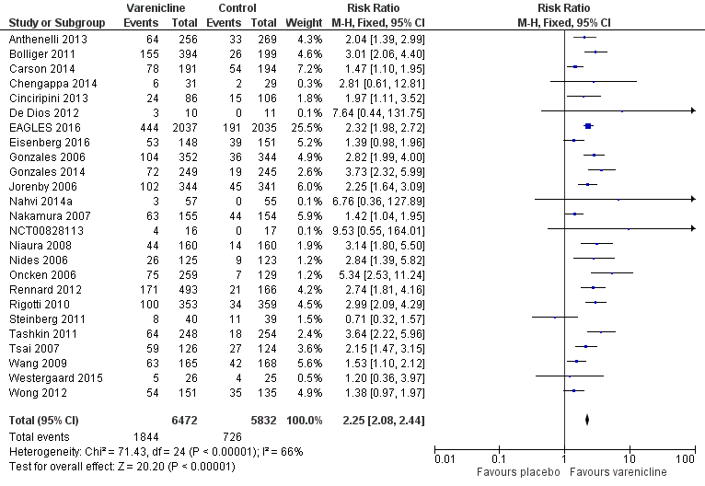

Long term varenicline versus Placebo- Abstinence/cessation, 6-12 months

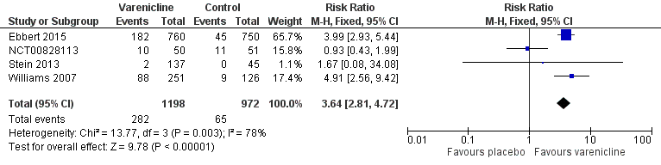

Low dose varenicline versus Placebo- Abstinence/cessation- 12 months

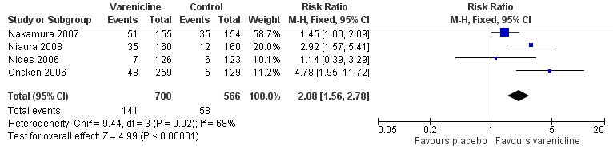

Variable dosing of varenicline versus Placebo- Abstinence/cessation, 12 months

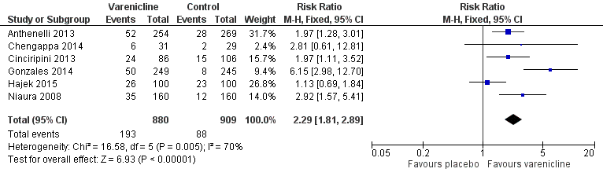

Varenicline versus Placebo- Abstinence/cessation in smokers reducing to quit, 12 months

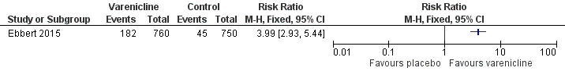

Varenicline versus Placebo- Abstinence/cessation in smokers with schizophrenia, bipolar, or other psychiatric disorder, 6 months

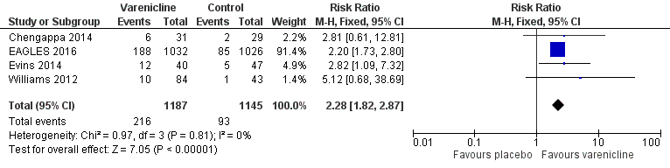

Varenicline versus Placebo- Abstinence/cessation in smokers with depression and motivated/wishing to quit, 12 months

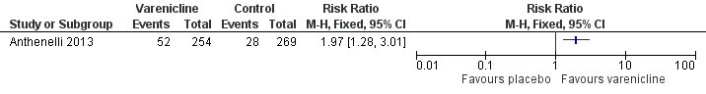

Varenicline versus Placebo- Abstinence/cessation in smokers who previously failed to quit on varenicline but are motivated/wishing to try quitting again, 12 months

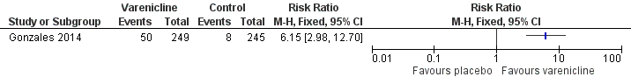

Varenicline versus Placebo- Adverse events (nausea), Range of follow-up times

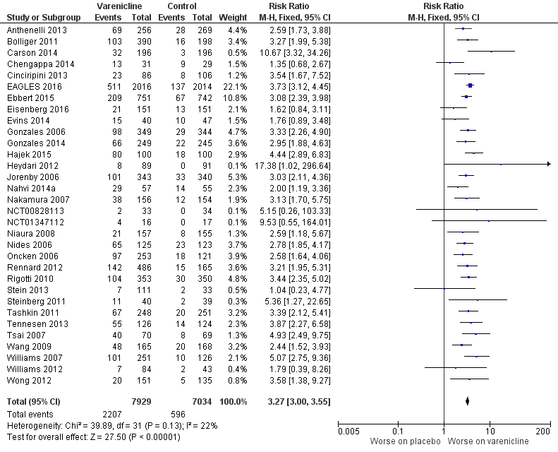

Varenicline versus Placebo- Adverse events (insomnia), Range of follow-up times

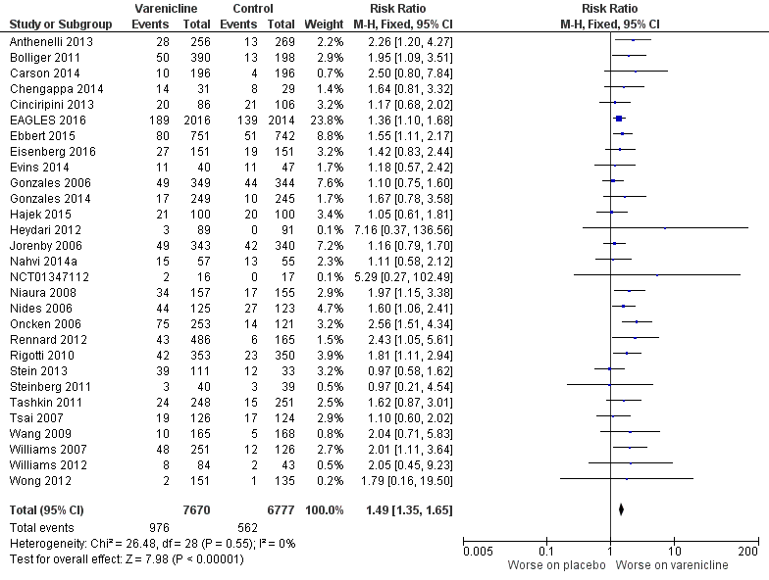

Varenicline versus Placebo- Adverse events (abnormal dreams), Range of follow-up times

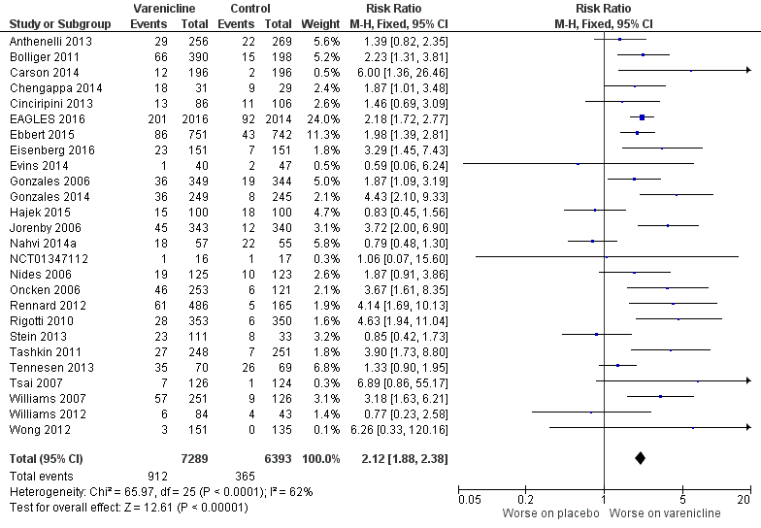

Varenicline versus Placebo- Adverse events (headache), Range of follow-up times

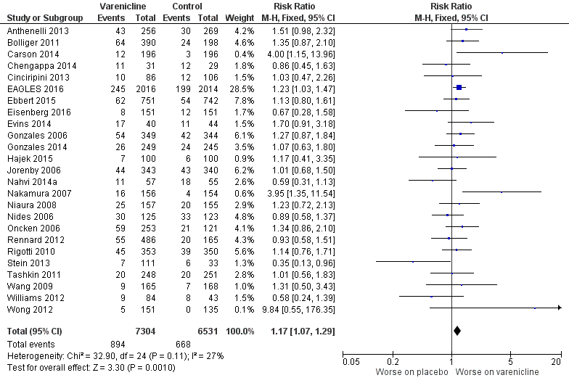

Varenicline versus Placebo- Adverse events (depression), Range of follow-up times

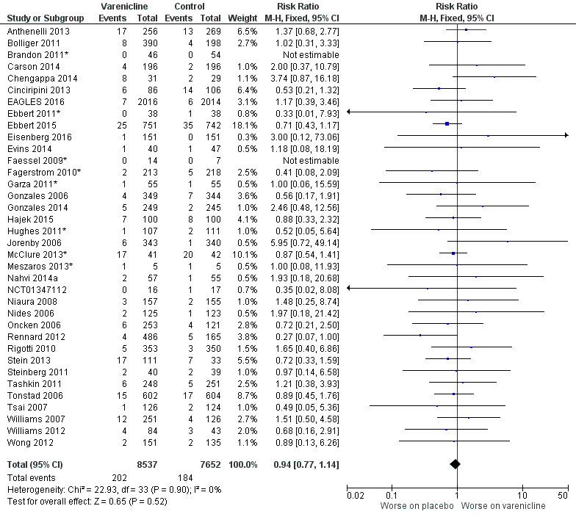

Varenicline versus Placebo- Adverse events (suicidal ideation), Range of follow-up times

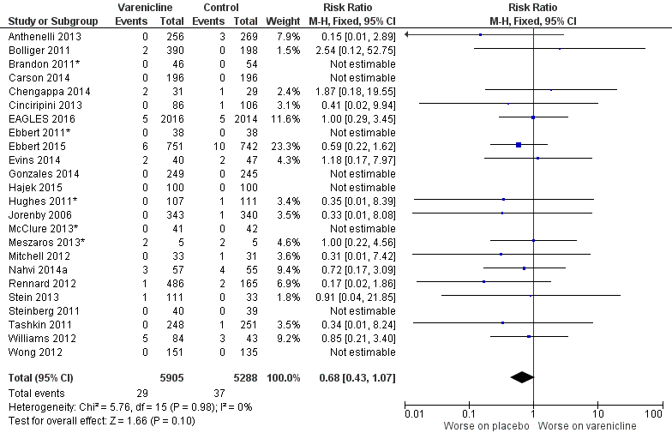

Varenicline versus Placebo- Serious adverse event (at least one), Range of follow-up times

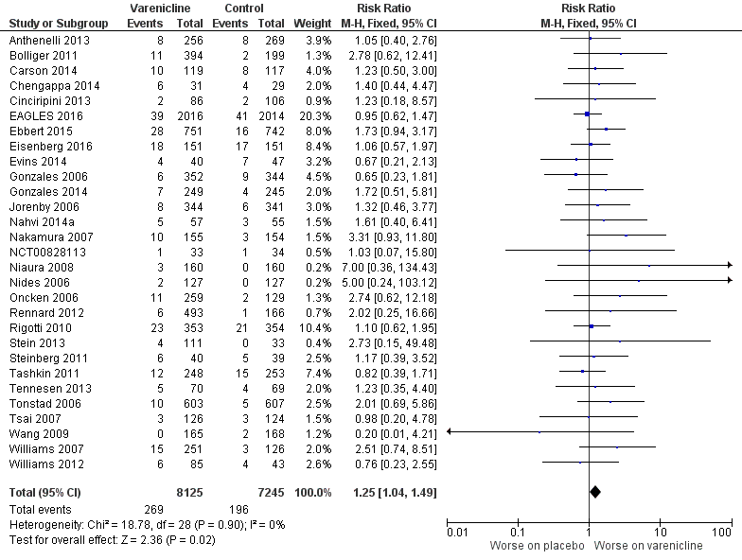

Varenicline versus Placebo- Serious adverse event (at least one during or immediately after treatment), Range of follow-up times

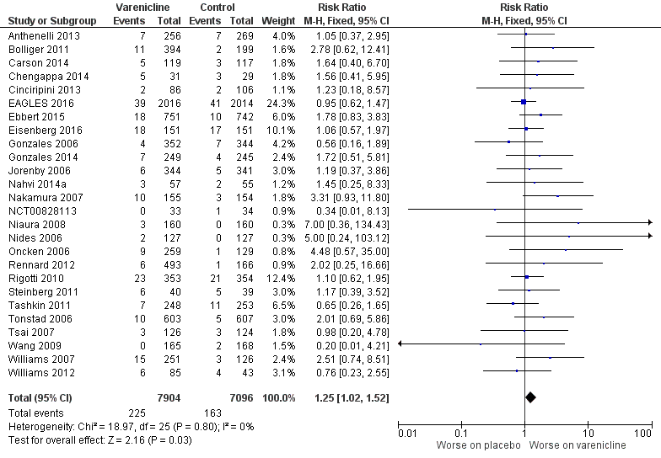

Varenicline versus Placebo- Neuropsychiatric events (depression, suicidal ideation), not deaths, Range of follow-up times

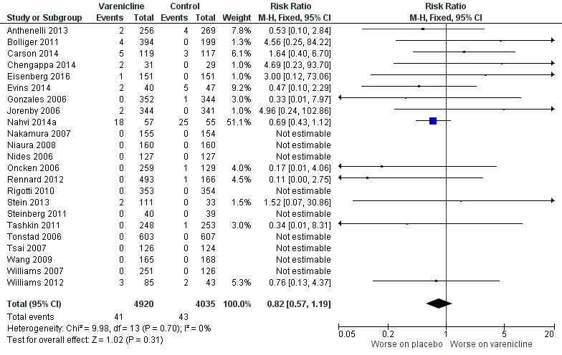

Varenicline versus Placebo- Serious adverse events (cardiac, including deaths), Range of follow-up times

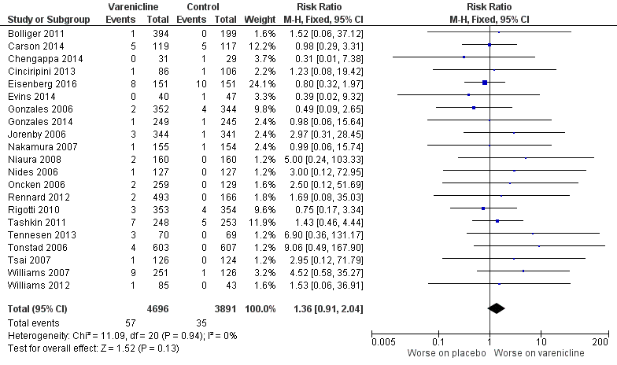

Farley 2012 {1469}

Buproprion versus Placebo- Weight gain, End of treatment

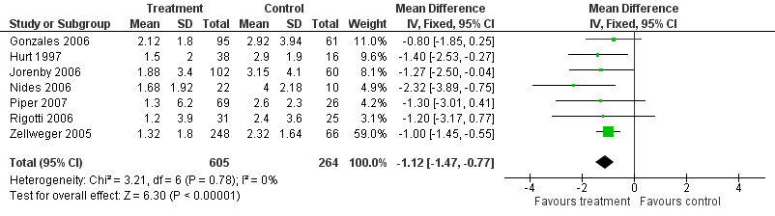

Buproprion versus Placebo- Weight gain, 6 months

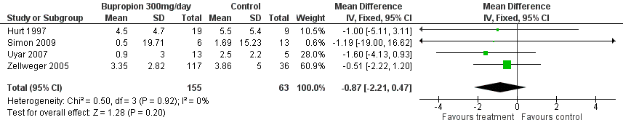

Buproprion versus Placebo- Weight gain, 12 months

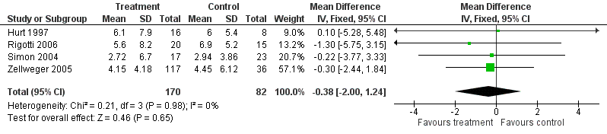

NRT versus Placebo- Weight gain, End of treatment
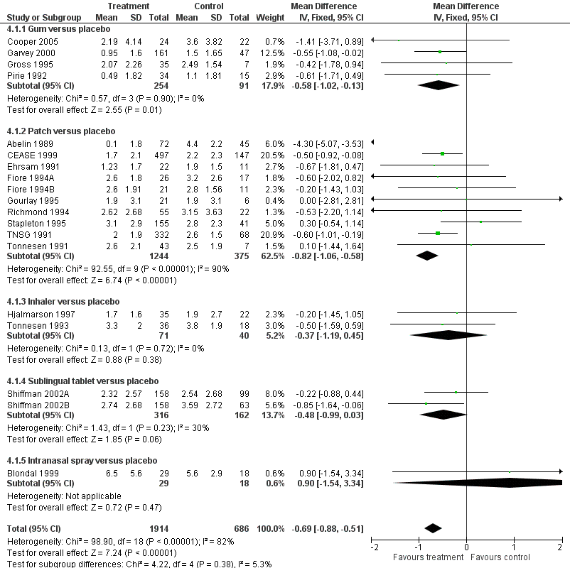

NRT versus Placebo- Weight gain, 6 months

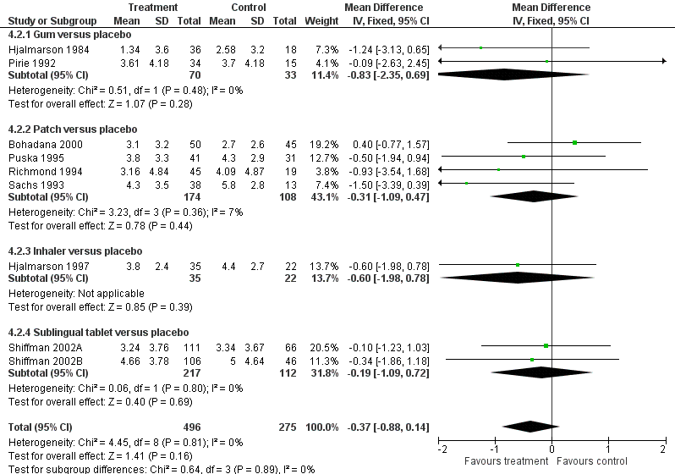

NRT versus Placebo- Weight gain, 12 months

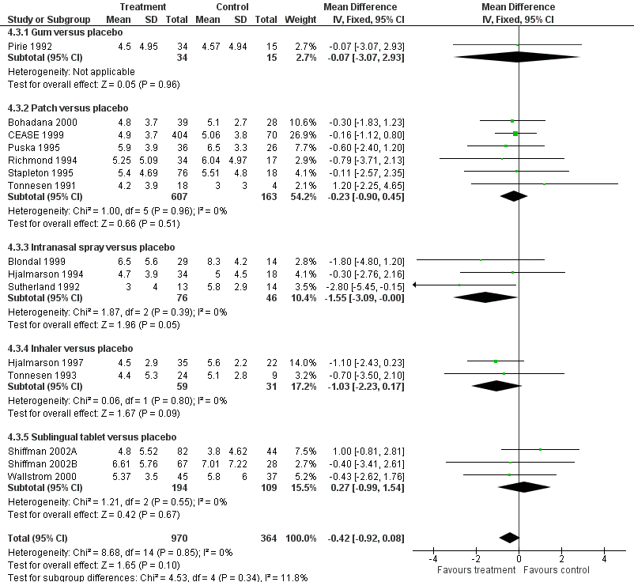

Varenicline 2mg/day versus Placebo- Weight gain, End of treatment

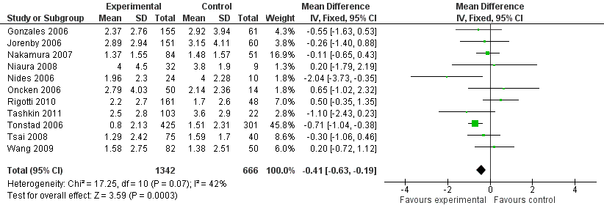

Varenicline 2mg/day versus Placebo- Weight gain, 6 months

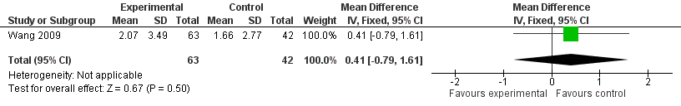

Varenicline 2mg/day versus Placebo- Weight gain, 12 months

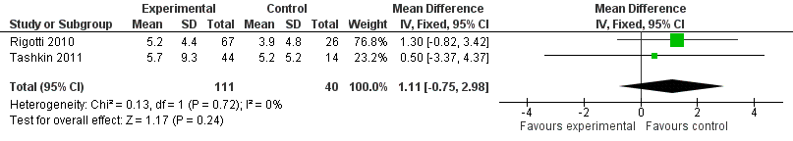

Varenicline 1mg/day versus Placebo- Weight gain, End of treatment

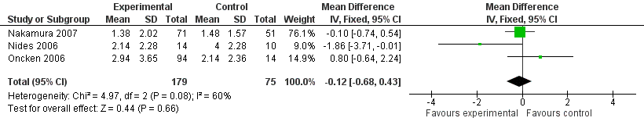

Hartmann-Boyce 2018 {332}

NRT patch versus Placebo- Adverse events (Palpitations/chest pains), Range of follow-up times

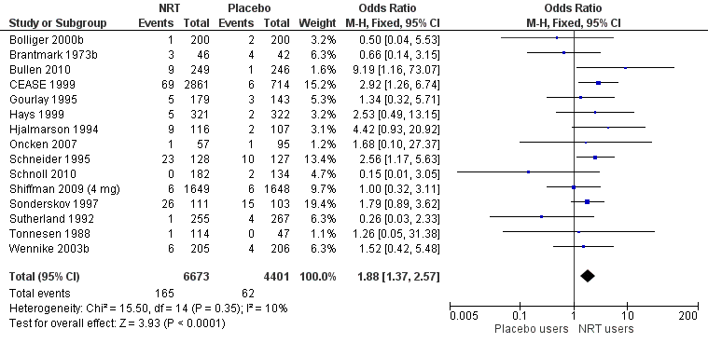

Hollands 2019 {3841}

Interventions to increase adherence for tobacco dependence versus Usual or standard care- Abstinence/cessation, 6 months

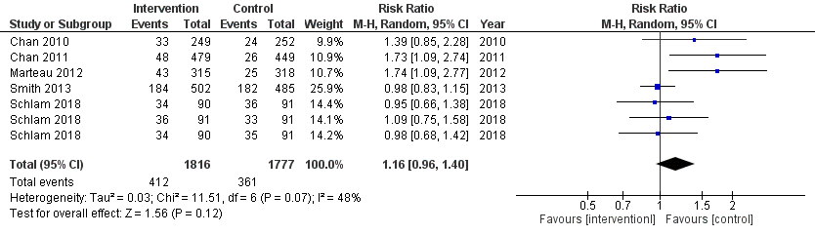

Howes 2020 {96}

Bupropion versus Placebo- Abstinence/cessation, 6 months

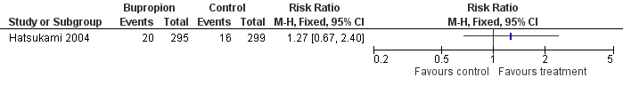

Bupropion versus Placebo- Reduction in cotinine >50%, 12 months

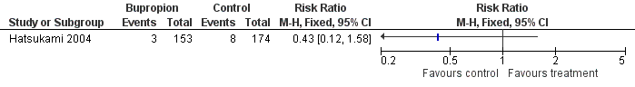

St John’s wort versus Placebo- Abstinence/cessation, 6 months

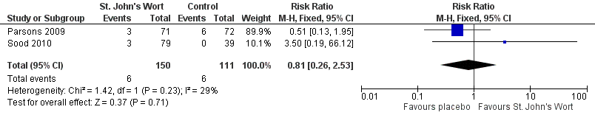

S-Adenosyl-L-Methionine (SAMe) versus Placebo- Abstinence/cessation, 6 months

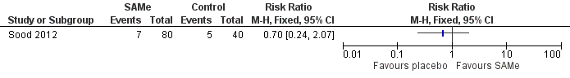

Lancaster 2017 {539}

Individual counselling versus Minimal contact control- Abstinence/cessation, 6+ months

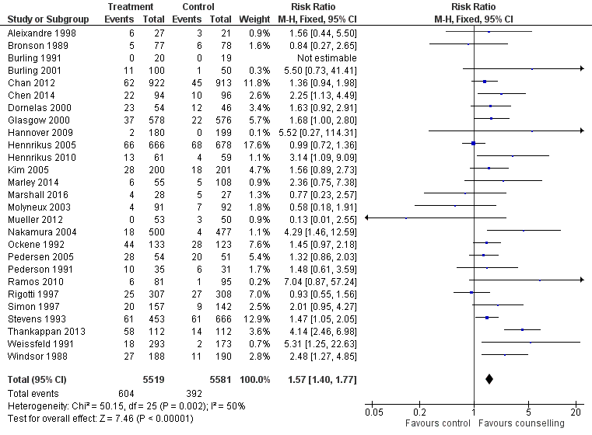

Lindson-Hawley 2016 {671}

NRT versus Placebo- Abstinence/cessation, 12 months to 24 months

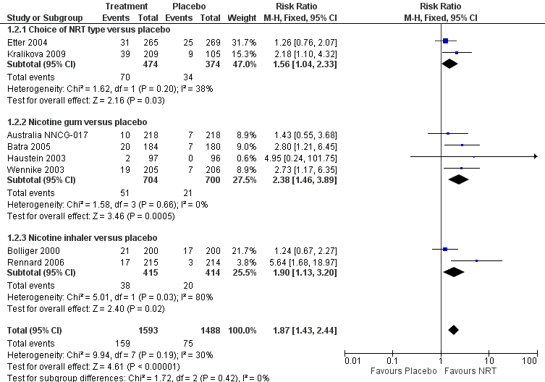

NRT versus Placebo- Reduction in cigarettes/day of >50% of baseline or cessation, 12+ months

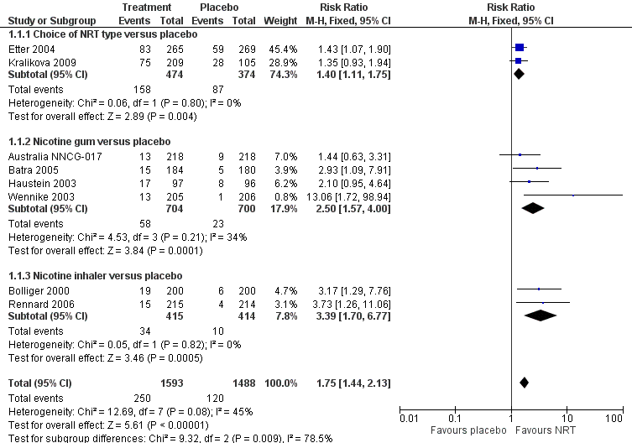

Bupropion versus Placebo- Abstinence/cessation, 6 months

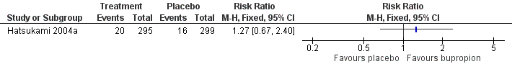

Bupropion versus Placebo- Reduction in cigarettes/day of >50% of baseline or cessation, 12 months

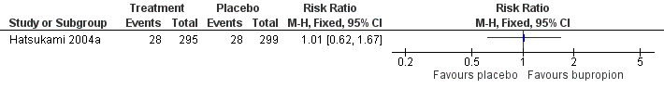

Varenicline versus Placebo- Abstinence/cessation, 6 months

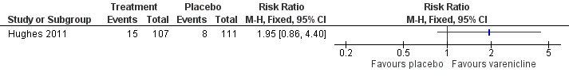

Telephone counselling plus self-help materials versus Usual care- Abstinence/cessation, 12 months &

Telephone counselling plus self-help materials versus Usual care- Reduction in cigarettes/day of >50% of baseline or cessation, 12 months

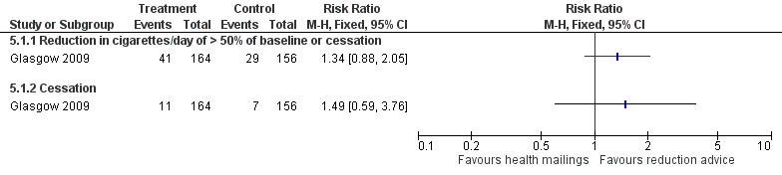

E-cigarettes versus Placebo- Abstinence/cessation, 12 months

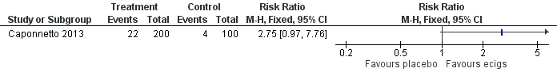

E-cigarettes versus Placebo- Reduction in cigarettes/day of >50% of baseline or cessation, 12months

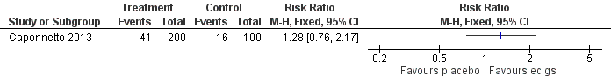

Livingstone-Banks 2019 {1077}

Non-tailored print-based self-help materials (no face-to-face contact) versus No materials/no intervention- Abstinence/cessation, 6+ months

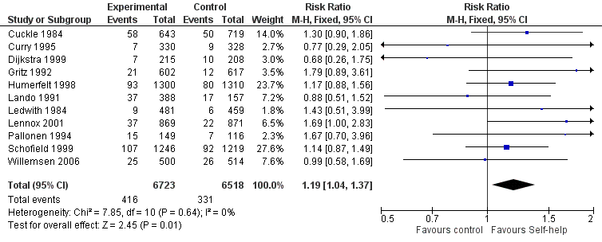

Non-tailored print-based self-help (no face-to-face contact) versus No materials/no interventions- Abstinence/cessation, 6 months

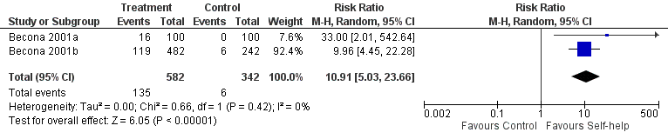

Non-tailored print-based self-help materials (no face-to-face contact) versus Brief leaflet- Abstinence/cessation, 6+ months

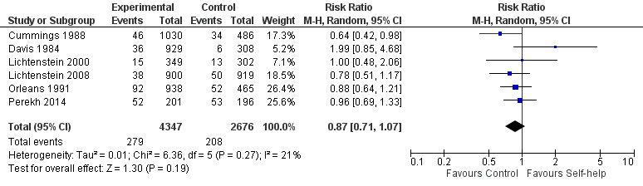

Non-tailored print-based self-help materials (with face-to-face contact) versus No treatment or leaflet only- Abstinence/cessation, 6+ months

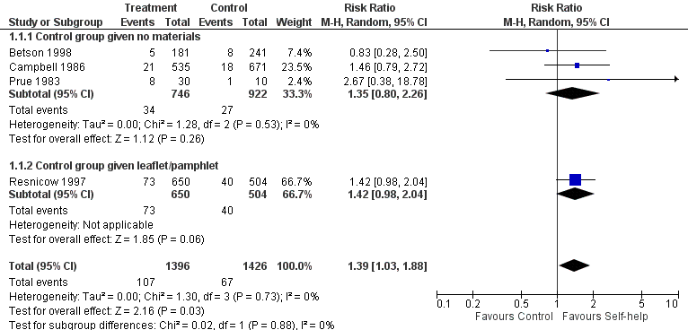

Individually tailored print-based self-help materials (no face-to-face contact) versus No materials/ no interventions- Abstinence/cessation- 6+ months

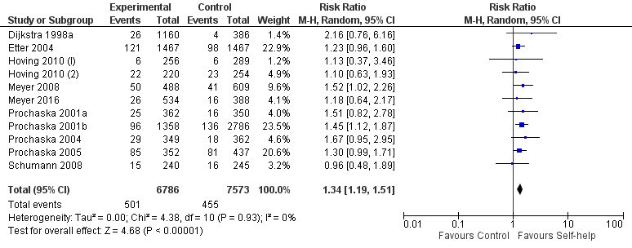

Matkin 2019 {1228}

Hotline and self-help materials versus Minimal intervention- Abstinence/cessation, 12-18 months

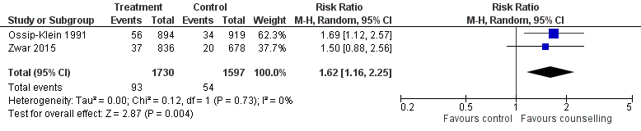

Intense telephone counselling versus Minimal intervention- Abstinence/cessation, 6+ months

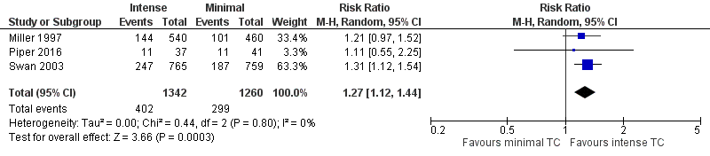

Brief motivational telephone counselling versus Usual care telephone call- Abstinence/cessation- 12 months

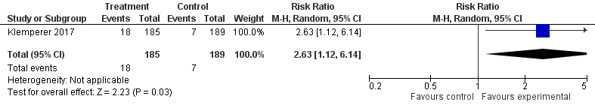

Telephone counselling for smoking reduction versus Usual care telephone call- Abstinence/cessation, 12 months

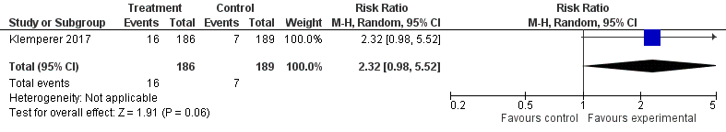

Stead 2013 {1998}

Physician advice (minimal or intensive interventions) versus No advice (or usual care)- Abstinence/cessation, 6+ months

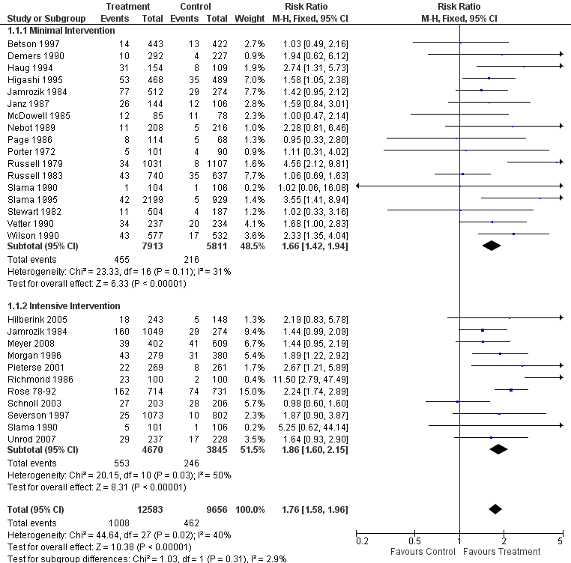

Physician advice with follow-up versus Minimal intervention /advice with single visit- Abstinence/cessation, 6+ months

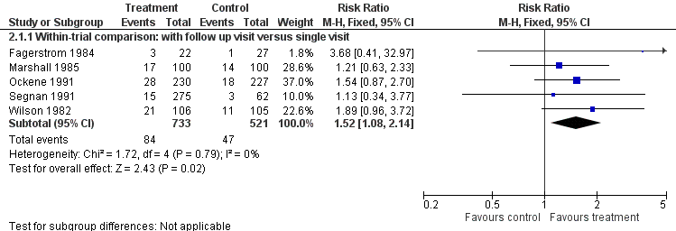

Intensive advice versus Minimal advice- Abstinence/cessation, 6+ months

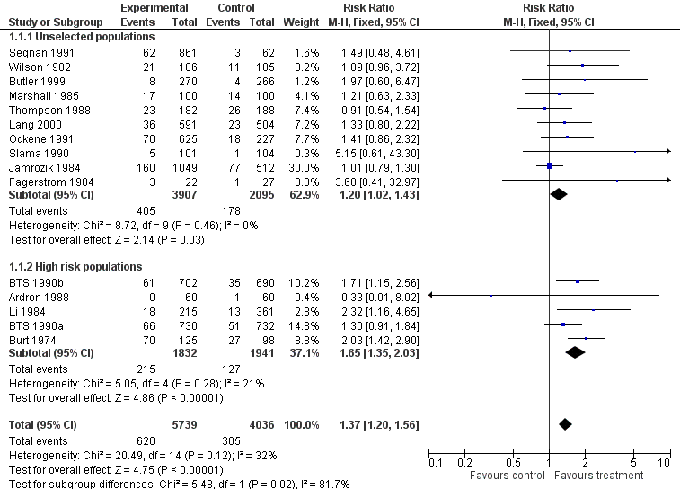

Stead 2016 {1356}

Combined pharmacotherapy and behavioural interventions versus Usual care or minimal intervention- Abstinence/cessation, 6+ months
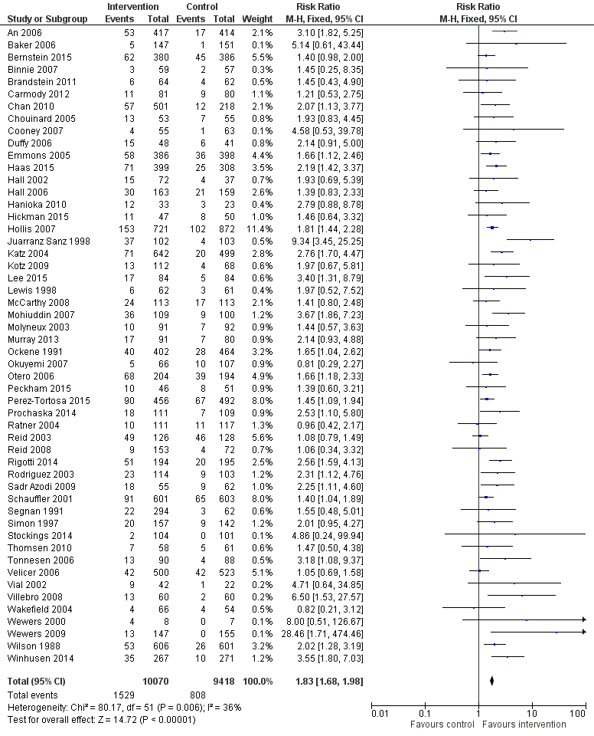

Combined pharmacotherapy and behavioural interventions versus Usual care or no intervention- Abstinence/cessation, 12 months

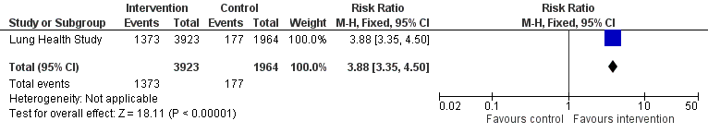

Stead 2017 {538}

Group therapy versus No intervention- Abstinence/cessation, 6+ months

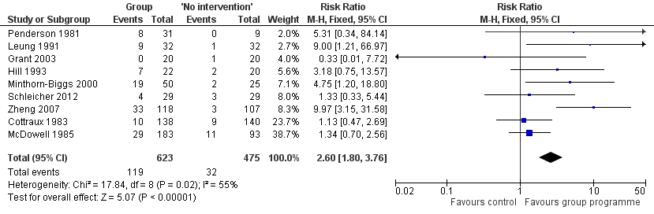

Taylor 2017 {411}

Interactive and tailored internet intervention versus Non-active control- Abstinence/cessation, 6-12 months

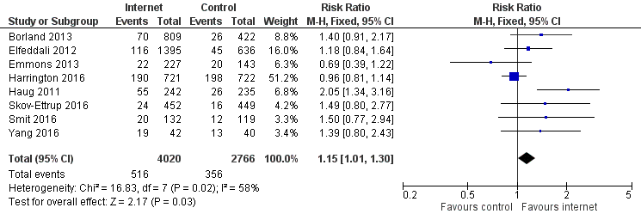

Internet plus behavioural support versus Non-internet-based non-active control- Abstinence/cessation, 6-12 months

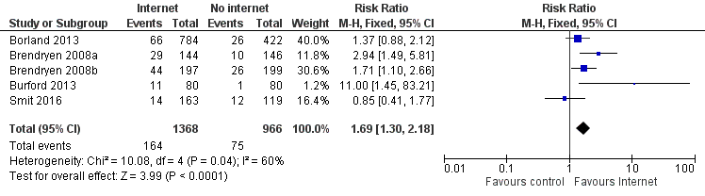

Tsoi 2013 {1698}

Bupropion versus Placebo- Abstinence/cessation, 6 months

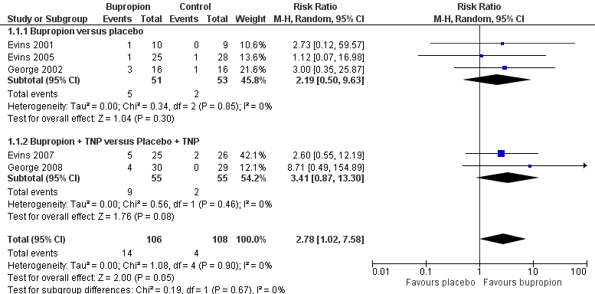

Bupropion versus Placebo- Reduction in number of cigarettes per day from baseline, 6 months

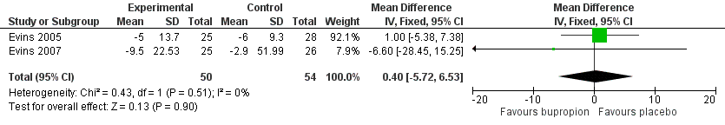

Bupropion versus Placebo- Tobacco smoking reduction- Expired CO level, 6 months

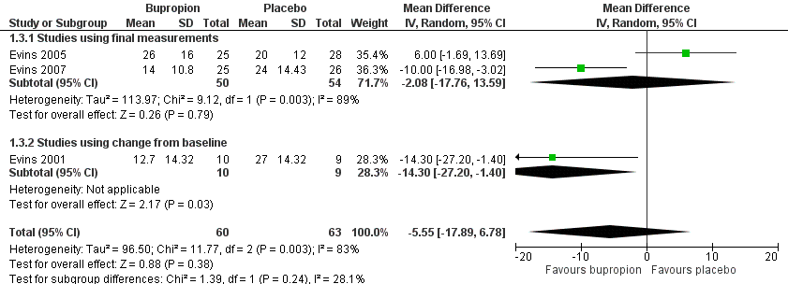

Bupropion versus Placebo- Change in emotional state (positive symptoms, negative symptoms, depressive symptoms), End of treatment
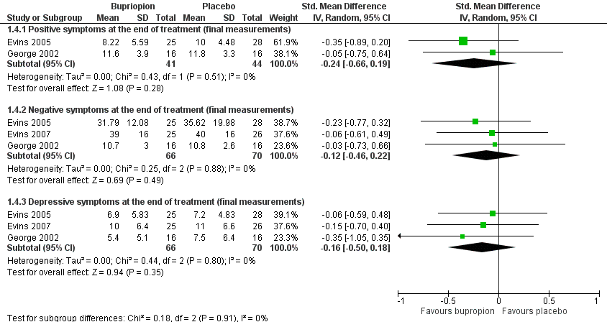

Varenicline versus Placebo- Abstinence/cessation, 6 months

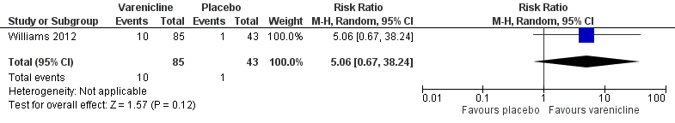

Van der Meer 2013 {1223}

Bupropion versus Placebo (current depression)- Abstinence/cessation, 6-12 months

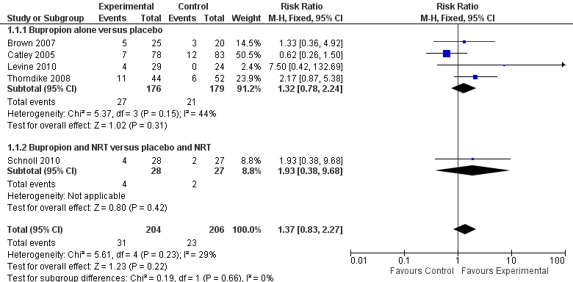

Bupropion versus Placebo (past depression)- Abstinence/cessation, 6-12 months
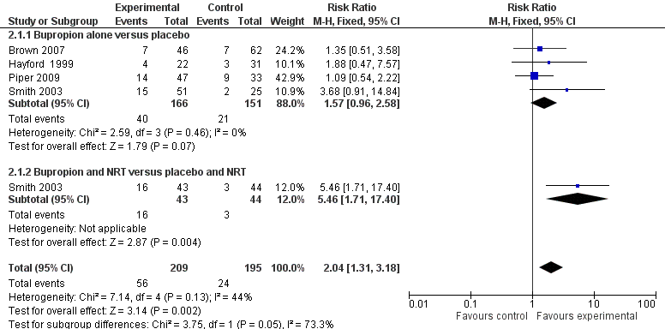

NRT versus Placebo (past depression)- Abstinence/cessation, 6+ months

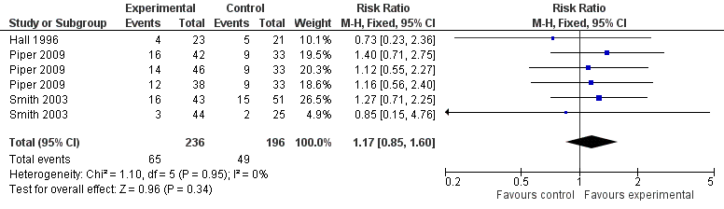

Vodoplivec-Jamsek 2012 {1343}

Mobile phone short message service versus Control- Abstinence/cessation, 6 months

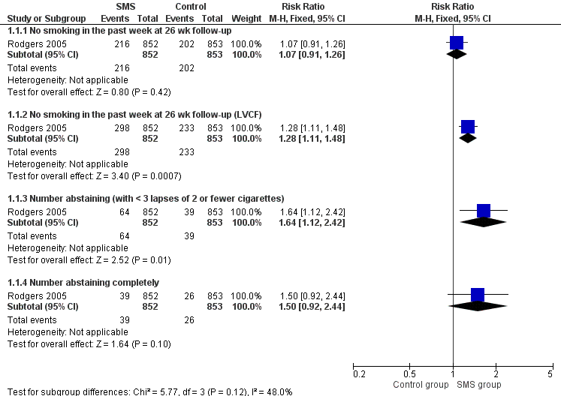

Mobile phone short message service versus Control - Adverse events (rates of car crash), 6 months

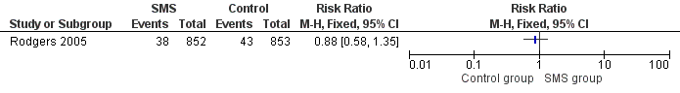

Mobile phone short message service versus Control - Adverse events (pain in thumb/finger joint), 6 months

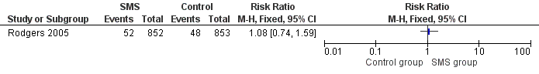

White 2014 {1618}

Acupuncture versus Sham acupuncture- Abstinence/cessation, 6-12 months

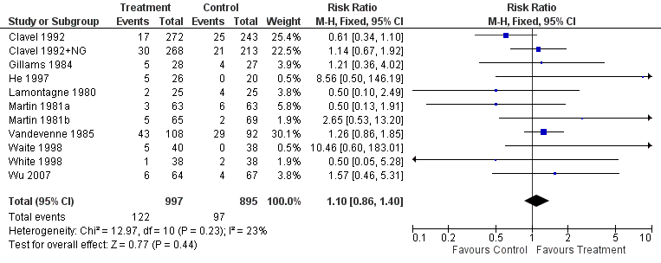

Acupuncture versus Waiting list/no intervention- Abstinence/cessation, 6-12 months

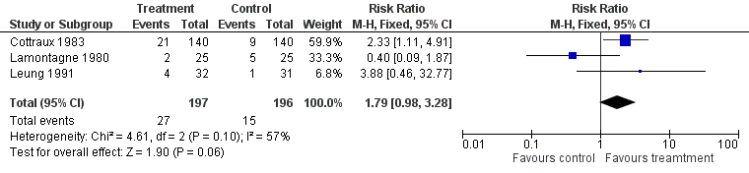

Continuous auricular stimulation versus Sham stimulation- Abstinence/cessation, 6-12 months

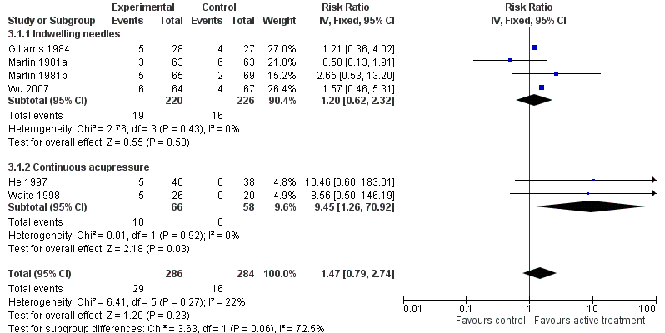

Laser therapy versus Sham laser- Abstinence/cessation, 6-12 months

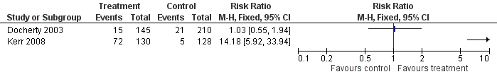

Electrostimulation versus Sham electrostimulation- Abstinence/cessation, 6-12 months

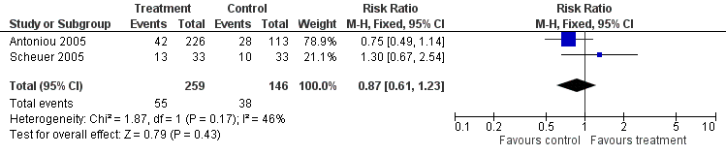

Whittaker 2019 {1803}

Mobile-phone based intervention versus Usual care Abstinence/cessation, 6+ months

