Genomic analysis of the class Phycisphaerae reveals a versatile group of complex carbon-degrading bacteria

Wouter B. Lenferink, Mike S.M. Jetten, Maartje A.H.J. van Kessel, Sebastian Lücker*

Submitted to Antonie van Leeuwenhoek

SUPPLEMENTARY INFORMATION

Table of contents
- Supplementary Figure S1 – S4
- Supplementary Table S1 – S2

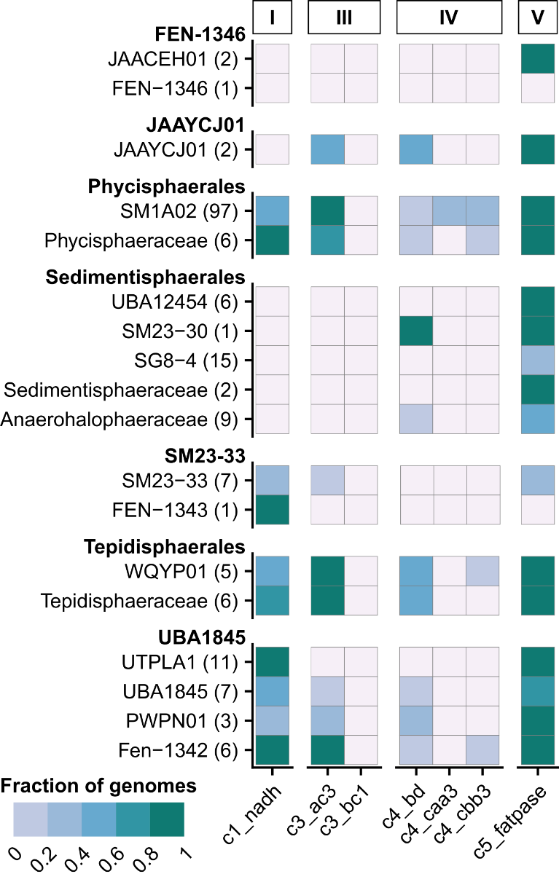
Supplementary information
Supplementary Figure 1. Automatic and manually curated annotation of electron transfer chain (ETC) components, summarized for each Phycisphaerae family. From left to right, hits are displayed for the NADH dehydrogenase (c1_nadh), alternative complex III (c3_ac3), cytochrome bc₁ complex (c3_bc1), bd-type quinol oxidase (c4_bd), caa₃-type cytochrome c oxidase (c4_caa3), cbb₃-type cytochrome c oxidase (c4_cbb3), and the F-type ATPase (c5_fatpase). Numbers in parentheses behind family names represent the number of included genomes. Fill colour represents the fraction of genomes in a family predicted to encode the complete complex.
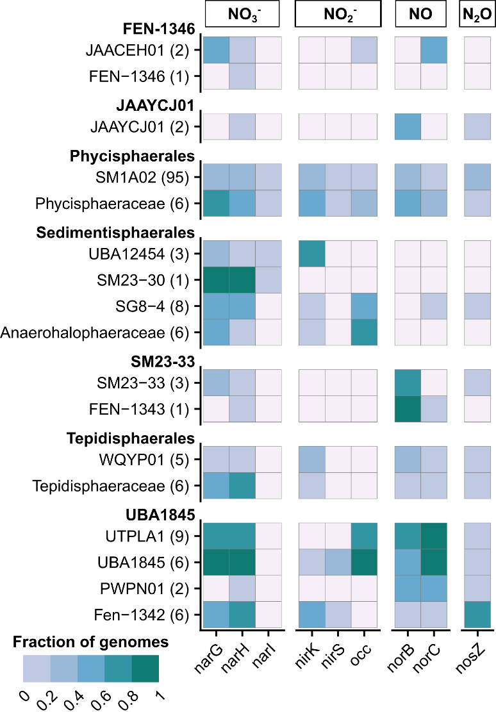
Supplementary Figure 2. Manually curated annotation of genes involved in denitrification, summarized for each Phycisphaerae family. From left to right, hits are displayed for nitrate (narGHI), nitrite (nirK, nirS, occ), nitric oxide (norBC), and nitrous oxide (nosZ) reduction. Numbers in parentheses behind family names represent the number of included genomes. Fill colours represent the fraction of genomes per family predicted to contain the respective gene.

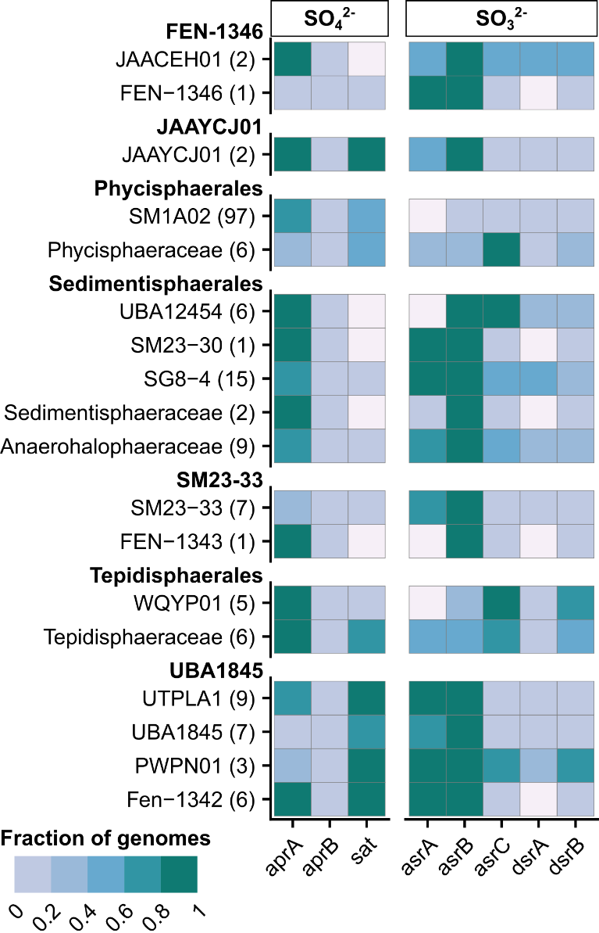
Supplementary Figure 3. Manually curated annotation of genes involved in sulphur reduction, summarized for each Phycisphaerae family. From left to right, hits are displayed for sulfate (aprAB, sat) and sulphite (asrABC, dsrAB) reduction. Numbers in parentheses behind family names represent the number of included genomes. Fill colours represent the fraction of genomes per family predicted to contain the respective gene.

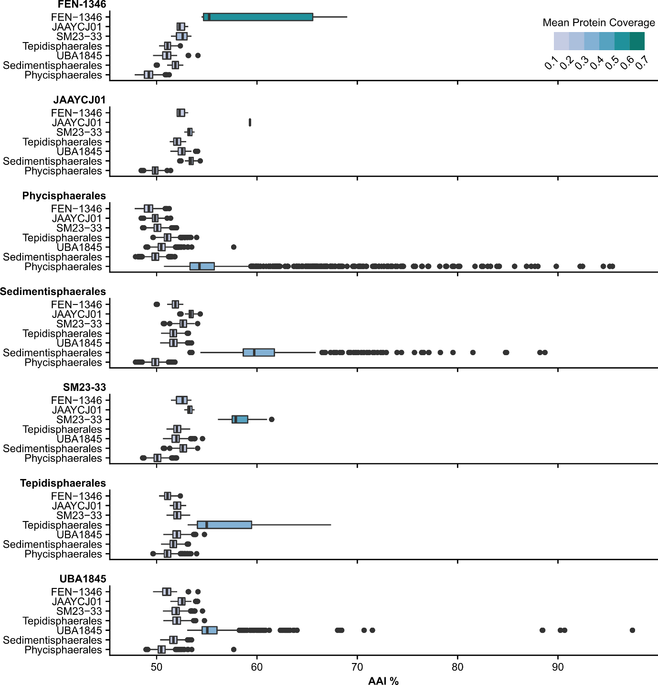
Supplementary Figure 4. Average amino acid identity (AAI) comparisons between distinct Phycisphaerae orders. Names in bold indicate the respective order all other genomes were compared to.

Table S1. Genome assemblies included in this study, corresponding CheckM statistics, and GTDB-Tk taxonomy. Asterisks indicate in-house genomes.
Assembly | Completeness | Contamination | Coding density | GC content | Size | Order | Family | Genus | Species
AMOX_SL1* | 86.8% | 2.1% | 87.9% | 60.8% | 4.90 Mb | Phycisphaerales | SM1A02 | NA | AMOX_SL1
AOM_BES5* | 91.5% | 1.6% | 86.3% | 65.6% | 4.29 Mb | UBA1845 | UBA1845 | SURF-32 | AOM_BES5
AOM_Fe1* | 94.7% | 2.0% | 89.3% | 58.8% | 5.28 Mb | Sedimentisphaerales | Anaerohalophaeraceae | B28-G16 | AOM_Fe1
COM_RAS1* | 89.1% | 1.6% | 86.7% | 66.1% | 5.50 Mb | UBA1845 | Fen-1342 | NA | COM_RAS1
COM_RAS2* | 89.8% | 0.8% | 88.6% | 62.6% | 4.33 Mb | UBA1845 | UTPLA1 | PLA3 | COM_RAS2
COM_TrWB2* | 83.7% | 2.1% | 87.1% | 65.8% | 4.20 Mb | Phycisphaerales | SM1A02 | UBA2396 | COM_TrWB2
DAMOX_Bav1* | 87.1% | 0.4% | 87.0% | 60.6% | 5.04 Mb | UBA1845 | UTPLA1 | UTPLA1 | DAMOX_Bav1
GCA_000284115.1 | 95.5% | 0.0% | 88.5% | 73.2% | 3.88 Mb | Phycisphaerales | Phycisphaeraceae | Phycisphaera | Phycisphaera mikurensis
GCA_001303465.1 | 71.6% | 0.0% | 88.2% | 54.8% | 4.46 Mb | Sedimentisphaerales | SG8-4 | SG8-4 | SG8-4 sp001303465
GCA_001303665.1 | 75.0% | 1.1% | 88.5% | 67.8% | 3.43 Mb | SM23-33 | SM23-33 | SM23-33 | SM23-33 sp001303665
GCA_001303695.1 | 70.8% | 0.0% | 87.5% | 51.0% | 4.01 Mb | Sedimentisphaerales | SM23-30 | SM23-30 | SM23-30 sp001303695
GCA_001603075.1 | 100.0% | 1.1% | 89.3% | 62.8% | 5.65 Mb | Sedimentisphaerales | SG8-4 | PLanc-01 | PLanc-01 sp001603075
GCA_001824635.1 | 87.3% | 1.7% | 86.3% | 49.5% | 2.62 Mb | Sedimentisphaerales | UBA12454 | GWF2-50-10 | GWF2-50-10 sp001824635
GCA_001825665.1 | 97.7% | 1.1% | 90.6% | 41.0% | 4.83 Mb | Sedimentisphaerales | UBA12454 | UBA12454 | UBA12454 sp001825665
GCA_001825675.1 | 92.1% | 3.4% | 88.6% | 42.0% | 4.86 Mb | Sedimentisphaerales | UBA12454 | UBA12454 | UBA12454 sp001825675
GCA_001997385.1 | 98.9% | 1.1% | 89.4% | 46.2% | 2.95 Mb | Sedimentisphaerales | Sedimentisphaeraceae | Sedimentisphaera | Sedimentisphaera cyanobacteriorum
GCA_002084585.1 | 89.8% | 1.1% | 87.9% | 50.1% | 1.81 Mb | Sedimentisphaerales | Anaerohalophaeraceae | 4572-13 | 4572-13 sp002084585
GCA_002117005.1 | 98.9% | 1.1% | 89.5% | 46.3% | 3.19 Mb | Sedimentisphaerales | Sedimentisphaeraceae | Sedimentisphaera | Sedimentisphaera salicampi
GCA_002167845.2 | 93.1% | 1.0% | 91.1% | 63.2% | 3.31 Mb | Phycisphaerales | SM1A02 | UBA12014 | UBA12014 sp002167845
GCA_002171655.1 | 80.6% | 1.7% | 91.9% | 58.7% | 2.98 Mb | Phycisphaerales | SM1A02 | UBA8087 | UBA8087 sp002171655
GCA_002295885.1 | 96.0% | 1.1% | 91.8% | 65.1% | 2.34 Mb | Phycisphaerales | SM1A02 | UBA854 | UBA854 sp002295885
GCA_002311745.1 | 79.5% | 0.0% | 89.5% | 62.7% | 2.93 Mb | Tepidisphaerales | Tepidisphaeraceae | UBA1161 | UBA1161 sp002311745
GCA_002327785.1 | 89.3% | 5.4% | 87.1% | 60.8% | 6.32 Mb | Sedimentisphaerales | SG8-4 | PLanc-01 | PLanc-01 sp002327785
Table S1. Continued.
GCA_002337545.1 | 88.5% | 0.0% | 87.5% | 59.0% | 3.53 Mb | Phycisphaerales | SM1A02 | UBA1924 | UBA1924 sp002337545
GCA_002338715.1 | 91.4% | 3.4% | 85.6% | 57.0% | 5.25 Mb | UBA1845 | UBA1845 | UBA1845 | UBA1845 sp002338715
GCA_002343075.1 | 92.2% | 3.4% | 87.5% | 59.6% | 4.47 Mb | Tepidisphaerales | Tepidisphaeraceae | UBA2421 | UBA2421 sp002343075
GCA_002343325.1 | 81.7% | 1.1% | 89.0% | 67.2% | 3.13 Mb | Phycisphaerales | SM1A02 | UBA2396 | UBA2396 sp002343325
GCA_002347125.1 | 87.3% | 4.6% | 88.8% | 62.3% | 4.76 Mb | Sedimentisphaerales | SG8-4 | UBA2266 | UBA2266 sp002347125
GCA_002364005.1 | 91.5% | 1.1% | 88.0% | 61.7% | 3.40 Mb | Phycisphaerales | SM1A02 | UBA1924 | UBA1924 sp002364005
GCA_002364485.1 | 97.4% | 1.1% | 92.0% | 62.9% | 2.56 Mb | Phycisphaerales | SM1A02 | UBA854 | UBA854 sp002364485
GCA_002364555.1 | 96.7% | 0.6% | 90.4% | 57.4% | 2.59 Mb | Phycisphaerales | SM1A02 | UBA1668 | UBA1668 sp002364555
GCA_002418285.1 | 96.6% | 0.0% | 89.9% | 61.9% | 4.84 Mb | Phycisphaerales | SM1A02 | UBA5793 | UBA5793 sp002418285
GCA_002480345.1 | 91.4% | 0.0% | 86.8% | 67.9% | 3.85 Mb | Phycisphaerales | SM1A02 | UBA1926 | UBA1926 sp002480345
GCA_002480565.1 | 95.3% | 0.0% | 88.7% | 50.0% | 6.01 Mb | Phycisphaerales | Phycisphaeraceae | UBA7800 | UBA7800 sp002480565
GCA_002591705.1 | 82.7% | 4.2% | 91.9% | 59.6% | 2.53 Mb | Phycisphaerales | SM1A02 | UBA854 | UBA854 sp002591705
GCA_002683195.1 | 89.0% | 1.7% | 91.0% | 63.4% | 3.59 Mb | Phycisphaerales | SM1A02 | GCA-002862325 | GCA-002862325 sp002683195
GCA_002684315.1 | 74.5% | 4.6% | 92.8% | 59.2% | 2.73 Mb | Phycisphaerales | SM1A02 | UBA8087 | UBA8087 sp002684315
GCA_002684755.1 | 83.3% | 5.1% | 91.0% | 66.7% | 2.98 Mb | Phycisphaerales | SM1A02 | UBA12014 | UBA12014 sp002684755
GCA_002686995.1 | 80.7% | 0.6% | 90.4% | 66.5% | 7.80 Mb | Phycisphaerales | Phycisphaeraceae | GCA-2686995 | GCA-2686995 sp002686995
GCA_002689385.1 | 90.9% | 3.4% | 93.6% | 45.1% | 1.94 Mb | Phycisphaerales | SM1A02 | GCA-002718515 | GCA-002718515 sp002689385
GCA_002690755.1 | 94.3% | 4.1% | 90.5% | 66.1% | 3.47 Mb | Phycisphaerales | SM1A02 | UBA12014 | UBA12014 sp002690755
GCA_002700845.1 | 76.9% | 4.0% | 94.1% | 55.1% | 1.77 Mb | Phycisphaerales | SM1A02 | UBA8653 | UBA8653 sp002700845
GCA_002702575.1 | 98.9% | 6.3% | 93.5% | 57.8% | 3.17 Mb | Phycisphaerales | SM1A02 | UBA1668 | UBA1668 sp002702575
GCA_002704825.1 | 83.1% | 3.5% | 88.8% | 51.8% | 6.42 Mb | Phycisphaerales | Phycisphaeraceae | UBA7800 | UBA7800 sp002704825
GCA_002706885.1 | 85.2% | 0.3% | 90.6% | 65.9% | 3.57 Mb | Phycisphaerales | SM1A02 | GCA-2706885 | GCA-2706885 sp002706885
GCA_002709295.1 | 98.9% | 4.0% | 91.9% | 65.7% | 3.68 Mb | Phycisphaerales | SM1A02 | GCA-002862325 | GCA-002862325 sp002709295
GCA_002709755.1 | 94.3% | 0.6% | 92.4% | 59.9% | 2.62 Mb | Phycisphaerales | SM1A02 | UBA8087 | UBA8087 sp002709755
GCA_002711415.1 | 96.6% | 0.6% | 93.0% | 61.0% | 2.80 Mb | Phycisphaerales | SM1A02 | GCA-2711415 | GCA-2711415 sp002711415
GCA_002716385.1 | 84.7% | 6.6% | 93.4% | 57.7% | 2.79 Mb | Phycisphaerales | SM1A02 | UBA1668 | UBA1668 sp002716385
GCA_002716625.1 | 89.5% | 0.0% | 89.3% | 50.9% | 3.35 Mb | Phycisphaerales | Phycisphaeraceae | UBA6626 | UBA6626 sp002716625
GCA_002717655.1 | 93.1% | 1.8% | 93.3% | 55.2% | 3.07 Mb | Phycisphaerales | SM1A02 | UBA1668 | UBA1668 sp002717655
Table S1. Continued.
GCA_002718515.1 | 85.5% | 6.3% | 94.8% | 45.3% | 1.95 Mb | Phycisphaerales | SM1A02 | GCA-002718515 | GCA-002718515 sp002718515
GCA_002839495.1 | 88.1% | 3.4% | 89.0% | 45.5% | 1.83 Mb | Sedimentisphaerales | UBA12454 | UBA12454 | UBA12454 sp002839495
GCA_002862305.1 | 97.7% | 2.3% | 92.3% | 68.0% | 2.67 Mb | Phycisphaerales | SM1A02 | UBA8087 | UBA8087 sp002862305
GCA_002862325.1 | 82.6% | 1.8% | 91.9% | 64.9% | 2.44 Mb | Phycisphaerales | SM1A02 | GCA-002862325 | GCA-002862325 sp002862325
GCA_003141275.1 | 96.0% | 3.5% | 88.6% | 49.2% | 3.05 Mb | Sedimentisphaerales | SG8-4 | Fen-1362 | Fen-1362 sp003141275
GCA_003141315.1 | 96.6% | 1.1% | 88.7% | 47.7% | 2.35 Mb | Sedimentisphaerales | SG8-4 | Fen-1359 | Fen-1359 sp003141315
GCA_003142595.1 | 97.7% | 1.1% | 90.3% | 44.0% | 2.28 Mb | Sedimentisphaerales | UBA12454 | UBA12454 | UBA12454 sp003142595
GCA_003153655.1 | 89.6% | 2.3% | 89.4% | 57.0% | 4.65 Mb | Tepidisphaerales | Tepidisphaeraceae | PALSA-1353 | PALSA-1353 sp003153655
GCA_003153915.1 | 79.8% | 2.3% | 88.1% | 62.4% | 2.63 Mb | SM23-33 | SM23-33 | FEN-1349 | FEN-1349 sp003153915
GCA_003162245.1 | 94.7% | 6.8% | 87.6% | 67.1% | 4.76 Mb | UBA1845 | Fen-1342 | Fen-1342 | Fen-1342 sp003162245
GCA_003170085.1 | 89.5% | 0.9% | 87.8% | 66.0% | 4.47 Mb | FEN-1346 | FEN-1346 | FEN-1346 | FEN-1346 sp003170085
GCA_003170415.1 | 96.6% | 1.1% | 88.7% | 49.8% | 2.67 Mb | Sedimentisphaerales | SG8-4 | Fen-1362 | Fen-1362 sp003170415
GCA_003171235.1 | 87.2% | 1.1% | 84.2% | 64.2% | 3.61 Mb | SM23-33 | SM23-33 | FEN-1344 | FEN-1344 sp003171235
GCA_003171335.1 | 95.5% | 1.1% | 84.3% | 64.4% | 4.20 Mb | SM23-33 | FEN-1343 | FEN-1343 | FEN-1343 sp003171335
GCA_003520025.1 | 82.9% | 0.0% | 89.8% | 60.5% | 2.13 Mb | Phycisphaerales | SM1A02 | UBA12567 | UBA12567 sp003520025
GCA_003551645.1 | 95.5% | 2.3% | 87.7% | 63.5% | 2.83 Mb | SM23-33 | SM23-33 | PUND01 | PUND01 sp003551645
GCA_003562195.1 | 89.2% | 4.0% | 91.2% | 57.8% | 2.75 Mb | Phycisphaerales | SM1A02 | PWVT01 | PWVT01 sp003562195
GCA_003576875.1 | 89.8% | 0.0% | 89.3% | 63.5% | 3.36 Mb | UBA1845 | UTPLA1 | PLA3 | PLA3 sp003576875
GCA_003576905.1 | 97.7% | 3.4% | 88.1% | 63.8% | 4.71 Mb | UBA1845 | UTPLA1 | UTPLA1 | UTPLA1 sp003576905
GCA_003597935.1 | 72.7% | 4.0% | 84.8% | 67.3% | 4.30 Mb | UBA1845 | UBA1845 | SURF-32 | SURF-32 sp003597935
GCA_003644175.1 | 82.7% | 1.2% | 88.3% | 53.6% | 2.51 Mb | Sedimentisphaerales | Anaerohalophaeraceae | B28-G16 | B28-G16 sp003644175
GCA_003644205.1 | 77.8% | 1.7% | 89.1% | 48.7% | 2.64 Mb | Sedimentisphaerales | Anaerohalophaeraceae | QNBT01 | QNBT01 sp003644205
GCA_003644295.1 | 77.1% | 3.9% | 89.5% | 45.7% | 1.82 Mb | Sedimentisphaerales | SG8-4 | B140-G9 | B140-G9 sp003644295
GCA_003671025.1 | 95.5% | 0.6% | 90.4% | 60.3% | 3.25 Mb | Phycisphaerales | SM1A02 | QWPT01 | QWPT01 sp003671025
GCA_003671055.1 | 96.6% | 2.8% | 92.1% | 58.2% | 2.85 Mb | Phycisphaerales | SM1A02 | F1-140-MAGs142 | F1-140-MAGs142 sp003671055
GCA_003671065.1 | 76.1% | 0.0% | 92.7% | 58.5% | 2.45 Mb | Phycisphaerales | SM1A02 | QWPT01 | QWPT01 sp003671065
GCA_003671075.1 | 93.2% | 0.6% | 91.0% | 63.0% | 3.35 Mb | Phycisphaerales | SM1A02 | QWPT01 | QWPT01 sp003671075
GCA_003696675.1 | 95.5% | 2.3% | 90.7% | 66.0% | 3.28 Mb | Phycisphaerales | SM1A02 | UBA6054 | UBA6054 sp003696675
Table S1. Continued.
GCA_003696725.1 | 95.5% | 1.7% | 92.0% | 72.4% | 2.46 Mb | Phycisphaerales | SM1A02 | J020 | J020 sp003696725
GCA_003697045.1 | 94.9% | 1.1% | 92.4% | 62.3% | 2.83 Mb | Phycisphaerales | SM1A02 | J022 | J022 sp003697045
GCA_005223045.1 | 94.3% | 2.3% | 88.1% | 52.9% | 5.98 Mb | Sedimentisphaerales | SG8-4 | SG8-4 | SG8-4 sp005223045
GCA_005240095.1 | 89.7% | 0.6% | 88.9% | 63.6% | 4.67 Mb | UBA1845 | UBA1845 | SBAX01 | SBAX01 sp005240095
GCA_005776885.1 | 86.0% | 0.6% | 93.8% | 66.6% | 2.49 Mb | Phycisphaerales | SM1A02 | SXOD01 | SXOD01 sp005776885
GCA_005787685.1 | 95.3% | 1.1% | 92.9% | 53.3% | 2.37 Mb | Phycisphaerales | SM1A02 | SYAC01 | SYAC01 sp005787685
GCA_005789005.1 | 82.3% | 1.2% | 93.0% | 53.7% | 2.23 Mb | Phycisphaerales | SM1A02 | SYAC01 | SYAC01 sp005789005
GCA_005790565.1 | 91.3% | 0.6% | 92.8% | 60.6% | 2.66 Mb | Phycisphaerales | SM1A02 | F1-140-MAGs142 | F1-140-MAGs142 sp005790565
GCA_005790605.1 | 91.6% | 0.6% | 92.7% | 59.9% | 3.03 Mb | Phycisphaerales | SM1A02 | F1-140-MAGs142 | F1-140-MAGs142 sp005790605
GCA_005792145.1 | 98.5% | 0.0% | 94.4% | 52.0% | 2.52 Mb | Phycisphaerales | SM1A02 | F1-60-MAGs104 | F1-60-MAGs104 sp005792145
GCA_005798965.1 | 75.1% | 0.6% | 94.3% | 67.0% | 2.06 Mb | Phycisphaerales | SM1A02 | SYIB01 | SYIB01 sp005798965
GCA_005799205.1 | 79.0% | 0.0% | 96.1% | 60.0% | 2.0 Mb | Phycisphaerales | SM1A02 | F1-60-MAGs104 | F1-60-MAGs104 sp005799205
GCA_005799475.1 | 88.4% | 0.6% | 95.6% | 65.1% | 2.17 Mb | Phycisphaerales | SM1A02 | F1-60-MAGs104 | F1-60-MAGs104 sp005799475
GCA_005799495.1 | 96.0% | 1.1% | 94.8% | 63.5% | 2.36 Mb | Phycisphaerales | SM1A02 | F1-60-MAGs104 | F1-60-MAGs104 sp005799495
GCA_006969385.1 | 98.9% | 0.0% | 86.3% | 57.3% | 5.48 Mb | UBA1845 | UTPLA1 | ECT2AJA-110-A | ECT2AJA-110-A sp006969385
GCA_007121565.1 | 79.5% | 1.2% | 88.9% | 57.3% | 1.72 Mb | Sedimentisphaerales | Anaerohalophaeraceae | T3Sed10-213 | T3Sed10-213 sp007121565
GCA_007124345.1 | 73.9% | 2.7% | 90.0% | 67.2% | 2.87 Mb | Phycisphaerales | SM1A02 | SLFH01 | SLFH01 sp007124345
GCA_007693725.1 | 92.1% | 0.0% | 91.1% | 64.8% | 2.71 Mb | Phycisphaerales | SM1A02 | REDD01 | REDD01 sp007693725
GCA_007693765.1 | 93.3% | 0.0% | 88.7% | 69.7% | 2.90 Mb | Phycisphaerales | SM1A02 | RECZ01 | RECZ01 sp007693765
GCA_007693785.1 | 95.5% | 1.1% | 88.2% | 69.4% | 3.06 Mb | Phycisphaerales | SM1A02 | RECY01 | RECY01 sp007693785
GCA_007693845.1 | 94.0% | 4.0% | 88.5% | 61.3% | 3.26 Mb | Phycisphaerales | SM1A02 | SKZB01 | SKZB01 sp007693845
GCA_007693965.1 | 97.7% | 0.0% | 87.9% | 65.8% | 3.48 Mb | Phycisphaerales | SM1A02 | RECQ01 | RECQ01 sp007693965
GCA_007694925.1 | 91.5% | 0.0% | 90.0% | 68.1% | 2.99 Mb | Phycisphaerales | SM1A02 | SLFH01 | SLFH01 sp007694925
GCA_007747445.1 | 94.3% | 0.0% | 84.1% | 48.7% | 4.29 Mb | Phycisphaerales | Phycisphaeraceae | Poriferasphaera | Poriferasphaera corsicensis
GCA_008363215.1 | 96.6% | 0.0% | 89.1% | 65.8% | 3.57 Mb | Phycisphaerales | SM1A02 | J022 | J022 sp008363215
GCA_009691705.1 | 97.4% | 1.1% | 95.4% | 58.7% | 1.99 Mb | Phycisphaerales | SM1A02 | F1-60-MAGs104 | F1-60-MAGs104 sp009691705
GCA_009691725.1 | 95.1% | 0.0% | 95.3% | 58.5% | 2.07 Mb | Phycisphaerales | SM1A02 | F1-60-MAGs104 | F1-60-MAGs104 sp009691725
GCA_009691805.1 | 92.1% | 0.6% | 92.8% | 58.6% | 2.62 Mb | Phycisphaerales | SM1A02 | F1-140-MAGs142 | F1-140-MAGs142 sp009691805
Table S1. Continued.
GCA_009691915.1 | 96.2% | 0.0% | 95.2% | 63.6% | 2.27 Mb | Phycisphaerales | SM1A02 | F1-60-MAGs104 | F1-60-MAGs104 sp009691915
GCA_009692015.1 | 88.3% | 0.0% | 95.5% | 60.4% | 1.74 Mb | Phycisphaerales | SM1A02 | F1-60-MAGs104 | F1-60-MAGs104 sp009692015
GCA_009692045.1 | 96.2% | 1.1% | 94.9% | 60.3% | 2.17 Mb | Phycisphaerales | SM1A02 | SYPI01 | SYPI01 sp009692045
GCA_009781185.1 | 91.5% | 1.1% | 87.2% | 57.0% | 4.65 Mb | Tepidisphaerales | WQYP01 | WQYP01 | WQYP01 sp009781185
GCA_009827205.1 | 89.7% | 2.8% | 92.5% | 60.4% | 2.94 Mb | Phycisphaerales | SM1A02 | GCA-2732755 | GCA-2732755 sp009827205
GCA_009827215.1 | 89.5% | 0.0% | 92.0% | 56.2% | 2.59 Mb | Phycisphaerales | SM1A02 | UBA1924 | UBA1924 sp009827215
GCA_009908915.1 | 80.1% | 1.1% | 85.7% | 64.3% | 2.95 Mb | SM23-33 | SM23-33 | JAAAOJ01 | JAAAOJ01 sp009908915
GCA_009926625.1 | 98.5% | 1.1% | 94.2% | 63.6% | 2.58 Mb | Phycisphaerales | SM1A02 | F1-60-MAGs104 | F1-60-MAGs104 sp009926625
GCA_009926815.1 | 76.5% | 4.0% | 94.2% | 69.5% | 2.29 Mb | Phycisphaerales | SM1A02 | SYAC01 | SYAC01 sp009926815
GCA_011048645.1 | 88.6% | 0.1% | 90.0% | 55.3% | 2.49 Mb | Sedimentisphaerales | Anaerohalophaeraceae | T3Sed10-213 | T3Sed10-213 sp011048645
GCA_011054455.1 | 86.9% | 0.5% | 87.6% | 68.9% | 3.97 Mb | UBA1845 | Fen-1342 | DSPM01 | DSPM01 sp011054455
GCA_011332905.1 | 97.7% | 1.1% | 93.3% | 55.7% | 2.87 Mb | Sedimentisphaerales | SG8-4 | DTPU01 | DTPU01 sp011332905
GCA_011367345.1 | 96.6% | 0.0% | 91.4% | 67.1% | 4.28 Mb | Tepidisphaerales | Tepidisphaeraceae | DSYW01 | DSYW01 sp011367345
GCA_011369955.1 | 100.0% | 1.1% | 90.4% | 67.0% | 3.88 Mb | UBA1845 | UTPLA1 | SpSt-539 | SpSt-539 sp011369955
GCA_011370245.1 | 96.6% | 2.3% | 90.3% | 61.4% | 5.15 Mb | Tepidisphaerales | WQYP01 | SpSt-394 | SpSt-394 sp011370245
GCA_011525745.1 | 97.7% | 1.1% | 83.4% | 65.3% | 5.40 Mb | UBA1845 | UTPLA1 | PLA4 | PLA4 sp011525745
GCA_011525805.1 | 95.5% | 0.0% | 88.2% | 67.0% | 4.54 Mb | Phycisphaerales | SM1A02 | UBA5793 | UBA5793 sp011525805
GCA_011682595.1 | 75.8% | 1.1% | 87.5% | 64.4% | 2.43 Mb | FEN-1346 | JAACEH01 | JAACEH01 | JAACEH01 sp011682595
GCA_012514125.1 | 88.5% | 2.4% | 87.1% | 50.1% | 2.98 Mb | JAAYCJ01 | JAAYCJ01 | JAAZAW01 | JAAZAW01 sp012514125
GCA_012517095.1 | 94.3% | 3.4% | 90.6% | 55.3% | 4.26 Mb | Sedimentisphaerales | Anaerohalophaeraceae | FEN-1350 | FEN-1350 sp012517095
GCA_012719955.1 | 96.6% | 1.7% | 84.3% | 63.5% | 5.29 Mb | UBA1845 | PWPN01 | JAAXZI01 | JAAXZI01 sp012719955
GCA_012729015.1 | 96.6% | 1.1% | 87.1% | 66.6% | 4.45 Mb | FEN-1346 | JAACEH01 | JAAYDY01 | JAAYDY01 sp012729015
GCA_012729395.1 | 96.6% | 2.3% | 85.2% | 63.4% | 5.74 Mb | UBA1845 | PWPN01 | JAAYDF01 | JAAYDF01 sp012729395
GCA_012729595.1 | 96.0% | 0.0% | 85.5% | 57.4% | 4.12 Mb | UBA1845 | PWPN01 | JAAYCU01 | JAAYCU01 sp012729595
GCA_012729675.1 | 96.6% | 0.0% | 87.3% | 54.9% | 2.80 Mb | Sedimentisphaerales | Anaerohalophaeraceae | T3Sed10-213 | T3Sed10-213 sp012729675
GCA_012729725.1 | 97.7% | 3.4% | 90.9% | 59.6% | 3.22 Mb | SM23-33 | SM23-33 | JAAYCO01 | JAAYCO01 sp012729725
GCA_012729815.1 | 97.6% | 3.2% | 90.9% | 64.0% | 5.47 Mb | JAAYCJ01 | JAAYCJ01 | JAAYCJ01 | JAAYCJ01 sp012729815
GCA_012744475.1 | 100.0% | 2.3% | 88.4% | 62.6% | 5.75 Mb | Sedimentisphaerales | SG8-4 | PLanc-01 | PLanc-01 sp012744475
Table S1. Continued.
GCA_012965315.1 | 94.4% | 2.8% | 94.5% | 43.2% | 1.91 Mb | Phycisphaerales | SM1A02 | GCA-002718515 | GCA-002718515 sp012965315
GCA_013003065.1 | 96.4% | 1.3% | 90.2% | 68.7% | 4.57 Mb | Phycisphaerales | SM1A02 | JABDLI01 | JABDLI01 sp013003065
GCA_013044065.1 | 73.5% | 0.0% | 87.7% | 56.7% | 2.80 Mb | Tepidisphaerales | WQYP01 | JABEVA01 | JABEVA01 sp013044065
GCA_013044165.1 | 96.3% | 0.0% | 86.6% | 56.2% | 3.58 Mb | Tepidisphaerales | WQYP01 | JABEVB01 | JABEVB01 sp013044165
GCA_013140575.1 | 94.9% | 2.3% | 85.1% | 63.4% | 5.05 Mb | UBA1845 | UBA1845 | JABFSN01 | JABFSN01 sp013140575
GCA_013151185.1 | 93.5% | 0.0% | 87.2% | 56.6% | 3.71 Mb | UBA1845 | UBA1845 | UBA1845 | UBA1845 sp013151185
GCA_013349435.1 | 90.9% | 3.4% | 86.9% | 48.4% | 3.14 Mb | Sedimentisphaerales | Anaerohalophaeraceae | QNBT01 | QNBT01 sp013349435
GCA_013349615.1 | 89.4% | 1.2% | 87.7% | 49.0% | 3.77 Mb | Sedimentisphaerales | SG8-4 | CS2-K091 | CS2-K091 sp013349615
GCA_013360675.1 | 96.6% | 0.0% | 91.2% | 67.3% | 2.92 Mb | Phycisphaerales | SM1A02 | JABWBB01 | JABWBB01 sp013360675
GCA_013360695.1 | 92.1% | 5.1% | 88.7% | 66.5% | 3.84 Mb | Phycisphaerales | SM1A02 | JABWBC01 | JABWBC01 sp013360695
GCA_013822085.1 | 89.4% | 0.0% | 89.1% | 73.1% | 2.26 Mb | Phycisphaerales | SM1A02 | WM-009 | WM-009 sp013822085
GCA_014237965.1 | 85.4% | 0.6% | 90.9% | 63.3% | 3.03 Mb | Phycisphaerales | SM1A02 | UBA12014 | UBA12014 sp014237965
GCA_014238125.1 | 96.6% | 4.7% | 94.2% | 44.0% | 2.07 Mb | Phycisphaerales | SM1A02 | GCA-002718515 | GCA-002718515 sp014238125
GCA_014238205.1 | 96.6% | 0.0% | 93.8% | 58.0% | 2.44 Mb | Phycisphaerales | SM1A02 | SP202 | SP202 sp014238205
GCA_014238785.1 | 96.0% | 0.6% | 93.9% | 45.1% | 1.81 Mb | Phycisphaerales | SM1A02 | GCA-002718515 | GCA-002718515 sp014238785
GCA_014238965.1 | 95.5% | 1.7% | 93.8% | 56.9% | 2.60 Mb | Phycisphaerales | SM1A02 | JABAAC01 | JABAAC01 sp014238965
GCA_014379105.1 | 76.1% | 0.0% | 89.5% | 59.7% | 4.0 Mb | Tepidisphaerales | Tepidisphaeraceae | Tepidisphaera | Tepidisphaera mucosa
GCA_014379385.1 | 87.6% | 4.0% | 88.1% | 66.3% | 3.12 Mb | Phycisphaerales | SM1A02 | JACMLW01 | JACMLW01 sp014379385
GCA_014381305.1 | 93.2% | 1.7% | 93.5% | 45.4% | 1.88 Mb | Phycisphaerales | SM1A02 | GCA-002718515 | GCA-002718515 sp014381305
GCA_014381385.1 | 93.8% | 4.0% | 94.3% | 45.7% | 1.89 Mb | Phycisphaerales | SM1A02 | GCA-002718515 | GCA-002718515 sp014381385
GCA_014381555.1 | 96.6% | 1.7% | 94.2% | 43.8% | 1.99 Mb | Phycisphaerales | SM1A02 | GCA-002718515 | GCA-002718515 sp014381555
GCA_014384025.1 | 94.3% | 4.6% | 87.1% | 46.3% | 6.69 Mb | Sedimentisphaerales | SG8-4 | NIOZ-UU13 | NIOZ-UU13 sp014384025
GCA_014584315.1 | 96.6% | 0.0% | 91.0% | 70.2% | 3.33 Mb | Phycisphaerales | SM1A02 | CAADGN01 | CAADGN01 sp014584315
GCA_900696425.1 | 97.7% | 0.0% | 89.4% | 67.3% | 3.62 Mb | Phycisphaerales | SM1A02 | CAADGA01 | CAADGA01 sp900696425
GCA_900696465.1 | 98.9% | 0.0% | 88.8% | 61.6% | 4.14 Mb | UBA1845 | UTPLA1 | UTPLA1 | UTPLA1 sp900696465
GCA_900696525.1 | 90.9% | 0.0% | 89.4% | 69.8% | 3.64 Mb | UBA1845 | Fen-1342 | CAADGL01 | CAADGL01 sp900696525
GCA_900696535.1 | 95.5% | 1.1% | 88.3% | 69.0% | 4.24 Mb | UBA1845 | Fen-1342 | CAADGM01 | CAADGM01 sp900696535
GCA_900696545.1 | 96.5% | 0.0% | 90.9% | 68.8% | 3.09 Mb | Phycisphaerales | SM1A02 | CAADGN01 | CAADGN01 sp900696545
Table S1. Continued.
GCA_900696685.1 | 93.8% | 8.0% | 89.5% | 65.8% | 4.32 Mb | Phycisphaerales | SM1A02 | UBA5793 | UBA5793 sp900696685
GCA_903831295.1 | 93.8% | 2.3% | 92.8% | 53.2% | 2.48 Mb | Phycisphaerales | SM1A02 | SYAC01 | SYAC01 sp903831295
GCA_903834785.1 | 97.7% | 3.5% | 86.9% | 65.9% | 4.32 Mb | Phycisphaerales | SM1A02 | CAILKP01 | CAILKP01 sp903834785
GCA_903845195.1 | 95.5% | 3.4% | 87.0% | 59.2% | 4.62 Mb | Tepidisphaerales | WQYP01 | CAIMWO01 | CAIMWO01 sp903845195
GCA_903847315.1 | 98.9% | 2.3% | 90.4% | 44.7% | 2.44 Mb | Sedimentisphaerales | UBA12454 | UBA12454 | UBA12454 sp903847315
GCA_903857265.1 | 98.9% | 1.2% | 89.2% | 49.2% | 2.81 Mb | Sedimentisphaerales | SG8-4 | Fen-1362 | Fen-1362 sp903857265
GCA_903861235.1 | 71.4% | 1.5% | 94.7% | 69.6% | 2.12 Mb | Phycisphaerales | SM1A02 | SYAC01 | SYAC01 sp903861235
GCA_903871935.1 | 97.7% | 2.0% | 89.1% | 60.4% | 6.32 Mb | Tepidisphaerales | Tepidisphaeraceae | CAIQIQ01 | CAIQIQ01 sp903871935
GCA_903891095.1 | 97.7% | 0.6% | 90.9% | 68.0% | 3.60 Mb | Phycisphaerales | SM1A02 | QWPT01 | QWPT01 sp903891095
GCA_903892515.1 | 96.6% | 2.3% | 85.4% | 63.1% | 4.89 Mb | SM23-33 | SM23-33 | CAITIS01 | CAITIS01 sp903892515
GCA_903905665.1 | 96.6% | 3.4% | 88.0% | 54.3% | 3.16 Mb | UBA1845 | UBA1845 | CAIVHJ01 | CAIVHJ01 sp903905665
GCA_903911205.1 | 96.4% | 2.4% | 90.8% | 61.8% | 3.87 Mb | Phycisphaerales | SM1A02 | QWPT01 | QWPT01 sp903911205
GCA_903914415.1 | 98.9% | 3.4% | 87.0% | 67.5% | 4.74 Mb | UBA1845 | Fen-1342 | Fen-1342 | Fen-1342 sp903914415
GCA_903919715.1 | 96.2% | 0.0% | 94.2% | 53.9% | 2.90 Mb | Phycisphaerales | SM1A02 | F1-60-MAGs104 | F1-60-MAGs104 sp903919715
GCA_903927725.1 | 91.5% | 3.4% | 93.6% | 67.7% | 2.51 Mb | Phycisphaerales | SM1A02 | SYIB01 | SYIB01 sp903927725
GCA_903927855.1 | 89.0% | 3.5% | 89.3% | 47.6% | 2.05 Mb | Sedimentisphaerales | SG8-4 | CAIYOL01 | CAIYOL01 sp903927855
GCA_903929885.1 | 97.7% | 0.0% | 90.2% | 68.4% | 3.56 Mb | Phycisphaerales | SM1A02 | UBA2402 | UBA2402 sp903929885
GCA_903961015.1 | 93.9% | 1.1% | 93.8% | 51.4% | 2.88 Mb | Phycisphaerales | SM1A02 | F1-60-MAGs104 | F1-60-MAGs104 sp903961015
TNR_A1* | 83.8% | 2.8% | 88.1% | 66.6% | 4.73 Mb | Phycisphaerales | SM1A02 | UBA5793 | TNR_A1
TNR_A2* | 84.7% | 2.3% | 88.7% | 62.9% | 4.01 Mb | UBA1845 | UTPLA1 | PLA3 | TNR_A2
TNR_N1* | 82.1% | 1.0% | 91.4% | 67.4% | 3.61 Mb | Phycisphaerales | SM1A02 | SYAC01 | TNR_N1
TNR_N2* | 80.0% | 0.6% | 90.3% | 70.3% | 3.51 Mb | Phycisphaerales | SM1A02 | NA | TNR_N2
TNR_N3* | 85.5% | 1.2% | 87.7% | 62.4% | 5.16 Mb | UBA1845 | UTPLA1 | NA | TNR_N3
TNR_N4* | 92.1% | 1.8% | 88.5% | 60.9% | 4.93 Mb | UBA1845 | UTPLA1 | UTPLA1 | TNR_N4

Table S2. dbCAN4 grouping of glycans with similar structural features. This table has been copied from J. Zheng, Q. Ge, Y. Yan, X. Zhang, L. Huang, Y. Yin, dbCAN3: automated carbohydrate-active enzyme and substrate annotation. Nucleic Acids Res. 51, W115–W121 (2023).
Glycan | Description | Organisms | Similar to
agarose | D-galactose (G) and 3,6-anhydro-L-galactose (L-AHG), G and L-AHG linked by β-(1−4) glycosidic bonds to form a disaccharide-repeating unit, which is then linked by α-(1−3) linkages | red algae | galactan
carrageenan | disaccharide-repeating unit same as agarose but sulphated galactan | red algae | galactan
porphyran | G and L-galactose-6-sulfate (L-G6S), G and L-G6S linked by β-1,4 linkage to form a disaccharide-repeating unit of G-1,4-(L-G6S), which is then linked by α-1,3 linkage | red algae | galactan
ulvan | sulphated rhamnose-3-sulfate (Rha3S) + another sugar forming disaccharide-repeating unit, β-D-GlcA-1,4-α-L-Rha3S, β-L-IdoA-1,4-α-L-Rha3S, β-D-Xyl-1,4-α-L-Rha3S, β-D-Xyl2S-1,4-α- L Rha3S | green algae | polyRha
laminarin | β-1,3-linked-D-glucopyranose backbone with β-1,6-linked-D-glucopyranose as a branched chain | brown algae | beta-glucan
alginate | β-1,4-D-mannuronic acid (MnA) and α-1,4- L-guluronic acid (GlcA), disaccharide-repeating unit by a 1,4 linkage and arranged as polyMnA, polyGlcA, or polyMnAGlcA blocks | brown algae | polyGlcA
fucoidan | highly sulphated polysaccharide, fucose-containing sulfated polysaccharide, α-1,3 linkages and α-1,4 linkages alternately linked with α- L-fucose backbone, and then mannose, galactose, or glucuronic acid to form the branches of the sulphated L-fucose chain | brown algae | polyfucose
xylan | β-1,4-xylose backbone with reducing end tetrasaccharide sequence (rhamnose, GalA, xylose), side chains contain arabinose, GlcA, arabinoxylan, glucuronoxylan, glucuronoarabinoxylan | plants and algae | xylan
arabinogalactan | beta-galactan backbone and side chain, side chains also contain arabinan, rhamnose, fucose, GlcA, xylose | plants and algae | galactan, arabinan
cellulose | β-1,4-glucose | plants and algae | beta-glucan
beta-mannan | β-1,4-mannose and β-1,4-glucose backbone, side chain contains galactose | plants and algae | beta-mannan, galactomannan, glucomannan, galactoglucomannan
mixed-linkage glucan | β-1,3-1,4-glucose | plants and algae | beta-glucan
xyloglucan | β-1,4-glucose backbone, side chains contain xylose, arabinose, galactose, GalA, fucose | plants and algae | beta-glucan
Table S2. Continued.
lichenin | β-1,3-1,4-glucose, also known as lichenan or moss starch | lichen (algae, bacteria, fungi composite) | beta-glucan
callose | β-1,3-glucose | plants and algae | beta-glucan
homogalacturonan | α-1,4-D-galacturonic acid (GalA) | plants and algae | pectin
rhamnogalacturonan I | α-linked GalA and Rha disaccharide-repeating unit backbone, side chains include beta-galactan and arabinan, also GlcA and fucose | plants and algae | pectin, galactan, arabinan
rhamnogalacturonan II | α-1,4-D-galacturonic acid (GalA) backbone, side chains include arabinose, Dha, Kdo, Rha, apiose, GalA, galactose, xylose, arabinose, fucose | plants and algae | pectin, galactan, arabinan
isolichenan | α-1,3-1,4-glucose, also known as isolichenin, cold-water-soluble α-glucan occurring in certain species of lichens | lichen (algae, bacteria, fungi composite) | alpha-glucan
starch | α-1,4-glucose with α-1,6 side chain | plants and algae | alpha-glucan
alpha-galactan | α-1,4 linked galactose and N-acetylgalactosamine (GalNAc) of exopolysaccharide galactosaminogalactan (fungal GAG), α-galactooligosaccharides (α-GOSs) from plants, also melibiose and raffinose that contain alpha-galactoside | fungi and plant | alpha-galactan, melibiose, raffinose
alpha-glucan | starch, glycogen, and malto-oligosaccharides, dextrin, dextran from bacteria, maltose, pullulan, isolichenan, nigerose, trehalose, kojibiose | starch, glycogen
sucrose | α-1,2 linked glucose and fructose | plants and algae | fructan
alpha-mannan | α-1,6- and α-1,2-D-mannose backbone | fungi and algae | galactomannan, arabinomannan
arabinan | can be found in hydroxyproline-rich glyoproteins (arabinan in extensin and lectin), arabinoxylan, arabinogalactans, pectins | plants and algae | arabinogalactans, pectins
chitin | polymer of β-1,4-N-acetylglucosamine | fungi and insects | chitosan
fructan | polymer of β-linked fructose with a terminal glucose | plants, bacteria, fungi, algae | inulin, levan, sucrose
exo-polysaccharide | diverse polysaccharides on the cell surface of microbes | bacteria, fungi, archaea | capsular polysaccharide, lipopolysaccharides
galactosaminogalactan | exopolysaccharide composed of galactose and N-acetylgalactosamine (GalNAc). It is commonly found in the biofilm and cell wall of various fungal species | fungi | exo-polysaccharide
Table S2. Continued.
host glycan | broad class of diverse glycans usually connected with proteins or lipids and contain modified mono-sugars such as amino-sugars, e.g., mucin (contain N-acetylgalactosamine (GalNAc), N-acetylglucosamine (GlcNAc), N-acetylneuraminic acid (NeuAc or sialic acid), galactose (Gal), and fucose (Fuc)), hyaluronan, lactose, LacNAc, mucin, blood group B substances, glycosphingolipid, sialic acid, glycosaminoglycan, mucin-type O-glycans, N-glycans, keratan sulfate, human milk oligosaccharides, human milk polysaccharides, heparan sulfate proteoglycans, sulfated glycosaminoglycans, heparin and heparan sulfate, dermatan sulfate | animals, plants | mucin, O-glycans, N-glycans
peptidoglycan | long polymers of disaccharides, each containing an N-acetylmuramic acid (MurNAc) and N-acetylglucosamine (GlcNAc) residue, that are linked by β-1,4 glycosidic bonds | bacteria | peptidoglycan

