Supporting Information

Lightweight insulating oil-well cement filled with hollow glass microspheres and numerical simulation of its unsteady heat transfer process

Hui Wang^{a,1}, Chong Ma^{a,1}, Yihui Yuanª*, Yanglei Chen^{b}, Tao Liuª, Ning Wangª*
ªState Key Laboratory of Marine Resource Utilization in South China Sea, Hainan University, Hainan 570228, China
^{b} Tarim Oilfield Company (TOC) of Petro China, Tarim 841001, China

* Corresponding author.
E-mail address: yuanyh@hainanu.edu.cn (Yihui Yuan)
Wangn02@foxmail.com (Ning Wang)

¹These authors contributed equally to this work.

Table of Contents
Fig. S1. Particle size distribution of different HGM. 1
Fig. S2. Scanning electron microscopy (SEM) profiles of HGM/OWC LWTI composites with different HGM diameters and contents. 2
Fig. S3. Changes in left boundary temperature with time in the 2D mathematical model of HGM/OWC LWTI composite materials: (a) HGM-D36.5; (b) HGM-D39.9 and (c) HGM-D51.8. 3
Table S1. Chemical composition and physical properties of cement used for testing. 4
Table S2. Physical properties of different HGM. 5
Table S3. Fitting ratios of HGM/OWC LWTI composites with different contents and sizes of HGM. 6
Table S4 Comparison of analytical and numerical solution results for k_{eff} of composites. 7
Table S5. Actual values and numerical simulation results of thermal conductivity of HGM/OWC LWTI composites. 8
Table S6. Compressive strength, specific strength, and flexural strength of HGM/OWC LWTI composites.. 9

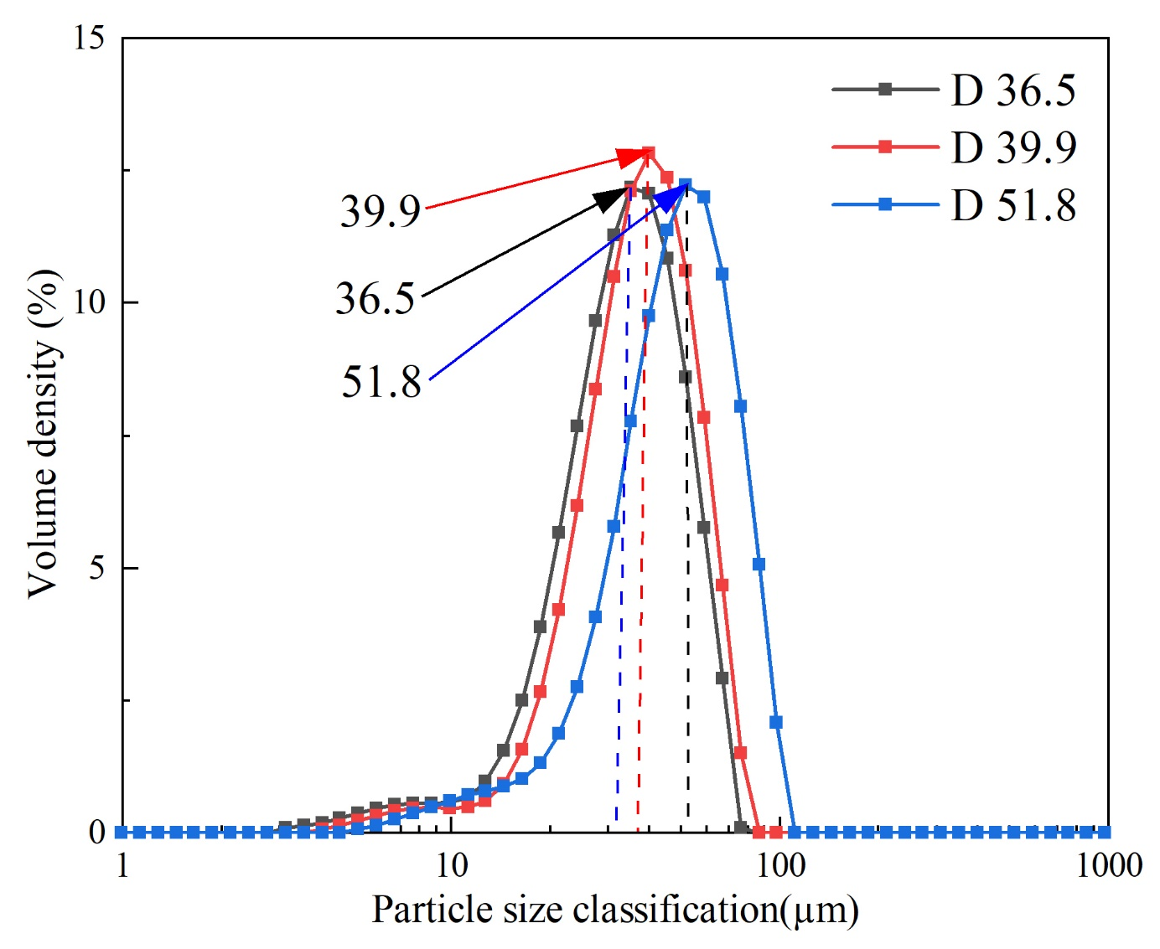
Fig. S1. Particle size distribution of different HGM.

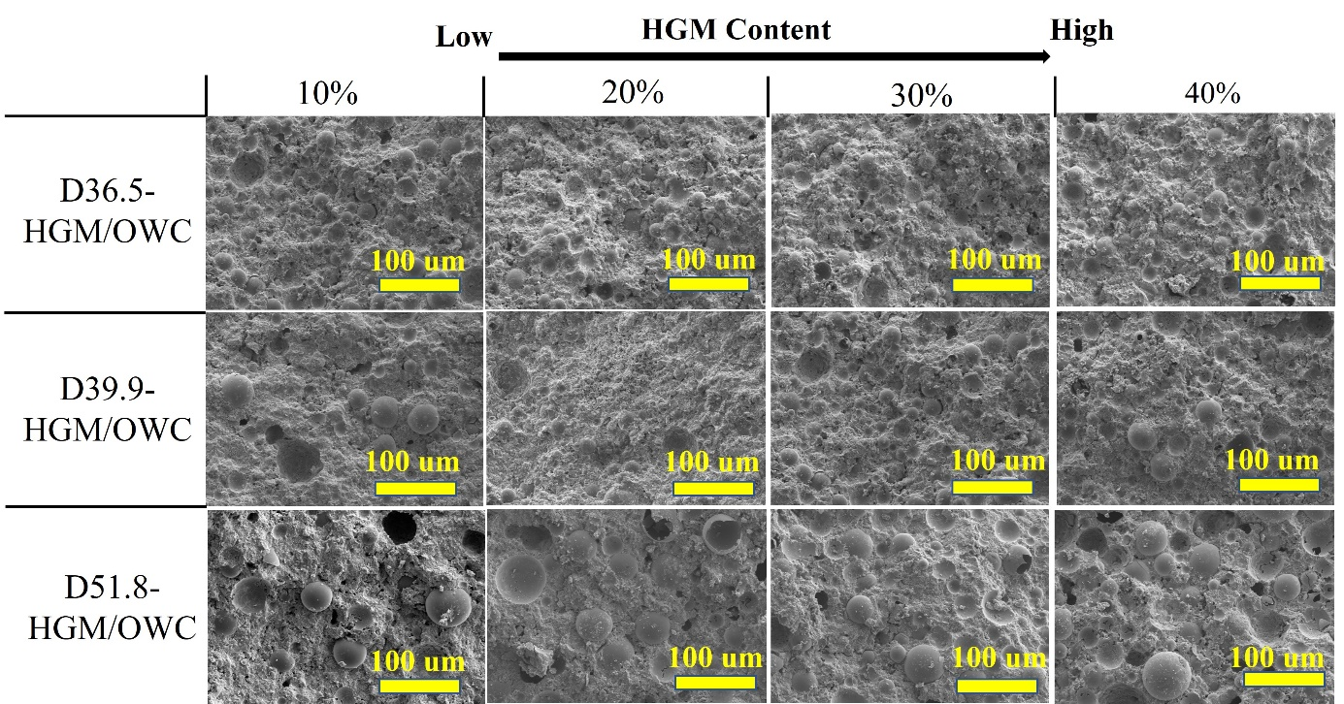
Fig. S2. Scanning electron microscopy (SEM) profiles of HGM/OWC LWTI composites with different HGM diameters and contents.

a | 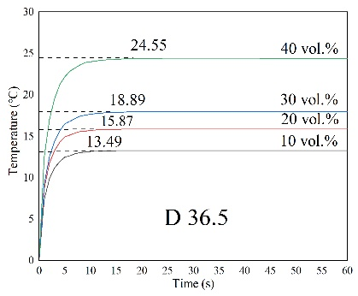 | b | 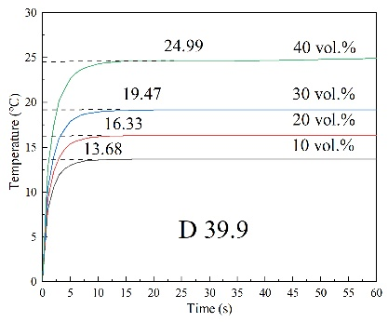 | c | 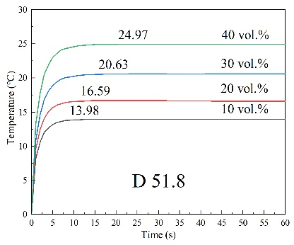
Fig. S3. Changes in left boundary temperature with time in the 2D mathematical model of HGM/OWC LWTI composite materials: (a) HGM-D36.5; (b) HGM-D39.9 and (c) HGM-D51.8.

Table S1. Chemical and mineral composition of G class oil well cement (wt.%).
Chemical composition
CaO | SiO₂ | Fe₂O₃ | Al₂O₃ | SO₂ | Others
44.1 | 50.1 | 3.4 | 2.2 | 0.1 | 0.1
Mineralogical composition
C₃S | C₂S | C₃A | C₄AF | CaSO₄ | Others
40.6 | 14.0 | 11.2 | 10.4 | 0.4 | 34.5

Table S2. Physical properties of the different HGM.
Model | Density (g/cm³) | Compressive strength (MPa) | Thermal Conductivity (W/(m·℃))
D36.5 | 0.52 | 82.74 | 0.069
D39.9 | 0.38 | 27.58 | 0.059
D51.8 | 0.19 | 3.45 | 0.055

Table S3. Fitting ratios of HGM/OWC LWTI composites with different contents and sizes of HGM.
HGM Content (vol.%) | Type | Cement Mass(g) | HGM Mass (g) | Water Mass (g) | Accelerator Mass (g) | SP  Mass (g) | W/C
0 | Blank | 200 | 0 | 48 | 20 | 3 | 0.24
 | D36.5 | 150.00 | 5.10 | 39.60 | 15.00 | 2.25 | 0.26
10 | D39.9 | 150.00 | 3.75 | 39.00 | 15.00 | 2.25 | 0.26
 | D51.8 | 150.00 | 1.76 | 37.76 | 15.00 | 2.25 | 0.25
 | D36.5 | 150.00 | 11.50 | 44.10 | 15.00 | 2.25 | 0.29
20 | D39.9 | 150.00 | 8.43 | 42.70 | 15.00 | 2.25 | 0.28
 | D51.8 | 150.00 | 3.93 | 40.00 | 15.00 | 2.25 | 0.27
 | D36.5 | 125.00 | 17.50 | 42.25 | 18.75 | 1.88 | 0.34
30 | D39.9 | 125.00 | 12.05 | 39.60 | 12.50 | 1.88 | 0.32
 | D51.8 | 125.00 | 5.60 | 35.60 | 12.50 | 1.88 | 0.28
 | D36.5 | 100.00 | 21.7 | 39.2 | 15 | 1.5 | 0.39
40 | D39.9 | 100.00 | 15.00 | 36.00 | 10.00 | 1.50 | 0.36
 | D51.8 | 100.00 | 7.00 | 31.00 | 10.00 | 1.50 | 0.31

Table S4. Comparison of analytical and numerical solution results for k_{eff} of composites.
Content of HGM (vol.%) | Result of Liang [41] |  |  | This work
Content of HGM (vol.%) | Actual value (W/(m·℃)) | Simulated value (W/(m·℃)) | Relative error(%) | Simulated value (W/(m·℃)) | Relative error(%)
5 | 0.226 | 0.212 | 5.89 | 0.224 | 0.76
10 | 0.216 | 0.196 | 9.25 | 0.213 | 1.17
15 | 0.204 | 0.181 | 11.39 | 0.202 | 1.08
20 | 0.190 | 0.166 | 12.27 | 0.188 | 0.84

Table S5. Actual values and numerical simulation results of thermal conductivity of HGM/OWC LWTI composites.
Content of HGM (vol.%) | Diameter (µm) | Thermal conductivity of actual value (W/(m·℃)) | Thermal conductivity simulated value (W/(m·℃)) | Error (%)
 | D36.5 | 0.727 | 0.741 | 1.93
10 | D39.9 | 0.715 | 0.731 | 2.24
 | D51.8 | 0.684 | 0.716 | 4.68
 | D36.5 | 0.614 | 0.63 | 2.61
20 | D39.9 | 0.583 | 0.612 | 4.97
 | D51.8 | 0.569 | 0.599 | 5.27
 | D36.5 | 0.527 | 0.529 | 0.38
30 | D39.9 | 0.499 | 0.514 | 3.01
 | D51.8 | 0.465 | 0.477 | 2.58
 | D36.5 | 0.386 | 0.407 | 5.44
40 | D39.9 | 0.373 | 0.399 | 6.97
 | D51.8 | 0.371 | 0.4 | 7.82

Table S6. Compressive strength, specific strength, and flexural strength of HGM/OWC LWTI composites.
HGM content (vol.%) | Type | Compressive strength (MPa) | Specific strength (MPa/g/cm³) | Flexural strength  (MPa)
0 | Blank | 44.31 | 21.30 | 14.88
 | D36.5 | 42.50 | 21.91 | 14.18
10 | D39.9 | 41.25 | 21.37 | 13.48
 | D51.8 | 40.63 | 21.38 | 13.07
 | D36.5 | 39.56 | 22.61 | 12.42
20 | D39.9 | 38.25 | 21.68 | 11.95
 | D51.8 | 37.75 | 21.95 | 11.7
 | D36.5 | 38.91 | 24.94 | 11.02
30 | D39.9 | 36.39 | 23.70 | 10.66
 | D51.8 | 34.02 | 22.37 | 10.08
 | D36.5 | 32.91 | 24.98 | 9.38
40 | D39.9 | 30.43 | 23.97 | 8.79
 | D51.8 | 29.44 | 22.07 | 8.44

