Exercise session sample

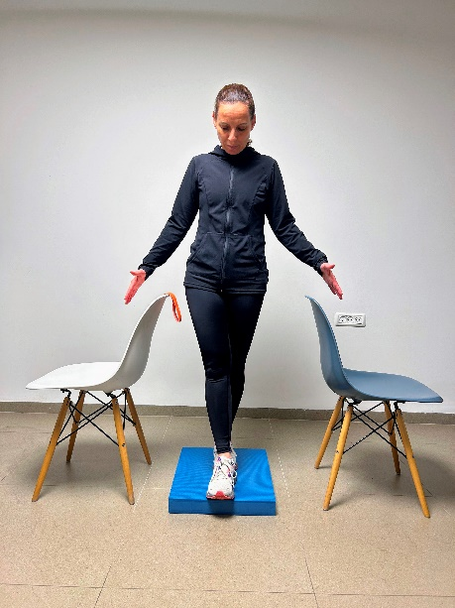
Set up
The set up included 2 chairs, a balance foam pad and an elastic band. The participant performed the exercises while standing between the chairs to allow immediate support when needed.

Exercise session structure

Exercise examples | Duration | Stage
Joints movements, Light Aerobic exercises | 5 min | Warm-up
Standing on a balance foam pad in different standing positions | 10 min | Balance exercises
Calf and toe raise, Squats, Lunge, Side hip strengthening – with/without elastic band | 10 min | Lower limb muscle strengthening
Sideways walking, Backward walking, Walking and turning around, Heel toe walking, Heel walking, Toe walking, Getting over obstacles- with/without cognitive tasks. | 10 min | Dynamic walking-balance exercises
Sit to Stand, Chair to chair transfers, Squats, Lunge- with/without elastic band | 10 min | Lower limb muscle strengthening
Stretching | 5 min | Cool down

Comments
- All exercises were done in standing position.
- All exercises were done without support, unless needed.
- Participants were encouraged to perform according to their abilities, and alternative exercises were provided as needed.

