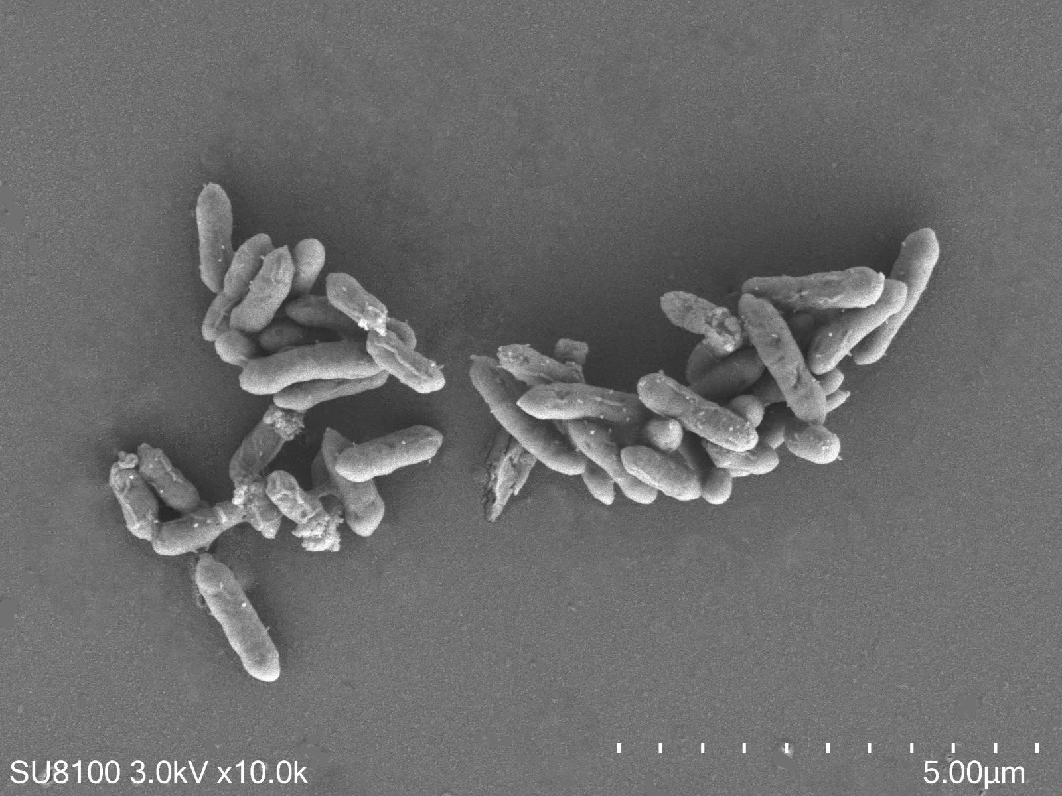
Supplementary Fig 1 Strain YQ-FP-027^{T} scanning electron microscope

No. | antibiotics | Inhibitory ring diameter（mm） | sensitivity
1 | penicillin | 32 | S
2 | cefazolin | 32 | S
3 | ampicillin | 30 | S
4 | chloromycetin | 30 | S
5 | ciprofloxacin | 16 | I
6 | norfloxacin | 17 | I
7 | erythromycin | 16 | I
8 | gentamycin | 11 | R
9 | cotrimoxazole | 0 | R
10 | Buprenorphine | 7 | R

Supplementary Table 1 Drug susceptibility test of Strain YQ-FP-027^{T}10 antibiotics

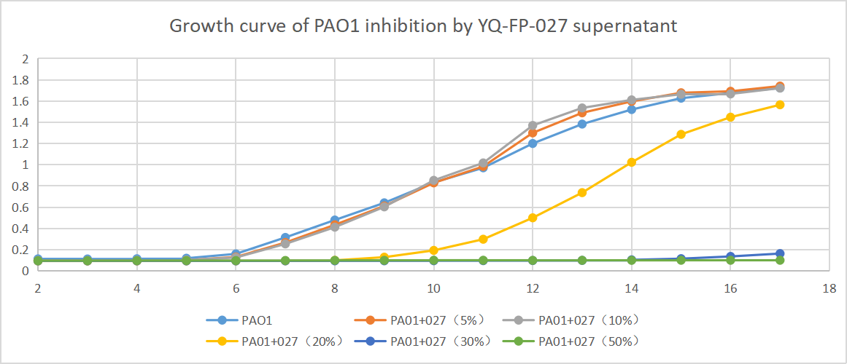
Supplementary Fig 2 Inhibition of PAO1 by Strain YQ-FP-027^{T} supernatant

No. | Test items | Content(μg/g)
LGG | acetic acid | 812.09
YQ-FP-027 | acetic acid | 458.17
LGG | propanoic acid | 19.99
YQ-FP-027 | propanoic acid | 2.63
LGG | isobutyric acid | 5.12
YQ-FP-027 | isobutyric acid | 1.89
LGG | butyric acid | 16.58
YQ-FP-027 | butyric acid | 2001.92
LGG | isovaleric acid | 6.94
YQ-FP-027 | isovaleric acid | 0.87
LGG | valeric acid | 26.17
YQ-FP-027 | valeric acid | 1.47

Supplementary Table 2 SCFA production of Strain YQ-FP-027^{T} and LGG

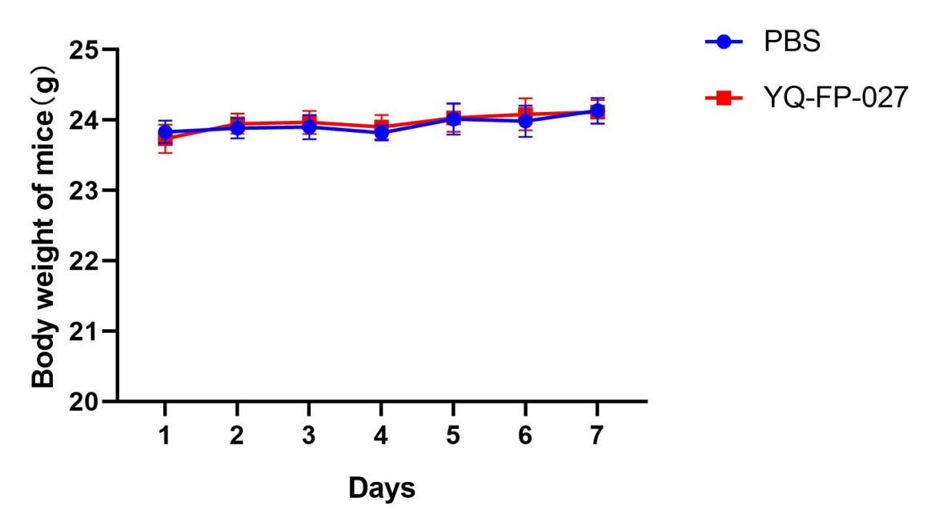
Supplementary Fig 3 Toxic effects of Strain YQ-FP-027^{T} on mice

