Supporting Information
Transparent, flame retardant and machinable cellulose/silica composite aerogels with nanoporous dual network for energy-efficient buildings
Jing Sun ^{1, 2}, Jing Hu ^{1, 2}, Ya Zhong ^{1, 2, 3*}, Junjun Zhang ^{1, 2}, Shuxuan Pan ^{1, 2}, Zichen Xiang ^{1, 2}, Sheng Cui ^{1, 2} and Xiaodong Shen ^{1, 2, 3}

¹ State Key Laboratory of Materials-Oriented Chemical Engineering, College of Materials Science and Engineering, Nanjing Tech University, Nanjing 210009, China;
² Jiangsu Collaborative Innovation Center for Advanced Inorganic Function Composites, Nanjing Tech University, Nanjing 210009, China
³ Suqian Advanced Materials Industry Technology Innovation Center of Nanjing Tech University, Suqian 223800, China)
* Corresponding author. E-mail address: yzhong@njtech.edu.cn (Ya Zhong)

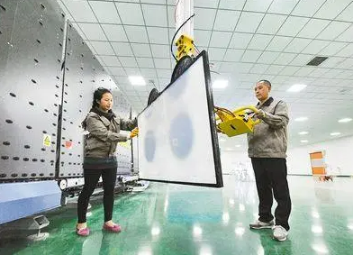
Fig. S1 The first mass production line for SiO₂ aerogel glass developed by Central South University

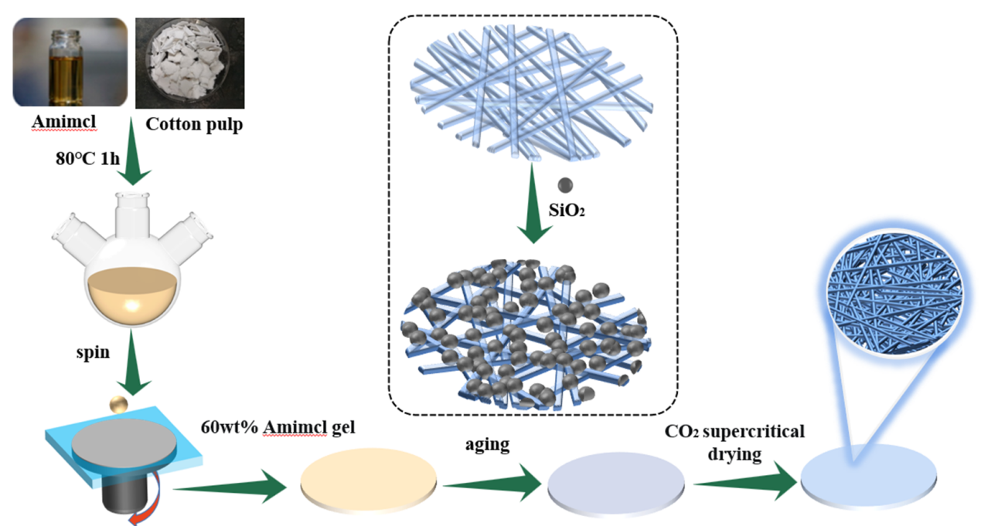
Fig. S2 Schematic representation of the preparation of transparent cellulose/silica composite aerogel films

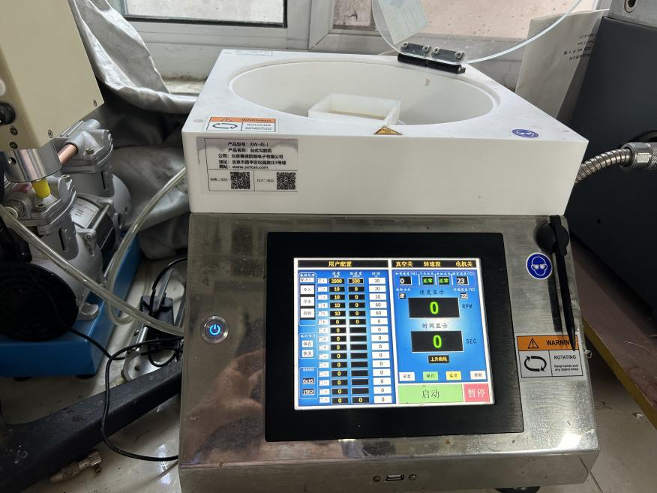
Fig. S3 Homogeniser equipment for laboratories. Pour the sol into the mould and put the mould in the screeding machine, set the vacuum degree to 0.01~0.1MPa, the rotation rate to 1000~2000rpm, the spinning acceleration to 200~500rpm/sec, the spinning time to 10~60s

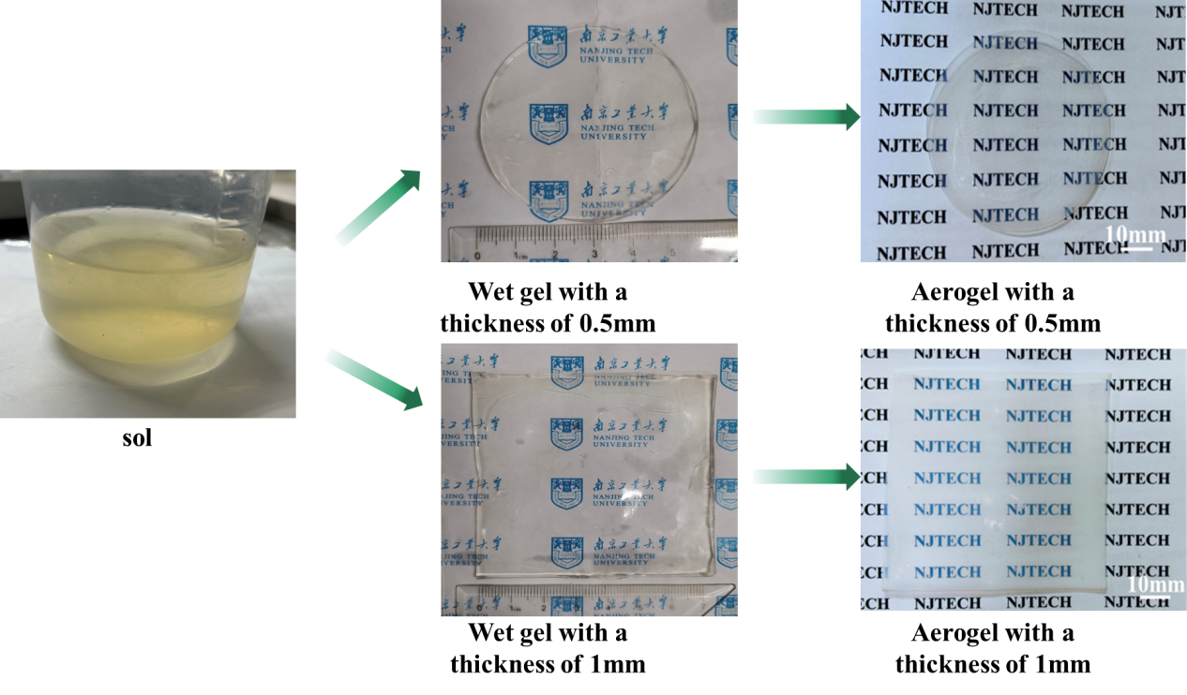
Fig. S4 Unmodified photographs of cellulose/silica composite aerogel films subjected to sol-gel method, supercritical CO₂ drying process
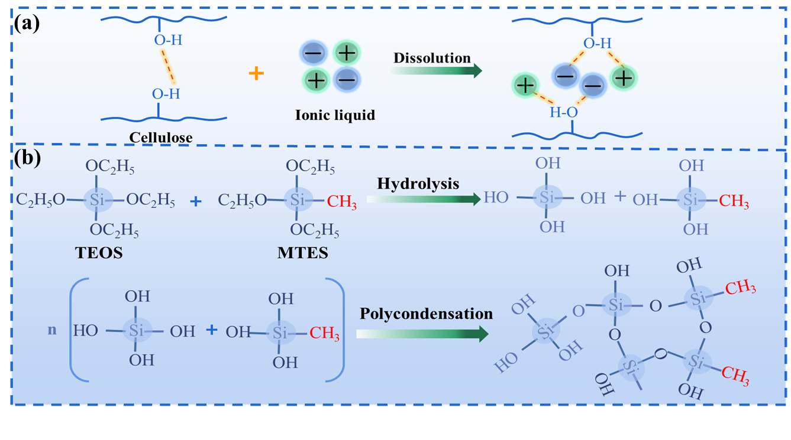
Fig. S5 (a) Ionic liquids dissolve cellulose, (b) Hydrolytic condensation process of double silicon source
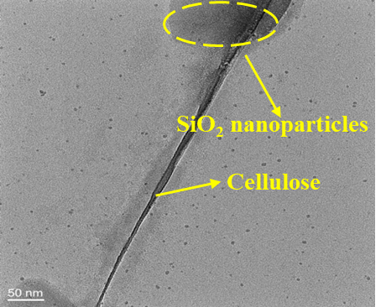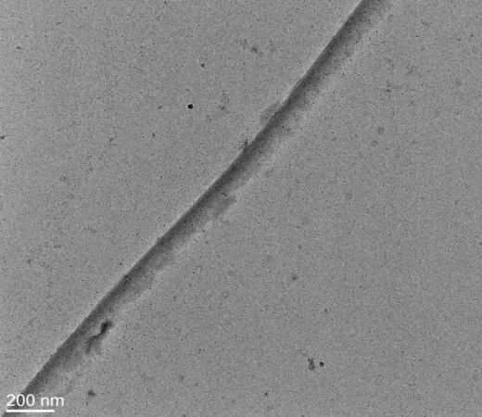
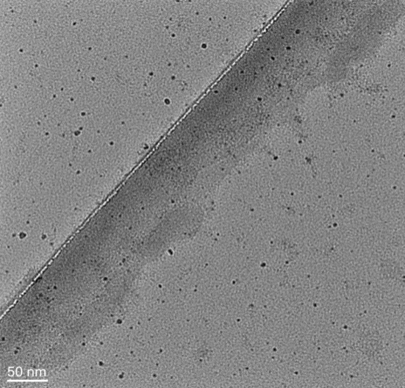
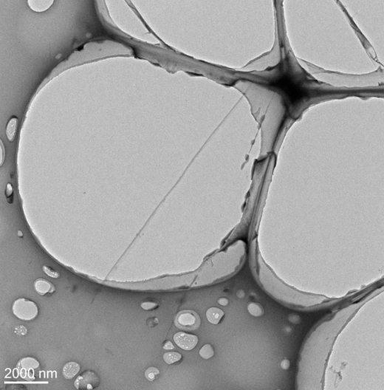

Fig. S6 TEM images of CAS4 sample
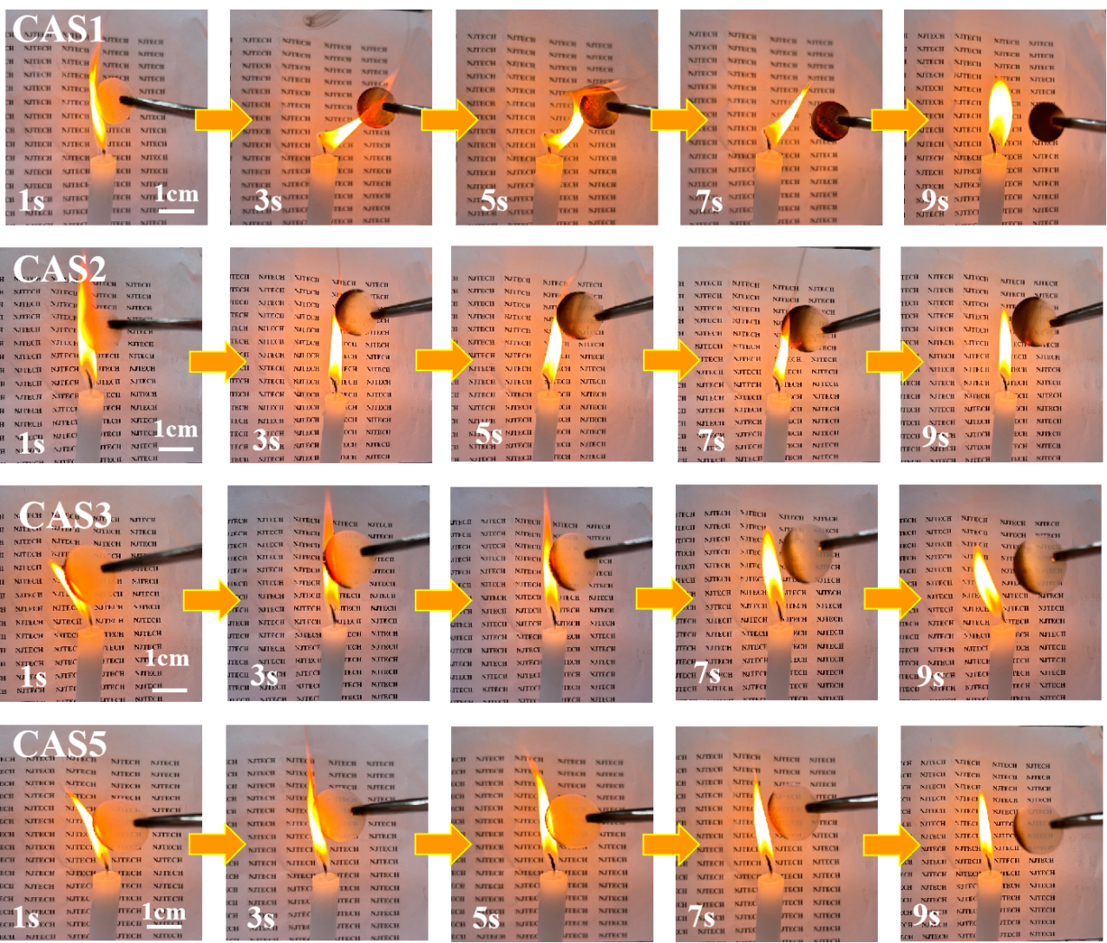
Fig. S7 Combustion processes of CAS1, CAS2, CAS3 and CAS5

Table S1 Summary of the textural properties of aerogels samples with different SiO₂ content
Sample | Silicon content (wt%) | Density (g/cm³) | Specific surface area  (m²/g) | Pore volume  (cm³/g) | Pore size  (nm) | Volume shrinkage (%)
CA | 0 | 0.058 | 171.4 | 0.77 | 19.59 | 22.91
CAS1 | 14 | 0.093 | 660.87 | 2.51 | 15.20 | 18.34
CAS2 | 18 | 0.103 | 719.15 | 3.84 | 15.12 | 16.21
CAS3 | 25 | 0.123 | 812.33 | 2.73 | 13.42 | 13.88
CAS4 | 38 | 0.164 | 952.18 | 2.91 | 12.23 | 11.35
CAS5 | 52 | 0.170 | 1089.70 | 1.78 | 9.89 | 10.47

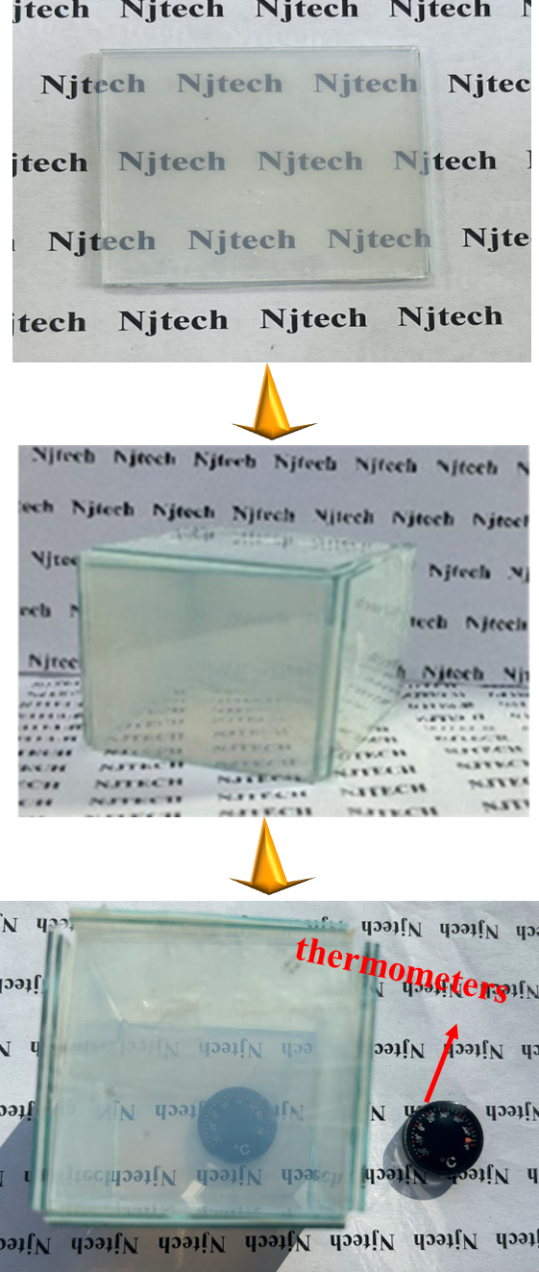
Fig. S8 Self-designed aerogels glasses model fabricated by using the CAS4 films with 0.5 mm thickness

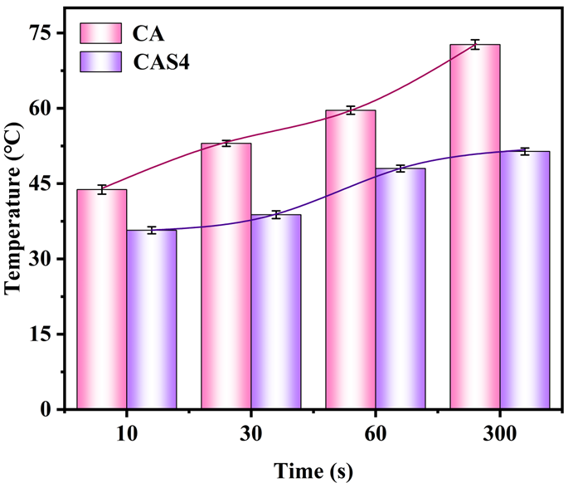
Fig. S9 Curve of the cold surface temperature of CA and CAS4 samples with time on a heating table at 130℃

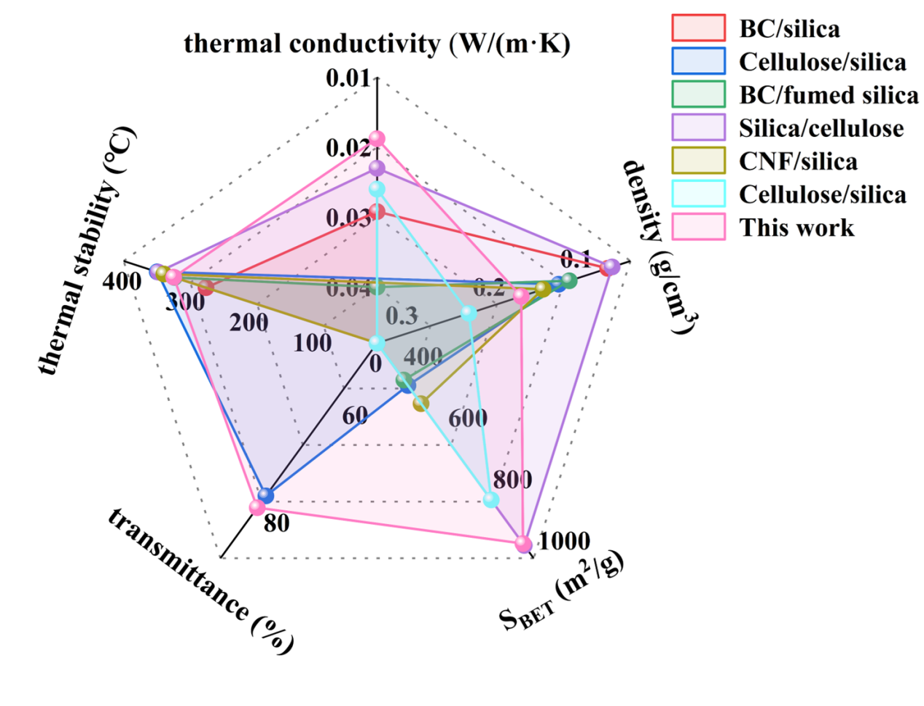

Fig. S10 Comparison of comprehensive performance of the representative CAS4 sample with BC/silica composite aerogels (Cai et al. 2018), cellulose/silica composite aerogels (Yuan et al. 2017), BC/fumed composite silica aerogels (Kunjalukkal Padmanabhan et al. 2021), Silica/cellulose composite aerogels (Chen et al. 2021), CNF/silica composite aerogels (Fu et al. 2018), and cellulose/silica composite aerogels (Demilecamps et al. 2015).

Table S2 Comparison of comprehensive properties of the as-prepared CAS with other representative aerogels materials.
material | thermal conductivity  (W·m⁻¹·K⁻¹) | density  (g/cm³) | S_{BET}  (m²/g) | transmittance | thermal stability  (℃) | ref.
BC/silica | 0.0292 | 0.066 | - | 0 | 270 | (Cai et al. 2018)
cellulose/silica | - | - | 5.63 | 0 | - | (Silviana et al. 2022)
cellulose/silica | - | 0.122 | 438 | 78.4% | 347 | (Yuan et al. 2017)
CNF/silica | - | 0.140 | 497.8 | - | 336.4 | (Fu et al. 2018)
cellulose/silica | 0.026 | 0.225 | 810 | 0 | - | (Demilecamps et al. 2015)
Cellulose/SiO₂ | 0.0257 | 0.233 |  | 0 |  | (Shi et al. 2013)
BC/fumed silica (FS) | 0.04 | 0.110 | 420 | 0 | 320 | (Kunjalukkal Padmanabhan et al. 2021)
Silica/cellulose | 0.023 | 0.061 | 958 | 0 | 345.5 | (Chen et al. 2021)
CNF/silica | 0.0226 | 0.1 | - | 0 |  | (Fu et al. 2016)
Cellulose/PFOES | 0.014 | - | 441 | 97-99% | ＞200 | (Abraham et al. 2023)
MTES/POSS | 0.0286 | 0.23 | 815 | 86% | >470 | (Ren et al. 2022)
PVPMS | 0.015 | 0.16~0.22 | 900~1000 | >80% | - | (Zu et al. 2018)
cellulose/silica | 0.0188 | 0.093~0.170 | 660.87~1089.70 | 91.7% | ＞331 | This work

References
Abraham Eldho et al (2023) Highly transparent silanized cellulose aerogels for boosting energy efficiency of glazing in buildings. Nature Energy 8:381-396
Cai Mengmeng, Sameera Shafi, Yaping Zhao (2018) Preparation of compressible silica aerogel reinforced by bacterial cellulose using tetraethylorthosilicate and methyltrimethoxylsilane co-precursor. Journal of Non-Crystalline Solids 481:622-626
Chen Y X et al (2021) One-pot synthesis of monolithic silica-cellulose aerogel applying a sustainable sodium silicate precursor. Construction and Building Materials 293
Demilecamps A et al (2015) Cellulose-silica aerogels. Carbohydr Polym 122:293-300
Fu Jingjing et al 2016 Cellulose nanofibril reinforced silica aerogels: optimization of the preparation process evaluated by a response surface methodology. RSC Advances 6:100326-100333
Fu Jingjing et al (2018) A thermally stable and hydrophobic composite aerogel made from cellulose nanofibril aerogel impregnated with silica particles. Journal of Materials Science 53:7072-7082
Kunjalukkal Padmanabhan, Sanosh, Carmelo Protopapa, Antonio Licciulli (2021) Stiff and tough hydrophobic cellulose-silica aerogels from bacterial cellulose and fumed silica. Process Biochemistry 103:31-38
Ren Jiafei et al (2022) Transparent, robust, and machinable hybrid silica aerogel with a “rigid-flexible” combined structure for thermal insulation, oil/water separation, and self-cleaning. Journal of Colloid and Interface Science 623:1101-1110
Shi J et al (2013) Heat insulation performance, mechanics and hydrophobic modification of cellulose-SiO₂ composite aerogels. Carbohydr Polym 98:282-289
Silviana S et al (2022) Optimization of the sound absorption coefficient (SAC) from cellulose-silica aerogel using the box-behnken design. ACS Omega 7:41968-41980
Yuan Bin et al (2017) Transparent Cellulose–silica composite aerogels with excellent flame retardancy via an in situ sol–gel process. ACS Sustainable Chemistry & Engineering 5:11117-11123
Zu G et al (2018) Transparent, superflexible doubly cross-linked polyvinylpolymethylsiloxane aerogel superinsulators via ambient pressure drying. ACS Nano 12:521-532

