Table S1. Inclusion and Exclusion Criteria
Inclusion Criteria
1. Patients with histologically proven recurrent GBM;
2. Patients must show unequivocal evidence for tumor recurrence or progression by MRI scan after failing prior surgical resection, biopsy, chemotherapy or radiation. A baseline MRI must be performed within 15 days prior to Day 0/Baseline;
3. Patients will consent to have a biopsy taken to confirm the presence of glioblastoma (based on frozen section) before injection of Ad-TD-nsIL12;
4. Patients may or may not have had prior chemotherapy;
5. Patients must be willing and able to give informed consent;
6. Aged ≥ 18 years;
7. Patients must have a KPS ≥ 70;
8. Patients must have recovered from the toxic effects of prior therapy (i.e. CTC grade 1 or less). For example, they must be at least 2 weeks post vincristine, 6 weeks post nitrosoureas, and 3 weeks post procarbazine or temozolomide administration;
9. Patients must have sufficient hematopoietic function of bone marrow and liver/renal function.
Exclusion Criteria
1. Radiation therapy within 4 weeks prior to Ad-TD-nsIL12 administration.
2. Uncontrolled active infection or unstable or severe infectious disease.
3. Predisposition to bleeding or use of anticoagulants or any medication that may increase the risk of bleeding before surgery. Patients may be eligible if, in the surgeon's clinical judgment, these medications can be discontinued prior to Ad-TD-nsIL12 injection.
4. Failure to obtain informed consent due to psychiatric problems or complex medical conditions.
5. Women who are pregnant and/or breastfeeding.
6. Patients with immunodeficiency, autoimmune diseases, active hepatitis B or C, or HIV positive.
7. Patients with multiple intracranial primary or recurrent GBM.
8. Patients with extracranial metastases.
9. Biological/immunotherapy (e.g., IL-2, IL-12, interferon) performed within 4 weeks before administration.
10. Concurrent chemotherapy, radiotherapy or biological therapy.
11. Presence of prohibited items for MRI examination, such as pacemakers, epicardial pacemaker wires, infusion pumps, surgical and/or aneurysm clips, shrapnel, metal prostheses, potentially magnetic implants, metal objects in the eye, etc.
12. White blood cell (WBC) < 2.5×10³/mm³, absolute neutrophil count (ANC) < 1.5×10³/mm³, platelets < 100,000/mm³, hemoglobin (Hgb) < 10.0 gm/dL, Prothrombin time/international normalized ratio (PT/INR) or partial thromboplastin time (PTT) > 1.8× control.
13. Grade 4 hematotoxicity.
14. Serum creatinine > 1.5 mg/dL.
15. Liver aminotransferase (aspartate aminotransferase (AST) and/or alanine aminotransferase (ALT)) or total bilirubin > 2 times the upper limit of normal.
16. Received any type of vaccine within 30 days prior to Ad-TD-nsIL12 administration.
17. Patients with a current diagnosis of other cancers.Cured cervical cancer in situ, basal or squamous cell carcinoma of the skin, and/or a previous history of another cancer that has been absent for at least three years remain eligible.
18. A history of encephalitis, multiple sclerosis, other central nervous system infections, or primary central nervous system disorders that may affect the subject's evaluation.
19. Patients who have been treated with gene transfer therapy or have been treated with any type of cytolytic virus.
20. Men or women who refused contraception during the study and within 6 months after Ad-TD-nsIL12 injection.

Table S2: Adverse Events recorded between first and 2 months after the last Ad-TD-nsIL12 injection
Event | Grade 1 | Grade 2 | Grade 3 | Grade 4 | Number of Patients (%)
 | number |  |  |  | n (%)
Cardiac disorders
Atrial fibrillation | 0 | 2 | 0 | 0 | 2(25.0%)
Heart failure | 0 | 0 | 2 | 0 | 2(25.0%)
Eye Disorders
Extraocular muscle paresis | 2 | 0 | 0 | 0 | 2(25.0%)
Eye pain | 1 | 0 | 0 | 0 | 1(12.5%)
Gastrointestinal disorders
Abdominal pain | 2 | 0 | 0 | 0 | 2(25.0%)
Constipation | 1 | 0 | 0 | 0 | 1(12.5%)
Diarrhea | 1 | 0 | 0 | 0 | 1(12.5%)
Nausea | 2 | 3 | 1* | 0 | 6(75.0%)
Vomiting | 3 | 2 | 1* | 0 | 6(75.0%)
General disorders and administration site conditions
Edema limbs | 0 | 1 | 0 | 0 | 1(12.5%)
Fatigue | 3 | 1 | 0 | 0 | 4(50.0%)
Fever | 7 | 0 | 0 | 0 | 7(87.5%)
Infections and infestations
Upper respiratory infection | 0 | 2 | 0 | 0 | 2(25.0%)
Urinary tract infection | 0 | 1 | 0 | 0 | 1(12.5%)
Nerve System Disorder
Amnesia | 1 | 1 | 0 | 0 | 2(25.0%)
Arachnoiditis | 1 | 0 | 0 | 0 | 1(12.5%)
Cognitive disturbance | 3 | 4 | 0 | 0 | 7(87.5%)
Dizziness | 3 | 1 | 1 | 0 | 5(62.5%)
Dysarthria | 1 | 3 | 0 | 0 | 4(50.0%)
Headache | 1 | 4 | 0 | 0 | 5(62.5%)
Hydrocephalus | 0 | 3 | 1 | 0 | 4(50.0%)
Intracranial hemorrhage | 0 | 2 | 0 | 0 | 2(25.0%)
Memory impairment | 2 | 3 | 0 | 0 | 5(62.5%)
Muscle weakness one-sided | 1 | 1 | 2 | 0 | 4(50.0%)
Seizure | 1 | 2 | 2* | 0 | 5(62.5%)
Psychiatric disorders
Insomnia | 1 | 0 | 0 | 0 | 1(12.5%)
Respiratory, thoracic and mediastinal disorders
Pneumonitis | 2 | 4 | 0 | 0 | 6(75.0%)
Vascular disorders
Hypertension | 0 | 2 | 1 | 0 | 3(37.5%)
Hypotension | 0 | 2 | 0 | 0 | 2(25.0%)

1. Adverse events were graded according to Common Terminology Criteria for Adverse Events (CTCAE, version 5.0)

2. Laboratory abnormalities are not included.

Table S3: Adenovirus genome detection in CSF and Serum after first injection
Dose Group | No | Time after  administration（days） | CSF | Serum
1 5x10⁹ | 1 | 0 | 0 | 0
1 5x10⁹ |  | 1 | 0 | 0
1 5x10⁹ |  | 4 | 0 | 0
1 5x10⁹ | 2 | 0 | 0 | 0
1 5x10⁹ |  | 1 | 0 | 0
1 5x10⁹ |  | 4 | 0 | 0
1 5x10⁹ | 3 | 0 | 0 | 0
1 5x10⁹ |  | 1 | 0 | 0
1 5x10⁹ |  | 4 | 0 | 0
1 1x10¹⁰ | 4 | 0 | 0 | 0
1 1x10¹⁰ |  | 1 | 0 | 0
1 1x10¹⁰ |  | 4 | 0 | 0
1 1x10¹⁰ | 5 | 0 | 0 | 0
1 1x10¹⁰ |  | 1 | 0 | 0
1 1x10¹⁰ |  | 4 | 0 | 0
1 1x10¹⁰ | 6 | 0 | 0 | 0
1 1x10¹⁰ |  | 1 | 0 | 0
1 1x10¹⁰ |  | 4 | 0 | 0
1 5x10¹⁰ | 7 | 0 | 0 | 0
1 5x10¹⁰ |  | 1 | 0 | 0
1 5x10¹⁰ |  | 4 | 0 | 0
1 5x10¹⁰ | 8 | 0 | 0 | 0
1 5x10¹⁰ |  | 1 | 0 | 0
1 5x10¹⁰ |  | 4 | 0 | 0

Figure S1: The patients’ best KPS scores at baseline and during the trial were compared. four patients showed an improvement in their best KPS during follow-up, while KPS remained stable for the other four patients. (— stands for median value, Mann-Whitney U test).

Figure S2：Kaplan–Meier curve for overall survival after the first Ad-TD-nsIL12 injection. The median survival time after virotherapy was 5.1 months, with patient 6 remaining alive 20.6 months after first virus injection. (n=8)
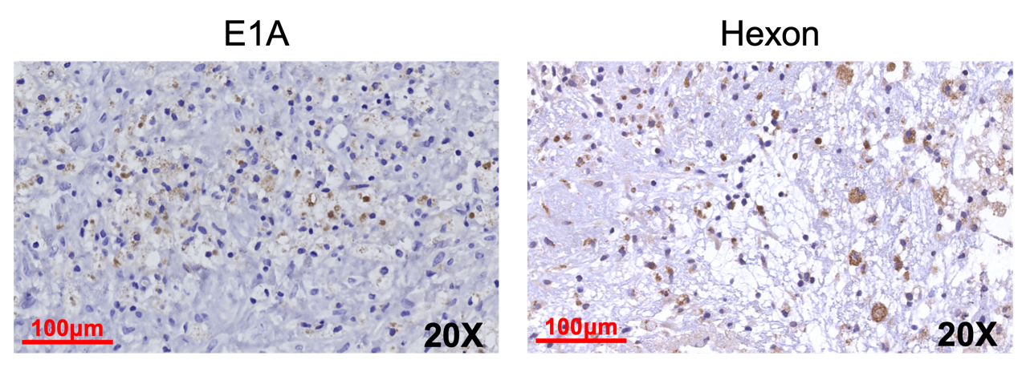
Figure S3: In the post-treatment samples of patient 2, EIA and hexon were both observed, indicating the virus infection and replication one month after the 3rd virus treatment.
Figure S4: Expression of Ad-TD-nsIL12 associated inflammatory cytokines in CSF of Patient 4 (A) and 5 (B). In patient 4, the levels of IFN-Y, IL-10 and IL-21 increased slightly after treatment. IFN-Y, IL-10, and IL-21 in patient 6 after treatment. No significant increase in IL-12 was observed after treatment.

