Supplementary Materials of “Unravelling spontaneous Bloch-type skyrmion in centrosymmetric two-dimensional ferromagnets”
Jing Man Pang¹, Xiao Hang Niu², Hong Jian Zhao³, Meiguang Zhang², Yu Qian², Yun Zhang^{2*}, Laurent Bellaiche⁴
¹ Faculty of Chemistry and Chemical Engineering, Baoji University of Arts and Sciences, 1 Hi-Tech Avenue, Baoji, Shaanxi, P. R. China
²China College of Physics and Optoelectronic Technology, Collaborative Innovation Center of Rare-Earth Functional Materials and Devices Development, Baoji University of Arts and Sciences, Baoji 721016, China
³Key Laboratory of Material Simulation Methods and Software of Ministry of Education, College of Physics, Jilin University, Changchun 130012, China
⁴Physics Department and Institute for Nanoscience and Engineering, University of Arkansas, Fayetteville, Arkansas 72701, USA
*E-mail: zhangyun_xtu@163.com
Keywords: two-dimensional centrosymmetric magnets, magnetic skyrmions, first-principle calculation
1. Density Functional Theory (DFT) calculations
First-principles calculations are performed by using the VASP package [1, 2], with an energy cutoff of 400 eV. We further employ the GGA + U approach [3] to tackle the strong correlation effect of Cr’s 3d electrons. The effective Hubbard U is set to 1.0 eV, as done in previous works [4-6]. During the calculations, the two-dimensional materials are mimicked by slabs, with the vacuum space between adjacent slabs being 15 Å -- preventing interactions between adjacent layers. To sample the Brillouin zone, the 9 × 9 × 1 Γ-centered k-point mesh (associated with the unit cell) is used for structural relaxations, while the denser 24 × 24 × 1 k-point mesh is employed for magnetic anisotropy (MAE) calculations. The magnetic parameters for Cr₂Ge₂Te₆ are obtained by the four-state energy mapping method [7, 8], using a 3 × 3 × 1 supercell and 2 × 2 × 1 k-point mesh to ensure accuracy.
2. Parallel tempering Monte-Carlo simulations and topological analyses
Monte-Carlo simulations are carried out with the Material Simulation and Property Calculation Package (MSPCP) [9, 10]. Parallel tempering Monte Carlo (PTMC) computations with the heat bath algorithm [11] are performed based on the Hamiltonian of Eq. (4) of the main text to find the ground or metastable states. The obtained results, presented in Figure 3 of the main text, are based on a 60 × 60 × 1 supercell (that contains 7200 Cr ions), which is sufficiently large. 200,000 MC sweeps are used at each temperature. Additionally, conjugate gradient (CG) method [12] is also applied to further optimize the spin configuration. The energy convergence criteria of this CG algorithm is set to be 10⁻⁶ eV. This combination of MC simulations and the CG method guarantees that the resulted magnetic configurations are all located at energy minima and provide the real ground state.
The topological charge Q is calculated using the definition of Berg and Lüscher [13] for discrete lattice, which is:
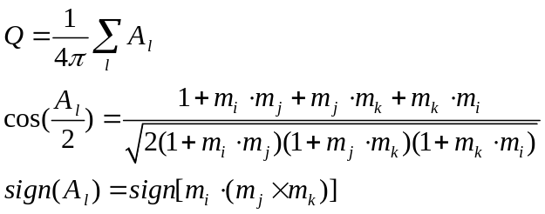
where l runs over all elementary triangles made of neighboring spin sites and A_{l} is the solid angle formed by the three unit spin vectors m_{i}, m_{j}, and m_{k} of the lth triangle. The triangles should cover all lattice area with no overlap and sites i, j, and k should be in a counterclockwise order.
3. Magnetic parameters for several two-dimensional magnets with honeycomb structure.
It is also experimentally confirmed that the emergence of gap opening within the magnon bands of two-dimensional centrosymmetric magnets, such as CrXTe₃ and CrI₃, primarily arises from the Dzyaloshinskii–Moriya interaction (DMI) between second nearest-neighbor (NN) pairs within the 2D honeycomb lattice. Specifically, these two-dimensional magnets possess finite out-of-plane component of the DMI, i.e. d_{z}, as listed in Table SI, which is consistent with our DFT results. In addition, our DFT results also unveil the existence of finite planar component (d_{x}) aligned along second NN pairs, which plays a crucial role in the Bloch-type skyrmions observed in Cr₂Ge₂Te₆.
Tran et al. [16] have also suggested that the formation of skyrmions in CrCl₃ is attributed to the in-plane component of the second NN DMI. However, their Green function method yields a DMI value of 0.54 meV, which is significantly larger than our result of 0.01 meV. It has been reported that gap opening within the magnon bands for monolayer CrX₃ (X= I, Br, and Cl) is largest for CrI₃, followed by CrBr₃, while it is absent in CrCl₃. This evolution naturally follows the order of spin-orbit coupling (SOC) of the halogen atom (I > Br > Cl), due to the DMI arising from the SOC. Moreover, they have demonstrated that the in-plane DMI includes not only the component aligned along the second NN Cr-Cr bond but also the non-negligible component perpendicular to the bond, which contradicts our symmetry analysis that the in-plane component of DMI that is perpendicular to the bond should be zero. The topological spin structure of CrCl₃ is convincingly ascribed to the dipole-dipole interaction or biquadratic exchange interaction [20, 21].
Table SI. Magnetic parameters of monolayer Cr₂Si₂Te₆, Cr₂Ge₂Te₆, CrCl₃ and CrI₃. J₁, J₂, d_{x}, d_{z} and MAE represent the first and second NN Heisenberg exchange, second NN DMI, and total magnetic anisotropy, respectively. The unit is meV.
 | J₁ | J₂ | d_{x} |  | d_{z} | MAE | κ
Cr₂Si₂Te₆ | 8.01 | 0.20 | 0.22 | 0.47 |  | 0.211 | 3.94 | This work
Cr₂Si₂Te₆ | 3.35 | 0.34 | / | 0.27 |  | 0.010 | / | [15]
Cr₂Ge₂Te₆ | 10.85 | -0.34 | 0.27 | 0.61 |  | 0.065 | 0.288 | This work
Cr₂Ge₂Te₆ | 6.14 | 0.74 | / | 0.72 |  | 0.010 | / | [15]
CrCl₃ | 4.16 | 0.28 | 0.01 | 0.0003 |  | 0.033 | 157.68 | This work
CrCl₃ | 3.60 | 0.10 | 0.54 | / |  | 0.034 | 0.04 | [16]
CrBr₃ | 1.36 | 0.06 | / | 0.04 |  | 0.07 | / | [17]
CrI₃ | 4.90 | 1.43 | 0.18 | 0.24 |  | 0.69 | 25.84 | [18]
CrI₃ | 4.75 | 0.36 | / | 0.20 |  | 0.28 | / | [19]

4. The effect of solely considering second NN d_{z} component on spin texture for two-dimensional centrosymmetric magnets.
As previously highlighted, two-dimensional centrosymmetric magnets manifest notable d_{z} component of second NN DMI. To elucidate the effects of second NN d_{z} on the spin texture of two-dimensional centrosymmetric magnets (e.g., Cr₂Ge₂Te₆), we conduct the PTMC simulations with fixed first NN Heisenberg exchange J₁ = 10.85 meV and single ion anisotropy SIA = 0.026 meV while varying the second NN d_{z}. As depicted in Figure S1, our results indicate that when the magnitude of the d_{z} component aligns comparably with that of the Heisenberg exchange interaction, it leads to the emergence of a non-collinear spin texture. However, it does not yield any topological spin textures.
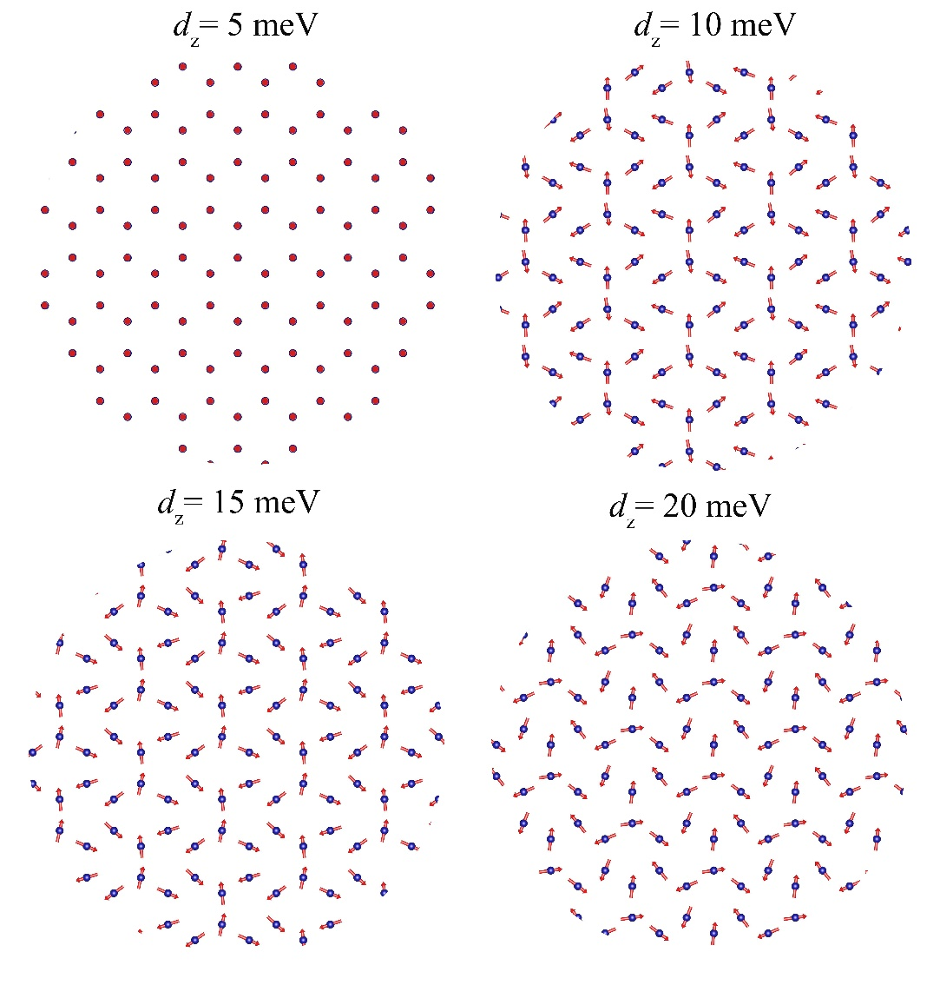
Figure S1. The spin texture of monolayer Cr₂Ge₂Te₆ that solely comprises the second NN d_{z} component.
References:
1. G. Kresse, J. Furthmüller, Phys. Rev. B 54, 11169 (1996).
2. G. Kresse, J. Hafner, Phys. Rev. B 47, 558 (1993).
3. J. P. Perdew, K. Burke, M. Ernzerhof, Phys. Rev. Lett. 77, 3865 (1996).
4. Gong, C.; Li, L.; Li, Z.; Ji, H.; Stern, A.; Xia, Y.; Cao, T.; Bao, W.; Wang, C.; Wang, Y.; Qiu, Z. Q.; Cava, R. J.; Louie, S. G.; Xia, J.; Zhang, X. Nature 2017, 546, 265−269.
5. Zhang B H, Hou Y S, Wang Z, Wu R. Q. Phys. Rev. B 2019, 100(22): 224427.
6. Y. M. Fang, S. Q. Wu, Z. Z. Zhu, and G. Y. Guo. Phys. Rev. B 98, 125416 (2018)
7. H. Xiang, C. Lee, H. J. Koo, X. Gong, M. H. Whangbo, Dalton Trans. 42, 823 (2013).
8. C. Xu, B. Xu, B. Dupé, L. Bellaiche, Phys. Rev. B 99, 104420 (2019).
9. H. J. Xiang, S. H. Wei, M. H. Whangbo, Phys. Rev. Lett. 100, 167207 (2008).
10. P. S. Wang, H. J. Xiang, Phys. Rev. X 4, 011035 (2014).
11. Y. Miyatake, M. Yamamoto, J. J. Kim, M. Toyonaga, O. Nagai, J. Phys. C 19, 2539 (1986).
12. E. Stiefel, J. Res. Nat. Bur. Standards 49, 409 (1952).
13. B. Berg, M. Lüscher, Nucl. Phys. B 190, 412-424 (1981).
14. H. B. Tran, Y. Matsushita, Scripta Mater. 239: 115799 (2024).
15. Khela M, Da̧browski M, Khan S, et al. Nat. Commun. 2023, 14(1): 1378.
16. H. B. Tran, Y. Matsushita, Scripta Mater. 239: 115799 (2024)
17. Z. Cai, et al. Phys. Rev. B 104(2): L020402 (2021).
18. C. Xu, J. Feng, S. Prokhorenko, Y. Nahas, H. Xiang, L. Bellaiche, Phys. Rev. B 101, 060404 (2020).
19. L. Chen, J.-H. Chung, M. B. Stone, A. I. Kolesnikov, B. Winn, V. O. Garlea, D. L. Abernathy, B. Gao, M. Augustin, E. J. G. Santos, and P. Dai, Phys. Rev. X 11, 031047 (2021).
20. X. Lu, R. Fei, L. Zhu, and L. Yang, Nat. Commun. 11, 4724 (2020).
21. M. Augustin, S. Jenkins, R. F. L. Evans, K. S. Novoselov, and E. J. G. Santos, Nat. Commun. 12, 185 (2021).

