Supplementary Information
Degradation of organic pollutants by the Cl⁻/PMS process
Miaomiao Ye, Ziyi Luo, Wen Jin, Xingyuan Wang, Tuqiao Zhang, Xiaowei Liu*
Zhejiang Key Laboratory of Drinking Water Safety and Distribution Technology, Zhejiang University, Hangzhou, Zhejiang 310058, PR China
∗Corresponding author. Tel.: +86-571-88206759
Email address: liuxiaowei@zju.edu.cn (X.W. Liu)

Number of Pages: 8
Number of Figures: 6
Number of Tables: 2

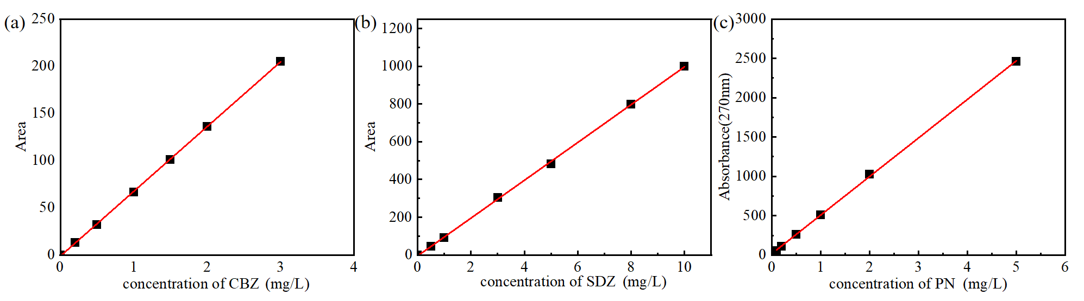
Fig. S1. The standard curves of (a) carbamazepine, (b) sulfadiazine and (c) phenol.

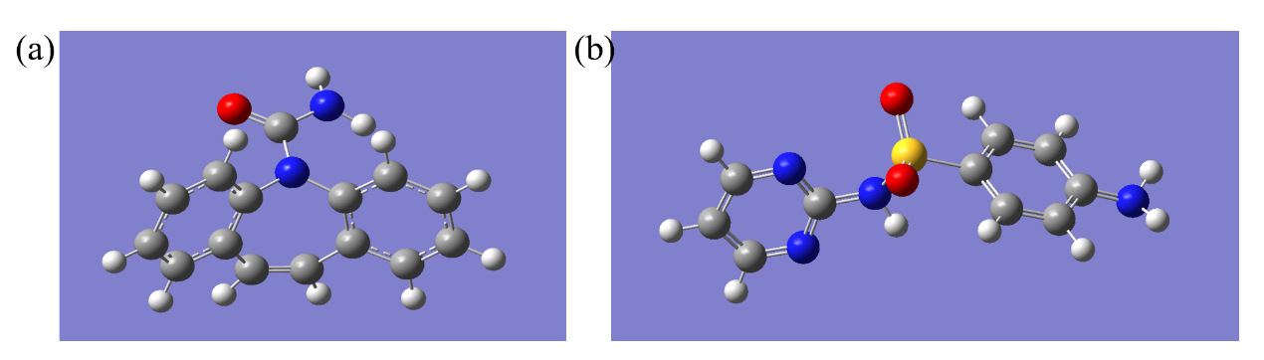
Fig. S2. The three-dimensional model of (a) CBZ and (b) SDZ molecule after guassian optimization. The gray ones are C atoms, the white ones are H atoms, the yellow one is S atom, the blue ones are N atoms, and the red one is O atom.
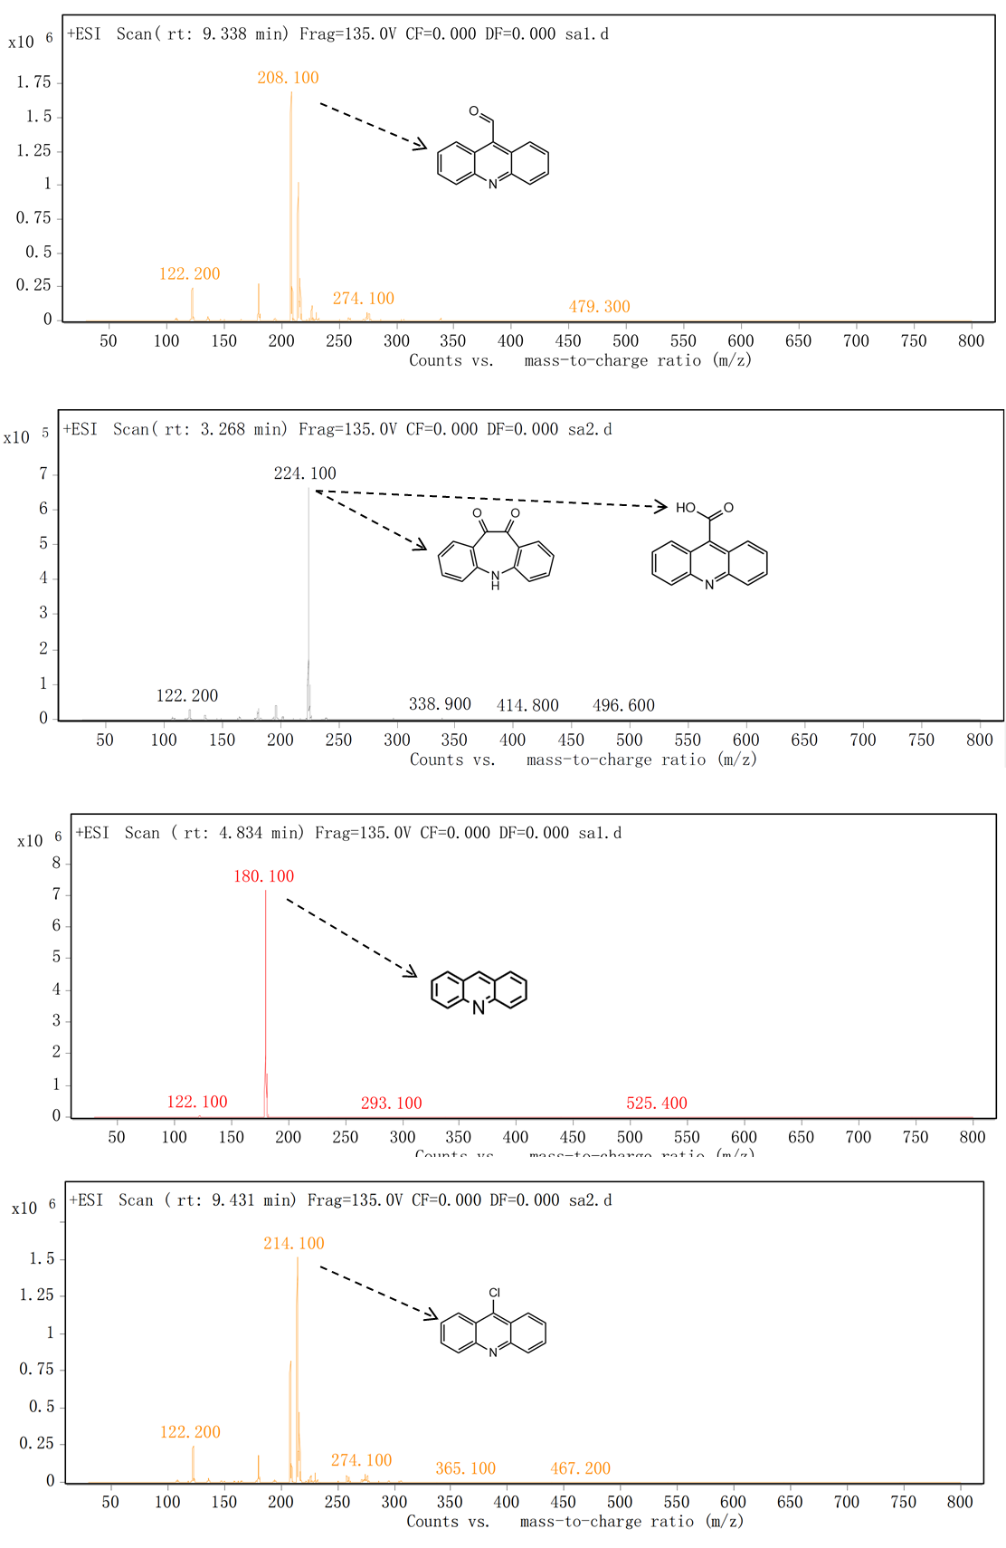
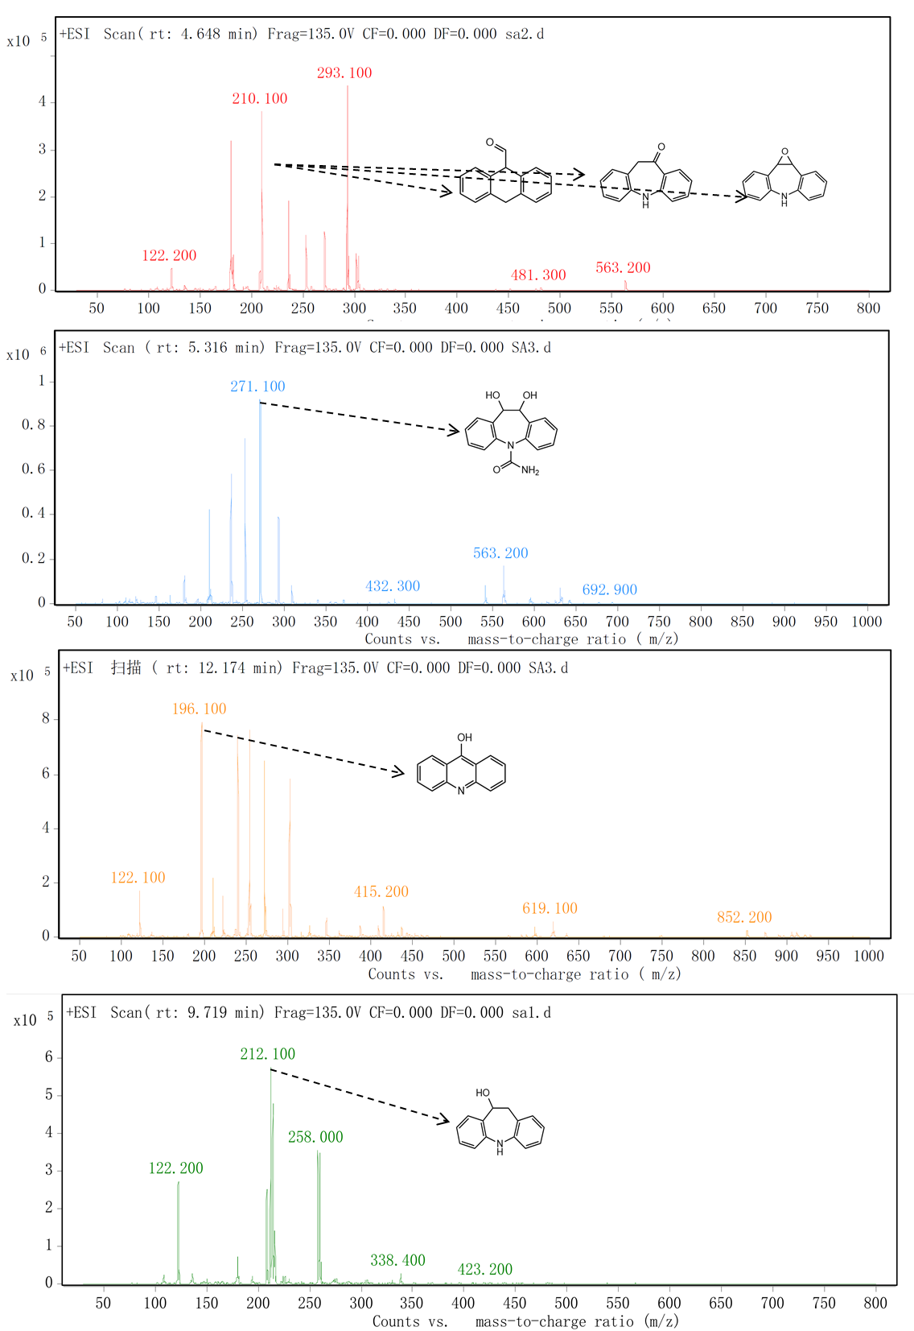
Fig. S3. Mass spectra of the obtained degradation by-products.

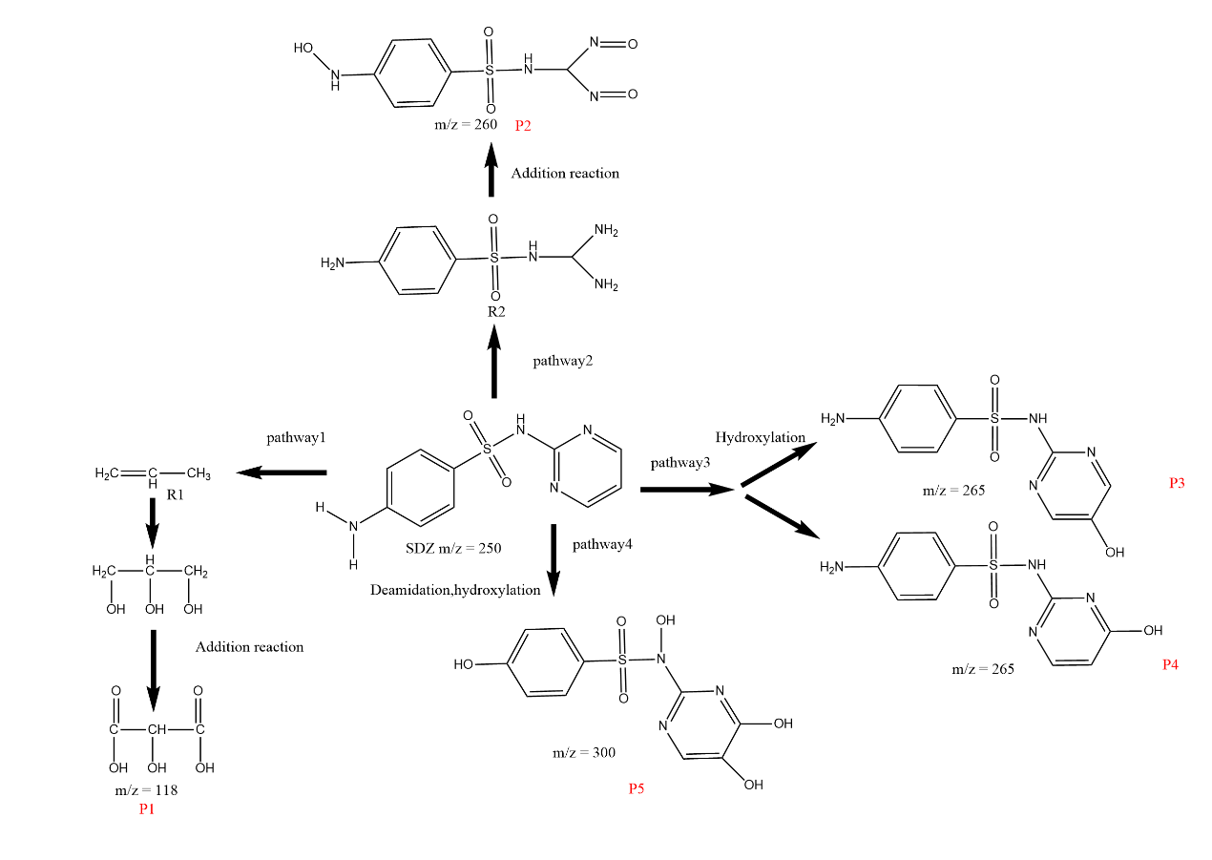
Fig. S4. A possible degradation pathway of SDZ by the Cl⁻/PMS process.

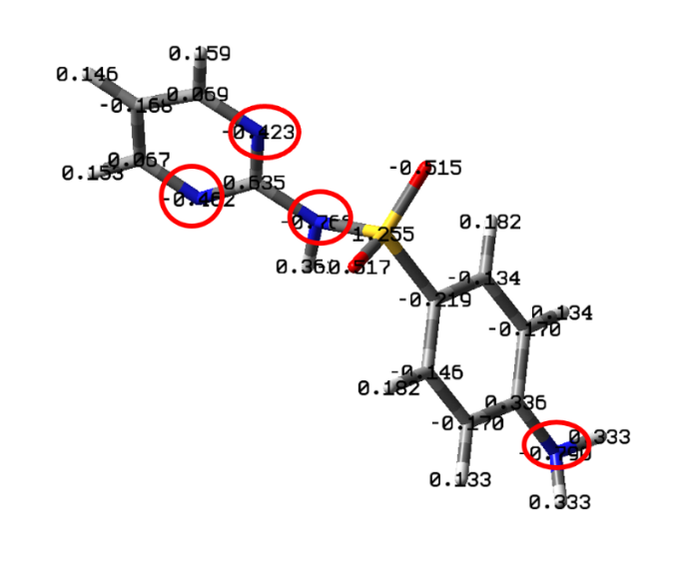
Fig. S5. Active reaction site calculated based on Mulliken charge of SDZ.

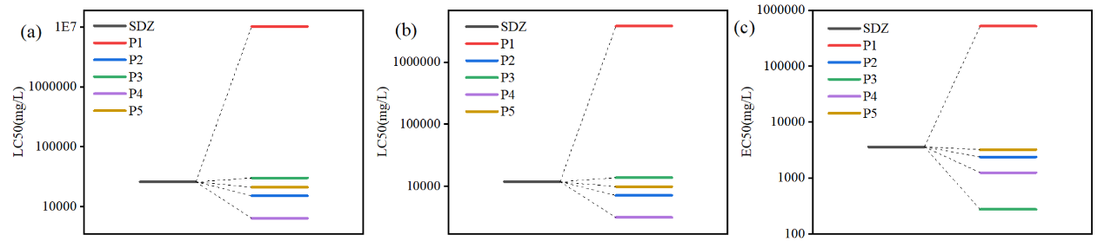
Fig. S6. Toxicity prediction analysis of the (a) fish LC50, (b) daphnid LC50, (c) green algae EC50 of SDZ and its degradation by-products.

Table S1 Calculation results of Fukui function of carbamazepine
Atom | Site | q_{N}(e/A) | q_{N+1}(e/A) | q_{N-1}(e/A) | f⁰ | f⁺ | f⁻
C | 1 | -0.19364 | -0.30947 | -0.12792 | 0.090775 | 0.11583 | 0.06572
C | 2 | -0.22249 | -0.30685 | -0.12379 | 0.091530 | 0.08436 | 0.0987
C | 3 | -0.07301 | -0.10574 | -0.06611 | 0.019815 | 0.03273 | 0.0069
C | 4 | 0.14903 | 0.10107 | 0.17232 | 0.035625 | 0.04796 | 0.02329
N | 5 | -0.52800 | -0.51211 | -0.46772 | 0.022195 | -0.01589 | 0.06028
C | 6 | 0.18637 | 0.14895 | 0.21416 | 0.032605 | 0.03742 | 0.02779
C | 7 | -0.08179 | -0.08367 | -0.04687 | 0.018400 | 0.00188 | 0.03492
C | 8 | -0.20699 | -0.24457 | -0.17087 | 0.036850 | 0.03758 | 0.03612
C | 9 | -0.23202 | -0.25642 | -0.20967 | 0.023375 | 0.0244 | 0.02235
C | 10 | -0.23151 | -0.33286 | -0.15297 | 0.089945 | 0.10135 | 0.07854
C | 11 | -0.23738 | -0.24646 | -0.23411 | 0.006175 | 0.00908 | 0.00327
C | 12 | -0.21038 | -0.21886 | -0.20783 | 0.005515 | 0.00848 | 0.00255
C | 13 | -0.22323 | -0.30799 | -0.12837 | 0.089810 | 0.08476 | 0.09486
C | 14 | -0.23276 | -0.25099 | -0.20866 | 0.021165 | 0.01823 | 0.0241
C | 15 | -0.20400 | -0.24313 | -0.16714 | 0.037995 | 0.03913 | 0.03686
C | 16 | 0.83123 | 0.83292 | 0.81928 | -0.00682 | -0.00169 | -0.01195
O | 17 | -0.64902 | -0.68042 | -0.58881 | 0.045805 | 0.0314 | 0.06021
N | 18 | -0.88345 | -0.89232 | -0.86113 | 0.015595 | 0.00887 | 0.02232
H | 19 | 0.23797 | 0.20049 | 0.27036 | 0.034935 | 0.03748 | 0.03239
H | 20 | 0.23667 | 0.19981 | 0.26855 | 0.034370 | 0.03686 | 0.03188
H | 21 | 0.23787 | 0.20961 | 0.26318 | 0.026785 | 0.02826 | 0.02531
H | 22 | 0.24084 | 0.20686 | 0.27123 | 0.032185 | 0.03398 | 0.03039
H | 23 | 0.24142 | 0.20551 | 0.27065 | 0.032570 | 0.03591 | 0.02923
H | 24 | 0.25226 | 0.22465 | 0.27455 | 0.024950 | 0.02761 | 0.02229
H | 25 | 0.24900 | 0.22405 | 0.27391 | 0.024930 | 0.02495 | 0.02491
H | 26 | 0.23926 | 0.20622 | 0.26994 | 0.031860 | 0.03304 | 0.03068
H | 27 | 0.23853 | 0.20685 | 0.27087 | 0.032010 | 0.03168 | 0.03234
H | 28 | 0.23466 | 0.2093 | 0.26231 | 0.026505 | 0.02536 | 0.02765
H | 29 | 0.42153 | 0.39918 | 0.44416 | 0.022490 | 0.02235 | 0.02263
H | 30 | 0.41303 | 0.41638 | 0.41651 | 6.5E-05 | -0.00335 | 0.00348

Table S2 Calculation results of Fukui function of sulfadiazine
Atom | Site | q_{N}(e/A) | q_{N+1}(e/A) | q_{N-1}(e/A) | f⁰ | f⁺ | f⁻
C | 1 | -0.27942 | -0.16743 | -0.06454 | 0.051445 | -0.11199 | 0.21488
C | 2 | 0.19452 | 0.14712 | 0.12551 | -0.010805 | 0.0474 | -0.06901
C | 3 | -0.28094 | -0.16072 | -0.03802 | 0.06135 | -0.12022 | 0.24292
C | 4 | -0.19382 | -0.08171 | -0.1278 | -0.023045 | -0.11211 | 0.06602
C | 5 | -0.39597 | -0.16655 | -0.06002 | 0.053265 | -0.22942 | 0.33595
C | 6 | -0.18605 | -0.06131 | -0.1174 | -0.028045 | -0.12474 | 0.06865
N | 7 | -0.81931 | -0.41085 | -0.21953 | 0.09566 | -0.40846 | 0.59978
S | 8 | 2.34042 | 1.18032 | 1.15435 | -0.012985 | 1.1601 | -1.18607
N | 9 | -0.87408 | -0.43734 | -0.32289 | 0.057225 | -0.43674 | 0.55119
O | 10 | -0.93215 | -0.47841 | -0.40014 | 0.039135 | -0.45374 | 0.53201
O | 11 | -0.91706 | -0.47248 | -0.4229 | 0.02479 | -0.44458 | 0.49416
C | 12 | 0.59376 | 0.28943 | 0.29703 | 0.0038 | 0.30433 | -0.29673
N | 13 | -0.5149 | -0.25558 | -0.20385 | 0.025865 | -0.25932 | 0.31105
C | 14 | 0.06512 | 0.08596 | 0.02864 | -0.02866 | -0.02084 | -0.03648
C | 15 | -0.34878 | -0.20349 | -0.06376 | 0.069865 | -0.14529 | 0.28502
C | 16 | 0.07272 | 0.06824 | 0.0343 | -0.01697 | 0.00448 | -0.03842
N | 17 | -0.49505 | -0.2201 | -0.20114 | 0.00948 | -0.27495 | 0.29391
H | 18 | 0.40481 | 0.19196 | 0.21448 | 0.01126 | 0.21285 | -0.19033
H | 19 | 0.4049 | 0.19197 | 0.21476 | 0.011395 | 0.21293 | -0.19014
H | 20 | 0.23862 | 0.106 | 0.13226 | 0.01313 | 0.13262 | -0.10636
H | 21 | 0.23834 | 0.10538 | 0.13151 | 0.013065 | 0.13296 | -0.10683
H | 22 | 0.26727 | 0.12231 | 0.14627 | 0.01198 | 0.14496 | -0.121
H | 23 | 0.26671 | 0.12073 | 0.14601 | 0.01264 | 0.14598 | -0.1207
H | 24 | 0.44072 | 0.21449 | 0.22436 | 0.004935 | 0.22623 | -0.21636
H | 25 | 0.22904 | 0.09078 | 0.12791 | 0.018565 | 0.13826 | -0.10113
H | 26 | 0.24797 | 0.10652 | 0.13481 | 0.014145 | 0.14145 | -0.11316
H | 27 | 0.23259 | 0.09477 | 0.1298 | 0.017515 | 0.13782 | -0.10279

