Supplementary figures
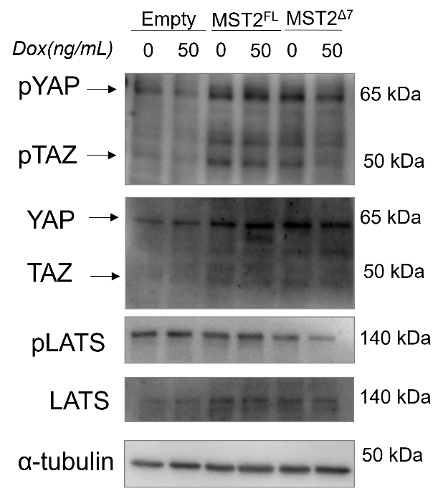
Figure S1- The overexpression of MST2^{Δ7} resulted in decreased phosphorylation of downstream proteins when compared to untreated cells. MCF10A cells were stably transfected with doxycycline (dox) inducible vector empty or bearing FFSS-MST2^{FL} (MCF10A-MST2^{FL}) or FFSS-MST2^{Δ7} (MCF10A-MST2^{Δ7}). The induction of MST2^{Δ7} by dox resulted in higher levels of phosphorylation in LATS, YAP and TAZ. Tubulin was used as an endogenous control.

Figure S2- The overexpression of MST2^{Δ7} does not induce cell death. This figure is complimentary to Figure 4. A) and B) MCF10A cells bearing an empty vector, FFSS-MST2^{FL} or FFSS-MST2^{Δ7} constructs were induced with 0, 10 ng/mL and 50 ng/mL of Dox for 24 and 48h A) Live and dead assay showed that MST2^{FL} overexpression after 24h of induction with doxycycline does not result in increased cell death. But, in 48h (B) the overexpression of MST2^{FL} increased cell death whereas MST2^{Δ7} overexpression did not reproduce this outcome. (C) In a live and dead assay in performed on the U2OS cell line, under conditions similar to those for MCF10A cells, it was observed after 72h of doxycycline induction, the overexpression of MST2^{FL} led to an increase in cell death, which was not observed with MST2^{Δ7} overexpression, regardless of the cell type. Left: fluorescence microscope images of the live and dead assay. In this assay, DAPI (blue) stains all cell nuclei while propidium iodate (red) stains dead cells. Scale bar=200 µm. Right: graph showing mean±± SEM (n=3 independent replicates) of live or dead cells in the conditions indicated in the figure.
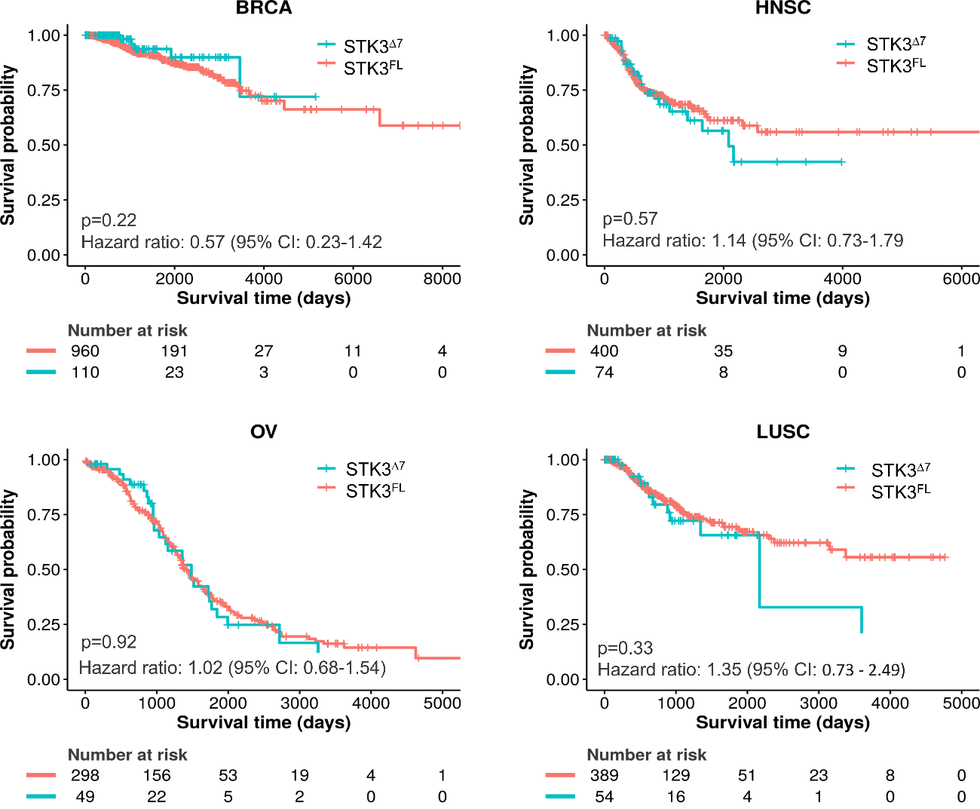
Figure S3- Disease-specific survival curve in different types of tumors. The curves indicate that expression of STK3^{Δ7} did not result in significantly worse survival when compared to patients who only expressed STK3 (J 6-7 and 7-8) in Breast invasive carcinoma (BRCA), Head and Neck squamous cell carcinoma (HNSC), Lung squamous cell carcinoma (LUSC), Ovarian serous cystadenocarcinoma (OV).

