- Supplementary Information
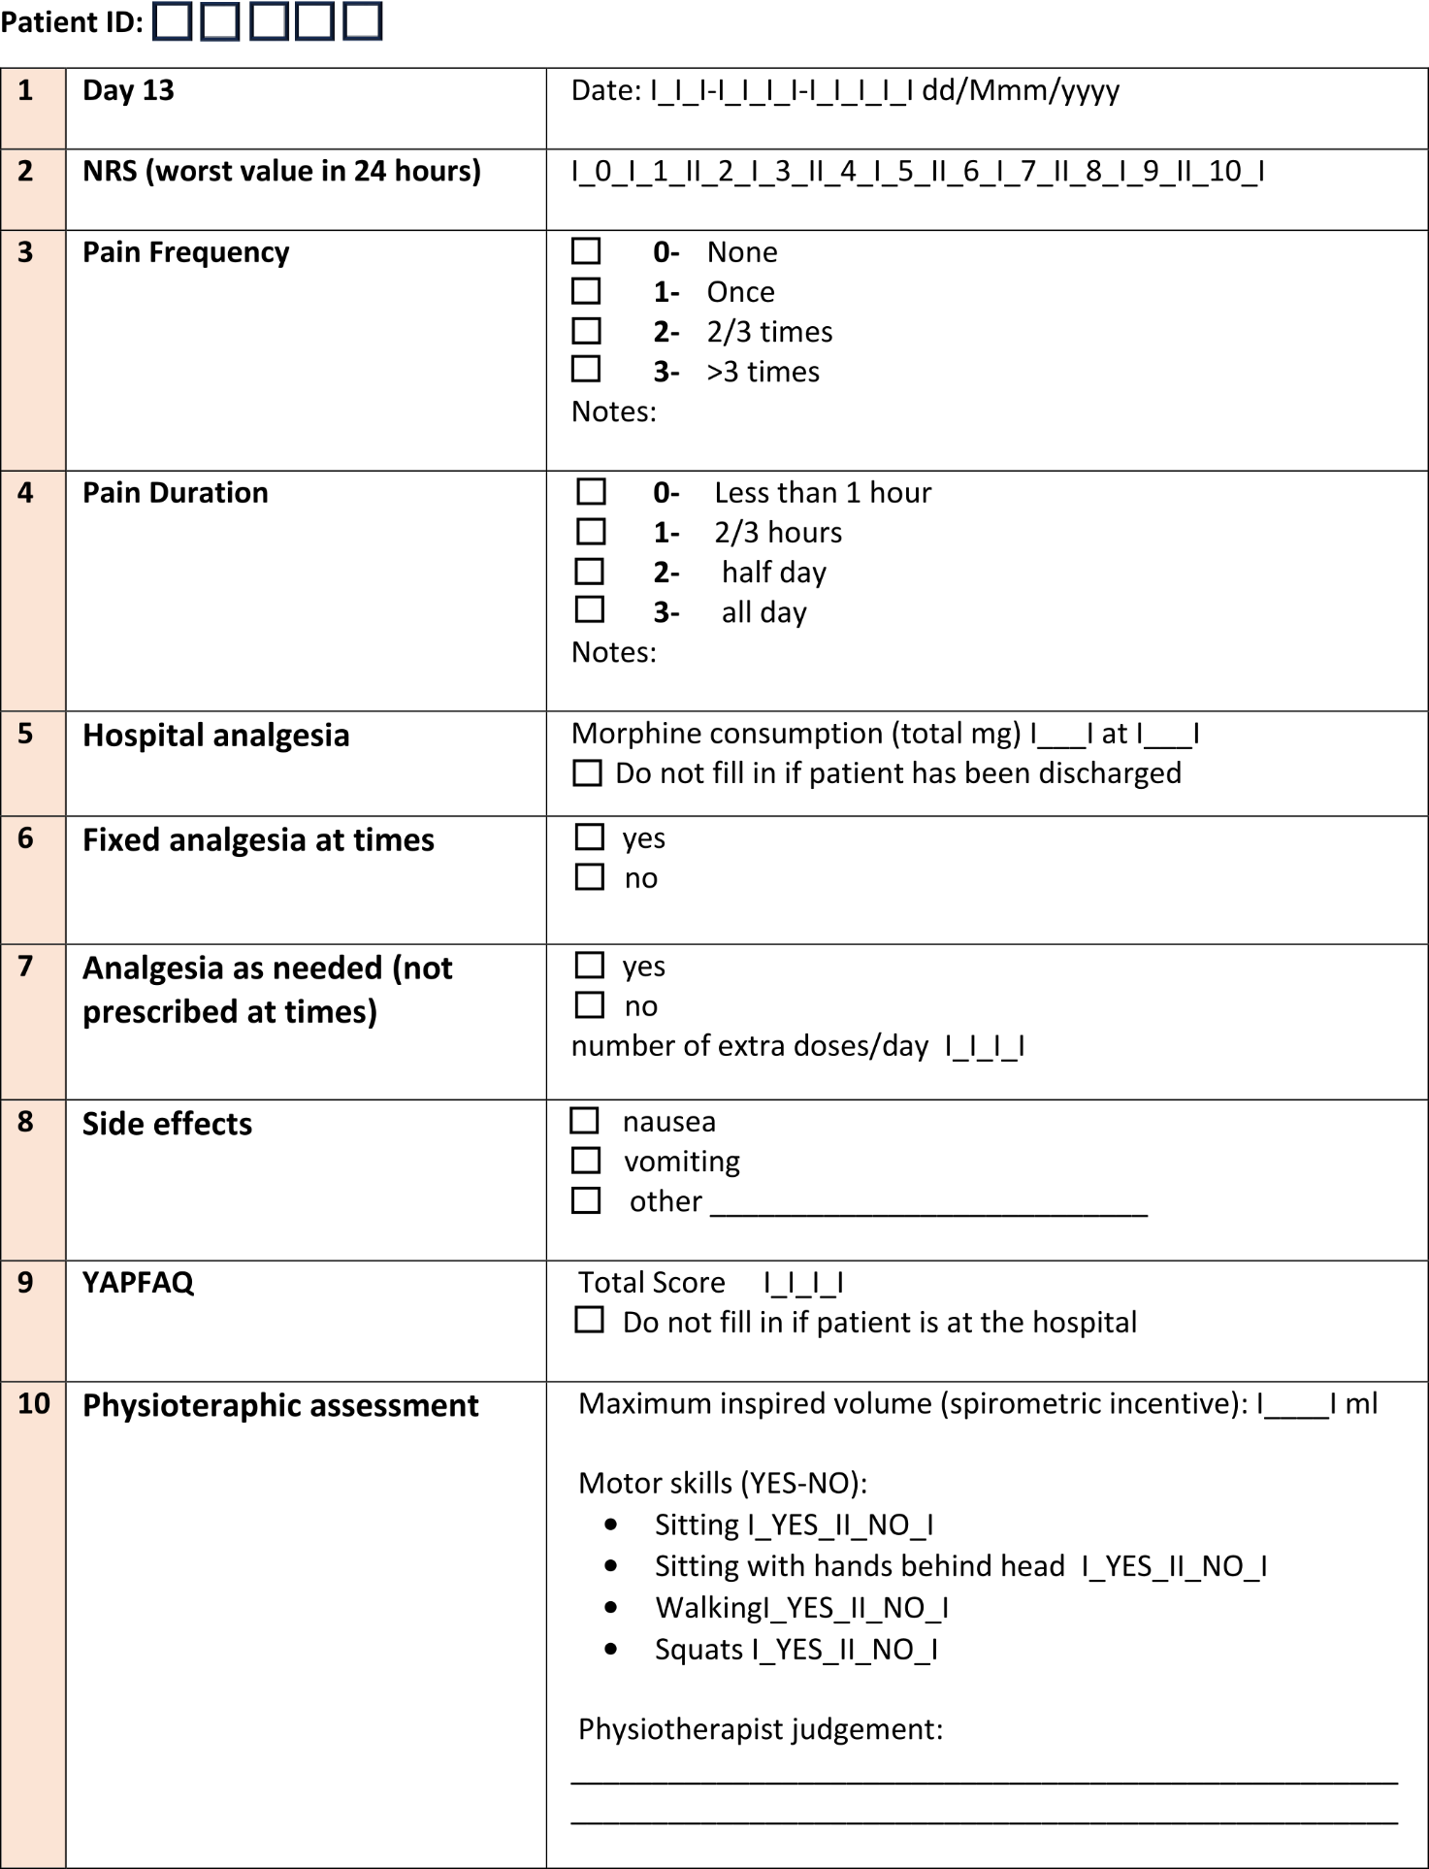
Supplementary Figure 1: Post-operative questionnaire to be filled out within the first 13 days after the surgical intervention. This paper survey has been used as an outline for the development of its digital counterpart delivered through our application.

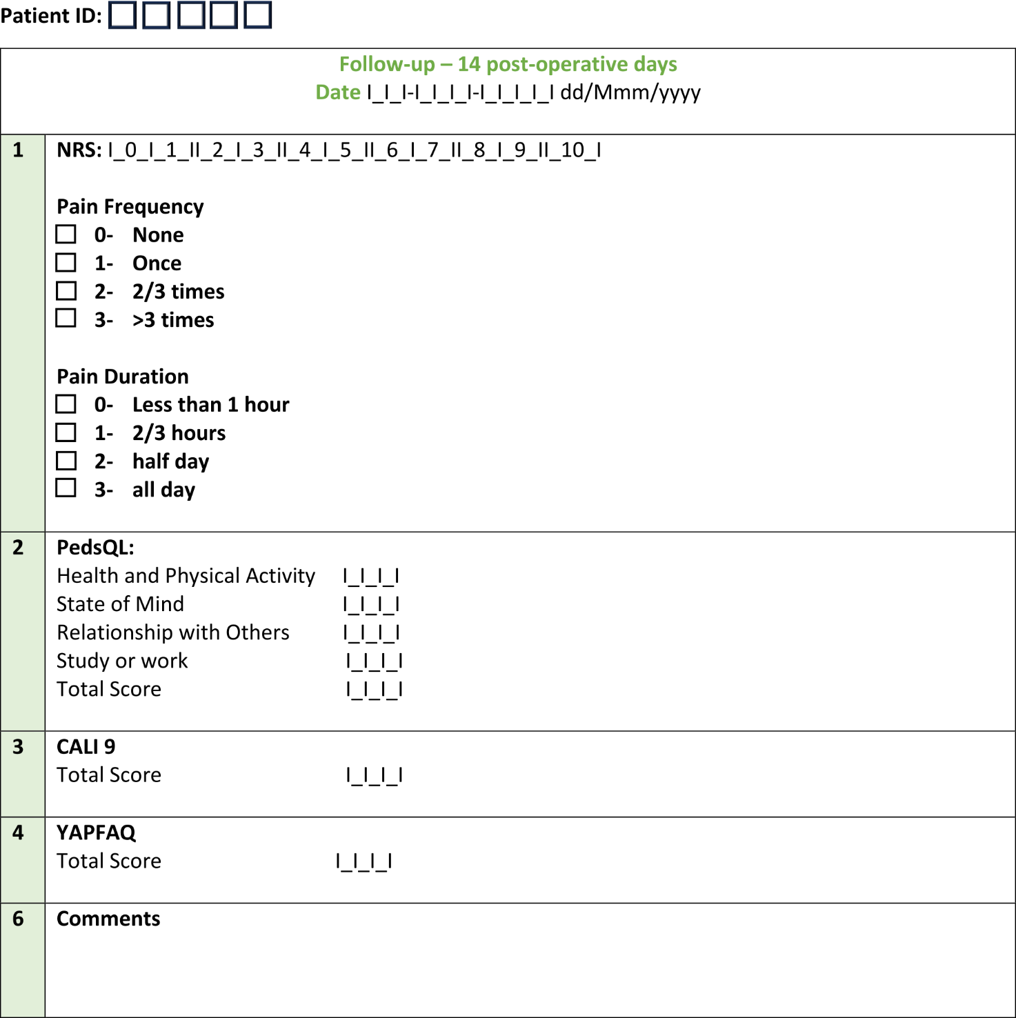
Supplementary Figure 2: Follow-up questionnaire to be filled out from the 14th until 6 months day after the surgical intervention. This paper survey has been used as an outline for the development of its digital counterpart delivered through our application.

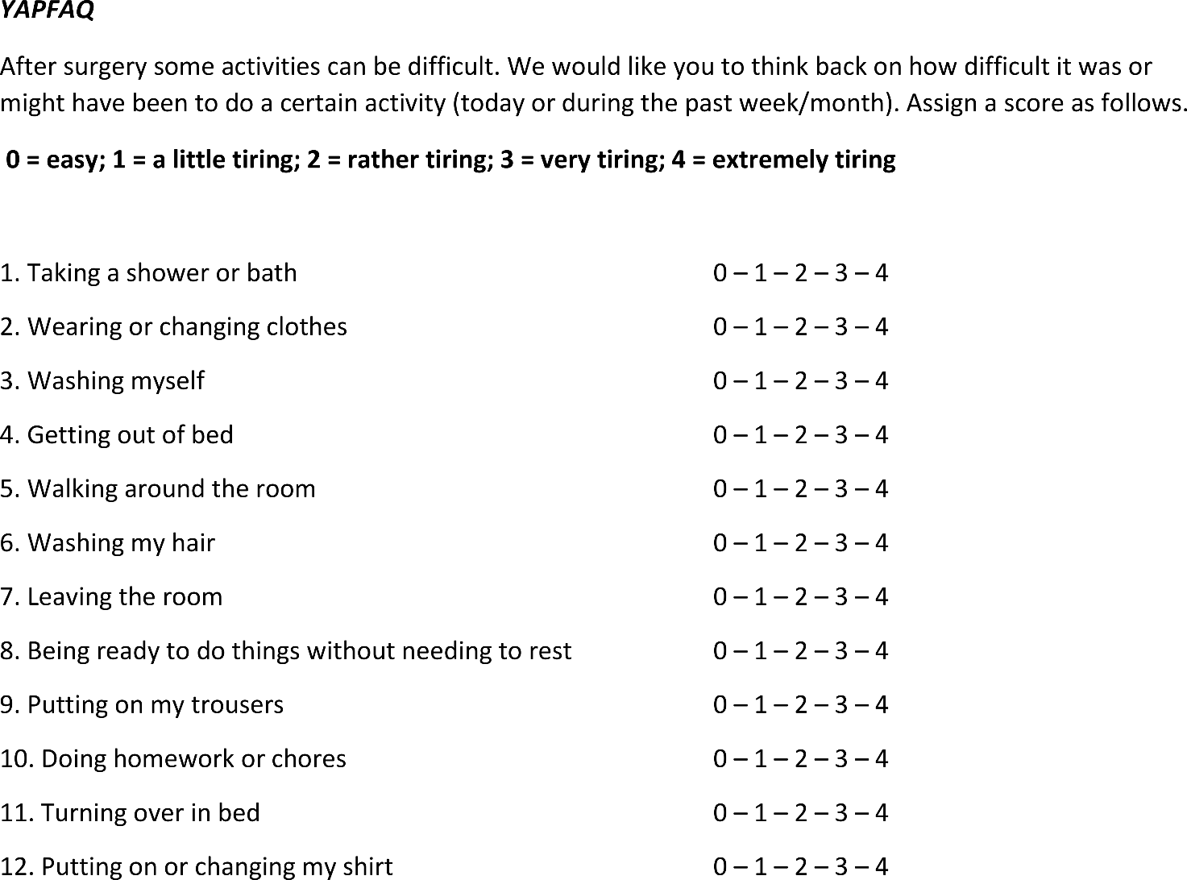

Supplementary Figure 3: Youth Acute Pain Function (YAPFAQ) assessment scale, included both in the post-operative and follow-up surveys.
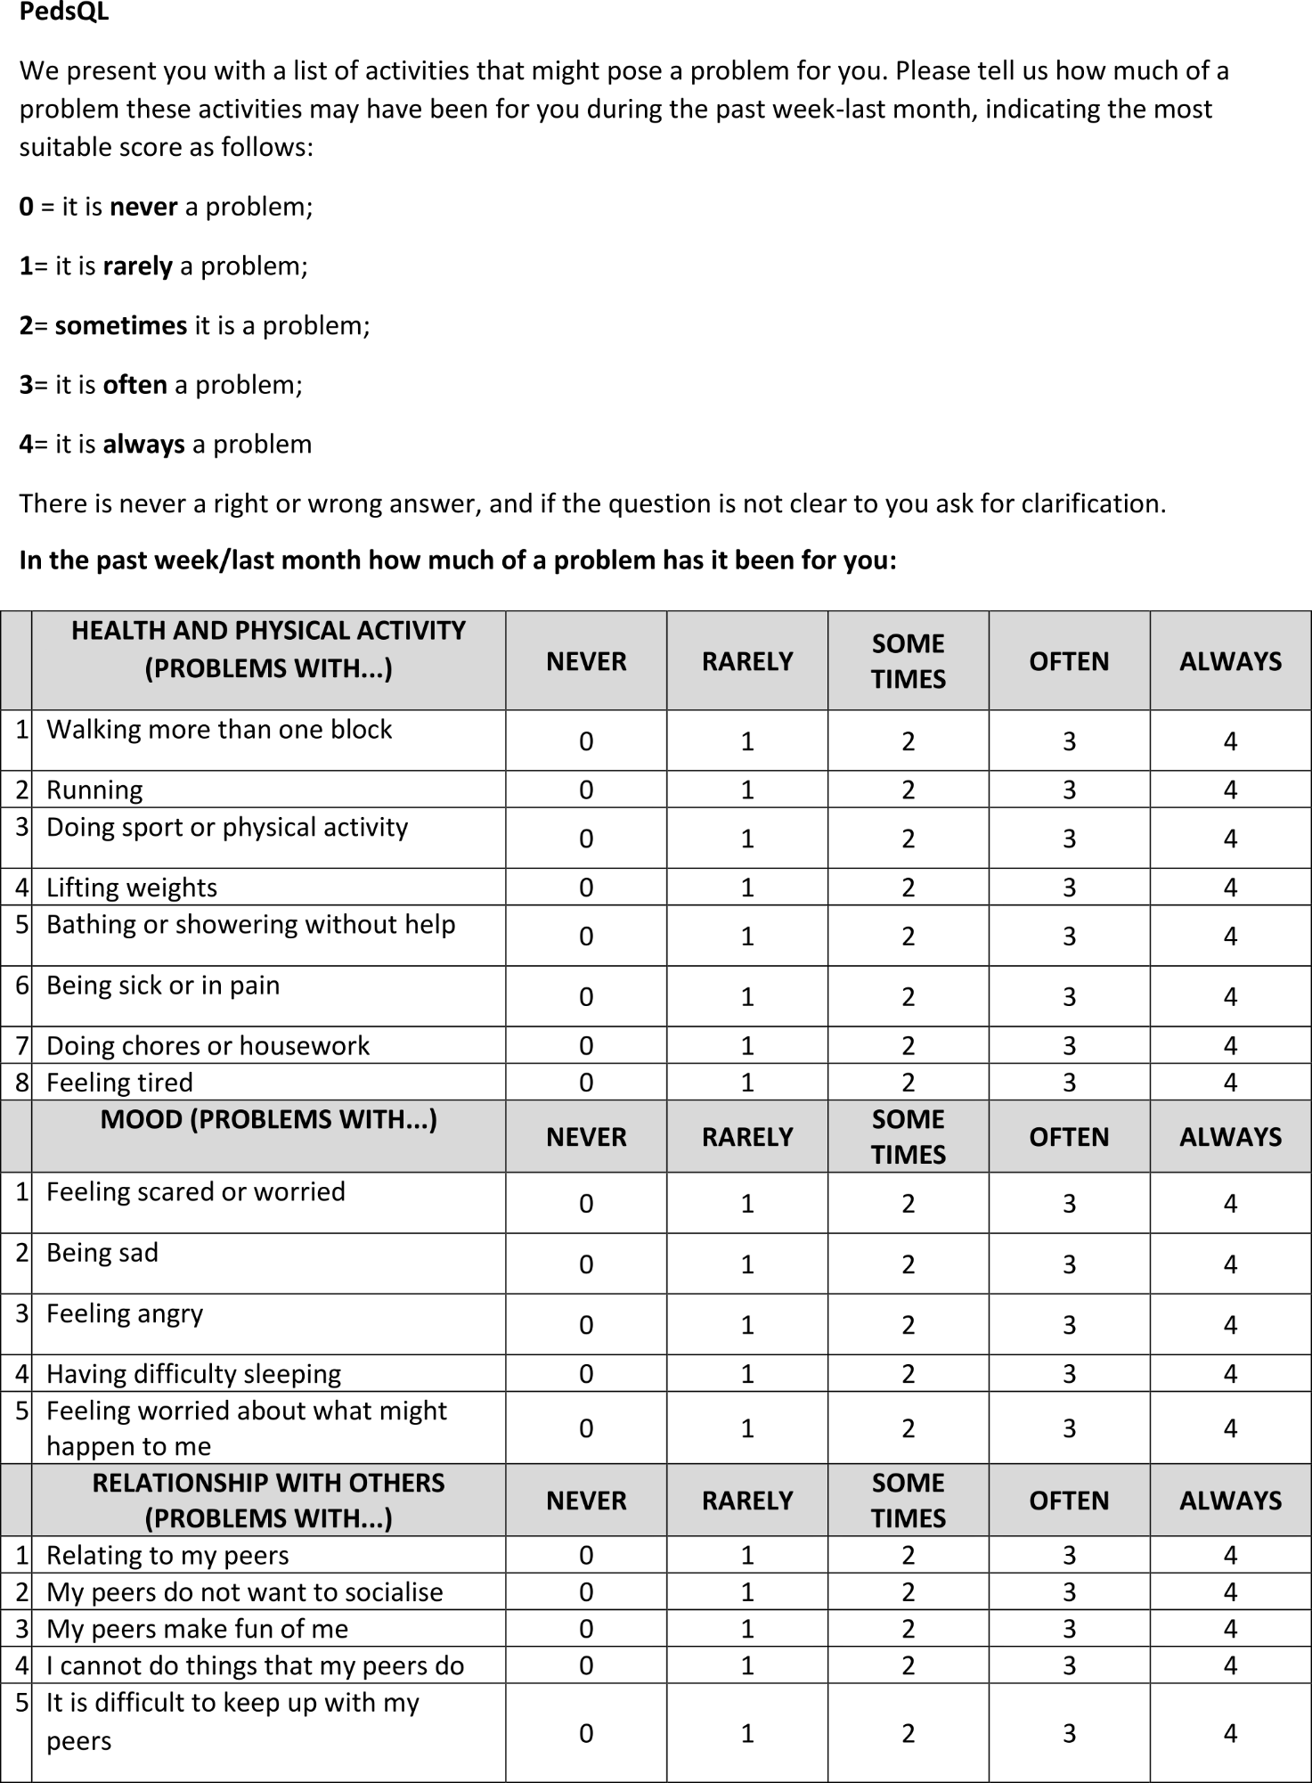
Supplementary Figure 4: PedsQL (Pediatric Quality of Life Inventory) assessment scale, specific of the only follow-up form, with raw scores not yet transformed into the 0-100.

