Supplementary File
Figure S1. Proportions reporting solicited local and systemic symptoms in the 7 days after each vaccine dose within the study population (PTV) and the total population of the pivotal BNT162b2 trials (31). P-values relate to the comparison between the study population and the trial population at each vaccine dose (*<0.05; ** <0.001; ***<0.0001).

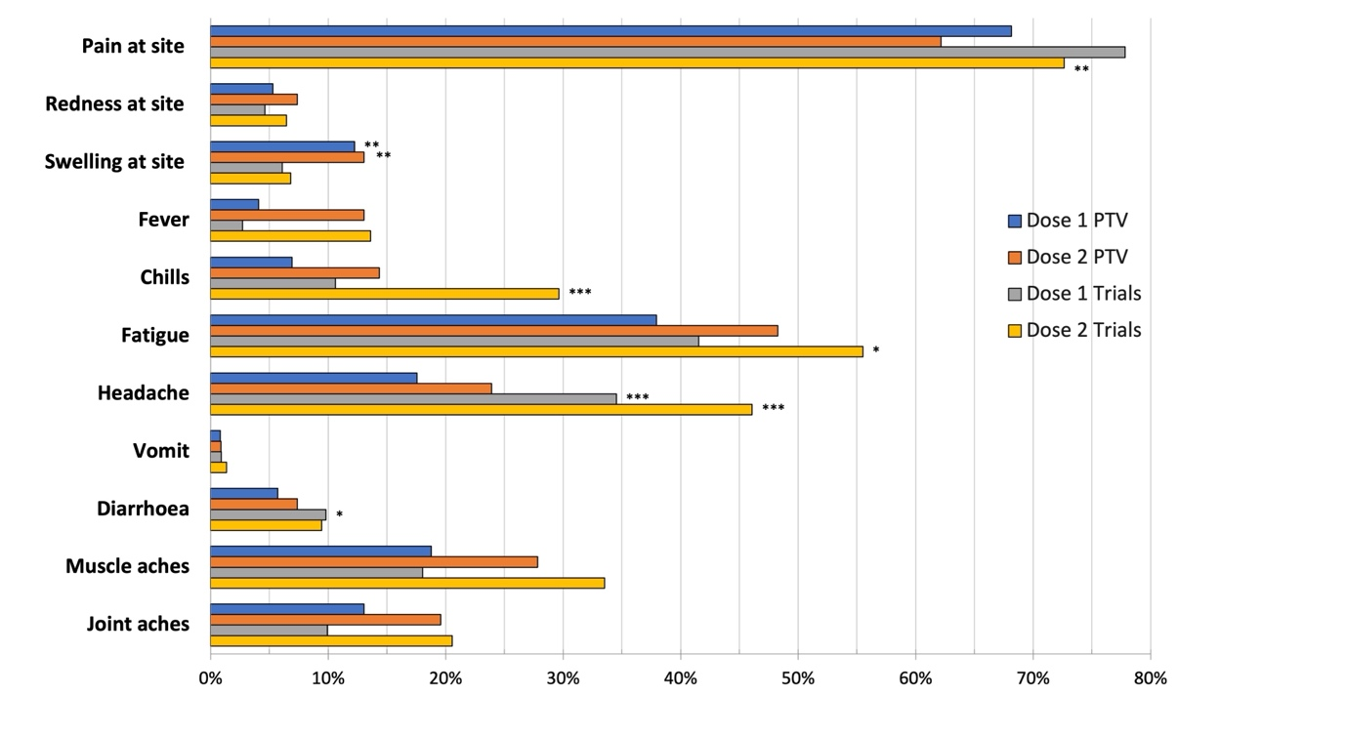

Table S1. Solicited and unsolicited side effects in the 7 days after each vaccine dose

 |  | Dose 1 (n=245) |  | Dose 2 (n=230)
Participants with solicited symptoms |  | N | % | N | %
$≥$1 symptom |  | 191 | 78.0 | 175 | 76.1
$≥$1 local symptom |  | 172 | 70.2 | 145 | 63.0
$≥$1 local severe symptom |  | 9 | 3.7 | 11 | 4.8
$≥$1 systemic symptom |  | 122 | 49.8 | 138 | 60.0
$≥$1 severe systemic symptom |  | 13 | 5.3 | 26 | 11.3
Participants with unsolicited symptoms
$≥$1 symptom |  | 18 | 7.3 | 21 | 9.1
$≥$1 severe symptom |  | 1 | 0.4 | 3 | 1.3
Participants with solicited and/or unsolicited symptoms
$≥$1 symptom |  | 192 | 78.4 | 175 | 76.1
$≥$1 severe symptom |  | 20 | 8.2 | 32 | 13.9
Type of solicited symptoms
Local | Pain | 167 | 68.2 | 143 | 62.2
 | Redness | 13 | 5.3 | 17 | 7.4
 | Swelling | 30 | 12.2 | 30 | 13.0
Systemic | Fever | 10 | 4.1 | 30 | 13.0
Systemic | Chills | 17 | 6.9 | 33 | 14.3
 | Fatigue | 93 | 38.0 | 111 | 48.3
 | Headache | 43 | 17.6 | 55 | 23.9
 | Vomiting | 2 | 0.8 | 2 | 0.9
 | Diarrhoea | 14 | 5.7 | 17 | 7.4
 | Muscle pain | 46 | 18.8 | 64 | 27.8
 | Joint pain | 32 | 13.1 | 45 | 19.6
Type of unsolicited symptoms
 | Light-headiness, dizziness | 4 | 1.6 | 4 | 1.7
 | Sleep disturbances | 3 | 1.2 | 2 | 0.9
 | Loss of appetite, nausea | 4 | 1.6 | 5 | 2.2
 | Alteration of taste, dry mouth, gingivitis | 2 | 0.8 | 3 | 1.3
 | Upper respiratory tract symptoms | 2 | 0.8 | 1 | 0.4
 | Skin rash, itching | 0 | 0.0 | 3 | 1.3
 | Tachycardia, hot flushes | 2 | 0.8 | 3 | 1.3
 | Paraesthesia | 1 | 0.4 | 1 | 0.4
 | Thrombophlebitis | 1 | 0.4 | 0 | 0.0
 | Dysuria | 0 | 0.0 | 1 | 0.4
 | Exacerbation of pre-existing condition^{b} | 2 | 0.8 | 2 | 0.9
ªLocal indicates the vaccine injection site (upper arm). ^{b}Herpes labialis (n=2), toothache (n=2).
Figure S2. Neutralisation activity against wild-type SARS-CoV-2 (WT) and the Omicron BA.2 variant in samples collected from 28 people with HIV who received three doses of the BNT162b2 vaccine, measured by cPass.
