Figure 7A (AHH-1 cells)
TLR2
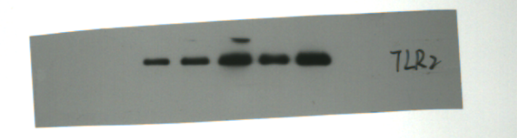
TLR4
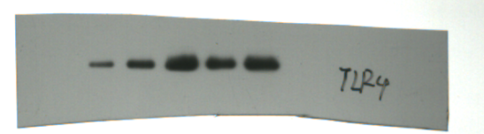
MyD88
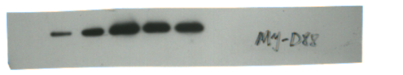
β-actin
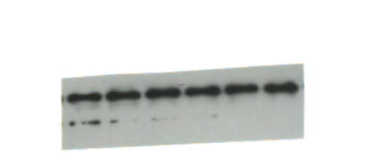

Figure 7B (HIEC cells)
TLR2
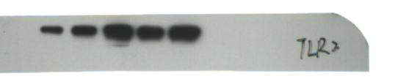
TLR4
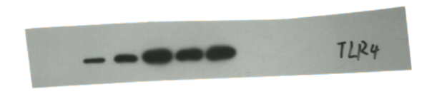
MyD88
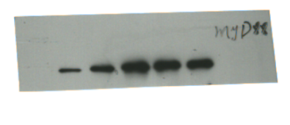
β-actin
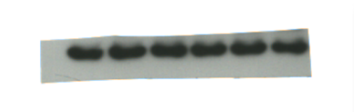
Figure 8A (AHH-1 cells)
G-CSF
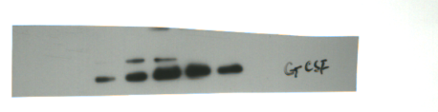
GM-CSF
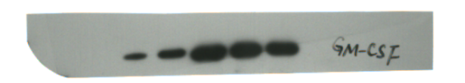
IL-6
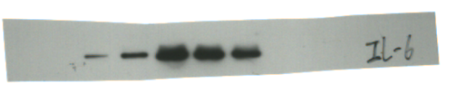
IL-12
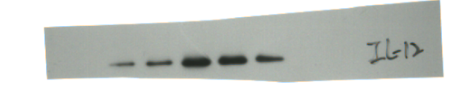
β-actin
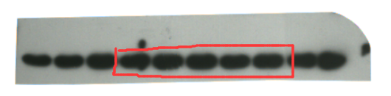
Figure 8B (HIEC cells)
G-CSF
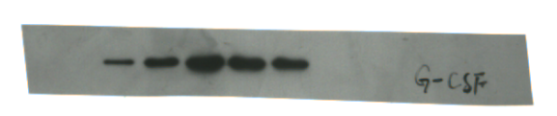
GM-CSF
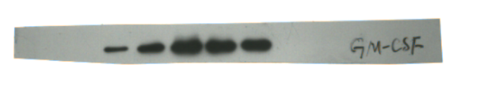
IL-6
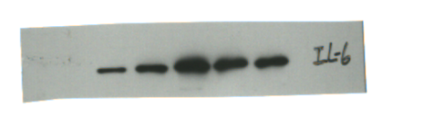
IL-12
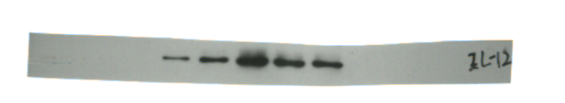
β-actin
