Supplementary Table S1. Comparison of specifications for the WDS and IKD
 | Dimensions(cm) | Mass(kg) | Sensor | Mode
WDS | 30 x 30 x 9 | 2.85 | Axially aligned torque  (700 Nm max) | Isometric
IKD  (Biodex 4 pro) | 132 x 165 x 152 | 612 | Axially aligned torque  (680 Nm max) | Isometric  Isokinetic resistance  Passive motion
WDS, wearable dynamometry system; IKD, isokinetic dynamometry.

Supplementary Table S2. Inter-rater and Inter-session reliabilities of the WDS and IKD: Calculated separately for extension and flexion
 | Measurement (Nm) |  | CIM (Nm) [95% CI] | Pearson’s r | p-value | ICC^{a)} | SEM (Nm) | MDC (Nm)
Inter-rater Reliability
Extension | Rater A | Rater B
WDS (ours) | 166.92 ± 48.59 | 169.24 ± 49.29 | 2.32 [-8.63, 13.26] | 0.970 | <0.001 | 0.984 | 6.26 (3.72%) | 17.34 (10.32%)
IKD (Biodex) | 169.17 ± 52.82 | 170.23 ± 54.21 | 1.06 [-10.91, 13.03] | 0.960 | <0.001 | 0.981 | 7.33 (4.32%) | 20.33 (11.98%)
Flexion
WDS (ours) | 77.84 ± 23.89 | 77.94 ± 23.50 | 0.10 [-5.20, 5.40] | 0.960 | <0.001 | 0.981 | 3.29 (4.23%) | 9.13 (11.72%)
IKD (Biodex) | 76.17 ± 25.45 | 75.78 ± 25.04 | -0.39 [-6.04, 5.26] | 0.940 | <0.001 | 0.971 | 4.30 (5.66%) | 11.93 (15.70%)
Inter-session Reliability
Extension | Session Ⅰ | Session Ⅱ
WDS (ours) | 165.66 ± 47.69 | 170.49 ± 50.05 | 4.83 [-6.10, 15.77] | 0.930 | <0.001 | 0.965 | 9.20 (5.47%) | 25.49 (15.17%)
IKD (Biodex) | 168.91 ± 52.79 | 170.50 ± 54.24 | 1.59 [-10.38, 13.56] | 0.950 | <0.001 | 0.974 | 8.69 (5.12%) | 24.09 (14.19%)
Flexion
WDS (ours) | 77.27 ± 23.21 | 78.51 ± 24.16 | 1.23 [-4.07, 6.53] | 0.890 | <0.001 | 0.944 | 5.59 (7.17%) | 15.49 (19.88%)
IKD (Biodex) | 74.87 ± 24.62 | 77.08 ± 25.81 | 2.21 [-3.43, 7.85] | 0.880 | <0.001 | 0.935 | 6.42 (8.45%) | 17.79 (23.41%)
CIM, change in mean; CI, confidence interval; ICC, intraclass correlation coefficient; WDS, wearable dynamometry system; IKD, isokinetic dynamometry; SEM, standard error of measurement; MDC, minimal detectable change. ^{a)}ICC_{(2,k)} was used for agreement and inter-rater reliability, whereas ICC_{(3,k)} was used for inter-session reliability.

Supplementary Table S3. UEQ-S results for healthcare professionals (n=9)
 | IKD | WDS | CIM [95% CI] | p-value
Supportive | 1.67±1.12 | 2.22±0.44 | 0.49 [0.24, 0.73] | 0.051
Easy | -0.11±1.96 | 2.56±0.53 | 2.67 [1.95, 3.39] | 0.003
Efficient | 0.11±1.69 | 2.11±0.93 | 2.00 [1.32, 2.68] | 0.009
Clear | 0.22±1.86 | 2.33±0.71 | 2.11 [1.41, 2.81] | 0.009
Exciting | 1.44±1.01 | 1.78±0.83 | 0.33 [-0.13, 0.80] | 0.458
Interesting | 1.22±1.09 | 2.22±0.97 | 1.00 [0.48, 1.52] | 0.057
Inventive | 0.56±1.59 | 2.11±0.78 | 1.56 [0.93, 2.18] | 0.022
Leading edge | 0.67±1.50 | 1.70±0.82 | 1.03 [0.45, 1.62] | 0.091
Total score | 5.78±8.84 | 17.10±4.08 | 11.30 [7.89, 14.80] | 0.005
CIM, change in mean; CI, confidence interval; WDS, wearable dynamometry system; IKD, isokinetic dynamometry.

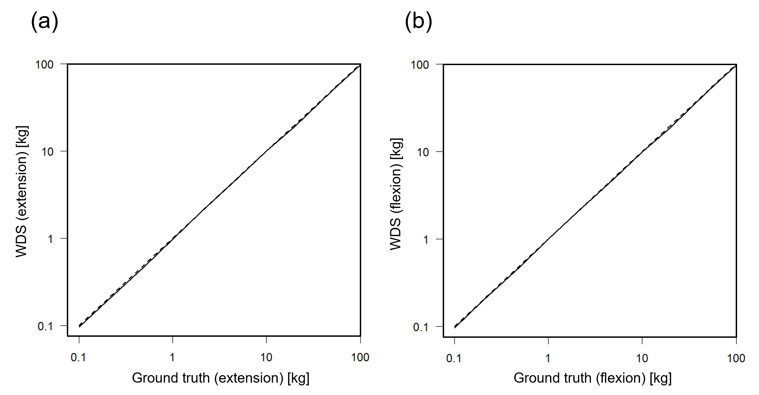
Supplementary Fig. S1. Calibration Curve of the WDS. The dotted line indicates the identity line, whereas the solid line indicates the calibration curve.

