Supporting Information
Appendix 1
Pathogenic bacteria | Negative  control | 50ZnO/50CuO-300C  5 mg/mL | 50ZnO/50CuO-300C  10 mg/mL | 50ZnO/50CuO-400C  5 mg/mL | 50ZnO/50CuO-500C  5 mg/mL
S. aureus | 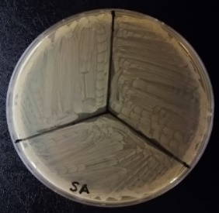  (a) | 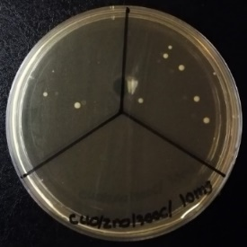  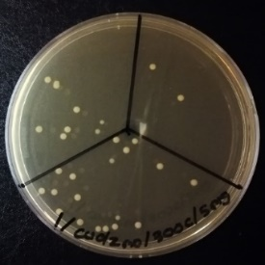  (b) | (c) | 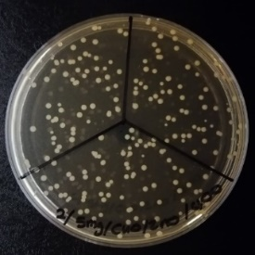  (d) | 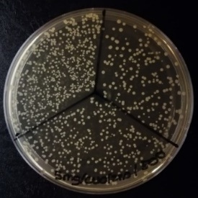  (e)

Figure S1 MIC/MBC for 50ZnO/50CuO nanocomposites. (a) 10% DMSO as negative control, (b) 50ZnO/50CuO-300C at 5 mg/mL, (c) 50ZnO/50CuO-300C at 10 mg/mL, (d) 50ZnO/50CuO-400C at 5 mg/mL, and (e) 50ZnO/50CuO-500C at 5 mg/mL. (Photos were taken by G Ambarasan.)
Appendix 2
Pathogenic bacteria | Negative  control | 25ZnO/75CuO-300C  5 mg/mL | 25ZnO/75CuO-300C  10 mg/mL | 75ZnO/25CuO-300C  2.5 mg/mL | 75ZnO/25CuO-300C  1.25 mg/mL | 75ZnO/25CuO-300C  0.625 mg/mL
S. aureus | 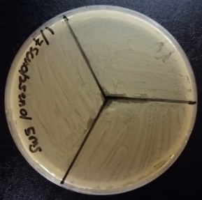  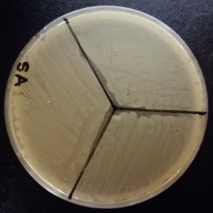  (a) | 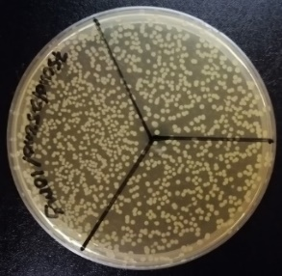  (b) | (c) | 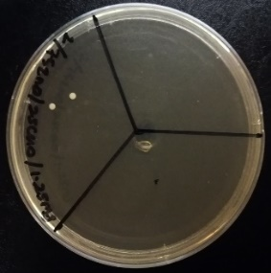  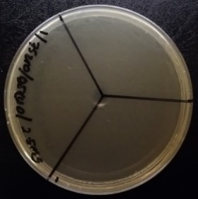  (d) | 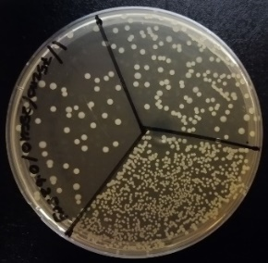  (e) | (f)

Figure S2 MIC/MBC for ZnO/CuO-300C nanocomposites. (a) 10% DMSO as negative control, (b) 25ZnO/75CuO-300C at 5 mg/mL, (c) 25ZnO/75CuO-300C at 10 mg/mL, (d) 75ZnO/25CuO-300C at 2.5 mg/mL, (e) 75ZnO/25CuO-300C at 1.25 mg/mL and (f) 75ZnO/25CuO-300C at 0.625 mg/mL. (Photos were taken by G Ambarasan.)
Appendix 3
Pathogenic bacteria | 75ZnO/25CuO-300C  30 min | 75ZnO/25CuO-300C  1 h | 75ZnO/25CuO-300C  3 h | 75ZnO/25CuO-300C  6 h | 75ZnO/25CuO-300C  12 h | 75ZnO/25CuO-300C  24 h
S. aureus | 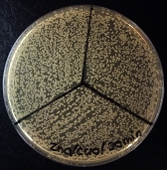  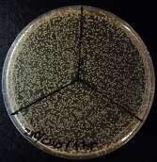  (a) | (b) | 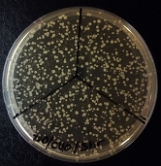  (c) | 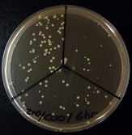  (d) | 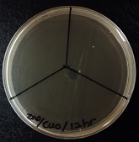  (e) | 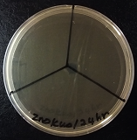  (f)

Figure S3 Time-kill assay showing antimicrobial activity exhibited by 2.5 mg/mL of 75ZnO/25CuO-300C nanocomposites at different time against S. aureus. (a) 0.5 h (30 min), (b) 1 h, (c) 3 h, (d) 6 h, (e) 12 h and (f) 24 h. (Photos were taken by G Ambarasan.)

