Supplementary information
Purification, characterization, and self-assembly of the polysaccharides from Allium schoenoprasum
Fengrui Zhang^{a,1}, Jun Zheng^{a,1}, Zeyu Li^{a,1}, Zixuan Cai^{a,b}, Fengqiao Wangª, Liubin Feng^{c}, and Dong Yang^{a,*}
ªBeijing Key Laboratory of Functional Food from Plant Resources, College of Food Science & Nutritional Engineering, China Agricultural University, 17 East Tsinghua Rd., Beijing 100083, China
^{b}Xinghua Industrial Research Centre for Food Science and Human Health, China Agricultural University, Xinghua 225700, Jiangsu Province, China
^{c}High-field NMR Center, College of Chemistry and Chemical Engineering, Xiamen University, Siming South Rd. 422, Xiamen 361005, China
¹These authors contributed equally to this work.
*To whom correspondence should be addressed: dyang@cau.edu.cn
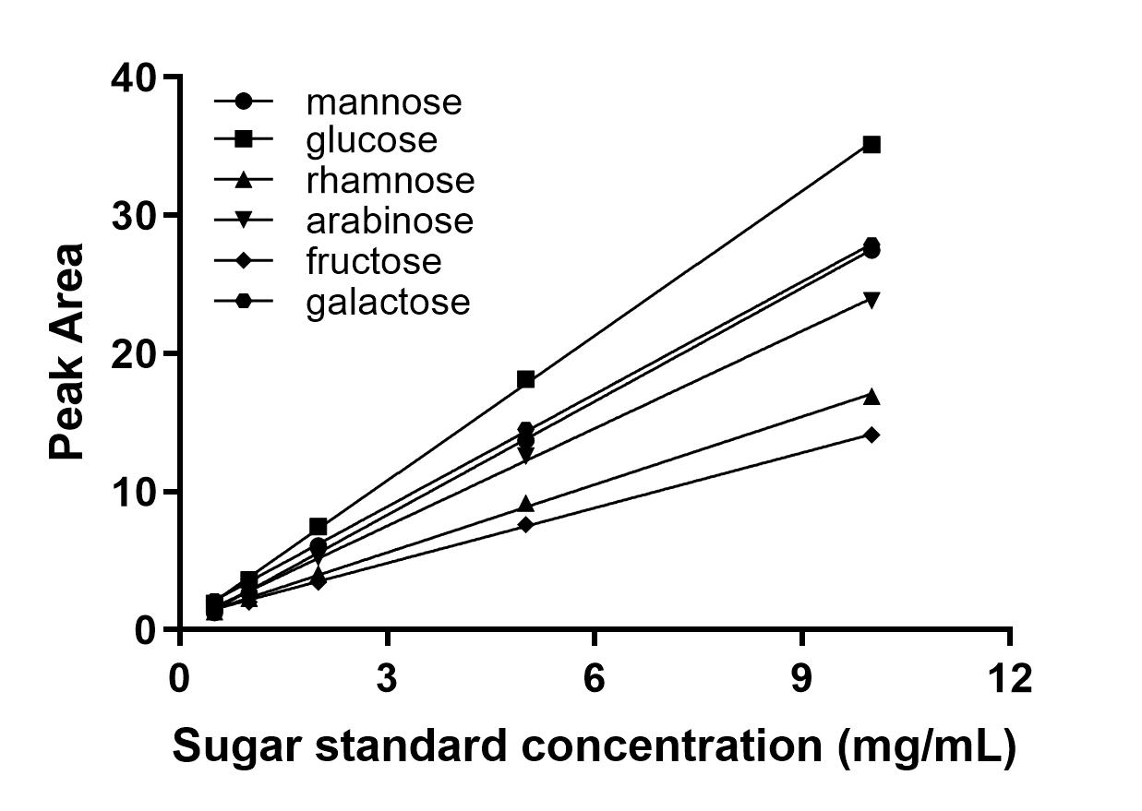
Figure S1. The fitting curve of monosaccharide standard with HPLC peak area. The peak area of standard monosaccharide solutions with known concentrations were plotted against their corresponding concentrations to yield fitting curves for monosaccharide composition analysis.

Table S1 Fitting curve parameters of monosaccharide standards.
Sugar Standard | Fitting Curve | R²
rhamnose | y = 1.6409x + 0.6746 | 0.9990
arabinose | y = 2.3535x + 0.4621 | 0.9995
galactose | y = 2.7162x + 0.768 | 0.9996
glucose | y = 3.4976x + 0.305 | 0.9997
mannose | y = 2.7423x + 0.0856 | 0.9993
fructose | y = 1.3325x + 0.8339 | 0.9995

Figure S2 Coarse-grained model structure of AssP in aqueous solution. The coarse-grained model of the polysaccharide AssP and water molecules in an aqueous solution are represented by different beads. Red, arabinose residues; yellow, fructose residues; green, glucose or galactose residues; blue, water molecules.

Table S2 Repulsion parameters between monosaccharide residue beads.
Bead | W | A | F | G
W | 25.000 | - | - | -
A | 88.586 | 25.000 | - | -
F | 83.606 | 25.505 | 25.000 | -
G | 92.185 | 25.037 | 25.286 | 25.000
A, arabinose residue; F, fructose residue; G, glucose or galactose residue; W, water.

