Supplementary Information

HER2 quantitative continuous scoring for accurate patient selection in
HER2-negative trastuzumab deruxtecan–treated breast cancer

Ansh Kapil¹, Andreas Spitzmüller¹, Nicolas Brieu¹, Susanne Haneder¹,
Anatoliy Shumilov¹, Armin Meier¹, Fabiola Cecchi², Alice Barkell³, Nathalie Harder¹, Katrin Schneider¹, Ana Hidalgo-Sastre¹, Regina Alleze¹, Markus Schick¹,
Günter Schmidt¹, Hadassah Sade¹, Zenta Tsuchihashi⁴, Fumitaka Suto⁴,
Mark Gustavson², J. Carl Barrett² & Danielle Carroll³

¹Computational Pathology, Oncology R&D, AstraZeneca, Munich, Germany ²Translational Medicine, Oncology R&D, AstraZeneca, Gaithersburg, MD, USA ³Translational Medicine, Oncology R&D, AstraZeneca, Cambridge, UK
⁴Translational Science, Daiichi Sankyo, Inc., Basking Ridge, NJ, USA

Supplementary Table S1. Terms and definitions used in this manuscript.
Term | Definition | Reference
HER2 IHC status 3+ | Circumferential membrane staining that is complete, intense, and in >10% of tumor cells | 2018 ASCO/CAP¹
HER2 IHC status 2+ | Weak to moderate complete membrane staining observed in >10% of tumor cells | 2018 ASCO/CAP¹
HER2 IHC status 1+ | Incomplete membrane staining that is faint or barely perceptible and within >10% of the invasive tumor cells | 2018 ASCO/CAP¹
HER2 IHC status 0 | No staining observed or incomplete membrane staining that is faint or barely perceptible and within ≤10% of the invasive tumor cells | 2018 ASCO/CAP¹
HER2-positive case | HER2 IHC status 3+ or HER2 IHC status 2+ and ISH+ | 2018 ASCO/CAP¹
HER2-low case | HER2 IHC status 1+ or HER2 IHC status 2+ and ISH− | Miglietta et al.²
HER2 QCS score | Statistical aggregation of OD and spatial properties of tumor cells in a WSI. Common aggregation methods involve computation of quantiles of the distribution of OD values of tumor cells or of the  % OD-positive tumor cells
HER2 QCS-positive  case | HER2 QCS score of a WSI is larger than a predefined cut point
Membrane OD | Estimation of the amount of DAB and, therefore, HER2 protein on tumor cell membrane using the HSD algorithm for digital WSIs
OD-positive cell | Tumor cells that shows an average membrane and/or cytoplasm OD larger than a predefined threshold

ASCO, American Society of Clinical Oncology; CAP, College of American Pathologists; DAB, 3,3'-diaminobenzidine; HER2, human epidermal growth factor receptor 2; HSD, hue saturation density; IHC, immunohistochemistry; ISH, in situ hybridization; OD, optical density; QCS, quantitative continuous scoring; WSI, whole-slide image.

Additional Kaplan-Meier analysis curves for progression-free survival with data from NCT02564900 (DS8201-A-J101 [J101])

Supplementary Figure S1. Kaplan-Meier curves for patient stratification on J101 data set using the stromal TIL densities on (A) the full cohort, (B) the HER2-negative cohort, and (C) the HER2-positive cohort. HER2, human epidermal growth factor receptor 2; sTIL, stromal tumor-infiltrating lymphocyte; TIL, tumor-infiltrating lymphocyte.

A 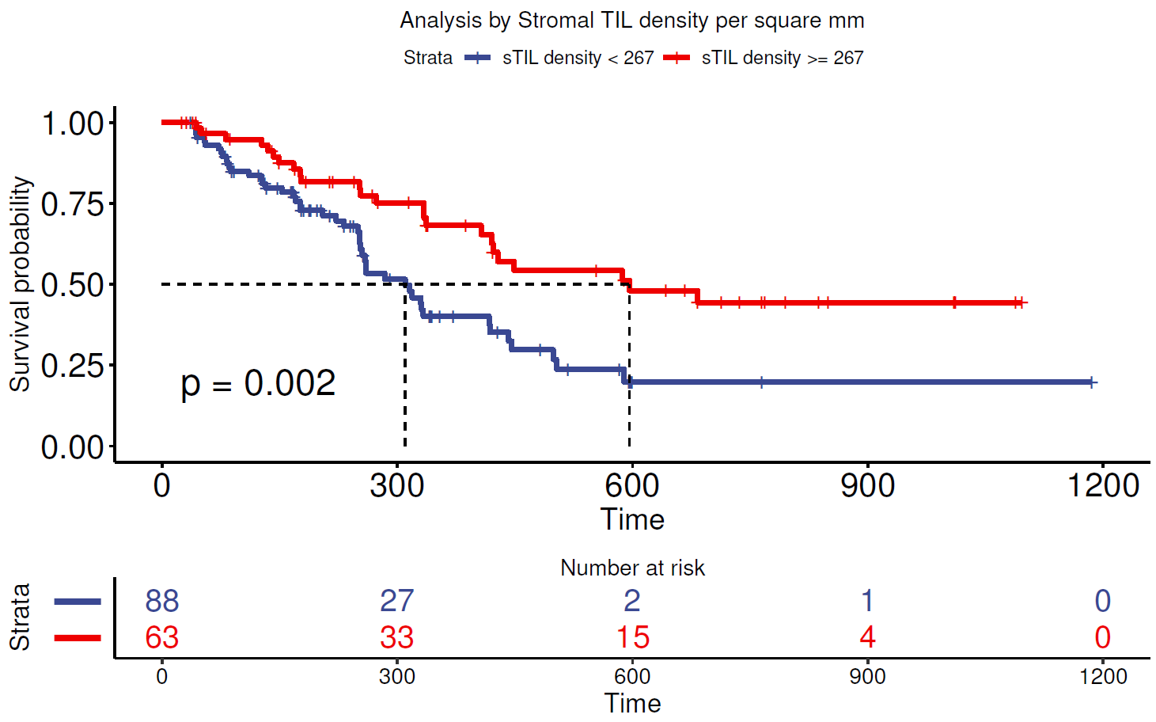

B
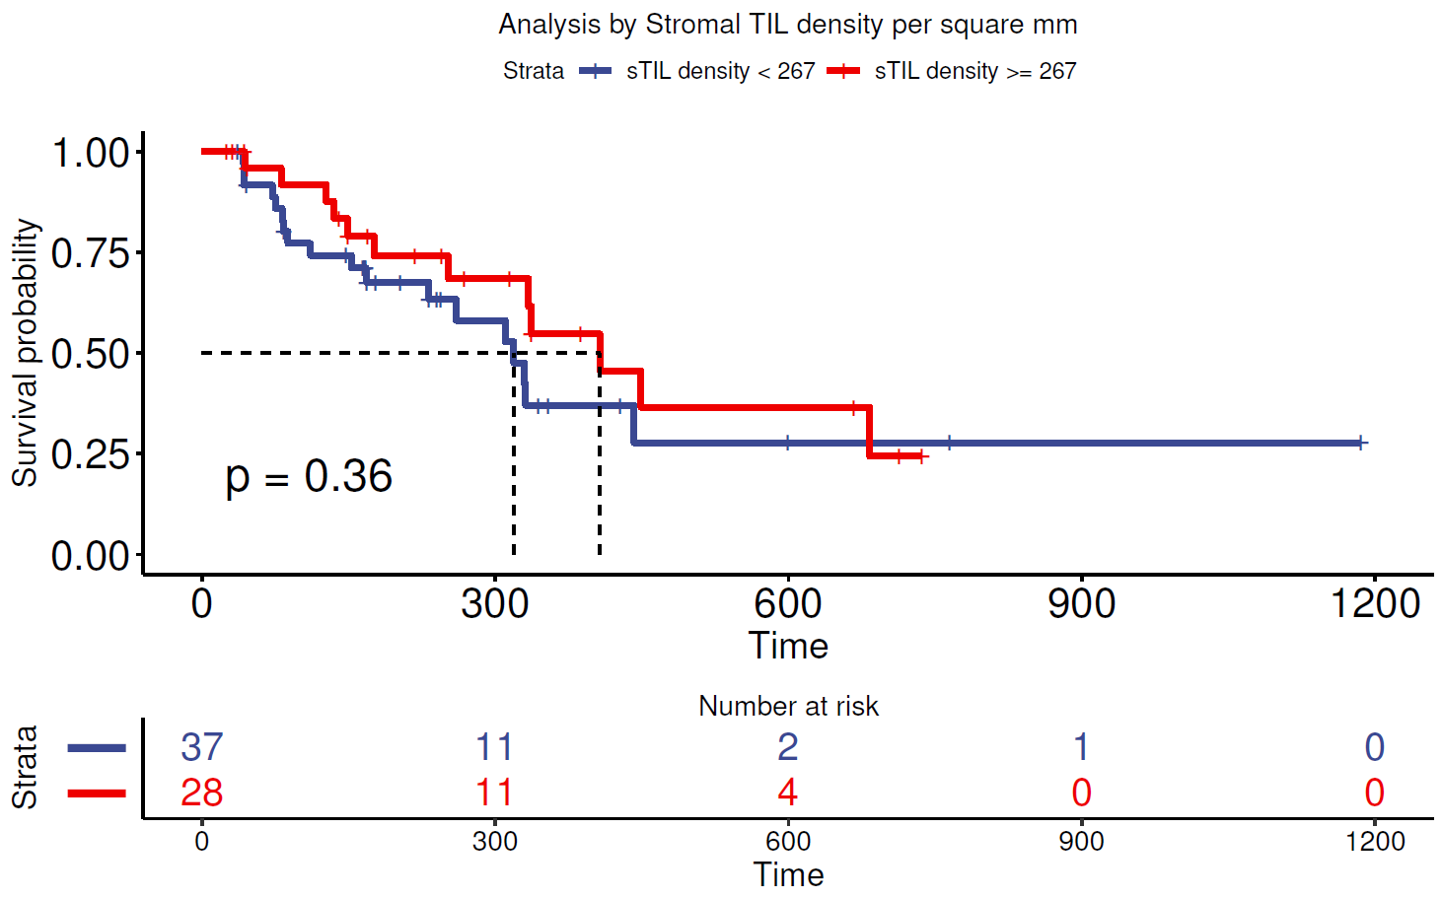
C
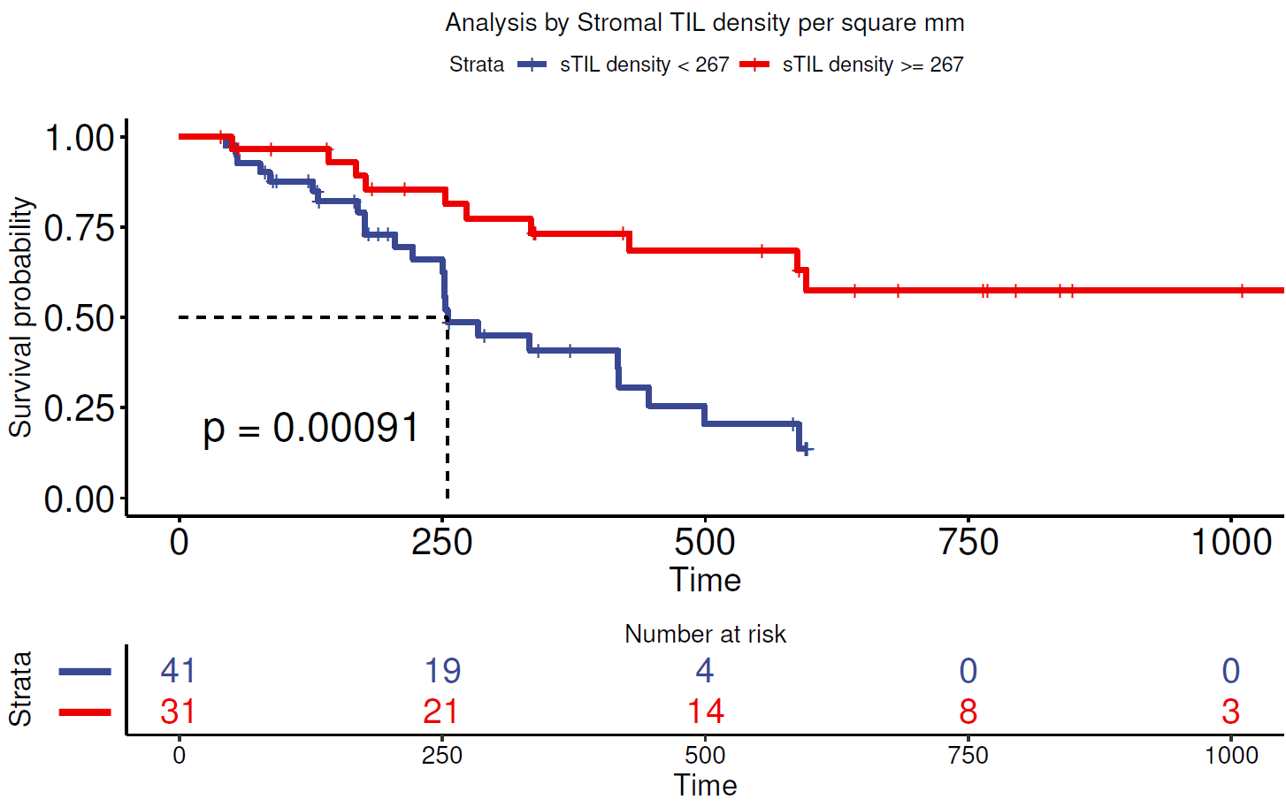
Supplementary Figure S2. Kaplan-Meier curves for patient stratification on J101 data set using the bivariate combination of best HER2 QCS-based features and sTIL densities. Stratification using % OD-positive cells or sTIL density for (A) the full cohort, (B) the HER2-negative cohort, and (C) the HER2-positive cohort. Stratification using bSPS or sTIL density for (D) the full cohort, (E) the HER2-negative cohort, and (F) the HER2-positive cohort. bSPS, binary spatial proximity scores; HER2, human epidermal growth factor receptor 2; Neg, negative; OD, optical density; Pos, positive;
QCS, quantitative continuous scoring; sTIL, stromal tumor-infiltrating lymphocyte.
A 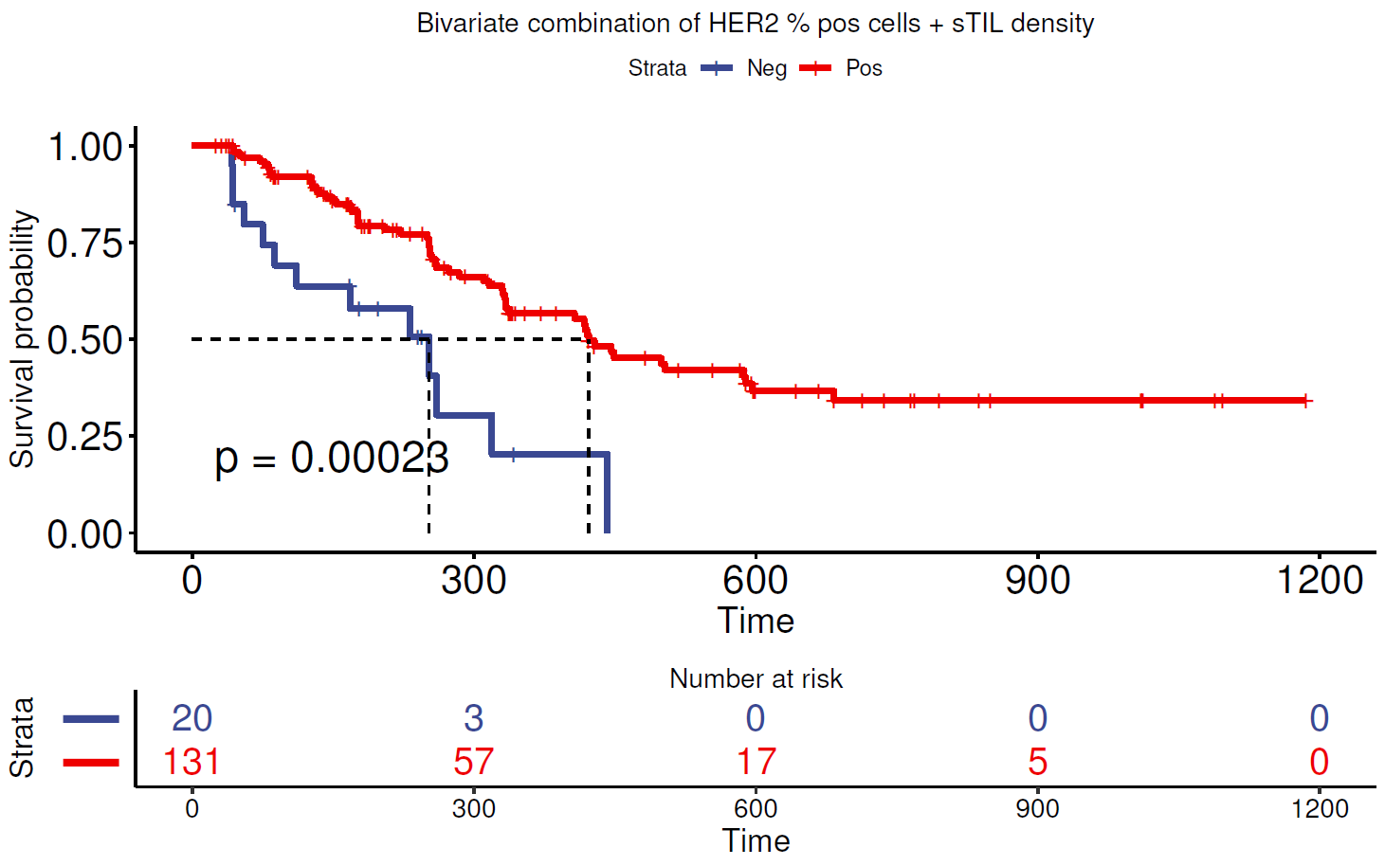
B 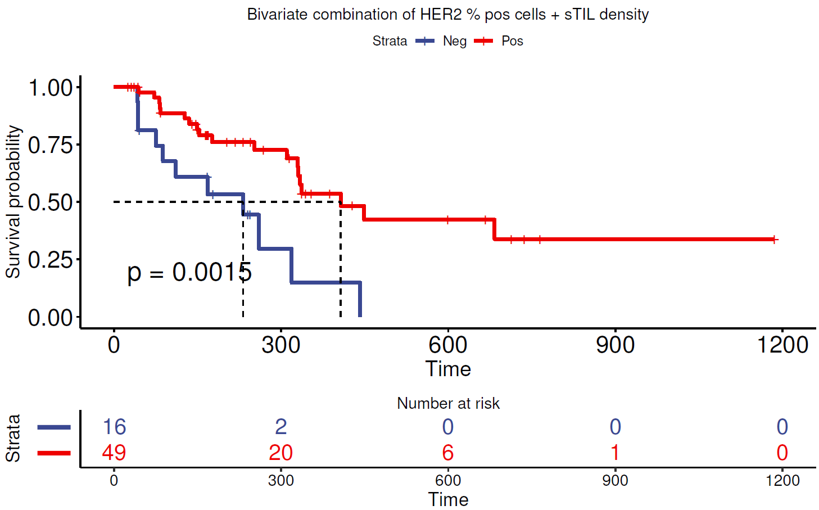
C 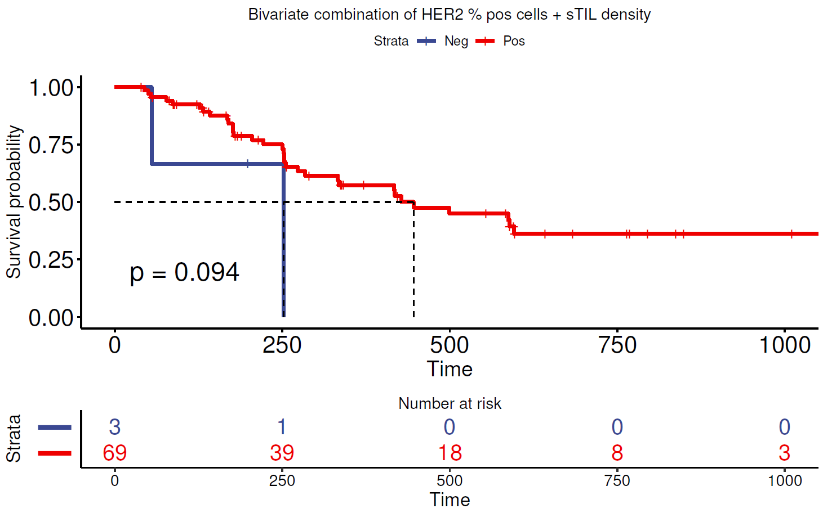
D 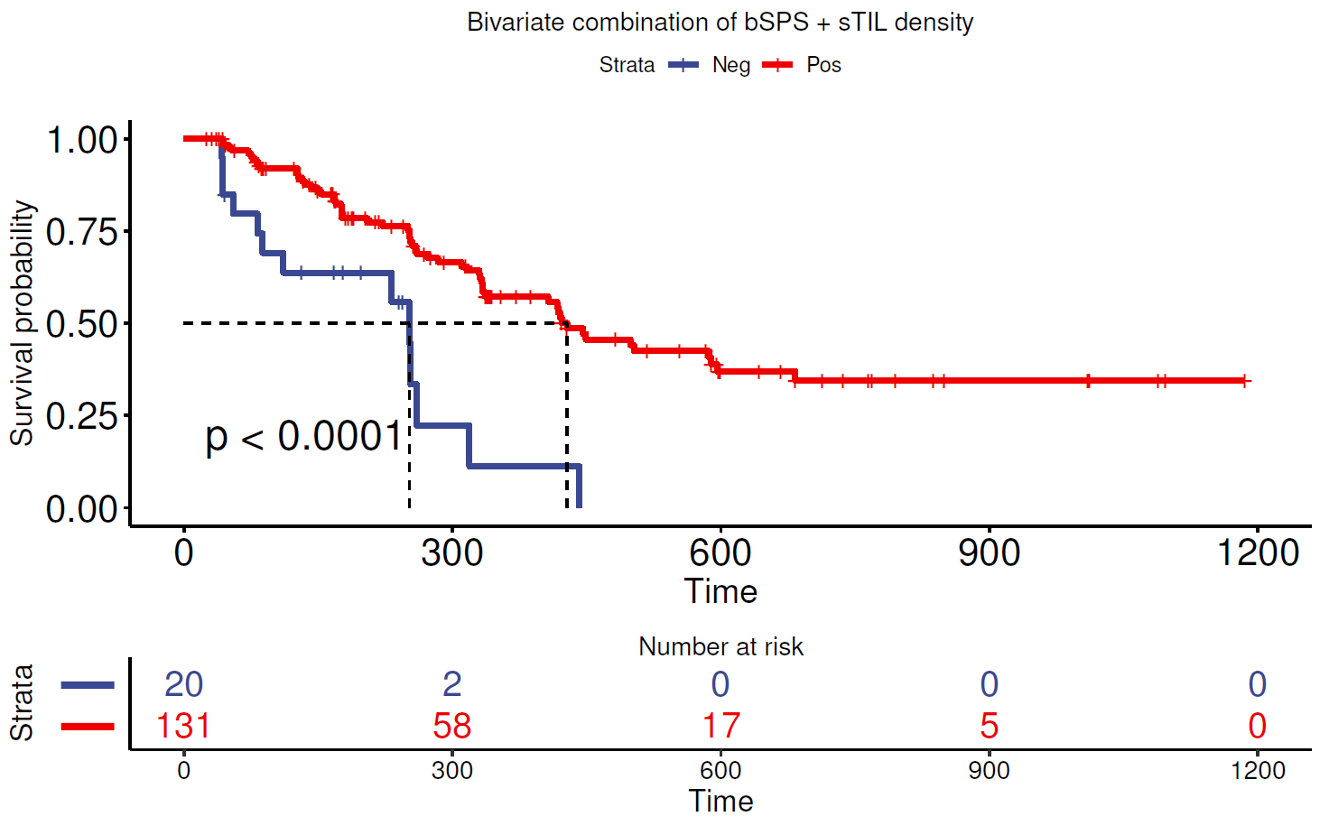
E 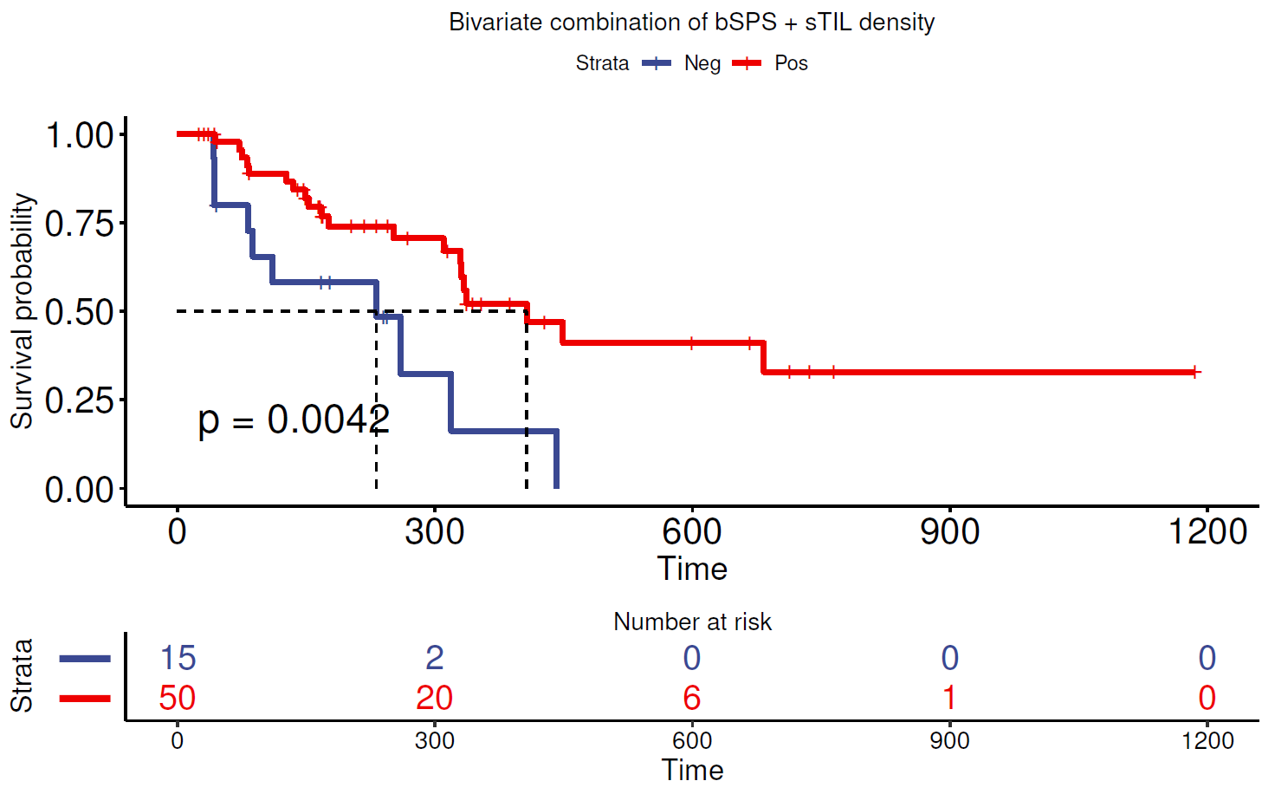
F 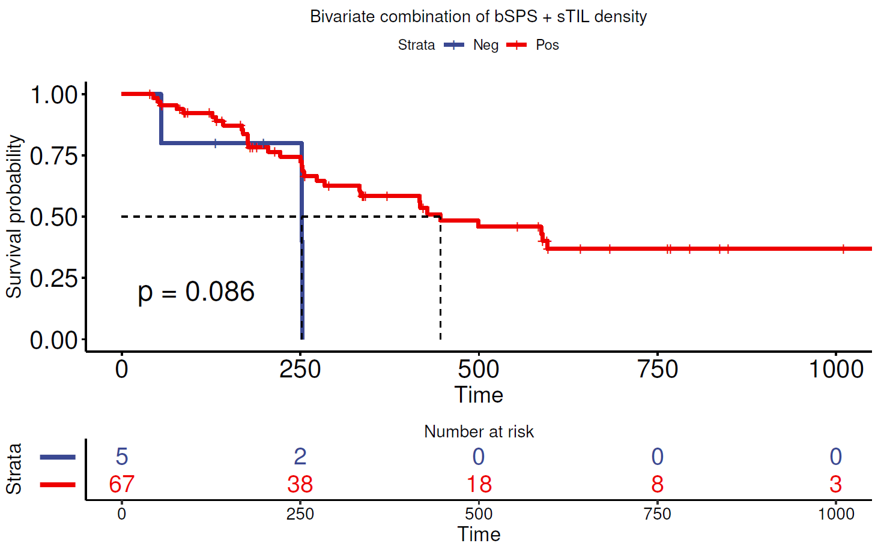

Application of quantitative continuous scoring-based analysis on immuno-oncology–treated (anti–PD-L1–treated) clinical trial data
The pathologist’s visual assessment of tumor proportion score (TPS) on anti–programmed death-ligand 1 (PD-L1)–stained tissue samples is an established method to select patients with metastatic non-small cell lung cancer (NSCLC) who are likely to respond to anti–PD-L1 / PD-L1 monotherapy³. The quantitative continuous scoring (QCS)-based analysis of PD-L1 can redefine the PD-L1 TPS estimation by allowing PD-L1 to be scored in a more objective and quantifiable manner.

By applying the QCS-based image analysis pipeline using⁴ the epithelial segmentation model, the PD-L1 expression of each tumor cell compartment was estimated by the respective optical density (OD) of 3,3-diaminobenzidine (DAB), and tumor cells with a membrane OD greater than OD_{threshold} (refers to the OD threshold set to label a cell OD positive) were considered OD positive. A slide comprising a greater percentage of OD-positive tumor cells than a cut-point value was considered QCS positive (see Supplementary Fig. S3).

Supplementary Figure S3. PD-L1 QCS workflow that takes as an input a whole-slide image acquired from a PD-L1 IHC tissue section (left column), segments the tumor cells to membrane, cytoplasm, and nucleus (middle column), and derives OD-based readouts per cell that are aggregated as histograms (right column). Following cut-point optimization, a PD-L1 QCS-positive case is defined as one in which ≥57% of cells exhibit OD ≥8. IHC, immunohistochemistry; OD, optical density; PD-L1, programmed death-ligand 1; QCS, quantitative continuous scoring.
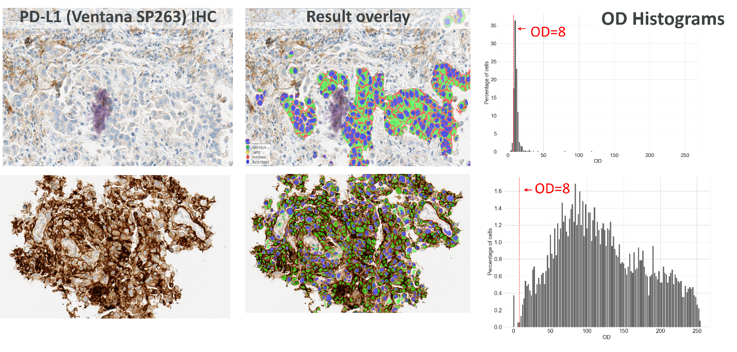
The OD_{threshold} and cut-point parameters were linked to patient overall survival by minimizing the Kaplan-Meier log–rank p values and keeping ≥50% prevalence in the QCS-positive subgroup. A PD-L1 QCS–based analysis (OD_{threshold}=8, cut point ≥57%) stratifies durvalumab-treated patients with NSCLC at a higher prevalence and with a significant Kaplan-Meier log–rank p value (64%; p=0.0001) for overall survival compared with pathologist TPS (59%; p=0.01) (Supplementary Fig. S4). Median overall survival of 19.2 vs 7.9 months was observed in the QCS-positive vs -negative subgroup, respectively. The box plots (Supplementary Fig. S5A) indicate an overall good agreement (72% concordance) of the fully automated QCS with the pathologist TPS, which quantitatively supports the positive visual assessment of the cell segmentation accuracy. The grouped Kaplan-Meier (Supplementary Fig. S5B shows four arms based on stratification where QCS and pathologist TPS agree/disagree on the category. The survival of discordant cases favors the QCS for patient selection compared with pathologist TPS.

The novel QCS-based approach provides an objective way of correlating a quantitative estimate of PD-L1 immunohistochemistry (IHC) expression on tumor cells with survival of patients with NSCLC treated with durvalumab in later lines of therapy. An efficacy data-driven definition of PD-L1 tumor cell positivity may identify more patients benefiting from therapy with higher precision. Further validation of the QCS-based approach is needed to correlate with outcomes in the first-line setting and in comparison with other PD-L1 cutoff levels.

Supplementary Figure S4. Kaplan-Meier curves for overall survival stratification with (left) manual tumor proportion score (25% cut point) and (right) automated quantitative continuous scoring (57% cut point).
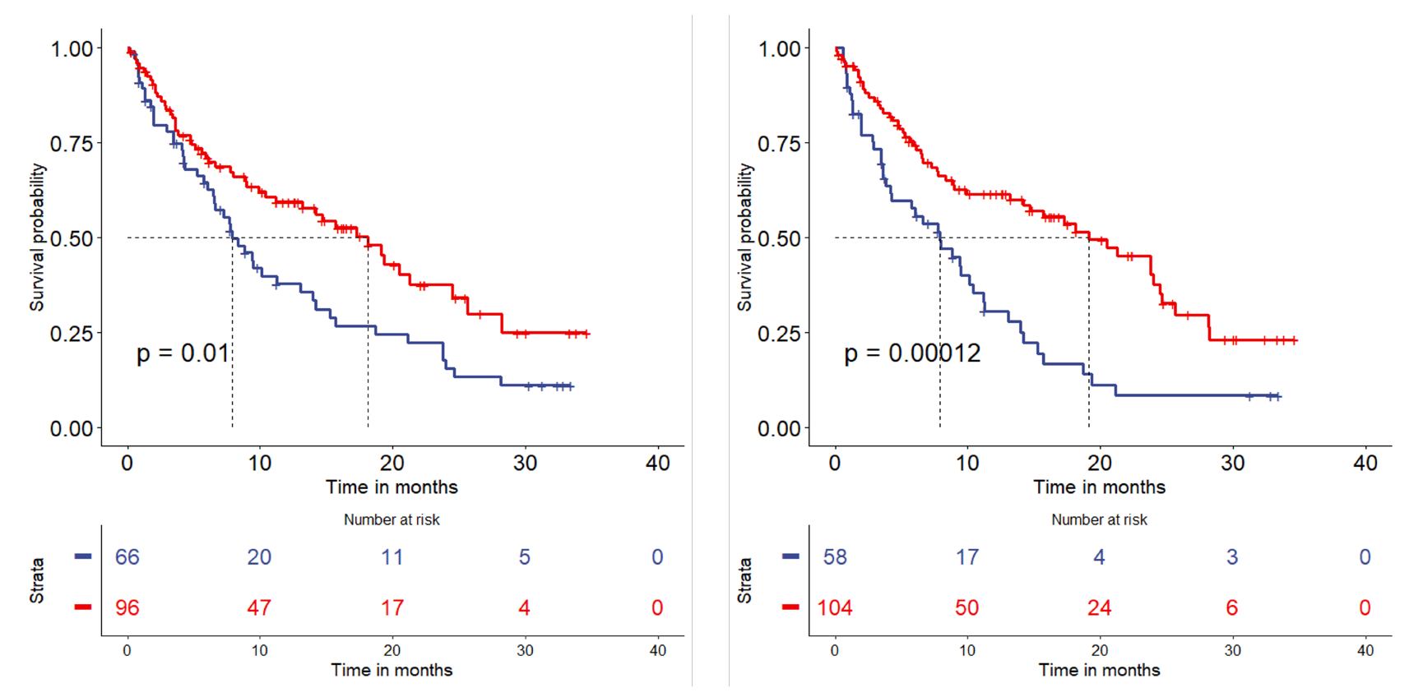

Supplementary Figure S5. Subgroup analysis. (A) Box plot indicating % OD-positive cells (OD ≥8) within the PD-L1–high and –low groups per pathologist assessment by TPS. (B) Grouped Kaplan-Meier curves showing stratification where QCS and pathologists agree/disagree on the scoring category. OD, optical density; Path, pathologist; PD-L1, programmed death-ligand 1; QCS, quantitative continuous scoring; TPS, tumor proportion score.
A
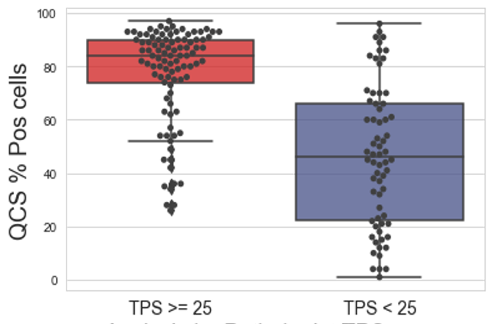

B

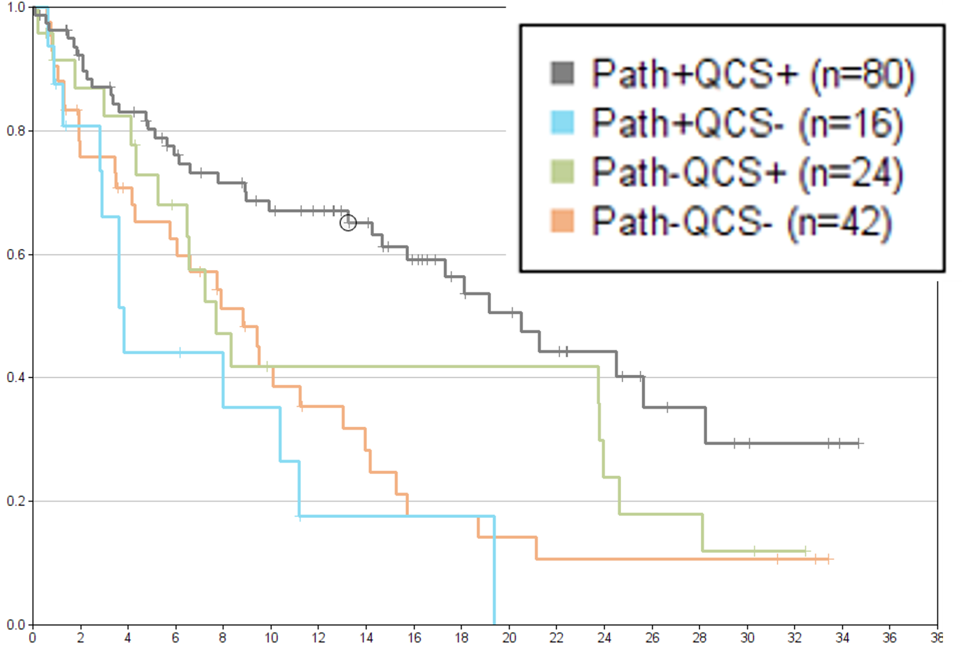

Optical density computation
The human epidermal growth factor receptor 2 QCS quantifies DAB staining intensity generated by a human epidermal growth factor receptor 2 immunohistochemistry assay in individual cell compartments using the hue saturation density model⁵. Images are acquired using a red-green-blue color model that comprises 8-bit (256) gray values for each color channel. Using Beer-Lambert’s law, each color channel is converted to density using a logarithm and parameters I₀, which are related to physical properties such as sectioning thickness and slide scanner illumination brightness. Based on those log-transformed channels, a color separation using the hue saturation density model estimates the density of the brown color from the DAB dye, which is referred to in the manuscript as the OD. An initial output in the range (0 ... 5.75)⁵ is converted to the standard red-green-blue grayscale range (0 ... 255) by applying a scaling factor.

Supplementary Figure S6. The hue saturation density model⁵ estimates 3,3-diaminobenzidine (DAB) staining and, therefore, human epidermal growth factor receptor 2 (HER2) expression in each tumor cell as optical density. HRP, horseradish peroxidase; IHC, immunohistochemistry; RGB, red-green-blue.
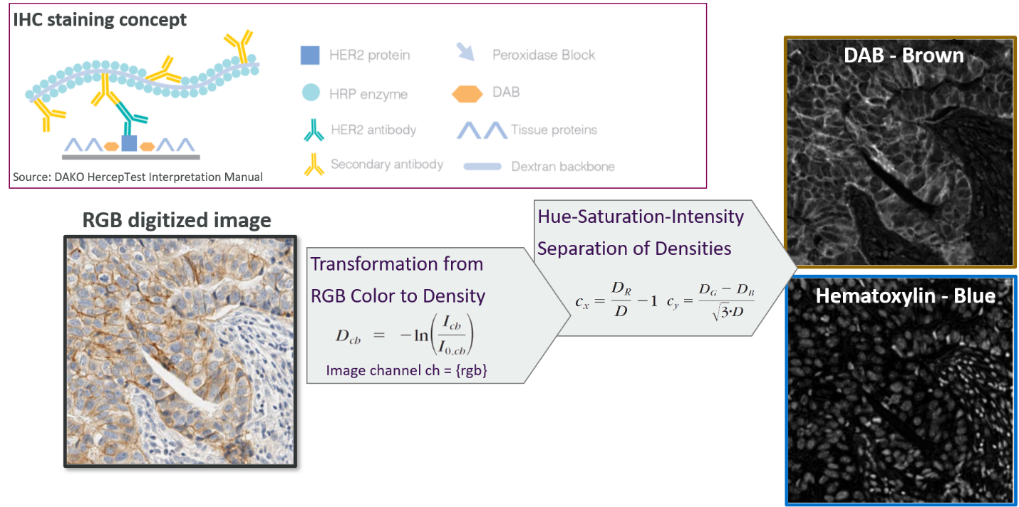

References
1. Wolff, A. C. et al. Human epidermal growth factor receptor 2 testing in breast cancer: American Society of Clinical Oncology/College of American Pathologists clinical practice guideline focused update. Arch. Pathol. Lab. Med. 142, 1364–1382 (2018).
2. Miglietta, F. et al. Evolution of HER2-low expression from primary to recurrent breast cancer. NPJ Breast Cancer 7, 137 (2021).
3. Rebelatto, M. C. et al. Development of a programmed cell death ligand-1 immunohistochemical assay validated for analysis of non-small cell lung cancer and head and neck squamous cell carcinoma. Diagn. Pathol. 11, 95 (2016).
4. Kapil, A. et al. Domain adaptation-based deep learning for automated tumor cell (TC) scoring and survival analysis on PD-L1 stained tissue images. IEEE Trans. Med. Imaging 40, 2513–2523 (2021).
5. Van der Laak, J. A., Pahlplatz, M. M., Hanselaar, A. G. & de Wilde, P. C.
Hue-saturation-density (HSD) model for stain recognition in digital images from transmitted light microscopy. Cytometry 39, 275–284 (2000).

