Supplementary Information: Thermo-optical tweezers based on photothermal waveguides

Fuwang Li¹, Jian Wei¹, Xiaomei Qin¹, Xue Chen²*, Dawei Chen¹, Wentao Zhang³, Jiaguang Han^{3,4}, and Libo Yuan¹, Hongchang Deng¹*

1. Photonics Research Center, School of Optoelectronic Engineering, Guilin University of Electronic Technology, Guilin 541004, China.
2. School of Mechanical and Electrical Engineering, Guilin University of Electronic Technology, Guilin 541004, China.
3. Guangxi Key Laboratory of Optoelectronic Information Processing, School of Optoelectronic Engineering, Guilin University of Electronic Technology, Guilin 541004, China.
4. Center for Terahertz Waves and College of Precision Instrument and Optoelectronics Engineering, and the Key Laboratory of Optoelectronics Information and Technology (Ministry of Education), Tianjin University, Tianjin, 300072, China.
*Corresponding author. Email: hcdeng@guet.edu.cn

Supplementary Figures
Fig. S1. Experimental Setup of the TOT System. Components include M for dielectric mirrors, L for lenses, HWP for the half-wave plate, SLM for the spatial light modulator, DCM for the dichroic mirror, and MO for the microscope objective. Insets: This schematic diagram of the TOT system illustrates the manipulation of PS particles. The red and blue arrows indicate the thermophoretic and drag forces acting on the PS particles, driven by the thermal convection flow.

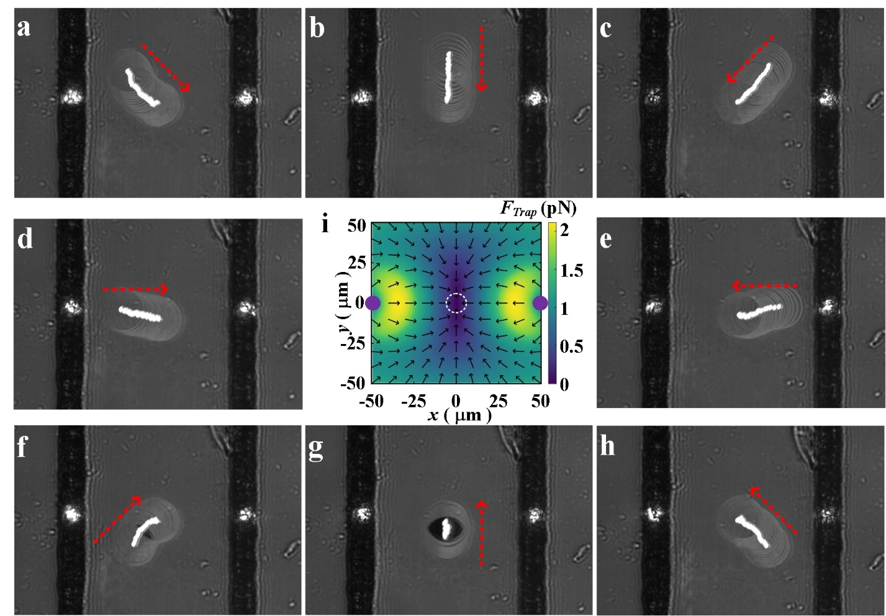
Fig. S2. Dynamic manipulation of a single PS particle in different positions by DFLs. (A)-(D), (E)-(H) The PS particles initially positioned in the upper left, upper, upper right, left, right, lower left, lower, and lower right directions all converge towards the central trapping potential well. (I) This section depicts the trapping force distributions on the x-y plane. The white dotted circle indicates the predicted center of the trapping potential well, while the blue dots at y=0 mark the positions of the double laser sources. The color bar illustrates the amplitude, and the arrows indicate the directions of the trapping force. The incident beam power of each laser is 16.0 mW, with a distance of 100 μm between the two tracks. Scale bars measure 25 μm.

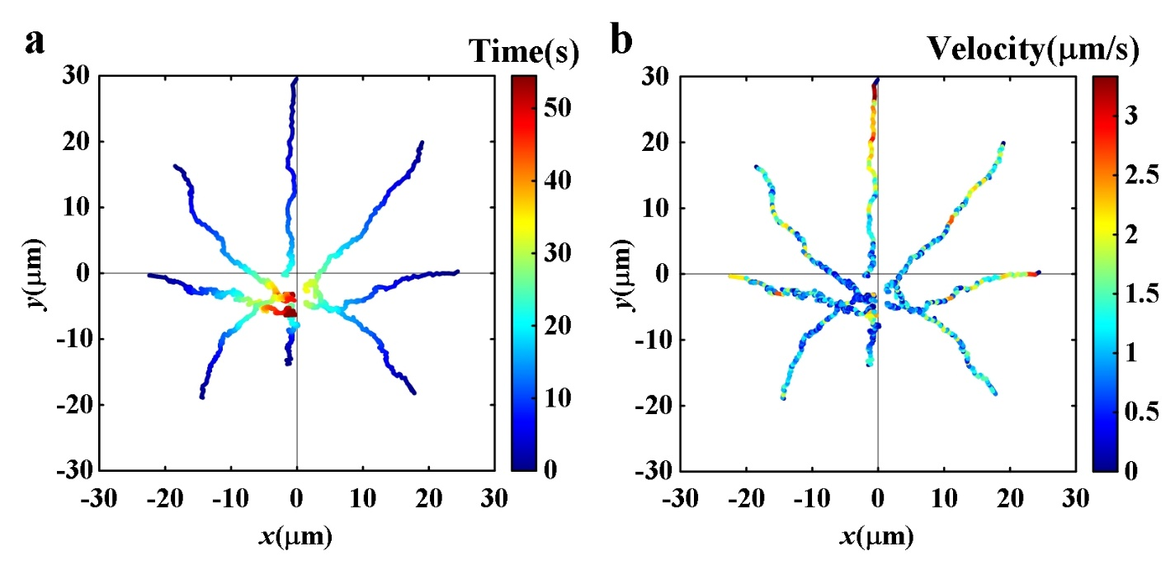
Fig. S3. The trajectories vary with time for the PS particles moving from the upper left, upper, upper right, left, right, lower left, lower, and lower right directions to the trapping potential well (the center of the reticle). (A) The particles ultimately stabilize near the center of the potential well. (B) The velocities of the PS particles, originating from various positions, vary over time. Initially, the velocities are relatively high at the start of their migration, but they slow down significantly upon nearing the center. This behavior aligns well with the distribution of the trapping force depicted in Fig. S2(I). The average velocity of the particles moving in the eight directions is approximately 0.87 μm/s. For a visual representation, experimental videos are provided in Movie S2.
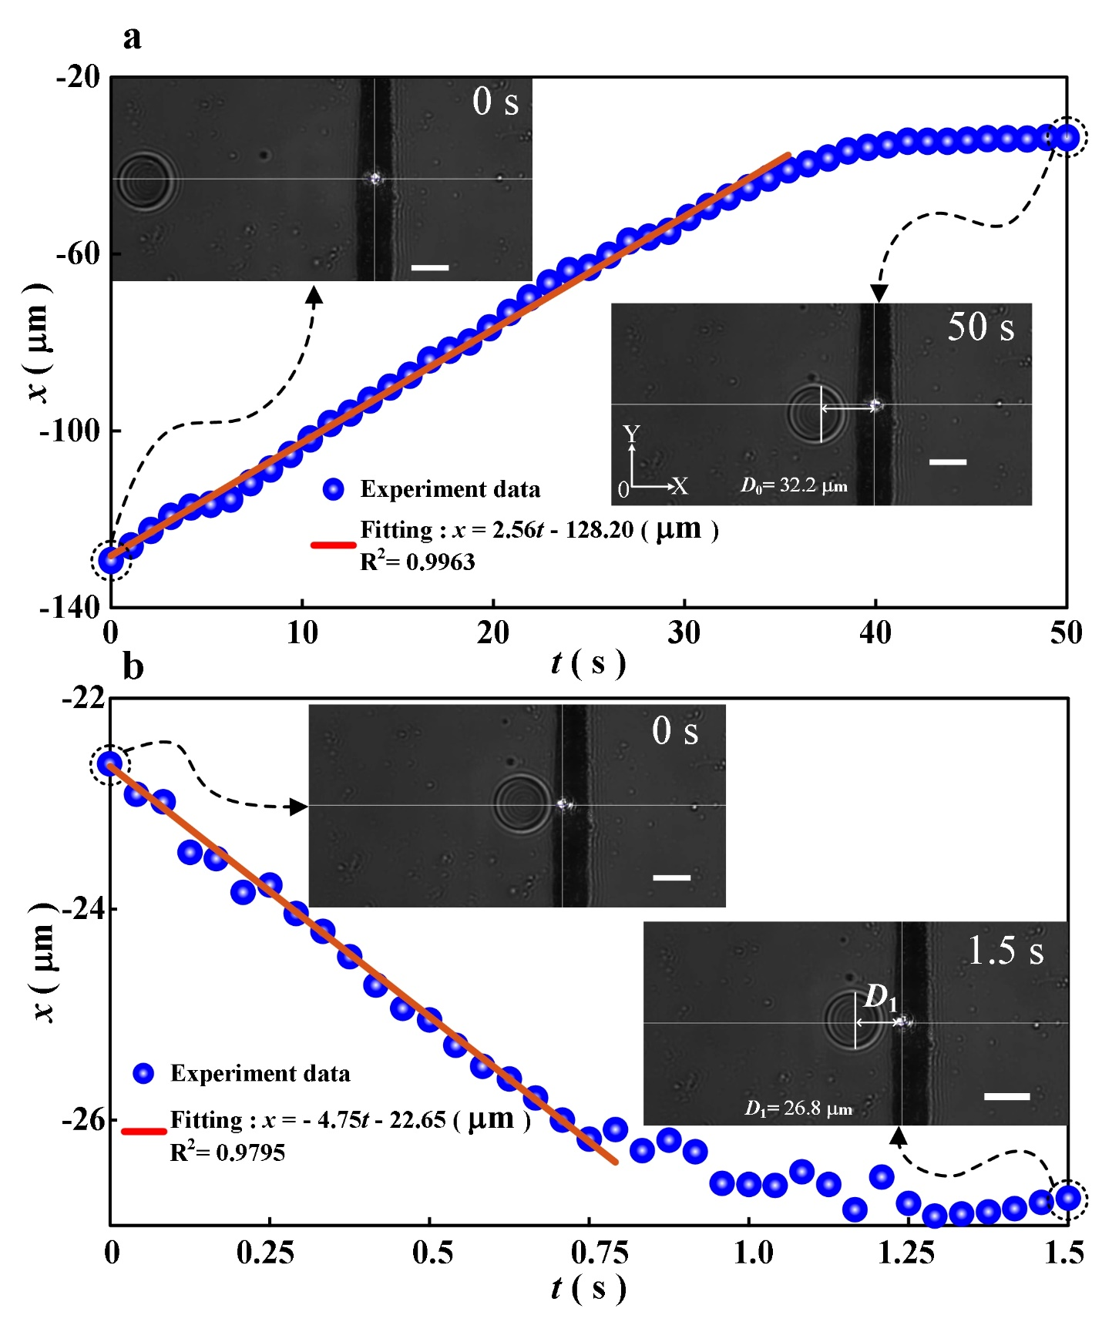
Fig. S4. Dynamic manipulation of fluorinated oil microparticles (diameter: 30μm) with negative refractive index by the TOT. (A) The x-displacements of a distant fluorinated oil particle vary over time. This particle is attracted towards the trapping potential well. The red line represents a fit of the x-displacement of the fluorinated oil microparticle from 0 to 35 seconds. (B) The x-displacements of a nearby fluorinated oil particle also vary over time. In contrast, this particle is repelled away from the trapping potential well. The red line here fits the x-displacement of the fluorinated oil microparticle from 0 to 0.8 seconds. The incident beam power, measured at the rear aperture of the objective, is 16.1 mW. The scale bar measures 25 μm. The experimental video present this phenomenon is available in Movie S8.

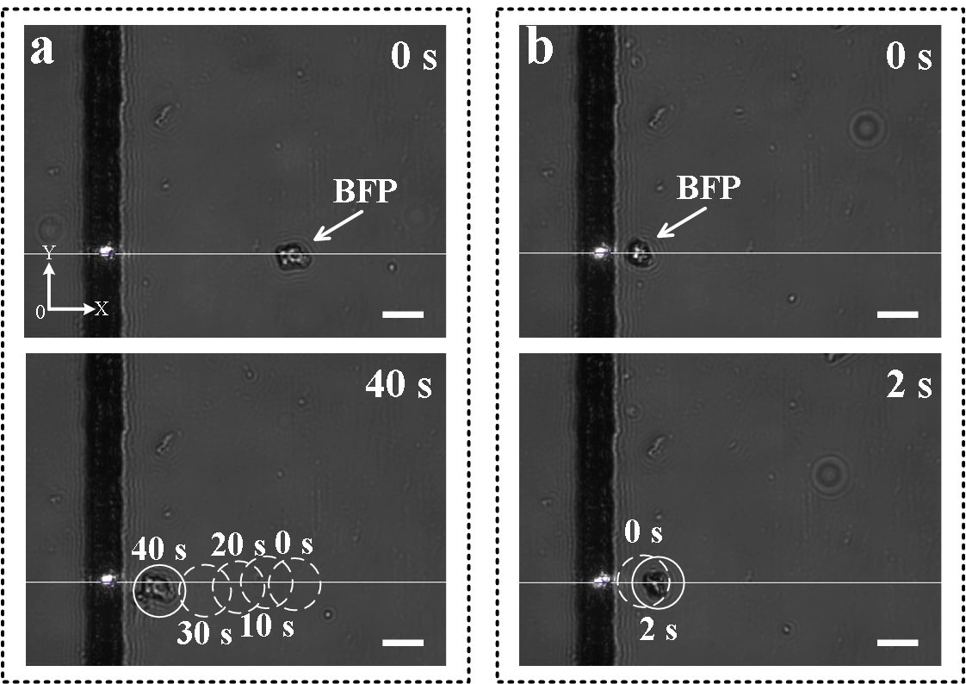

Fig. S5. Dynamic manipulation of irregular substances, denoted as bamboo fiber particle (BFP), by the TOT. (A) Distant irregular BFP substance is attracted towards the trapping potential well. The positions of the irregular BFP substance at different moments are indicated by the white circles. (B) Nearby irregular BFP substance is repelled to the annular trapping potential well. The positions of the irregular BFP substance at two specific moments are represented by the white dotted circle and the white solid circle. The incident beam power (measured at the rear aperture of the objective) is 12.1 mW. The Scale bar: 20 μm. The Experimental video is presented in movie S9.

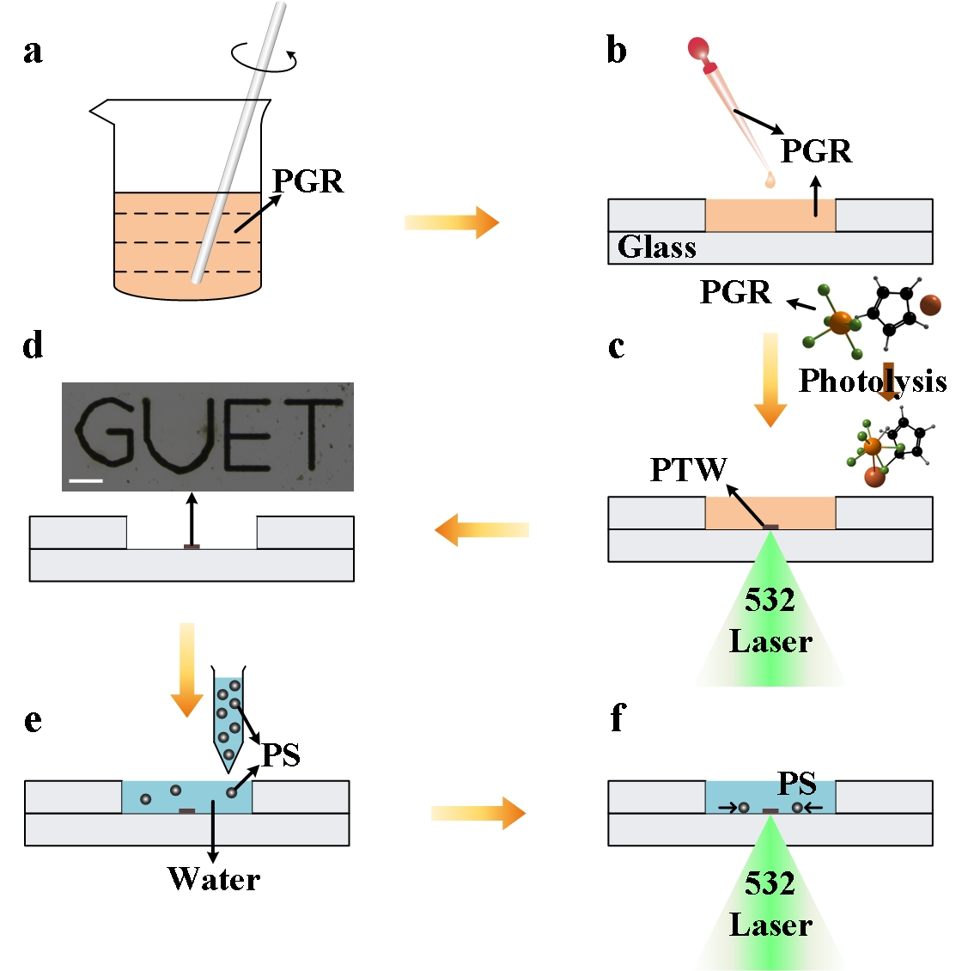
Fig. S6. Synthesis of PTW and sample preparation. (A) Preparation of PGR solution. (B) Dropping the PGR solution into the micro-channel. (C) Focusing the laser on the bottom of the micro-channel, which triggers the PGR to self-assemble into a crystalline structure, forming a solid PTW. (D) Engraving a 'GUET' patterned structure of PTW with a scale of 100 μm. (E) Introducing an aqueous solution of PS particles into the micro-channel. (F) Utilizing the TOT system to manipulate microparticles.

