Supporting Information for
Effect of coal fly ash on stem elongation of wheat
Shengpu Wang¹, Xinpeng Hu¹, Bingbing Li¹, Haojia Zhang¹, Xin Xiao^{1*}, Ruoxi Qian², Xi Huang¹
Address: 1. China University of Mining and Technology, Xuzhou 221008, China
2. Department of Mathematical and Computational Sciences, University of Toronto, Toronto L5B 4P2, Canada
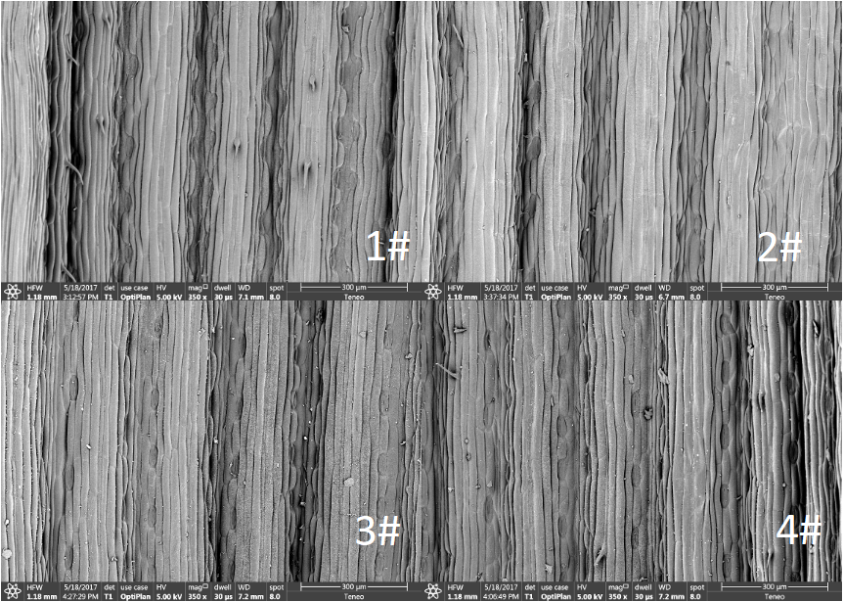
a
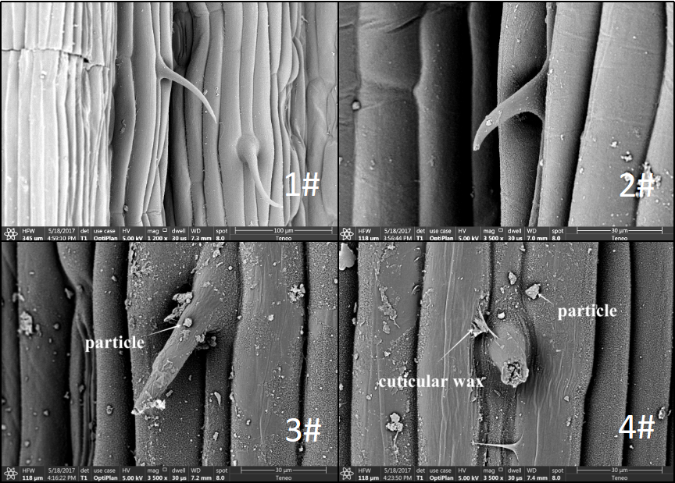
b
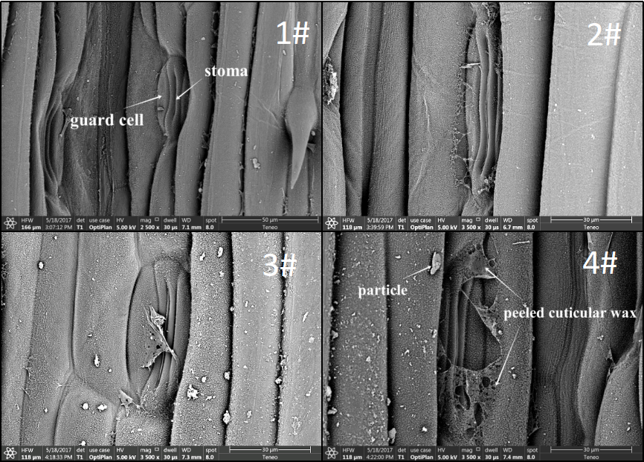
c
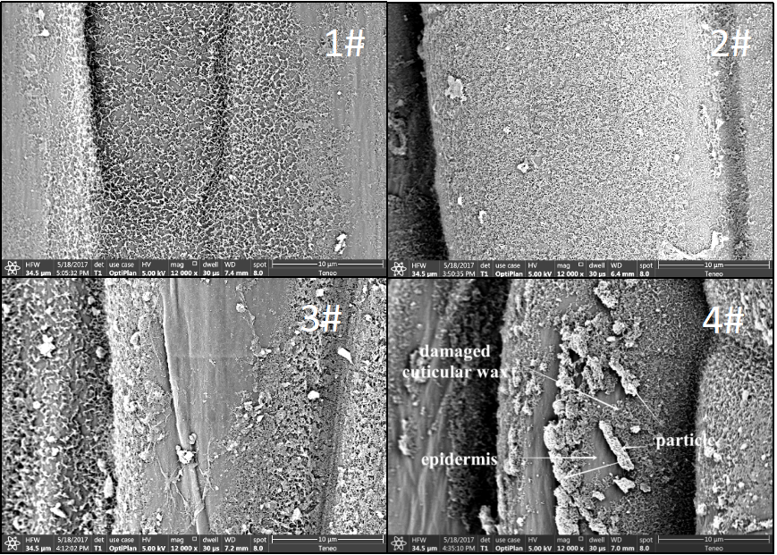
d

Figure S1 Scanning electron microscopy (SEM) micrographs showing the structural injury of blades in four treatments with the overview of epidermis (a) and detailed view of blade trichomes (b), stomata (c), cuticular wax of blades (d).

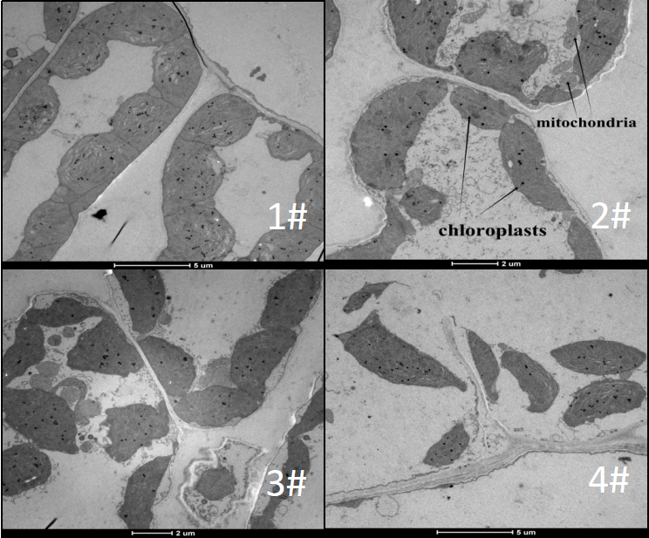
a
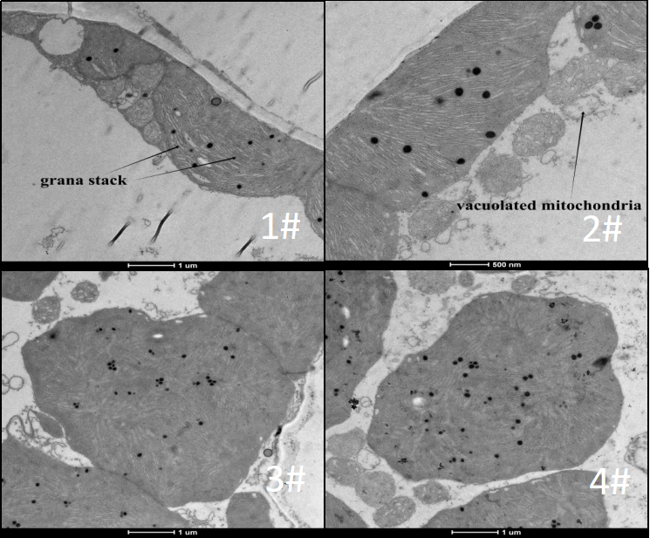

b
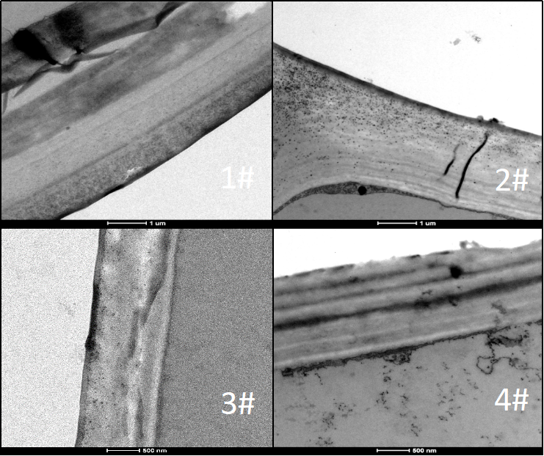
c
Figure S2 Transmission Electron Microscopy (TEM) micrographs showing the subcellular structure of blades at elongation stage in four treatments with the overview of cell (a), detailed view of chloroplast (b) and cytoderm (c).

