Extended data

Extended data tables

Extended Data Table 1 Crop classification into crop groups, following Yu et al.³⁰.
Crop groups | Crops
Cereals | Wheat, rice, maize, barley, pearl millet, small millet, sorghum, other cereals
Starchy roots | Potato, sweet potato, yams, cassava, other roots
Pulses | Bean, chickpea, cowpea, pigeon pea, lentil, other pulses
Oil crops | Soybean, ground nut, coconut
Fruits and vegetables | Banana, plantain, tropical fruit, temperate fruit

Extended Data Table 2 Cumulative share of cropland area where at least 25% [50%, 75%] of the current production of 27 food crops would shift outside crop specific Safe Climatic Spaces (SCS) at global warming levels from 1.5 °C to 5 °C. “Cropland within SCS in all scenarios” shows the share of cropland area where less than 25% [50%, 75%] of current production would be pushed outside crop specific SCS at all warming levels.
 | Cumulative share of cropland area where at least 25% of production shifts outside the SCS at warming level (%) |  |  |  |  | Cropland within SCS in all scenarios (%)
Region | 1.5 °C | 2 °C | 3 °C | 4 °C | 5 °C | Cropland within SCS in all scenarios (%)
Global | 23 [18 - 14] | 28 [22 - 18] | 40 [34 - 30] | 50 [45 - 40] | 57 [52 - 47] | 43 [48 - 53]
East Asia & Pacific | 22 [17 - 14] | 27 [21 - 18] | 40 [34 - 31] | 47 [41 - 38] | 52 [46 - 42] | 48 [54 - 58]
Europe & Central Asia | 15 [11 - 9] | 16 [11 - 9] | 17 [12 - 9] | 21 [14 - 11] | 25 [17 - 14] | 75 [83 - 86]
Latin America & Caribbean | 20 [16 - 12] | 25 [20 - 16] | 45 [40 - 34] | 61 [56 - 50] | 71 [66 - 60] | 29 [34 - 40]
Middle East & North Africa | 52 [44 - 37] | 57 [49 - 41] | 66 [58 - 51] | 74 [67 - 60] | 78 [72 - 66] | 22 [28 - 34]
North America | 17 [12 - 10] | 18 [13 - 10] | 20 [15 - 11] | 24 [18 - 14] | 29 [22 - 17] | 71 [78 - 83]
South Asia | 33 [24 - 19] | 48 [35 - 27] | 69 [57 - 45] | 82 [73 - 63] | 90 [86 - 81] | 10 [14 - 19]
Sub-Saharan Africa | 27 [21 - 15] | 34 [28 - 22] | 51 [46 - 42] | 67 [62 - 59] | 76 [72 - 69] | 24 [28 - 31]

Extended Data Table 3 Percentual net change in cropland area within the crop specific Safe Climatic Space (SCS) for 27 food crops in global warming scenarios from 1.5 °C to 5 °C. The percentual change is calculated as change compared to cropland area within the SCS in baseline conditions. ‘Med’ indicates median estimate from 8 GCMs, and ‘25th’ and ‘75th’ indicate 25th and 75th percentiles of the GCM estimates.
 | Global warming (°C), measure
Crop | 1.5, med [25th, 75th] | 2, med [25th, 75th] | 3, med [25th, 75th] | 4, med [25th, 75th] | 5, med [25th, 75th]
Coconut | 10 [9, 10] | 5 [4, 9] | -12 [-21, -2] | -34 [-42, -25] | -43 [-51, -32]
Banana | 5 [5, 6] | 3 [1, 6] | -11 [-16, -1] | -25 [-31, -18] | -33 [-39, -23]
Sorghum | 3 [2, -4] | 1 [-2, 4] | -5 [-9, 1] | -11 [-15, -6] | -18 [-21, -10]
Tropical fruit | 3 [3 - 4] | 1 [0, 4] | -6 [-10, 0] | -15 [-18, -10] | -20 [-24, -13]
Barley | -5 [-5, -4] | -8 [-8, -7] | -13 [-15, -11] | -20 [-22, -17] | -25 [-30, -22]
Chickpea | 4 [4, 6] | 1 [-1, 5] | -6 [-8, 0] | -8 [-10, -3] | -8 [-13, -6]
Groundnut | 2 [2, 4] | 1 [-1, 4] | -8 [-13, -1] | -18 [-22, -11] | -26 [-30, -16]
Pearl millet | 4 [3, 5] | 2 [0, 4] | -8 [12, -3] | -16 [-21, -11] | -26 [-30, -19]
Cassava | 3 [2, 4] | -1 [-4, 4] | -16 [-23, -7] | -33 [-39, -25] | -41 [-48, -30]
Maize | 1 [0, 2] | -2 [-4, 2] | -10 [-14, -5] | -23 [-27, -16] | -30 [-39, -24]
Yams | 4 [2, 4] | -3 [-5, 2] | -20 [-27, -10] | -38 [-46, -30] | -48 [-54, -37]
Plantain | 1 [0, 2] | -3 [-5, 2] | -16 [-22, -8] | -32 [-37, -24] | -39 [-46, -28]
Bean | -1 [-1, 0] | -4 [-6, -1] | -14 [-19, -9] | -27 [-31, -21] | -33 [-38, -27]
Sweet potato | -1 [-1, 1] | -4 [-6, 0] | -14 [-18, -7] | -26 [-31, -20] | -33 [-42, -26]
Temperate fruit | -2 [-3, -1] | -4 [-6, -1] | -11 [-15, -8] | -21 [-24, -15] | -27 [-32, -21]
Vegetables | -2 [-3, -1] | -5 [-7, -2] | -13 [-17, -9] | -24 [-28, -18] | -30 [-35, -24]
Cowpea | -3 [-5, -1] | -8 [-13, -3] | -21 [-26, -16] | -31 [-35, -25] | -37 [-39, -31]
Wheat | -6 [-7, -5] | -11 [-12, -7] | -18 [-20, -15] | -26 [-29, -21] | -31 [-35, -27]
Other pulses | -5 [-6, -4] | -8 [-11, -5] | -17 [-20, -13] | -26 [-29, -20] | -31 [-37, -26]
Other cereals | -6 [-7, -5] | -9 [-12, -5] | -18 [-21, -14] | -27 [-30, -22] | -33 [-40, -30]
Pigeon pea | -4 [-5, -2] | -10 [-13, -5] | -23 [-29, -16] | -35 [-40, -29] | -39 [-44, -33]
Other roots | -5 [-7, -4] | -10 [-12, -5] | -19 [-23, -14] | -28 [-33, -24] | -34 [-37, -27]
Rice | 2 [2, 2] | 0 [-2, 2] | -11 [-16, -3] | -25 [-31, -17] | -34 [-41, -25]
Soybean | -6 [-6, -4] | -10 [-13, -6] | -21 [-26, -16] | -35 [-40, -27] | -41 [-49, -36]
Lentil | -4 [-5, -3] | -10 [-11, -5] | -18 [-19, -12] | -25 [-28, -21] | -29 [-34, -25]
Small millet | -7 [-7, -5] | -10 [-12, -6] | -19 [-23, -14] | -31 [-35, -24] | -38 [-47, -33]
Potato | -8 [-9, -7] | -12 [-14, -9] | -21 [-24, -17] | -30 [-33, -25] | -35 [-41, -30]

Extended Data Table 4 Global share of cropland in categories of change in potential crop diversity of 27 food crops, compared to baseline potential diversity in 1970-2000. “Cropland with emerging climatic potential” indicates that the area hosts marginal crop production in baseline climate but would shift into the Safe Climatic Space (SCS) of at least one crop in the future scenario. “Marginal in baseline and outside the SCS in scenario” indicates that the area hosts marginal production in baseline climate and is not within the SCS of any crop in the future scenario.
 | Share of global cropland in category in global warming scenario (%)
Diversity change compared to baseline (%) | 1.5 °C | 2 °C | 3 °C | 4 °C | 5 °C
-100 | 2.8 | 4.8 | 15.2 | 24.0 | 30.2
-99.99 to -75 | 1.6 | 2.5 | 3.6 | 4.3 | 4.2
-75 to -50 | 5.2 | 6.8 | 5.1 | 5.3 | 4.6
-50 to -25 | 9.1 | 10.1 | 9.7 | 7.0 | 7.0
-25 to 0 | 21.9 | 21.0 | 15.9 | 11.3 | 8.2
no change | 17.6 | 13.7 | 11.8 | 12.6 | 12.1
0 to +25 | 20.5 | 19.1 | 15.4 | 12.3 | 11.7
+25 to +50 | 10.6 | 11.0 | 11.8 | 10.6 | 10.0
+50 to +75 | 3.3 | 3.3 | 3.6 | 4.4 | 4.3
+75 to +100 | 2.7 | 3.1 | 3.3 | 3.4 | 2.9
Cropland with emerging climatic potential | 1.5 | 1.7 | 2.3 | 2.7 | 2.8
Marginal in baseline and outside the SCS in scenario | 3.1 | 3.0 | 2.4 | 2.1 | 2.0

Extended Data Table 5 Global share of cropland in categories of change in potential crop diversity within crop groups, compared to baseline potential diversity in 1970-2000. Abbreviations: C: cereals, F: fruits and vegetables, O: oil crops, P: pulses, and S: starchy roots. “Cropland with emerging climatic potential” indicates that the area hosts marginal or no production of the crops in the group in baseline climate but would shift into the Safe Climatic Space (SCS) of at least one crop in the group in the future scenario. “Marginal in baseline and, outside the SCS in scenario” indicates that the area hosts marginal or no production of crops in the group in baseline climate and is not within the SCS of any crop in the future scenario.
Share of global cropland in category in global warming scenario (%) | 5 °C | S | 36.2 | 0.4 | 7.7 | 1.3 | 0.2 | 18.1 | 4.2 | 9.3 | 0.7 | 10.6 | 1.7 | 9.5
 | 5 °C | P | 33.7 | 1.2 | 5.5 | 4.4 | 0.9 | 19.0 | 2.3 | 9.9 | 1.6 | 10.3 | 3.4 | 7.6
 | 5 °C | O | 35.4 | 0.0 | 3.9 | 0.5 | 0.0 | 15.4 | 0.0 | 4.8 | 0.0 | 12.8 | 5.0 | 22.0
 | 5 °C | F | 30.9 | 1.0 | 3.8 | 3.6 | 1.3 | 22.7 | 3.9 | 13.3 | 4.9 | 3.2 | 6.5 | 4.9
 | 5 °C | C | 26.8 | 1.2 | 8.5 | 10.1 | 8.9 | 14.8 | 7.2 | 7.3 | 2.6 | 5.2 | 3.2 | 4.2
 | 4 °C | S | 29.6 | 0.7 | 7.4 | 1.7 | 1.5 | 22.0 | 5.1 | 9.4 | 0.4 | 11.4 | 1.4 | 9.4
 | 4 °C | P | 27.5 | 2.7 | 5.7 | 5.8 | 1.9 | 21.9 | 2.4 | 10.2 | 1.1 | 9.7 | 3.4 | 7.7
 | 4 °C | O | 29.0 | 0.0 | 5.1 | 2.5 | 0.0 | 17.8 | 0.0 | 5.0 | 0.0 | 14.4 | 3.9 | 22.3
 | 4 °C | F | 25.2 | 1.1 | 3.9 | 3.7 | 2.2 | 27.9 | 3.9 | 12.7 | 4.5 | 3.8 | 6.1 | 5.0
 | 4 °C | C | 26.8 | 1.2 | 8.5 | 10.1 | 8.9 | 14.8 | 7.2 | 7.3 | 2.6 | 5.2 | 3.2 | 4.2
 | 3 °C | S | 20.6 | 0.9 | 6.3 | 2.6 | 4.1 | 30.2 | 4.9 | 8.3 | 0.5 | 11.5 | 1.0 | 9.2
 | 3 °C | P | 18.0 | 4.2 | 7.4 | 7.8 | 5.2 | 23.3 | 2.2 | 10.6 | 0.6 | 9.7 | 2.8 | 8.1
 | 3 °C | O | 19.8 | 0.0 | 6.6 | 5.2 | 0.0 | 21.7 | 0.0 | 5.1 | 0.0 | 16.5 | 2.1 | 23.2
 | 3 °C | F | 16.3 | 1.2 | 3.6 | 4.4 | 4.4 | 35.6 | 3.7 | 11.6 | 3.4 | 5.3 | 5.1 | 5.4
 | 3 °C | C | 17.4 | 1.3 | 8.7 | 11.3 | 11.4 | 17.0 | 9.1 | 8.5 | 2.5 | 5.3 | 2.9 | 4.6
 | 2 °C | S | 10.9 | 1.6 | 6.3 | 3.2 | 4.2 | 43.1 | 3.5 | 6.5 | 0.5 | 10.4 | 0.5 | 9.4
 | 2 °C | P | 6.5 | 4.5 | 8.6 | 9.3 | 7.0 | 29.8 | 1.7 | 11.3 | 0.5 | 9.9 | 1.9 | 9.0
 | 2 °C | O | 8.9 | 0.0 | 6.8 | 5.0 | 0.0 | 34.8 | 0.0 | 4.2 | 0.0 | 14.1 | 1.1 | 25.2
 | 2 °C | F | 6.8 | 0.6 | 3.8 | 5.4 | 5.0 | 46.1 | 3.6 | 10.6 | 1.8 | 6.3 | 3.3 | 6.6
 | 2 °C | C | 6.1 | 1.1 | 9.3 | 11.6 | 13.9 | 24.3 | 10.2 | 8.5 | 2.8 | 4.5 | 2.3 | 5.3
 | 1.5 °C | S | 7.4 | 1.2 | 5.7 | 3.3 | 3.2 | 50.1 | 2.9 | 6.1 | 0.4 | 9.7 | 0.4 | 9.6
 | 1.5 °C | P | 4.0 | 3.3 | 7.3 | 9.3 | 5.5 | 36.6 | 1.7 | 11.3 | 0.4 | 9.7 | 1.5 | 9.4
 | 1.5 °C | O | 6.2 | 0.0 | 5.4 | 3.8 | 0.0 | 41.2 | 0.0 | 3.5 | 0.0 | 12.6 | 0.9 | 26.4
 | 1.5 °C | F | 4.6 | 0.3 | 3.2 | 5.1 | 4.4 | 52.4 | 3.3 | 9.6 | 1.1 | 6.1 | 2.8 | 7.1
 | 1.5 °C | C | 3.9 | 1.0 | 7.0 | 10.7 | 13.3 | 31.4 | 10.1 | 8.4 | 2.7 | 4.0 | 2.0 | 5.6
Diversity change compared to baseline (%) |  |  | -100 | -99.99 to -75 | -75 to -50 | -50 to -25 | -25 to 0 | no change | 0 to +25 | +25 to +50 | +50 to +75 | +75 to +100 | Cropland with emerging climatic potential | Marginal in baseline and outside the SCS in scenario

Extended Data Table 6 Regional share of cropland with emerging climatic potential (%) for crop groups on the current total cropland at five global warming levels. Cropland with emerging climatic potential indicates that the area hosts marginal or no production of the crops in the group in baseline climate but would shift into the Safe Climatic Space (SCS) of at least one crop in the group in the future scenario. Abbreviations: C: cereals, F: fruits and vegetables, O: oil crops, P: pulses, and S: starchy roots.
Share of cropland with emerging climatic potential on current total cropland (%) in scenario | 5 °C | S | 2 | 3 | 3 | 1 | 1 | 1 | 2 | 0
 | 5 °C | P | 3 | 5 | 6 | 2 | 4 | 5 | 3 | 1
 | 5 °C | O | 5 | 6 | 11 | 2 | 1 | 8 | 2 | 2
 | 5 °C | F | 6 | 6 | 17 | 2 | 4 | 11 | 4 | 0
 | 5 °C | C | 4 | 5 | 5 | 3 | 6 | 3 | 4 | 2
 | 4 °C | S | 1 | 2 | 2 | 1 | 1 | 1 | 1 | 0
 | 4 °C | P | 3 | 5 | 6 | 2 | 5 | 4 | 3 | 1
 | 4 °C | O | 4 | 4 | 9 | 2 | 0 | 5 | 2 | 2
 | 4 °C | F | 6 | 5 | 16 | 2 | 6 | 10 | 4 | 1
 | 4 °C | C | 3 | 4 | 5 | 2 | 5 | 3 | 4 | 2
 | 3 °C | S | 1 | 1 | 1 | 1 | 1 | 1 | 1 | 0
 | 3 °C | P | 3 | 3 | 6 | 1 | 4 | 3 | 3 | 1
 | 3 °C | O | 2 | 3 | 2 | 2 | 0 | 2 | 1 | 3
 | 3 °C | F | 5 | 3 | 14 | 2 | 6 | 9 | 3 | 1
 | 3 °C | C | 3 | 4 | 4 | 2 | 6 | 3 | 4 | 2
 | 2 °C | S | 1 | 1 | 0 | 1 | 1 | 0 | 1 | 0
 | 2 °C | P | 2 | 2 | 4 | 1 | 3 | 2 | 2 | 0
 | 2 °C | O | 1 | 1 | 0 | 1 | 0 | 1 | 1 | 2
 | 2 °C | F | 3 | 2 | 9 | 1 | 5 | 5 | 2 | 1
 | 2 °C | C | 2 | 3 | 3 | 1 | 6 | 2 | 3 | 1
 | 1.5 °C | S | 0 | 1 | 0 | 1 | 1 | 0 | 1 | 0
 | 1.5 °C | P | 1 | 2 | 3 | 0 | 2 | 2 | 1 | 0
 | 1.5 °C | O | 1 | 1 | 0 | 1 | 0 | 1 | 1 | 1
 | 1.5 °C | F | 3 | 2 | 7 | 1 | 5 | 4 | 2 | 1
 | 1.5 °C | C | 2 | 2 | 3 | 1 | 6 | 2 | 3 | 1
Region |  |  | Global | East Asia & Pacific | Europe & Central Asia | Latin America & Caribbean | Middle East & North Africa | North America | South Asia | Sub-Saharan Africa

Extended data figures

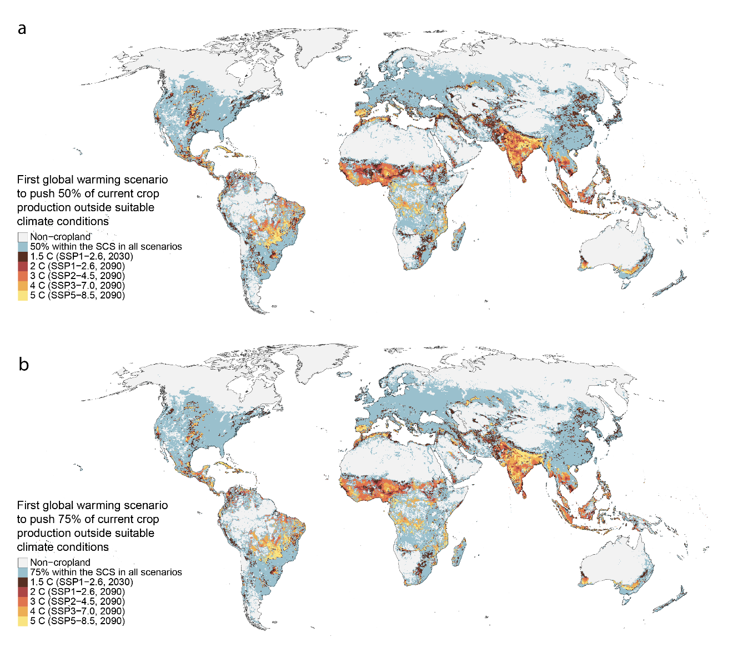
Extended Data Figure 1 First global warming scenario that would push current local crop production into considerable risk. ‘Considerable risk’ is defined as at least 50% (panel a) or 75% (panel b) of local current production of the 27 food crops (in a grid cell, in metric tons) outside crop specific Safe Climatic Spaces (SCS). “-% within SCS in all scenarios” category indicates that in the grid cell, current production would not be pushed into considerable risk in any scenario, i.e., at least a) 50%, b) 25% of production in that location is within crop specific SCS in all five global warming scenarios. A cell is assigned within the SCS for an individual crop if at least half of the eight General Circulation Models used in future projections indicate so.

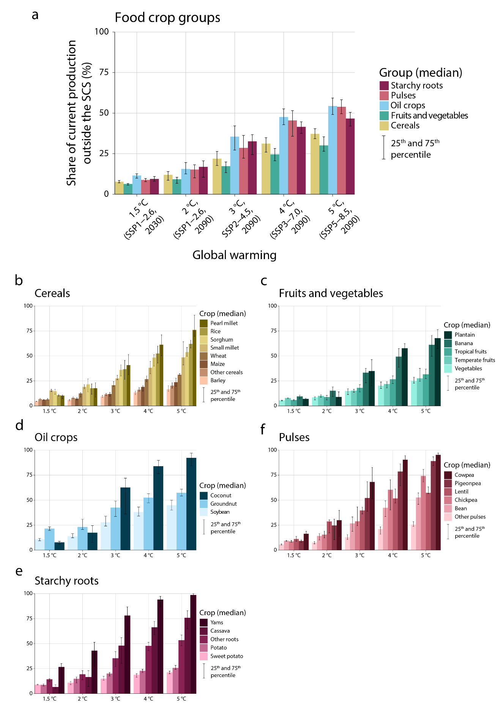
Extended Data Figure 2 Share of current, globally aggregated food crop production (in metric tons) outside crop specific Safe Climatic Space (SCS) at five global warming levels. The share of production (in metric tons) outside the SCS has been calculated individually for 27 crops, with estimates from eight General Circulation Models (GCM). The crop group level results are aggregates from results for individual crops. Bar height shows the median estimate from the GCMs, and whiskers show the 25th and 75th percentiles of the estimates. Panel a): crop groups (see Extended Data Table 1), panels b) – f): individual crops.
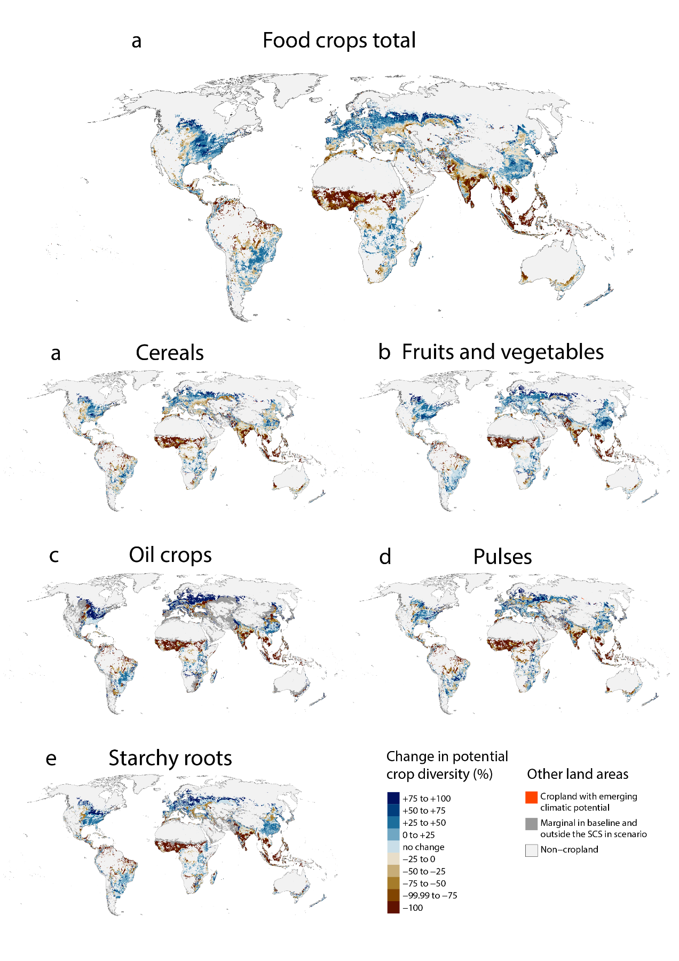
Extended Data Figure 3 Global percentual change in potential crop diversity at 3 °C (SSP2-4.5, 2090) global warming. Change in potential diversity is measured as percentual change in the number of crops that could be cultivated in each location given temperature and moisture conditions, from baseline climate conditions (1970-2000) to a future global warming scenario. The number of crops that could be cultivated in a location is determined by the geographical extent of the crop specific Safe Climatic Spaces (SCS), regardless of current cultivation areas. For an individual crop, a single location is defined within the SCS if at least half of the eight General Circulation Models indicate so. “Marginal in baseline and outside SCS in scenario” indicates that the location currently hosts marginal or no production of the crops within a crop group and does not shift into the SCS of any crop in the crop group in future scenarios. “Cropland with emerging climatic potential” indicates that the location currently hosts marginal or no production of the crops within a group but shifts into the SCS of at least one crop in a future scenario. Panel a): food crops total; panels b) – f): crop groups (Extended Data Table 1).

