Supplement: Diverging impacts of climate change on the global potential diversity of food crops

Sara Heikonen^{1*}, Matias Heino¹, Mika Jalava¹, Stefan Siebert², Daniel Viviroli³, Matti Kummu^{1*}

¹Aalto University, Department of Built Environment, Finland
²University of Göttingen, Department of Crop Sciences, Germany
³University of Zürich, Department of Geography, Switzerland.

*corresponding author, e-mail: sara.heikonen@aalto.fi and matti.kummu@aalto.fi

Supplementary figures

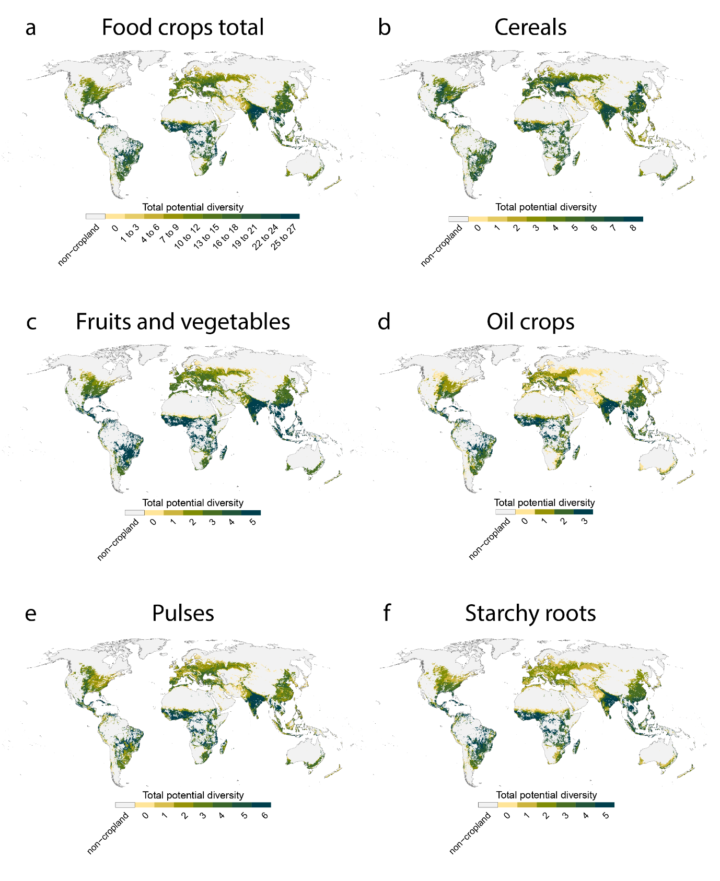
Supplementary Figure 1 Total potential food crop diversity in baseline climate conditions (1970-2000). Potential crop diversity has been determined by projecting the extent of cropland within the crop specific Safe Climatic Spaces (SCS) of the 27 food crops on the current cropland, regardless of the current cultivation areas of each crop. Potential diversity is measured as number of crops that could be cultivated in each location (grid cell) based whether the crop specific SCS covers the location in the scenario. In each panel, the category with the highest value indicates maximum diversity in that crop group. Panels a): food crops total; panels b) – e): crop groups (Extended Data Table 1).
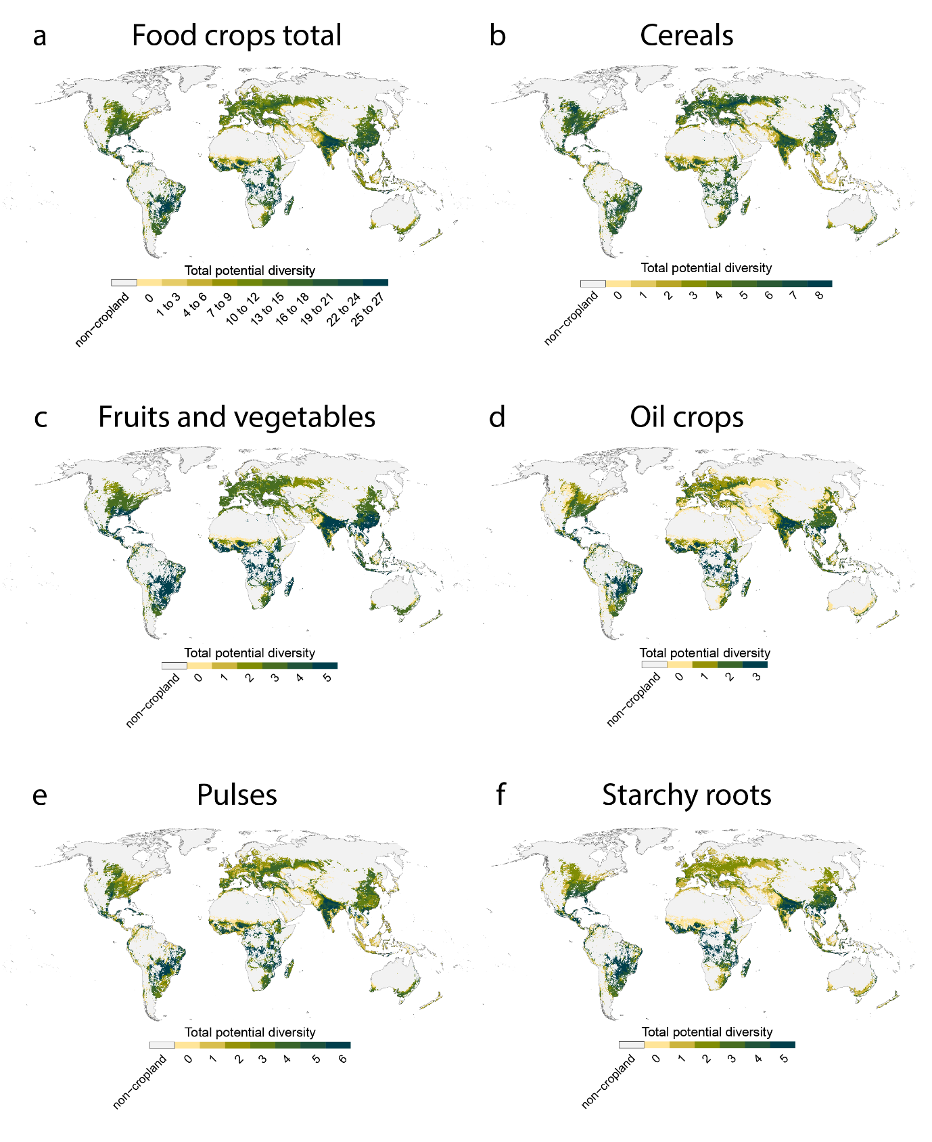
Supplementary Figure 2 Figure S1 Total potential food crop diversity in 2 °C global warming scenario (SSP1-2.6, 2090). Potential crop diversity has been determined by projecting the extent of cropland within the crop specific Safe Climatic Spaces (SCS) of the 27 food crops on the current cropland, regardless of the current cultivation areas of each crop. Potential diversity is measured as number of crops that could be cultivated in each location (grid cell) based whether the crop specific SCS covers the location in the scenario. In each panel, the category with the highest value indicates maximum diversity in that crop group. Panel a): food crops total; panels b) – e) crop groups (Extended Data Table 1).
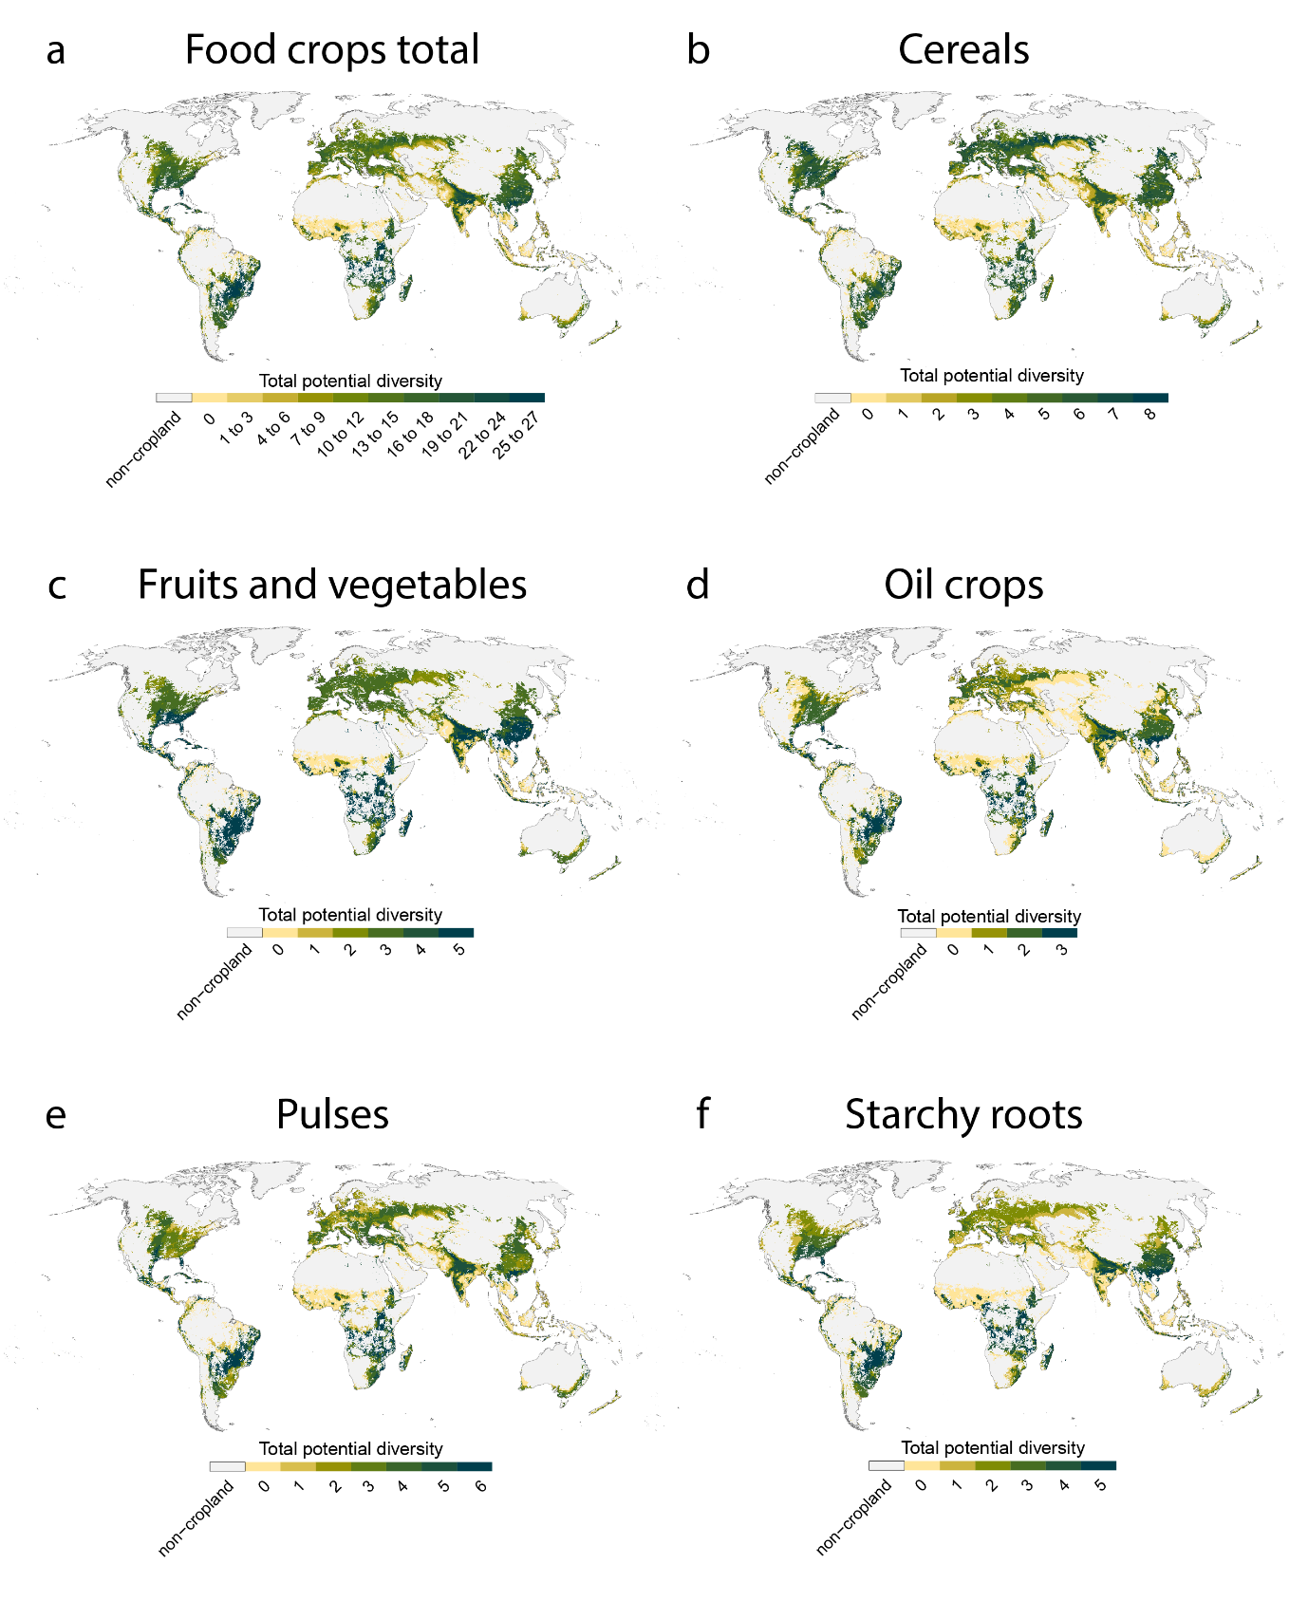
Supplementary Figure 3 Total potential food crop diversity in 3 °C global warming scenario (SSP2-4.5, 2090). Potential crop diversity has been determined by projecting the extent of cropland within the crop specific Safe Climatic Spaces (SCS) of the 27 food crops on the current cropland, regardless of the current cultivation areas of each crop. Potential diversity is measured as number of crops that could be cultivated in each location (grid cell) based whether the crop specific SCS covers the location in the scenario. In each panel, the category with the highest value indicates maximum diversity in that crop group. Panel a): food crops total; panels b) – e): crop groups (Extended Data Table 1).

Supplementary Note 1

Uncertainty analysis with SPAM 2005 crop production data
Since the Safe Climatic Space (SCS) concept¹ defines the climatic niche for food crop production based on the baseline climatic extent of current croplands, the spatial extent of the crop production data used might have an important impact on which climate conditions are to be within the niche. To validate our main results, we performed some of the analyses also using the previous version of the SPAM 2010 food production data set², SPAM 2005³, which represents crop production in the year 2005. The two data sets have moderate differences in the spatial extent of cultivation areas as well as the local production volume of individual crops².

Examining the impacts of global warming to current crop production, Supplementary Table 1 shows the share of current cropland area where at least 50% (in brackets, 25% and 75%) of current production shifts outside the crop specific SCS in each global warming scenario, using the SPAM 2005 data. The results presented in Supplementary Table 1 are similar to the main results produced using the SPAM 2010 data (Figure 1, Extended Data Table 2), generally with difference of 1 – 3 percentage points in values. The largest differences are found in Sub-Saharan Africa, where the difference to main results grows to 5 percentage points at maximum. Overall, we did not detect signs of a broader or narrower definition of the climatic niche for crop production between results related to risk to current production, produced using the two data sets.

Supplementary Table 1 Cumulative share of cropland area where at least 25% [50%, 75%] of the current production of 27 food crops would shift outside crop specific Safe Climatic Spaces (SCS) at global warming levels from 1.5 °C to 5 °C. “Cropland within SCS in all scenarios” shows the share of cropland area where less than 25% [50%, 75%] of current production would be pushed outside crop specific SCS at all warming levels. Analogous to Extended Data Table 2 but produced using SPAM 2005³ crop production data.
 | Cumulative share of cropland area where at least 25% of production shifts outside the SCS at warming level (%) |  |  |  |  | Cropland within SCS in all scenarios (%)
Region | 1.5 °C | 2 °C | 3 °C | 4 °C | 5 °C | Cropland within SCS in all scenarios (%)
Global | 23 [17, 13] | 28 [21, 16] | 41 [34, 29] | 52 [46, 41] | 59 [53, 49] | 41 [47, 51]
East Asia & Pacific | 24 [18, 14] | 29 [22, 18] | 42 [36, 32] | 49 [43, 39] | 55 [48, 44] | 45 [52, 56]
Europe & Central Asia | 13 [10, 9] | 13 [11, 9] | 15 [12, 10] | 18 [14, 11] | 23 [17, 15] | 77 [83, 85]
Latin America & Caribbean | 21 [16, 12] | 27 [21, 16] | 48 [42, 35] | 64 [58, 52] | 73 [68, 62] | 27 [32, 38]
Middle East & North Africa | 54 [46, 38] | 59 [51, 42] | 67 [59, 51] | 74 [68, 61] | 79 [73, 67] | 21 [27, 33]
North America | 16 [11, 8] | 17 [11, 8] | 21 [14, 10] | 24 [17, 12] | 29 [20, 15] | 71 [80, 85]
South Asia | 31 [23, 18] | 46 [33, 26] | 66 [53, 43] | 81 [71, 62] | 89 [84, 80] | 11 [16, 20]
Sub-Saharan Africa | 23 [16, 10] | 30 [22, 16] | 46 [41, 36] | 66 [62, 57] | 77 [72, 69] | 23 [28, 31]

With regards to changes cropland area within the SCSs of individual crops in projected climate conditions, there is some variability between results produced with SPAM 2010 (Extended Data Table 3) and SPAM 2005 data sets (Supplementary Table 2). For most crops, the difference between estimations using the two data sets is 5 percentage points at maximum. For eight crops or crop types, there are larger (6 – 10 percentage points) disagreements between the results: coconut, tropical fruit, temperate fruit, chickpea, pigeon pea, other pulses, sweet potato, and other roots. The largest disagreements are found at 4 °C and higher warming levels. Generally, SPAM 2010 results show lower decrease in cropland area within the SCS than SPAM 2005 results in the 4 °C and 5 °C global warming scenarios, indicating a broader climatic niche when using SPAM 2010 data. At 1.5 °C – 3 °C warming, there is a similar but more subtle pattern, and there are also several crops or crop types for which SPAM 2005 results show lower decrease in cropland area within the SCS, e.g., pigeon pea and other roots. Overall, the order of crops from least to most negatively affected is similar in both results.

Finally, for global change in potential food crop diversity of all 27 crops, the results produced using SPAM 2010 (Extended Data Table 4) and SPAM 2005 (Supplementary Table 3) are also similar. The differences in share of cropland area in the categories of change in potential diversity are from 0 to 6 percentage points. The largest difference is found in the 0 – 25% diversity increase category, where SPAM 2005 results allocate more cropland area. Across all categories of change in potential diversity, SPAM 2010 results show slightly more decrease in diversity than SPAM 2005 results at 1.5 °C and 2 °C warming, and less decrease in diversity at 4 °C and 5 °C warming.

To conclude, the results produced using the SPAM 2005 are mostly similar to the main results produced using SPAM 2010 data at regional and global scale and support the conclusions drawn from the main results. Across the results on risk to current production, projected change in cropland area within the SCS, and projected change in potential crop diversity, we did not detect constant trends in the disagreements between results. The differences in results produced using the two data sets were the smallest in aggregated results for all crops and the largest in results for individual crops. The larger differences in results for individual crops could be explained by the improved (i.e. more spatially extensive) input data on crop production in the SPAM 2010 data production process², as well as changes in the actual distribution of the cultivation areas of each crop. Therefore, the robustness of results especially on the level of individual crops is impacted by the crop production data. We believe that results produced using the improved crop production data set, SPAM 2010, provide improved estimate of shifts in the climatic niches of crops compared to results produced using the SPAM 2005 data.

Supplementary Table 2 Percentual net change in cropland area within the crop specific Safe Climatic Space (SCS) for 27 food crops in global warming scenarios from 1.5 °C to 5 °C. The percentual change is calculated as change compared to cropland area within the SCS in baseline conditions. ‘Med’ indicates median estimate from 8 GCMs, and ‘25th’ and ‘75th’ indicate 25th and 75th percentiles of the GCM estimates. Analogous to Extended Data Table 3 but produced using SPAM 2005³ crop production data.
 | Global warming (°C), measure
Crop | 1.5, med [25th, 75th] | 2, med [25th, 75th] | 3, med [25th, 75th] | 4, med [25th, 75th] | 5, med [25th, 75th]
Coconut | 13 [12, 14] | 11 [10, 13] | -11 [-21, 2] | -38 [-46, -27] | -48 [-57, -36]
Banana | 5 [5, 5] | 3 [1, 6] | -10 [-17, -1] | -28 [-34, -19] | -36 [-44, -26]
Sorghum | 3 [3, 4] | 0 [-1, 4] | -7 [-10, 0] | -16 [-20, -11] | -23 [-28, -15]
Tropical fruit | 1 [0, 2] | -1 [-3, 1] | -10 [-14, -4] | -21 [-25, -16] | -28 [-33, -21]
Barley | -5 [-6, -5] | -9 [-10, -8] | -16 [-17, -14] | -23 [-24, -18] | -28 [-34, -25]
Chickpea | 1 [0, 2] | -3 [-5, 1] | -9 [-12, -3] | -14 [-17, -9] | -18 [-23, -12]
Groundnut | 2 [1, 2] | 0 [-3, 2] | -10 [-15, -3] | -23 [-27, -15] | -31 [-37, -21]
Pearl millet | 6 [5, 7] | 4 [2, 7] | -7 [-12, 1] | -19 [-25, -13] | -29 [-34, -21]
Cassava | 3 [2, 4] | -1 [-3, 3] | -16 [-23, -7] | -35 [-42, -27] | -44 [-51, -33]
Maize | 1 [0, 2] | -2 [-4, 2] | -11 [-16, -6] | -26 [-31, -19] | -34 [-42, -26]
Yams | 4 [3, 5] | -1 [-3, 4] | -18 [-25, -9] | -39 [-48, -30] | -50 [-58, -38]
Plantain | 0 [-1, 1] | -4 [-6, 1] | -17 [-24, -10] | -34 [-40, -27] | -43 [-50, -33]
Bean | 1 [0, 1] | -2 [-3, 1] | -12 [-17, -6] | -25 [-30, -19] | -33 [-39, -26]
Sweet potato | -5 [-7, -4] | -10 [-11, -5] | -20 [-24, -12] | -30 [-35, -25] | -39 [-47, -30]
Temperate fruit | 1 [1, 2] | -1 [-2, 2] | -11 [-16, -6] | -25 [-30, -18] | -32 [-39, -25]
Vegetables | 0 [-1, 0] | -4 [-5, -1] | -13 [-18, -8] | -26 [-30, -20] | -33 [-39, -26]
Cowpea | -3 [-4, -2] | -7 [-12, -3] | -22 [-28, -15] | -35 [-38, -28] | -40 [-44, -34]
Wheat | -7 [-8, -6] | -13 [-14, -9] | -20 [-22, -17] | -28 [-31, -22] | -33 [-37, -29]
Other pulses | -6 [-7, -5] | -10 [-13, -7] | -20 [-24, -16] | -31 [-34, -25] | -36 [-42, -32]
Other cereals | -8 [-9, -7] | -12 [-15, -8] | -19 [-22, -16] | -29 [-32, -23] | -35 [-41, -32]
Pigeon pea | 1 [1, 2] | -3 [-6, 0] | -15 [-22, -9] | -30 [-34, -21] | -35 [-42, -29]
Other roots | -2 [-4, -1] | -7 [-10, -2] | -18 [-24, -11] | -32 [-37, -25] | -40 [-44, -30]
Rice | 1 [1, 2] | -1 [-3, 2] | -12 [-18, -4] | -28 [-34, -20] | -37 [-45, -28]
Soybean | -8 [-8, -6] | -12 [-16, -8] | -25 [-31, -19] | -39 [-44, -32] | -45 [-54, -40]
Lentil | -5 [-6, -4] | -11 [-12, -6] | -19 [-21, -15] | -26 [-31, -23] | -33 [-38, -28]
Small millet | -7 [-8, -6] | -11 [-14, -7] | -22 [-27, -17] | -35 [-40, -28] | -42 [-52, -36]
Potato | -9 [-11, -8] | -14 [-16, -10] | -23 [-26, -19] | -32 [-35, -27] | -37 [-44, -33]

Supplementary Table 3 Global share of cropland in categories of change in potential crop diversity of 27 food crops, compared to baseline potential diversity in 1970-2000. “Cropland with emerging climatic potential” indicates that the area hosts marginal crop production in baseline climate but would shift into the Safe Climatic Space (SCS) of at least one crop in the future scenario. “Marginal in baseline and outside the SCS in scenario” indicates that the area hosts marginal production in baseline climate and is not within the SCS of any crop in the future scenario. Analogous to Extended Data Table 4 but produced with SPAM 2005³ crop production data.
 | Share of global cropland in category in global warming scenarios (%)
Diversity change compared to baseline (%) | 1.5 °C | 2 °C | 3 °C | 4 °C | 5 °C
-100 | 2.8 | 5.0 | 16.6 | 26.8 | 34.0
-99.99 to -75 | 1.4 | 2.1 | 2.6 | 3.0 | 2.6
-75 to -50 | 3.3 | 4.1 | 3.7 | 4.0 | 4.0
-50 to -25 | 10.6 | 13.0 | 11.3 | 8.0 | 6.9
-25 to 0 | 20.8 | 19.3 | 15.5 | 12.5 | 10.1
no change | 17.2 | 13.1 | 11.9 | 11.9 | 11.5
0 to +25 | 26.2 | 25.1 | 18.1 | 14.2 | 12.4
+25 to +50 | 8.7 | 8.9 | 10.0 | 8.9 | 8.3
+50 to +75 | 2.7 | 2.8 | 3.4 | 3.8 | 3.5
+75 to +100 | 2.6 | 2.9 | 3.1 | 3.2 | 3.0
Cropland with emerging climatic potential | 1.1 | 1.2 | 1.6 | 1.8 | 1.9
Marginal in baseline and outside the SCS in scenario | 2.7 | 2.6 | 2.2 | 2.0 | 1.9

Uncertainty analysis with Safe Climatic Space defined based on crop calendar
The Safe Climatic Space (SCS) concept¹ defines the climatic niche for food crops based on average annual climate parameter values, following the Holdridge Life Zones method⁴. Therefore, it has limited capability of representing the seasonal variability of climate conditions. However, the seasonal variability strongly influences cropping patterns for example in regions with monsoon rainfall and multiple cropping seasons. For instance, in Latin America, soybean is cultivated during the rainy winter, and maize might be planted early in the spring when the drier season begins⁵. Therefore, the climatic niches of these crops in Latin America are not similar in reality but the distinction cannot be represented using the original SCS approach. To examine the impact of seasonality of climate conditions to the results in this study, we performed additional analyses where the crop specific SCSs were defined based on local (grid cell level) crop calendar. The additional analyses were limited to two crops (maize and soybean) because of limited availability of crop calendar data for the crop types in SPAM 2010².

We performed the analyses considering the crop calendar for maize and soybean using the GGCMI Phase 3 crop calendar dataset⁶. These two crops were selected because for them, the spatial coverage of the crop calendar data was the largest out of the crops that match the crops in SPAM 2010² crop production data. Using both the irrigated and rainfed crop calendars⁶, we created monthly cropping season filter rasters for maize and soybean. Then, at grid cell level, we selected only the months of temperature and precipitation data⁷ that fall within the cropping season of each crop for further calculation. Next, we applied the same crop specific SCS calculation steps as described in Methods and performed analyses on the changes in cropland within the SCS on the current production areas of these crops as well as on the total cropland area of all 27 crops. We compared the results from these analyses to corresponding analyses using the original, annual SCS method. The comparison was done on the overlapping parts of the total cropland area, maize production area, and soybean production area between the seasonal and annual SCS methods.

At global scale, the seasonal and original SCS approach produced similar results for the share of current crop production that would shift outside the SCS (Supplementary Table 4, Supplementary Table 5). However, the approaches show different impacts for croplands in the temperate regions in the Northern Hemisphere as well as regions near the Equator. The annual approach shows larger adverse impacts to current production in East Asia and the Pacific, the Middle East and North Africa, South Asia, and Sub-Saharan Africa. On the other hand, the seasonal approach shows larger adverse impacts in Europe and Central Asia and in North America. For both crops, the differences between results using the two approaches start growing at 3 °C global warming.

When shifts in the cropland within the SCS are projected on the total cropland of all crops, globally, the seasonal SCS approach consistently shows lower decrease in cropland area within the SCS than the annual SCS approach (Supplementary Table 6). Again, the difference in results produced using the two approaches starts growing at 3 °C global warming. The differences in results between the two approaches are larger for soybean than for maize at most warming levels.

At 3 °C warming, areas where the two approaches disagree are distributed across world regions (Supplementary Figure 4). However, the seasonal approach estimates more area within the SCS in the equatorial region and near the outer edges of current croplands. These areas within the seasonal SCS but outside the annual SCS partially overlap current multiple cropping areas⁵ and monsoon regions, especially for maize. On the other hand, the annual approach estimates more cropland within the SCS especially in Europe and Central Asia, Southern America, and Central and Southern Africa. The areas where the two approaches agree and disagree are distributed similarly for soybean and maize.

Supplementary Table 4 Median share (%) of current soybean production (in metric tons) outside the crop specific Safe Climatic Space (SCS) at five warming levels, using the original, annual SCS method (‘Ann’ columns) and seasonal SCS method based on crop calendar (‘Seas’ columns). Tot major crop is the major production (contributing to the highest 95% of global total in metric tons) in region. These values differ between SCS methods because grid cells contributing to the major production areas are found by assigning all production areas to climatic bins using precipitation and PET data, and then choosing the climatic bins that include the highest ≤ 95% of production¹. NA indicates that there currently is no major production in the region, and therefore the effects to current production cannot be calculated.
Share of current production outside SCS (%) at warming level
 | 1.5°C |  | 2°C |  | 3°C |  | 4°C |  | 5°C |  | Tot major prod (1000 mtons)
Region | Ann | Seas | Ann | Seas | Ann | Seas | Ann | Seas | Ann | Seas | Ann | Seas
Global | 11 | 12 | 14 | 16 | 28 | 30 | 38 | 40 | 45 | 46 | 237323 | 237251
East Asia & Pacific | 11 | 7 | 13 | 9 | 21 | 13 | 38 | 14 | 45 | 16 | 13799 | 14389
Europe & Central Asia | 29 | 38 | 34 | 43 | 45 | 52 | 62 | 62 | 66 | 70 | 3925 | 2930
Latin America & Caribbean | 7 | 8 | 12 | 16 | 30 | 25 | 47 | 29 | 54 | 36 | 118495 | 118547
Middle East & North Africa | 58 | NA | 14 | NA | 6 | NA | 19 | NA | 78 | NA | 6 | 0
North America | 13 | 15 | 15 | 19 | 22 | 41 | 22 | 65 | 23 | 74 | 89673 | 89632
South Asia | 17 | 15 | 41 | 22 | 63 | 14 | 94 | 7 | 100 | 8 | 10392 | 10677
Sub-Saharan Africa | 29 | 18 | 36 | 21 | 54 | 30 | 61 | 37 | 71 | 46 | 1033 | 1076

Supplementary Table 5 Median share (%) of current maize production (in metric tons) outside the crop specific Safe Climatic Space (SCS) at five warming levels, using the original, annual SCS method (‘Ann columns’) and seasonal SCS method based on crop calendar (‘Seas’ columns). Tot major crop is the major production (contributing to the highest 95% of global total in metric tons) in region. These values differ between SCS methods because grid cells contributing to the major production areas are found by assigning all production areas to climatic bins using precipitation and PET data, and then choosing the climatic bins that include the highest ≤ 95% of production¹.
Share of current production outside SCS (%) at warming level
 | 1.5°C |  | 2°C |  | 3°C |  | 4°C |  | 5°C |  | Tot major prod (1000 mtons)
Region | Ann | Seas | Ann | Seas | Ann | Seas | Ann | Seas | Ann | Seas | Ann | Seas
Global | 6 | 4 | 7 | 5 | 12 | 10 | 19 | 19 | 24 | 27 | 806143 | 806152
East Asia & Pacific | 10 | 2 | 10 | 3 | 13 | 4 | 18 | 6 | 23 | 8 | 198682 | 202592
Europe & Central Asia | 3 | 7 | 4 | 10 | 9 | 21 | 17 | 44 | 23 | 60 | 94953 | 93651
Latin America & Caribbean | 7 | 6 | 9 | 6 | 16 | 10 | 27 | 14 | 37 | 17 | 104346 | 98711
Middle East & North Africa | 13 | 1 | 13 | 1 | 14 | 1 | 15 | 1 | 12 | 1 | 5903 | 9740
North America | 3 | 1 | 3 | 1 | 5 | 7 | 7 | 23 | 11 | 32 | 326653 | 330236
South Asia | 15 | 12 | 30 | 14 | 43 | 18 | 64 | 22 | 85 | 28 | 22894 | 22569
Sub-Saharan Africa | 11 | 12 | 16 | 13 | 28 | 20 | 37 | 32 | 41 | 38 | 52713 | 48653

Supplementary Table 6 Median net change (%) in global total cropland area within the crop specific Safe Climatic Space (SCS) at five global warming levels. ‘Ann’ columns show net change using the original, annual SCS method, and ‘Seas’ columns show net change using the seasonal SCS method based on crop calendar. Net change was calculated as percentual change in the total cropland area within the SCS (regardless of where crop is currently grown) from baseline climate conditions to a future warming scenario. Total cropland area refers to the current, total cropland of the 27 food crops.
Share of current total cropland outside SCS (%) at warming level
 | 1.5°C |  | 2°C |  | 3°C |  | 4°C |  | 5°C
Crop | Ann | Seas | Ann | Seas | Ann | Seas | Ann | Seas | Ann | Seas
Soybean | -6 | -2 | -10 | -4 | -21 | -12 | -35 | -19 | -41 | -25
Maize | +1 | 0 | -2 | -1 | -10 | -5 | -23 | -10 | -30 | -13

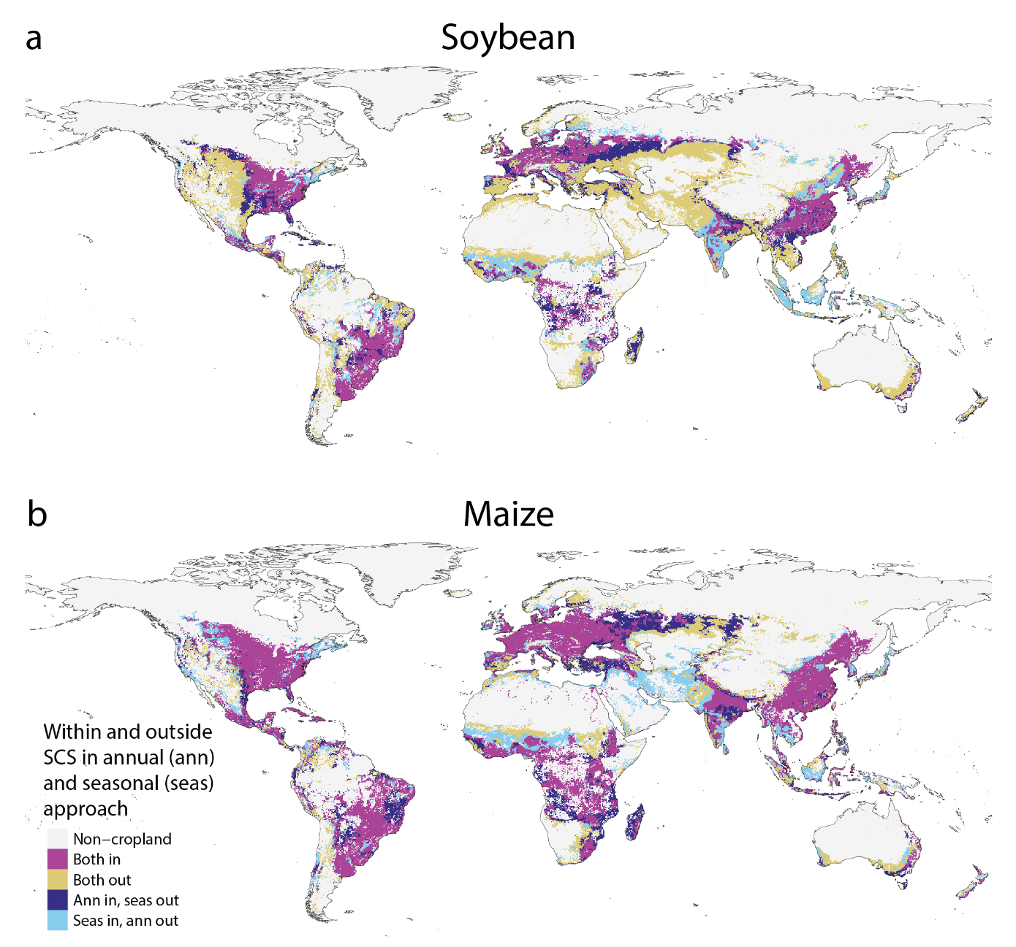
Supplementary Figure 4 Current cropland within and outside the Safe Climatic Space (SCS) at 3 °C global warming (SSP2-4.5, 2090) using the original, annual SCS approach and seasonal SCS approach which considers crop calendar and only includes climate parameters within the cropping season. Panels: a) soybean, b) maize.

Supplementary Note 2

Changes in potential crop diversity within elevation and latitude zones
We measured changes in potential crop diversity for food crops in total also within elevation and latitude zones, using the same calculation steps as for summarization within geographical regions (Methods). The elevation zones were created using the HydroSHEDS v1⁸ Void-filled Digital Elevation Model (DEM) at 30 arc-second resolution. The DEM was upscaled to 5 arc minute resolution using the bilinear method in the resample function from the terra R package⁹, and then classified into four elevation regions: less than 800 m (75 % of current cropland), 800 to 1500 m (16 %), 1500 to 2500 m (6.5 %), and more than 2500 m (2.5 %). The latitude regions were delineated by creating a 5 arc minute resolution raster with latitude as the cell value, and classifying the raster into three zones: 40° to 90° N (high latitudes in the Northern Hemisphere, 24.5 % of current cropland), 40° N to 40° S (extended equatorial region, 75 %), and 40° to 90° S (high latitudes in the Southern Hemisphere, 0.5 %). The third latitude zone includes very little cropland since it covers only the southernmost parts of South America, Australia, and New Zealand. Both elevation and latitude zone rasters were polygonised to allow calculating zonal statistics of the change in potential diversity.

Within elevation zones, the zone with elevation of less than 800 m faces the largest decrease in potential food crop diversity, and the zone with elevation of more than 2500 m the smallest decrease (Supplementary Figure 5). The pattern of change in the lowest elevation zone closely aligns with the global change shown in Figure 5. In contrast, the elevation zones 800 to 1500 and 1500 to 2500 m exhibit changes similar to these noted in regions like North America (Figure 5), showing an increase in potential diversity across most of the current cropland area in all scenarios. Unlike the other elevation zones, the highest elevation zone shows changes in potential diversity that are driven by large shares of area with emerging climatic potential (10% to 31% at 1.5 °C to 5 °C global warming, respectively). It is worth noting that this zone also encompasses a larger share of baseline marginal cropland land area than other elevation zones and covers only 2.5 % of the current total cropland area.

Within latitude zones, the extended equatorial region (40° N to 40° S) faces more extensive loss of potential diversity than the higher latitude zones (40° to 90°) in the Northern and Southern Hemispheres (Supplementary Figure 5). Higher latitudes in the Northern Hemisphere, similarly as North America as well as Europe and Central Asia (Figure 5), faces loss in potential diversity on 25% to 30% of current cropland area in all scenarios. At higher latitudes in the Southern Hemisphere, covering little current cropland, potential diversity decreases on less than 20% of cropland area in all scenarios. Moreover, this zone has the largest share of cropland area with emerging climatic potential (up to +14%) within the three latitude zones.

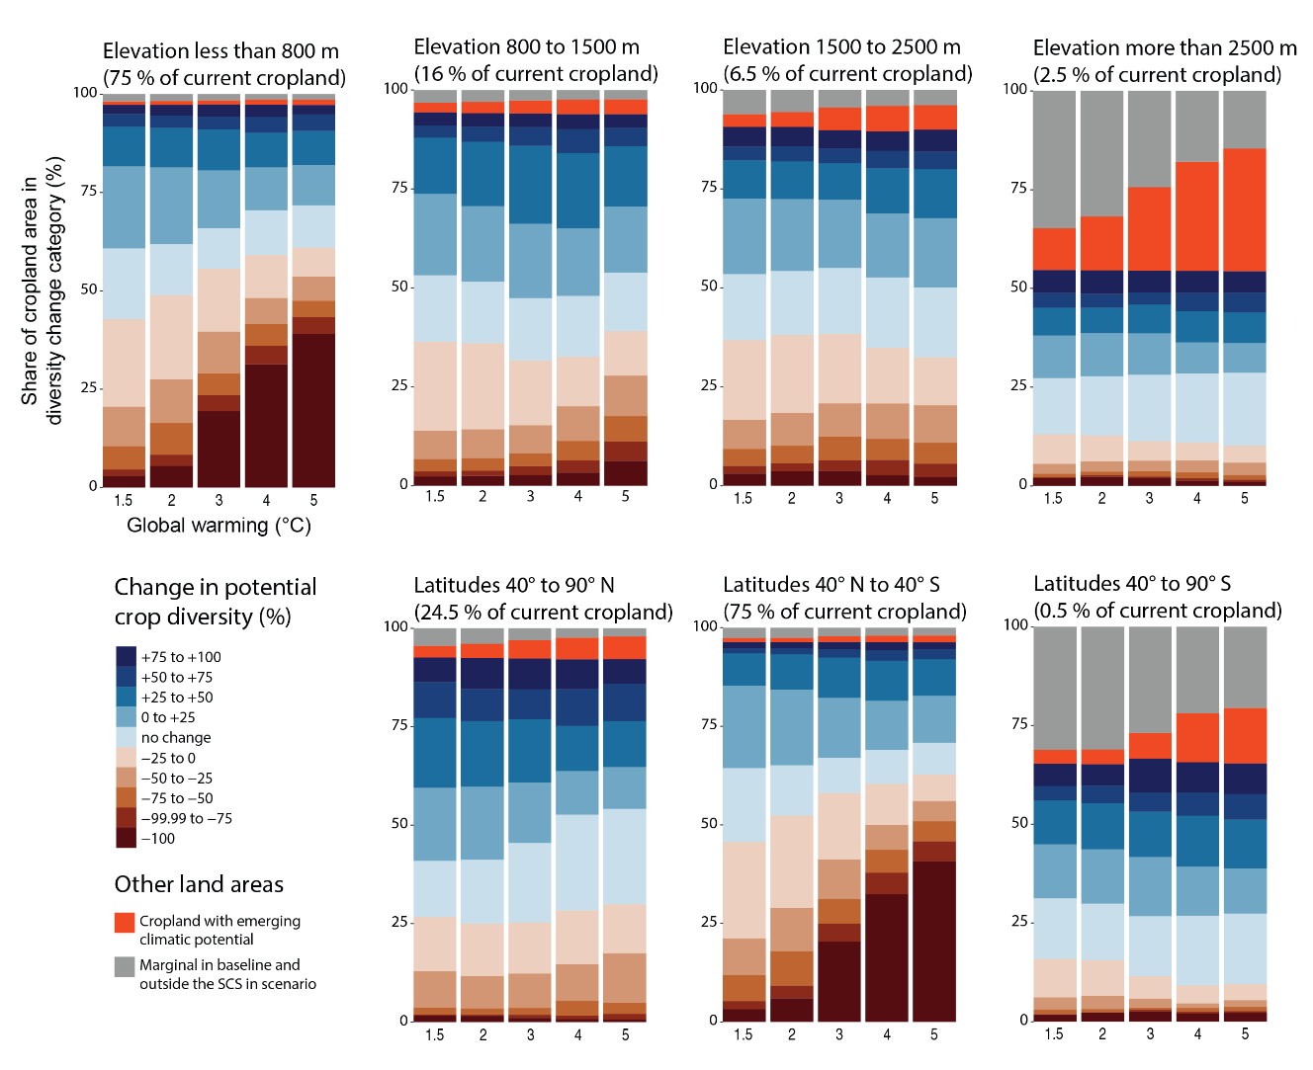
Supplementary Figure 5 Change in potential crop diversity for food crops in elevation and latitude zones. Stacked bars show the share of current cropland area in categories of diversity change at five global warming levels from 1.5 °C (SSP1-2.6, 2030) to 5 °C (SSP5-8.5, 2090). Change in potential diversity is measured as percentual change in the number of crops that could be cultivated in each location given temperature and moisture conditions, from baseline climate conditions (1970-2000) to a future global warming scenario. The number of crops that could be cultivated in a location is determined by the geographical extent of the crop specific Safe Climatic Spaces (SCS), regardless of current cultivation areas. For an individual crop, a single location is defined within the SCS if at least half of the eight General Circulation Models indicate so. “Marginal in baseline and outside the SCS in scenario” indicates that the location currently hosts marginal crop production and does not shift into the SCS of any crop in future scenarios. “Cropland with emerging climatic potential” indicates that the location currently hosts marginal crop production but shifts into the SCS of at least one crop in a future scenario.

Supplementary references

1. Kummu, M., Heino, M., Taka, M., Varis, O. & Viviroli, D. Climate change risks pushing one-third of global food production outside the safe climatic space. One Earth 4, 720–729 (2021).
2. Yu, Q. et al. A cultivated planet in 2010 – Part 2: The global gridded agricultural-production maps. Earth System Science Data 12, 3545–3572 (2020).
3. Wood-Sichra, Ulrike, Joglekar, Alison B., & You, Liangzhi. Spatial production allocation model (SPAM) 2005: Technical documentation. (2016).
4. Holdridge, L. R. Determination of World Plant Formations from Simple Climatic Data. Science 105, 367–368 (1947).
5. Waha, K. et al. Multiple cropping systems of the world and the potential for increasing cropping intensity. Global Environmental Change 64, 102131 (2020).
6. Jägermeyr, J., Müller, C., Minoli, S., Ray, D. & Siebert, S. GGCMI Phase 3 crop calendar. (2021) doi:10.5281/zenodo.5062513.
7. Fick, S. E. & Hijmans, R. J. WorldClim 2: new 1-km spatial resolution climate surfaces for global land areas. International Journal of Climatology 37, 4302–4315 (2017).
8. Lehner, B., Verdin, K. & Jarvis, A. New Global Hydrography Derived From Spaceborne Elevation Data. Eos, Transactions American Geophysical Union 89, 93–94 (2008).
9. Hijmans, R. J. terra: Spatial Data Analysis. (2023).

